Extended Figure and Legends
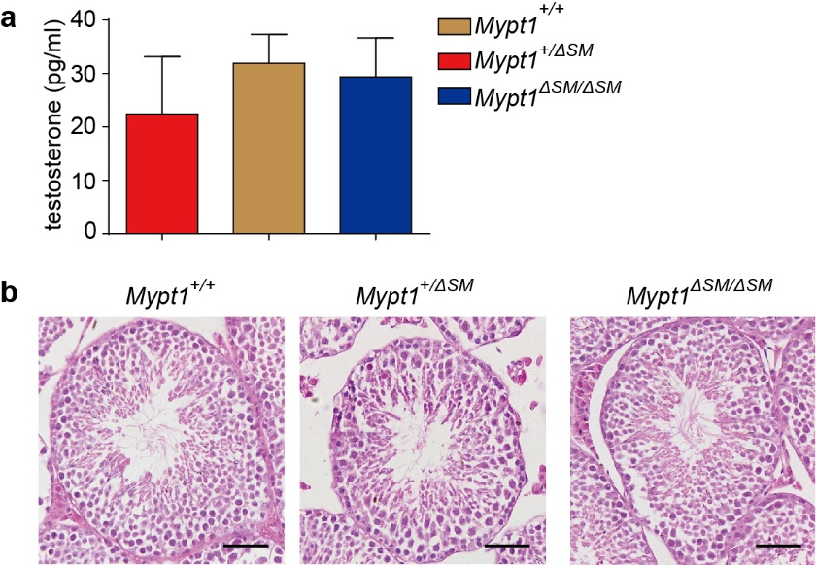
Extended Figure 1. The phenotype of testis from different genotypic mice. Equal level of testostenrone (T) (a) (n=3) and H-E staining of testis (b) from different genotypic mice. Scar bar = 50 μm. The bars indicate the mean values ± SEM.

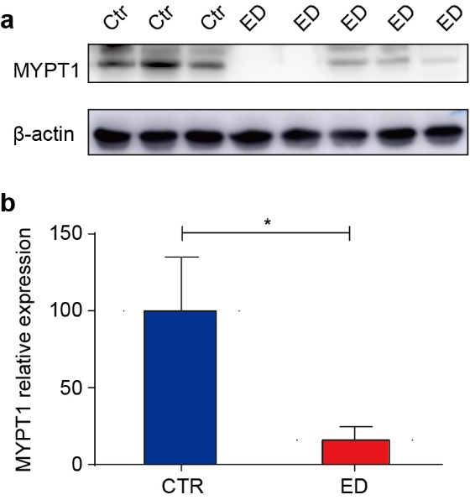
Extended Figure 2. Decreased MYPT1 protein expression was detected in penile smooth muscle from ED patients. a, CC biopsies from five patients with intractable ED and three patients with penile cancer were collected and sampled for a Western blot assay. β-actin was used as the internal loading control. Panel A shows the MYPT1 expression in CC. b, Quantification of relative MYPT1 level with respect to β-actin (Control, n=3; ED, n=5); *p<0.05; t-test.
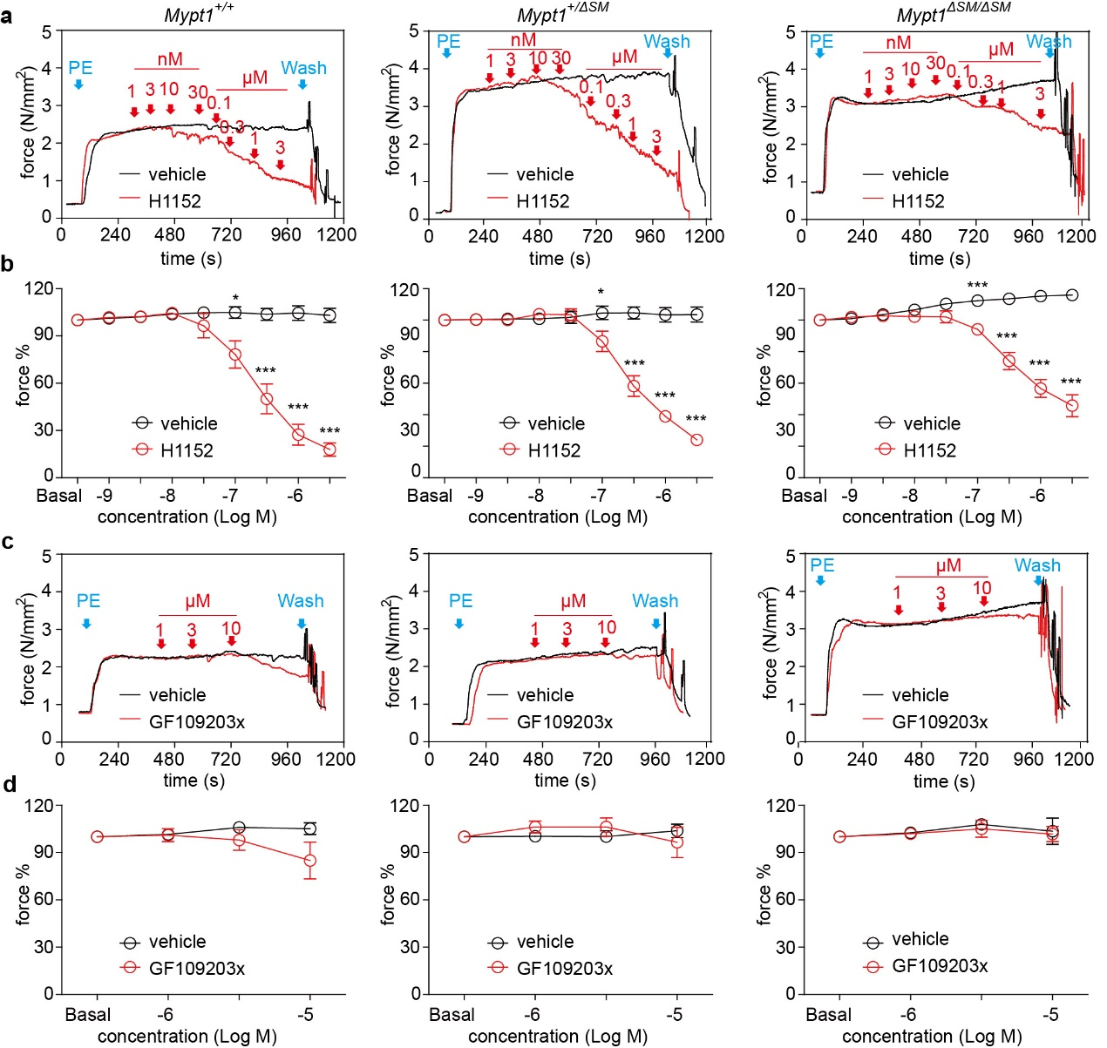
Extended Figure 3. Relaxant effects of H1152 and GF109203x on PE-evoked contraction of the dorsal artery. a and c, Representative tracings of dorsal arteries precontracted using 10 μM PE and then exposed to H1152 (1 nM to 3 μM) (a) or GF109203X (10 μM to 3 μM) (c). b and d, Quantification of the relative ratios of force relaxation by the reagents. The bars indicate the mean values ± SEM; *p<0.05, ***p<0.001 by t-test. n=6.
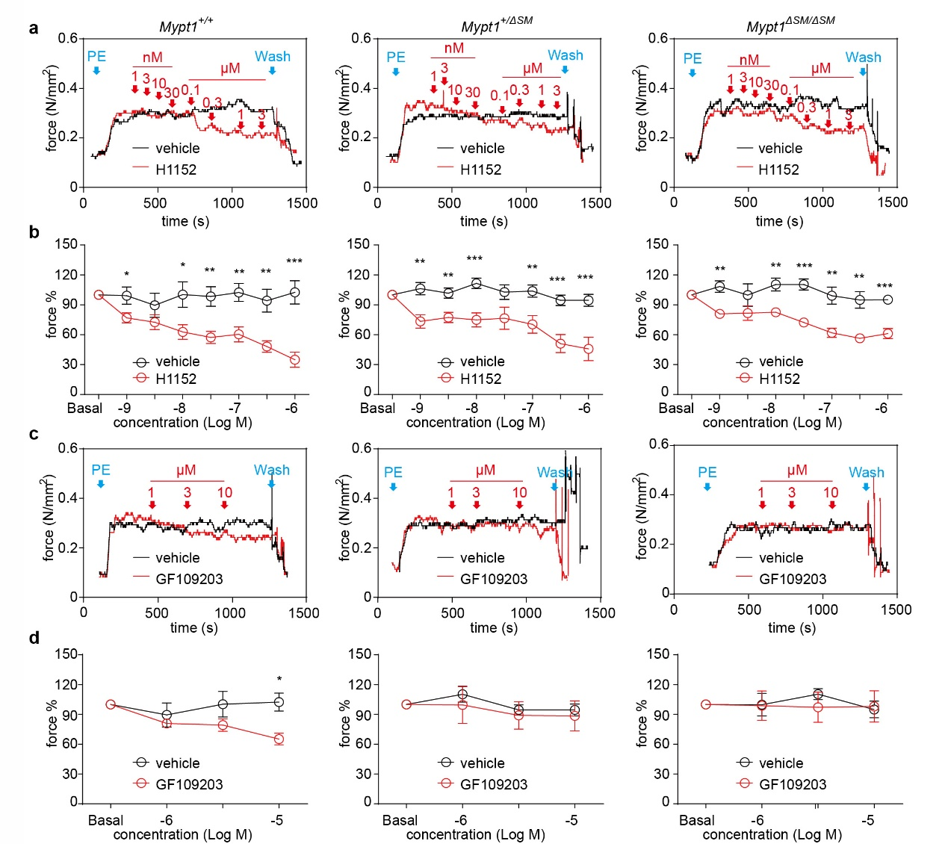
Extended Figure 4. Relaxant effects of H1152 and GF109203x on PE-evoked contraction of the CC. a and c, Representative tracings of dorsal arteries precontracted using 10 μM PE and then exposed to H1152 (1 nM to 3 μM) (a) and GF109203X (10 μM to 3 μM) (c). b and d, Quantification of the relative ratios of force relaxation by the reagents. The bars indicate the mean values ± SEM; *p<0.05, **p<0.01, ***p<0.001 by t-test. n=4-10.
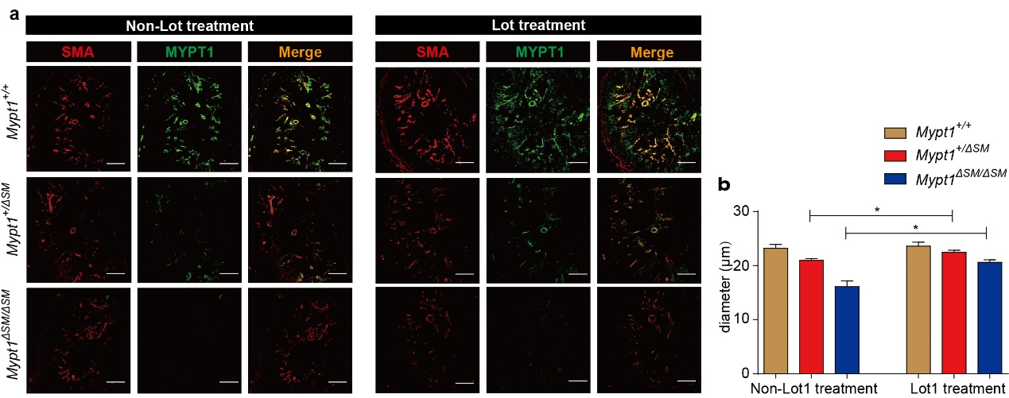
Extended Figure 5. Lotusine treatment led to elevated MYPT1 expression and an enlarged diameter of the central artery of the CC. a, Immunofluorescence staining showed an increase in MYPT1 expression and the diameter of the penile central artery after lotusine treatment (Scale bar = 100 μm). b, Quantitation of the central artery diameters. SMA (red); MYPT1 (green). The bars indicate the mean values ± SEM; *p<0.05 by t-test. n=3-4.

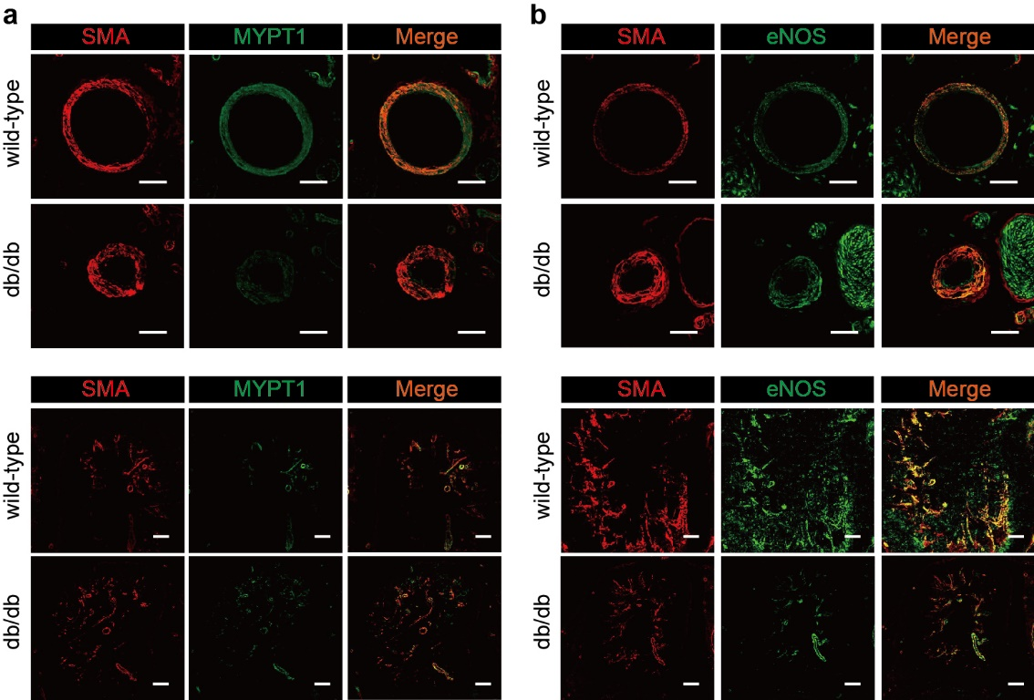
Extended Figure 6. Expression of eNOS and MYPT1 in CC from db/db mice. Immunological staining of the dorsal artery (upper panels) and CC (lower panels) in db/db showed reduced expression of eNOS (a) and comparable expression of eNOS (b) in both the dorsal artery and CC (Scalr bar=50 μm (upper panels), Scalr bar=100 μm (lower panels)).

