Supplementary Figures for “Genomic mechanism of antimicrobial resistance revealed from 3,163 Klebsiella pneumoniae genomes”
Hongru Li, Sifei Wang, Jiabin Li, Han Xia, Kai Ye, Yanyan Liu, Xiaofei Yang

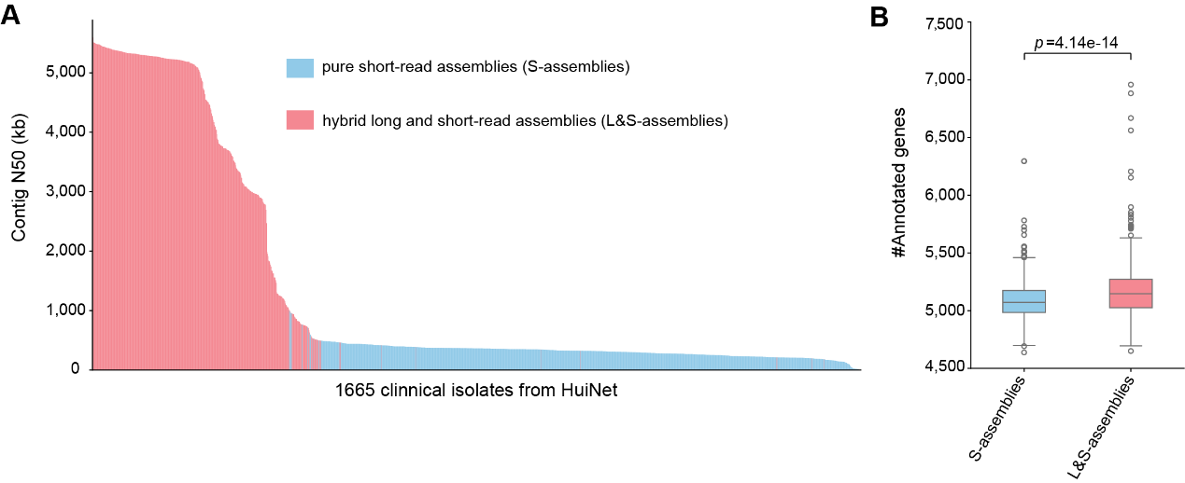
Supplementary Figure 1. A, Assembly continuity (contig N50) of pure short-read assemblies (S-assemblies) and hybrid long- and short-read assemblies (L&S-assemblies) from the 1,665 HuiNet isolates. B, Number of annotated genes per genome recovered from the two assembly strategies. The hybrid assemblies recovered significantly more genes (two-sided Mann–Whitney U test, p=4.14×10⁻¹⁴).
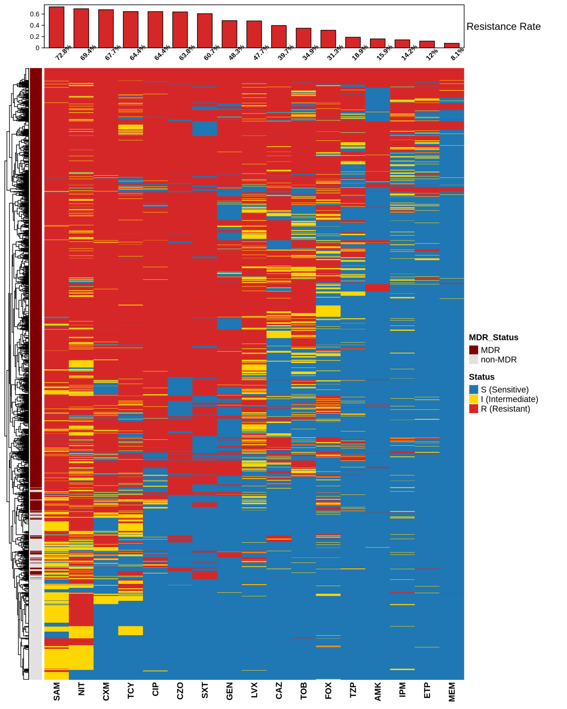
Supplementary Figure 2. Hierarchical clustering heatmap of antimicrobial resistance phenotypes among 1,665 isolates. The heatmap illustrates the phenotypic resistance profiles where each row represents an individual bacterial isolate (n = 1,665) and each column corresponds to one of the 17 tested antimicrobial agents. Isolates are organized by hierarchical clustering based on their susceptibility patterns to reveal clusters with similar multidrug-resistance (MDR) signatures. The color scale denotes clinical categories: deep red for resistant (R), bright gold for intermediate (I), and deep blue for sensitive (S) phenotypes. The left-side vertical annotation bar distinguishes MDR isolates (dark red) from non-MDR isolates (light gray).

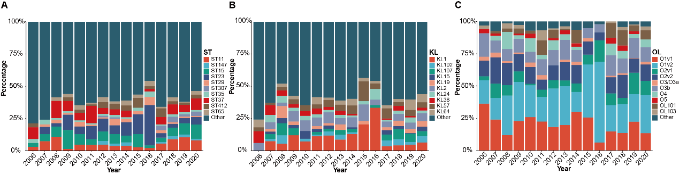
Supplementary Figure 3. The trend of molecular typing of K. pneumoniae over time. 20 ST types (A), 15 K capsular types (B) and 11 O serotypes (C) were compared respectively.

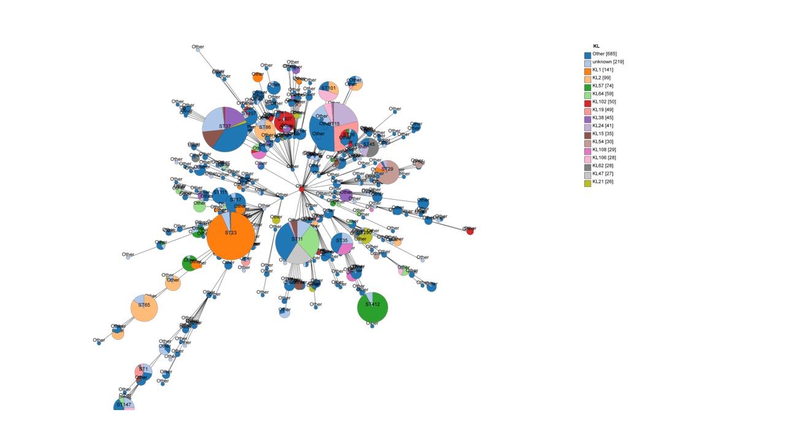
Supplementary Figure 4. Population genomic structure and distribution of Capsule (KL) Loci in K. pneumoniae isolates. The population landscape was visualized using GrapeTree based on the MSTree V2 algorithm, reflecting the phylogenetic relationships of 1,665 isolates derived from core-genome SNPs. Each node represents a specific Sequence Type (ST), with branch lengths proportional to genetic distances. Node size correlates with the number of isolates per ST, highlighting the dominance of lineages such as ST11, ST23, ST15, and ST37. The internal pie charts represent the distribution of capsule synthesis (KL) loci within each ST.

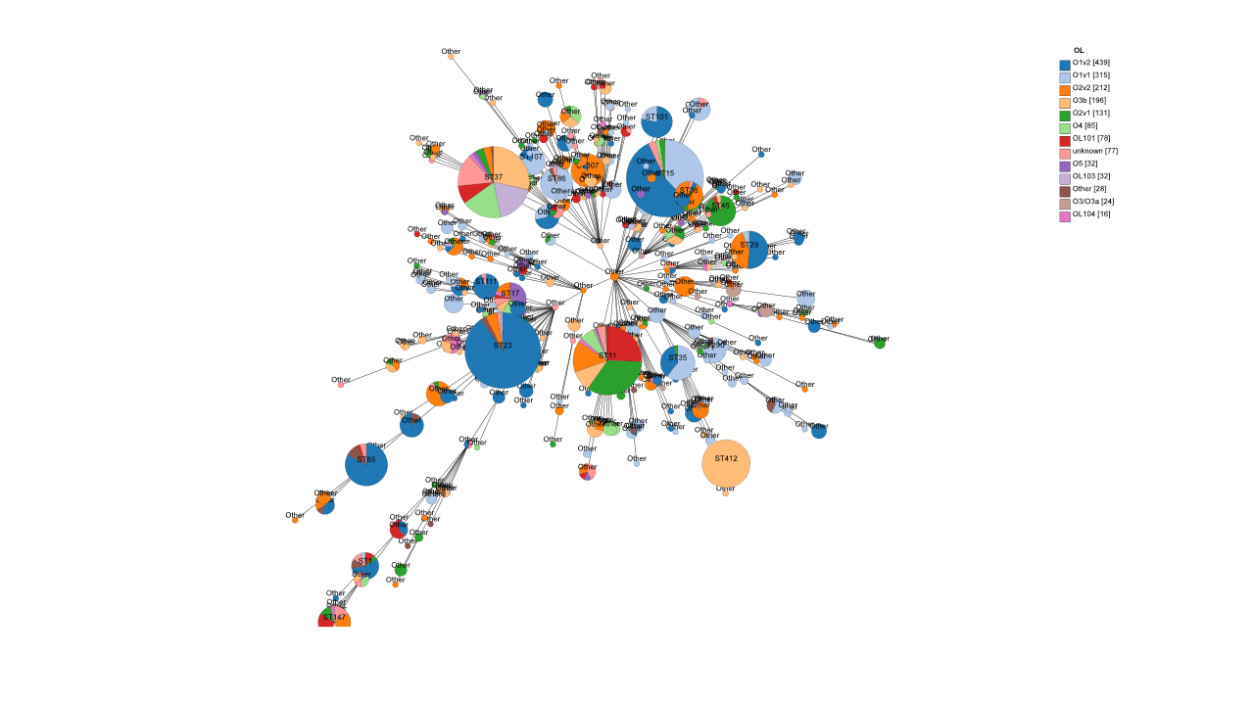
Supplementary Figure 5. Phylogenomic distribution and O-Antigen serotype diversity of K. pneumoniae isolates. The population structure of 1,665 K. pneumoniae clinical isolates was visualized using a GrapeTree based on core-genome SNPs and the MSTree V2 algorithm. In this graphical representation, each node corresponds to a specific Sequence Type (ST), with branch lengths reflecting the degree of genetic divergence. The diameter of each node is proportional to the number of isolates within that ST, highlighting the expansion of major clonal lineages across the HuiNet platform. The color segments within each node (pie charts) indicate the distribution of O-antigen serotypes (OL types).

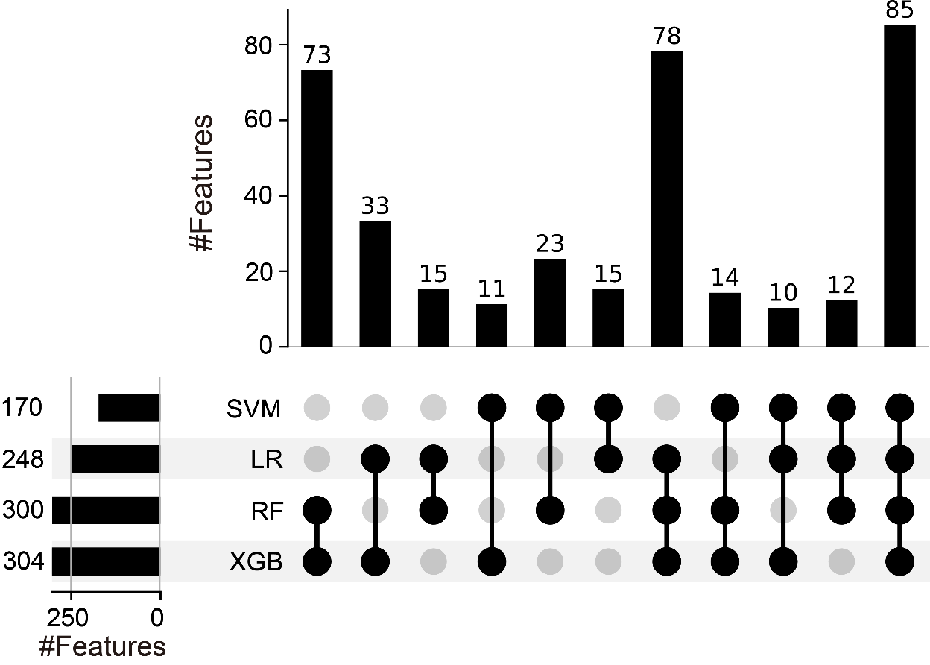
Supplementary Figure 6. Number of features supported by different model combinations. In this graphical representation, each row corresponds to one machine-learning model, including SVM, logistic regression (LR), random forest (RF), and XGBoost (XGB). The horizontal bars on the left indicate the total number of isolates identified by each individual model, whereas the vertical bars at the top represent the number of isolates shared by specific combinations of models. In the dot matrix, black dots mark the models included in each intersection, and connected black dots indicate that these models jointly contributed to the corresponding overlap; gray dots indicate models not included in that intersection.

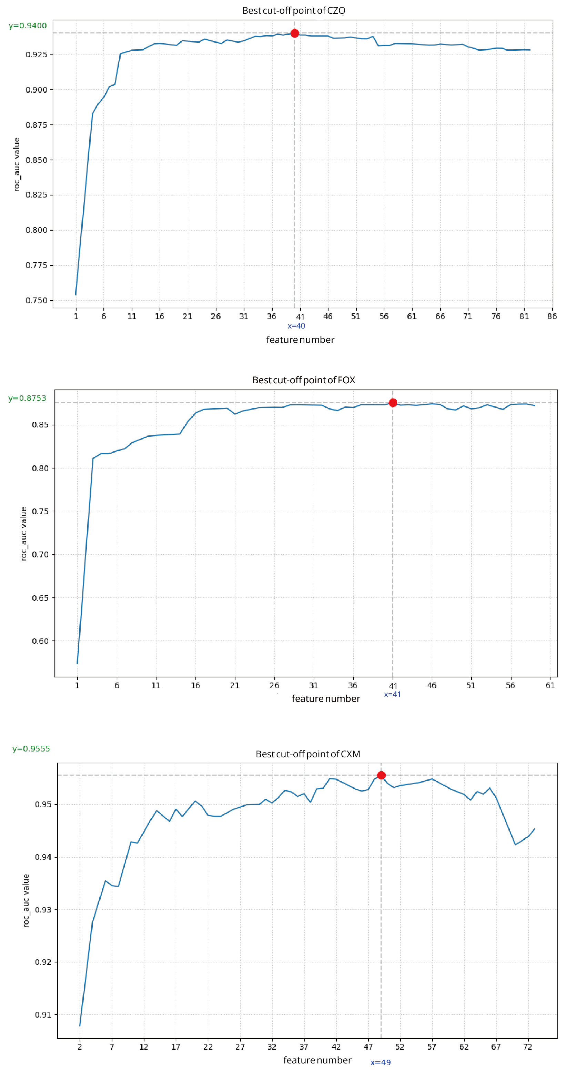
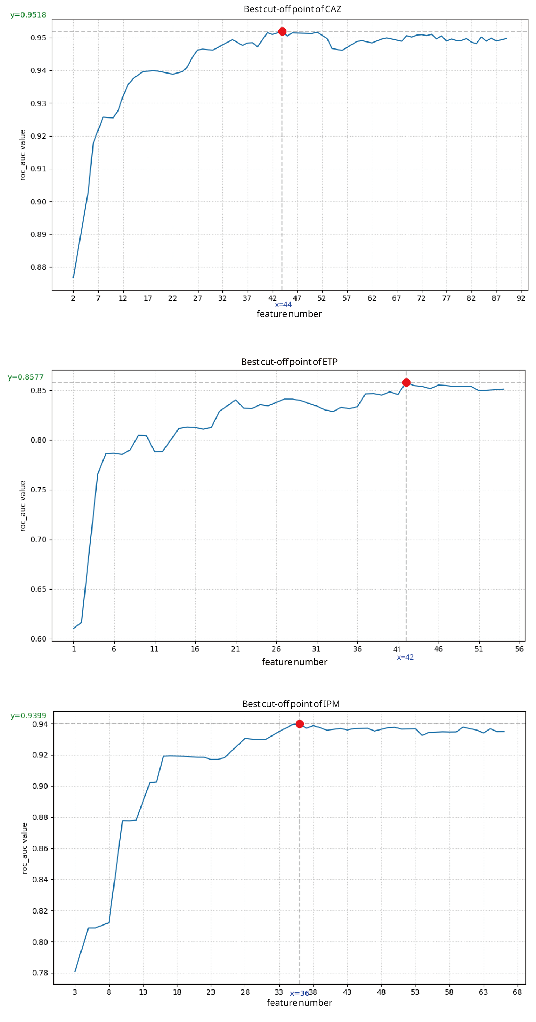
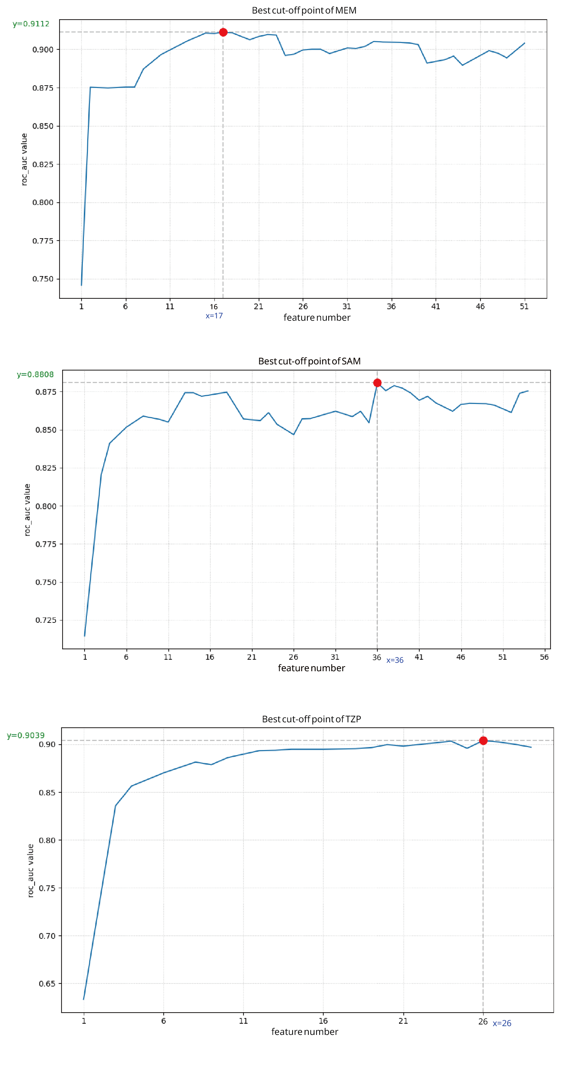
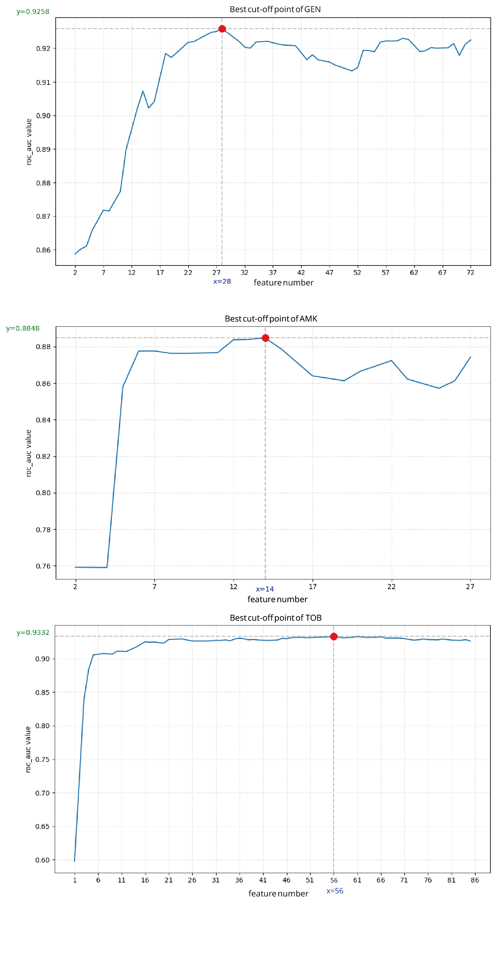
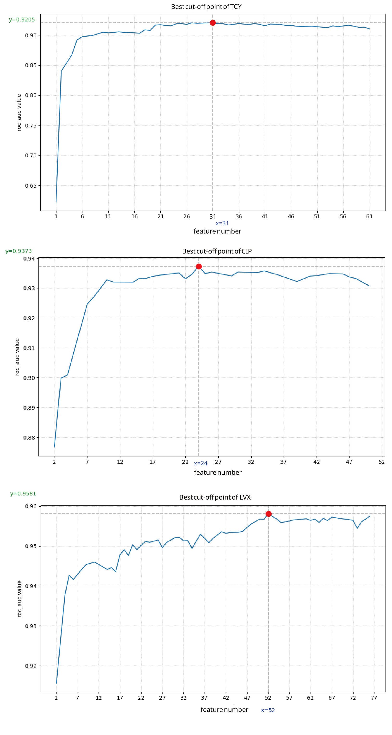
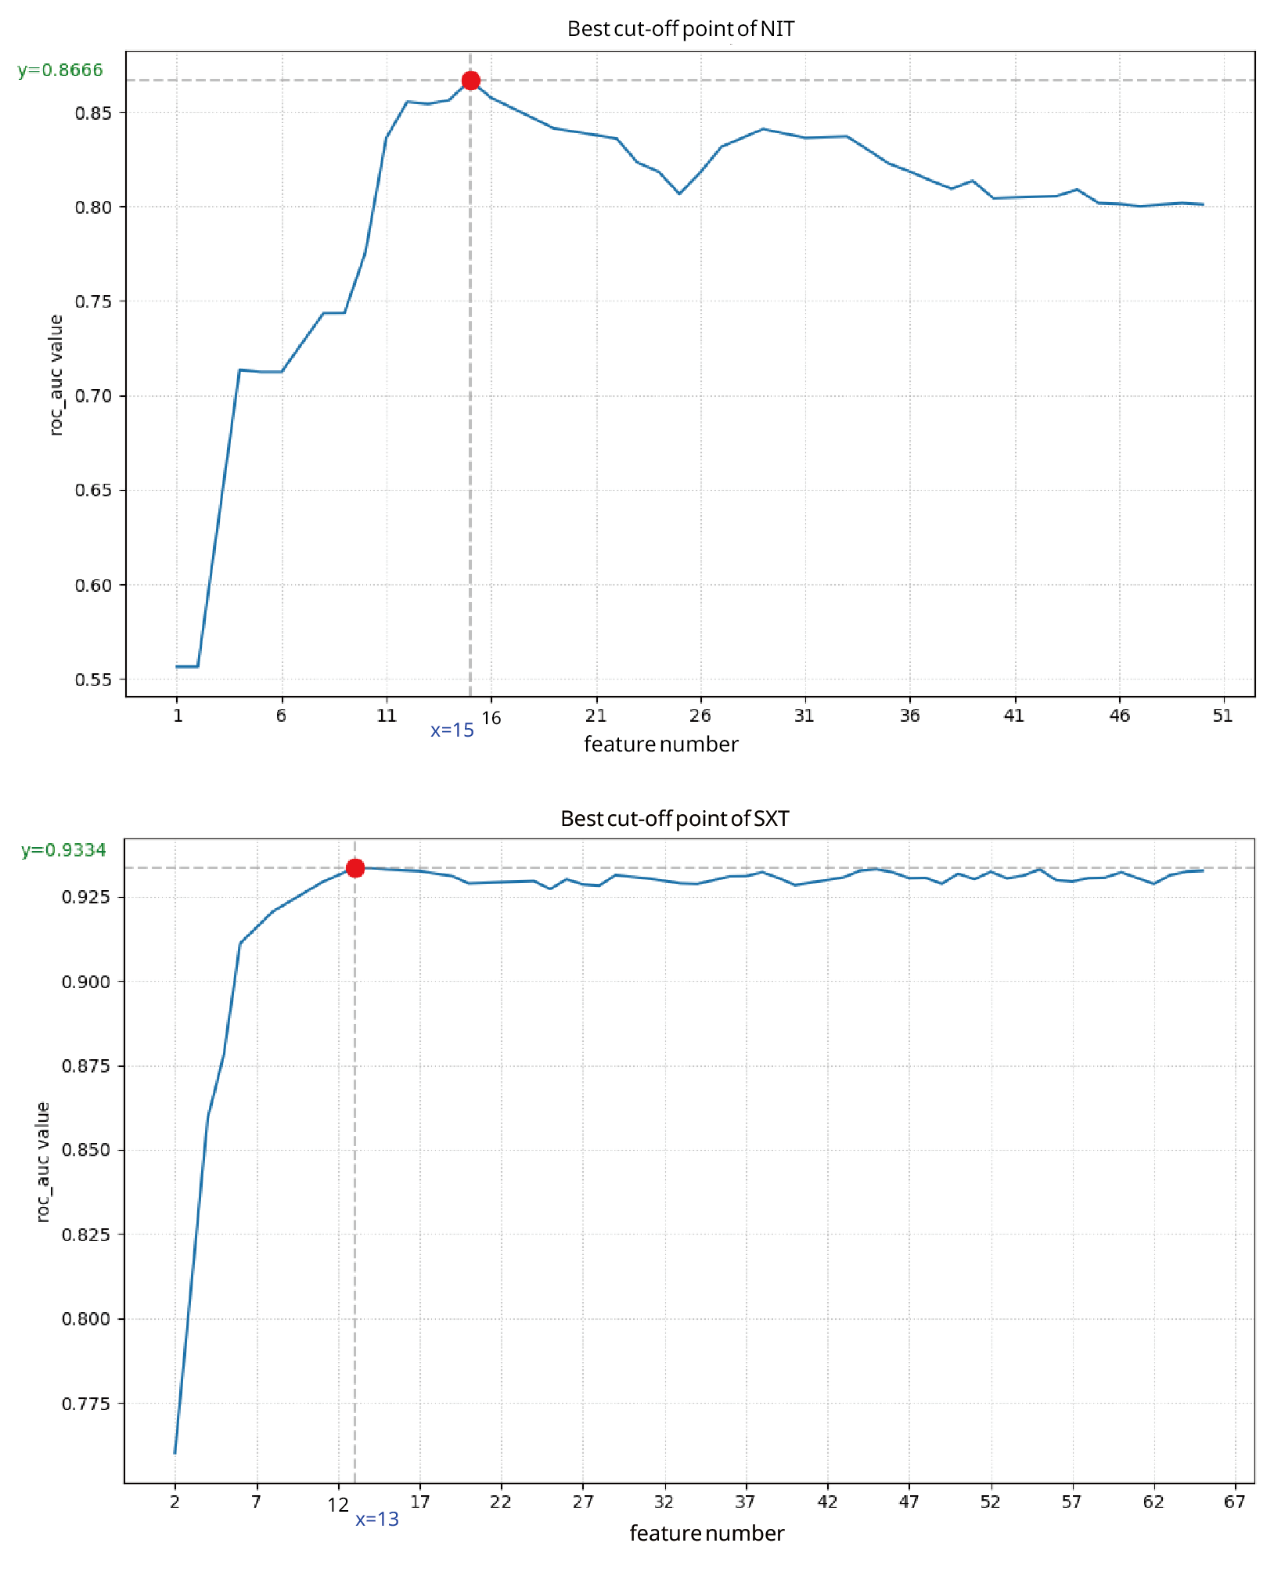
Supplementary Figure 7. K_{med} selection strategy for each of the 17 antibiotic. As the feature set progressively expanded, the test AUC of the model trained on the training set increased rapidly, reached an early local maximum, and then declined. The feature set corresponding to this local maximum was selected as the final feature set.

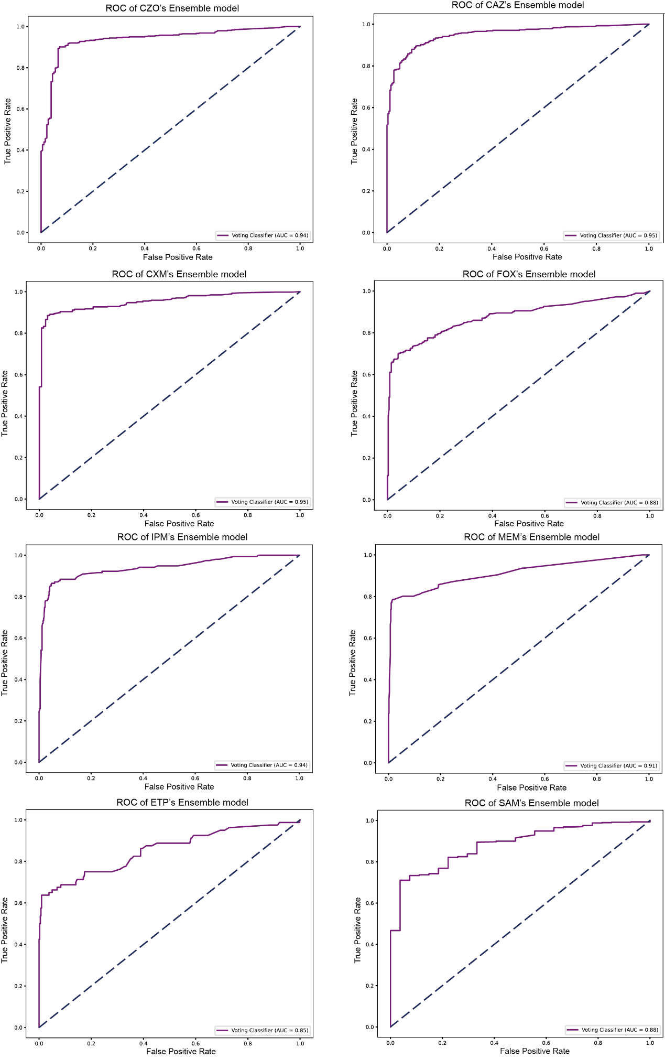
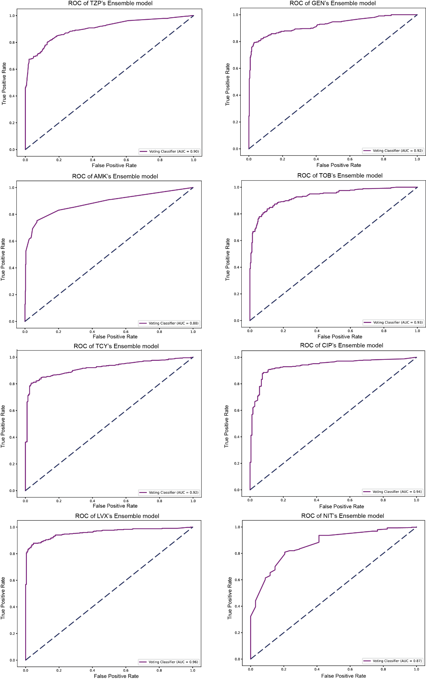
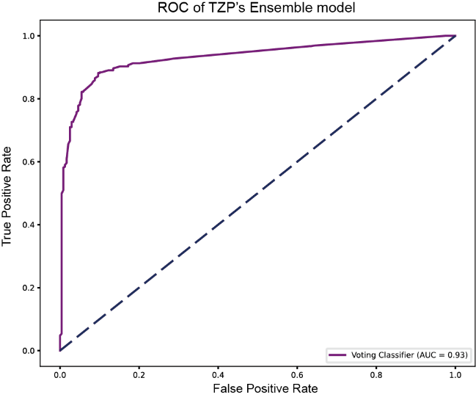
Supplementary Figure 8. ROC-AUC curves of the ensemble models for the 17 antibiotics.
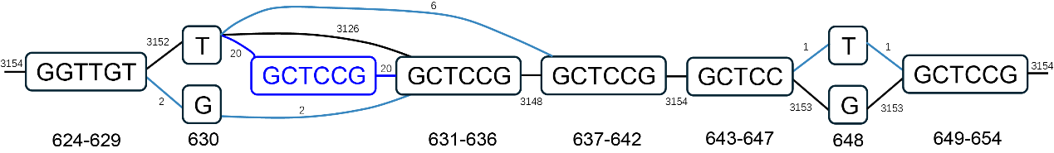
Supplementary Figure 9. Pangraph representation of the full microsatellite repeat region in ompA associated with nitrofurantoin resistance. Black lines show the route of the reference genome, while the bright blue one shows the insertion directly related to NIT’s AMR phenotype. Other blue lines show other variation existing in pangenomes. The graph shows sequence variation across the complete repeat-containing region, including repeat expansion and contraction events involving the GCTCCG motif (encoding one AP unit). The major repeat expansion event highlighted in Figure 4c is shown here in its broader genomic context.

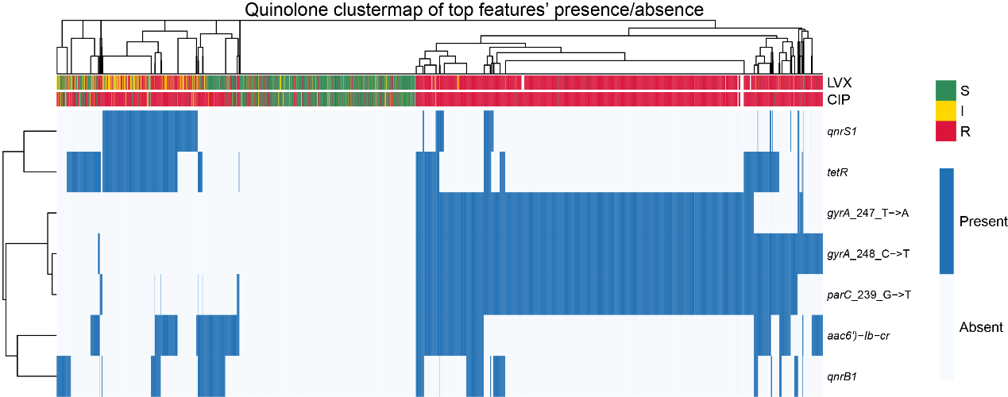
Supplementary Figure 10. Clustered heatmap based on the union of the top five features for CIP and LVX. Resistant isolates formed two major groups, dominated mainly by v-features and g-features, respectively.

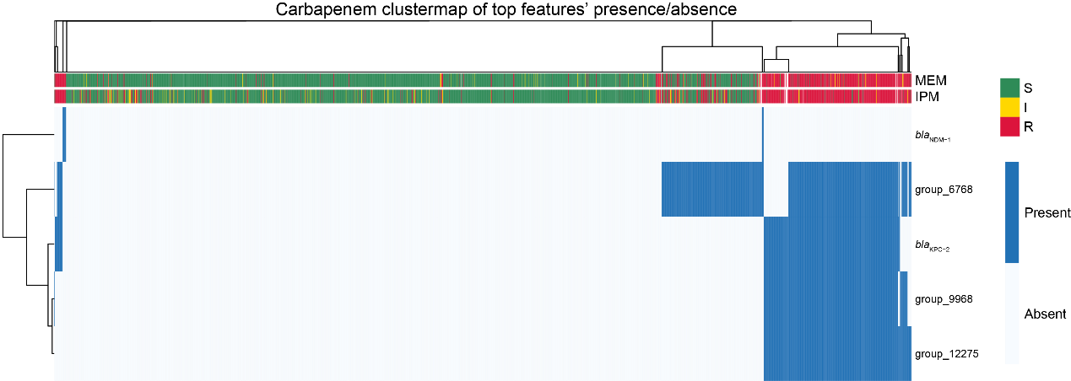
Supplementary Figure 11. Clustered heatmap based on the union of g-features among the top five features for IPM and MEM. Resistant isolates formed two major groups, dominated by bla_{KPC-2} and bla_{NDM-1}, respectively.

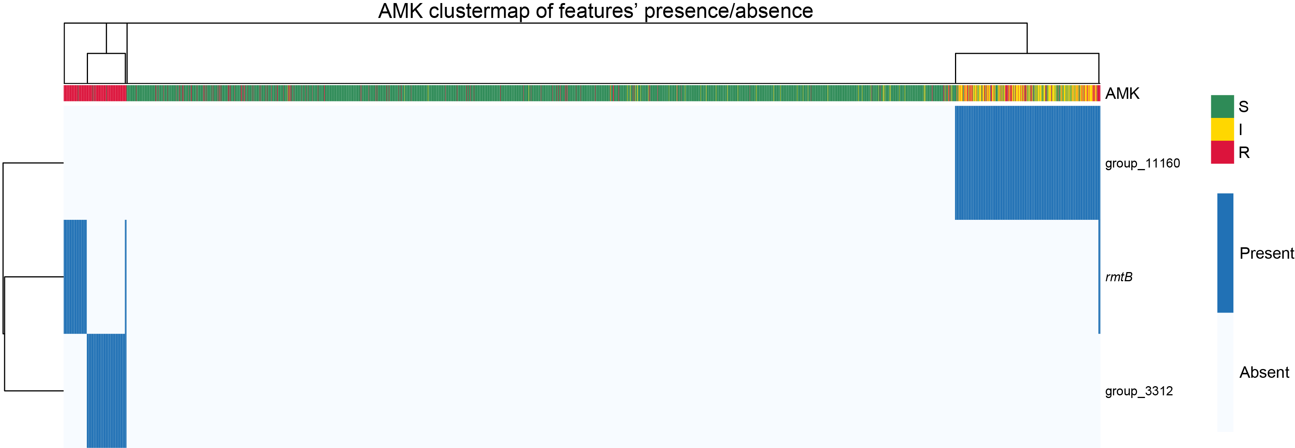
Supplementary Figure 12. Clustered heatmap based on g-features among the top five features for AMK. Most resistant isolates can be identified by these three g-features.

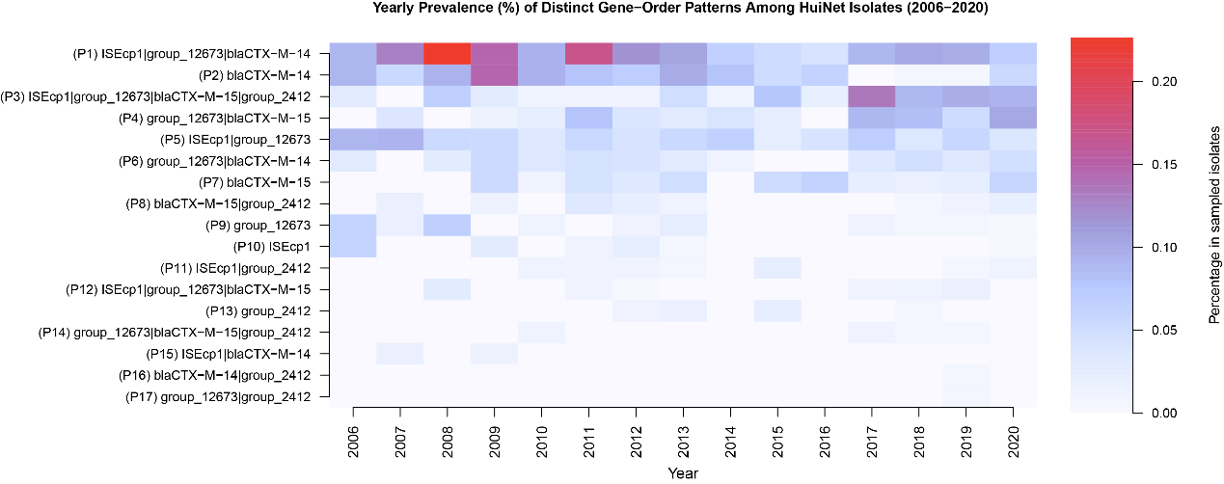
Supplementary Figure 13. Yearly prevalence of distinct gene-order patterns among HuiNet isolates. Heatmap showing the annual prevalence of 17 gene-order patterns involving ISEcp1, group_12673, group_2412, bla_{CTX-M-14} and bla_{CTX-M-15} detected in all 3,163 samples among HuiNet isolates from 2006 to 2020. Rows represent unique gene-order patterns, and columns represent sampling years. Color intensity indicates the proportion of sampled isolates carrying each pattern in a given year.

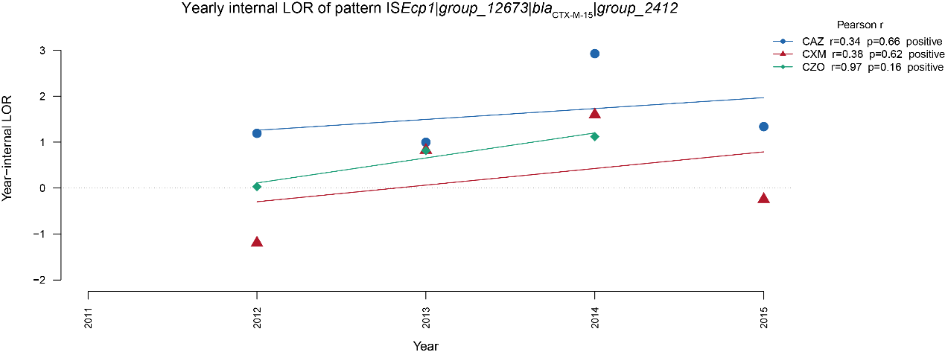
Supplementary Figure 14. Temporal changes in year-internal associations between pattern ISEcp1|group_12673|bla_{CTX-M-15}|group_2412 and cephalosporin resistance. Points show the yearly LOR of this pattern for resistance to CAZ, CXM, and CZO from 2011 to 2015. Lines indicate fitted linear trends across years, and Pearson correlation coefficients summarize the direction and strength of temporal changes in LOR for each antibiotic; corresponding P values are reported for the linear trend tests.

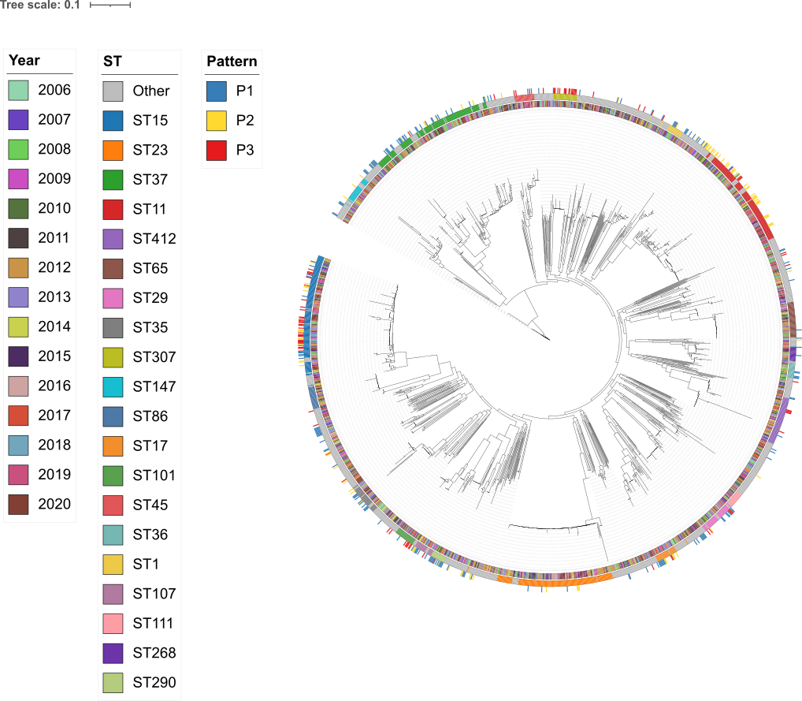
Supplementary Figure 15. Phylogenetic distribution of bla_{CTX-M}-associated genetic patterns among 1,665 HuiNet isolates. The phylogeny of 1,665 HuiNet isolates is annotated to show the population-wide distribution of three blaCTX-M-associated genetic patterns. The outer pattern ring indicates P1, P2 and P3, corresponding to ISEcp1–group_12673–bla_{CTX-M-14}, bla_{CTX-M-14}, and ISEcp1–group_12673–bla_{CTX-M-15}–group_2412, respectively. Additional annotation rings show collection year and normalized ST type; STs represented by 15 or fewer isolates were grouped as “Other”. Branch lengths represent substitutions per site.

