Supplementary information

Type 1 Diabetes Care Access and Cost: A geospatial Study in Ghana, Peru, and Nepal

Carlos Ochoa-Pereira, Jessica Hanae Zafra-Tanaka, Benjamin Demah Nuertey, Bina Shrestha,
David Beran, Nicolas Ray.

Table of Contents
Software and data processing 3
Equation 1 3
Country data sources 5
Ghana 5
Peru 7
Nepal 13
Prompts used in LLM for complementary costs data collection 18
References 18

Software and data processing
AccessMod is an open-source, WHO-supported geospatial modelling tool used to analyse time-based catchments and population coverage for health services. It can model complex travel scenarios by allowing users to define multiple sequential modes of transport and set travel speeds for different land cover types and road classes.

Two main analyses were performed in AccessMod: travel time analysis and geographic coverage analysis. The travel time analysis estimates the accessibility of the population to specific health services, while the geographic coverage analysis defines the catchment area of each health facility according to a set of parameters. To achieve this, AccessMod uses several basic geospatial data layers and tables by default. These data were collected from various sources (see example for Ghana in Table 1). Preparation of the baseline geographic layers for use in AccessMod and subsequent steps includes projecting all layers into an appropriate local coordinate system that preserves areas, as well as resampling (to match pixel size) and aligning (to match pixel position) all raster layers, usually using the population raster as a reference. Additionally, the Zonal Statistics function in AccessMod was used to calculate the population covered by either specialised or general health service providers at travel time thresholds from 1 to 12 hours.

Equation 1
The following formulas are used to calculate the total annual costs for the decentralised model (M2). The main changes are in the travel costs, which assume that patients make 11 visits to a smaller local facility and 1 visit to a large specialised facility, and in the work lost, which has also been adjusted to reflect the population visiting smaller facilities 11 times per year and a large facility once per year.

$$M2_{med}=\left(TM2_{med}×\text{Prev}\right)+\left(FixC×\text{Prev}\right)+LWM2$$
$$TM2_{med}=\left(WTT_{d}×CT_{med}×11×2\right)+\left(WTT_{c}×CT_{med}×2\right)$$
$$FixC=CSA+\left(SGA×11\right)+CSE+CGl+\left(CIn×12\right)+\left(CSt×12\right)+\left(CLt×12\right)+\left(CSy×12\right)$$
$$LWM2=\left(CLW×11×T1D_ResPop_M2\right)+\left(CLW×T1D_ResPop_M1\right)$$

Country data sources

Ghana
Table 1. Description and sources of the geospatial data used for the accessibility analysis of Ghana
Geospatial Data | Data type | Data source
DEM | Raster | Digital Elevation Model data from CGIAR-CSI SRTM Version 4 at 30m resolution - December, 2024. https://srtm.csi.cgiar.org/
Land cover | Raster | Sentinel-2, 10m resolution land cover time series of the world. Produced by Impact Observatory, Microsoft, and Esri – 2022. https://livingatlas.arcgis.com/landcover/
Population | Raster | Facebook. Ghana: High Resolution (30m) Population Density Maps + Demographic Estimates - November 2021. https://data.humdata.org/
Roads | Vector | Multi-layer dataset from OpenStreetMap via GeoFabrik - November 2023.  https://download.geofabrik.de/  Additional AI-created road layer from Facebook microsites - July 2020.  https://github.com/facebookmicrosites/Open-Mapping-At-Facebook/wiki/Available-Countries
Hydrography | Vector | Multi-layer dataset from OpenStreetMap via GeoFabrik - November 2023 (see the roads).
Administrative boundaries | Vector | Polygon layers from GeoPoDe - November 2020.  https://geopode.world/GHA/geometry-export
Health facilities | Vector | New HF master list from 2024 provided by the Ghana Health Service.
Travel speed  scenarios | Table | Data collected and averaged from a visual survey given to 80 health experts from the GHS during a capacity building event in June 2024.

Table 2. Speed scenario used in AccessMod for Ghana
class | label | speed | mode
1 | Water | 0 | WALKING
2 | Trees | 2.5 | WALKING
4 | Flooded vegetation | 1.0 | WALKING
5 | Crops | 3.7 | WALKING
7 | Built area | 4.3 | WALKING
8 | Bare ground | 2.7 | WALKING
10 | Clouds | 1.0 | WALKING
11 | Rangeland | 4.3 | WALKING
1000 | Trunk | 86.7 | MOTORIZED
1001 | Primary | 73.0 | MOTORIZED
1002 | Secondary | 60.0 | MOTORIZED
1003 | Tertiary | 40.7 | MOTORIZED
1004 | Unclassified | 32.0 | MOTORIZED
1005 | Residential | 28.5 | MOTORIZED
1006 | Link | 45.0 | MOTORIZED
1007 | Track | 28.7 | MOTORIZED
1008 | Path | 4.3 | WALKING

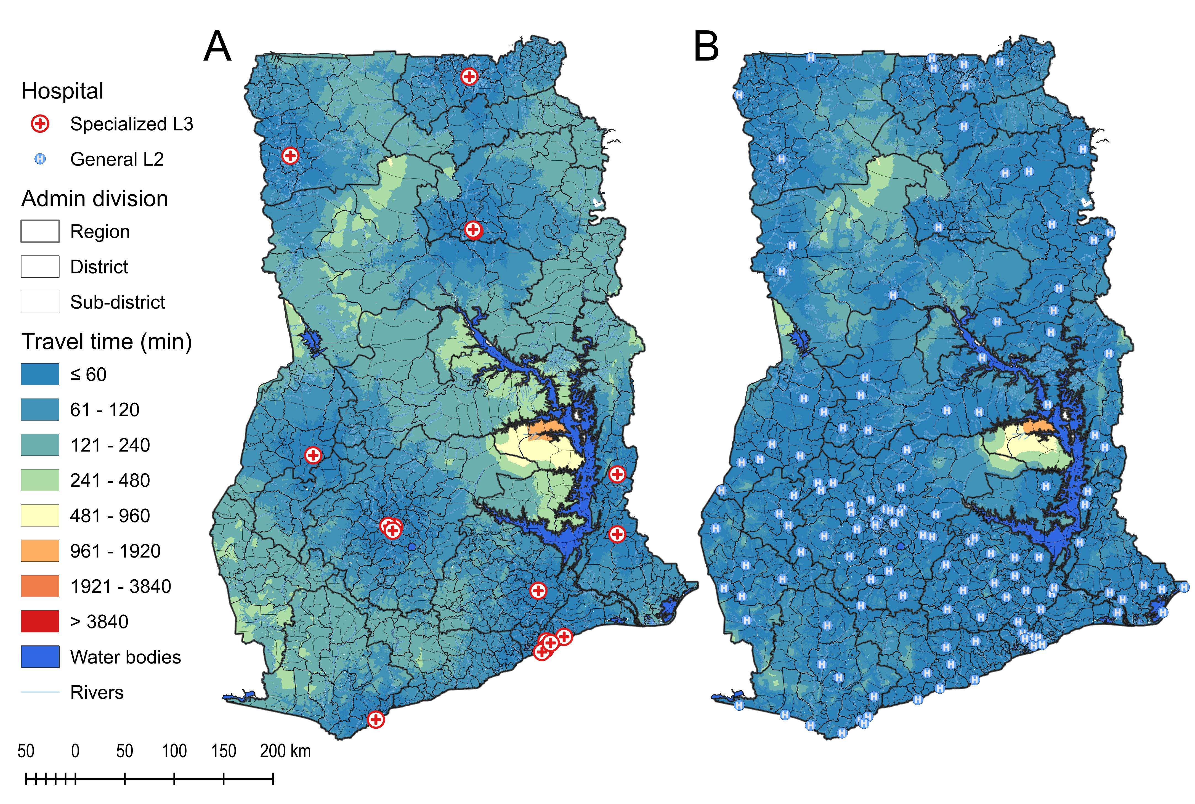
Figure 1. Travel time and health facility distribution in centralised (A) and decentralised (B) models in Ghana

Peru
Table 3. Description and sources of the geospatial data used for the accessibility analysis of Peru
Geospatial Data | Data type | Data source
DEM | Raster | Tiled raster layer at 90m resolution from  https://github.com/sikli/srtm_country
Land cover | Raster | Sentinel-2, 10m resolution land cover time series of the world. Produced by Impact Observatory, Microsoft, and Esri - 2022.  https://livingatlas.arcgis.com/landcover/
Population | Raster | Constrained and UN-adjusted population layer 90m resolution downloaded from WorldPop - 2020. ftp://ftp.worldpop.org.uk
Roads | Vector | Multi-layer dataset from OpenStreetMap via GeoFabrik - November 2023. https://download.geofabrik.de/
Hydrography | Vector | Multi-layer dataset from OpenStreetMap via GeoFabrik - November 2023 (see Roads).
Administrative boundaries | Vector | Polygon layers from GeoBoundaries.¹ www.geoboundaries.org
Health facilities | Vector | Layers by department joined and filtered by co-authors. https://www.geogpsperu.com/
Travel speed scenarios | Table | Data based on Carrasco-Escobar et al. 2020 and slightly adapted to OpenStreetMap road layer.

Multi-speed scenario
We downloaded the World Urban Areas data for Peruvian cities from ESRI. Based on the authors' experience, the cities where mobility speed was reduced and adjustment was necessary were Lima, Arequipa, Chiclayo, and Trujillo. The urban areas layer was created in 2013, so city areas were much smaller than what is visible in satellite imagery. Therefore, the city polygons were modified to generally cover all densely populated areas. The filtered areas for the four cities were then merged with the ADM0 (National) polygon in a multipart polygon. That layer was later used in R (package inAccessMod)² to produce the multi-speed scenario, which became the default LCM for the whole country, as well as slowed-down specific scenarios for the main cities.
To correct the speed within the selected four cities, we used a travel speed raster produced in AccessMod with the default speed scenario. We obtained travel time values representing the time needed to reach specific health facilities from multiple locations within the cities. We then used the same locations as departure points to reach the same health facility using the directions tool in Google Maps at different times of the day. A ratio between the times from AccessMod and Google Maps was calculated for each city to be used later in R to adjust their specific speed scenarios. The ratios for the different cities were: Lima (0.286), Arequipa (0.313), Chiclayo (0.34), and Trujillo (0.322). The different types of land or road are presented in Table 3 with additional postscripts: ADM0 for the whole country except the mentioned cities, CAPT for the capital Lima, SEC for Arequipa as a secondary city, and TERC for Chiclayo and Trujillo as tertiary cities. The ratios for the two tertiary cities were averaged to 0.331.
Table 4. Multi-speed scenario used in AccessMod for Peru
class | label | speed | mode
1 | Shrubs_ADM0 | 3.6 | WALKING
2 | Herbaceous_vegetation_ADM0 | 4.86 | WALKING
3 | Cultivated_and_managed_vegetation_agriculture_ADM0 | 2.87 | WALKING
4 | Urban_built_up_ADM0 | 5 | WALKING
5 | Bare_sparse_vegetation_ADM0 | 3 | WALKING
6 | Snow_and_Ice_ADM0 | 1.62 | WALKING
7 | Permanent_water_bodies_ADM0 | 0 | WALKING
8 | Herbaceous_wetland_ADM0 | 2 | WALKING
9 | Moss_and_lichen_ADM0 | 4.68 | WALKING
10 | Closed_forest_evergreen_broad_leaf_ADM0 | 1.62 | WALKING
11 | Closed_forest_deciduous_broad_leaf_ADM0 | 1.62 | WALKING
12 | Closed_forest_unknown_ADM0 | 1.62 | WALKING
13 | Open_forest_evergreen_broad_leaf_ADM0 | 3.24 | WALKING
14 | Open_forest_deciduous_broad_leaf_ADM0 | 3.24 | WALKING
15 | Open_forest_unknown_ADM0 | 3.24 | WALKING
16 | Open_sea_ADM0 | 0 | WALKING
17 | trunk_ADM0 | 100 | MOTORIZED
18 | trunk link_ADM0 | 50 | MOTORIZED
19 | primary_ADM0 | 70 | MOTORIZED
20 | primary link_ADM0 | 35 | MOTORIZED
21 | motorway_ADM0 | 80 | MOTORIZED
22 | motorway link_ADM0 | 40 | MOTORIZED
23 | secondary_ADM0 | 60 | MOTORIZED
24 | secondary link_ADM0 | 30 | MOTORIZED
25 | tertiary_ADM0 | 50 | MOTORIZED
26 | tertiary link_ADM0 | 25 | MOTORIZED
27 | road_ADM0 | 30 | MOTORIZED
28 | raceway_ADM0 | 20 | MOTORIZED
29 | residential_ADM0 | 30 | MOTORIZED
30 | living street_ADM0 | 20 | MOTORIZED
31 | service_ADM0 | 30 | MOTORIZED
32 | track_ADM0 | 20 | MOTORIZED
33 | pedestrian_ADM0 | 5 | WALKING
34 | path_ADM0 | 5 | WALKING
35 | footway_ADM0 | 5 | WALKING
36 | bridleway_ADM0 | 5 | WALKING
37 | cycleway_ADM0 | 5 | WALKING
38 | steps_ADM0 | 2 | WALKING
39 | unclassified_ADM0 | 40 | MOTORIZED
40 | train_ADM0 | 50 | MOTORIZED
41 | masa de agua_ADM0 | 15 | MOTORIZED
42 | Shrubs_CAPT | 1.0296 | WALKING
43 | Herbaceous_vegetation_CAPT | 1.38996 | WALKING
44 | Cultivated_and_managed_vegetation_agriculture_CAPT | 0.82082 | WALKING
45 | Urban_built_up_CAPT | 1.43 | WALKING
46 | Bare_sparse_vegetation_CAPT | 0.858 | WALKING
47 | Snow_and_Ice_CAPT | 0.46332 | WALKING
48 | Permanent_water_bodies_CAPT | 0 | WALKING
49 | Herbaceous_wetland_CAPT | 0.572 | WALKING
50 | Moss_and_lichen_CAPT | 1.33848 | WALKING
51 | Closed_forest_evergreen_broad_leaf_CAPT | 0.46332 | WALKING
52 | Closed_forest_deciduous_broad_leaf_CAPT | 0.46332 | WALKING
53 | Closed_forest_unknown_CAPT | 0.46332 | WALKING
54 | Open_forest_evergreen_broad_leaf_CAPT | 0.92664 | WALKING
55 | Open_forest_deciduous_broad_leaf_CAPT | 0.92664 | WALKING
56 | Open_forest_unknown_CAPT | 0.92664 | WALKING
57 | Open_sea_CAPT | 0 | WALKING
58 | trunk_CAPT | 28.6 | MOTORIZED
59 | trunk link_CAPT | 14.3 | MOTORIZED
60 | primary_CAPT | 20.02 | MOTORIZED
61 | primary link_CAPT | 10.01 | MOTORIZED
62 | motorway_CAPT | 22.88 | MOTORIZED
63 | motorway link_CAPT | 11.44 | MOTORIZED
64 | secondary_CAPT | 17.16 | MOTORIZED
65 | secondary link_CAPT | 8.58 | MOTORIZED
66 | tertiary_CAPT | 14.3 | MOTORIZED
67 | tertiary link_CAPT | 7.15 | MOTORIZED
68 | road_CAPT | 8.58 | MOTORIZED
69 | raceway_CAPT | 5.72 | MOTORIZED
70 | residential_CAPT | 8.58 | MOTORIZED
71 | living street_CAPT | 5.72 | MOTORIZED
72 | service_CAPT | 8.58 | MOTORIZED
73 | track_CAPT | 5.72 | MOTORIZED
74 | pedestrian_CAPT | 1.43 | WALKING
75 | path_CAPT | 1.43 | WALKING
76 | footway_CAPT | 1.43 | WALKING
77 | bridleway_CAPT | 1.43 | WALKING
78 | cycleway_CAPT | 1.43 | WALKING
79 | steps_CAPT | 0.572 | WALKING
80 | unclassified_CAPT | 11.44 | MOTORIZED
81 | train_CAPT | 14.3 | MOTORIZED
82 | masa de agua_CAPT | 4.29 | MOTORIZED
83 | Shrubs_SEC | 1.1268 | WALKING
84 | Herbaceous_vegetation_SEC | 1.52118 | WALKING
85 | Cultivated_and_managed_vegetation_agriculture_SEC | 0.89831 | WALKING
86 | Urban_built_up_SEC | 1.565 | WALKING
87 | Bare_sparse_vegetation_SEC | 0.939 | WALKING
88 | Snow_and_Ice_SEC | 0.50706 | WALKING
89 | Permanent_water_bodies_SEC | 0 | WALKING
90 | Herbaceous_wetland_SEC | 0.626 | WALKING
91 | Moss_and_lichen_SEC | 1.46484 | WALKING
92 | Closed_forest_evergreen_broad_leaf_SEC | 0.50706 | WALKING
93 | Closed_forest_deciduous_broad_leaf_SEC | 0.50706 | WALKING
94 | Closed_forest_unknown_SEC | 0.50706 | WALKING
95 | Open_forest_evergreen_broad_leaf_SEC | 1.01412 | WALKING
96 | Open_forest_deciduous_broad_leaf_SEC | 1.01412 | WALKING
97 | Open_forest_unknown_SEC | 1.01412 | WALKING
98 | Open_sea_SEC | 0 | WALKING
99 | trunk_SEC | 31.3 | MOTORIZED
100 | trunk link_SEC | 15.65 | MOTORIZED
101 | primary_SEC | 21.91 | MOTORIZED
102 | primary link_SEC | 10.955 | MOTORIZED
103 | motorway_SEC | 25.04 | MOTORIZED
104 | motorway link_SEC | 12.52 | MOTORIZED
105 | secondary_SEC | 18.78 | MOTORIZED
106 | secondary link_SEC | 9.39 | MOTORIZED
107 | tertiary_SEC | 15.65 | MOTORIZED
108 | tertiary link_SEC | 7.825 | MOTORIZED
109 | road_SEC | 9.39 | MOTORIZED
110 | raceway_SEC | 6.26 | MOTORIZED
111 | residential_SEC | 9.39 | MOTORIZED
112 | living street_SEC | 6.26 | MOTORIZED
113 | service_SEC | 9.39 | MOTORIZED
114 | track_SEC | 6.26 | MOTORIZED
115 | pedestrian_SEC | 1.565 | WALKING
116 | path_SEC | 1.565 | WALKING
117 | footway_SEC | 1.565 | WALKING
118 | bridleway_SEC | 1.565 | WALKING
119 | cycleway_SEC | 1.565 | WALKING
120 | steps_SEC | 0.626 | WALKING
121 | unclassified_SEC | 12.52 | MOTORIZED
122 | train_SEC | 15.65 | MOTORIZED
123 | masa de agua_SEC | 4.695 | MOTORIZED
124 | Shrubs_TERC | 1.1916 | WALKING
125 | Herbaceous_vegetation_TERC | 1.60866 | WALKING
126 | Cultivated_and_managed_vegetation_agriculture_TERC | 0.94997 | WALKING
127 | Urban_built_up_TERC | 1.655 | WALKING
128 | Bare_sparse_vegetation_TERC | 0.993 | WALKING
129 | Snow_and_Ice_TERC | 0.53622 | WALKING
130 | Permanent_water_bodies_TERC | 0 | WALKING
131 | Herbaceous_wetland_TERC | 0.662 | WALKING
132 | Moss_and_lichen_TERC | 1.54908 | WALKING
133 | Closed_forest_evergreen_broad_leaf_TERC | 0.53622 | WALKING
134 | Closed_forest_deciduous_broad_leaf_TERC | 0.53622 | WALKING
135 | Closed_forest_unknown_TERC | 0.53622 | WALKING
136 | Open_forest_evergreen_broad_leaf_TERC | 1.07244 | WALKING
137 | Open_forest_deciduous_broad_leaf_TERC | 1.07244 | WALKING
138 | Open_forest_unknown_TERC | 1.07244 | WALKING
139 | Open_sea_TERC | 0 | WALKING
140 | trunk_TERC | 33.1 | MOTORIZED
141 | trunk link_TERC | 16.55 | MOTORIZED
142 | primary_TERC | 23.17 | MOTORIZED
143 | primary link_TERC | 11.585 | MOTORIZED
144 | motorway_TERC | 26.48 | MOTORIZED
145 | motorway link_TERC | 13.24 | MOTORIZED
146 | secondary_TERC | 19.86 | MOTORIZED
147 | secondary link_TERC | 9.93 | MOTORIZED
148 | tertiary_TERC | 16.55 | MOTORIZED
149 | tertiary link_TERC | 8.275 | MOTORIZED
150 | road_TERC | 9.93 | MOTORIZED
151 | raceway_TERC | 6.62 | MOTORIZED
152 | residential_TERC | 9.93 | MOTORIZED
153 | living street_TERC | 6.62 | MOTORIZED
154 | service_TERC | 9.93 | MOTORIZED
155 | track_TERC | 6.62 | MOTORIZED
156 | pedestrian_TERC | 1.655 | WALKING
157 | path_TERC | 1.655 | WALKING
158 | footway_TERC | 1.655 | WALKING
159 | bridleway_TERC | 1.655 | WALKING
160 | cycleway_TERC | 1.655 | WALKING
161 | steps_TERC | 0.662 | WALKING
162 | unclassified_TERC | 13.24 | MOTORIZED
163 | train_TERC | 16.55 | MOTORIZED
164 | masa de agua_TERC | 4.965 | MOTORIZED

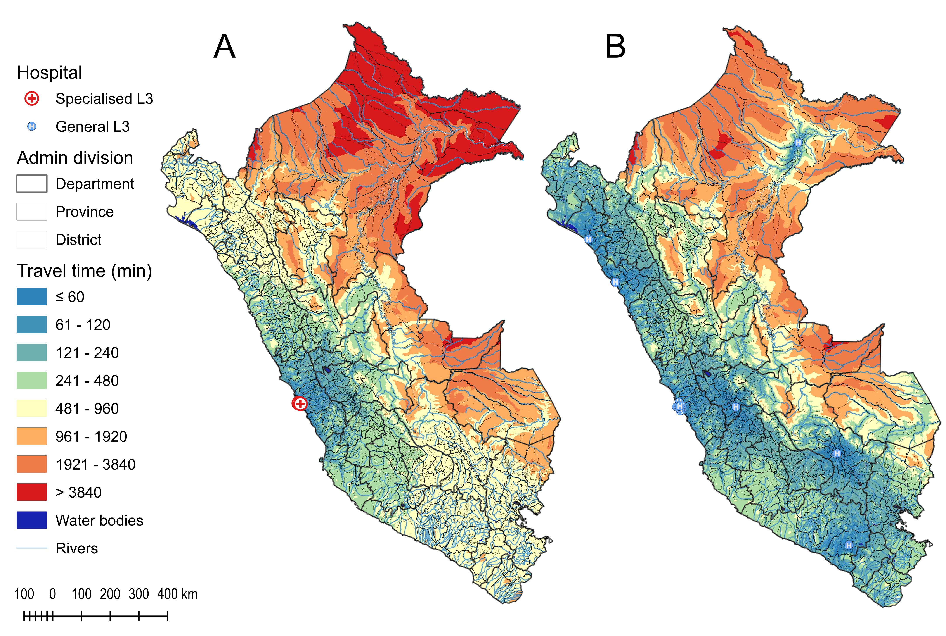
Figure 2. Travel time and health facility distribution in centralised (A) and decentralised (B) models in Peru

Nepal
Table 5. Description and sources of the geospatial data used for the accessibility analysis of Nepal
Geospatial Data | Data type | Data source
DEM | Raster | Tiled raster layer at 90m resolution from https://github.com/sikli/srtm_country
Land cover | Raster | Downloaded from the Copernicus Global Land Service at 100m resolution (https://lcviewer.vito.be/download)
Population | Raster | Constrained and UN-adjusted population layer 90m resolution downloaded from WorldPop - 2020. ftp://ftp.worldpop.org.uk
Roads | Vector | Multi-layer dataset from OpenStreetMap via GeoFabrik - November 2023.https://download.geofabrik.de/
Hydrography | Vector | Multi-layer dataset from OpenStreetMap via GeoFabrik - November 2023 (see Roads).
Administrative boundaries | Vector | Polygon layers from GeoBoundaries.¹ www.geoboundaries.org
Health facilities | Vector | Filtered DHS SPA data from 2021. Validation and addition of facilities with the support of local experts.
Travel speed scenarios | Table | Average data from Ochoa et al. (2023) for the dry season, and two surveys during UNFPA workshops in maternal health given to MoH members 2025.

Multi-speed scenario
As described in the methods, Nepal is geographically divided into three distinct zones: the Terai (the subtropical plains in the south on the border with India), the Hilly region (medium-altitude mountains), and the Himalaya mountains (high mountains in the north on the border with China). We used these geographic zones as a template for our travel speed scenarios (Table 5). As in Peru, we first created a single-scenario merged land cover layer in AccessMod and then adapted it to the three geographic zones using the R package ‘inAccessMod’. The different types of land or road are presented in Table 6 with additional postscripts: Hills for the Hilly region, Mountain for the Himalaya mountains, and Terai for the Terai region.

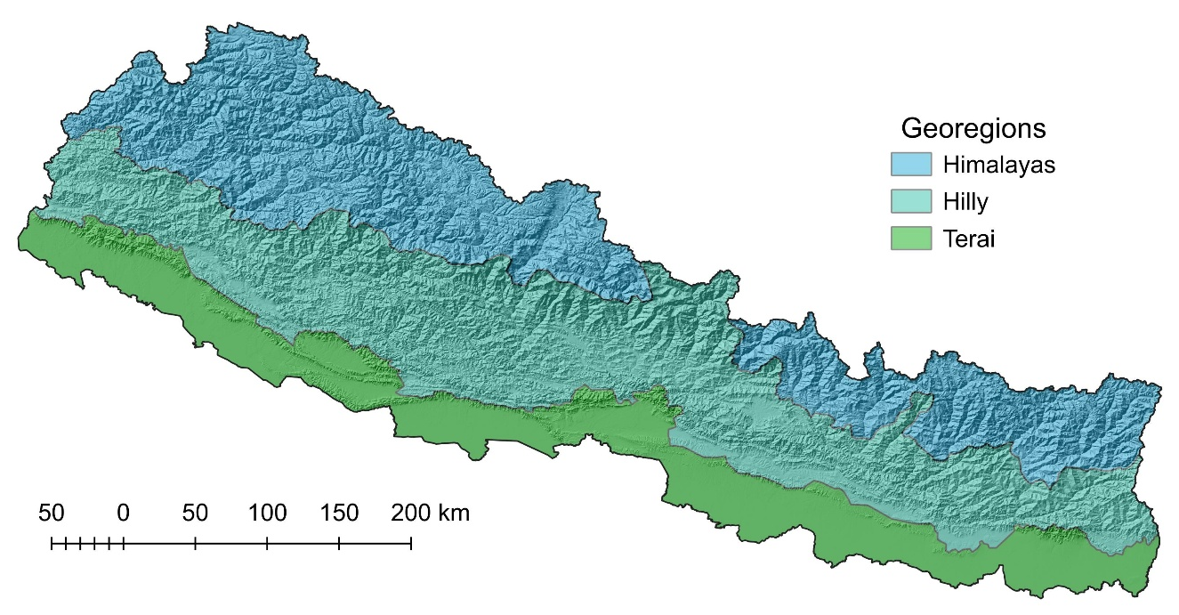
Figure 3. Geographical zones of Nepal

Table 6. Multi-speed scenario used in AccessMod for Nepal
class | label | speed | mode
1 | Shrubs_Hills | 3.6 | WALKING
2 | Herbaceous vegetation_Hills | 4.3 | WALKING
3 | Cultivated and managed vegetation/agriculture_Hills | 3.2 | WALKING
4 | Urban / built up_Hills | 4.3 | WALKING
5 | Bare / sparse vegetation_Hills | 3.4 | WALKING
6 | Snow and Ice_Hills | 1.6 | WALKING
7 | Permanent water bodies_Hills | 0 | WALKING
8 | Herbaceous wetland_Hills | 0.5 | WALKING
9 | Moss and lichen_Hills | 3.6 | WALKING
10 | Closed forest, evergreen needle leaf_Hills | 3.2 | WALKING
11 | Closed forest, evergreen, broad leaf_Hills | 3.2 | WALKING
12 | Closed forest, deciduous needle leaf_Hills | 3.2 | WALKING
13 | Closed forest, deciduous broad leaf_Hills | 3.2 | WALKING
14 | Closed forest, mixed_Hills | 3.2 | WALKING
15 | Closed forest, unknown_Hills | 3.2 | WALKING
16 | Open forest, evergreen needle leaf_Hills | 3.2 | WALKING
17 | Open forest, evergreen broad leaf_Hills | 3.2 | WALKING
18 | Open forest, deciduous broad leaf_Hills | 3.2 | WALKING
19 | Open forest, mixed_Hills | 3.2 | WALKING
20 | Open forest, unknown_Hills | 3.2 | WALKING
21 | trunk_Hills | 50 | MOTORIZED
22 | motorway_Hills | 40 | MOTORIZED
23 | primary_Hills | 40 | MOTORIZED
24 | secondary_Hills | 30.7 | MOTORIZED
25 | tertiary_Hills | 22.7 | MOTORIZED
26 | unclassified_Hills | 16.7 | MOTORIZED
27 | unknown_Hills | 16.7 | MOTORIZED
28 | track_Hills | 13.3 | MOTORIZED
29 | residential_Hills | 12.3 | MOTORIZED
30 | living street_Hills | 8.5 | MOTORIZED
31 | path_Hills | 4.3 | WALKING
32 | bridleway_Hills | 4.3 | WALKING
33 | cycleway_Hills | 4.3 | WALKING
34 | footway_Hills | 4.3 | WALKING
35 | pedestrian_Hills | 4.3 | WALKING
36 | steps_Hills | 1.5 | WALKING
37 | Shrubs_Mountain | 3.6 | WALKING
38 | Herbaceous vegetation_Mountain | 4.3 | WALKING
39 | Cultivated and managed vegetation/agriculture_Mountain | 3.2 | WALKING
40 | Urban / built up_Mountain | 4.3 | WALKING
41 | Bare / sparse vegetation_Mountain | 3.65 | WALKING
42 | Snow and Ice_Mountain | 1.6 | WALKING
43 | Permanent water bodies_Mountain | 0 | WALKING
44 | Herbaceous wetland_Mountain | 0.5 | WALKING
45 | Moss and lichen_Mountain | 3.6 | WALKING
46 | Closed forest, evergreen needle leaf_Mountain | 3.2 | WALKING
47 | Closed forest, evergreen, broad leaf_Mountain | 3.2 | WALKING
48 | Closed forest, deciduous needle leaf_Mountain | 3.2 | WALKING
49 | Closed forest, deciduous broad leaf_Mountain | 3.2 | WALKING
50 | Closed forest, mixed_Mountain | 3.2 | WALKING
51 | Closed forest, unknown_Mountain | 3.2 | WALKING
52 | Open forest, evergreen needle leaf_Mountain | 3.2 | WALKING
53 | Open forest, evergreen broad leaf_Mountain | 3.2 | WALKING
54 | Open forest, deciduous broad leaf_Mountain | 3.2 | WALKING
55 | Open forest, mixed_Mountain | 3.2 | WALKING
56 | Open forest, unknown_Mountain | 3.2 | WALKING
57 | trunk_Mountain | 25 | MOTORIZED
58 | motorway_Mountain | 25 | MOTORIZED
59 | primary_Mountain | 25 | MOTORIZED
60 | secondary_Mountain | 26 | MOTORIZED
61 | tertiary_Mountain | 22.5 | MOTORIZED
62 | unclassified_Mountain | 15.5 | MOTORIZED
63 | unknown_Mountain | 15.5 | MOTORIZED
64 | track_Mountain | 12.5 | MOTORIZED
65 | residential_Mountain | 14 | MOTORIZED
66 | living street_Mountain | 13 | MOTORIZED
67 | path_Mountain | 4.3 | WALKING
68 | bridleway_Mountain | 4.3 | WALKING
69 | cycleway_Mountain | 4.3 | WALKING
70 | footway_Mountain | 4.3 | WALKING
71 | pedestrian_Mountain | 4.3 | WALKING
72 | steps_Mountain | 1.5 | WALKING
73 | Shrubs_Terai | 3.6 | WALKING
74 | Herbaceous vegetation_Terai | 4.6 | WALKING
75 | Cultivated and managed vegetation/agriculture_Terai | 3.2 | WALKING
76 | Urban / built up_Terai | 4.72 | WALKING
77 | Bare / sparse vegetation_Terai | 3.52 | WALKING
78 | Snow and Ice_Terai | 1.6 | WALKING
79 | Permanent water bodies_Terai | 0 | WALKING
80 | Herbaceous wetland_Terai | 0.5 | WALKING
81 | Moss and lichen_Terai | 3.6 | WALKING
82 | Closed forest, evergreen needle leaf_Terai | 3.2 | WALKING
83 | Closed forest, evergreen, broad leaf_Terai | 3.2 | WALKING
84 | Closed forest, deciduous needle leaf_Terai | 3.2 | WALKING
85 | Closed forest, deciduous broad leaf_Terai | 3.2 | WALKING
86 | Closed forest, mixed_Terai | 3.2 | WALKING
87 | Closed forest, unknown_Terai | 3.2 | WALKING
88 | Open forest, evergreen needle leaf_Terai | 3.2 | WALKING
89 | Open forest, evergreen broad leaf_Terai | 3.2 | WALKING
90 | Open forest, deciduous broad leaf_Terai | 3.2 | WALKING
91 | Open forest, mixed_Terai | 3.2 | WALKING
92 | Open forest, unknown_Terai | 3.2 | WALKING
93 | trunk_Terai | 49.6 | MOTORIZED
94 | motorway_Terai | 49.2 | MOTORIZED
95 | primary_Terai | 46.3 | MOTORIZED
96 | secondary_Terai | 39.8 | MOTORIZED
97 | tertiary_Terai | 31.5 | MOTORIZED
98 | unclassified_Terai | 26.5 | MOTORIZED
99 | unknown_Terai | 20 | MOTORIZED
100 | track_Terai | 23.1 | MOTORIZED
101 | residential_Terai | 24.3 | MOTORIZED
102 | living street_Terai | 18 | MOTORIZED
103 | path_Terai | 4.3 | WALKING
104 | bridleway_Terai | 4.3 | WALKING
105 | cycleway_Terai | 4.3 | WALKING
106 | footway_Terai | 4.3 | WALKING
107 | pedestrian_Terai | 4.3 | WALKING
108 | steps_Terai | 1.5 | WALKING

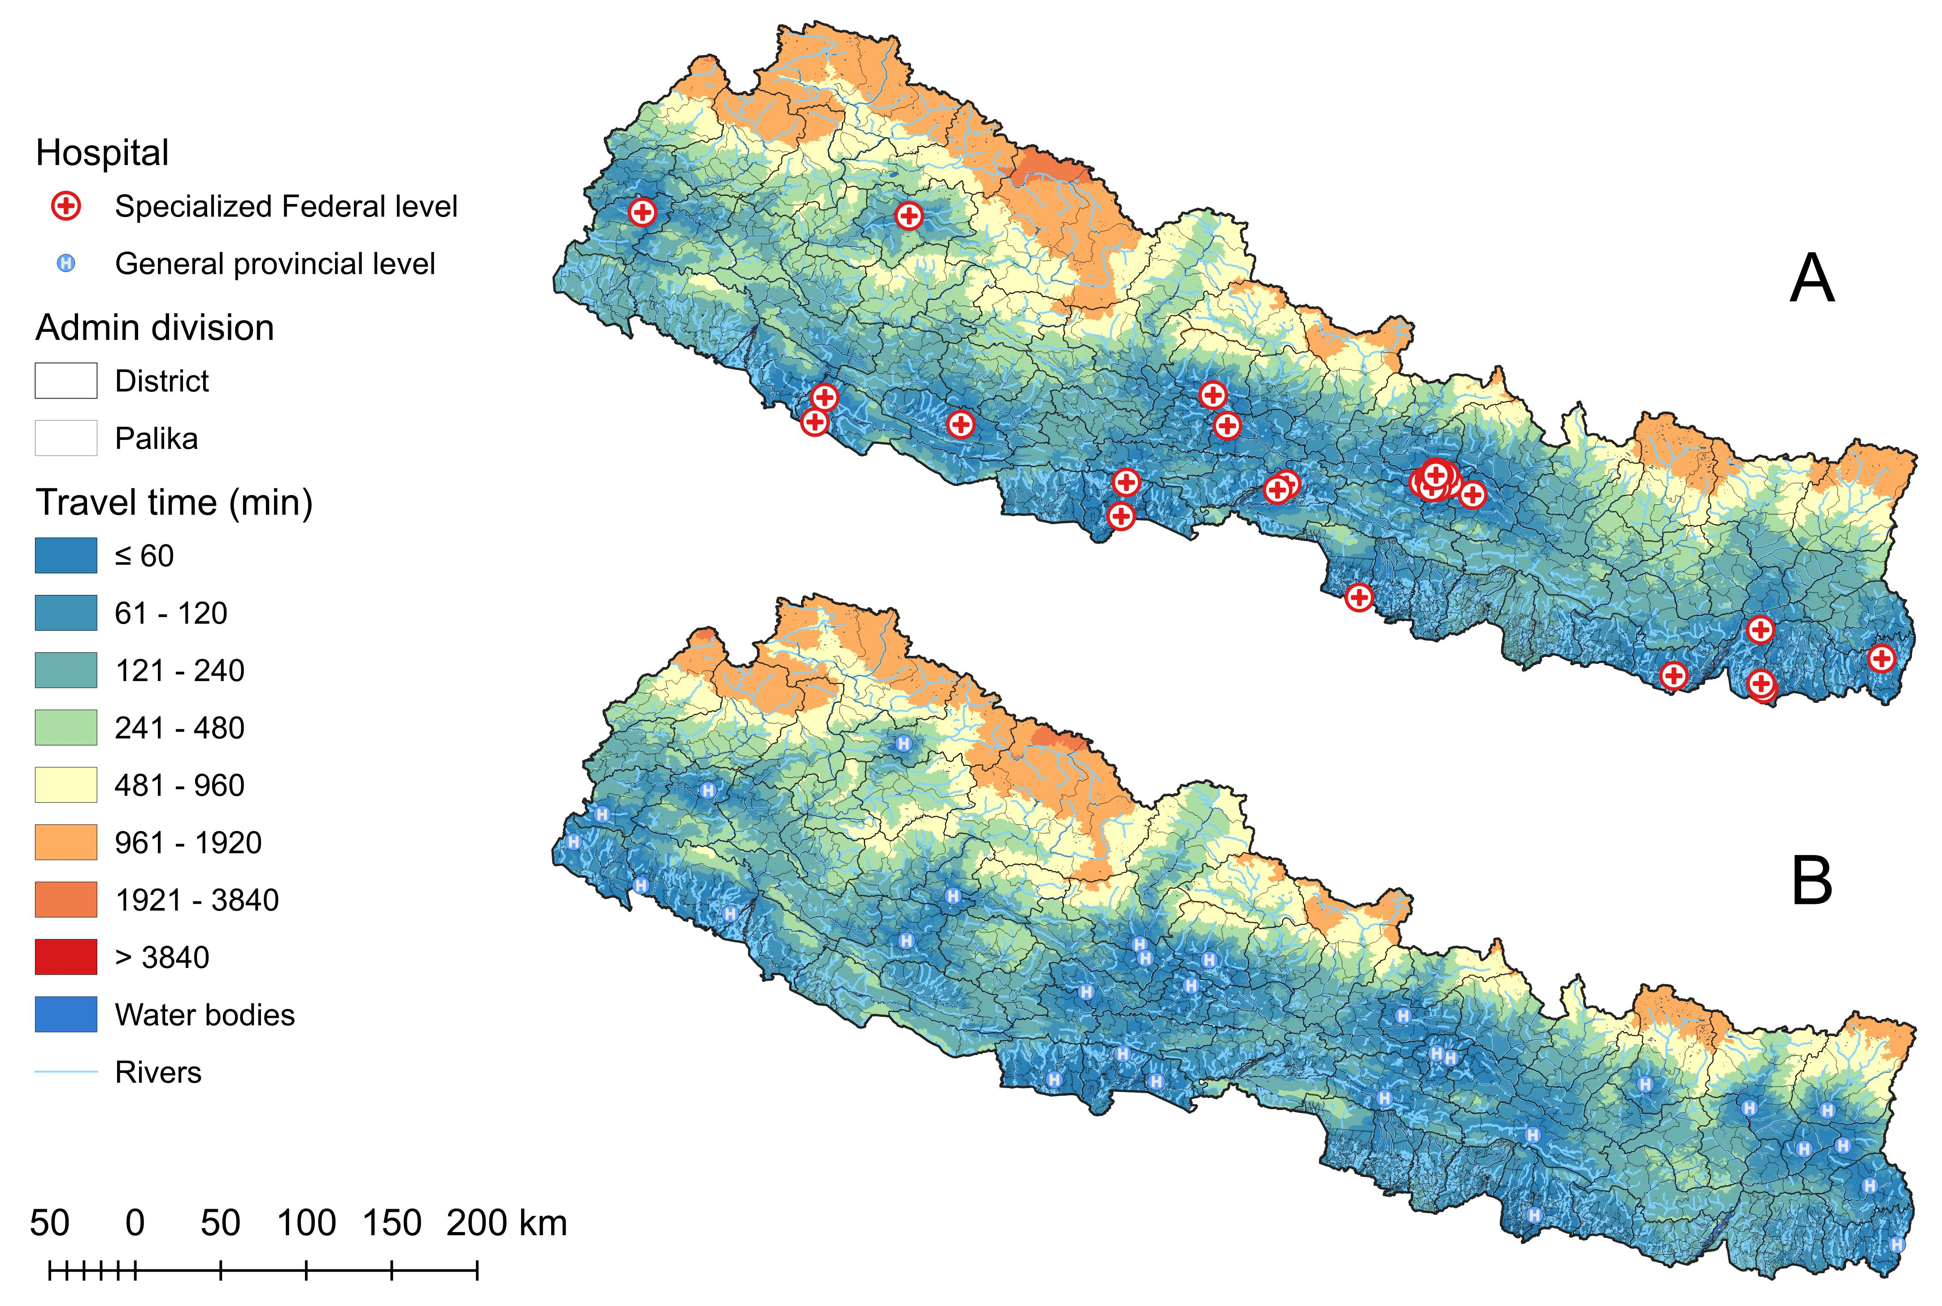
Figure.4. Travel time and health facility distribution in centralised (A) and decentralised (B) models in Nepal

Prompts used in LLM for complementary costs data collection
It is important to consider that AI responses are not deterministic, so they may vary slightly each time the same prompt is launch, as the websites they come from change and are updated. These prompts were submitted between 27 February and 1 April 2025.
- Analyse and summarize information about the average costs of syringes for insulin injection of diabetes sufferers in Ghana, Peru and Nepal. Focus on average prices for the general public, it can include pharmacies, or wholesale, no specific brand and no trends.
- Find and summarize information on travel costs on any available measurement units, such as per hour of travel, for rural and intercity transport for Ghana, Peru, and Nepal. For Peru, check information on fluvial transport. The most common means of transport for the general public by land or water (no flights). Avoid transport used mainly by tourists.
- Search and summarize information about the prices of insulin per vial, glucometers, piecing lancets and glucometer strips in Ghana, Peru, and Nepal, checking and referencing scientific papers and the internet in general.
- Obtain a representative value for the cost of a lost day of work in Ghana, Peru, and Nepal. This should be based in the lowest reported salary for any job based on wages. Explore different sources for each country and summarize them separately.

References
1 Runfola, D. et al. geoBoundaries: A global database of political administrative boundaries. PloS one 15, e0231866 (2020).
2 inAccessMod v. 2.0 (unige-geohealth, 2025).
3 Ochoa, C. et al. Vulnerability to snakebite envenoming and access to healthcare in the Terai region of Nepal: a geospatial analysis. The Lancet Regional Health-Southeast Asia 9 (2023).

