Table 1 Batch Processing parameters and biochemical parameters from SCADA system of 5 L benchtop fermenter
Age (Hours) | pH | Agitation (RPM) | DO (%) | Air (LPM) | Air (VVM) | Biomass (%) | Oleic Acid (%) | Glucose (%) | Sophorolipid Yield (gL⁻¹)
0 | 4.5 | 300 | 100 | 5 | 1 | 0 | 10 | 10 | 0
24 | 4.5 | 350 | 20.4 | 5 | 1 | 0.5 | 9.5 | 9.1 | 11
48 | 4.5 | 450 | 15.7 | 5 | 1 | 1.5 | 8.1 | 7.5 | 25
72 | 4.5 | 500 | 19.4 | 5 | 1 | 2.5 | 6.9 | 6.3 | 37
96 | 4.5 | 550 | 24.2 | 5 | 1 | 4.5 | 5.6 | 5 | 48
120 | 4.5 | 550 | 34.8 | 5 | 1 | 5 | 4.4 | 4.3 | 69
144 | 4.5 | 550 | 58.3 | 5 | 1 | 5.5 | 2.3 | 1.9 | 89
168 | 4.5 | 550 | 57.7 | 5 | 1 | 5.5 | 1.5 | 1.1 | 94
192 | 4.5 | 550 | 54.4 | 5 | 1 | 5.5 | 1.4 | 1.1 | 109

Table 2 Batch Processing parameters and biochemical parameters from SCADA system of 100 L benchtop fermenter
Age (Hours) | pH | Agitation (RPM) | DO (%) | Air (LPM) | Air (VVM) | Biomass (%) | Oleic Acid (%) | Glucose (%) | Sophorolipid Yield (g/L)
0 | 4.5 | 400 | 100 | 100 | 1 | 0 | 10 | 10 | 0
24 | 4.5 | 550 | 20.4 | 100 | 1 | 5 | 9.3 | 8.8 | 13
48 | 4.5 | 650 | 15.7 | 100 | 1 | 10 | 8.4 | 7.6 | 22
72 | 4.5 | 700 | 19.4 | 100 | 1 | 13 | 6.3 | 5.9 | 32
96 | 4.5 | 750 | 24.2 | 100 | 1 | 18 | 5.1 | 4.8 | 49
120 | 4.5 | 800 | 34.8 | 100 | 1 | 18 | 4.4 | 4.3 | 73
144 | 4.5 | 800 | 58.3 | 100 | 1 | 18 | 3.1 | 3.2 | 92
168 | 4.5 | 800 | 57.7 | 100 | 1 | 18 | 2.1 | 2.1 | 105
192 | 4.5 | 800 | 54.4 | 100 | 1 | 18 | 1.5 | 1.5 | 110

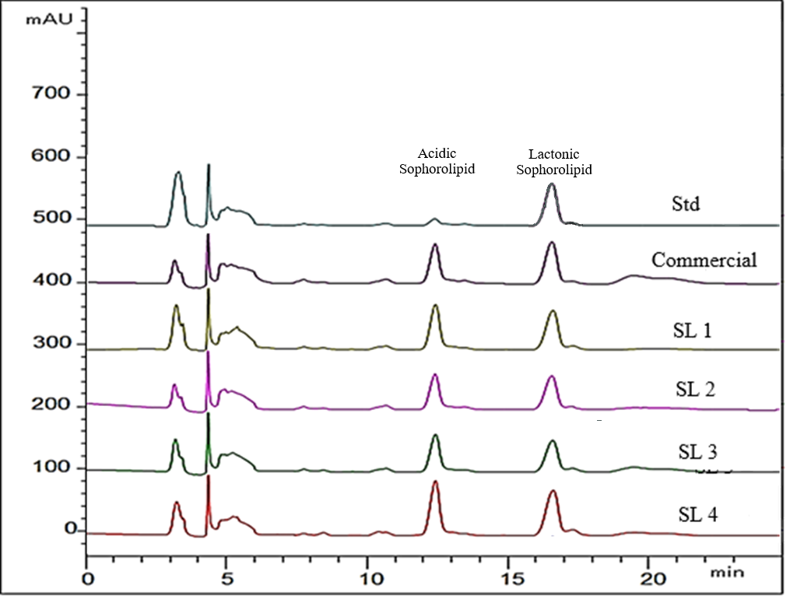
Figure 1 Overlay HPLC Chromatogram of all samples

