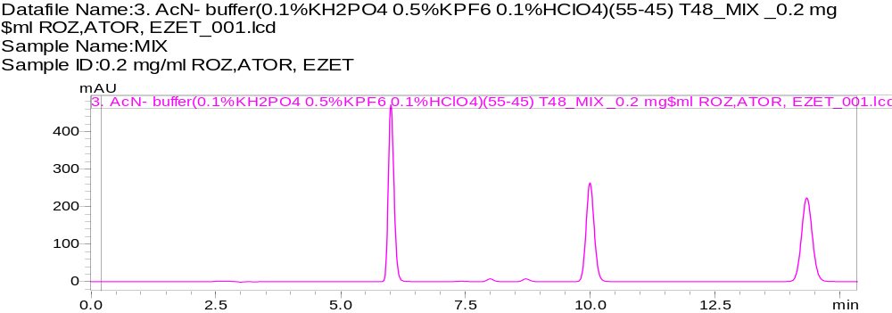
Figure 1S. Typical chromatogram of the standard solution of rosuvastatin, atorvastatin, and ezetimibe (0.2 mg/mL) under chromatographic conditions ACN-buffer (0.1 %KH₂PO₄, 0.5 % KPF₆, 0.1% HCLO₄) (55-45), t 48 °C
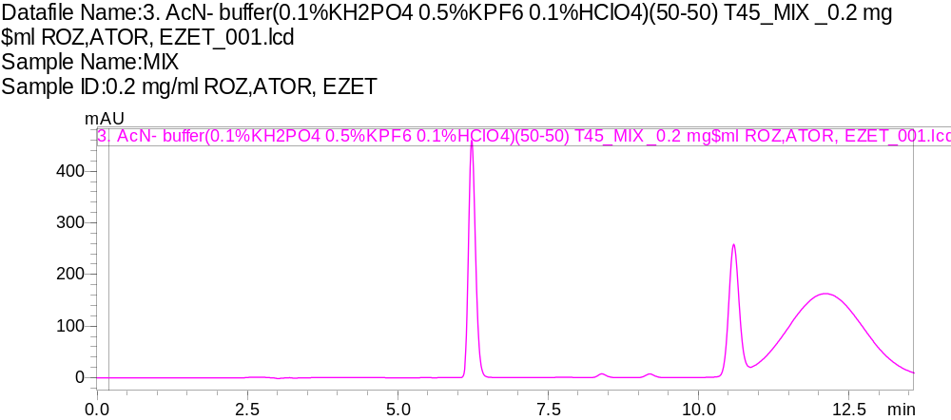
Figure 2S. Typical chromatogram of the standard solution of rosuvastatin, atorvastatin, and ezetimibe (0.2 mg/mL) under chromatographic conditions ACN-buffer (0.1 %KH₂PO₄, 0.5 % KPF₆, 0.1% HCLO₄) (50-50), t 45 °C

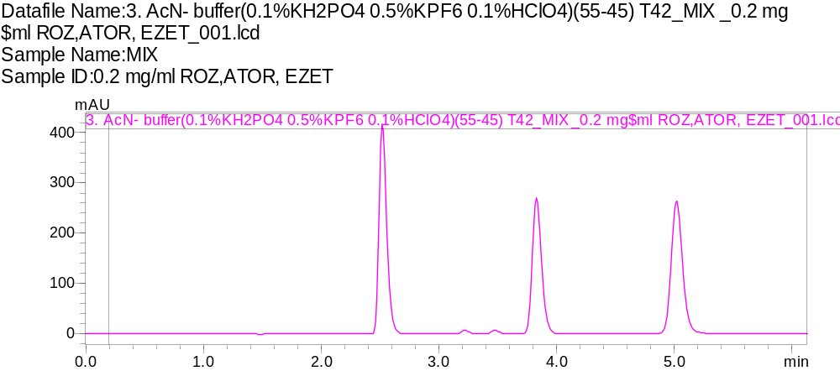
Figure 3S. Typical chromatogram of the standard solution of rosuvastatin, atorvastatin, and ezetimibe (0.2 mg/mL) under chromatographic conditions ACN-buffer (0.1 %KH₂PO₄, 0.5 % KPF₆, 0.1% HCLO₄) (55-45), t 42 °C

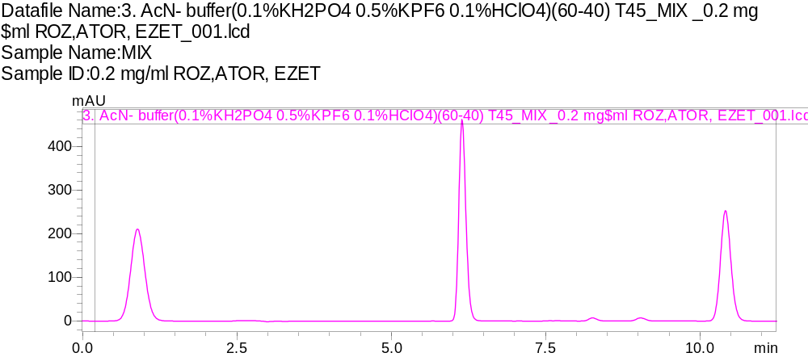
Figure 4S. Typical chromatogram of the standard solution of rosuvastatin, atorvastatin, and ezetimibe (0.2 mg/mL) under chromatographic conditions ACN-buffer (0.1 %KH₂PO₄, 0.5 % KPF₆, 0.1% HCLO₄) (60-40), t 45 °C

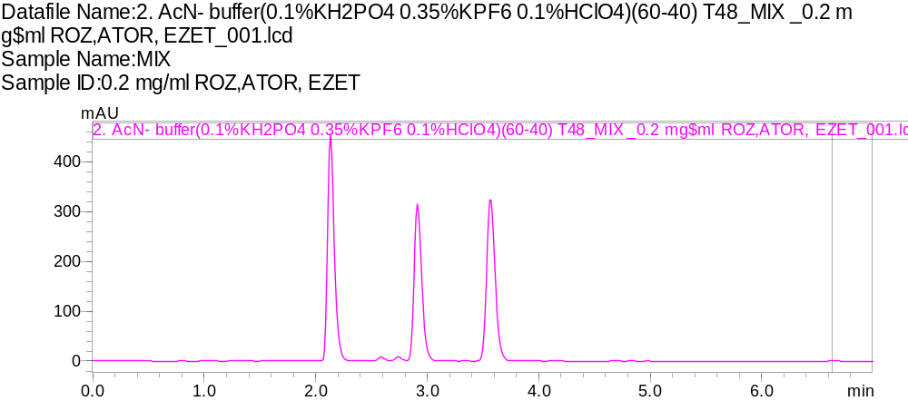
Figure 5S. Typical chromatogram of the standard solution of rosuvastatin, atorvastatin, and ezetimibe (0.2 mg/mL) under chromatographic conditions ACN-buffer (0.1 %KH₂PO₄, 0.35 % KPF₆, 0.1% HCLO₄) (60-40), t 48 °C

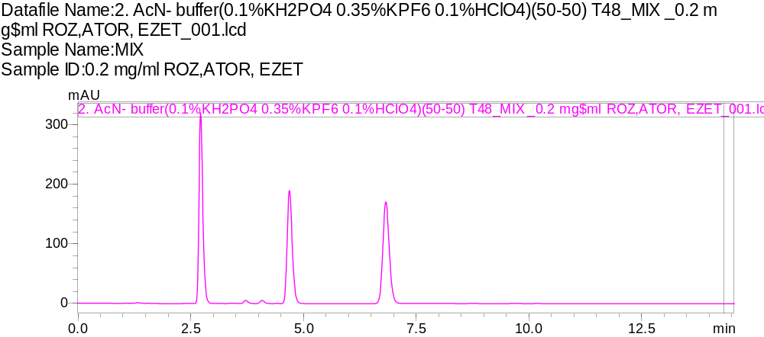
Figure 6S. Typical chromatogram of the standard solution of rosuvastatin, atorvastatin, and ezetimibe (0.2 mg/mL) under chromatographic conditions ACN-buffer (0.1 %KH₂PO₄, 0.35 % KPF₆, 0.1% HCLO₄) (50-50), t 48 °C

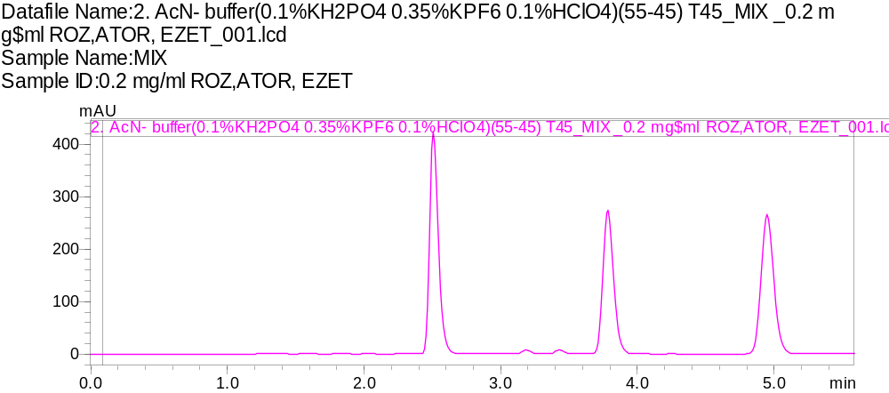

Figure 7S. Typical chromatogram of the standard solution of rosuvastatin, atorvastatin, and ezetimibe (0.2 mg/mL) under chromatographic conditions ACN-buffer (0.1 %KH₂PO₄, 0.35 % KPF₆, 0.1% HCLO₄) (55-45), t 45 °C

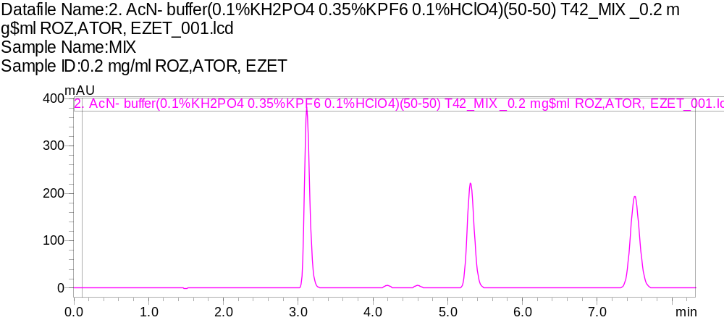
Figure 8S. Typical chromatogram of the standard solution of rosuvastatin, atorvastatin, and ezetimibe (0.2 mg/mL) under chromatographic conditions ACN-buffer (0.1 %KH₂PO₄, 0.35 % KPF₆, 0.1% HCLO₄) (50-50), t 42 °C
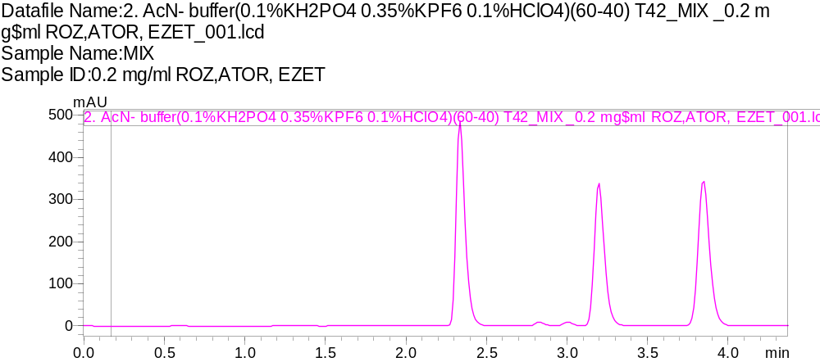
Figure 9S. Typical chromatogram of the standard solution of rosuvastatin, atorvastatin, and ezetimibe (0.2 mg/mL) under chromatographic conditions ACN-buffer (0.1 %KH₂PO₄, 0.35 % KPF₆, 0.1% HCLO₄) (60-40), t 42 °C
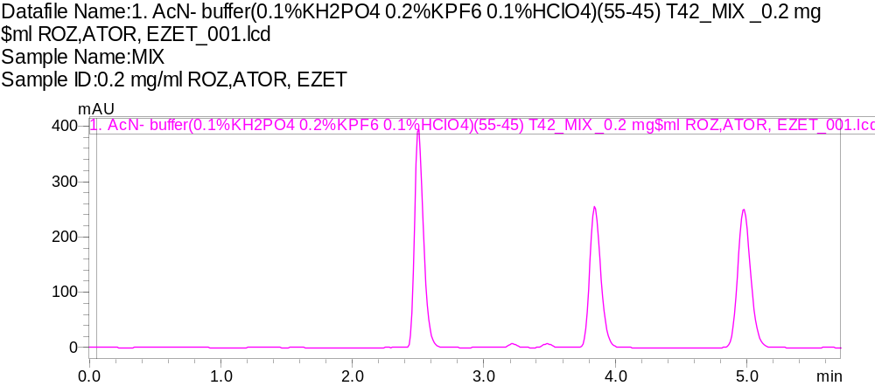
Figure 10S. Typical chromatogram of the standard solution of rosuvastatin, atorvastatin, and ezetimibe (0.2 mg/mL) under chromatographic conditions ACN-buffer (0.1 %KH₂PO₄, 0.2 % KPF₆, 0.1% HCLO₄) (55-45), t 42 °C
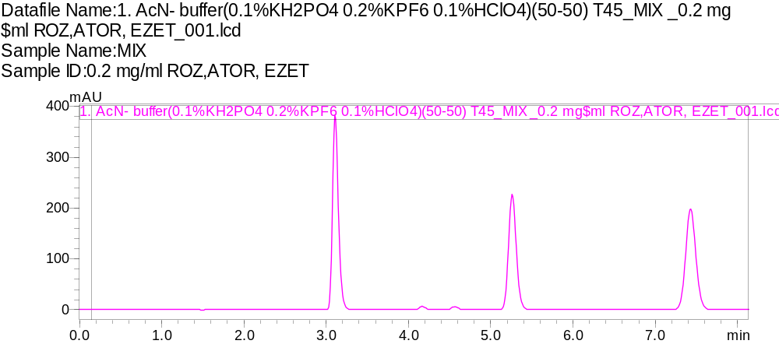
Figure 11S. Typical chromatogram of the standard solution of rosuvastatin, atorvastatin, and ezetimibe (0.2 mg/mL) under chromatographic conditions ACN-buffer (0.1 %KH₂PO₄, 0.2 % KPF₆, 0.1% HCLO₄) (50-50), t 45 °C

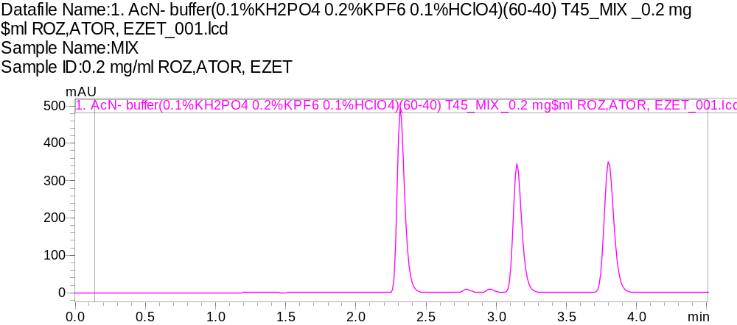
Figure 12S. Typical chromatogram of the standard solution of rosuvastatin, atorvastatin, and ezetimibe (0.2 mg/mL) under chromatographic conditions ACN-buffer (0.1 %KH₂PO₄, 0.2 % KPF₆, 0.1% HCLO₄) (60-40), t 45 °C
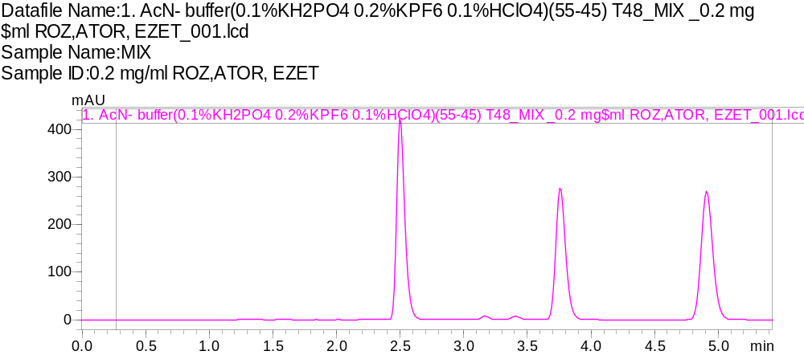
Figure 13S. Typical chromatogram of the standard solution of rosuvastatin, atorvastatin, and ezetimibe (0.2 mg/mL) under chromatographic conditions ACN-buffer (0.1 %KH₂PO₄, 0.2 % KPF₆, 0.1% HCLO₄) (55-45), t 48 °C
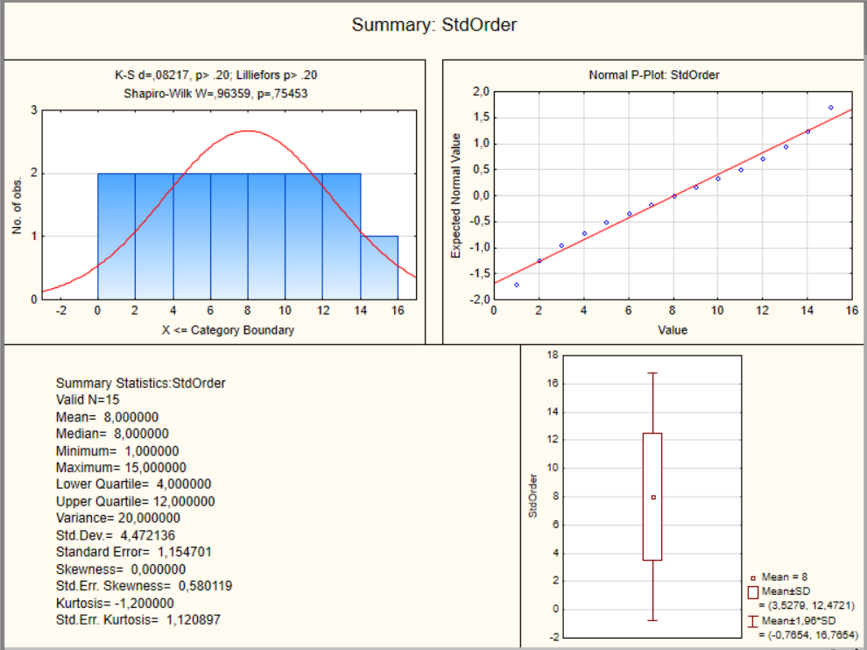
Figure 14S. Distribution and normality assessment of the experimental run order (StdOrder)
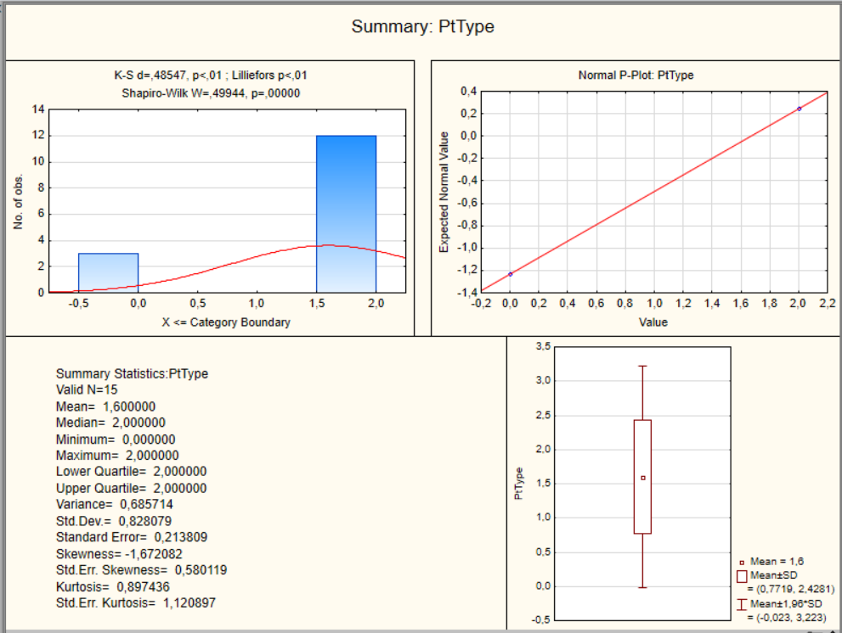
Figure 15S. Distribution and normality assessment of the mobile-phase type (PtType)
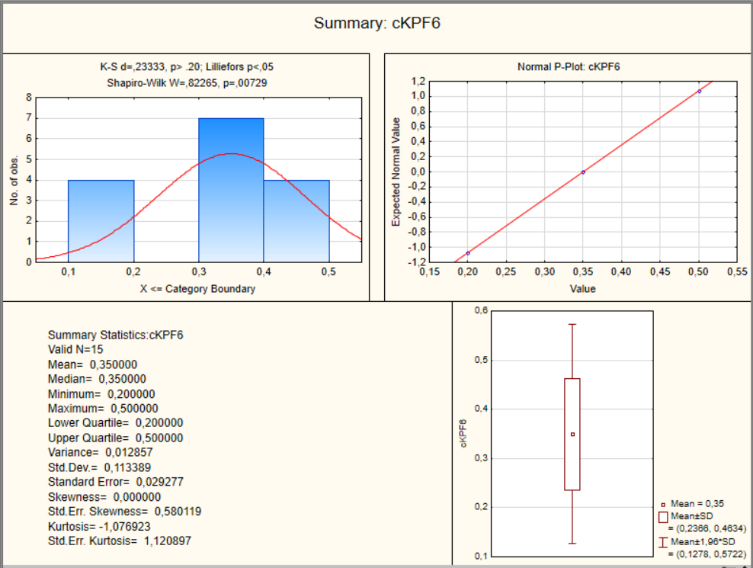
Figure 16S. Distribution and normality assessment of KPF₆ concentration (cKPF₆)

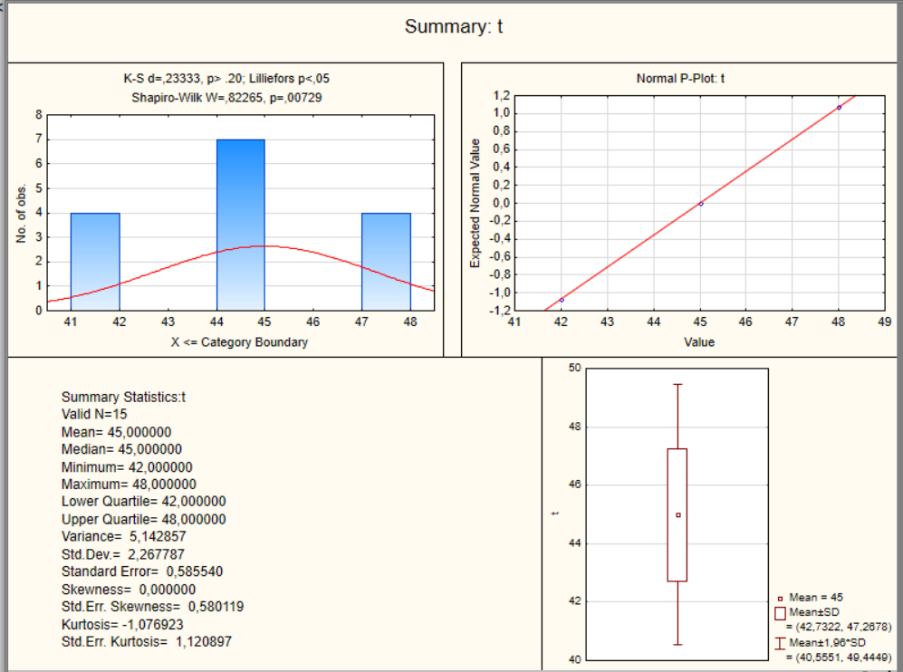
Figure 17S. Distribution and normality assessment of retention time (Rt)
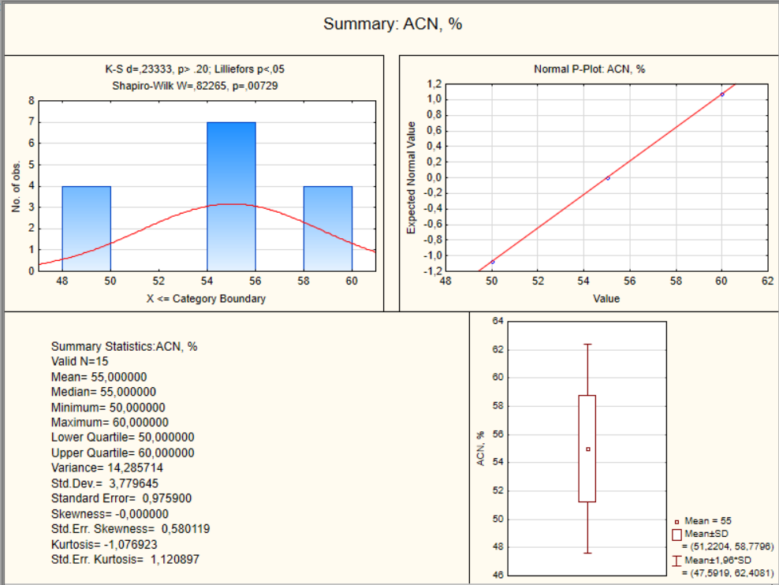
Figure 18S. Distribution and normality assessment of ACN content in the mobile phase (ACN, %)
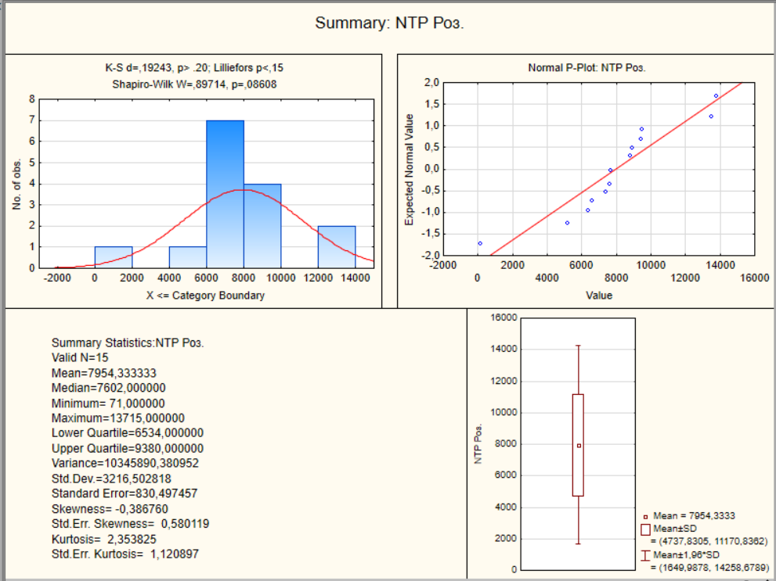
Figure 19S. Distribution and normality assessment of NTP ROS
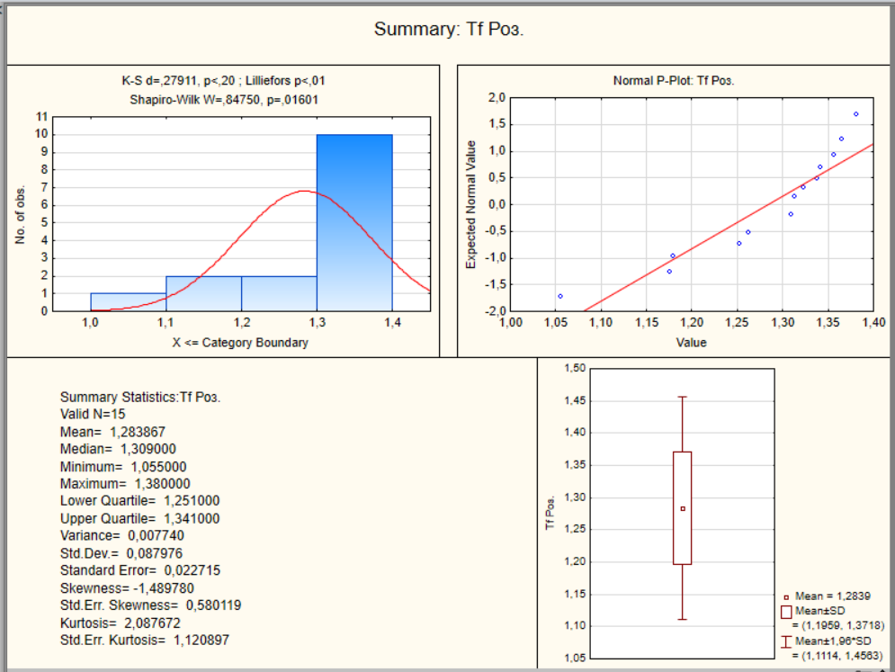
Figure 20S. Distribution and normality assessment of Tf ROS
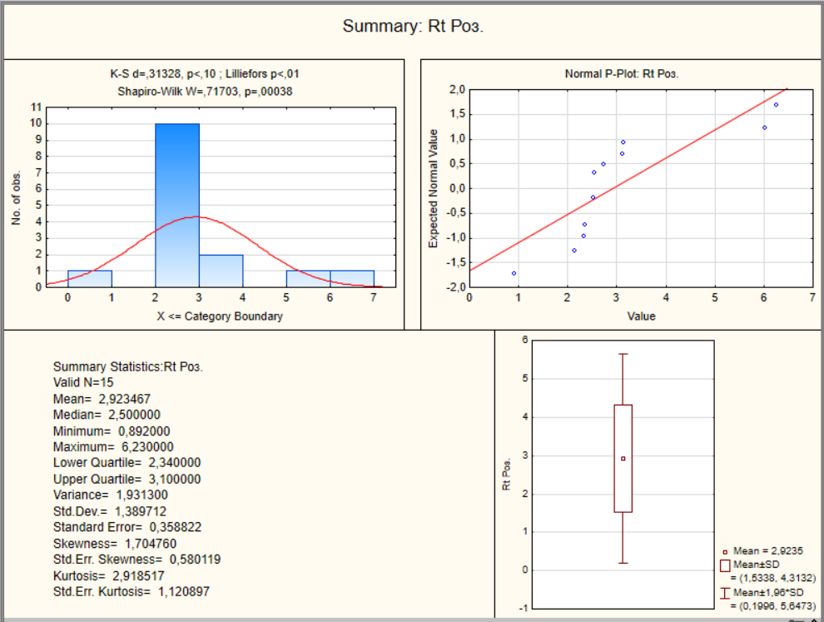
Figure 20S. Distribution and normality assessment of Rt ROZ
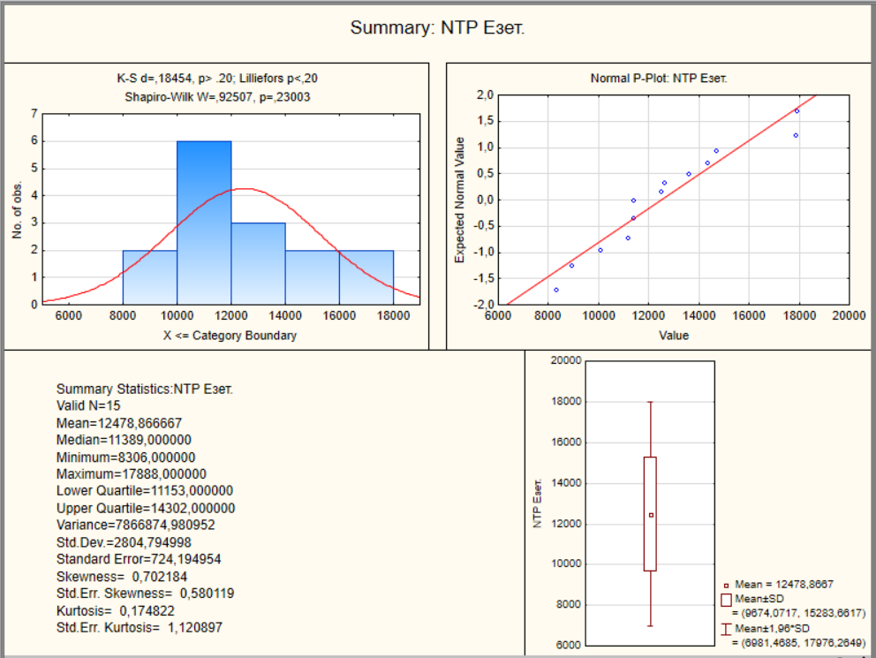
Figure 21S. Distribution and normality assessment of NTP EZET
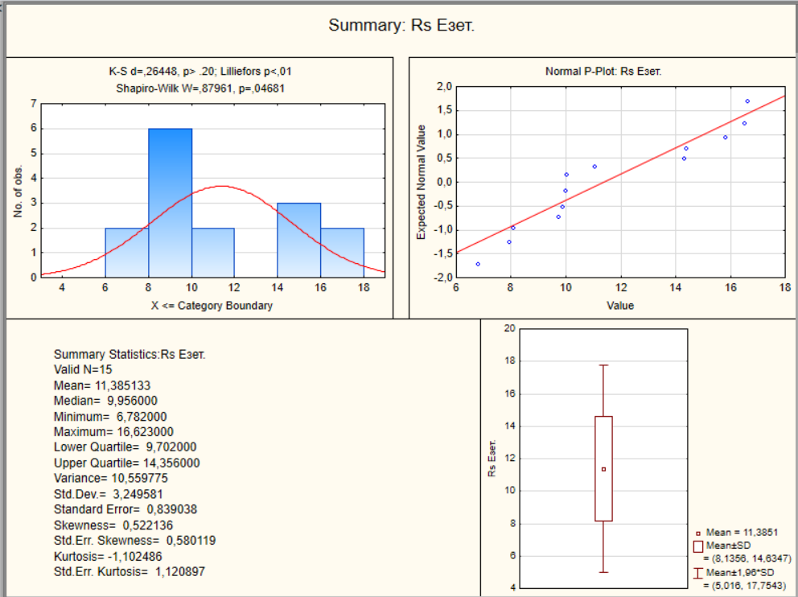
Figure 22S. Distribution and normality assessment of Rs EZET
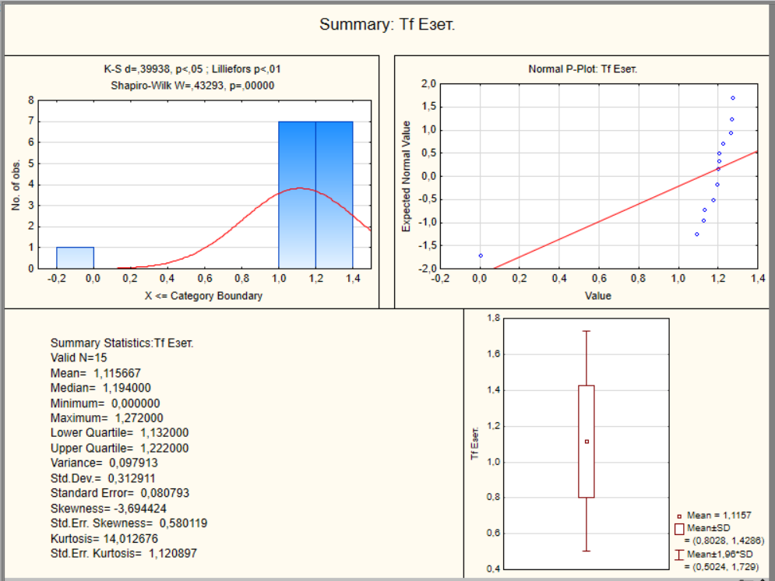
Figure 23S. Distribution and normality assessment of Tf EZET

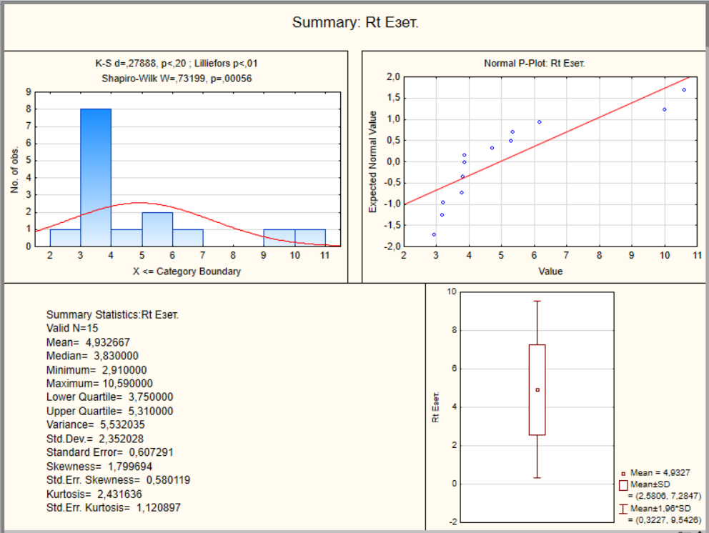
Figure 24S. Distribution and normality assessment of Rt EZET
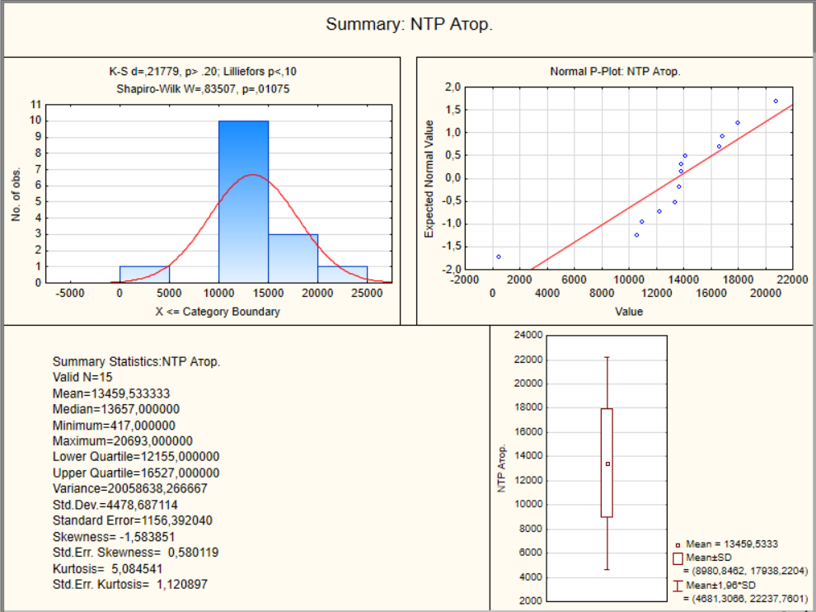
Figure 25S. Distribution and normality assessment of NTP ATOR
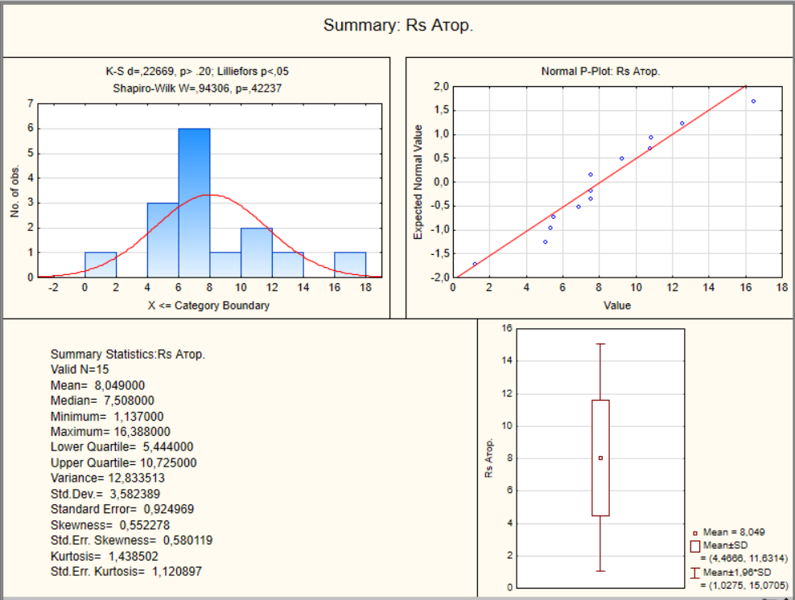
Figure 26S. Distribution and normality assessment of Rs ATOR
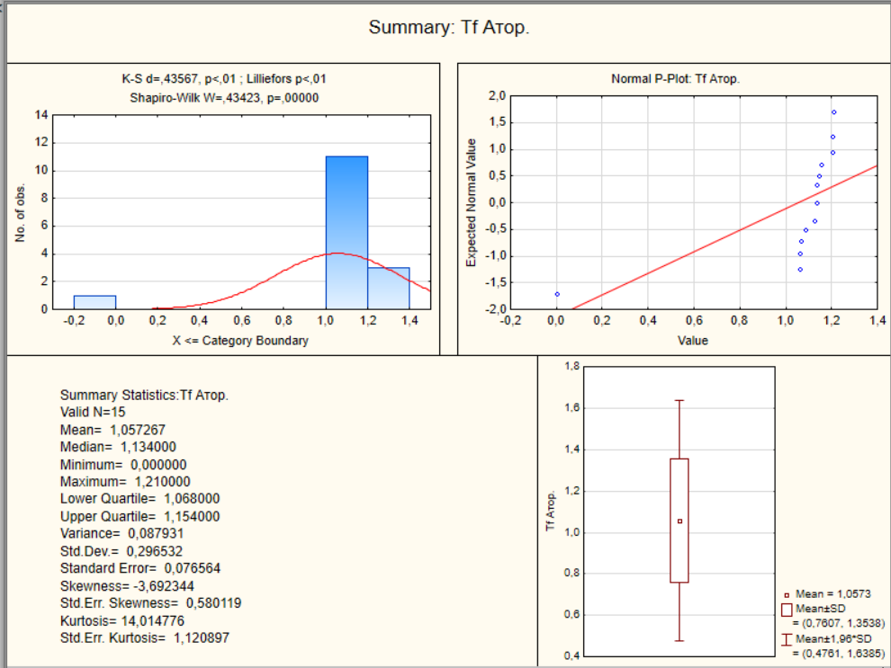
Figure 27S. Distribution and normality assessment of Tf ATOR
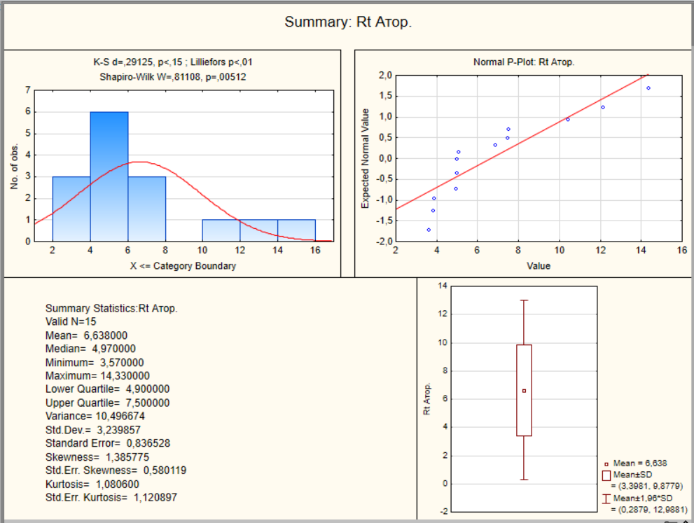
Figure 28S. Distribution and normality assessment of Rt ATOR

Table 1S. Descriptive statistics of the investigated chromatographic parameters and experimental factors
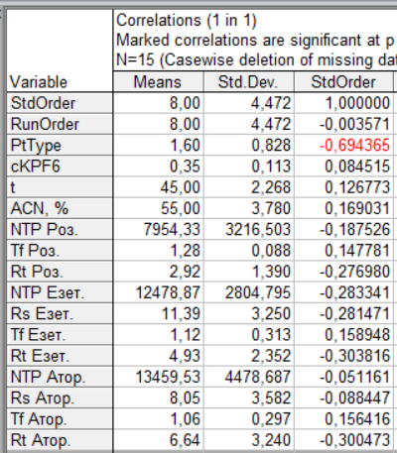
Table 2S. Pairwise correlation matrix of the investigated chromatographic parameters and experimental factors
