Supplementary Material

Supplementary Figure 1. Experimental design of morphine and PEA treatment protocols in rat organotypic spinal cord slices.
(A) Rat organotypic spinal cord slice cultures were left untreated (CTR) or exposed to morphine (MOR, 30 µM) for 48 hours. Slices were then incubated for 6 hours under basal conditions or with c.m. obtained from untreated or PEA-treated RBL-2H3 cells. (B) In a separate experimental protocol, spinal cord slices were maintained under control conditions or treated for 6 hours with ultramicronized PEA (50 nM), c.m. obtained from untreated RBL-2H3 cells, or their combination. c.m., conditioned medium; MOR, morphine; PEA, N-palmitoylethanolamine.
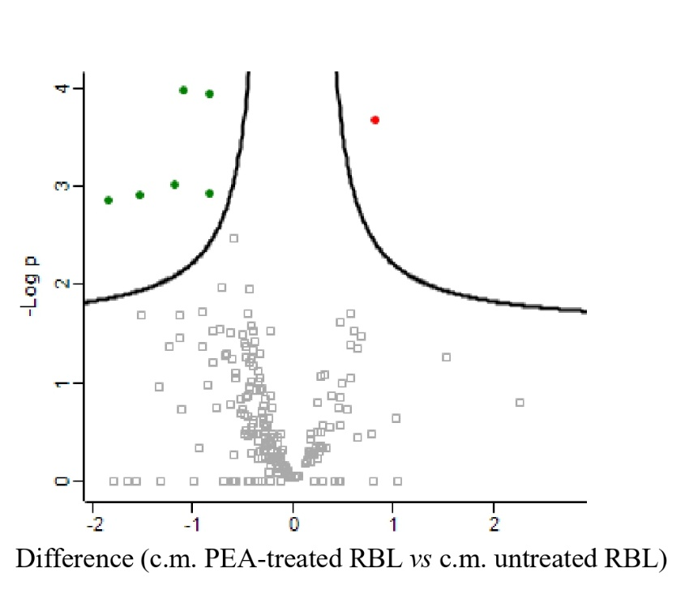

Supplementary Figure 2. PEA alters the mast cell secretome under IgE-dependent activation.
Volcano plot representing differential protein release in conditioned media from RBL-2H3 mast cells pre-sensitized with anti-DNP IgE (50 ng/mL) and stimulated with DNP-BSA (625 ng/mL) for 24 h, in the absence or presence of PEA (100 µM, 18 h). Proteins significantly upregulated by PEA are shown in red, whereas proteins significantly downregulated by PEA are shown in green.

p-value | log2ratio | Protein IDs | Protein names | Gene  names | unique peptides | Mol. weight [kDa]
1,37E-03 | -1,83 | F1LR87;Q6AXR4 | Beta-hexosaminidase subunit beta | Hexb | 4 | 61,5
1,23E-03 | -1,53 | P14844 | C-C motif chemokine 2 | Ccl2 | 2 | 16,46
9,53E-04 | -1,17 | Q6AYK6 | Calcyclin-binding protein | Cacybp | 3 | 26,541
1,07E-04 | -1,08 | P06302;Q63453;Q63452;F1M034 | Prothymosin alpha | Ptma | 4 | 12,382
1,15E-04 | -0,84 | Q8CJH4;Q6IN37 | GM2 activator protein | Gm2a | 5 | 21,521
1,18E-03 | -0,82 | P00770 | Mast cell protease 2 | Mcpt2 | 6 | 27,101
2,15E-04 | 0,83 | F1M790;Q62786 | Prostaglandin F2 receptor negative regulator | Ptgfrn | 15 | 98,667

Supplementary Table 1. Differentially released proteins in the mast cell secretome following PEA treatment.
Proteins differentially released by RBL-2H3 mast cells pre-sensitized with anti-DNP IgE (50 ng/mL) in the absence or presence of PEA (100 µM, 18 h) and stimulated with DNP-BSA (625 ng/mL) for 24 h. Negative log2 ratio values indicate proteins significantly downregulated by PEA treatment, whereas positive values indicate proteins significantly upregulated by PEA.
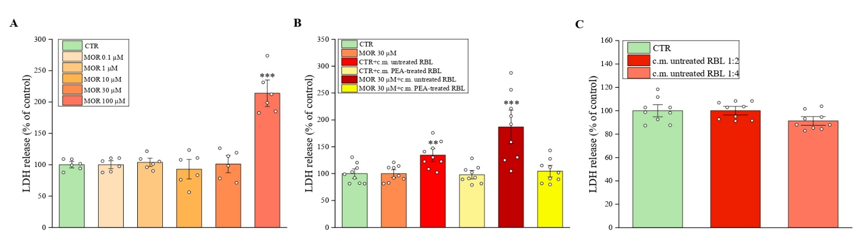Supplementary Figure 3. Evaluation of cytotoxic effects of morphine and mast cell-derived conditioned media on organotypic spinal cord slices.
Lactate dehydrogenase (LDH) release from organotypic spinal cord slices, treated for 48 hours with increasing concentrations of morphine (0.1-100 µM) (A); exposed to morphine (30 µM, 48 h) followed by a 6-hour treatment with undiluted conditioned medium (c.m.) from control or PEA-treated RBL-2H3 cells, previously stimulated with DNP-BSA (625 ng/mL, 24 h) (B); and treated with serum-free medium for 48 hours and then incubated for 6 hours with 1:2 or 1:4 diluted c.m. from DNP-BSA-stimulated control RBL-2H3 cells (C). Media were collected after 18 hours from treatments in a fresh serum-free medium. Values represent the mean ± SEM (n=6) and are normalized to the total protein concentration. **p < 0.01; ***p < 0.001 vs. CTR slices.

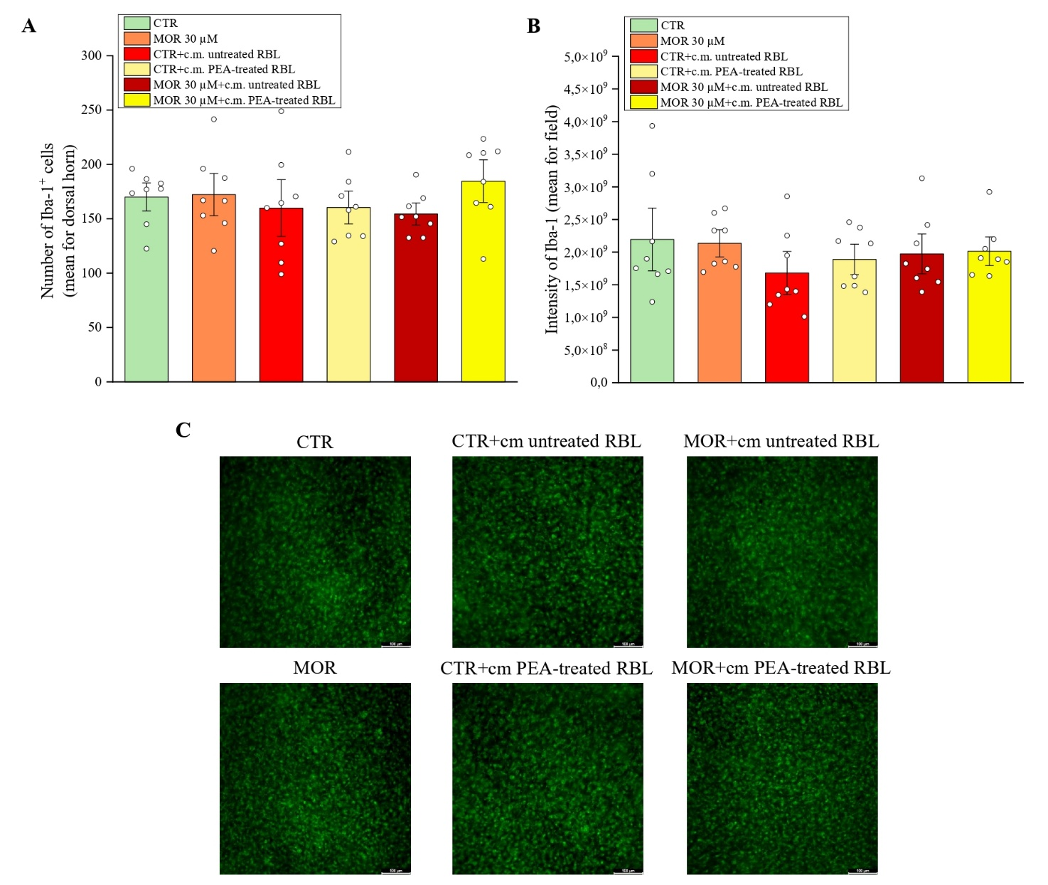

Supplementary Figure 4. Effects of PEA-treated mast cell conditioned medium on microglia activation. Immunofluorescence analysis of microglia activation in rat organotypic spinal cord slice cultures exposed to mast cell-conditioned media under basal conditions or following morphine treatment. Slices were treated with morphine (30 µM) for 48 h and subsequently incubated for 6 h with c.m. derived from RBL-2H3 mast cells stimulated with DNP-BSA (625 ng/mL) and either untreated or pretreated with PEA (100 µM, 18 h). Slices were then washed and maintained in fresh medium for an additional 18 h before immunofluorescence analysis. (A) Quantification of Iba-1⁺ cell number in the dorsal horn. (B) Quantification of Iba-1 fluorescence intensity in the dorsal horn. (C) Representative images of Iba-1 immunofluorescence. Data are expressed as mean ± S.E.M. of three independent experiments, with n = 8 slices per condition.
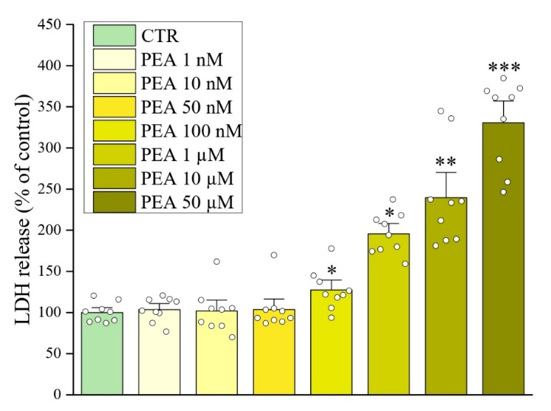
Supplementary Figure 5. Evaluation of cytotoxic effects of PEA on organotypic spinal cord slices.
Lactate dehydrogenase (LDH) release from organotypic spinal cord slices, treated for 24 hours with increasing concentrations of ultramicronized PEA (1nM-100 µM). Values represent the mean ± SEM (n=6) and are normalized to the total protein concentration. *p < 0.05: **p < 0.01; ***p < 0.001 vs. CTR slices.

