Supporting Information
A Comprehensive Route for Safe and Sustainable Graphene Oxide Synthesis
Kartik Joshiª†, Parveen Kumarª†, Pawan Kumar^{b}, Rajinder Kumar^{c}, Ashavani Kumar^{a*}
- Department of Physics, National Institute of Technology Kurukshetra, Haryana 136119, India
- Department of Chemistry & Chemical Science, Central University of Jammu, Rahya Suchani, Bagla, Jammu, 181143, UT of J & K, India
- Central Research Facility, Indian Institute of Technology (IIT)- Delhi, Delhi 110016, India
†- These authors contributed equally to this work.
Corresponding author E-mail: ashavani@yahoo.com, ashavani@nitkkr.ac.in

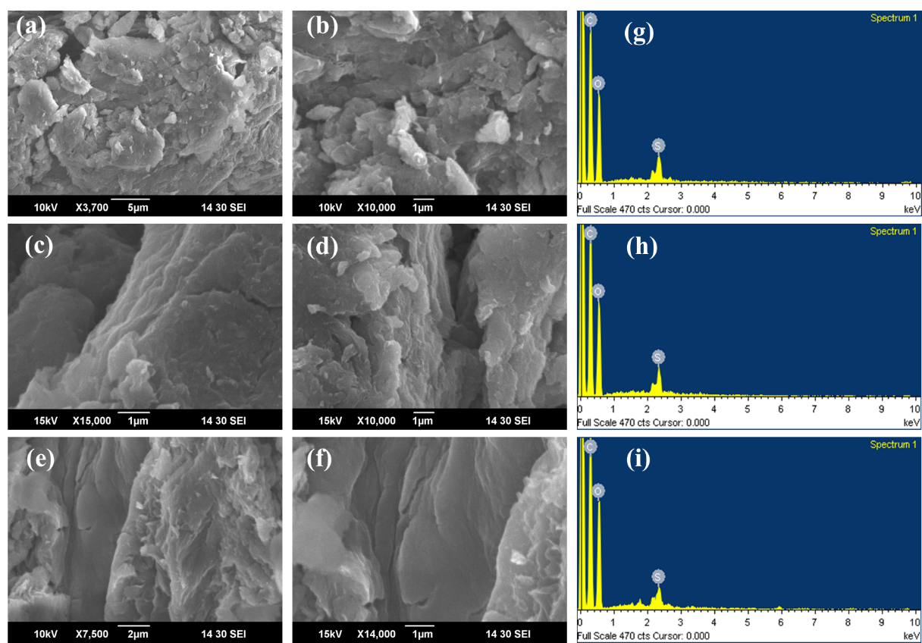
Figure S1 SEM images of (a and b) GO1, (c and d) GO2, and (e and f) GO3, (g, h, and i) show the EDS analysis for GO1, 2, and 3, respectively.
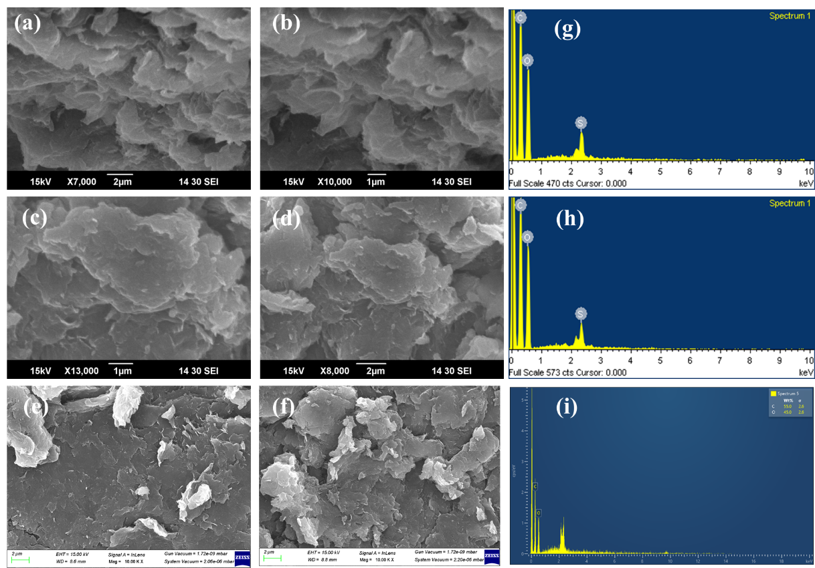
Figure S2 SEM images of (a and b) GO4, (c and d) GO5, and (e and f) GO6, (g, h, and i) show the EDS analysis for GO4, 5, and 6, respectively.

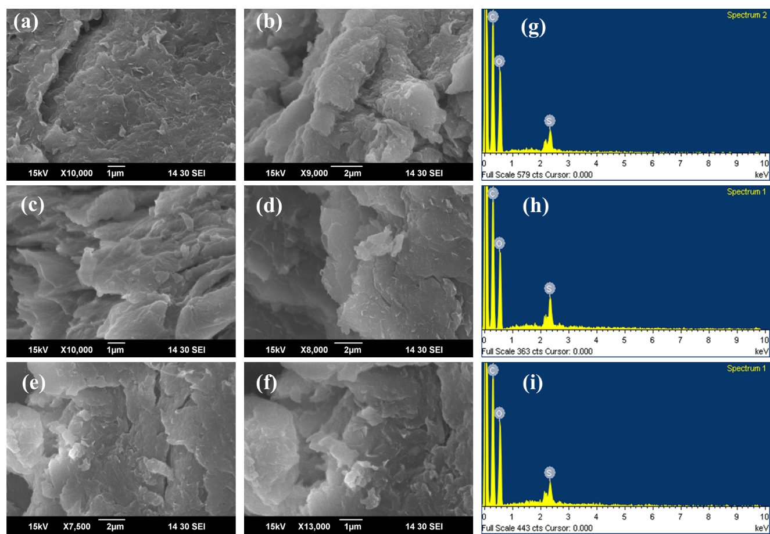
Figure S3 SEM images of (a and b) GO7, (c and d) GO8, and (e and f) GO9, (g, h, and i) show the EDS analysis for GO7, 8, and 9, respectively.

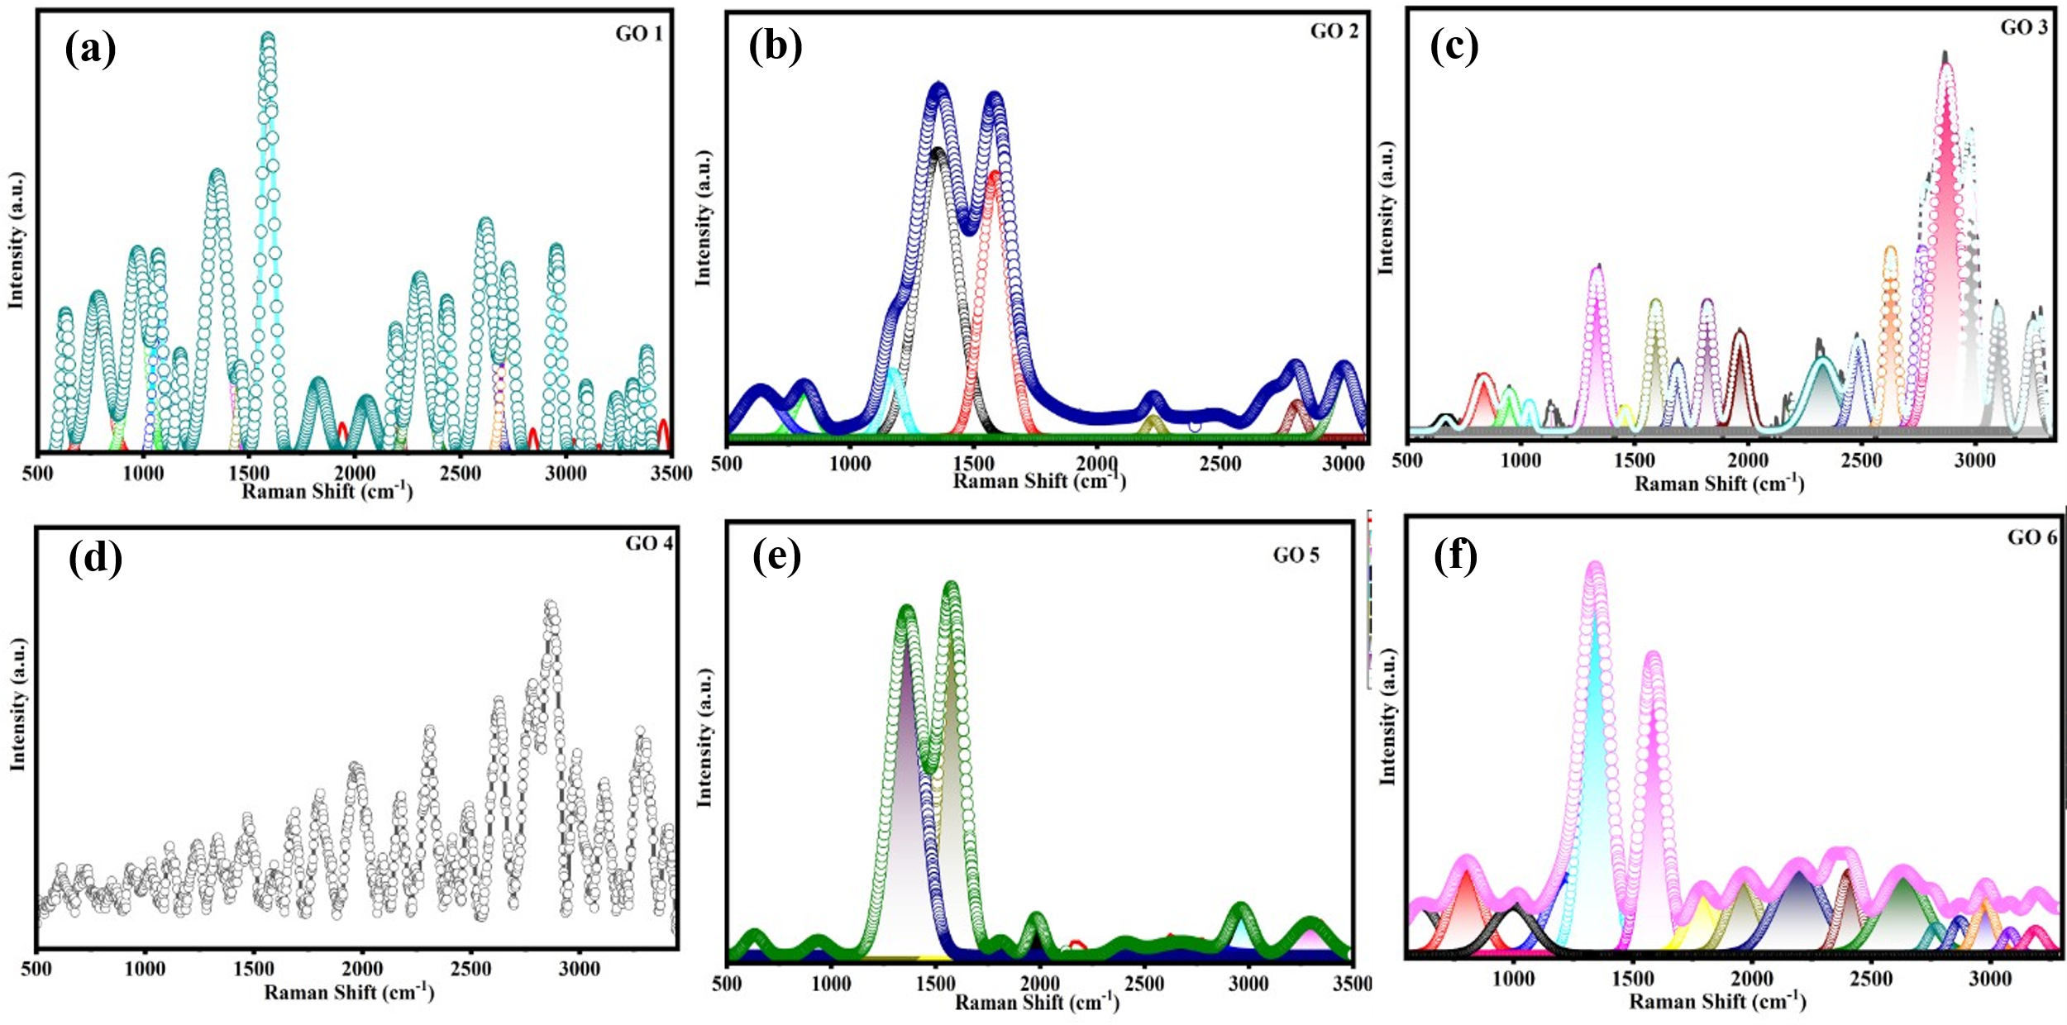
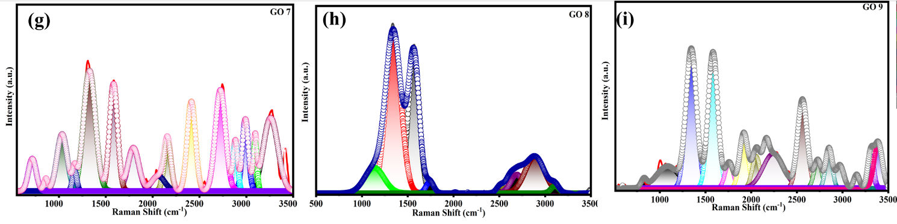
Figure S4 Full spectra of Raman analysis for (a) GO1, (b) GO2, (c) GO3, (d) GO4, (e) GO5, (f) GO6, (g) GO7, (h) GO8, and (i) GO9.

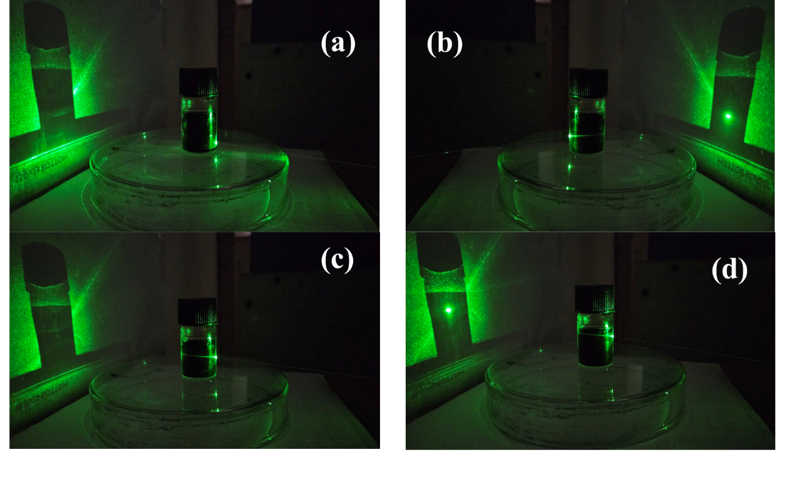
Figure S5 (a), (b), (c), and (d) The Tyndall effect images for GO8.
Table S1 Yield of the GO samples
Sample name | Yield
GO 1 | 150 %
GO 2 | 123 %
GO 3 | 71 %
GO 4 | 140 %
GO 5 | 124 %
GO 6 | 190 %
GO 7 | 146 %
GO 8 | 113 %
GO 9 | 112 %

Eq. S1 is used to calculate the yield of the GO samples[1]. The calculated yield of the GO samples is shown in Table S1; however, the yield of the samples prepared without H₂O₂ is almost similar to that of the sample with H₂O₂[2].
$Yield=\frac{mass of final GO (gm)}{intial mass of graphite powder (gm)}*100$ (Eq. S1)

XPS Analysis
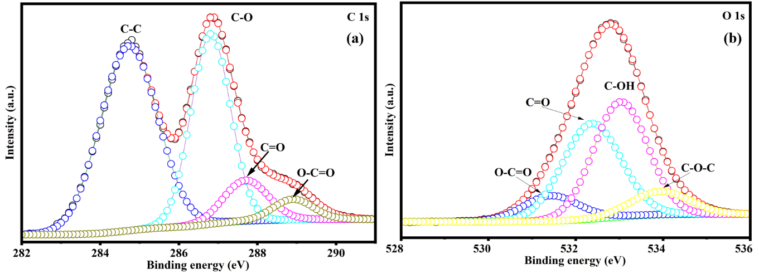
Figure S6 (a and b) XPS spectra of GO1.
The chemical bonding of GO1 is determined by using XPS. Fig. S6 (a and b) represents the carbon and oxygen XPS spectra. In Fig. S6 (a), the sp₂ peak (C-C) (284.7 eV) has a lower intensity than the sp₃ (286.8 eV), which shows the oxidation degree of the GO1 sample. However, the other functional groups, such as carboxyl (288.9 eV) and carbonyl (287.7 eV), are also present. Fig S6 (b) shows the presence of functional groups in oxygen spectra. The deconvoluted oxygen functional groups, such as oxygen atoms in the hydroxyl group (C-OH, 533.0 eV), carbonyl (532.3 eV), carboxylate group (531.3 eV), and epoxide group (533.9 eV)[3]. The C/O ratio of GO1, as per the XPS elemental composition analysis, is 1.99.

Figure S7 UV-Vis spectra for the remaining GO samples, respectively.
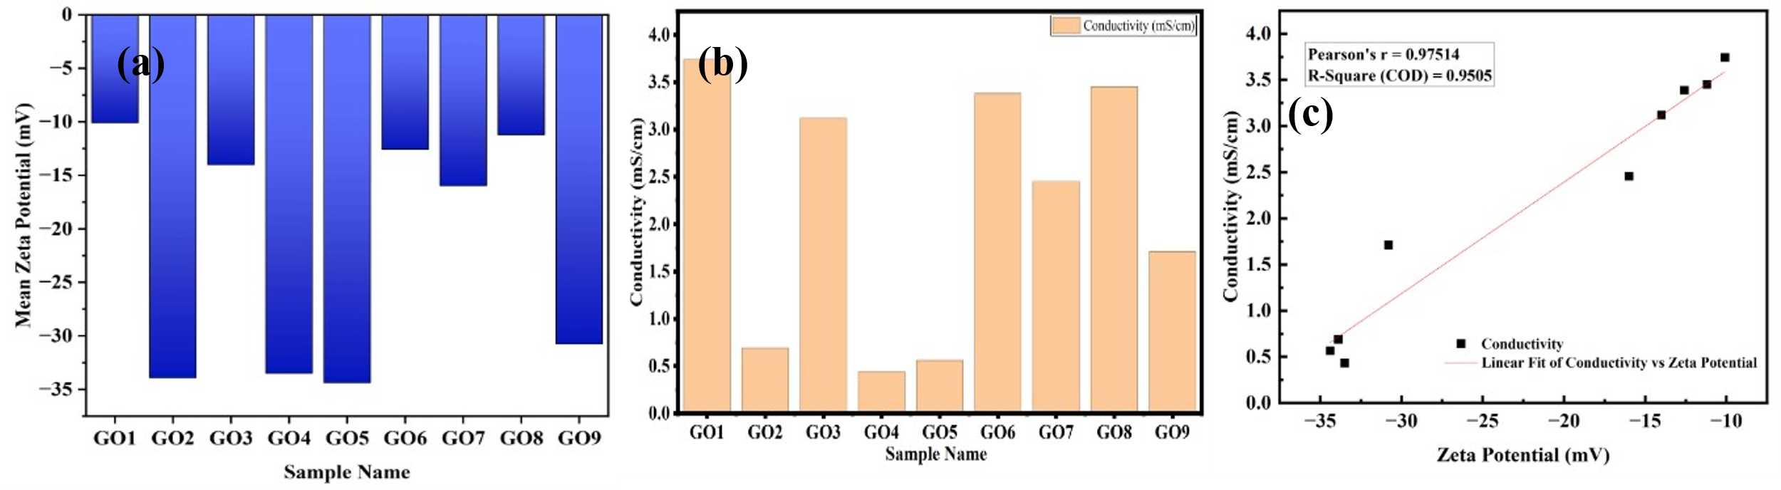
Figure S8 (a) Zeta-potential (b) conductivity graph for all samples (c) to analyse the correlation between zeta-potential and conductivity.

References
[1] C. Botas, A.M. Pérez-Mas, P. Álvarez, R. Santamaría, M. Granda, C. Blanco, R. Menéndez, Optimization of the size and yield of graphene oxide sheets in the exfoliation step, Carbon N. Y. 63 (2013) 576–578. https://doi.org/https://doi.org/10.1016/j.carbon.2013.06.096.
[2] J. Chen, Y. Li, L. Huang, C. Li, G. Shi, High-yield preparation of graphene oxide from small graphite flakes via an improved Hummers method with a simple purification process, Carbon N. Y. 81 (2015) 826–834. https://doi.org/https://doi.org/10.1016/j.carbon.2014.10.033.
[3] R. Al-Gaashani, A. Najjar, Y. Zakaria, S. Mansour, M.A. Atieh, XPS and structural studies of high quality graphene oxide and reduced graphene oxide prepared by different chemical oxidation methods, Ceram. Int. 45 (2019) 14439–14448.

