Supplemental Information

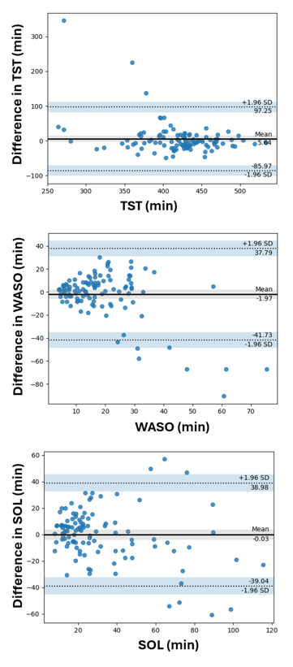
Figure S1. Sleep tracker vs PSG Bland-Altman plots for TST, SOL and WASO.
Bland-Altman plots illustrate sleep variables: total sleep time (TST), wake after sleep onset (WASO), and sleep onset latency (SOL). The y-axis displays the difference between the sleep tracker and polysomnography (PSG) measurements (Oura - PSG), while the x-axis shows the values recorded by the sleep tracker. The solid dark horizontal lines indicate the mean difference (MD) between the two methods, highlighting any systematic bias. The dotted lines represent the upper and lower 95% Bland-Altman agreement limits (MD ± 1.96×SD).
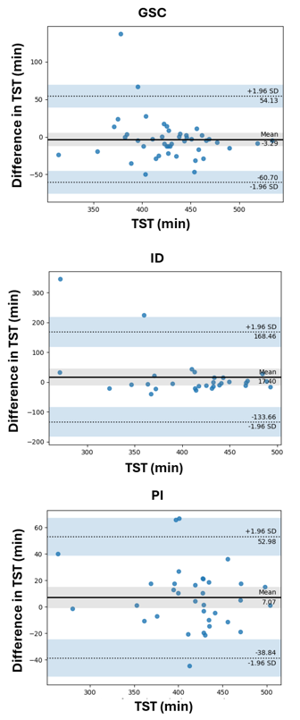
Figure S2. Sleep tracker vs PSG Bland-Altman plots for TST in the study groups.
Bland-Altman plots show total sleep time (TST) for each study group: good sleeper controls (GSC), insomnia disorders (ID), paradoxical insomnia (PI). The y-axis displays the difference between the sleep tracker and polysomnography (PSG) measurements (Oura - PSG), while the x-axis shows the values recorded by the sleep tracker. The solid dark horizontal lines indicate the mean difference (MD) between the two methods. The dotted lines represent the upper and lower 95% agreement limits (MD ± 1.96×SD).

