Supplementary material:
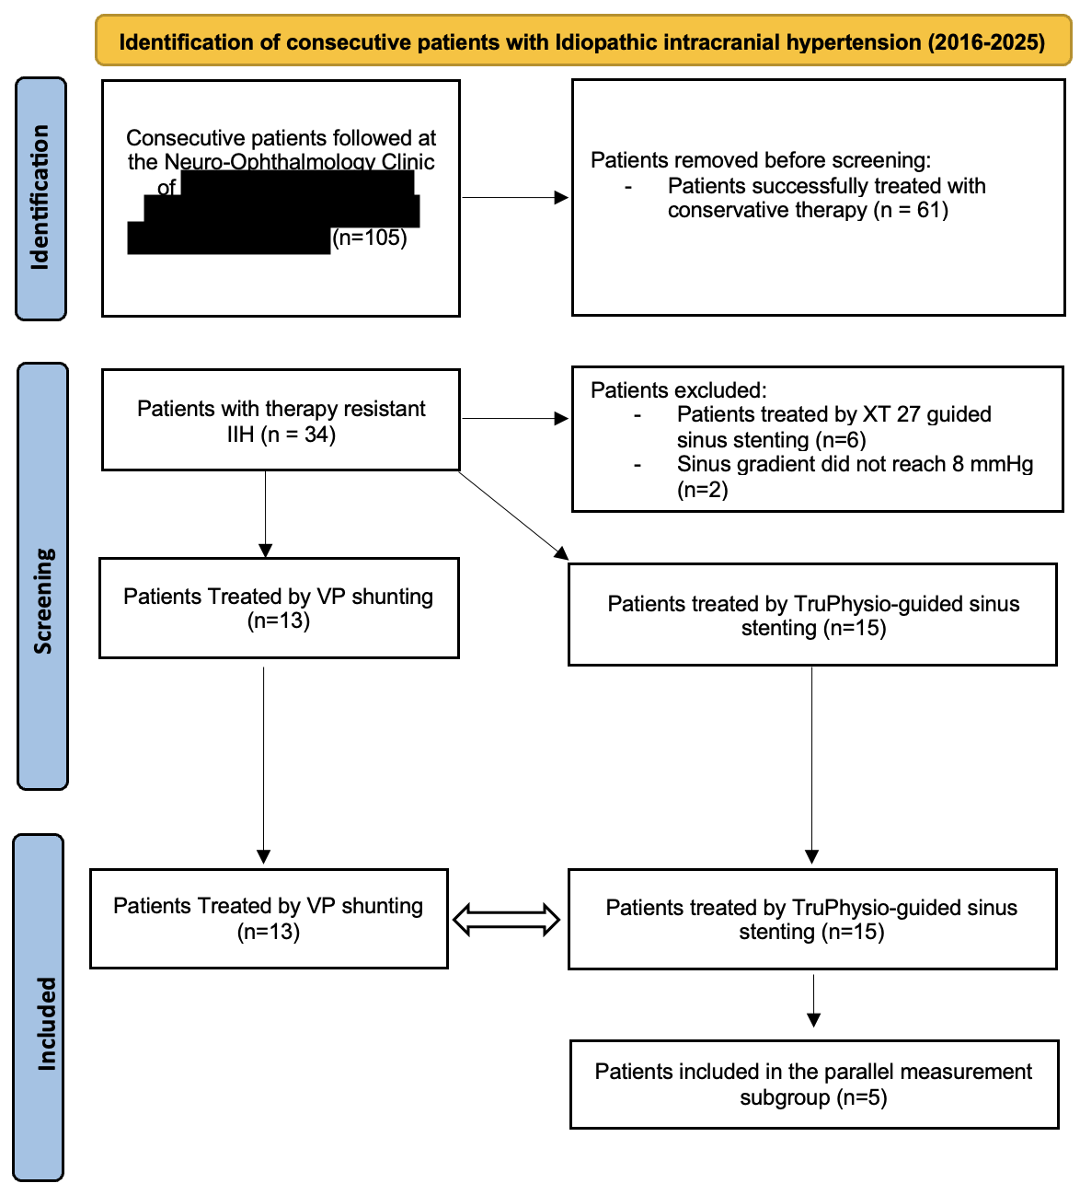
Supplementary Figure S1. Flow diagram of patient selection. Consecutive patients with idiopathic intracranial hypertension (2016–2025) were screened. After exclusion of patients successfully treated conservatively and those not meeting gradient criteria or previously treated, therapy-resistant patients underwent either VP shunting (n=13) or TruePhysio-guided venous sinus stenting (n=15).

