Supporting Information
Directing Recruitment and Differentiation of Endogenous Stem Cells via DNA Origami-based Nanorobots to Attenuate Osteoarthritis Progression
Song Xue^{1,2†}, Peng Zhang^{1,†}, Yuxiang Ren^{1,†}, Canfeng Li¹, Shiqian Huang², Rui Cheng³, Yue Xu¹, Hongxin Zhuo¹, Hongmao Cai¹, Xin Li¹, Xinyu Zhao¹, Xiaocheng Jiang¹, Ru Feng⁴, Jianwei Zuo¹, Bo Zhu⁵, Shaowei Zheng⁵, Peng Chen¹, Lucy Di Silvio³, Yan Xu^{6-8,}*, Tianyu Chen^{9,}*, Xintao Zhang^{1,}*
¹ Department of Sports Medicine and Rehabilitation, Peking University Shenzhen Hospital, Shenzhen Peking University-The Hong Kong University of Science and Technology Medical Center, Shenzhen, China.
² Clinical Research Centre, Zhujiang Hospital, Southern Medical University, Guangzhou, China.
³ Center for Oral, Clinical and Translational Sciences, Faculty of Dentistry, Oral & Craniofacial Sciences, King's College London, London, UK.
⁴ Department of Sports Medicine and Rehabilitation, Shenzhen Xinhua Hospital, Peking University Shenzhen Hospital, Shenzhen, China.
⁵ Department of Spinal and Neural Functional Reconstruction, China Rehabilitation Research Center, Capital Medical University, Beijing, China.
⁶ Department of Sports Medicine, Peking University Third Hospital, Institute of Sports Medicine of Peking University, Beijing, China.
⁷ Beijing Key Laboratory of Research and Translation for Drugs and Medical Devices in Precision Diagnosis and Treatment of Sports Injuries, Beijing, China.
⁸ Engineering Research Center of Sports Trauma Treatment Technology and Devices, Ministry of Education, Beijing, China.
⁹ Department of Orthopedics, The Third Affiliated Hospital of Southern Medical University, Guangzhou, China.
* Corresponding authors
E-mail addresses: zhangxintao@sina.com (Zhang XT); nysycty@163.com (Chen TY); yanxu@139.com (Xu Y)
† These authors contributed equally

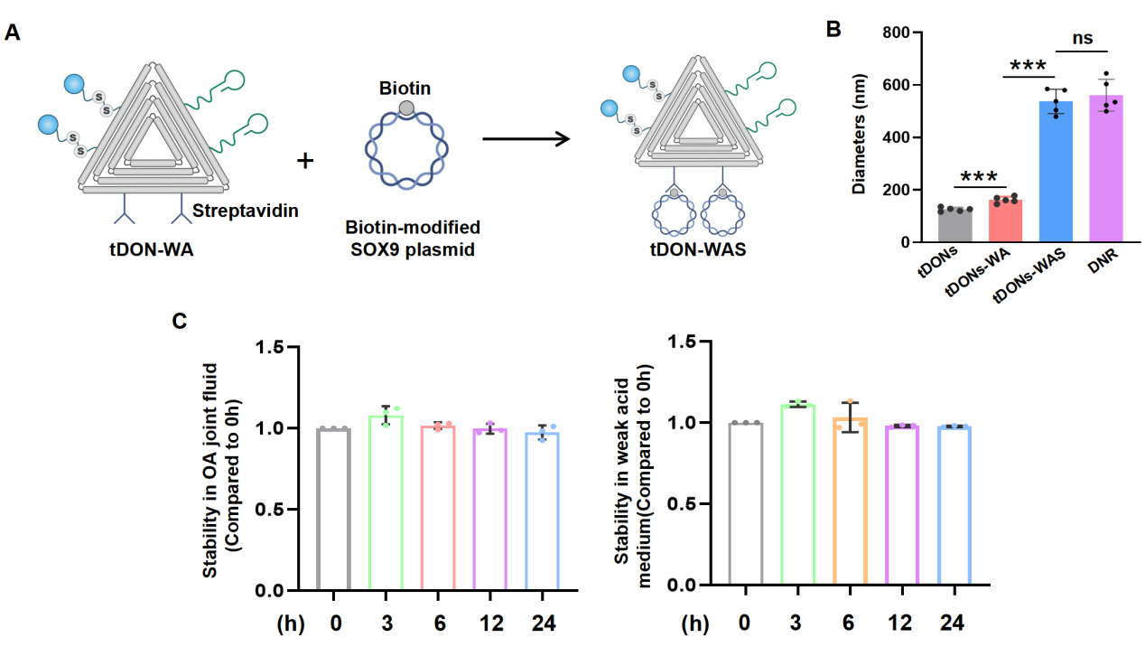
Figure S1. A) The schematic diagram for the hybridizable tDONs linked with SOX9 plasmid. Specifically, the streptavidin-decorated tDON-WA react with the biotin-modified SOX9 plasmid via mixed incubation at neutral pH environment and room temperature. B) The diameters detection of different tDON-based nanodevices. C) The stability of DNR in different mediums (left: joint fluid from OA patient; right: weak acid medium) for consecutive 24 h (0, 3, 6, 12, 24 h).

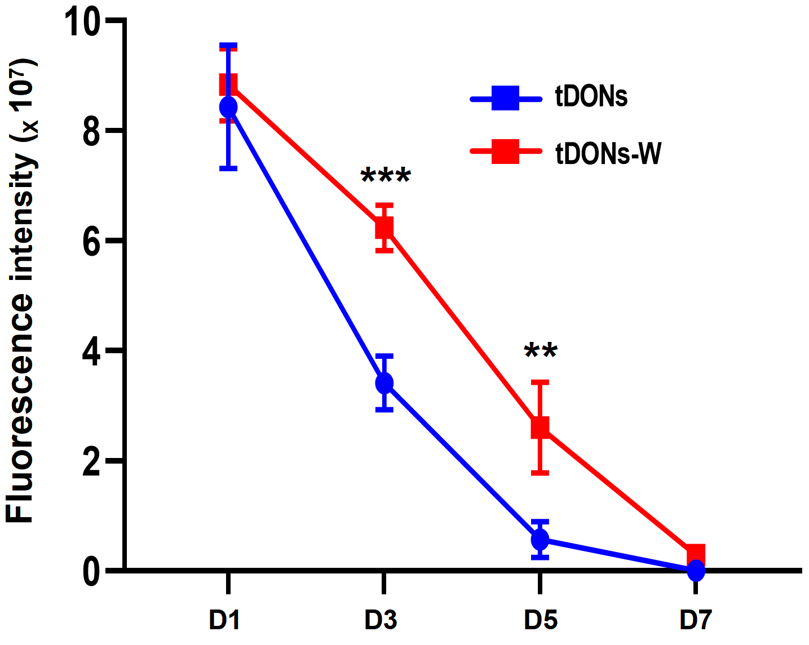
Figure S2. The fluorescence intensity alterations after different IA injection of tDONs-W and tDONs for consecutive 7 days. ** P < 0.01 and *** P < 0.001.
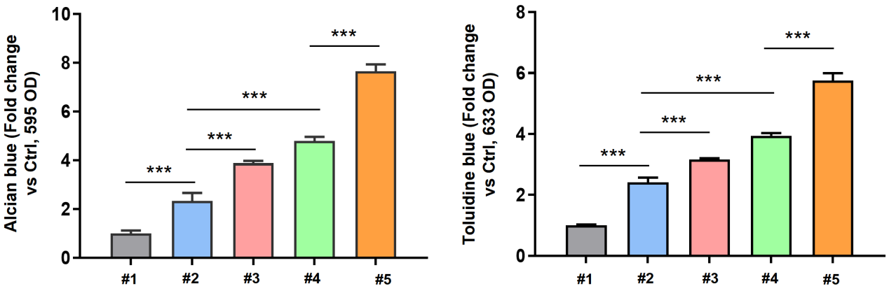
Figure S3. Statistical analysis of the positive alcian blue and toluidine blue staining for MSCs after different treatment. *** P < 0.001. #1: Ctrl；#2: tDONs-WA; #3: tDONs-WAR; #4:tDONs-WAS; #5: DNR.

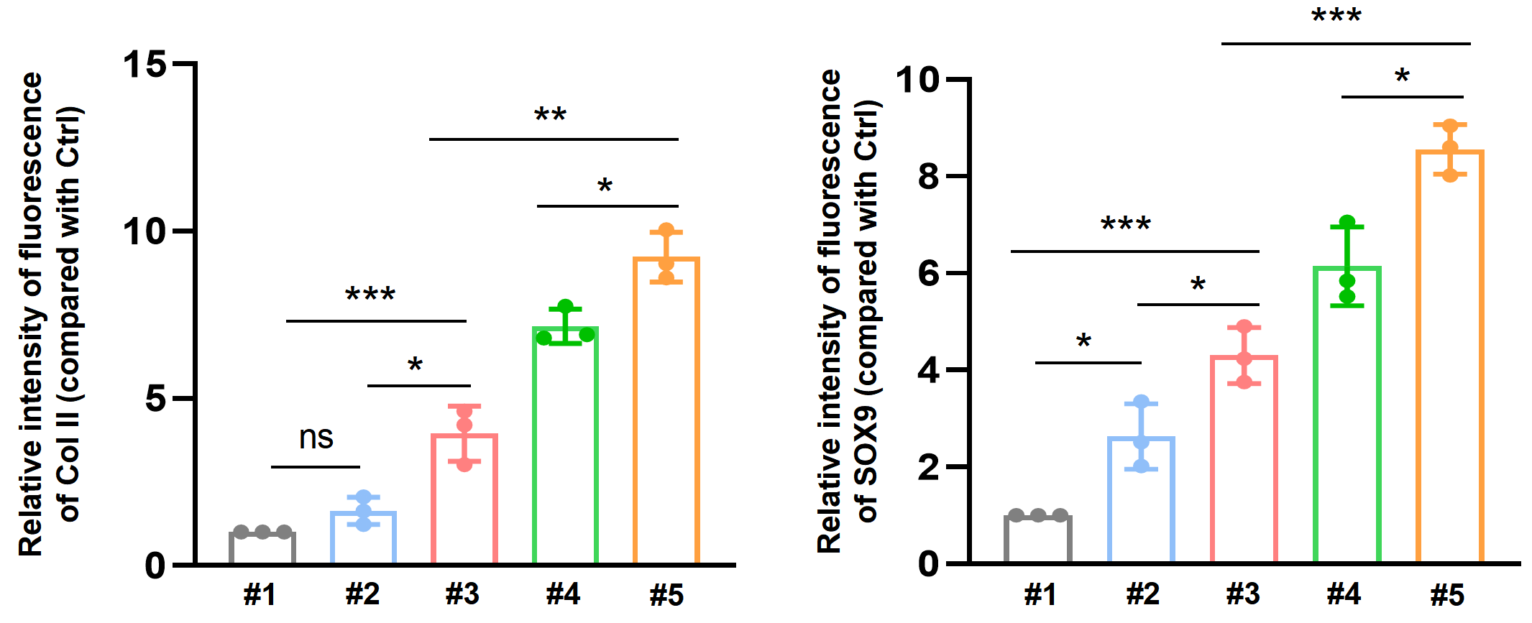
Figure S4. Statistical analysis of the relative intensity of fluorescence of Col II and SOX9 (compared with Ctrl) among different treatment. ^{ns} P ＞ 0.05, * P < 0.05, ** P < 0.01 and *** P < 0.001. #1: Ctrl；#2: tDONs-WA; #3: tDONs-WAR; #4:tDONs-WAS; #5: DNR.
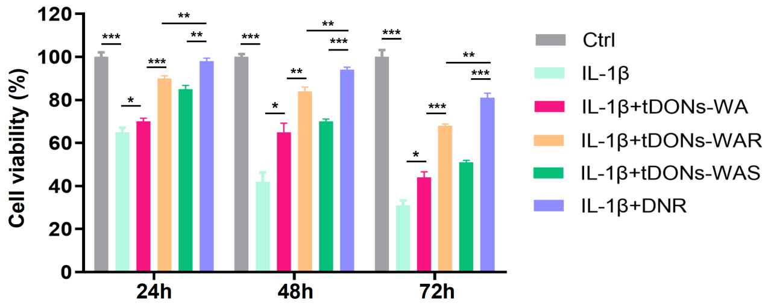
Figure S5. Cell viability analysis for MSCs after different treatment. * P < 0.05, ** P < 0.01 and *** P < 0.001.

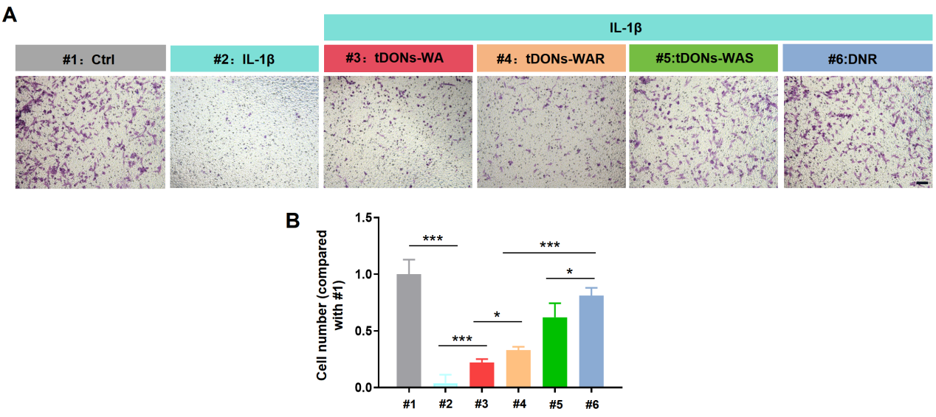
Figure S6. Migratory capacity of MSCs after treated with different DNA nanodevices via transwell assay (A) and statistical analysis of the positive cell number among these groups (B). Scale bar, 100 μm. * P < 0.05, and *** P < 0.001.

