Theoretical Research on Tetrazine-Based Nitrogen-Chain Energetic Materials: Balancing Detonation Performance and Sensitivity via Structural Regulation
Qian Zhang, Xiao-Nan He, Han-Jie Ni, Jia-Nan Li, Lan-Ying Xu, Yan Huang*, Tao Long*
School of Chemistry and Chemical Engineering Huanggang Normal University, Huanggang 438000, China

content
Fig. S1 Designed molecular structures of molecules 01 to 18 2
Table S1 Density of designed molecules 01 to 18 (at B3PW91/6-311+g(d,p) level) 2
Fig. S2 Designed molecular structures of series I to IV 4
Table S2 Density of designed molecules series I to IV (at B3PW91/6-311+g(d,p) level) 4
Table S3 HOMO and LUMO calculation details of designed molecules series I to IV (at M06-2X/6-311+G(d,p) level) 5
Table S4 Theoretical density values for similar nitrogen-rich molecules at different calculation level 6
Table S5 Calculation details of similar nitrogen-rich molecules M01 to M03 6
Fig. S5 Isodesmic reactions of Series III designed molecules 9
Fig. S6 Isodesmic reactions of Series IV designed molecules 10
Table S6 Calculation details of designed molecules series I to IV (at M06-2X/6‑311+G(d,p) level) 10
Fig. S7 AICD map of designed molecules I-04 to I-06 and III-05 to 06 at M06-2X/6-311+G(d,p) level (small arrows indicate direction and magnitude of magnetically induced currents on AICD isosurface of 0.05 a.u.) 11
Table S7 The AV1245 index of designed molecules I-04 to I-06 and III-05 to 06 at M06-2X/6-311+G(d,p) level 12
Fig. S8 Possible decomposition reaction of I06 12
Table S8 The coordinates of TS-01 to TS-04 (at M06-2X/def2tzvp level) 13

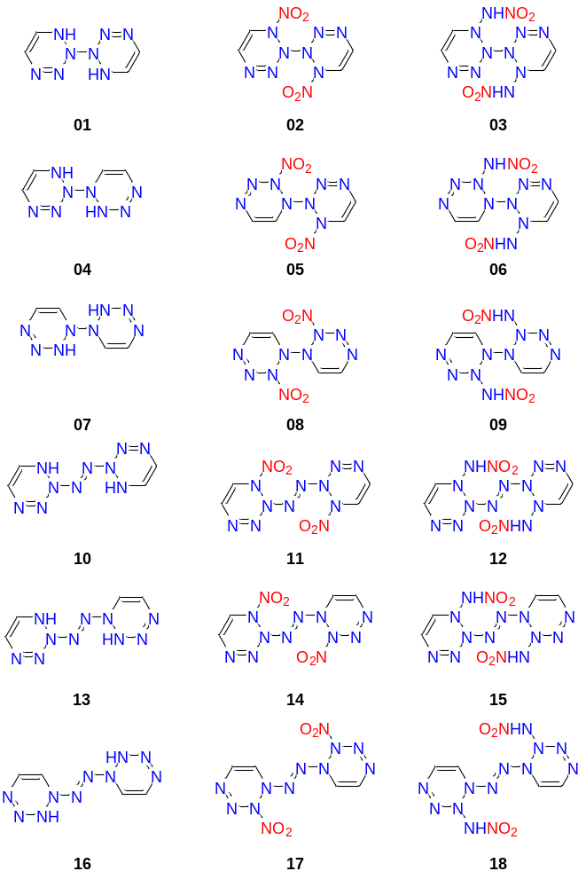

Fig. S1 Designed molecular structures of molecules 01 to 18

Table S1 Density of designed molecules 01 to 18 (at B3PW91/6-311+g(d,p) level)
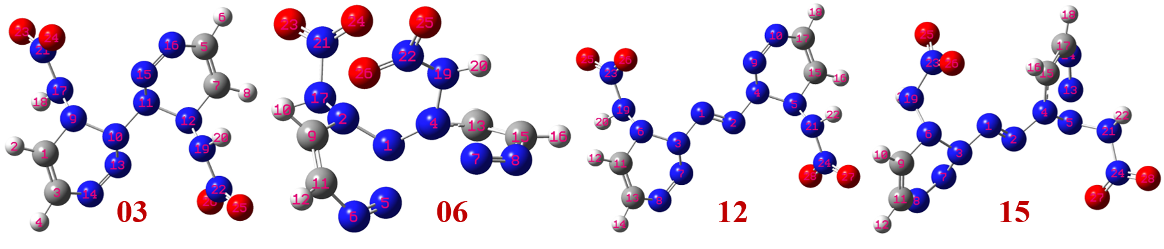
Compd. | volume [Angstrom³] | $$\frac{M}{V_{M}}$$  [g/cm³] | overall surface area  [Angstrom²] | $$vσ_{tot}^{2}$$  [(kal/mol]²] | Density ª  [g/cm³]
01 | 187.9 | 1.468 | 184.8 | 49.12 | 1.420
02 | 247.2 | 1.721 | 237.0 | 24.35 | 1.621
03 | 280.4 | 1.694 | 263.7 | 46.31 | 1.641
04 | 187.6 | 1.471 | 185.7 | 63.70 | 1.453
05 | 245.5 | 1.732 | 231.4 | 28.15 | 1.641
06 | 282.0 | 1.685 | 262.1 | 35.22 | 1.608
07 | 185.7 | 1.486 | 179.6 | 53.20 | 1.446
08 | 247.4 | 1.720 | 236.1 | 22.70 | 1.617
19 | 280.4 | 1.695 | 264.3 | 27.35 | 1.601
10 | 219.0 | 1.472 | 219.5 | 74.83 | 1.478
11 | 274.7 | 1.718 | 267.2 | 27.53 | 1.625
12 | 309.5 | 1.686 | 300.4 | 56.34 | 1.653
13 | 214.7 | 1.502 | 213.4 | 63.79 | 1.484
14 | 274.5 | 1.719 | 265.4 | 33.75 | 1.639
15 | 309.4 | 1.686 | 296.2 | 48.64 | 1.637
16 | 214.0 | 1.507 | 212.8 | 41.49 | 1.442
17 | 272.2 | 1.734 | 264.3 | 26.25 | 1.638
18 | 307.6 | 1.696 | 300.4 | 30.68 | 1.610
ª$ρ=1.0046×(\frac{M}{V_{M}})+0.0021(vσ_{tot}^{2})-0.1586$, ref: B. M. Rice, E. F. C. Byrd. J. Comput. Chem. 2013, 34, 2146-2151.
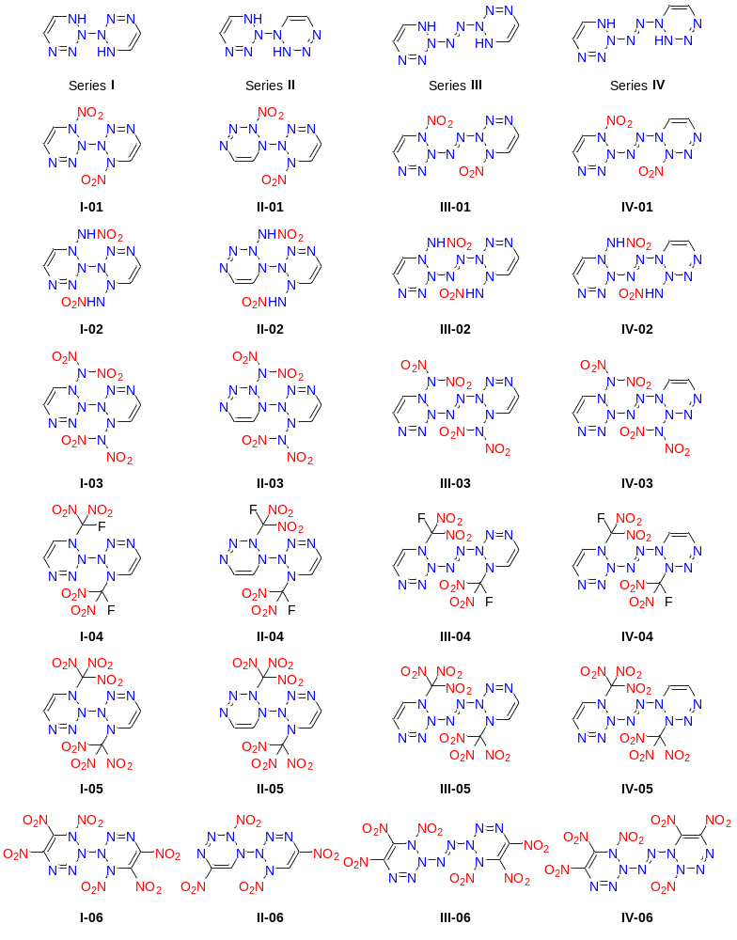

Fig. S2 Designed molecular structures of series I to IV

Table S2 Density of designed molecules series I to IV (at B3PW91/6-311+g(d,p) level)
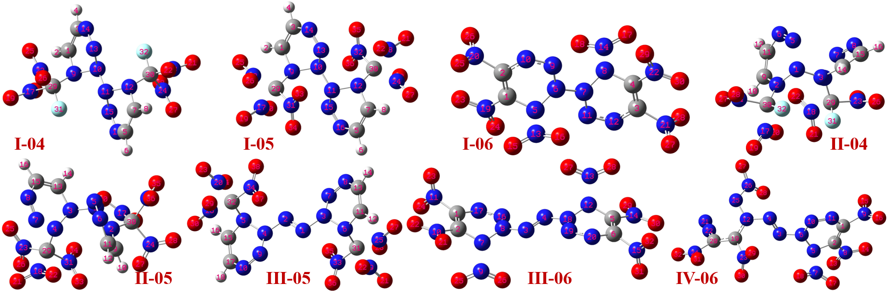
Compd. | volume [Angstrom³] | $$\frac{M}{V_{M}}$$  [g/cm³] | overall surface area  [Angstrom²] | $$vσ_{tot}^{2}$$  [(kal/mol]²] | Density ª  [g/cm³]
I-03 | 336.6 | 1.856 | 299.7 | 17.19 | 1.742
I-04 | 353.1 | 1.929 | 307.0 | 17.96 | 1.817
I-05 | 398.4 | 1.935 | 328.5 | 16.79 | 1.820
I-06 | 368.6 | 1.965 | 344.8 | 15.24 | 1.847
II-03 | 335.9 | 1.860 | 290.4 | 19.14 | 1.750
II-04 | 354.8 | 1.920 | 300.9 | 19.23 | 1.810
II-05 | 399.0 | 1.932 | 321.1 | 12.18 | 1.808
II-06 | 307.1 | 1.872 | 289.8 | 28.12 | 1.781
III-03 | 365.2 | 1.838 | 337.8 | 23.51 | 1.737
III-04 | 383.6 | 1.897 | 346.2 | 19.65 | 1.788
III-05 | 429.8 | 1.902 | 375.3 | 16.07 | 1.786
III-06 | 395.8 | 1.948 | 373.7 | 16.66 | 1.833
IV-03 | 370.7 | 1.810 | 347.0 | 28.98 | 1.721
IV-04 | 388.7 | 1.872 | 346.0 | 29.47 | 1.784
IV-05 | 434.4 | 1.881 | 377.1 | 20.14 | 1.774
IV-06 | 400.4 | 1.925 | 372.6 | 26.36 | 1.831
ª$ρ=1.0046×(\frac{M}{V_{M}})+0.0021(vσ_{tot}^{2})-0.1586$, ref: B. M. Rice, E. F. C. Byrd. J. Comput. Chem. 2013, 34, 2146-2151.

Table S3 HOMO and LUMO calculation details of designed molecules series I to IV (at M06-2X/6-311+G(d,p) level)
Compd. | HOMO |  | LUMO |  | HOMO-LUMO energy gap [eV]
Compd. |  | Energy [eV] |  | Energy [eV] | HOMO-LUMO energy gap [eV]
I-01 | 65 | -8.203 | 66 | -2.323 | 5.880
I-02 | 73 | -8.421 | 74 | -1.956 | 6.465
I-03 | 95 | -8.592 | 96 | -2.367 | 6.225
I-04 | 103 | -8.912 | 104 | -2.447 | 6.465
I-05 | 117 | -8.967 | 118 | -2.883 | 6.084
I-06 | 109 | -10.16 | 110 | -4.647 | 5.511
II-01 | 65 | -9.029 | 66 | -2.388 | 6.640
II-02 | 73 | -8.547 | 74 | -1.951 | 6.597
II-03 | 95 | -8.864 | 96 | -2.377 | 6.487
II-04 | 103 | -9.097 | 104 | -2.614 | 6.483
II-05 | 117 | -9.170 | 118 | -2.885 | 6.285
II-06 | 87 | -10.23 | 88 | -3.675 | 6.553
III-01 | 72 | -8.380 | 73 | -2.652 | 5.728
III-02 | 80 | -8.185 | 81 | -2.106 | 6.079
III-03 | 102 | -8.568 | 103 | -2.277 | 6.291
III-04 | 110 | -8.689 | 111 | -2.548 | 6.142
III-05 | 124 | -8.735 | 125 | -2.723 | 6.013
III-06 | 116 | -10.19 | 117 | -4.764 | 5.424
IV-01 | 72 | -8.624 | 73 | -2.821 | 5.803
IV-02 | 80 | -8.486 | 81 | -2.369 | 6.118
IV-03 | 102 | -8.626 | 103 | -2.491 | 6.134
IV-04 | 110 | -8.720 | 111 | -2.726 | 5.994
IV-05 | 124 | -8.819 | 125 | -3.017 | 5.802
IV-06 | 116 | -9.460 | 117 | -4.852 | 4.608

Table S4 Theoretical density values for similar nitrogen-rich molecules at different calculation level
Compd. | Chemical structure | Geometric optimization structure | Density [g/cm³]
Compd. | Chemical structure | Geometric optimization structure | Method-01 ª | Method-02 ª | Method-03 ª | Ref.
M01 | 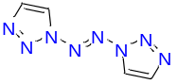 | 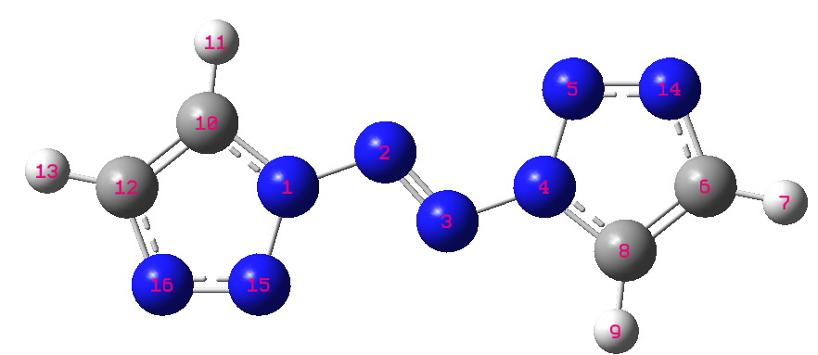 | 1.445 ^{b} | 1.453 ^{b} | 1.450 ^{b} | 1.64 ^{d}
M02 | 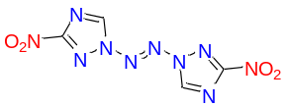 | 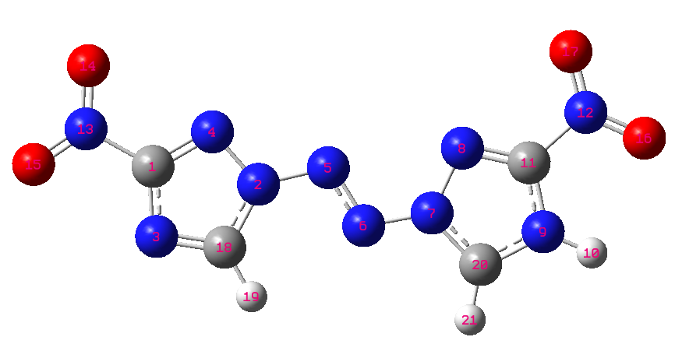 | 1.840 ^{b} | 1.845 ^{b} | 1.788 ^{b} | 1.80 ^{c}
M03 | 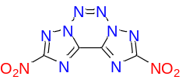 | 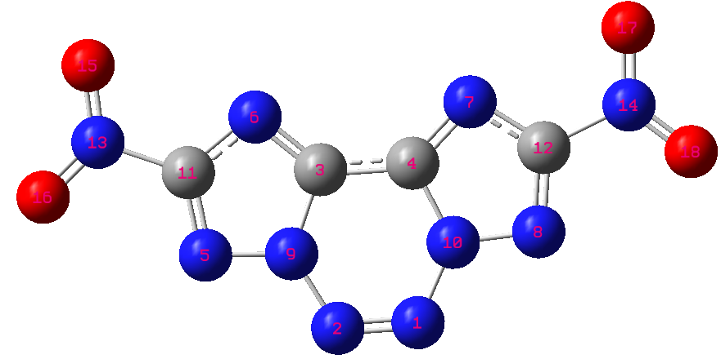 | 1.781 ^{b} | 1.791 ^{b} | 1.788 ^{b} | 1.907 e
ª Method-01: m062x/6-311+g(d,p); Method-02: wb97xd/6-311+g(d,p); Method-03: b3pw91/6-311+g(d,p)
^{b} $ρ=1.0046×(\frac{M}{V_{M}})+0.0021(vσ_{tot}^{2})-0.1586$, ref: B. M. Rice, E. F. C. Byrd. J. Comput. Chem. 2013, 34, 2146-2151.
^{c} P. Yin, D. A. Parrish, J. M. Shreeve. Chem. Eur. J. 2014, 20, 1-7.
^{d} Y. C. Li, C. Qi, S. P. Pang, et al. J. Am. Chem. Soc. 2010, 132, 12172-12173.
^{e} D. E. Chavez, J. C. Bottaro, D. A. Parrish, et al. Angew. Chem. Int. Ed. 2015, 54, 12973-12975.

Table S5 Calculation details of similar nitrogen-rich molecules M01 to M03
Compd. | Calculation method | volume [Angstrom³] | $$\frac{M}{V_{M}}$$  [g/cm³] | overall surface area  [Angstrom²] | $$vσ_{tot}^{2}$$  [(kal/mol]²]
M01 | M06-2X/6‑311+G(d,p) | 181.0 | 1.506 | 188.2 | 43.18
M01 | ωB97X‑D/def2tvzp | 180.0 | 1.514 | 187.7 | 43.29
M01 | B3PW91/6‑311+G(d,p) | 179.9 | 1.515 | 187.8 | 41.57
M02 | M06-2X/6‑311+G(d,p) | 244.0 | 1.736 | 247.1 | 121.00
M02 | ωB97X‑D/def2tvzp | 242.8 | 1.745 | 246.6 | 119.27
M02 | B3PW91/6‑311+G(d,p) | 242.7 | 1.745 | 246.9 | 91.88
M03 | M06-2X/6‑311+G(d,p) | 224.1 | 1.868 | 225.0 | 30.17
M03 | ωB97X‑D/def2tvzp | 223.1 | 1.877 | 224.6 | 30.55
M03 | B3PW91/6‑311+G(d,p) | 223.1 | 1.877 | 224.8 | 29.13

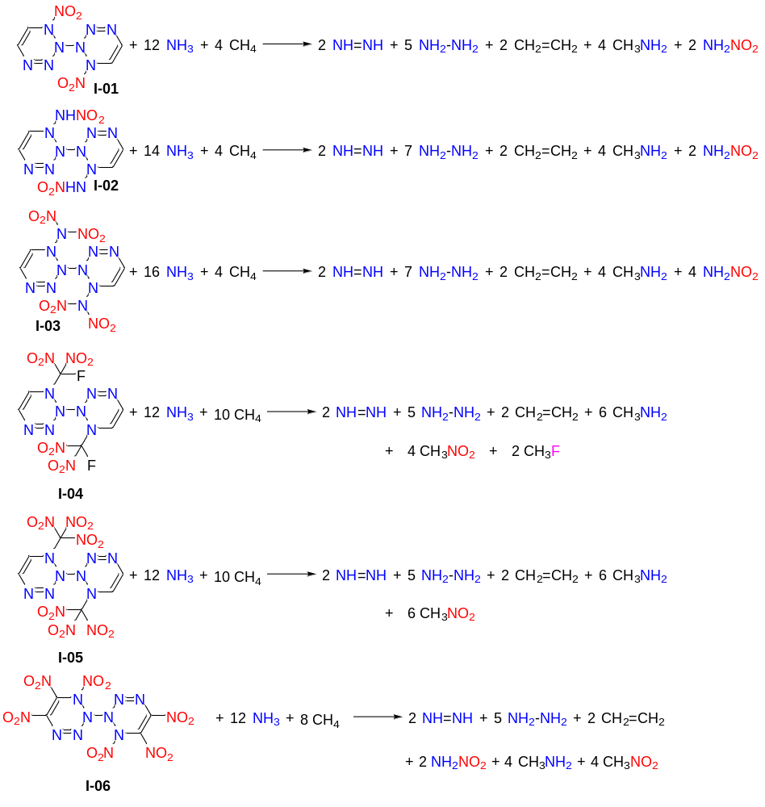
Fig. S3 Isodesmic reactions of Series I designed molecules
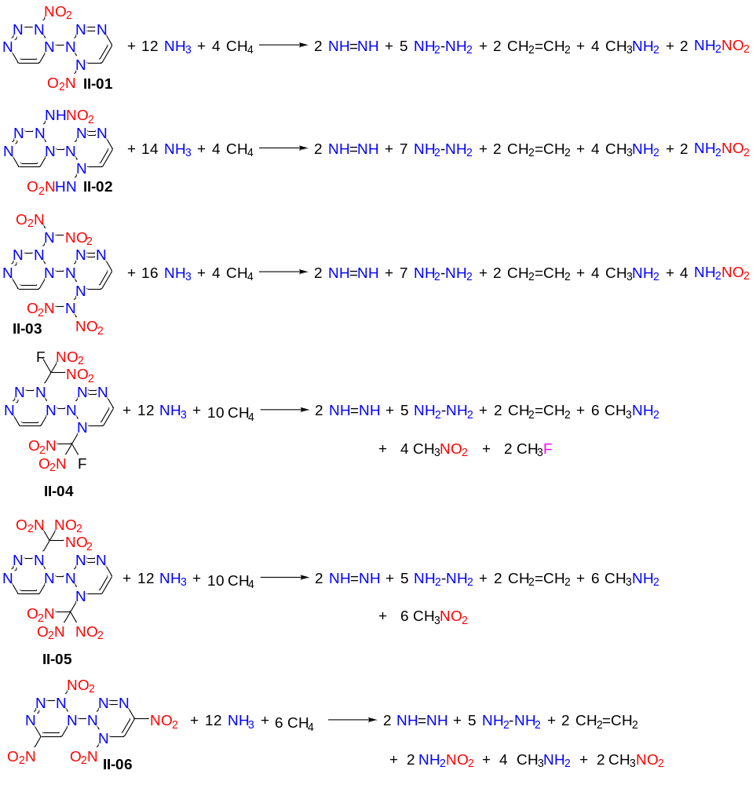
Fig. S4 Isodesmic reactions of Series II designed molecules
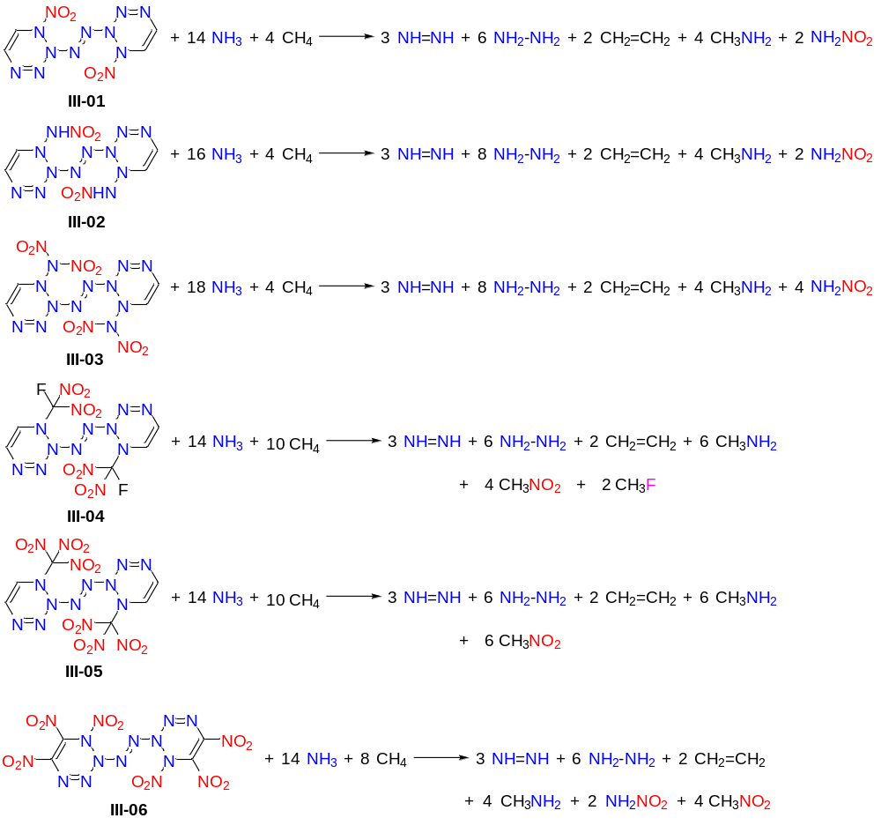

Fig. S5 Isodesmic reactions of Series III designed molecules

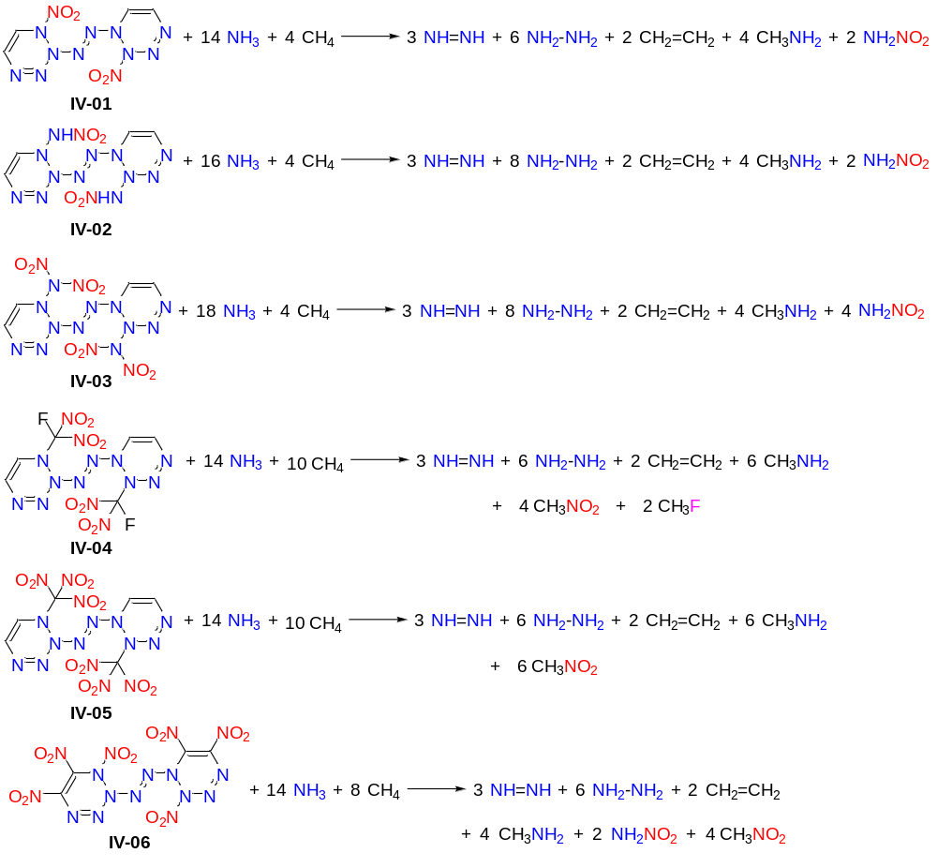

Fig. S6 Isodesmic reactions of Series IV designed molecules

Table S6 Calculation details of designed molecules series I to IV (at M06-2X/6‑311+G(d,p) level)
Compd. | Formula | M.W. | OB% | ΔH_{gas}  [kJ/mol] | ΔH_{sub}  [kJ/mol] | ΔH_{solid}  [kJ/mol]
I-01 | C₄H₄O₄N₁₀ | 256.4 | -37.44 | 1505 | 109.1 | 1396
I-02 | C₄H₆O₄N₁₂ | 286.2 | -39.14 | 1698 | 136.9 | 1561
I-03 | C₄H₄O₈N₁₄ | 376.2 | -8.51 | 1782 | 141.2 | 1641
I-04 | C₆H₄O₈N₁₂F₂ | 410.2 | -19.50 | 1096 | 146.8 | 948.8
I-05 | C₄H₄O₁₂N₁₄ | 464.2 | -6.89 | 1428 | 161.1 | 1267
I-06 | C₄O₁₂N₁₄ | 436.1 | 14.67 | 1480 | 172.0 | 1308
II-01 | C₄H₄O₄N₁₀ | 256.4 | -37.44 | 1505 | 108.8 | 1396
II-02 | C₄H₆O₄N₁₂ | 286.2 | -39.14 | 1698 | 130.0 | 1568
II-03 | C₄H₄O₈N₁₄ | 376.2 | -8.51 | 1782 | 136.7 | 1645
II-04 | C₆H₄O₈N₁₂F₂ | 410.2 | -21.45 | 1096 | 143.7 | 951.9
II-05 | C₄H₄O₁₂N₁₄ | 464.2 | -6.89 | 1428 | 151.6 | 1276
II-06 | C₄H₂O₈N₁₂ | 346.1 | -4.62 | 1492 | 142.7 | 1350
III-01 | C₄H₄O₄N₁₂ | 284.2 | -33.78 | 1848 | 128.3 | 1720
III-02 | C₄H₆O₄N₁₄ | 314.2 | -35.65 | 2041 | 164.9 | 1876
III-03 | C₄H₄O₈N₁₆ | 404.2 | -7.92 | 2125 | 173.2 | 1951
III-04 | C₆H₄O₈N₁₄F₂ | 438.2 | -18.26 | 1438 | 176.7 | 1262
III-05 | C₆H₄O₁₂N₁₆ | 492.2 | -6.50 | 1770 | 197.3 | 1573
III-06 | C₄O₁₂N₁₆ | 464.1 | 13.79 | 1822 | 196.4 | 1626
IV-01 | C₄H₄O₄N₁₂ | 284.2 | -33.78 | 1848 | 131.1 | 1717
IV-02 | C₄H₆O₄N₁₄ | 314.2 | -35.65 | 2041 | 158.4 | 1882
IV-03 | C₄H₄O₈N₁₆ | 404.2 | -7.92 | 2125 | 183.9 | 1941
IV-04 | C₆H₄O₈N₁₄F₂ | 438.2 | -18.26 | 1438 | 183.5 | 1255
IV-05 | C₆H₄O₁₂N₁₆ | 492.2 | -6.50 | 1770 | 202.1 | 1568
IV-06 | C₄O₁₂N₁₆ | 464.1 | 13.79 | 1822 | 202.7 | 1620

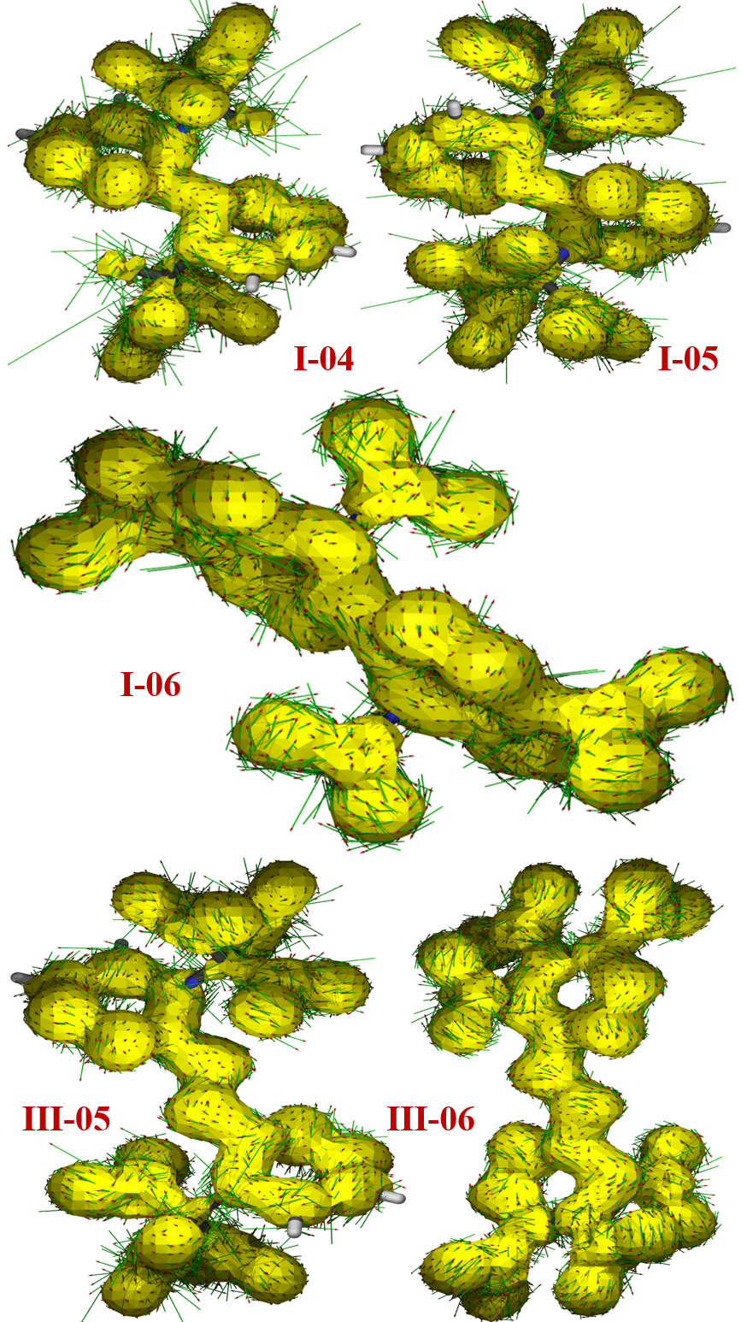

Fig. S7 AICD map of designed molecules I-04 to I-06 and III-05 to 06 at M06-2X/6-311+G(d,p) level (small arrows indicate direction and magnitude of magnetically induced currents on AICD isosurface of 0.05 a.u.)

Table S7 The AV1245 index of designed molecules I-04 to I-06 and III-05 to 06 at M06-2X/6-311+G(d,p) level
Compd. | Atom labels | 1000*AV1245 index | Multicenter bond order
I-04 | 1,3,14,13,10,9 | 12.54718780 | -5.0270527509E-02
I-04 | 1,3,14,13,10,9,11-12,7,5,16,15 | 41.36652068 | 0.0001770930
I-05 | 1,3,14,13,10,9 | 36.90338122 | 0.0034996034
I-05 | 1,3,14,13,10,9,11-12,7,5,16,15 | 32.18070531 | 0.0001387035
I-06 | 1-2,10,9,6,5 | -5.71472512 | 0.0081746099
I-06 | 1-2,10,9,6,5,7-8,4,3,12,11 | -2.77615443 | -1.6444967477E-04
III-05 | 4,5,15,17,10,9 | 17.86460394 | -4.2621950035E-02
III-05 | 4,5,15,17,10,9,2,1,3,7-8,13,11,6 | 4.32701537 | 0.0001734080
III-06 | 1-2,7-8,16-17 | 9.01640382 | -3.6047363924E-02
III-06 | 1-2,7-8,16-17,3-4,18-20,6,5,12 | 11.74862600 | -1.4773297469E-04

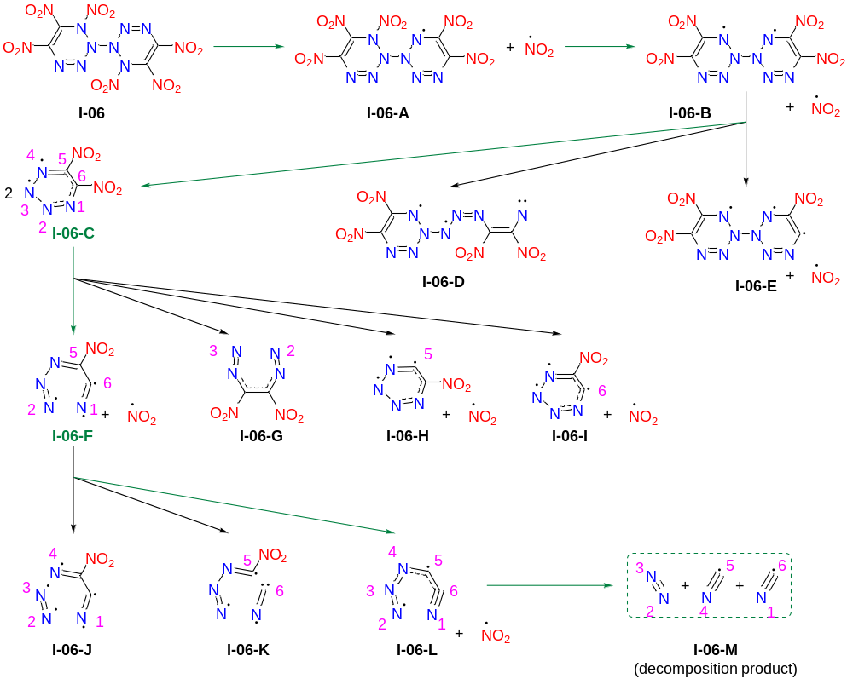

Fig. S8 Possible decomposition reaction of I06

Table S8 The coordinates of TS-01 to TS-04 (at M06-2X/def2tzvp level)
Molecule | Molecular structure | Coordinates
TS-01 | 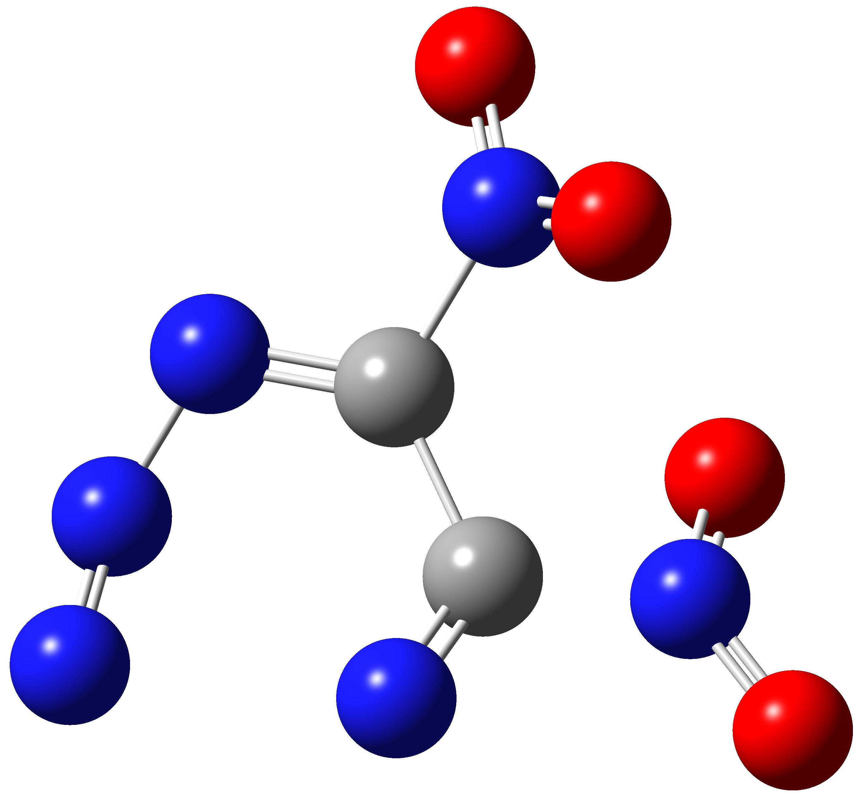 | C -0.48554900 0.46046400 -0.04661400  C 0.12560200 -0.84596300 0.29708400  N -2.72085200 -1.45647600 -0.03717700  N -0.47072600 -1.68537700 0.97027600  N -2.43204900 -0.43172600 -0.44301300  N -1.75470800 0.68945400 -0.30000200  N 0.26010000 1.69987400 0.27661100  N 1.55514300 -1.00094300 -0.31769800  O 1.01012700 1.60275000 1.24356700  O 0.07234200 2.67124600 -0.43444100  O 1.79302800 -0.16530100 -1.18873400  O 2.26216800 -1.90752600 0.06138400
TS-02 | 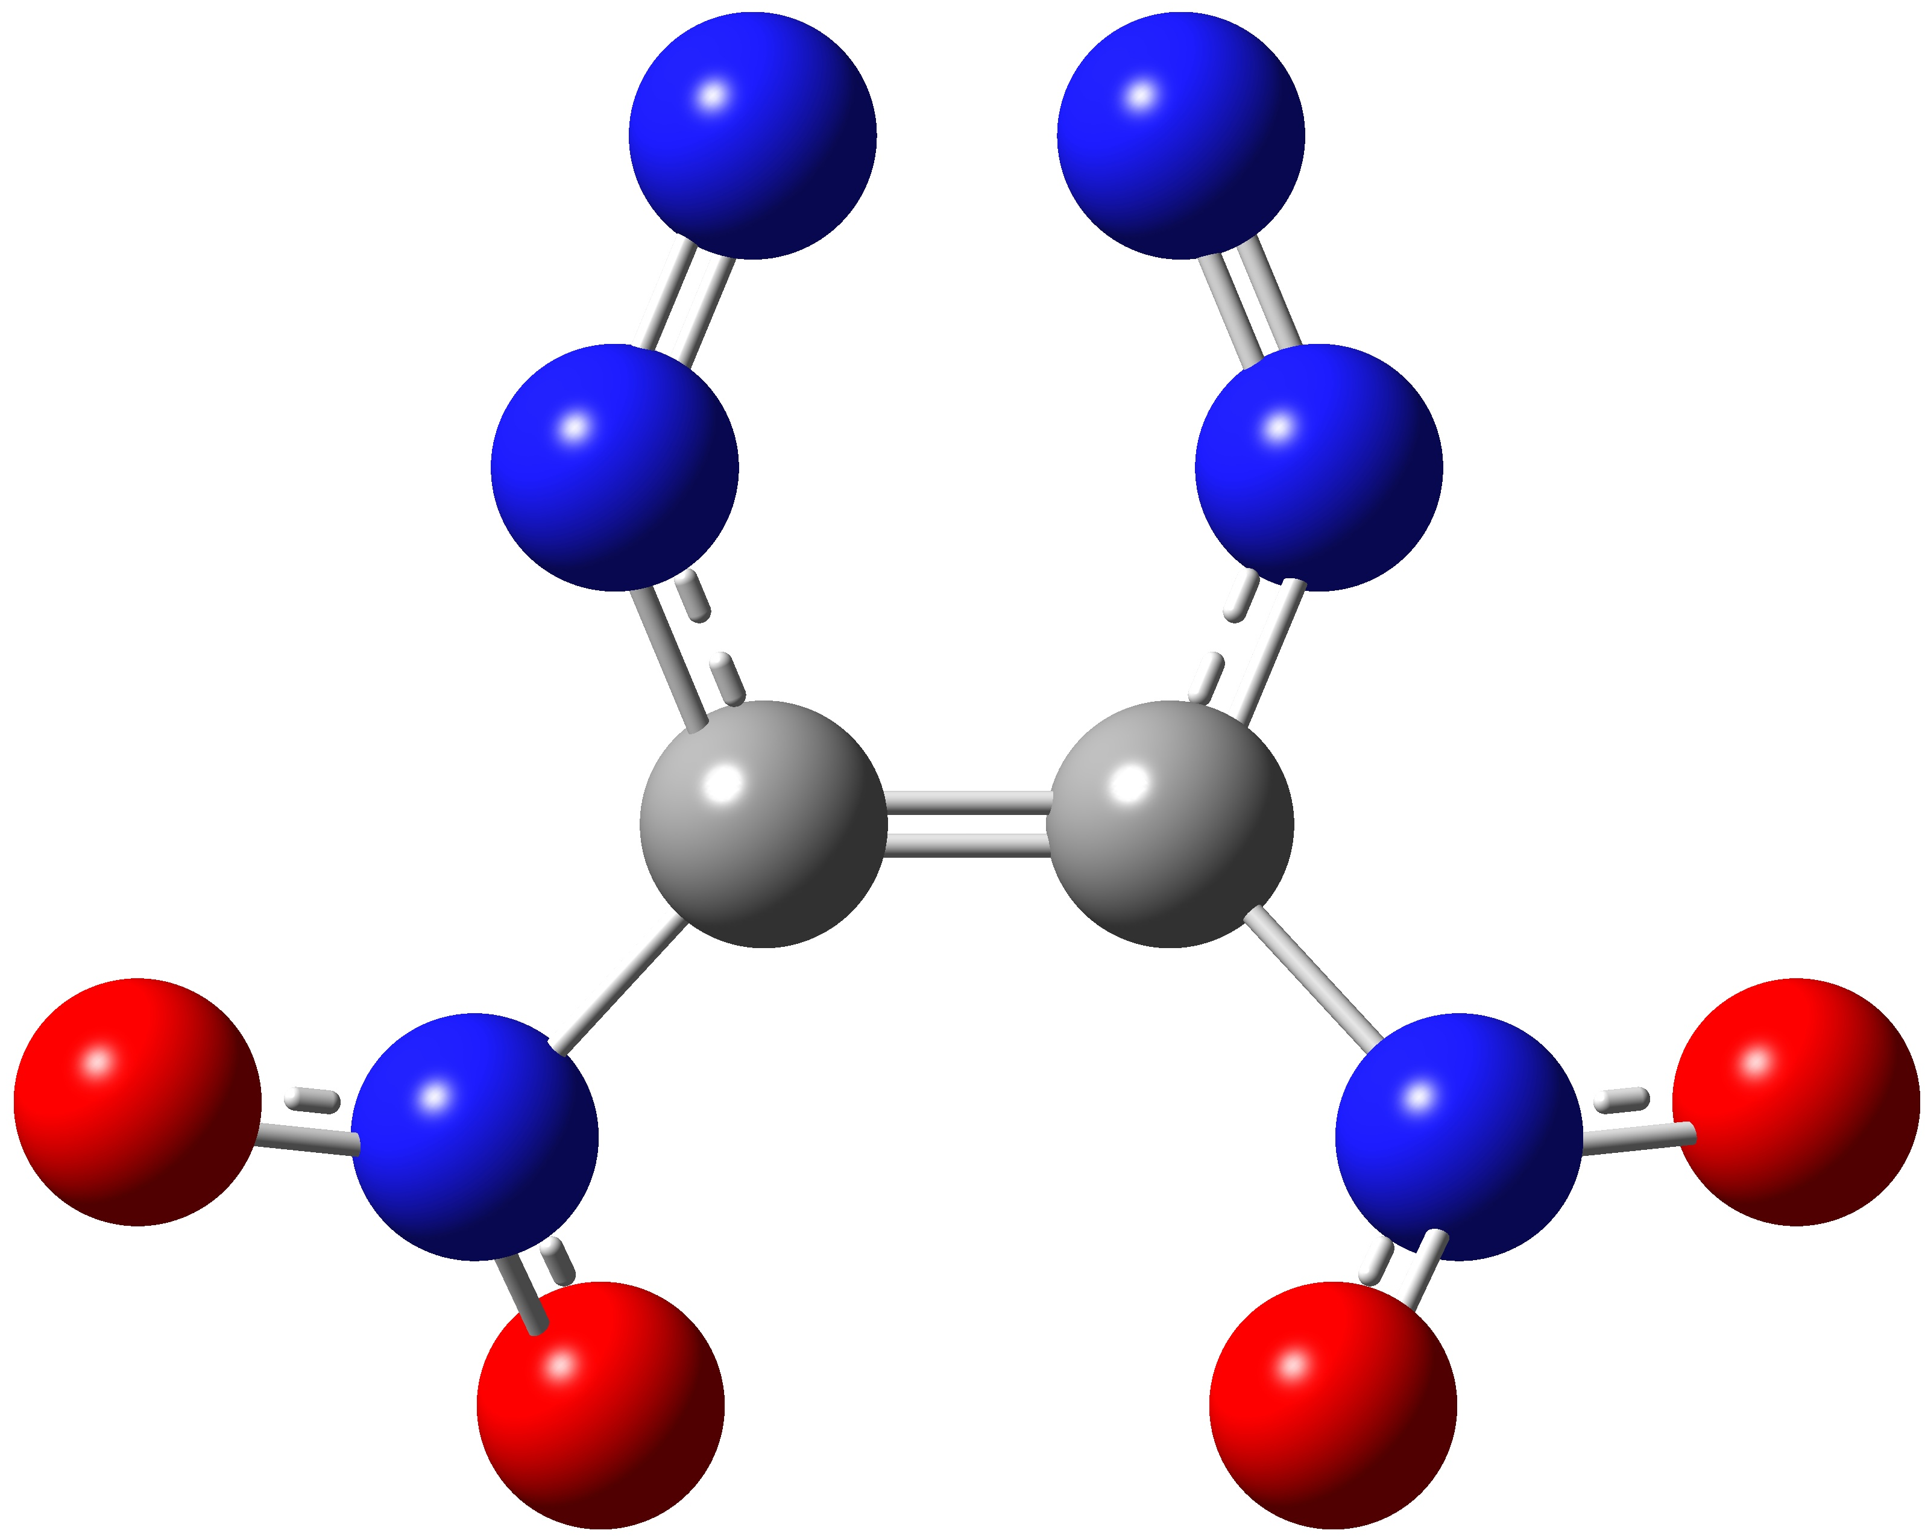 | C 0.67933100 0.13576500 -0.08051600  C -0.67932900 0.13577700 0.08050800  N -0.71606300 2.44077600 0.49347700  N -1.17748800 1.32971300 0.51298900  N 0.71611000 2.44076600 -0.49347300  N 1.17751000 1.32969300 -0.51299300  N 1.64628700 -0.91106100 0.23595900  N -1.64630300 -0.91103500 -0.23595900  O 1.22476000 -1.80951800 0.95853700  O 2.77333500 -0.79434000 -0.22901100  O -1.22479600 -1.80949800 -0.95854000  O -2.77334600 -0.79429700 0.22902000
TS-03 | 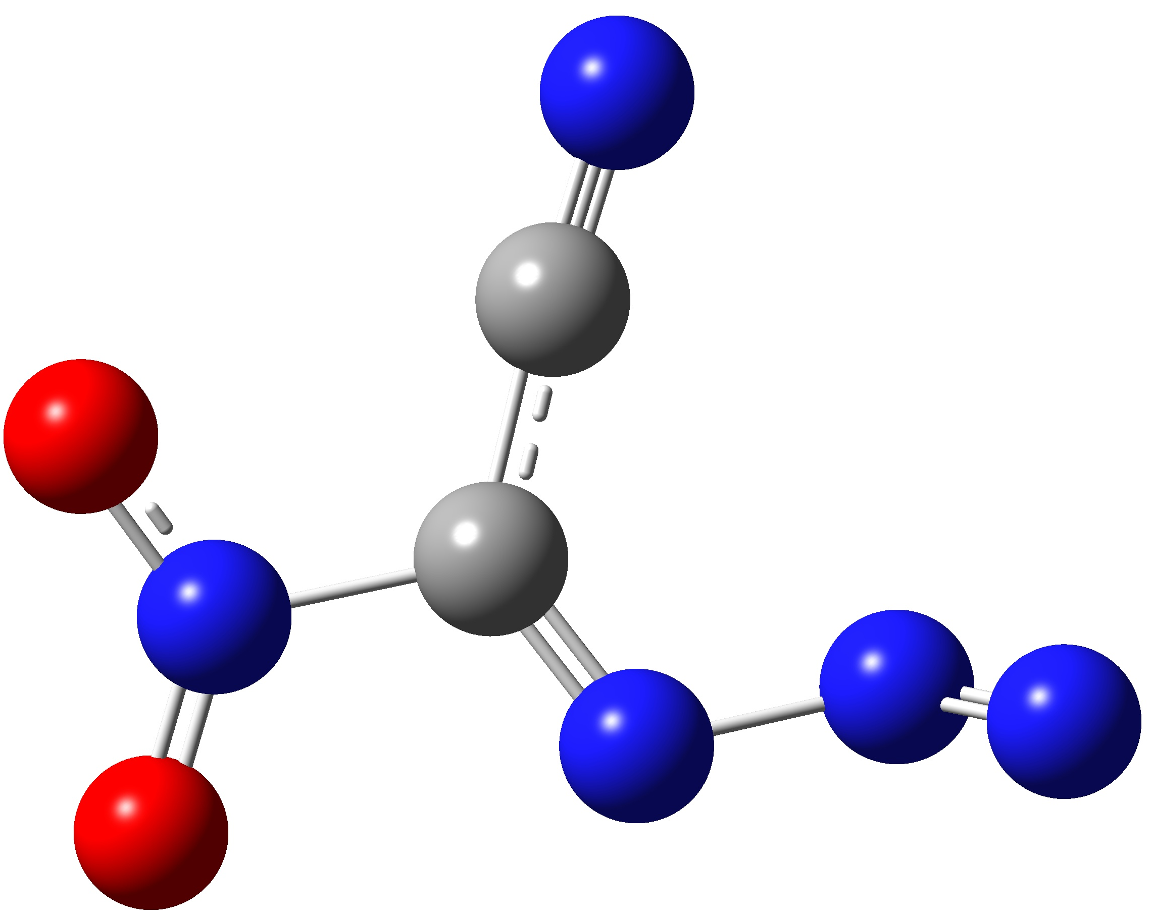 | C -0.10170300 0.00476600 -0.03512800  C 0.12800500 1.41584500 -0.06074300  N 3.02146600 -0.64193800 0.40670800  N 0.39109200 2.54713100 -0.10770100  N 2.11829700 -0.52239200 -0.32183200  N 0.74968800 -0.93923400 -0.06326400  N -1.55789300 -0.41350000 0.02830900  O -2.34169900 0.50029100 0.25771000  O -1.81034700 -1.59205900 -0.13524900
TS-04 | 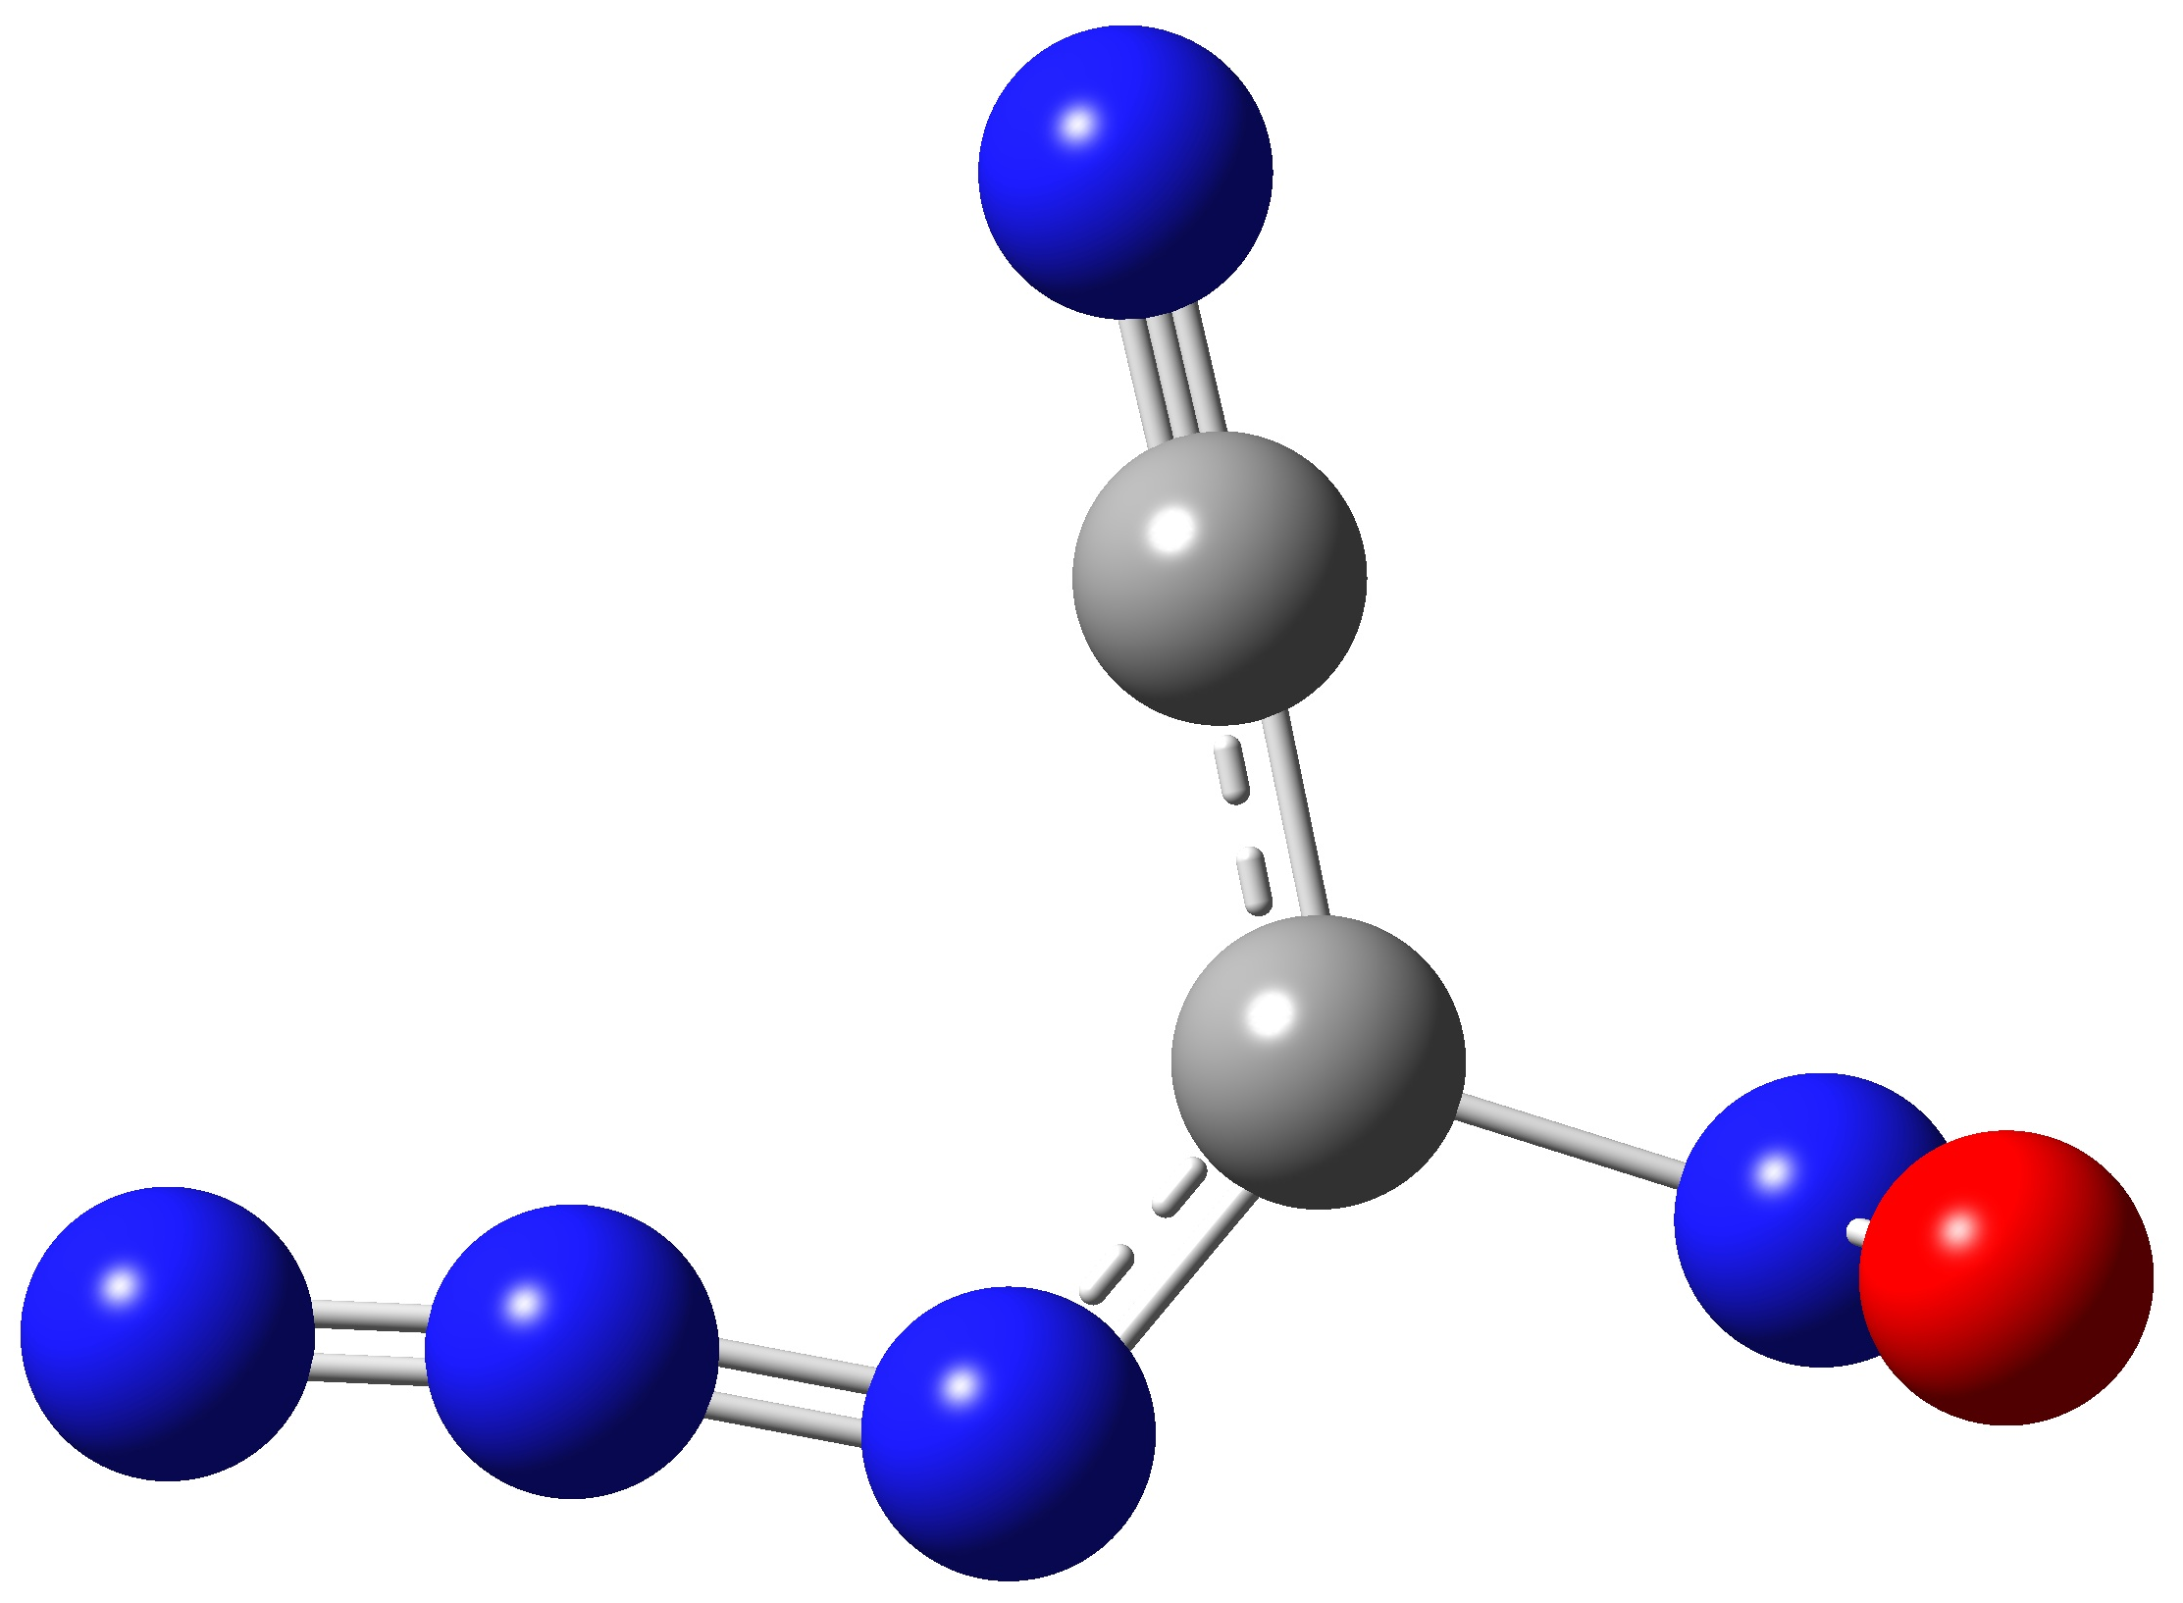 | C 0.12840800 0.08744800 0.00021400  C -0.14973700 1.44950700 -0.00026300  N -3.11025800 -0.67740600 0.00033400  N -0.41471600 2.59191700 -0.00063400  N -1.97285600 -0.72742000 0.00020900  N -0.74458100 -0.95864500 0.00001300  N 1.54377900 -0.35700400 0.00005400  O 2.06401900 -0.51915600 1.09605300  O 2.06328100 -0.52107200 -1.09599500

