Brain-like adaptive dendritic memristive networks - Supplementary Information

Fabio Michieletti^{1,‡}, Davide Cipollini^{1,‡}, Davide Pilati^{1,2}, Irdi Murataj¹, Guiseppe Leonetti¹, Gianfranco Durin¹, Carlo Ricciardi², Ilia Valov^{3,4}, Gianluca Milano^{1*}

¹Advanced Materials Metrology and Life Sciences Division, INRiM (Istituto Nazionale di Ricerca Metrologica), Turin, Italy.
²Department of Applied Science and Technology, Politecnico di Torino, Turin, Italy
³Forschungszentrum Jülich, Peter Grünberg Institute (PGI-7), Jülich, Germany
⁴Institute of Electrochemistry and Energy Systems, Bulgarian Academy of Sciences (BAS), Sofia, Bulgaria
‡ these authors contributed equally to this work

*e-mail: g.milano@inrim.it

Supplementary Section 1 - Dimethyl sulfoxide (DMSO) as solvent
Dimethyl sulfoxide (DMSO) is a relatively inexpensive, stable, and environmentally compatible aprotic solvent widely exploited for organic and inorganic synthesis due to its specific chemical and physical properties, as detailed in the following. Its dielectric constant (46.0)¹ is high enough to allow charge separation of metal salts (solubility of AgNO₃ in DMSO is 130 g/100 ml)² and consequently, to solubilize a wide variety of weakly polar and polarizable molecules. The low viscosity of DMSO (1.948 cP) and its lower volatility (boiling point is at 189 °C)³ when compared to water, contribute to a good discharge–charge behavior and therefore can be exploited as an electrolytic solvent in non-aqueous lithium–based³ and zinc-based⁴ batteries as well as Ag-DMSO dynamic windows.⁵ Although Ag dendrites are generally grown via electrochemical process of aqueous electrolytic solutions,^{6,7} water as an electrolytic solvent has its major drawback in terms of electrochemical stability window (ESW) limited to 1.23 V at 25 °C above which, electrolysis of water into hydrogen and oxygen gases occurs (this has generally limited the voltage of aqueous batteries to ⩽1.5 V).⁸ On the other hand, replacing water with DMSO as the solvent for AgNO₃ significantly expands the ESW (-2.9 V to +1.5 V).⁴ This translates into a broader usable potential range where the solvent is sufficiently stable to not generate undesired reactive species that might interfere with the intended reaction. In DMSO, the anodic and cathodic limits are determined by Ag oxidation and reduction respectively,⁹ while avoiding any hydrogen and oxygen gases production from water electrolysis. Moreover, DMSO is employed as a host liquid for dynamically reconfigurable platforms of self-ordered micro- and nano-objects, guided wiring networks and liquid coupling oscillators thanks to its low electrical conductivity while providing high ion mobility and tuning of the electrolyte properties by adding additives.¹⁰

Supplementary Section 2 - Electrochemical principles of dendritic growth
Silver dendrite growth/dissolution on gold electrodes is governed by electrochemical reduction/oxidation of silver ions/atoms.
Unipolar voltage growth
In the simplest case, when a negative constant potential is forced between an electrode and the electrolyte, silver ions in the solution are reduced on the metallic surface (Ag⁺ + e⁻ → Ag) thanks to the induced reduction reaction barrier lowering. After the formation of initial silver nanoparticles, the dendritic structure is demonstrated to origin from the interplay between two phenomena:¹¹ crystallographic preferential attachment (Ag⁺ ions tend to favorably attach to the (111) crystal faces) and diffusion limited aggregation (DLA).¹² In detail, the reduction of Ag⁺ is a diffusion limited reaction in this system:¹³ the diffusion of Ag⁺ ions in the electrolyte is slow compared to the reaction rate, causing the gradual depletion of Ag⁺ in the electrolyte area near the growing surface. In this condition, Ag⁺ diffusion from bulk solution across the depleted region is necessary for allowing successive reduction. Being the diffusion a stochastic process, the probability to reach silver protrusions is higher, not preventing the nucleation of new ones. This phenomenon, in addition to crystallographic preferential attachment and the higher electric field here established, favors the growth of initialized branches. As a result, 3D dendritic structures are formed in these conditions.
Unipolar voltage dissolution
Under the application of positive constant potential, silver atoms are redissolved in the electrolyte (Ag → Ag⁺ + e⁻). Although a higher electric field is established on dendrites tips, dissolution is observed across the whole surface.¹⁴ As a result, thinner regions of the structure are fully dissolved first, causing the detachment of metal islands (dead metal) that are electrically disconnected from the electrode.¹³
Bipolar voltage growth
By applying a voltage between two electrodes in a two-terminal fashion and without a reference electrode, each terminal acts as a virtual reference for the other one, placing the electrolyte potential at an intermediate value. Consequently, growth (reduction) on one side is always coupled with dissolution (oxidation) on the other side and vice versa. By continuously reversing the applied voltage in a square wave form, dendrites form and partially dissolve on both sides. The processes are not symmetrical due to stochasticity of the growth, surface thinning and formation of dead metals (as detailed above). Dissolution moreover tends to suppress the vertical growth due to electropolishing of protrusions¹⁵ and preferential directional formation between the electrodes arises, where the electric field progressively increases due to distance reduction. Furthermore, dead metal islands in the solution tend to attach to bigger structures due to Ostwald ripening,¹⁶ attaching with higher probability to regions in between the electrodes where most of the dendrites are located, eventually favoring the bridging.

Supplementary Section 3 - Modeling
The model here developed constitutes a two-dimensional lattice-based framework for electrochemical dendrite growth in a planar electrolyte solution, under the influence of multiterminal electrical signals. The system is defined on a square lattice of spacing $Δx$ with diagonals ($Δx\sqrt{2}$). Two scalar fields, the electric potential $v(x,y)$ and an adimensional ion concentration $c(x,y)$, govern the redox of the ions at the interface delimiting the ionic solution and the dynamically growing metal clusters. The electric potential $v$ imposed by the forcing electrodes is assumed to propagate instantaneously and its spatial distribution is computed solving the Laplace equation $∇^{2}v=0.$
The solution is derived with red-black Gauss-Seidel SOR iterative method, with Dirichlet conditions on the electrode potentials and on the aggregated metal. Furthermore, von Neumann boundary conditions are implemented to confine the electric field within the simulation domain.
The dimensionless ion concentration field in the electrolyte $c(x,y)$ is typically governed by one of the following two factors, or a combination of them: the migration due to the field and the diffusion-limited ionic transport. Our model exclusively incorporates the latter mechanism as our focus rests on the diffusion-limited experimental regime.
In the absence of redox events, the concentration field obeys the diffusion equation ${∂_{t}c(x,y)=D∇}^{2}c(x,y)$ in the electrolyte domain. When redox events occur, these diffusive dynamics are coupled to mass-conserving discrete, localized source and sink terms associated with oxidation and reduction, respectively. The numerical implementation treats these contributions via operator splitting, i.e, redox source/sink updates are applied separately from diffusion. Specifically, reduction consumes ionic mass locally and from neighboring electrolyte pixels, after which the updated concentration field evolves by an implicit diffusion step.
The initial concentration is set to an adimensional value $c_{0}=1.$ To emulate the infinite reservoir of ions provided by the electrolyte drop, the external electrolyte borders surrounding the in-silico system are kept fixed at $c_{0}=1$.
The details of the reaction-diffusion are described in the next paragraphs.
Redox probability
A redox event is allowed only on those sites that are at the interface between the growing metal cluster and the electrolyte. In a redox event a lattice site is converted from electrolyte to metal (reduction) or from metal to electrolyte (oxidation).
The redox rate is modeled as an activated function of the effective voltage difference, $k=k_{0}(e^{max(0, (Δv-v_{th})/v_{scale})}$- 1), and the event probability over one timestep $Δt$ is $P=1-e^{-kΔt}$, corresponding to an independent Poissonian process at each eligible interfacial site. The threshold $v_{th}$​ effectively selects the portion of the interfacial voltage-difference distribution that contributes to redox activation. Sites below threshold are suppressed, whereas sites above threshold acquire a finite reaction rate. The present model should therefore be regarded as an interfacial kinetic model of redox activation, where the electric field enters the reaction rule through local metal–electrolyte voltage differences at candidate interfacial sites, rather than through an explicit description of field-driven ionic transport in the electrolyte bulk. Since the model does not explicitly include Nernst corrections to the interfacial voltage drop or field-driven ionic migration in the electrolyte bulk, $v_{th}$ should be understood as an effective phenomenological threshold that also absorbs these unresolved contributions.
For a reduction, $Δv\left(x,y\right)=v_{el}\left(x,y\right)- {<v}_{met}>$ is the difference between the candidate electrolyte site electric potential $v_{el}(x,y)$ and the average potential of the adjacent metal sites, where $<ᐧ>$ denotes the average over the metal sites that are neighbours of the candidate site. For an oxidization, that is a metal site converting into an electrolyte site, the symmetric formula is defined: $Δv(x,y)=v_{met}(x,y)- <v_{el}>$, where this time $<ᐧ>$ indicates the average over electrolyte sites that are neighbours of the candidate. We hold symmetric the threshold $v_{th}$ for both redox processes.
Diffusion-limited shortage of ions at the electrode interfaces is taken into account through a kinetic limiting factor in the final reduction probability, $P_{red}= \left(1-e^{-kΔt}\right)\frac{c(x,y)^{β}}{1+c(x,y)^{β}}$ , where $c(x,y)$ is the concentration field at the candidate site $(x,y)$. No such factor is included in the oxidation probability as abundance of ions is a negligible mechanism for the oxidation process when the system is outside a saturated concentration regime, which we exclude in our experimental setting.
Reaction-diffusion scheme
In the reaction-diffusion implementation, oxidation events are collected first. When a metallic site is selected for oxidation, the mass stored in the metallic bookkeeping field at that site is instantaneously transferred back to the concentration field at the same spatial position, and the site is reclassified as electrolyte. Note that at this stage the released mass has not yet diffused in the electrolyte, but it becomes part of the mobile concentration field for the subsequent concentration update.
After oxidation, reduction events are collected and the newly reduced pixels are immediately reclassified as metallic sites. Nevertheless, the progressive aspect of the reaction-diffusion scheme concerns the ionic mass required to complete the reduction event.
In this sense, we model the reduction as the progressive growth of a coarse-grained metallic site of size $Δx$ during the morphological time step $Δt$. The implementation relies on sub cycled reaction-diffusion steps, such that it allows the reduction process to be progressively supplied by the surrounding electrolyte. First, any concentration already present at the newly reduced pixel is transferred locally to the metallic bookkeeping field, up to the required amount. Any remaining demand is then supplied progressively from the surrounding electrolyte during the sub cycled reaction-diffusion update.
During this sub cycled stage, the lattice is kept fixed. At each sub step, every newly reduced metallic site acts as a scheduled mass-conserving discrete sink on its first-neighbors electrolyte pixels, while the newly metallic pixel itself is excluded from the mobile electrolyte domain. After this local consumption step, the concentration field evolves by diffusion over the sub step. Therefore, ions released by oxidation earlier in the same morphological step are included in the concentration field and can diffuse during these sub steps, unless they are consumed by nearby reduction sinks. A more detailed description follows.
Let $i$ denote a newly reduced site and let ${N_{i}}^{(el)}$ be the set of its neighbouring electrolyte pixels.
First, the initially present concentration $c_{i}$ in a pixel selected for reduction is treated as a local contribution to the coarse-grained reduction event. This local amount is instantaneously transferred from the concentration field to the metallic mass bookkeeping field at the same spatial position. Therefore, only the residual amount ${D_{i}}^{neigh}=max(0, γ-c_{i})$ has to be supplied by the neighbouring electrolyte.
The consumption from neighbouring electrolyte is then distributed over $N_{sub}$​ sub steps. At sub step $n$, the scheduled cumulative amount to be consumed from the neighbours is
${S_{i}}^{(n)}=\frac{n+1}{N_{sub}}{D_{i}}^{neigh},$ where $n∈[0, N_{sub}-1]$.
Since earlier sub steps may consume less than scheduled because of local depletion, the missing amount is carried over. Therefore, if the cumulative amount already supplied by the neighbouring electrolyte is ${G_{i}}^{(n)}=\sum_{p=0}^{n-1}{ }{g_{i}}^{(p)}$, the demand at substep $n$ is ${d_{i}}^{(n)}=max(0,{S_{i}}^{(n)}-{G_{i}}^{(n)}).$
To ensure that the total requested amount never exceeds the residual target, this demand is also capped as ${d_{i}}^{(n)}←min({d_{i}}^{(n)}, {D_{i}}^{neigh}-{G_{i}}^{(n)}$).
The amount that can be requested from the neighbouring electrolyte is bounded by the available concentration, ${A_{i}}^{(n)}=\sum_{j ∈{N_{i}}^{(el)}}^{ }{ }{c_{j}}^{(n)}$ so that the target removal at that substep is ${m_{i}}^{(n)}=min{(d_{i}}^{(n)}, {A_{i}}^{(n)})$.
This amount is distributed among the neighbouring electrolyte pixels proportionally to their current concentration:
${q_{ij}}^{(n)}={m_{i}}^{(n)}\frac{{c_{j}}^{(n)}}{{A_{i}}^{(n)}}$, where $j∈{N_{i}}^{(el)}$ and for ${A_{i}}^{(n)}>0$.
If an electrolyte pixel $j$ is shared by multiple newly reduced sites, the total requested removal from that pixel is capped so that the concentration never becomes negative.
Because the same electrolyte pixel can neighbour multiple newly reduced sites, several sinks may request concentration from the same pixel. We therefore define ${Q_{j}}^{(n)}=\sum_{i}^{ }{ }{q_{ij}}^{(n)}$ as the total requested removal from electrolyte pixel $j$ at substep $n$, obtained by summing all individual requests ${q_{ij}}^{(n)}$​ over the newly reduced sites $i$.
The actual removed amount is ${r_{ij}}^{(n)}={q_{ij}}^{(n)}min(1, \frac{{c_{j}}^{(n)}}{{Q_{j}}^{(n)}})$, for ${Q_{j}}^{(n)}>0$. If ${Q_{j}}^{(n)}$= 0, then ${r_{ij}}^{(n)}=0$.
The removed amount ${r_{ij}}^{(n)}$ is thus obtained by rescaling the ideal request ${q_{ij}}^{(n)}$​ whenever multiple sinks over-request the same electrolyte pixel. The multiplicative factor $min(1, \frac{{c_{j}}^{(n)}}{{Q_{j}}^{(n)}})$ leaves the request unchanged when enough concentration is available and proportionally reduces all requests from pixel $j$ when the total requested amount ${Q_{j}}^{(n)}$ exceeds its available concentration $c_{j}$. This guarantees non-negative concentration while preserving the relative weights of the competing sinks.
After the sink update, the concentration at the neighbouring electrolyte pixels is decreased by the total amount removed from them.
The amount effectively consumed by each newly reduced site is accumulated as ${g_{i}}^{(n)}=\sum_{j∈{N_{i}}^{(el)}}^{ }{ }{r_{ij}}^{(n)}.$
The additional mass removed from the neighbouring electrolyte during the sub steps is accumulated and added to the same metallic bookkeeping field that already stores the local contribution transferred at the beginning of the reduction event.
Between consecutive sink applications, the intermediate concentration field ${c_{j}}^{(n, +)}={c_{j}}^{(n)}-\sum_{i}^{ }{ }{r_{ij}}^{(n)}$ evolves by a Backward Euler diffusion step of duration Δ$t/N_{sub}$ on the electrolyte domain, with no-flux conditions at metal/electrolyte interfaces and fixed concentration $c_{0}=1$ at the outer electrolyte reservoir.
Note that while oxidation is treated as an impulsive event the reduction is implemented through sub cycling steps. This choice reflects the fact that oxidation locally liberates material already stored in the metal phase, whereas reduction requires the progressive supply of reactant from the surrounding electrolyte.
Interpretation of $γ$
We interpret $γ$ as the total amount of reactant required to complete the newly reduced coarse-grained metallic pixel over the morphological interval $Δt$. This interpretation is appropriate because one lattice site is a micrometric coarse-grained cell, rather than an elementary atomic or molecular reduction event. In this framework, the concentration initially present in the selected pixel contributes locally to the event, while the remaining demand must be supplied by the neighbouring electrolyte during the reaction-diffusion sub steps.
Numerically, this motivates a sub cycled reaction-diffusion update in which the lattice is held fixed after the morphological event, and the residual consumption is applied progressively over several concentration sub steps interleaved with diffusion over $Δt/N_{sub}$​. We selected $N_{sub}=100$ to resolve the competition between interfacial consumption and diffusive replenishment within one morphological time step. The total amount actually consumed by each site can be smaller than $γ$ if the local contribution and the neighbouring electrolyte cannot supply enough reactant during the timestep.
In our nondimensional formulation, $γ$​ is interpreted as the number of bulk-equivalent electrolyte cells consumed by one coarse-grained reduction event. Since the microscopic stoichiometry associated with the conversion of a micrometric lattice cell is not explicitly resolved, $γ$ is treated as a phenomenological coarse-graining parameter. Values of order $γ∼1$ correspond to consuming a mass comparable to that contained in one electrolyte cell at the reference concentration $c_{0}=1$. Larger values represent events whose growth must be sustained by diffusive supply from the neighbouring electrolyte during the morphological time step.
Spatiotemporal scales of the reaction-diffusion process
The use of sub-cycling the reaction-diffusion process takes origin from the following argument. The pixel size, $Δx$, is typically set in the range 1−1.5 μm in our simulations to balance computational cost and morphological detail. Using a one-dimensional estimate along one lattice direction, this spatial discretization defines a diffusive time scale, which can be estimated as $τ_{diff}(Δx)∼Δx^{2}/(2D)$ , where $D$ is the diffusion coefficient of Ag⁺ in DMSO which can be set to $D=2.9×10^{-10}m^{2}/s$.^{17,18} This gives $τ_{diff}≈1.7 ×10^{-3}s$ for $Δx=1 μm$, or for $τ_{diff}=3.9×10^{-3}s$ for $Δx=1.5 μm$ which is the upper limit we consider to still provide a sufficient morphological detail. Therefore, the characteristic time required for concentration perturbations caused by a redox to relax over one lattice spacing is much shorter than the morphological time step used in the simulations, $Δt=0.2 s$. Equivalently, during a single morphological time step, diffusion can redistribute concentration over a length scale of order $l_{D}∼\sqrt{2DΔt}≈10.8 μm$, corresponding to several lattice pixels. Therefore, local depletion generated at the metal/electrolyte interface is significantly smoothed within one morphological update. Indeed, smaller time steps $Δt$ can be used but at the cost of significantly slowing down the process, especially over the experimentally relevant time scales considered here. By subcycling the reaction-diffusion dynamics within each morphological step, we separate the slower morphological update, during which the coarse-grained metallic structure evolves, from the faster concentration dynamics required to resolve the depletion and redistribution of ions in the electrolyte.
Electrical double layer
The electrical double layer dynamically modulates the effective voltage as seen by the electrolyte, that is the boundary conditions imposed to solve the Laplace equation in a time step.
Each wetted metallic site is represented by a parallel resistor-capacitor circuit connected in series with a resistance, which terminates at an electrolyte node. The potential of this node, $V_{ref}$(t), serves to couple the wetted metallic sites. $V_{ref}$(t) is taken at each time step as the average potential $v$ on the electrolyte sites. The conservation of charge is used to solve the voltage drop ${V_{i}}^{(C)}$ on each capacitor of the wet sites, $\sum_{i}^{ }{ }I_{i}=\sum_{i}^{ }{ }C_{i}\frac{d{V^{(C)}}_{i}}{dt}=0$. In the numerical implementation, the time derivative is discretized over the simulation time step $Δt$.
We conclude this section by noting that the model incorporates the formation of dead metals, defined as metal islands that are not in electrical contact with the electrodes. These clusters are treated analogously to floating electrodes, and their potential is set equal to the average potential of the surrounding electrolyte as Dirichlet conditions for solving the Laplace equation with the iterative red-black Gauss-Seidel SOR method (see Methods in the main text).

Supplementary Section 4 - Tuning isotropic or directional growth dynamics.
Experimental results show that it is possible to tune the balance between isotropic and directional growth depending on the applied voltage amplitude. By considering the same growth conditions (in terms of electrolyte concentration, pulse length, etc.), a more directional growth can be promoted by increasing the applied voltage amplitude. An example is reported in Figure S1 where it is possible to observe the transition from a nearly isotropic growth by applying a stimulation with amplitude of 1V to a more directional growth by applying a stimulation amplitude of 3.5 V.
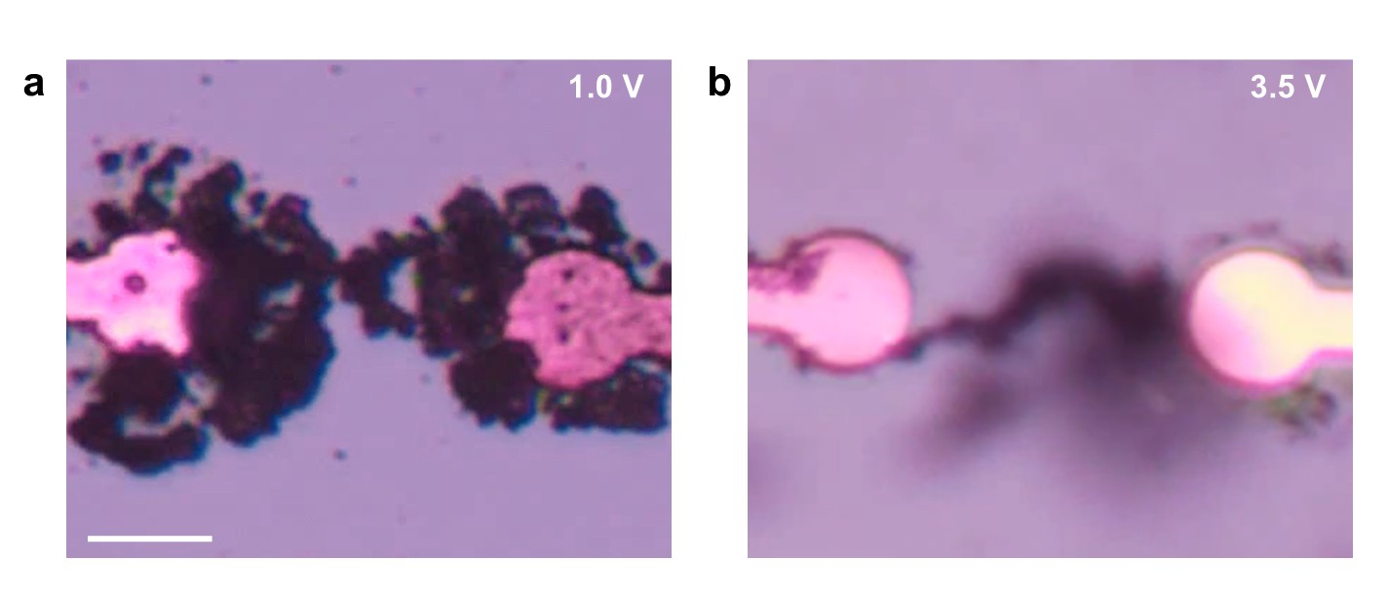
Figure S1 | Effect of applied voltage on directional growth dynamics. a. Nearly isotropic dendritic growth under stimulation with voltage pulses with amplitude of 1V and b. More directional dendritic growth obtained with voltage pulses with amplitude of 3.5 V. Results were obtained by considering electrolyte solution of AgNO₃ in DMSO with 50 mM concentration, input pulses of 200 ms width and null inter-pulse time (scale bar, 10 μm).

Supplementary Section 5 - Effect of AgNO₃ concentration on dendritic growth
The AgNO₃ concentration in the electrolyte solution influences, besides the time to connection, also dendritic growth dynamics, resulting in dendrites with different morphologies. Figure S2 reports optical images acquired when the first connection in between dendrites is established (the relative time to connection is reported in Figure 1e), for AgNO₃ concentration from 1 mM to 200 mM.
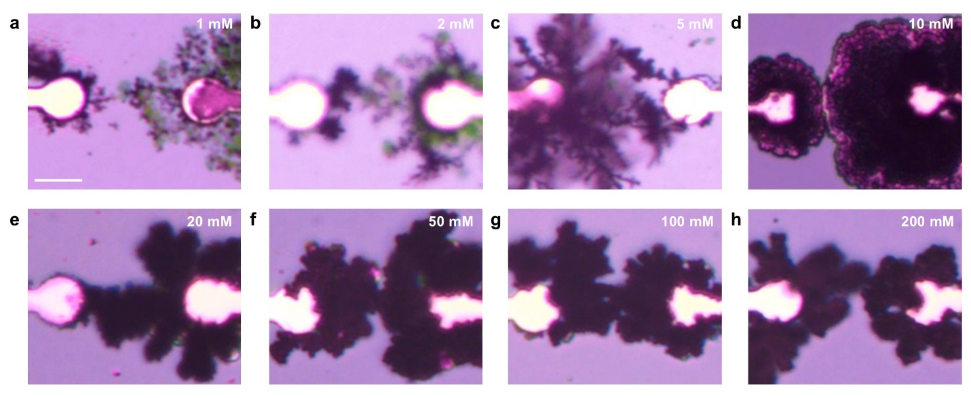
Figure S2 | Effect of AgNO₃ concentrations on dendrite morphology. a-h. Snapshots of the optical microscope real-time recordings acquired at the time of connection for the solution with salt concentration from 1 mM to 200 mM. Results were obtained with input pulses of 1.5 V amplitude, 1 s width and time inter pulse of 2 s (scale bar, 10 μm).

Supplementary Section 6 - Effect of inter-pulse time on dendritic growth
Increasing the inter-pulse time in between bipolar pulses results in a net reduction of the energy provided to the system, leading to a reduced number of redox reactions for units of time. Consistently, our experimental and modeling results show an increase of the time-to-connection by increasing the inter-pulse time. While the above-mentioned aspect is considered to be dominant in our working conditions, it is worth remarking that the inter-pulse time can also affect i) the electrical double layer charging dynamics and ii) the reorganization of the local Ag⁺ concentration in non-trivial ways since the absence of an applied potential permits the electrolytic solution to evolve towards equilibrium.

Supplementary Section 7 - Dendritic connection obtained through ms voltage pulses
Electrochemical dendritic growth and connection can be triggered by fast symmetric voltage pulses, up to the 10 ms time scale, as shown in Figure S3 for a 0.1 M solution of AgNO₃ in DMSO. Here, a symmetric input square wave with voltage amplitude of 2.5 V and 10 ms pulse width (Figure S3a) triggers a dendritic connection in ~ 30 s, resulting in a steep conductance increase (Figure S3b) with a morphological directional growth (Figure S3c).
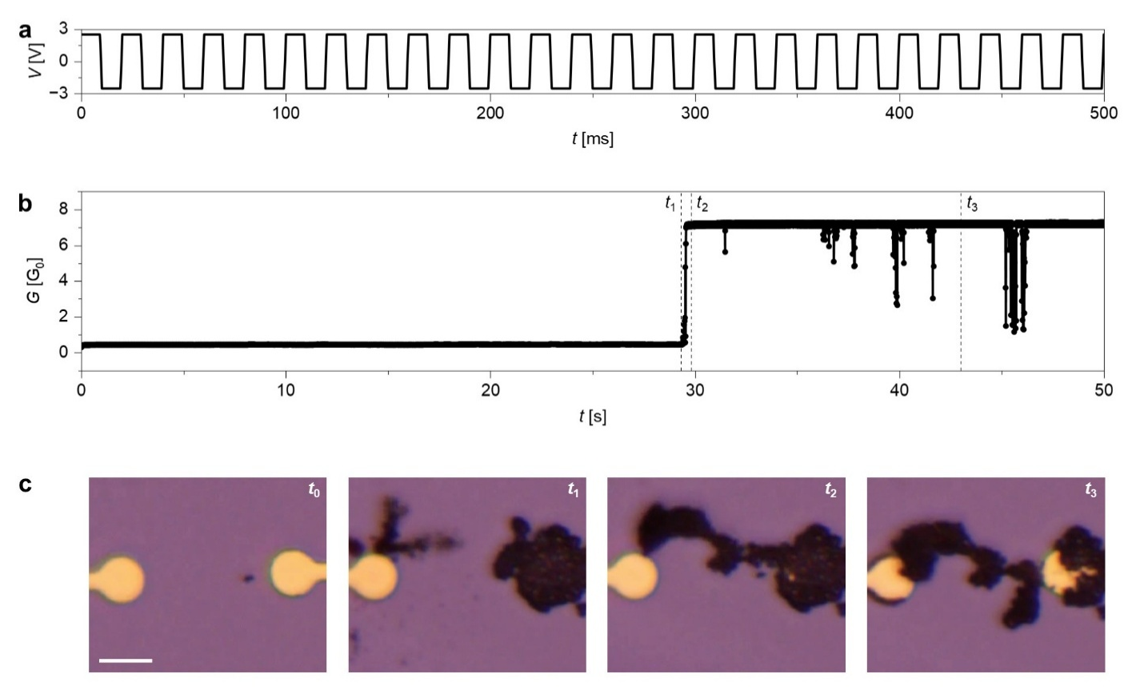
Figure S3 | Electrochemical growth of a dendritic connection under 10 ms bipolar voltage pulse stimulation. a. Magnification of the voltage waveform periodically repeated for the whole stimulation window. b. Synaptic conductance evolution over time demonstrating electrical connection establishment between electrochemically grown dendrites. c. Evolution of dendritic morphology under stimulation (scale bar, 10 μm).

Supplementary Section 8 - Stability of electrochemical dendrites connections
When operated in the proper input stimulation condition, a stable long-term electrochemical dendritic connection can be established, enabled by the formation of a large metallic bridge in the thinnest connection region, resulting in a structurally stable element (details in Supplementary Section 12). Figure S4 shows the conductance time trace of a dendritic connection grown with a symmetric bipolar square wave input voltage with amplitude 1.5 V, pulse width 1 s and 150 periods under a compliance current of 1 mA. As demonstrated in the figure, the system can retain a high conductance state with negligible variations for 1.5x10⁴ s.

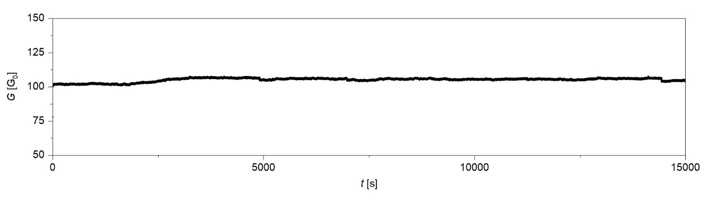
Figure S4 | Electrochemical dendrites long-term conductance retention. Time trace of dendritic connection conductance showing its capability of retaining the programmed state for 1.5x10⁴ s.

Supplementary Section 9 - Details of experimental and in silico conductance matrices and corresponding graph representations
While dendritic growth model neglects conduction change until a metallic contact between the two terminals is established (Figure 2e), the experimental results reported in Figure 2d indicate a non-negligible conductance even before contact formation. The latter arises from ionic transport through the electrolyte solution and faradaic currents, which contribute to a measurable current prior to the establishment of a metallic conduction path.

Supplementary Section 10 - Mechanism underlying memristive behavior of dendritic connections
Silver dendrites show bipolar resistive switching behavior after an initial strong reset process that introduces an asymmetry in the system structure. This can be obtained, for example, through the application of a strong negative voltage sweep. As shown in Figure S5, after the initial conductance suppression (between 0 V and -0.5 V) no significant change in the dendrite structure is observed (t₁). At -1.5 V a significant current increase is observed, and the symmetry is progressively broken by moving the metallic silver from the positive potential electrode towards the negative one. A second current drop takes place when a gap is formed in the proximity of the positive electrode (~ -2 V, t₃). The origin of this process is an interplay between oxidation at the positive potential side and Joule heating induced structural destabilization.

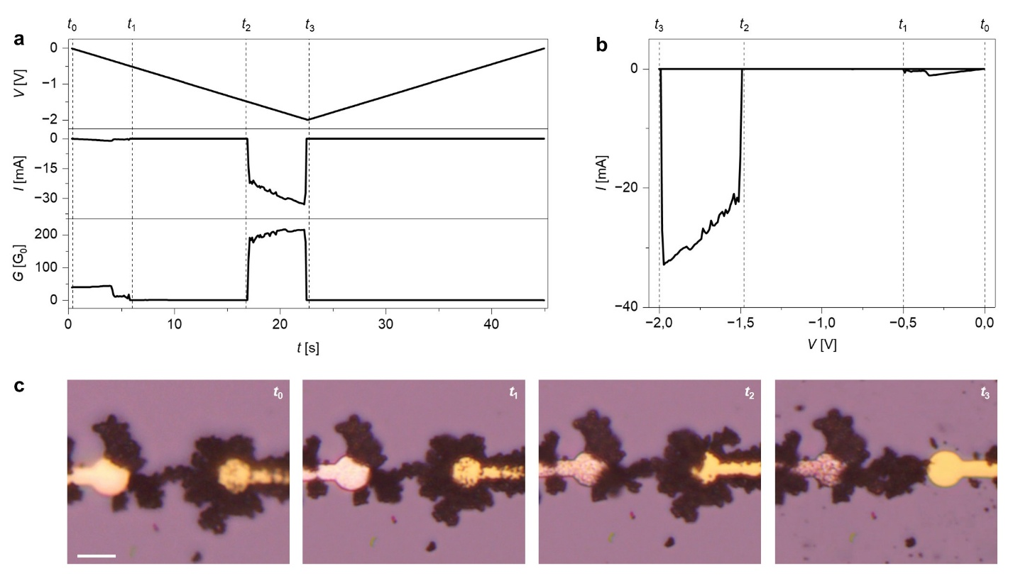
Figure S5 | Initial reset process of electrochemical dendrites memristive connection. a. Time traces of applied voltage, read current and dendritic conductance during the strong negative voltage sweep first reset process. b. Relative I-V sweep response. c. Evolution of dendritic morphology towards the asymmetric structure (scale bar, 10 μm).

The bipolar switching under both voltage pulses (Figure 3b-c) and I-V sweeps (Figure S6) emerges from the bridging and reopening of the dendrite-electrode gap enabled by redox reactions, with a similar process to standard ECM memristive cells.¹⁹ Here, the depleted electrode is used as voltage reference and the voltage waveform is applied to the electrode connected to the dendrite. During the set branch, the dendrite atoms undergo anodic dissolution and drift across the gap under the effect of the strong electric field here established. On the other electrode, the negative potential reduces both the dissolved ions and those already present in the solution until the gap is bridged. Further reduction reactions induce progressive conductance increase. When voltage polarity is reversed, a process similar to the one responsible for the initial asymmetry introduction triggers a reopening of the gap, leading to the reset of the device. Note that, to ensure reproducibility over device operations, it is crucial to force a current compliance on both switching polarities to prevent significant structural changes induced by Joule heating destabilization.

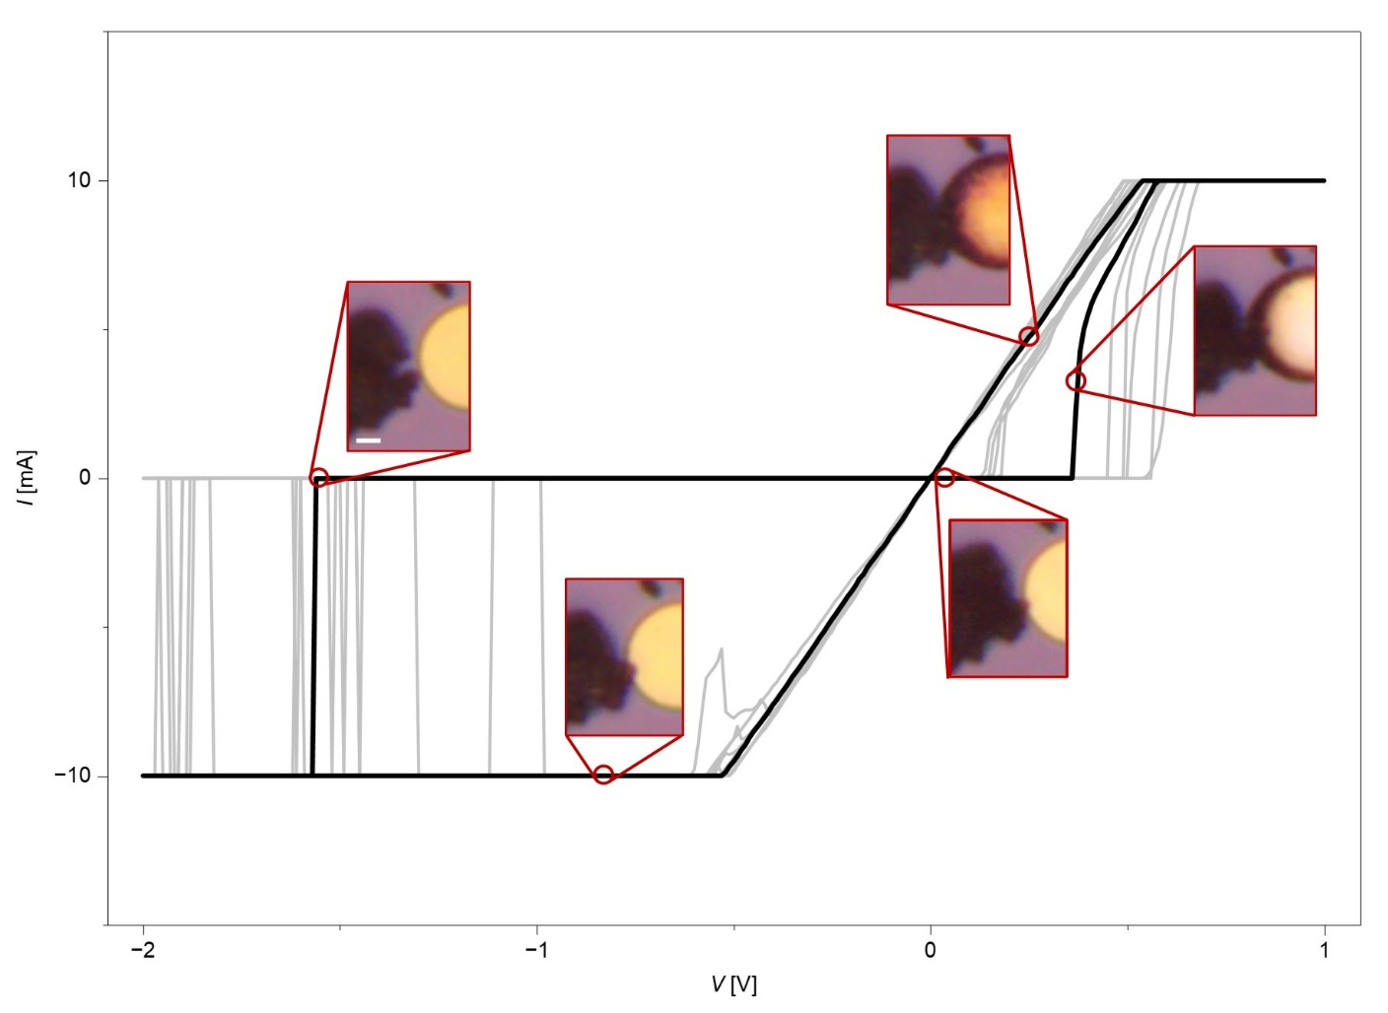
Figure S6 | Electrochemical dendrites resistive switching behavior under voltage sweeps. I-V curves of dendritic memristive connection under 10 cycles of voltage sweep showing transition between high resistive states and low resistive states due to morphological formation and rupture of metallic connection in the thinnest dendrite region (insets) (scale bar, 2 μm).

Supplementary Section 11 - Volatile and non-volatile memristive dynamics
The retention of memristive dendrite connections is a result of their topological properties. Indeed, the transition from long term to fading memory corresponds to a shift from stable to unstable structures. The inherent dependence of dendrite structure on the history of the input enables the modulation of connection volatility by changing the number of input pulses (i.e. the amount of electrical energy supplied), as shown in Figure 3d-e. As a result, each pulse produces a structural widening of the connection (Figure S7a). While a sufficient number of pulses promotes the formation of thicker stable connections, in fading memory connections the source of instability can be attributed to the thinnest dendrite regions.²⁰ Here, the filaments tend to reduce their surface-to-volume ratio, evolving towards a more stable shape and eventually breaking (Figure S7b, Supplementary Video 5). This process is induced by the thermodynamical favoring of local oxidation, promoted by two main contributions: i) the polar nature of the solvent (DMSO) energetically stabilizes Ag⁺ ions by solvation,²¹ ii) Ag chemical potential is increased in the necks (where their curvature is higher) due to a Gibbs–Thomson surface-energy contribution.²²

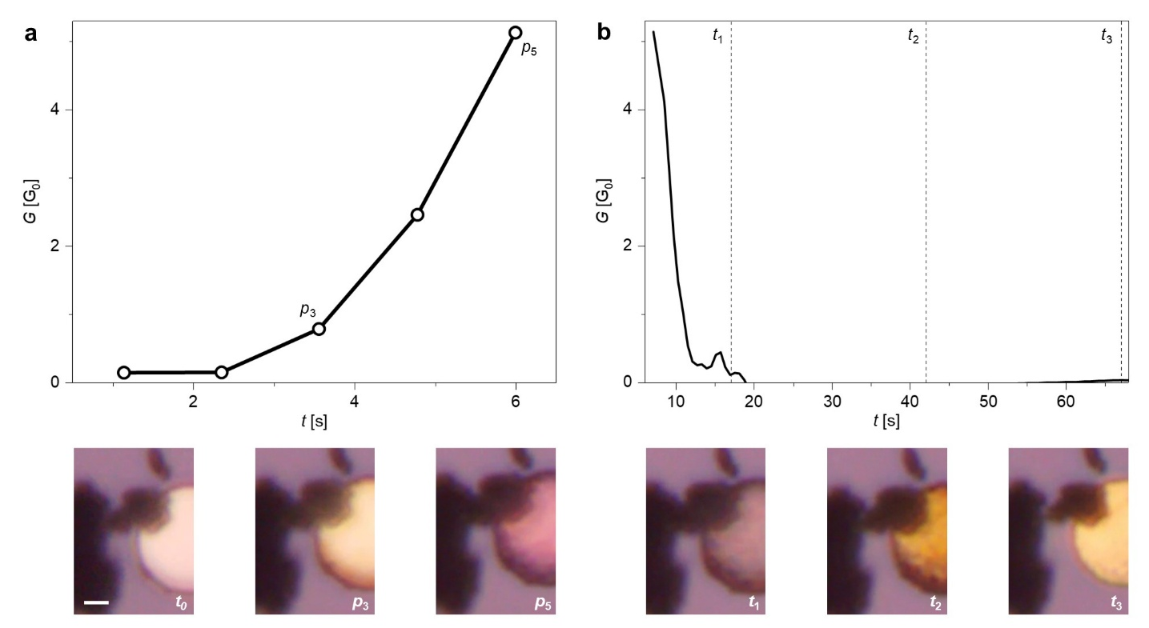
Figure S7 | Electrochemical dendrites memristive connection short-term memory process. a. Conductance curve (top) showing dendritic connection formation and potentiation under the application of 5 positive voltage pulses due to morphological bridging and growth of the thinnest metallic region (bottom). b. Time trace of system conductance after stimulation (top) showing connection relaxation due to spontaneous shrinking and breaking of the metallic bridge (bottom) (scale bar, 2 μm).

Supplementary Section 12 - Topological effects of associative learning in dendritic networks
Dendritic electrochemical networks offer a spatially embedded platform in which associative learning can manifest not only as changes in connection strength, but also as changes in the topology of the emerging conductive network.
Electrical activity applied to the terminals results in the formation of an electrochemical physical network, whose both nodes and edges are embedded in the physical space and need to cope with the geometric embedding via volume exclusion and non-crossing conditions.^{23–26} In contrast, nodes that are not engaged in the activation, or that do not lie along the emerging conductive pathways, remain weakly connected or disconnected. Consequently, activation patterns may lead to the formation of multiple spatially localized connected components, rather than a single globally connected network. Associated neuron terminals progressively become closer in a topological sense, as their electrical resistance distance²⁷ decreases. Importantly, this effect does not necessarily rely on the creation of long-range connections, but instead emerges from the gradual formation and reinforcement of conductive pathways through local growth processes. This behavior reflects a fundamental constraint of the system as the network growth is geometrically embedded. As a result, the set of accessible network configurations and their properties are restricted by spatial organization of terminals.²⁸ Hebbian-like activity-dependent network growth typically promotes the formation of hubs and rich-clubs.^{29,30} Indeed, our systems are constrained to a quasi-planar geometry, implying that connection costs depend strongly on spatial distance. Thus, due to the locality of growth and diffusion-limited transport, frequent activation alone may not be sufficient to guarantee hub formation, and connectivity develops primarily among spatially proximal nodes. This is particularly evident for highly active peripheral nodes, which tend to form local connectivity clusters rather than global hubs. This is related to the fact that hub formation requires not only activity but also geometric accessibility.

Supplementary Section 13 - Details on Pavlov’s dog implementation
The first investigation of classical conditioning in living systems was conducted by Ivan Pavlov with the well-known study on dogs.³¹ The electrical details of the multiterminal execution of the Pavlov’s Dog task are reported in Figure S8. The preliminary formation of the food (F) - saliva (S) association before conditioning is obtained by the creation of a first dendritic connection between the relative terminals (Figure S8a). Figure S8b reports the conductance increase obtained via dendritic metallic connection under the application of the input symmetric voltage waveforms (inset). Figure S8c shows the applied voltage to each electrode and the output S current during all the task phases.
i) F-S association: the bell (B) electrode is kept in floating voltage mode to prevent its influence on the preliminary F-S growth. The output S current overcomes the selected current threshold of 2 μA after connection establishment, indicating the formation of the desired association.
ii) Before conditioning: the first test phase is carried out by alternatively applying voltage pulses to the F and B electrodes, setting the inactive one to floating voltage, ensuring the S output current reading to be related to the probed representation only. The S terminal is set as reference, enabling its current reading to be used as system output. This test shows that, in this phase, S current overcomes the threshold during F stimulation alone, confirming system response to be unconditioned.
iii) Conditioning: in this phase, the B-F association is obtained through the application of voltage waveforms similar to those used for the F-S one. The S terminal is kept as voltage reference, showing the expected unconditioned response to F also in this phase.
iv) After conditioning: the same test performed for the before conditioning state is carried out, showing above-the-threshold current readings both under F and B stimulations, confirming the system conditioning success.
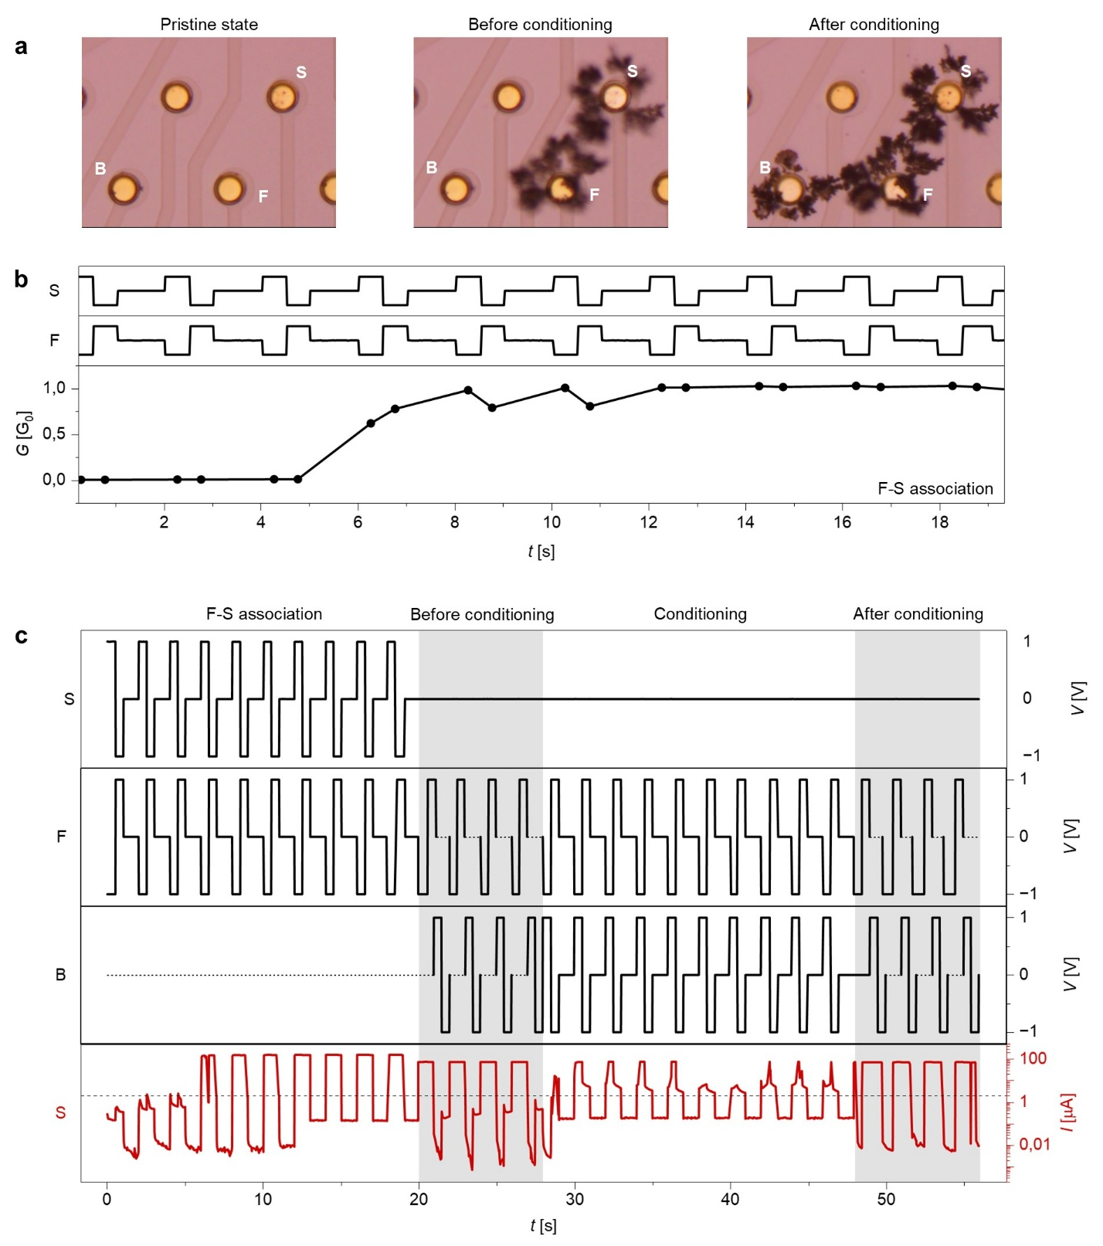
Figure S8 | Pavlov’s dog task multiterminal electrical implementation. a. Evolution of the dendrite network morphology during task execution showing the pristine state, the before conditioning structure, and the after conditioning one demonstrating the establishment of dendritic connections between bell (B), food (F) and saliva (S) representations electrodes b. Voltage waveforms applied to S and F electrodes for the establishment of the F-S association (top) and the relative conductance evolution (bottom). c. Raw representations of voltage waveforms applied to the representations electrodes (black) and the resulting current response read from S electrode (red). Dotted segments in applied voltages identify periods in which the relative electrodes are set to floating mode, preventing their influence on the potential landscape, ensuring proper forming (during F-S association) and testing (during grey shaded system probing) of the desired dendritic connection. The black dashed line in the read current plot shows the 2 μA minimum threshold set for defining an output as true.

Supplementary Section 14 - Operant reserve in biological systems and electrochemical dendrites
The study of organism behavior in the framework of operant conditioning in the original works by Skinner^{32,33} is based on the concept of operant reserve. The subject conditioning is modelled as a reservoir of actions that translates in an instantaneous action rate (e.g. button pressing for rats) that depends on the consequence (reward, punishment or absent) triggered by the action in the present time and on the previous action-consequence history. Experimentally, the reservoir size corresponds to the cumulative sum of the instantaneous action rate, obtained through cumulative records, permitting a simplified observation of behavior change over time.³³ In electrochemical dendrites, being the instantaneous action rate corresponding to the system conductance, the reservoir size can be obtained by evaluating its cumulative sum, permitting the comparison between dendrites and biological organisms operant conditioning behavior.

Supplementary Section 15 - Details on operant conditioning implementation
The long-term nature of the dendritic connection obtained through strong conditioning in the Rat punishment task is the result of a conductive filament with sufficient thickness to prevent spontaneous dissolution (as described in Supplementary Section 11). In this context, the presence of a current compliance during the whole task execution strongly limits the impact of Joule heating in filament breaking. Moreover, it also damps the effective applied voltage, resulting in significant reduction of anodic dissolution reaction rate. For these reasons, an interplay between destabilization and spontaneous dissolution processes is exploited to trigger conductance suppression even in the presence of current limitations. In this system, it can be obtained by selecting appropriate pulse polarity and inter-pulse windows. In particular, the punishment waveform is composed of periods containing a couple of short (330 ms), negative-voltage (-1.5 V) pulses separated by an equal-width low-voltage (10 mV) pause, followed by a similar longer pause (3s). The role of each segment is detailed in the following.
i) First pulse (-1.5 V, 330 ms): despite the applied voltage being dumped by compliance current, most of it drops across the thinnest connection region between the dendrites. This voltage, even if not sufficient to trigger a direct breaking, induces destabilization of the connection via local Joule heating and anodic dissolution.
ii) Short pause (10 mV, 330 ms): during this phase, the destabilized filament can partially relax towards a more energetically favorable configuration. This condition is achieved by minimizing the surface due to the Gibbs-Thomson effect, pushing the filament closer to rupture.
iii) Second pulse (-1.5 V, 330 ms): even if nominally equal to the first pulse, it acts stronger on the thinnest connection due to its reduced thickness and increased resistance.
iv) Long pause (10 mV, 3 s): this phase permits a subsequent relaxation to a more stable (less connected) state and prevents a reforming once the filament is broken.

Supplementary Section 16 - Biological plausibility of operant conditioning tasks
Figure S9 reports the comparison between the operant reserve size (details in Supplementary Section 14) of dendrites and the data on rats reported by Skinner,³² demonstrating comparable behavior. Figure S9a shows the conditioning dynamics, where an initial flat region of no response is followed by an almost linear increase after the establishment of button-food association. Figure S9b reports the reservoir dynamics during the first extinction after conditioning, where a saturation of the curve is due to progressive spontaneous decay of the action rate. On the other hand, Figure S9c shows the same extinction dynamics after periodic reconditioning, with a linear increase with constant slope indicating a persistence of action rate in the absence of rewards due to long-term memory. Finally, Figure S9d reports the behavior dynamics during the execution of the rat punishment task (after conditioning). Also in this case, the behavior under extinction, punishment and reconditioning demonstrate similar dynamics between electrochemical dendrites and biological organisms.

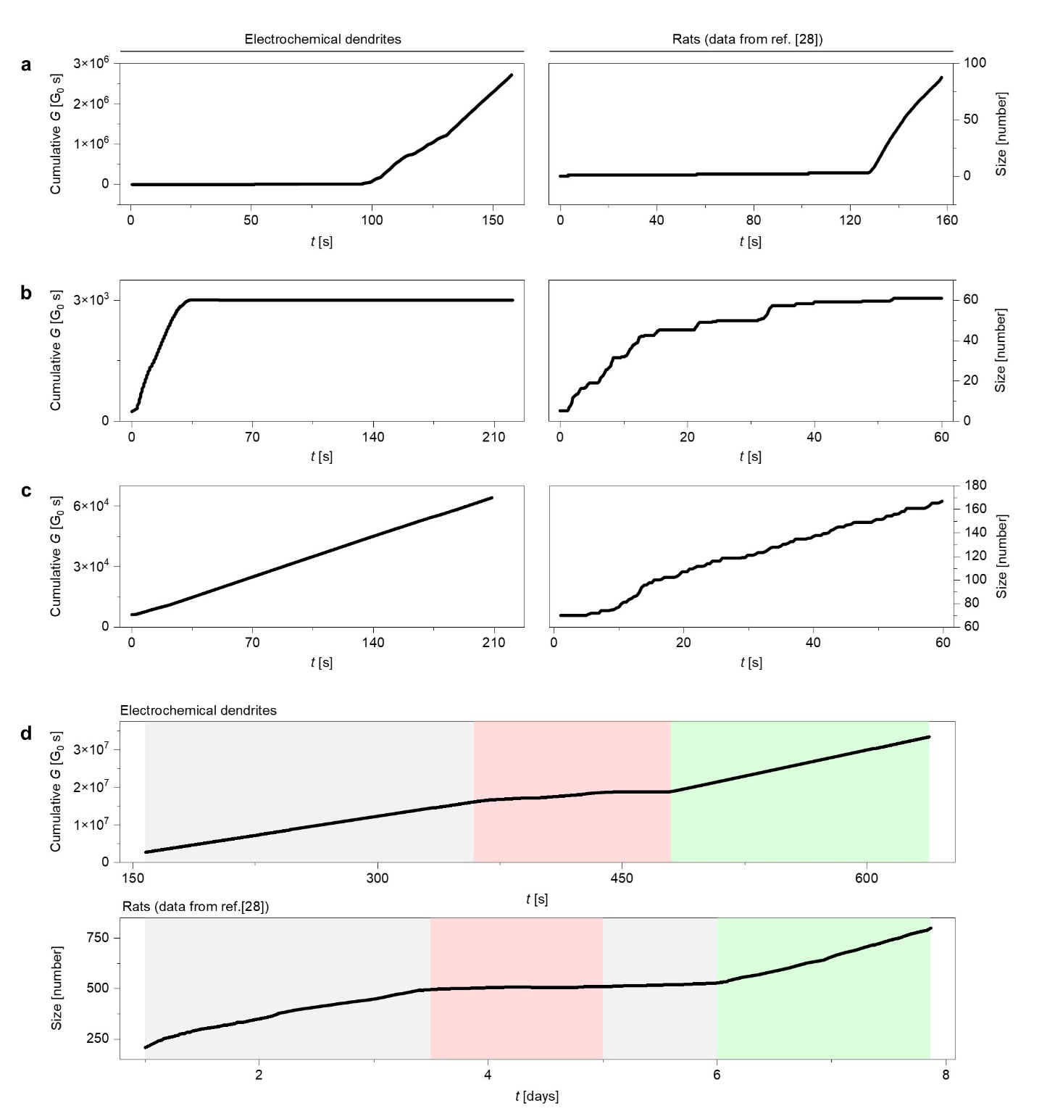
Figure S9 | Comparison between operant reserve dynamics in electrochemical dendrites and Skinner’s experiments on rats³² during the operant conditioning tasks. Cumulative dendritic conductance and rat reservoir size during conditioning (a), first extinction (b), extinction after periodic reconditioning (c) and rat punishment task execution (d). In the latter, extinctions are highlighted by gray shaded backgrounds, punishments by red and reconditionings by green shaded ones.

Supplementary Section 17 - Protocol details for the navigation task
Ground-truth path definition.
The navigation task is first mapped onto a discrete graph $G=(N,E)$, where each node $i∈N$ represents a spatial region and each edge $(i,j)∈E$ represents an allowed transition between neighboring regions. Each node is assigned a traversal cost $ρ_{i}$, which encodes the local difficulty of crossing that region. The ground-truth path is defined as the path $γ*$ connecting the start node S to the target node T that minimizes the cost functional
$$γ*=arg \min_{γ:S→T}[ \sum_{(i,j)∈γ}^{ }{ }d_{i,j}+λ_{cost} \sum_{(i,j)∈γ}^{ }{ }\frac{ρ_{i}+ρ_{j}}{2}]$$
where $d_{i,j}$ is the geometric length of the edge here considered unitary and $λ_{cost}$ controls the relative weight of terrain difficulty with respect to path length. Here $λ_{cost}=1$. This path is used as the graph-theoretic ground truth for evaluating the performance of the physical system.
Mapping node costs into the electrical stimulation.
To impose the navigation landscape on the electrochemical system, each graph node is associated with one electrode. The normalized traversal cost of node $i$ is mapped into the amplitude of the electrical signal applied to the corresponding electrode. Specifically, the stimulation amplitude is defined as an effective potential landscape,
$$V_{i}=λ_{map}\tilde{ρ_{i}} - μ_{goal}\tilde{ϕ_{i}}$$
where $\tilde{ρ_{i}}$ is the normalized node-cost field. The target$T$ and start $S$ nodes are arbitrarily assigned ${\tilde{ρ_{i}}}^{S,T}=0.5$ to locate them in an intermediate regime of voltage. $\tilde{ϕ_{i}}$ is a normalized directional coordinate that biases propagation toward the target and is defined as
$$\tilde{ϕ_{i}}= 1-\frac{d(i,T)}{max_{j}d(j,T)}$$
where $d(i,T)$ is the Euclidean distance between the node i and the target node $T$, such that $\tilde{ϕ_{T}}=1$ and it decreases for nodes that are farther from the target. The design of ${\tilde{ϕ}}_{i}$ reflects the reduction process on lower voltage electrodes.
The parameter $λ_{map}$ controls the repulsive contribution of high-cost regions, whereas $μ_{goal}$ controls the attractive bias toward the target.
Temporal stimulation protocol.
The spatial voltage landscape is delivered via a plane-wave stimulation protocol. We define the propagation direction as the line connecting the start node to the target node. Each electrode is assigned a normalized coordinate $s_{i}=(\vec{r_{i}}-\vec{r_{S}}) ⋅\hat{u}/(\vec{r_{T}}-\vec{r_{S}}) ⋅\hat{u}$, obtained by projecting its position onto the direction pointing from the start node toward the goal and identified by $\hat{u}$. Therefore, $s_{S(tart)}=0$ at the start and $s_{T}=1$ at the target. A stimulation front, perpendicular to the start-target direction, sweeps across the electrode array from $t=0 s$ to $t_{end}=26 s$. The signal applied on the target and start electrode is held fixed on a time window of $45 s$.
When the front reaches electrode i, the electrode is activated with amplitude $V_{i}$ for a duration of $τ_{pulse}=3.5 s$. The start and target electrodes are held active throughout the whole protocol.
The arrival time of the stimulation front at electrode $i$ is defined as $t_{i}=s_{i}t_{end}$.
Each electrode then receives a rectangular pulse of amplitude $N_{i}$ during the interval ${[t}_{i}, t_{i}+τ_{pulse}]$.
This stimulation sequence writes the terrain-dependent information into the evolving dendritic morphology by reinforcing conductive growth in regions favored by the cost landscape.
Conductance readout and path extraction.
The state of the system is then read out electrically. For each run, the readout time is defined relative to the first detected conductive connection between the start and target nodes: the conductance matrix is sampled 4 s after this first-connection event. At this time, the electrode-to-electrode conductance matrix $G_{ij}$ is measured from the physical network. This matrix defines a reduced conductance graph, in which an edge between electrodes $i$ and $j$ is retained only if $G_{ij}>0$. The edge cost used for digital readout is ${c_{ij}}^{readout}=1/G_{ij} .$
The ordered sequence of nodes is then extracted by applying Dijkstra’s shortest-path algorithm, as implemented in NetworkX,³⁴ to this reduced conductance graph. The resulting path is compared with the ground-truth graph path using the path-overlap metric, which counts the number of shared edges normalized over the number of edges in the ground truth path (Supplementary Section 18). Thus, the system does not replace the graph algorithm as an explicit path extractor but reduces the computational complexity of finding the solution to the navigation task. In fact, the practical advantage is that the readout is performed on this smaller active sub-network, leveraging the fact that Dijkstra’s shortest-path search scales as $O(ElogN)$.^{35–37}

Supplementary Section 18 - Accuracy of the navigation task
The path overlap was defined as the fraction of edges of the ground-truth optimal graph path that are also present in the path extracted from the conductance matrix, and normalized by the number of edges of the former path. For each parameter pair $(λ_{map}, μ_{goal})$, the conductance matrix was evaluated $4s$ after the first detection of a valid conductive path between the start and target electrodes. The overlap was averaged only over runs in which such a valid conductive path was still available at this readout time. Furthermore, to account for connection reliability, we finalize our metric defining the success-weighted overlap, as the mean overlap multiplied by the connection rate, where the latter is the fraction of the 25 independent runs exhibiting a valid conductive path at the $4s$ readout. Results are reported in the heat map in Figure S10 reporting success-weighted overlaps for each parameter pair $(λ_{map}, μ_{goal})$. High values therefore identify parameter regimes that both reliably preserve a conductive connection at readout and recover a path close to the graph-theoretic optimum.

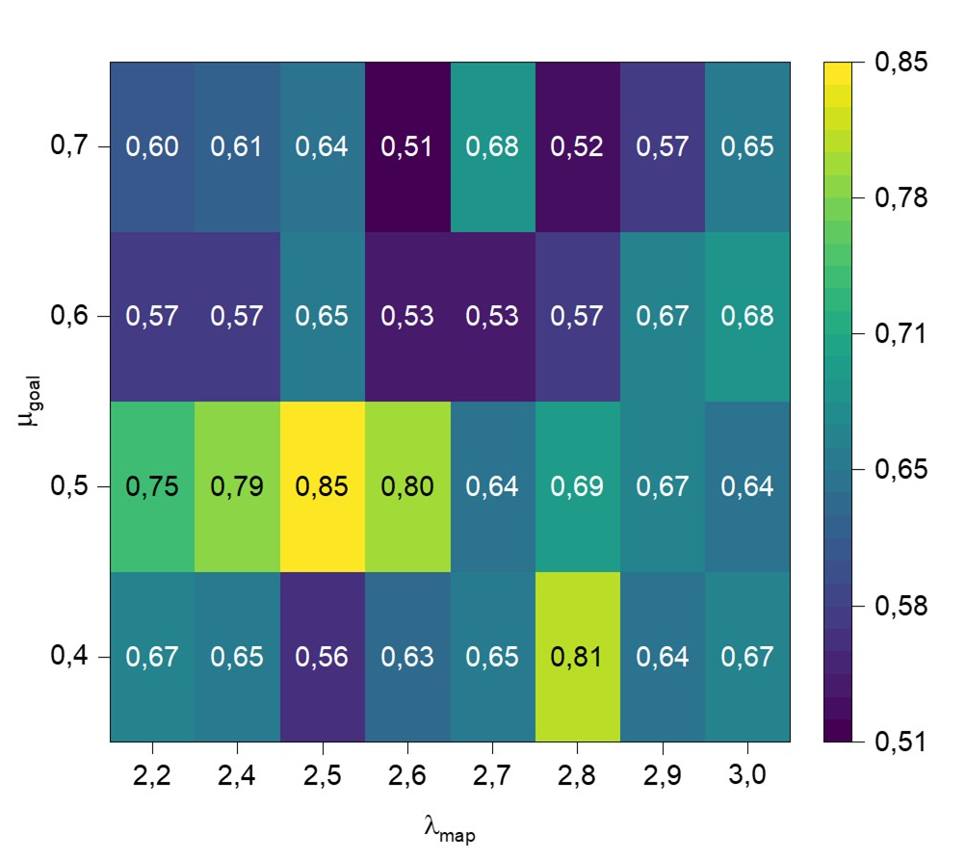
Figure S10 | Overlap between the extracted path from the measured conductance matrix and the ground-truth optimal path. The overlap is weighted by the fraction of successful connections between the start and target node. Averages over 25 independent runs.

Supplementary Section 19 - Model parameters
Parameters are grouped according to their role in the model: geometry and numerical discretization, redox and concentration dynamics, and electrical double-layer/circuit dynamics.
Parameters Figure 1
Parameter | Value | Unit | Description
System size | 90 | pixels | Linear size of the square simulation domain
Pixel conversion factor | 1.0 | $μ$m/pixel | Conversion factor
Electrode radius | 5 | pixels | Radius of circular electrodes
Time step | 0.2 | s | Morphological time step
Diagonal connections for the lattice | True | – | Whether diagonal neighbours are included
Table S1. Geometry parameters of the system for Figure 1.

Parameter | Symbol | Value | Unit | Description
Reduction prefactor | $${k_{0}}^{(red)}$$ | 1.863 | s⁻¹ | Kinetic prefactor for reduction
Oxidation prefactor | $${k_{0}}^{(ox)}$$ | 0.014 | s⁻¹ | Kinetic prefactor for oxidation
Concentration limiter exponent | $$β$$ | 1.776 | – | Controls concentration sensitivity of reduction probability
Voltage scale | $$V_{scale}$$ | 0.098 | V | Voltage scale controlling redox-rate activation
Reduction threshold | $${V_{th}}^{(red)}$$ | 0.093 | V | Effective threshold for reduction activation
Oxidation threshold | $${V_{th}}^{(ox)}$$ | 0.093 | V | Effective threshold for oxidation activation
Reduction consumption parameter | $$γ^{(red)}$$ | 1.411 | adimensional | Target adimensional mass of reactant consumption per reduced pixel, in bulk-equivalent electrolyte-cell units
Oxidation release parameter | $$γ^{(ox)}$$ | 1.411 | adimensional | Nominal oxidation mass scale; oxidation releases the mass stored in the metallic bookkeeping field
Diffusion coefficient | $$D$$ | 2.9$×$10⁻¹⁰ | m²/s | Diffusion coefficient of the concentration field
Reference concentration | $$c_{0}$$ | 1.0 | adimensional | Reference/bulk concentration
Table S2. Redox and concentration parameters for Figure 1. Note that parameters ${k_{0}}^{(*)}$ and ${V_{th}}^{(*)}$ are not distinguished in the explanation of the model in Supplementary Section S3. In the model we fixed ${V_{th}}^{(red)}={V_{th}}^{(ox)}$ assuming symmetric energies for the redox.

Parameter | Symbol | Value | Unit | Description
Bond conductance | – | 0.031 | S | Conductance assigned to newly formed metallic bonds
Apply EDL dynamics | – | True | – | Whether electrical double-layer dynamics are included
Double-layer capacitance | $$C_{i}$$ | 6.483 x 10⁻¹⁴ | F | Capacitance of each wetted metallic site (pixel)
Double-layer leakage resistance | – | 4.889 x 10¹⁴ | Ohm | Resistance parallel to the double-layer capacitance of each wetted metallic site (pixel)
Electrolyte series resistance | – | 2.980 x 10¹⁴ | Ohm | Series resistance coupling metal site to electrolyte
Table S3. Electrical and electrical double layer parameters for Figure 1.

Parameters Figure 2
For the multiterminal protocol a resistance of $4.6×10^{3} Ω$ is placed in series between the voltage sources and each electrode.
Parameter | Value | Unit | Description
System size | 150 | $μ$m | Linear size of the square simulation domain
Pixel conversion factor | 1.2 | $μ$m/pixel | Conversion factor
Electrode radius | 5 | $μ$m | Radius of circular electrodes
Time step | 0.2 | s | Morphological time step
Diagonal connections for the lattice | True | – | Whether diagonal neighbours are included
Table S4. Geometry parameters of the system for Figure 2.

Parameter | Symbol | Value | Unit | Description
Reduction prefactor | $${k_{0}}^{(red)}$$ | 2.0 | s⁻¹ | Kinetic prefactor for reduction
Oxidation prefactor | $${k_{0}}^{(ox)}$$ | 0.36 | s⁻¹ | Kinetic prefactor for oxidation
Concentration limiter exponent | $$β$$ | 2.87 | - | Controls concentration sensitivity of reduction probability
Voltage scale | $$V_{scale}$$ | 0.2 | V | Voltage scale controlling redox-rate activation
Reduction threshold | $${V_{th}}^{(red)}$$ | 0.0 | V | Effective threshold for reduction activation
Oxidation threshold | $${V_{th}}^{(ox)}$$ | 0.0 | V | Effective threshold for oxidation activation
Reduction consumption parameter | $$γ^{(red)}$$ | 2.66 | adimensional | Target adimensional mass of reactant consumption per reduced pixel, in bulk-equivalent electrolyte-cell units
Oxidation release parameter | $$γ^{(ox)}$$ | 2.66 | adimensional | Nominal oxidation mass scale; oxidation releases the mass stored in the metallic bookkeeping field
Diffusion coefficient | $$D$$ | 2.9x10⁻¹⁰ | m²/s | Diffusion coefficient of the concentration field
Reference concentration | $$c_{0}$$ | 1.0 | adimensional | Reference/bulk concentration
Table S5. Redox and concentration parameters for Figure 2. Note that parameters ${k_{0}}^{(*)}$ and ${V_{th}}^{(*)}$ are not distinguished in the explanation of the model in Supplementary Section S3. In the model we fixed ${V_{th}}^{(red)}={V_{th}}^{(ox)}$ assuming symmetric energies for the redox.

Parameter | Symbol | Value | Unit | Description
Bond conductance | – | 0.031 | S | Conductance assigned to newly formed metallic bonds
Apply EDL dynamics | – | True | - | Whether electrical double-layer dynamics are included
Double-layer capacitance | $$C_{i}$$ | 1.0 x 10⁻¹⁴ | F | Capacitance of each wetted metallic site (pixel)
Double-layer leakage resistance | – | 5.0 x 10¹⁴ | Ohm | Resistance parallel to the double-layer capacitance of each wetted metallic site (pixel)
Electrolyte series resistance | – | 1.8 x 10¹⁴ | Ohm | Series resistance coupling metal site to electrolyte
Table S6. Electrical and electrical double layer parameters for Figure 2.

Parameters Figure 5
The navigation task was simulated using the same parameters as those used for Figure 2, except that the system size was enlarged to 180 m to account for the larger number of electrodes and the electrical double layer was turned off for simplicity. Note that the 4.6103 series resistance at the sources is not accounted for during the reading of the conductance matrix, without loss of generality.

References
1. Steiner, E. C. & Gilbert, J. M. The Acidities of Weak Acids in Dimethyl Sulfoxide. II. The Hammett Acidity Function. J. Am. Chem. Soc. 87, 382–384 (1965).
2. Patai, S., Rappoport, Z. & Stirling, C. Sulphones and Sulphoxides (1988). The Chemistry of Sulphones and Sulphoxides (John Wiley & Sons, Ltd, Chichester, UK, 1988).
3. Xu, D., Wang, Z., Xu, J., Zhang, L. & Zhang, X. Novel DMSO-based electrolyte for high performance rechargeable Li–O2 batteries. Chemical Communications 48, 6948 (2012).
4. Kao-ian, W. et al. Highly stable rechargeable zinc-ion battery using dimethyl sulfoxide electrolyte. Mater. Today Energy 21, 100738 (2021).
5. Cai, Y. et al. Dynamic windows based on reversible silver electrodeposition with improved resting stability and cyclability. Cell Rep. Phys. Sci. 6, 102559 (2025).
6. Kozicki, M. N. Information in electrodeposited dendrites. Adv. Phys. X 6, (2021).
7. Usman Amin, M. et al. Electrochemical growth of dendritic silver nanostructures as facile SERS substrates. CrystEngComm 23, 694–699 (2021).
8. Wu, D. et al. 2022 Roadmap on aqueous batteries. Journal of Physics: Energy 4, 041501 (2022).
9. Aurbach, D. Nonaqueous Electrochemistry. (CRC Press, 1999).
10. Terasa, M.-I. et al. Pathways towards truly brain-like computing primitives. Materials Today 69, 41–53 (2023).
11. Mandke, M. V., Han, S.-H. & Pathan, H. M. Growth of silver dendritic nanostructuresvia electrochemical route. CrystEngComm 14, 86–89 (2012).
12. Witten, T. A. & Sander, I. M. PHYSICAL REVIEW LETTERS Diffusion-Limited Aggregation, a Kinetic Critical Phenomenon. vol. 47 (1981).
13. O’Regan, C. et al. CTAB-Influenced Electrochemical Dissolution of Silver Dendrites. Langmuir 32, 3601–3607 (2016).
14. Schneider, N. M. et al. In-Situ Electron Microscopy of Electrochemical Deposition, Dendrite Growth, and Etching. J. Heat Transfer 136, (2014).
15. Mandich, N. V. Pulse and pulse-reverse electroplating. Metal Finishing 100, 359–364 (2002).
16. Parthasarathy, P. & Virkar, A. V. Electrochemical Ostwald ripening of Pt and Ag catalysts supported on carbon. J. Power Sources 234, 82–90 (2013).
17. Nakagawa, S., Takehara, Z. & Yoshizawa, S. Diffusion coefficient of silver ion in the solution of dimethyl sulfoxide. Electrochim. Acta 18, 1043–1044 (1973).
18. Rogers, E. I. et al. Electrochemical Kinetics of Ag|Ag ⁺ and TMPD|TMPD ^{+•} in the Room-Temperature Ionic Liquid [C ₄ mpyrr][NTf ₂ ]; toward Optimizing Reference Electrodes for Voltammetry in RTILs. The Journal of Physical Chemistry C 111, 13957–13966 (2007).
19. Valov, I., Waser, R., Jameson, J. R. & Kozicki, M. N. Electrochemical metallization memories—fundamentals, applications, prospects. Nanotechnology 22, 289502 (2011).
20. Wang, W. et al. Surface diffusion-limited lifetime of silver and copper nanofilaments in resistive switching devices. Nat. Commun. 10, 81 (2019).
21. BASS, L. Spontaneous Dissolution of Metals in Polar Electrolytes. Nature 198, 982–983 (1963).
22. Valov, I. et al. Nanobatteries in redox-based resistive switches require extension of memristor theory. Nat. Commun. 4, 1771 (2013).
23. Barthélemy, M. Spatial networks. Phys. Rep. 499, 1–101 (2011).
24. Pete, G., Timár, Á., Stefánsson, S. Ö., Bonamassa, I. & Pósfai, M. Physical networks as network-of-networks. Nat. Commun. 15, 4882 (2024).
25. Pósfai, M. et al. Impact of physicality on network structure. Nat. Phys. 20, 142–149 (2024).
26. Dehmamy, N., Milanlouei, S. & Barabási, A.-L. A structural transition in physical networks. Nature 563, 676–680 (2018).
27. Klein, D. J. & Randić, M. Resistance distance. J. Math. Chem. 12, 81–95 (1993).
28. Barthelemy, M. From Complex to Spatial Networks. in Spatial Networks 3–8 (Springer International Publishing, Cham, 2022).
29. Bergoin, R., Torcini, A., Deco, G., Quoy, M. & Zamora-López, G. Emergence and maintenance of modularity in neural networks with Hebbian and anti-Hebbian inhibitory STDP. PLoS Comput. Biol. 21, e1012973 (2025).
30. Vértes, P. E., Alexander-Bloch, A. & Bullmore, E. T. Generative models of rich clubs in Hebbian neuronal networks and large-scale human brain networks. Philosophical Transactions of the Royal Society B: Biological Sciences 369, 20130531 (2014).
31. Pavlov, I. P. Conditioned reflexes: An investigation of the physiological activity of the cerebral cortex. Ann. Neurosci. 17, (2010).
32. Skinner, B. F. The Behavior of Organisms:An Experimental Analysis. vols ix, 457 p. ill. (New York, London, D. Appleton-Century company, incorporated, 1938).
33. Ferster, C. B. & Skinner, B. F. Schedules of Reinforcement. (Appleton-Century-Crofts, East Norwalk, 1957).
34. Hagberg, A., Swart, P. J. & Schult, D. A. Exploring network structure, dynamics, and function using NetworkX. Preprint at (2008).
35. Dijkstra, E. W. A note on two problems in connexion with graphs. Numer. Math. (Heidelb). 1, 269–271 (1959).
36. Hagberg, A., Swart, P. J. & Schult, D. A. Exploring network structure, dynamics, and function using NetworkX. Preprint at (2008).
37. Sedgewick, R. & Wayne, K. Algorithms FOURTH EDITION. (2011).

