Supplementary Figures S1-S3
Chromosome-Resolved Genome of Magnaporthe oryzae KJ201 Links East Asian Rice Blast Lineage Architecture with Pathogenicity Loci

Hyunjung Chung^{1†}, Yebin Nam^{2†}, Yoeguang Hue², Jinyong Kim³, Byungheon Choi², Sunmin An¹, Jaeho Ko⁴, Yong-Hwan Lee^{4,5}, Sook-Young Park^{2,3}, Ki-Tae Kim^{2,3*}

¹Crop Foundation Research Division, National Institute of Crop Science, Rural Development Administration, Wanju 55365, Republic of Korea
²Department of Plant Medicine, Sunchon National University, Suncheon 57922, Republic of Korea
³Department of Agricultural Life Science, Sunchon National University, Suncheon 57922, Republic of Korea
⁴Department of Agricultural Biotechnology, Seoul National University, Seoul 08826, Republic of Korea;
⁵Research Institute of Agriculture and Life Sciences, Seoul National University, Seoul 08826, Republic of Korea; Interdisciplinary Programs in Agricultural Genomics, Seoul National University, Seoul 08826, Republic of Korea; Plant Immunity Research Center, Seoul National University, Seoul 08826, Republic of Korea; Center for Plant Microbiome Research, Seoul National University, Seoul 08826, Republic of Korea; Plant Genomics and Breeding Institute, Seoul National University, Seoul 08826, Republic of Korea

†These authors contributed equally to this work.

*Corresponding author: Ki-Tae Kim; Email: kitaekim@scnu.ac.kr

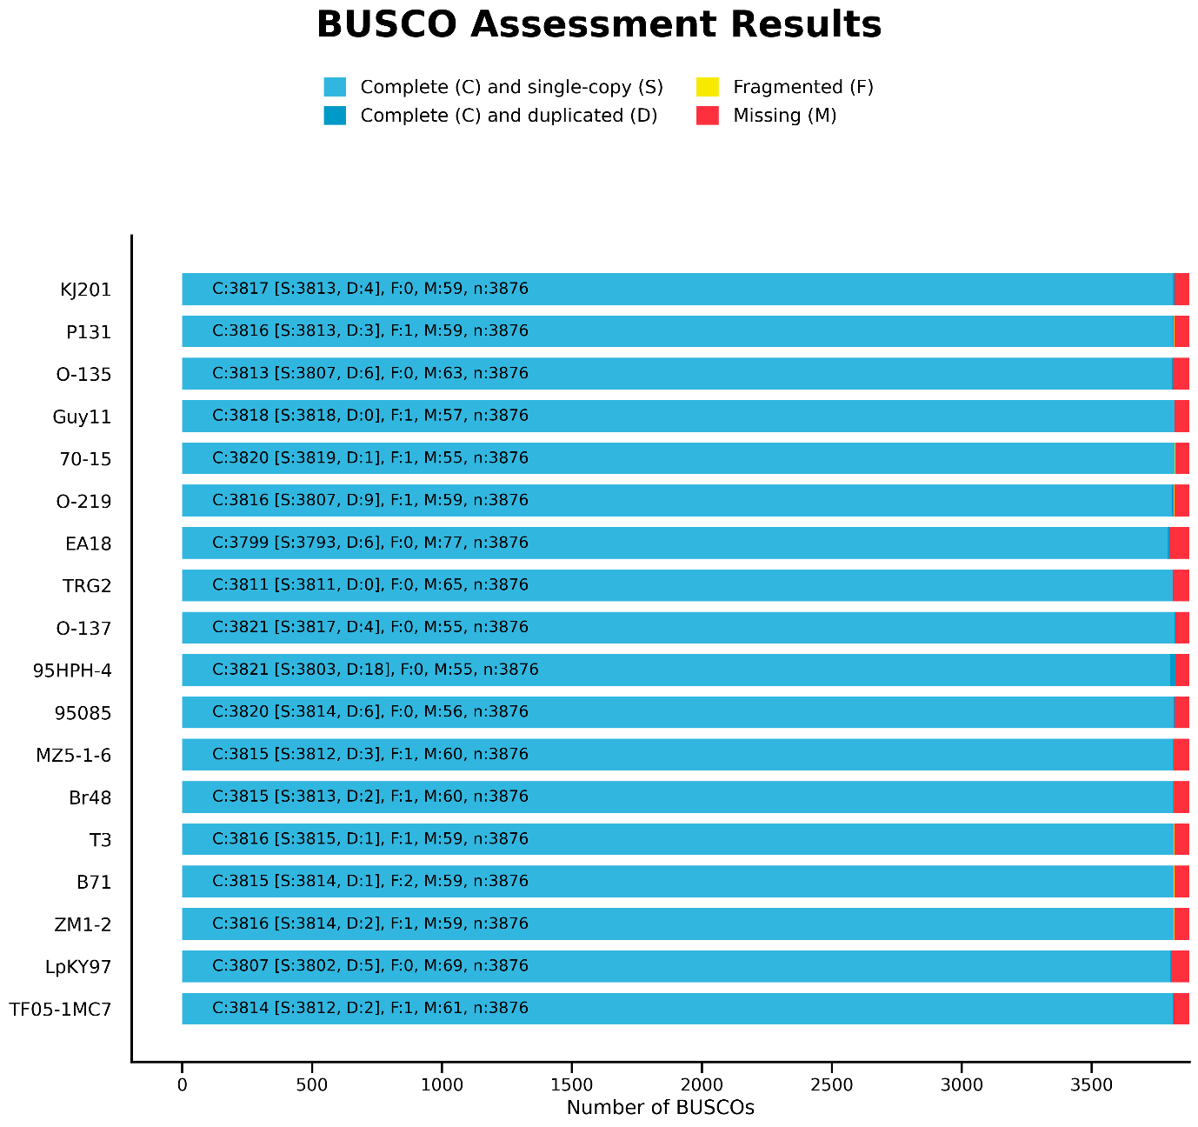Supplementary Figure S1. BUSCO completeness comparison of KJ201 and public M. oryzae genome assemblies.
Genome completeness of the chromosome-level KJ201 assembly and 17 public M. oryzae genome assemblies was assessed using BUSCO with the sordariomycetes_odb12.2 lineage dataset. Horizontal stacked bars show the number of BUSCO groups classified as complete single-copy (S), complete duplicated (D), fragmented (F), or missing (M) for each assembly. The total number of BUSCO groups assessed was 3,876.

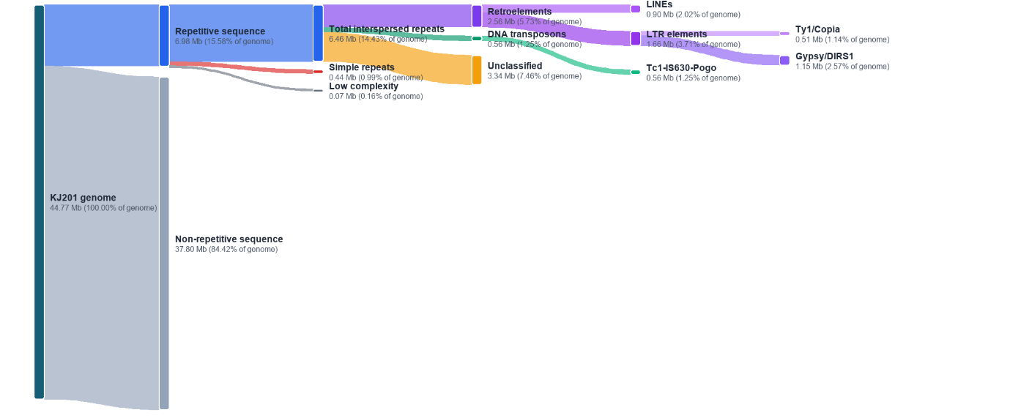
Supplementary Figure S2. Repeat composition of the KJ201 chromosome-level genome assembly.
Sankey diagram showing the classification of repetitive and non-repetitive sequences in the final KJ201 genome assembly. The KJ201 assembly comprised 44.77 Mb, including 37.80 Mb of non-repetitive sequence and 6.98 Mb of repetitive sequence. Repetitive sequences included simple repeats, low-complexity regions, and interspersed repeats. Interspersed repeats were further classified into unclassified repeats, retroelements, and DNA transposons. Retroelements included LTR elements and LINEs, with LTR elements further subdivided into Gypsy/DIRS1 and Ty1/Copia elements. Values indicate repeat length and percentage of the total genome assembly.

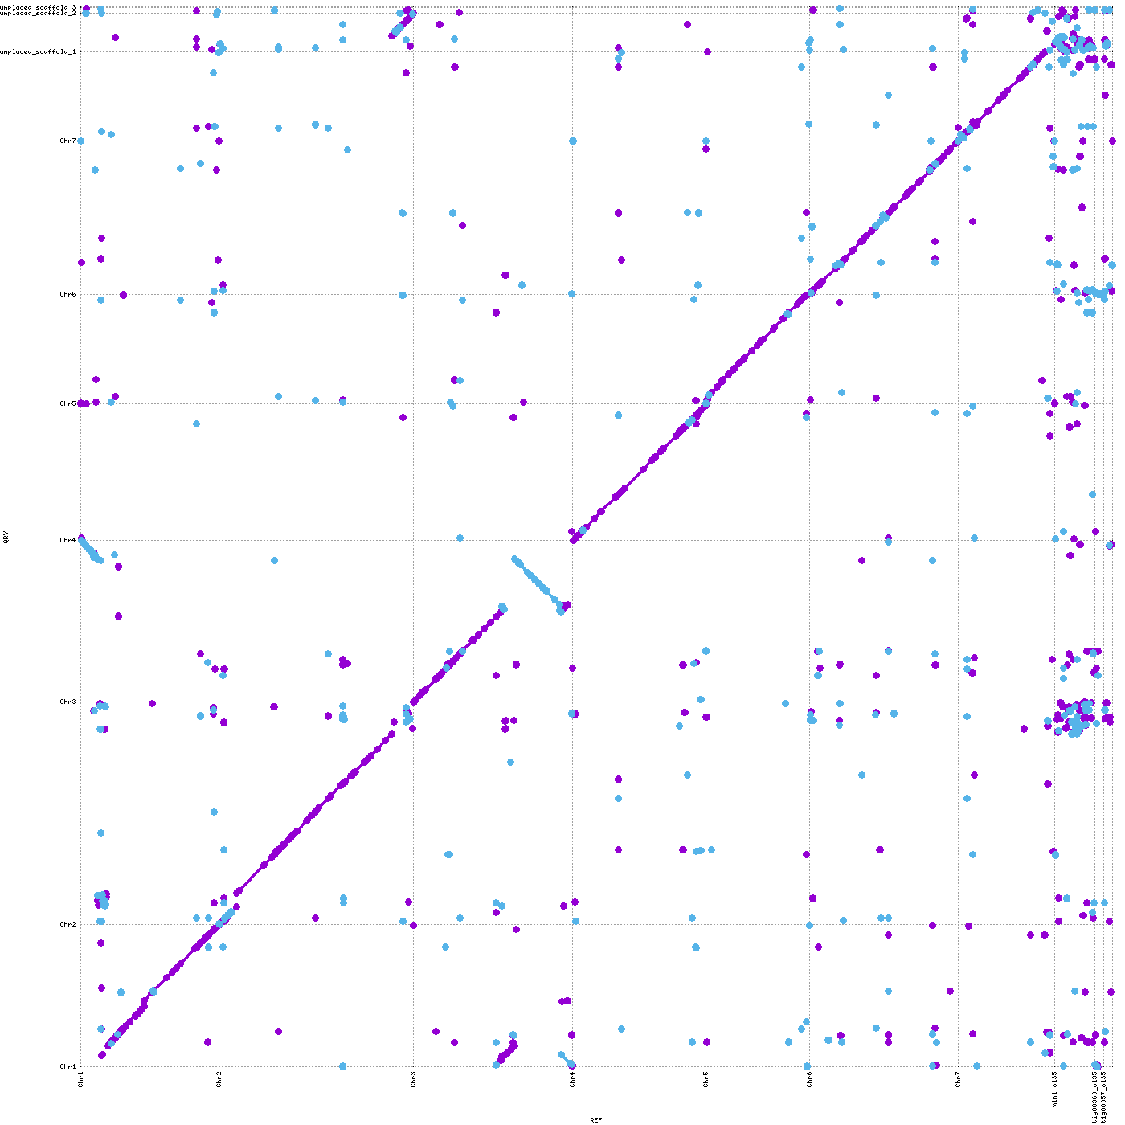
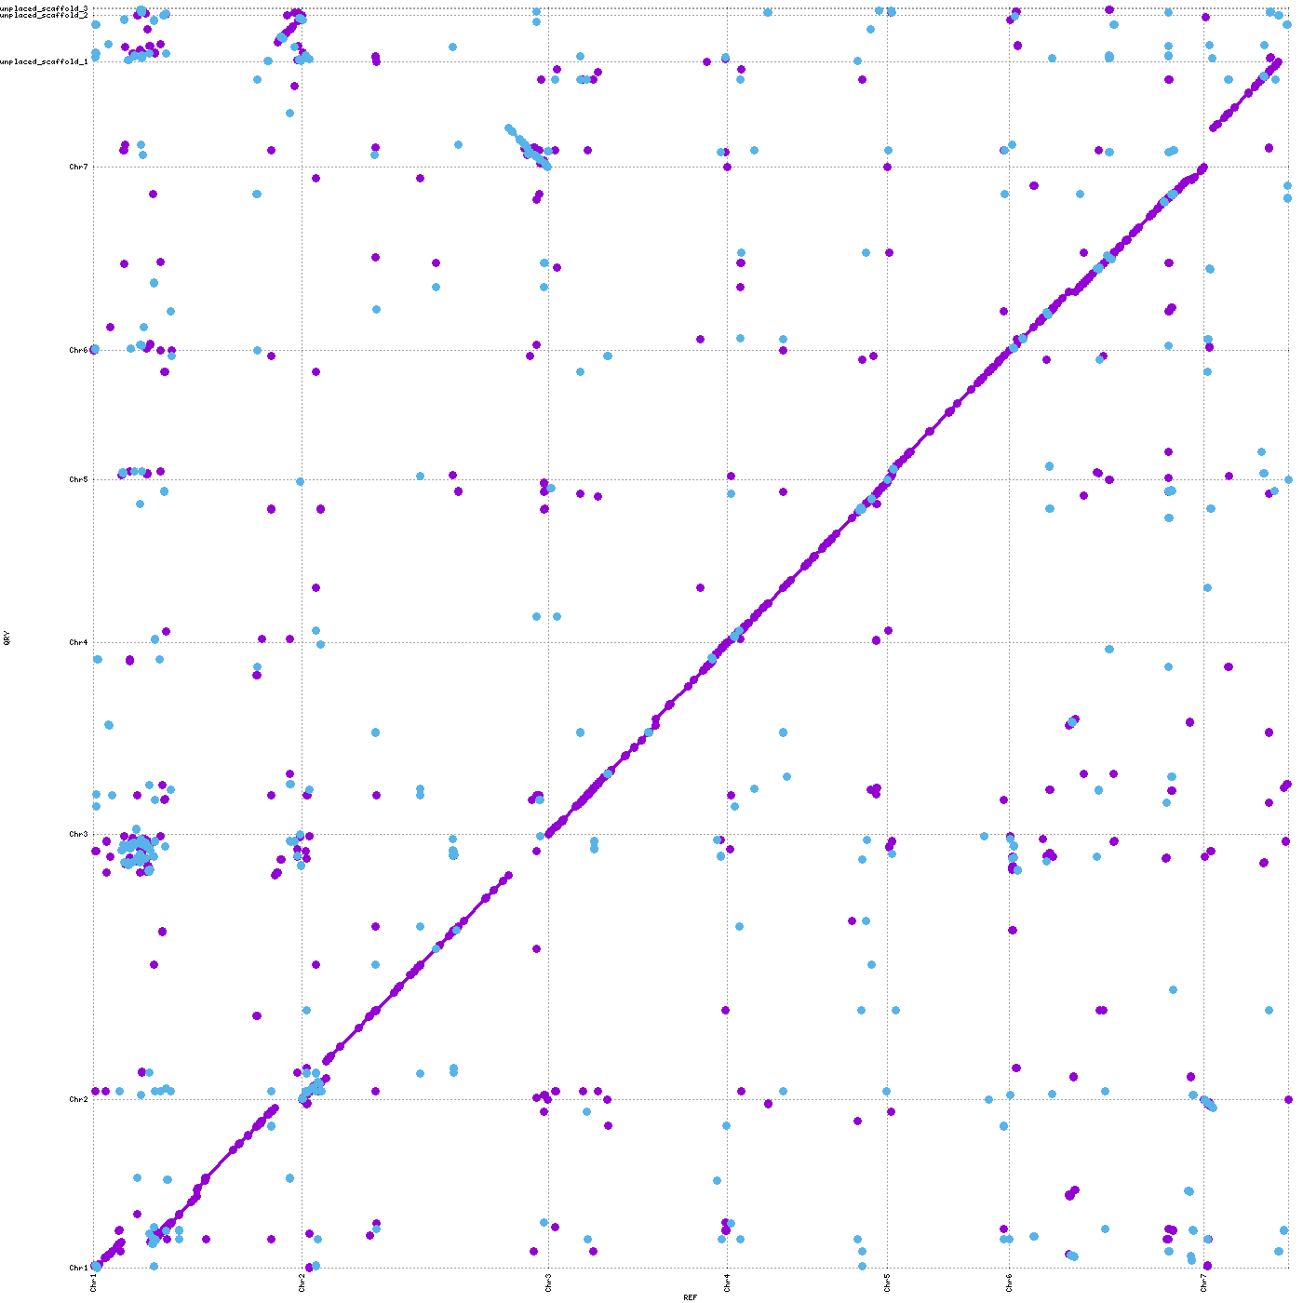
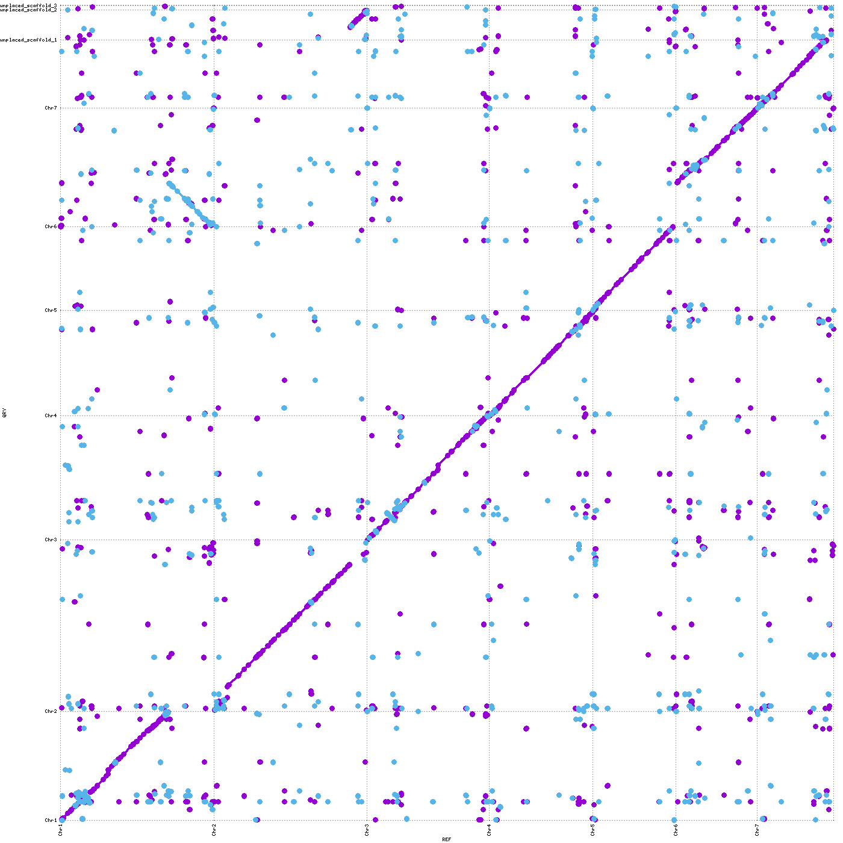
O-135
P131
70-15
KJ201
Supplementary Figure S3. Pairwise MUMmer dotplot comparisons of KJ201 with 70-15, O-135, and P131.
Pairwise whole-genome alignments were generated using MUMmer to compare the chromosome-level KJ201 assembly with representative rice-pathotype genomes. Dotplots show comparisons between KJ201 and 70-15, O-135, and P131 from left to right. The dominant diagonal alignment patterns indicate broad chromosome-scale collinearity between KJ201 and the compared genomes. Local breaks, scattered off-diagonal matches, and short reverse-orientation signals indicate repetitive regions, local rearrangements, inversions, or assembly-specific differences.

