Supplementary Figures
Legends
Supplementary Figure 1
Amplification of MTHFD2:PCR product was run on 2% agarose gel for 30 minutes at 90 V and 400 mA. 5 µl PCR product along with loading dye 2 µl was loaded in each well. As for size marker 100 bp ladder was used. NC represents the negative control for the PCR reaction. Bands were visible which indicates that amplification of target gene MTHFD2 occurred at 214bp size
Supplementary Figure 2
Amplification of SNP rs1667627:PCR product was run on 1.5% agarose gel. 5 µl PCR product along with loading dye 2 µl was loaded in each well. As for size marker 100 bp ladder was used. NC represent the negative control for the PCR reaction. Bands were visible which indicates that amplification of SNP rs1667627 occurred at 433bp size.

Supplementary Figure 1
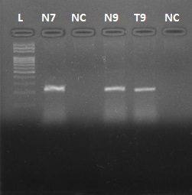
214 bp
100bp

Supplementary Figure 2
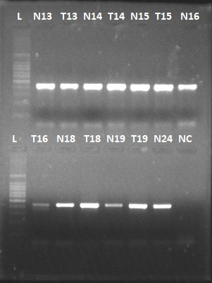
100bp
500bp
433bp

100bp

433bp

