Contents
Supplemental methods 1. Calculation of weight lifestyle scores
Supplemental Table 1. Details information for covariates.
Supplementary Table 2. Details information for lifestyle score.
Supplementary Table 3. The associations between seven lifestyle factors and the risk of SCA.
supplementary table 4.the association between healthy lifestyle scores and competing transition pathways of SCA development trajectory.
Supplementary table 5. Sensitivity analysis of the associations between lifestyle and incidence SCA.
Supplementary table 6. Sensitivity analysis of the associations between lifestyle score and main transition pathways of SCA development trajectory.
Supplementary table 7. Sensitivity analysis of the associations between lifestyle score and competing transition pathways of SCA development trajectory.
Supplementary Figure 1. Schoenfeld residual plots for lifestyle factors. Including lifestyle score, lifestyle class, ethnicity, social connection, diet, physical activity, sleep duration, alcohol consumption and smoking status.
Supplementary Figure 2. subgroup and stratified analyses of the associations between lifestyle score and incident SCA.

Supplemental methods
1. Calculation of weight lifestyle scores

since the impact of each lifestyle factor on SCA and SCA-associated disease trajectories varied, the classical lifestyle score calculation method may lead to biased estimates of the impact of incident SCA, for this reason, we introduced a weighted lifestyle score, the specific calculations are based on the following steps:

1.Variable Selection: Multiple lifestyle-related variables (e.g., smoking, drinking, sleep, physical activity, diet, social connection, and sedentary behavior) are selected as independent variables for the analysis, for each of the seven lifestyle factors, each factor was sequentially identified as an exposure and added to the model along with the other six factors and covariates

2.Extraction of Regression Coefficients: Hazard Ratios (HRs) for each variable are calculated using a Cox regression model. The regression coefficient is extracted using the formula $coef=∣ln\left(HR\right)∣$ , representing the importance of each variable as a weight.

3.Weighted Calculation: A weighted lifestyle score is calculated using the extracted regression coefficients to weight each lifestyle variable. The formula is:
$$\text{weight lifestyle score}=10⋅(\text{smoking_status }⋅w_{1}$$
$$+\text{alcohol consumption}⋅w_{2}$$
$$+\text{sleep duration}⋅w_{3}$$
$$+\text{physical activity}⋅w_{4}$$
$$+\text{diet}⋅w_{5}$$
$$+\text{social connection}⋅w_{6}$$
$$+\text{sedentary time}⋅w_{7})/\sum_{j=1}{7}w_{j}$$
In this case, $\sum_{j=1}{7}w_{j}$is equal to 1, so the equation can be simplified as: $\text{weight lifestyle score}=10⋅(\text{smoking_status }⋅w_{1}+\text{alcohol consumption}⋅w_{2}+\text{sleep duration}⋅w_{3}+\text{physical activity}⋅w_{4}+\text{diet}⋅w_{5}+\text{social connection}⋅w_{6}+\text{sedentary time}⋅w_{7})$.

4.Normalization
The weighted score is normalized to a range of 0 to 10 for easier interpretation.
This method effectively integrates information from multiple lifestyle factors into a composite index, reflecting their overall influence, making it suitable for health risk assessment and epidemiological research.
Supplemental Table 1. Details information for covariates.
Covariates | Field ID | Definition
Age | 21022 | Continuous variable.
Sex | 31 | Participants were categorized as male or female.
Ethnicity | 21000 | Participants were categorized into two groups: White and Others.
Education | 6138 | Participants from the UK Biobank baseline touchscreen questionnaire were classified into seven groups based on their reported educational qualifications: (1) College or University degree; (2) A levels/AS levels or equivalent; (3) O levels/GCSEs or equivalent; (4) CSEs or equivalent; (5) NVQ, HND, HNC or equivalent; (6) Other professional qualifications (e.g., nursing, teaching); and (7) None of the above. For analysis, groups 1, 5, and 6 were classified as 'higher vocational qualifications or more', while the remaining groups were categorized as 'lower vocational qualifications or less'.
Townsend Deprivation Index [TDI] | 22189 | Townsend deprivation index calculated immediately prior to participant joining UK Biobank. Based on the preceding national census output areas. Each participant is assigned a score corresponding to the output area in which their postcode is located. The score is based on four variables: households without a car, overcrowded households, households not owner occupied and persons unemployed.
BMI | 21001 | BMI, measured in kg/m², was calculated based on height and weight measured at the initial assessment center visit. Continuous variable.
Hypertension | 41270 | Incidence data for hypertension were obtained from hospital inpatient data, defined by the ICD-10 code I10-I13, I15.
Type 2 diabetes | 41270 | Incidence data for T2D were obtained from hospital inpatient data, defined by the ICD-10 code E11.
Dyslipidemia | 41270 | Incidence data for dyslipidemia were obtained from hospital inpatient data, defined by the ICD-10 code E79.0.

Supplemental Table 2. Details information for lifestyle score.
Lifestyle factors | Field ID | Definition
Smoking | 20116 | Participants were categorized into two groups based on their responses of questionnaires: Not smoking and Previous/current smoking.
Physical activity | 884,894,  904,914 | Regular physical activity was defined as meeting one of the following criteria:  (i) Frequency: vigorous activity once or moderate physical activity at least 5 days per week;  (ii) Time: vigorous activity for at least 75 minutes or moderate activity for 150 minutes per week.
Diet | Vegetable:1289(tablespoons cooked vegetables/day),1299(salad/raw vegetables/day);  Fruits:1309(pieces fresh fruit/day),1319(pieces dried fruit/day);  Fish:1329(oily fish/week),1339(non-oily fish/week);  Whole grains & refined grains:1438(whole meal or wholegrain bread slices/week),1448(whole meal or wholegrain bread slices/week),1458(bran/oat/muesli cereal bowls/week),1468(bran/oat/muesli cereal bowls/week);  Processed meats:1349(processed meat/week or daily),3680(age when last ate meat);  Unprocessed meats:1359(poultry/week or daily),1369(beef/week or day),1379(lamb or mutton/week or day),1389(pork/week or day),3680(age when last ate meat). | Based on the intake of seven components:  (1) vegetables (≥3servings/day);  (2) fruit (≥3servings/day);  (3) fish (≥2servings/day);  (4) whole grains (≥3servings/day);  (5) refined grains (≤ 2 servings/day);  (6) processed meat (≤1 servings/week);  (7) unprocessed meat (≤2 servings/week);  Having more than a half (i.e., 4 and more) of a healthy components’ intake were considered healthy.  Amount per serving: 1309 – 1 piece; 1319 – 5 pieces;1289, 1299 – 3heaped tablespoons; 1329, 1339 – once/week; 1438, 1448 – 1 slice/day; 1458, 1468 – 1 bowl/day; 1349 – 1 once/week; 3680 – 0 pieces/day if indicated having never eaten meat.
Alcohol consumption | 20117,1568,1578,1588,1598,1608,5364,4407,4418,4429,4440,4451,4462 | Up to 28 grams of alcohol per day for men or 14 grams of alcohol per day for women is considered healthy.
Sleep duration | 1160 | 7 to 9 hours of sleep is considered a healthy sleep pattern.
Social connection | 709,1031,6160 | 1. Number of household members (those living alone score l point).  2. Frequency of visits with friends/family (those visiting once a month, a few times a year, never or almost never, or having no family or friends score l point).  3. Participation in leisure/social activities (those not participating score l point).  The lower the score, the more frequent the social connections. A score of 0 is classified as least isolated. As score of 1 as moderately isolated, and a score of 2-3 as most isolated. A score of 0-1 is considered to have good social connections.
Sedentary behavior | 1,070,1,080 | Based on the sum of self-reported daily television viewing and computer use (excluding computer use at work) on the Global Physical Activity Questionnaire (GPAQ), according to the recommendations of the World Health Organization (WHO) and previous studies, a sedentary time of less than 4 hours.

Supplementary Table 3. The associations between seven lifestyle factors and the risk of SCA.
 | Total | Person years | Events | Model a |  | Model b
 |  |  |  | HR (95%CI) | P | HR (95%CI) | P
Smoking status
Current smoking | 40961 | 527304 | 386 | Ref |  | Ref
Never/previous smoking | 364009 | 4826285 | 1908 | 0.49(0.44,0.55) | 2.49×10⁻³⁶ | 0.51(0.45,0.57) | 2.21×10⁻³²
Alcohol consumption
Excessive drinking | 142931 | 1903977 | 779 | Ref |  | Ref
Moderate drinking | 262039 | 3449613 | 1515 | 1.04(0.96,1.14) | 0.356 | 1.00(0.91,1.09) | 0.966
Sleep duration
Unfavorable sleep | 287658 | 3802225 | 1639 | Ref |  | Ref
Favorable sleep | 117312 | 1551364 | 655 | 0.92(0.84,1.01) | 0.087 | 0.96(0.87,1.05) | 0.345
Physical activity
Irregular physical activity | 83775 | 1097437 | 621 | Ref |  | Ref
Regular physical activity | 321195 | 4256152 | 1673 | 0.67(0.61,0.74) | 3.01×10⁻¹⁷ | 0.77(0.70,0.84) | 2.20×10⁻⁸
Diet
Unhealthy diet | 239065 | 3151253 | 1445 | Ref |  | Ref
Healthy diet | 165905 | 2202337 | 849 | 0.90(0.83,0.98) | 0.016 | 0.94(0.86,1.02) | 0.144
Social connection
Unhealthy social connection | 53871 | 699446 | 372 | Ref |  | Ref
Healthy social connection | 351099 | 4654144 | 1922 | 0.76(0.68,0.85) | 1.10×10⁻⁶ | 0.82(0.73,0.92) | 5.04×10⁻⁴
Sedentary time
Unhealthy sedentary | 176560 | 2307149 | 1292 | Ref |  | Ref
Healthy sedentary | 228410 | 3046441 | 1002 | 0.73(0.67,0.80) | 2.91×10⁻¹³ | 0.86(0.79,0.94) | 9.42×10⁻⁴
Model a: age, sex
Model b: age, sex, ethnicity, education level, assessment center, TDI, BMI, T2D, hypertension, dyslipidemia
Definition of abbreviations: CI = confidence interval; HR = hazard ratio; SCA = sudden cardiac arrest.

Supplementary table 4. The association between healthy lifestyle scores and competing transition pathways of SCA development trajectory.
 | Cases | Transition proportions* | Lifestyle score*
 | Cases | Transition proportions* | HR (95%CI) | P value
MACE as intermediate disease
Baseline → SCA | 581 | 0.12% | 0.84 (0.79,0.90) | 2.01×10⁻⁷
Baseline → death | 17772 | 4.64% | 0.82 (0.81,0.83) | 9.82×10⁻²¹⁹
MACE → MACE + death | 9373 | 16.86% | 0.85 (0.84,0.86) | 3.62×10⁻⁸³
SCA → SCA + death | 1152 | 63.86% | 0.92 (0.88,0.96) | 3.48×10⁻⁴
IHD as intermediate disease
Baseline → SCA | 888 | 0.23% | 0.83 (0.79,0.88) | 4.12×10⁻¹¹
Baseline → death | 22989 | 6.01% | 0.82 (0.82,0.83) | 1.25×10⁻²⁸⁰
IHD → IHD + death | 4156 | 13.57% | 0.83 (0.81,0.85) | 3.17×10⁻⁴⁸
SCA → SCA + death | 1152 | 63.86% | 0.92 (0.88,0.96) | 3.48×10⁻⁴
Arrhythmia and heart failure as intermediate disease
Baseline → SCA | 889 | 0.23% | 0.85 (0.81,0.90) | 6.94×10⁻⁰⁹
Baseline → death | 20738 | 5.42% | 0.82 (0.81,0.83) | 1.58×10⁻²⁶⁵
arrhythmia and heart failure → arrhythmia and heart failure + death | 6407 | 19.27% | 0.84 (0.83,0.86) | 4.20×10⁻⁶¹
SCA → SCA + death | 1152 | 63.86% | 0.92 (0.88,0.96) | 3.48×10⁻⁴
Stroke as intermediate disease
Baseline → SCA | 1693 | 0.44% | 0.84 (0.81,0.88) | 2.10×10⁻¹⁷
Baseline → death | 24686 | 6.45% | 0.82 (0.81,0.83) | 3.97×10⁻³¹⁷
Stroke → Stroke + death | 2459 | 28.56% | 0.91 (0.88,0.94) | 1.05×10⁻⁹
SCA → SCA + death | 1152 | 63.86% | 0.92 (0.88,0.96) | 3.48×10⁻⁴
*Transition proportions refer to the proportion of people transitioning from the former state to the latter state.
*The model adjusted for age, sex, ethnicity, education level, assessment center, TDI, BMI, T2D, hypertension, dyslipidemia.
Definition of abbreviations: CI = confidence interval; HR = hazard ratio; IHD = ischaemic heart disease; MACE = major adverse cardiovascular events; SCA = sudden cardiac arrest;

Supplementary table 5. Sensitivity analysis of the associations between lifestyle and incidence SCA.
 | Total | Person years | Events | Model a |  | Model b
 |  |  |  | HR (95%CI) | P | HR (95%CI) | P
Introduced a weighted lifestyle score to replace classic lifestyle score
weight lifestyle score | 404970 | 5353590 | 2294 | 0.87 (0.86,0.89) | 1.44×10⁻⁵⁸ | 0.89 (0.87,0.90) | 8.78×10⁻⁴¹
Excluded participants who developed SCA within two years of entering the cohort
continuous variable
Lifestyle score | 404825 | 5353444 | 2149 | 0.83 (0.80,0.86) | 1.25×10⁻²⁶ | 0.87 (0.84,0.91) | 4.66×10⁻¹⁴
categorical variable
Unfavorable lifestyle | 4623 | 57728 | 59 | Ref |  | Ref
Moderate lifestyle | 193473 | 2544554 | 1179 | 0.40 (0.31,0.53) | 1.24×10⁻¹¹ | 0.44 (0.34,0.57) | 7.75×10⁻¹⁰
Favorable lifestyle | 206729 | 2751162 | 911 | 0.31 (0.24,0.40) | 3.31×10⁻¹⁸ | 0.38 (0.29,0.49) | 5.63×10⁻¹³
Excluded participants who diagnosed with any type of cancer before baseline
continuous variable
Lifestyle score | 368634 | 4891855 | 2028 | 0.83 (0.80,0.86) | 5.28×10⁻²⁶ | 0.87 (0.84,0.90) | 8.45×10⁻¹⁵
categorical variable
Unfavorable lifestyle | 4220 | 52882 | 59 | Ref |  | Ref
Moderate lifestyle | 176207 | 2326912 | 1118 | 0.39 (0.30,0.51) | 2.24×10⁻¹² | 0.42 (0.33,0.55) | 1.67×10⁻¹⁰
Favorable lifestyle | 188207 | 2512061 | 851 | 0.30 (0.23,0.39) | 2.19×10⁻¹⁹ | 0.36 (0.27,0.46) | 3.26×10⁻¹⁴
Model a: age, sex
Model b: age, sex, ethnicity, education level, assessment center, TDI, BMI, T2D, hypertension, dyslipidemia
Definition of abbreviations: CI = confidence interval; HR = hazard ratio;

Supplementary table 6. Sensitivity analysis of the associations between lifestyle score and main transition pathways of SCA development trajectory.
 | Cases | Transition proportions* | HR (95%CI) | P value
Introduced a weighted lifestyle score to replace classic lifestyle score
MACE as intermediate disease
Baseline → MACE | 55583 | 14.52% | 0.94 (0.94,0.94) |  | 3.11×10⁻²⁰⁶
MACE → MACE + SCA | 1223 | 2.20% | 0.93 (0.91,0.95) |  | 7.58×10⁻¹⁰
MACE + SCA → death | 737 | 60.26% | 0.96 (0.93,0.99) |  | 0.008
IHD as intermediate disease
Baseline → IHD | 30627 | 8.00% | 0.94 (0.93,0.94) |  | 1.70×10⁻¹³⁹
IHD → IHD + SCA | 916 | 2.99% | 0.94 (0.92,0.97) |  | 2.38×10⁻⁵
IHD + SCA → death | 512 | 55.90% | 0.88 (0.82,0.94) |  | 3.39×10⁻⁴
Arrhythmia and heart failure as intermediate disease
Baseline → Arrhythmia and heart failure | 33243 | 8.69% | 0.95 (0.95,0.96) |  | 2.19×10⁻⁷¹
Arrhythmia and heart failure → Arrhythmia and heart failure + SCA | 915 | 2.75% | 0.91 (0.88,0.93) |  | 6.43×10⁻¹²
Arrhythmia and heart failure + SCA → death | 557 | 60.87% | 0.94 (0.91,0.98) |  | 0.001
Stroke as intermediate disease
Baseline → Stroke | 8609 | 2.25% | 0.92 (0.91,0.93) |  | 1.16×10⁻⁶⁸
Stroke → Stroke + SCA | 111 | 1.29% | 1.03 (0.94,1.12) |  | 0.496
Stroke + SCA → death | 82 | 73.87% | 1.20 (0.91,1.59) |  | 0.196
Excluded participants who developed SCA within two years of entering the cohort
MACE as intermediate disease
Baseline → MACE | 55534 | 14.51% | 0.93 (0.92,0.94) |  | 2.60×10⁻⁹¹
MACE → MACE + SCA | 1174 | 2.11% | 0.92 (0.88,0.97) |  | 5.49×10⁻⁴
MACE + SCA → death | 712 | 60.65% | 0.90 (0.85,0.96) |  | 0.001
IHD as intermediate disease
Baseline → IHD | 30589 | 7.99% | 0.93 (0.92,0.94) |  | 3.65×10⁻⁵⁵
IHD → IHD + SCA | 878 | 2.87% | 0.94 (0.89,0.99) |  | 0.026
IHD + SCA → death | 494 | 56.26% | 0.88 (0.82,0.94) |  | 3.39×10⁻⁴
Arrhythmia and heart failure as intermediate disease
Baseline → Arrhythmia and heart failure | 33217 | 8.68% | 0.94 (0.93,0.95) |  | 2.84×10⁻³⁷
Arrhythmia and heart failure → Arrhythmia and heart failure + SCA | 889 | 2.68% | 0.90 (0.85,0.94) |  | 5.44×10⁻⁵
Arrhythmia and heart failure + SCA → death | 541 | 60.85% | 0.86 (0.80,0.92) |  | 2.83×10⁻⁵
Stroke as intermediate disease
Baseline → Stroke | 8608 | 2.25% | 0.90 (0.88,0.92) |  | 3.60×10⁻³²
Stroke → Stroke + SCA | 110 | 1.28% | 1.11 (0.95,1.29) |  | 0.189
Stroke + SCA → death | 81 | 73.64% | 1.20 (0.91,1.59) |  | 0.196
Excluded participants who diagnosed with any type of cancer before baseline
MACE as intermediate disease
Baseline → MACE | 49515 | 14.19% | 0.93 (0.92,0.94) |  | 2.46×10⁻⁸¹
MACE → MACE + SCA | 1090 | 2.20% | 0.91 (0.87,0.96) |  | 1.59×10⁻⁴
MACE + SCA → death | 649 | 59.54% | 0.92 (0.86,0.97) |  | 0.005
IHD as intermediate disease
Baseline → IHD | 27544 | 7.89% | 0.93 (0.92,0.94) |  | 3.17×10⁻⁴⁹
IHD → IHD + SCA | 823 | 2.99% | 0.94 (0.89,0.99) |  | 0.026
IHD + SCA → death | 455 | 55.29% | 0.89 (0.83,0.95) |  | 0.001
Arrhythmia and heart failure as intermediate disease
Baseline → Arrhythmia and heart failure | 29327 | 8.40% | 0.94 (0.93,0.95) |  | 4.78×10⁻³³
Arrhythmia and heart failure → Arrhythmia and heart failure + SCA | 812 | 2.77% | 0.88 (0.83,0.93) |  | 1.59×10⁻⁵
Arrhythmia and heart failure + SCA → death | 488 | 60.10% | 0.89 (0.83,0.95) |  | 0.001
Stroke as intermediate disease
Baseline → Stroke | 7611 | 2.18% | 0.90 (0.88.0.92) |  | 2.97×10⁻²⁸
Stroke → Stroke + SCA | 97 | 1.27% | 1.12 (0.95.1.32) |  | 0.168
Stroke + SCA → death | 71 | 73.20% | 1.31 (0.96,1.78) |  | 0.084
*Transition proportions refer to the proportion of people transitioning from the former state to the latter state.
The model adjusted for age, sex, ethnicity, education level, assessment center, TDI, BMI, T2D, hypertension, dyslipidemia.
Definition of abbreviations: CI = confidence interval; HR = hazard ratio; IHD = ischaemic heart disease; MACE = major adverse cardiovascular events; SCA = sudden cardiac arrest;

Supplementary table 7. Sensitivity analysis of the associations between lifestyle score and competing transition pathways of SCA development trajectory.
 | Cases | Transition proportions* | HR (95%CI) | P value
Introduced a weighted lifestyle score to replace classic lifestyle score
MACE as intermediate disease
Baseline → SCA | 581 | 0.12% | 0.87 (0.84,0.90) | 1.24×10⁻¹⁵
Baseline → death | 17772 | 4.64% | 0.87 (0.86,0.87) | <0.001
MACE → death | 9373 | 16.86% | 0.89 (0.88,0.90) | 6.94×10⁻¹⁶⁵
SCA → death | 1152 | 63.86% | 0.96 (0.94,0.98) | 3.19×10⁻⁴
IHD as intermediate disease
Baseline → SCA | 888 | 0.23% | 0.87 (0.85,0.90) | 3.98×10-23
Baseline → death | 22989 | 6.01% | 0.87 (0.86,0.87) | <0.001
IHD → death | 4156 | 13.57% | 0.88 (0.87,0.89) | 7.51×10-91
SCA → death | 1152 | 63.86% | 0.96 (0.94,0.98) | 3.19×10⁻⁴
Arrhythmia and heart failure as intermediate disease
Baseline → SCA | 889 | 0.23% | 0.88 (0.85,0.90) | 4.59×10⁻²¹
Baseline → death | 20738 | 5.42% | 0.87 (0.86,0.87) | <0.001
Arrhythmia and heart failure + death | 6407 | 19.27% | 0.88 (0.87,0.89) | 6.71×10⁻¹²⁴
SCA → death | 1152 | 63.86% | 0.96 (0.94,0.98) | 3.19×10⁻⁴
Stroke as intermediate disease
Baseline → SCA | 1693 | 0.44% | 0.88 (0.86,0.89) | 3.39×10⁻³⁹
Baseline → death | 24686 | 6.45% | 0.87 (0.86,0.87) | <0.001
Stroke → death | 2459 | 28.56% | 0.94 (0.92,0.95) | 1.64×10⁻¹⁵
SCA → death | 1152 | 63.86% | 0.96 (0.94,0.98) | 3.19×10⁻⁴
Excluded participants who developed SCA within two years of entering the cohort
MACE as intermediate disease
Baseline → SCA | 523 | 0.14% | 0.83 (0.78,0.89) | 3.18×10⁻⁷
Baseline → death | 17772 | 4.64% | 0.82 (0.81,0.83) | 9.71×10⁻²¹⁹
MACE → death | 9373 | 16.88% | 0.85 (0.84,0.86) | 3.52×10⁻⁸³
SCA → death | 1088 | 64.11% | 0.91 (0.87,0.95) | 9.09×10⁻⁵
IHD as intermediate disease
Baseline → SCA | 819 | 0.21% | 0.84 (0.79,0.88) | 4.22×10⁻¹⁰
Baseline → death | 22989 | 6.01% | 0.82 (0.82,0.83) | 1.23×10⁻²⁸⁰
IHD → death | 4156 | 13.59% | 0.83 (0.81,0.85) | 3.17×10⁻⁴⁸
SCA → death | 1088 | 64.11% | 0.91 (0.87,0.95) | 9.09×10⁻⁵
Arrhythmia and heart failure as intermediate disease
Baseline → SCA | 808 | 0.21% | 0.85 (0.80,0.90) | 1.16×10⁻⁸
Baseline → death | 20738 | 5.42% | 0.82 (0.81,0.83) | 156×10⁻²⁶⁵
Arrhythmia and heart failure + death | 6407 | 19.29% | 0.84 (0.83,0.86) | 4.03×10⁻⁶¹
SCA → death | 1088 | 64.11% | 0.91 (0.87,0.95) | 9.09×10⁻⁵
Stroke as intermediate disease
Baseline → SCA | 1587 | 0.41% | 0.85 (0.81,0.88) | 4.39×10⁻¹⁶
Baseline → death | 24686 | 6.45 | 0.82 (0.81,0.83) | 3.91×10⁻³¹⁷
Stroke → death | 2459 | 28.57% | 0.91 (0.88,0.94) | 1.05×10⁻⁹
SCA → death | 1088 | 64.11% | 0.91 (0.87,0.95) | 9.09×10⁻⁵
Excluded participants who diagnosed with any type of cancer before baseline
MACE as intermediate disease
Baseline → SCA | 773 | 0.22% | 0.83 (0.78,0.88) | 1.87×10⁻¹⁰
Baseline → death | 18851 | 5.40% | 0.82 (0.81,0.83) | 2.84×10⁻²⁴⁹
IHD → death | 3538 | 12.84% | 0.84 (0.81,0.86) | 9.72×10⁻³⁹
SCA → death | 1010 | 63.28% | 0.91 (0.87,0.96) | 1.93×10⁻⁴
IHD as intermediate disease
Baseline → SCA | 1499 | 0.43% | 0.84 (0.81.0.88) | 2.09×10⁻¹⁶
Baseline → death | 20283 | 5.81% | 0.82 (0.81.0.82) | 2.63×10⁻²⁷⁹
Stroke → death | 2106 | 27.67% | 0.91 (0.88.0.94) | 5.90×10⁻⁸
SCA → death | 1010 | 63.28% | 0.91 (0.87.0.96) | 1.93×10⁻⁴
Arrhythmia and heart failure as intermediate disease
Baseline → SCA | 784 | 0.22% | 0.85 (0.80,0.90) | 1.36×10⁻⁸
Baseline → death | 17049 | 4.89% | 0.82 (0.81,0.83) | 9.81×10⁻²³⁰
Arrhythmia and heart failure + death | 5340 | 18.21% | 0.84 (0.82,0.86) | 9.47×10⁻⁵⁷
SCA → death | 1010 | 63.28% | 0.91 (0.87,0.96) | 1.93×10⁻⁴
Stroke as intermediate disease
Baseline → SCA | 506 | 0.14% | 0.84 (0.78,0.90) | 8.27×10⁻⁷
Baseline → death | 14509 | 4.16% | 0.82 (0.81,0.83) | 1.56×10⁻¹⁹⁰
MACE → death | 7880 | 15.91% | 0.85 (0.83,0.86) | 4.55×10⁻⁷⁵
SCA → death | 23399 | 63.28% | 0.91 (0.87,0.96) | 1.93×10⁻⁴
*Transition proportions refer to the proportion of people transitioning from the former state to the latter state.
The model adjusted for age, sex, ethnicity, education level, assessment center, TDI, BMI, T2D, hypertension, dyslipidemia.
Definition of abbreviations: CI = confidence interval; HR = hazard ratio; IHD = ischaemic heart disease; MACE = major adverse cardiovascular events; SCA = sudden cardiac arrest;

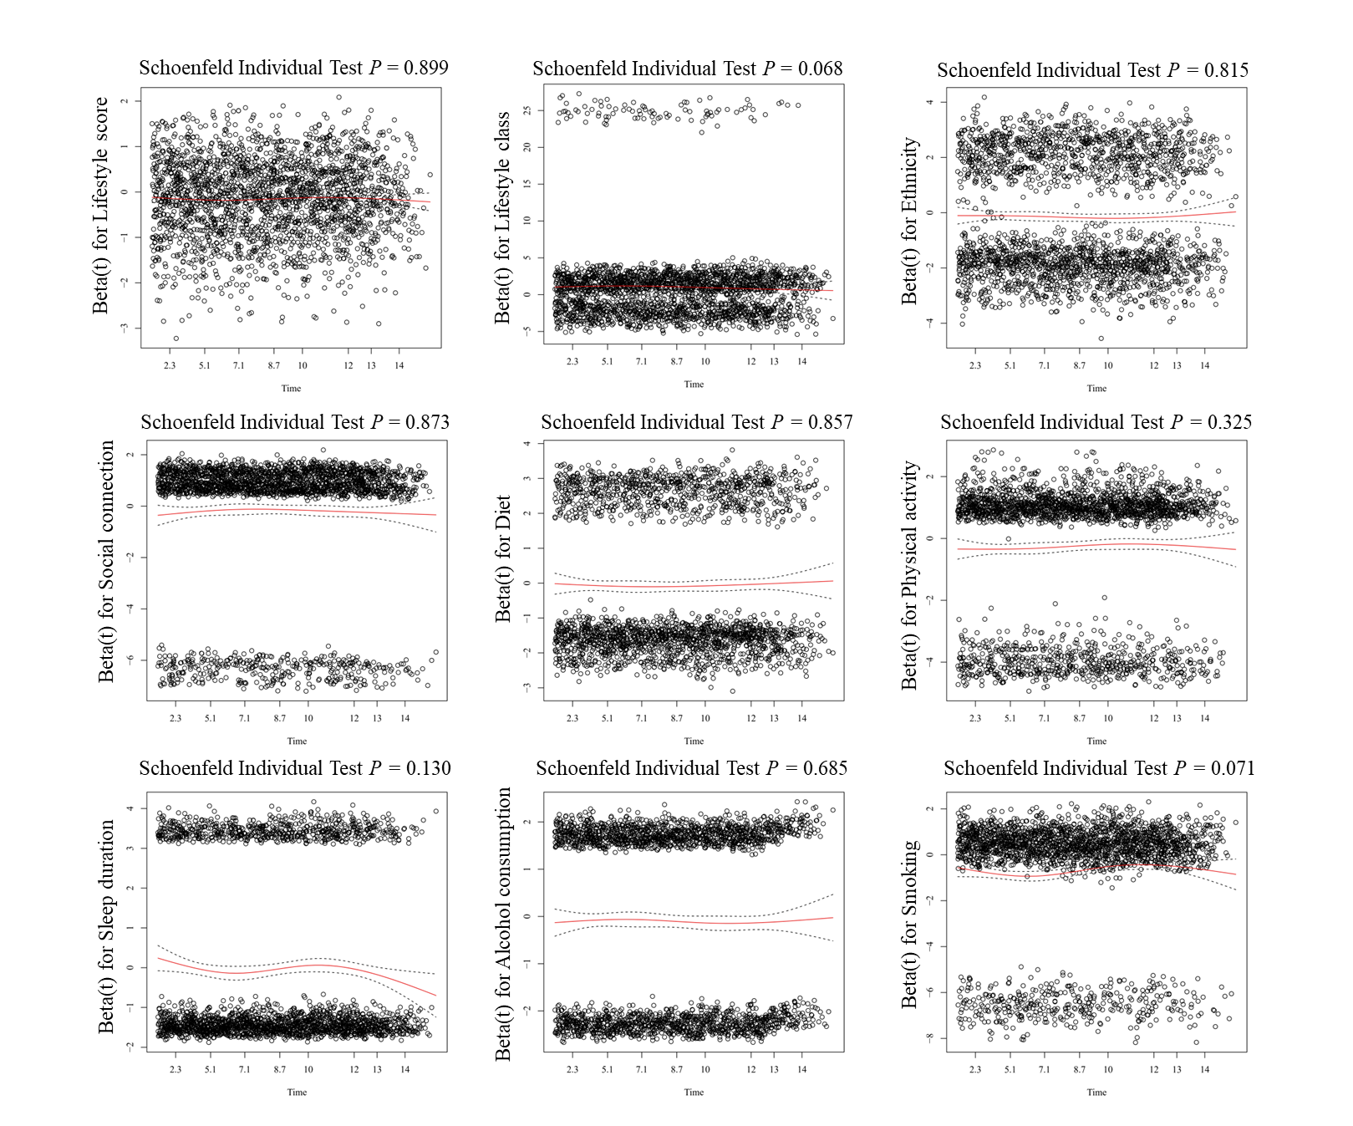

Supplementary Figure 1. Schoenfeld residual plots for lifestyle factors. Including lifestyle score, lifestyle class, ethnicity, social connection, diet, physical activity, sleep duration, alcohol consumption and smoking.

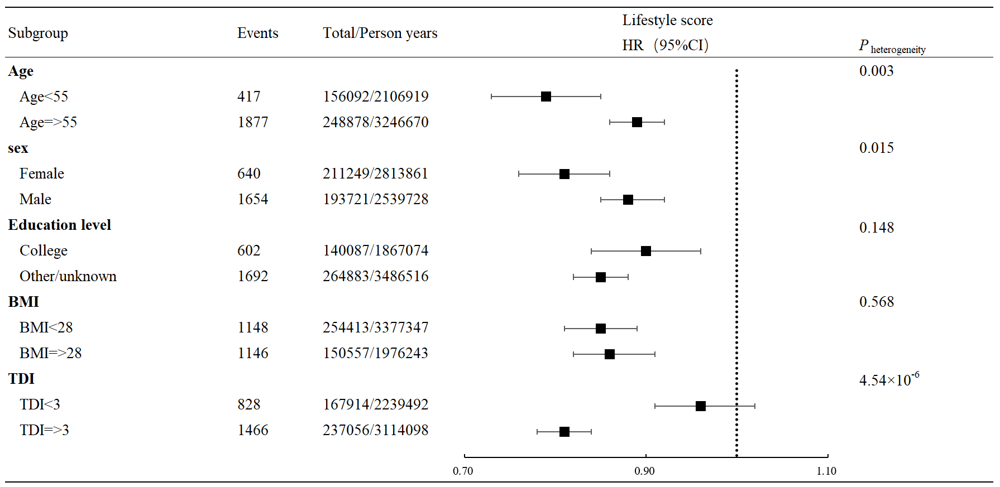

Supplementary Figure 2. subgroup and stratified analyses of the associations between lifestyle score and incident SCA.
Abbreviations: BMI = body mass index; CI = confidence interval; HR = hazard ratio; SCA = sudden cardiac arrest; TDI = Townsend deprivation index;

