Supplementary Information
This Supplementary Information provides implementation details, audit tables, and extended results that support the main manuscript. Section S1 documents analytical sample construction, CORE-8 item roles, anti-circularity checks, priority weighting, and WSQS scale interpretation. Section S2 documents predictor grouping, context encoding, and extended robustness results. Section S3 documents extended model-interpretation outputs, priority-conditioned pair mapping, nonlinear service-response summaries, and the survey-question map. Section S4 documents sample coverage and external benchmark diagnostics, including household composition, geographic reach and recruitment concentration, settlement-context and population-density coverage, and diversity in domestic water-provision arrangements.
S1. WSQS construction, coding, measurement structure diagnostics and anti-circularity
S1.1. Analytical sample construction
The final QA-passed analytical dataset contained 6,145 households from 9,562 cross-sectional survey responses. We retained records only after survey quality assurance, response cleaning, location screening, WSQS construction, and predictor processing. The primary modeling split used an 80:20 train-test partition, with 4,916 households assigned to the training set and 1,229 households assigned to the held-out test set.
A survey response was designated QA-passed only when it satisfied the following criteria:
- Data completeness: At least 95% of required survey items were completed, and no variables essential to the primary analysis had missing values.
- Valid location: The response could be assigned to a plausible inhabited location within the study region using the available and cross-validated location information. We excluded responses for which location could not be resolved, that were clearly outside the study region, or that showed major unresolved geographic inconsistencies. Exact respondent-entered latitude and longitude were not required for analytical inclusion when the remaining location information could be validated.
- Human-response verification: The response passed bot detection and integrity checks, including CAPTCHA, and showed no signs of automated or repeated submissions.
- Response-pattern validity: The response did not exhibit signs of inattentiveness or low-quality engagement, such as excessive straight-lining, contradictory answers, impossible response combinations, repeated non-substantive open-text entries, or unusually high item-level repetition.
- Duplicate-response screening: No duplicate submission was detected based on respondent identifiers, hashed contact information, device/session data, timestamps, location, or similar answer patterns.
Responses meeting all automated checks and any required manual review were retained as the final quality-assured analytical sample. Once designated QA-passed, records were not modified except through a documented correction and version-control process.
Domain-specific valid response counts varied because some survey items were missing or structurally inapplicable. Domain-level scores were calculated using available valid item responses, and aggregate WSQS outcomes were constructed using the weighting rules described in the main Methods. No item-level imputation was used to fabricate missing domain responses.
Supplementary Table S1. Analytical sample construction and modeling split.
Analytical stage | Definition | N retained | Notes
Final QA-passed household dataset | Household records retained after final QA, standardization, and lineage checks | 6,145 | Main household-level dataset
WSQS construction sample | Households with sufficient information to construct aggregate CORE-8 WSQS | 6,145 | Domain-specific valid counts vary
Equal-weight CORE-8 WSQS sample | Households with equal-weight aggregate WSQS | 6,145 | Primary non-circular modeling outcome
Population-priority CORE-8 WSQS sample | Households with population-priority-weighted aggregate WSQS | 6,145 | Sensitivity outcome using sample-average priorities
Individual-priority CORE-8 WSQS sample | Households with individual-priority-weighted aggregate WSQS | 6,145 | Sensitivity outcome using household-specific priorities
Main training sample | 80% training partition for nested CatBoost models | 4,916 | Same split structure used for M0–M3
Held-out test sample | 20% held-out partition for model evaluation | 1,229 | Used for primary validation and interpretation
Repeated-split robustness sample | Full model-ready sample resampled across repeated train-test partitions | 6,145 | Used to evaluate stability across splits
S1.2. CORE-8 WSQS construction items and anti-circularity rule
WSQS was constructed the WSQS from eight service-quality domains: affordability, access, reliability, efficiency, acceptability, perceived quality, quantity sufficiency, and customer service (the complete survey question book is presented in Table S2). We used one broad core item from each domain to construct the primary, equally weighted CORE-8 WSQS outcome. These CORE-8 items were excluded from all predictor sets.
We harmonized raw responses to a 1–5 severity scale, where 1 indicates the best service condition or lowest burden and 5 indicates the worst service condition or highest burden. The reporting transformation to the 0–100 WSQS scale is described in the main Methods. The construction items and allowed diagnostic predictors are shown below.
Supplementary Table S2. CORE-8 WSQS construction items and anti-circularity rule.
WSQS domain | CORE-8 construction item | Used in WSQS | Used as predictor | Allowed diagnostic predictors
Affordability | Q2.2 | Yes | No | Q2.3; Q2.5; Q2.8
Access | Q3.1 | Yes | No | Q3.2; Q3.3; Q3.5; Q3.6
Reliability | Q4.1 | Yes | No | Q4.2; Q4.3; Q4.4
Efficiency | Q5.1 | Yes | No | Q5.2; Q5.3
Acceptability | Q6.1 | Yes | No | Q6.2; Q6.3; Q6.4
Quality | Q7.1 | Yes | No | Q7.3; Q7.4
Quantity | Q8.1 | Yes | No | Q8.2; Q8.3; Q8.4
Customer service | Q9.1 | Yes | No | Q9.2; Q9.3; Q9.4
This crosswalk is the main anti-circularity screen. It separates broad outcome-construction items from diagnostic service-support predictors. For example, Q4.1 was used to represent the reliability domain in the WSQS outcome and was therefore excluded from the predictor set, while Q4.2, Q4.3, and Q4.4 were retained as diagnostic reliability-related service-support predictors.
S1.3. Measurement-structure diagnostics
We used exploratory factor analysis to characterize cross-item similarity, redundancy, and latent response structure among the 32 ordinal survey items spanning the eight WSQS service domains. Categorical responses were harmonized to ordered numerical scales with a consistent direction, such that lower values represented better service conditions or lower burden, and higher values represented worse service conditions or greater burden. Responses representing lack of knowledge, structural non-applicability, or conditions outside the relevant ordinal response scale were retained as missing rather than assigned artificial service-quality values. Pairwise Spearman correlations were used to characterize cross-item similarity because the underlying measures were primarily ordinal.
Sampling adequacy and overall factorability were assessed using the Kaiser–Meyer–Olkin statistic and Bartlett’s test of sphericity. The number of empirical factors was evaluated using parallel analysis, comparing observed correlation-matrix eigenvalues with the 95th percentile of eigenvalues obtained from independently permuted comparison datasets. Exploratory factor analysis was subsequently estimated using minimum-residual extraction with oblimin rotation because the underlying dimensions of household water-service experience were expected to correlate.
For diagnostic interpretation, an item was classified as having no salient loading when its largest absolute factor loading was below 0.30. Cross-loading was identified when an item had absolute loadings of at least 0.30 on two or more factors, and cross-loading was considered potentially problematic when the difference between the two largest absolute loadings was below 0.15. Pairwise absolute Spearman correlations of at least 0.80 were flagged as high similarity and correlations of at least 0.90 as potential redundancy. Cronbach’s alpha was calculated as a supplementary measure of item-set coherence. In addition to the broader 32-item diagnostic set, we calculated alpha across the eight CORE-8 construction indicators using complete observed responses, with the existing median-imputed measurement matrix used as a sensitivity analysis. Because WSQS is specified as a multidimensional service-quality composite rather than a unidimensional reflective scale, we interpreted these statistics descriptively and did not use them to define the domain structure. These diagnostics were not used to remove conceptually relevant operational indicators, redefine the eight WSQS domains, select the eight CORE-8 construction items, or estimate WSQS weights. This distinction is important because several survey measures represent complementary operational or conditional service characteristics rather than interchangeable reflective indicators of a single latent construct.
The 32-item diagnostic set showed strong factorability and substantial overall item-set coherence (KMO = 0.937; Bartlett’s χ²(496) = 40,065.6, p < 0.001; Cronbach’s α = 0.850). Parallel analysis supported retention of six empirical factors rather than a one-to-one reproduction of the eight conceptually specified WSQS domains. The clearest item clusters were defined by (i) sensory acceptability, (ii) provider responsiveness, (iii) operational performance, (iv) access burden, (v) seasonal variability, and (vi) contingency-related conditions. Only one item met the prespecified cross-loading criterion, no cross-loading was classified as problematic, and no item pair exceeded |ρ| = 0.80. Thirteen items had primary absolute loadings below 0.30, concentrated mainly among operational or conditional indicators. Together, these results indicate a multidimensional empirical response structure with limited redundancy and little substantial factor ambiguity, consistent with the broader item set capturing related but non-interchangeable dimensions of household water-service experience.
As a separate coherence diagnostic of the primary WSQS construction, the eight CORE-8 domain indicators had a Cronbach’s α of 0.757 (95% bootstrap CI, 0.747–0.767) among households with complete responses across all eight indicators. Standardized α was 0.766, with a mean inter-item Pearson correlation of 0.290 and mean inter-item Spearman correlation of 0.315. Results were effectively unchanged when the same calculation was applied to the existing median-imputed measurement matrix (α = 0.756; 95% bootstrap CI, 0.746–0.766). The near-identical complete-case and imputed estimates indicate that the observed coherence was not sensitive to the limited item-level missingness addressed in the broader measurement-diagnostics workflow.
Removal of individual CORE-8 domain indicators produced α values ranging from 0.712 to 0.760. Thus, no individual domain materially accounted for the overall coefficient. Removal of affordability produced only a negligible increase in α, from 0.757 to 0.760, whereas removal of each of the remaining domains reduced the coefficient. These results provide complementary evidence of moderate cross-domain coherence among the eight conceptually distinct WSQS components while remaining consistent with the multidimensional structure identified by the broader factor analysis. Accordingly, the reliability statistics support aggregating related service-quality dimensions within CORE-8 rather than evidence that WSQS represents a single underlying latent construct.
Supplementary Figure S1. Factor diagnostics among WSQS-related survey items.
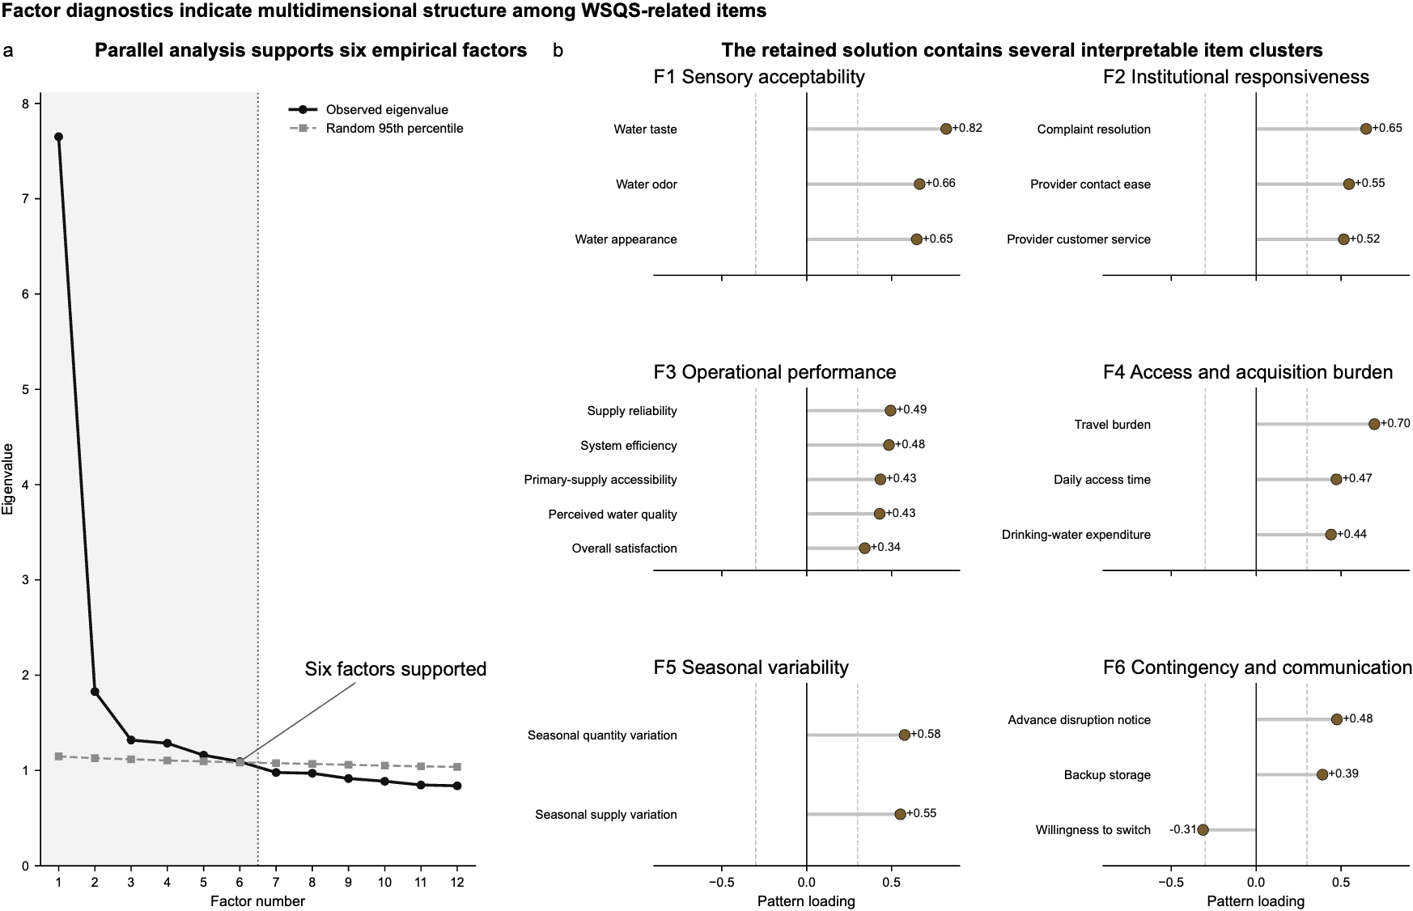

Supplementary Table S3. Overall measurement diagnostics.
Diagnostic | Result | Interpretation
Items analyzed | 32 | All requested WSQS-related items had adequate data and variation
Overall KMO | 0.937 | Excellent sampling adequacy
Bartlett’s test of sphericity | χ² (496) = 40,065.6; p < 0.001 | The correlation structure supports factor analysis
Factors retained by parallel analysis | 6 | Supports multidimensional latent organization
Overall Cronbach’s α | 0.850 | Substantial overall item-set coherence
High-correlation pairs, |ρ| ≥ 0.80 | 0 | No evidence of excessive pairwise similarity
Potentially redundant pairs, |ρ| ≥ 0.90 | 0 | No evidence of duplicate item content
Cross-loading items | 1 | Limited overlap across retained factors
Problematic cross-loadings | 0 | No substantial factor ambiguity
Weak primary loadings, |λ| < 0.30 | 13 | Mainly operational or conditional indicators

Supplementary Table S4. Internal coherence of the eight CORE-8 WSQS domain indicators.
Diagnostic | Observed complete-case analysis | Median-imputed sensitivity
Cronbach’s α | 0.757 | 0.756
95% bootstrap CI | 0.747–0.767 | 0.746–0.766
Standardized α | 0.766 | 0.766
Mean inter-item Pearson r | 0.290 | 0.290
Mean inter-item Spearman ρ | 0.315 | 0.314
Note. Cronbach’s α is reported as a descriptive measure of cross-domain coherence among the eight CORE-8 WSQS domain indicators rather than as evidence of a unidimensional reflective scale. The median-imputed sensitivity uses the same imputed measurement matrix used for the broader measurement-structure diagnostics.
Supplementary Table S5. Overall measurement diagnostics.

Item | Conceptual domain | Primary factor | Primary loading | Communality | Loading classification
Water taste | Acceptability | F1 | 0.821 | 0.677 | Salient primary loading
Water odor | Acceptability | F1 | 0.665 | 0.448 | Salient primary loading
Water appearance | Acceptability | F1 | 0.648 | 0.430 | Salient primary loading
Water clarity | Quality | F1 | 0.278 | 0.160 | No salient loading
Complaint resolution | Customer service | F2 | 0.648 | 0.429 | Salient primary loading
Provider contact ease | Customer service | F2 | 0.547 | 0.354 | Salient primary loading
Provider customer service | Customer service | F2 | 0.516 | 0.381 | Cross-loading
Peak-time shortages | Quantity | F2 | 0.267 | 0.157 | No salient loading
Weekly water volume | Quantity | F2 | −0.247 | 0.084 | No salient loading
Quality change over time | Quality | F2 | 0.246 | 0.117 | No salient loading
Quantity sufficiency | Quantity | F2 | 0.244 | 0.144 | No salient loading
Supply reliability | Reliability | F3 | 0.494 | 0.288 | Salient primary loading
System efficiency | Efficiency | F3 | 0.484 | 0.273 | Salient primary loading
Primary-supply accessibility | Access | F3 | 0.434 | 0.227 | Salient primary loading
Perceived water quality | Quality | F3 | 0.430 | 0.321 | Salient primary loading
Overall service acceptability | Acceptability | F3 | 0.342 | 0.171 | Salient primary loading
Affordability | Affordability | F3 | 0.277 | 0.123 | No salient loading
Value for money | Affordability | F3 | 0.245 | 0.137 | No salient loading
Water pressure | Reliability | F3 | 0.224 | 0.158 | No salient loading
Travel burden | Access | F4 | 0.696 | 0.493 | Salient primary loading
Daily access time | Access | F4 | 0.472 | 0.246 | Salient primary loading
Drinking-water expenditure | Affordability | F4 | 0.441 | 0.218 | Salient primary loading
Seasonal quantity variation | Quantity | F5 | 0.577 | 0.344 | Salient primary loading
Seasonal supply variation | Efficiency | F5 | 0.552 | 0.313 | Salient primary loading
Infrastructure maintenance | Efficiency | F5 | 0.191 | 0.116 | No salient loading
Repair/service delays | Customer service | F5 | 0.165 | 0.073 | No salient loading
Advance disruption notice | Reliability | F6 | 0.475 | 0.251 | Salient primary loading
Backup storage | Reliability | F6 | 0.391 | 0.177 | Salient primary loading
Willingness to switch | Acceptability | F6 | −0.312 | 0.169 | Salient primary loading
Corporation-water availability | Access | F6 | 0.290 | 0.127 | No salient loading
Supply frequency | Access | F6 | 0.290 | 0.121 | No salient loading
Affordability during disruption | Affordability | F6 | −0.258 | 0.145 | No salient loading
S1.4. Priority weighting implementation audit
Respondent-priority variables measured the importance assigned to service domains on a 0–10 scale. These variables were used to construct population-priority and individual-priority WSQS sensitivity outcomes and were also used as stated-priority predictors in the final M3 model. They were not embedded in the primary equal-weight WSQS outcome.
Table 2 (main article) reports the population-priority weights and domain-level priority summaries. The key audit point is that equal-weight WSQS was the primary modeled outcome, while population-priority and individual-priority WSQS were retained only as sensitivity outcomes.
S1.5. Supporting figures for WSQS construction and scale interpretation
Supplementary Figure S2. Agreement between WSQS weighting schemes.
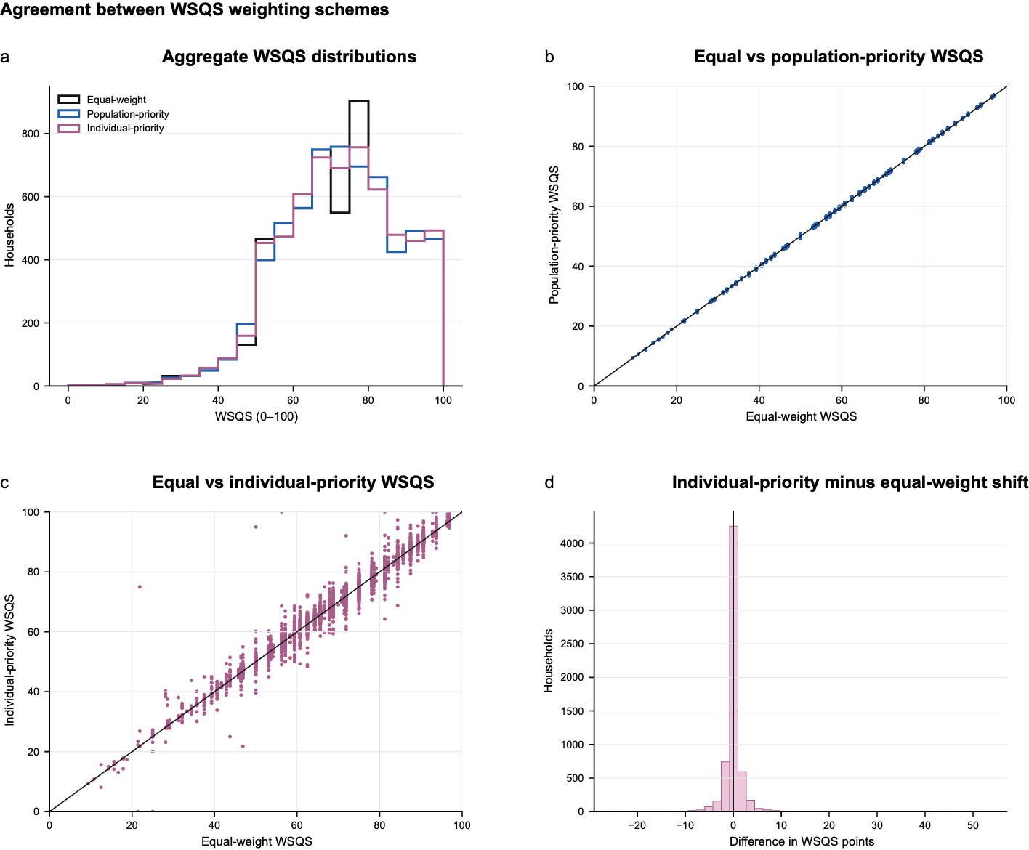
This figure compares household-level differences between population-priority and individual-priority WSQS relative to the equal-weight WSQS baseline. It supports the robustness of the WSQS framework by showing that priority weighting shifts some household-level scores without destabilizing the aggregate metric.
Supplementary Figure S3. Transformation from raw WSQS severity to 0–100 reporting scale.
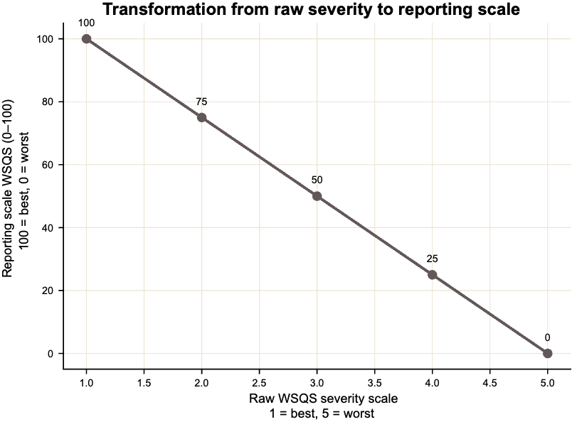
This figure shows the relationship between the raw WSQS modeling scale and the 0–100 reporting scale. The raw scale is severity-oriented, with lower values indicating better service quality and higher values indicating worse service quality. The reporting scale reverses this direction so that higher values indicate better service quality.
S2. Predictor groups, model design, and robustness
S2.1. Predictor groups and model inclusion
Predictors were grouped into three categories: diagnostic service-support variables, household-context variables, and respondent-priority variables. Service-support variables represented operational and institutional conditions associated with household water-service experience. Household-context variables represented source/regime, socioeconomic, dwelling, and household-composition characteristics. Respondent-priority variables captured the importance households assigned to service-quality domains.
The final predictor architecture contained 25 service-support predictors, 4 main household-context predictors, and 8 stated-priority predictors. Direct CORE-8 WSQS construction items were excluded from the predictor set.
Supplementary Table S6. Predictor groups and model inclusion.
Predictor group | Constructs included | M1 | M2 | M3 | Analysis use-case
Service-support | Cost, value for money, affordability disruption, access burden, waiting time, municipal availability, supply schedule, pressure, disruption notice, backup, seasonal variation, maintenance, appearance, taste, odor, clarity, quality change, volume, shortage, seasonal quantity, complaint resolution, provider contact, and infrastructure awareness | Yes | Yes | Yes | Tests whether diagnostic operational and institutional service conditions explain WSQS
Household context | Source/regime, ordered income band, household size, dwelling type | No | Yes | Yes | Tests whether household context adds information beyond service-support conditions
Respondent priorities | Affordability, access, reliability, efficiency, acceptability, quality, quantity, and customer-service priorities | No | No | Yes | Tests whether stated priorities add non-circular information beyond service-support and context
Excluded direct WSQS components | Q2.2, Q3.1, Q4.1, Q5.1, Q6.1, Q7.1, Q8.1, Q9.1 | No | No | No | Excluded to avoid mechanical outcome reconstruction
Sensitivity-only context variables | Age and gender | No | Sensitivity only | Sensitivity only | Used to test whether broader context encoding changes conclusions
S2.2. Household-context encoding
Household-context variables were encoded according to their substantive type. We treated source/regime and dwelling type as categorical predictors. Income was treated as an ordered socioeconomic category in the main model, ranging from 1 (lowest income band) to 5 (highest). Household size was treated as numeric and capped to reduce the influence of implausible outliers. Age and gender were retained only for sensitivity analyses, not for the main model.
Supplementary Table S7. Household-context variable encoding and sensitivity role.
Context construct | Raw survey column | Cleaned model variable | Encoding | Main model role
Source/regime | Q1.1 | context_source_regime_clean | Categorical | Main household context
Income | Q15.17 | context_income_ord_1low_5high | Ordered numeric, 1 low to 5 high | Main household context
Household size | Q15.10 | context_household_size_capped | Numeric, capped | Main household context
Dwelling type | Q15.14 | context_dwelling_clean | Categorical | Main household context
Age | Q15.3 | context_age_capped | Numeric, capped | Sensitivity only
Gender | Q15.2 | context_gender_clean | Categorical | Sensitivity only
Income category sensitivity | Q15.17 | context_income_cat_clean | Categorical | Sensitivity only
This encoding separates the main household-context specification from sensitivity checks. It also prevents demographic variables from driving the main interpretation while preserving them for robustness evaluation.
S2.3. Model design summary
Table 4 (main article) reports the fixed held-out nested model comparison. Supplementary Table S5 summarizes the model design and robustness structure without repeating the main performance table.
Supplementary Table S8. Model design and robustness structure.
Component | Final value / description
Primary modeling outcome | Raw equal-weight CORE-8 WSQS
Reporting outcome | Equal-weight CORE-8 WSQS on the 0–100 scale
Sensitivity outcomes | Population-priority CORE-8 WSQS; individual-priority CORE-8 WSQS
Training sample | 4,916 households
Held-out test sample | 1,229 households
Main split ratio | 80:20
Primary model | CatBoost regression
M0 | Mean-only baseline
M1 | Service-support predictors only
M2 | Service-support predictors + household context
M3 | Service-support predictors + household context + stated priorities
Main context variables | Source/regime, income, household size, dwelling type
Sensitivity context variables | Age, gender, categorical income encoding
Evaluation metrics | RMSE, MAE, R², Pearson correlation, Spearman rank correlation
Robustness checks | Repeated splits, benchmark learners, alternative WSQS outcomes, context encoding, grouped SHAP stability
S2.4. Repeated-split nested model robustness
Repeated train-test split analyses confirmed that the main nested-model pattern was stable. Across 10 repeated splits, service-support variables accounted for the main performance improvement. Household context did not materially improve performance after including service-support variables. Stated priorities produced a small additional improvement.
Supplementary Table S9. Repeated-split nested model performance.
Model | n repeats | Mean RMSE raw | SD RMSE raw | Mean R² | SD R² | Mean Spearman | SD Spearman
M0 mean-only baseline | 10 | 0.624 | 0.012 | −0.001 | 0.001 | — | —
M1 service-support | 10 | 0.415 | 0.011 | 0.556 | 0.033 | 0.733 | 0.024
M2 service + household context | 10 | 0.415 | 0.011 | 0.556 | 0.032 | 0.732 | 0.023
M3 service + household context + priorities | 10 | 0.413 | 0.011 | 0.561 | 0.032 | 0.735 | 0.024
S2.5. Benchmark comparison across model families
Benchmark comparisons showed that CatBoost performed best or comparably under the final M3 predictor set. Across five repeated splits, CatBoost had a mean RMSE of 0.413, followed by Histogram Gradient Boosting, Extra Trees, Random Forest, ElasticNet, and Ridge. The mean-only baseline had RMSE 0.625.
Supplementary Table S10. Benchmark model comparison using the final predictor set.
Learner | Model family | n repeats | Mean RMSE raw | SD RMSE raw | Mean R² | Mean Spearman
CatBoost | Nonlinear tree boosting with categorical handling | 5 | 0.413 | 0.008 | 0.563 | 0.744
Histogram Gradient Boosting | Gradient boosted trees | 5 | 0.424 | 0.009 | 0.540 | 0.724
Extra Trees | Tree ensemble | 5 | 0.425 | 0.008 | 0.537 | 0.724
Random Forest | Tree ensemble | 5 | 0.427 | 0.008 | 0.532 | 0.721
ElasticNet | Penalized linear benchmark | 5 | 0.431 | 0.007 | 0.523 | 0.709
Ridge | Linear benchmark | 5 | 0.431 | 0.007 | 0.523 | 0.709
Mean baseline | No-information baseline | 5 | 0.625 | 0.011 | 0.000 | —
These results justify using CatBoost as the primary model without making the interpretation dependent on a single learner.
S2.6. Context-specification sensitivity
Context-specification sensitivity analyses tested whether the main conclusion depended on how household context was encoded. The service-only model had a mean RMSE of 0.410 across repeated splits. Adding the main household context slightly increased RMSE to 0.411, while adding full context or categorical income produced negligible changes. Adding priorities yielded a small improvement in RMSE relative to the service-only model.
Supplementary Table S11. Context-specification sensitivity.
Specification | Context definition | Mean RMSE raw | SD RMSE raw | Mean R² | Mean Spearman | RMSE reduction vs service-only
M1 service only | No household context | 0.410 | 0.011 | 0.566 | 0.737 | 0.0000
M2 main context | Source/regime + ordered income + household size + dwelling | 0.411 | 0.010 | 0.564 | 0.737 | −0.0007
M2 full context | Main context + age + gender | 0.411 | 0.011 | 0.563 | 0.736 | −0.0011
M2 income categorical | Source/regime + categorical income + household size + dwelling | 0.411 | 0.010 | 0.564 | 0.737 | −0.0008
M3 main context + priorities | Main context + stated priorities | 0.410 | 0.011 | 0.566 | 0.738 | 0.0003
M3 full context + priorities | Full context + stated priorities | 0.409 | 0.012 | 0.567 | 0.738 | 0.0005
M3 income categorical + priorities | Income categorical context + stated priorities | 0.410 | 0.011 | 0.566 | 0.738 | 0.0002
These results indicate that the substantive conclusion is not sensitive to whether context is represented using the main specification, an expanded demographic specification, or categorical income encoding.
S3. Model interpretation and extended results
S3.1. Grouped SHAP attribution stability
Grouped SHAP attribution was evaluated in the primary held-out split and across repeated held-out splits. Both analyses produced the same qualitative ranking: service-support variables dominated, stated priorities contributed a small but nonzero share, and household context contributed the smallest share.
Supplementary Table S12. Grouped SHAP attribution in primary and repeated held-out splits.
Predictor block | Feature count | Primary held-out split share | Primary total mean absolute SHAP raw | Repeated-split mean share | Repeated-split SD share | Repeated-split mean total absolute SHAP raw
Service-support | 25 | 94.91% | 0.808 | 93.22% | 1.48% | 0.816
Household context | 4 | 0.94% | 0.008 | 2.04% | 0.65% | 0.018
Stated priorities | 8 | 4.15% | 0.035 | 4.74% | 0.92% | 0.042
This comparison shows that the service-support dominance is not a one-split occurrence. It also clarifies that the model does not ignore context, but its contribution is small once direct service-support conditions are included.
S3.2. Extended predictor-level SHAP ranking
Main Table 6 reports the top 15 predictors by mean absolute SHAP. Supplementary Figure S4 reports the extended all-predictor ranking from the final M3 model.
Supplementary Figure S4. Extended all-predictor SHAP ranking.
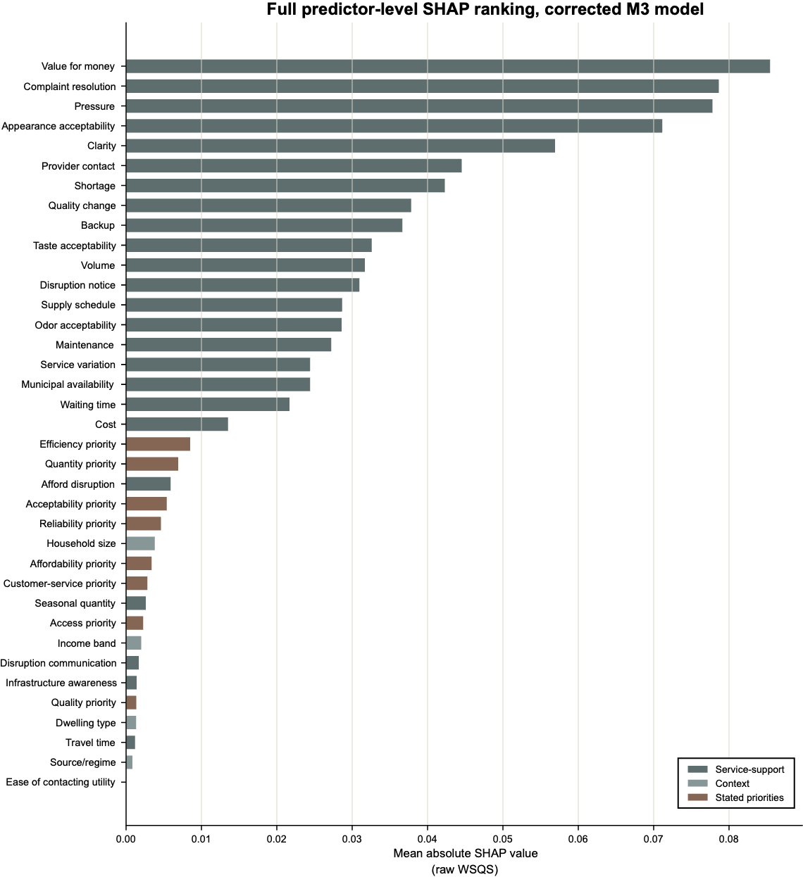
This figure reports all predictors in the final M3 model ranked by mean absolute SHAP value. It supports the main result that WSQS prediction is dominated by diagnostic service-support variables while also showing the smaller contributions of stated priorities and household context.
S3.3. Priority-conditioned service-priority pairs
Priority-conditioned contrasts were used to evaluate whether the predicted relationship between a service condition and WSQS differed by stated priority. The resolved priority-conditioned pairs linked service-support variables to their corresponding domain priorities. These contrasts were interpreted as model-based associations, not as causal interaction effects.
Supplementary Table S13. Resolved priority-conditioned service-priority pairs.
Service QID | Service variable | Priority QID | Priority variable | Pair label
Q8.2 | Weekly/available water volume | Q8.6 | Quantity priority | Available quantity × quantity priority
Q2.8 | Affordability disruption | Q2.9 | Affordability priority | Affordability disruption × affordability priority
Q2.3 | Monthly/drinking-water cost | Q2.9 | Affordability priority | Monthly cost × affordability priority
Q2.5 | Value for money | Q2.9 | Affordability priority | Value for money × affordability priority
Q3.2 | Travel time | Q3.9 | Access priority | Travel time × access priority
Q3.3 | Waiting time | Q3.9 | Access priority | Waiting time × access priority
Q3.5 | Municipal/corporation-water availability | Q3.9 | Access priority | Municipal availability × access priority
Q3.6 | Supply schedule | Q3.9 | Access priority | Supply schedule × access priority
Q4.2 | Water pressure | Q4.5 | Reliability priority | Water pressure × reliability priority
Q4.3 | Disruption notice | Q4.5 | Reliability priority | Disruption notice × reliability priority
Q4.4 | Backup reliability | Q4.5 | Reliability priority | Backup reliability × reliability priority
Q5.2 | Seasonal/service variation | Q5.4 | Efficiency priority | Service variation × efficiency priority
Q5.3 | Infrastructure maintenance | Q5.4 | Efficiency priority | Maintenance × efficiency priority
Q6.2 | Appearance acceptability | Q6.6 | Acceptability priority | Appearance × acceptability priority
Q6.3 | Taste acceptability | Q6.6 | Acceptability priority | Taste × acceptability priority
Q6.4 | Odor acceptability | Q6.6 | Acceptability priority | Odor × acceptability priority
Q7.3 | Water clarity | Q7.5 | Quality priority | Clarity × quality priority
Q7.4 | Quality change | Q7.5 | Quality priority | Quality change × quality priority
Q8.3 | Shortage experience | Q8.6 | Quantity priority | Shortage × quantity priority
Q8.4 | Seasonal quantity | Q8.6 | Quantity priority | Seasonal quantity × quantity priority
Q9.2 | Complaint resolution | Q9.5 | Customer-service priority | Complaint resolution × customer-service priority
Q9.3 | Provider contact | Q9.5 | Customer-service priority | Provider contact × customer-service priority
Q9.4 | Infrastructure awareness | Q9.5 | Customer-service priority | Infrastructure awareness × customer-service priority
Because the primary outcome is equal-weight WSQS, these priority effects are not mechanically embedded in the dependent variable.
S3.4. Nonlinear service-response summaries
Nonlinear service-response summaries were used to evaluate whether predicted WSQS changed gradually or unevenly across levels of key service-support variables. For each service variable, predicted raw WSQS severity and 0–100 WSQS were summarized across observed response levels. The endpoint contrast was defined as the difference between predicted WSQS at the worst and best observed service levels. On the raw scale, positive contrasts indicate higher predicted severity. On the 0–100 reporting scale, negative contrasts indicate lower predicted service quality.
Supplementary Table S14. Nonlinear service-response summaries.
Rank | Service variable | Predicted raw WSQS at best level | Predicted raw WSQS at worst level | Worst-minus-best raw | 0–100 equivalent | Largest adjacent raw jump
1 | Water pressure | 1.990 | 2.275 | 0.285 | −7.12 | 0.090
2 | Value for money | 1.959 | 2.201 | 0.243 | −6.07 | 0.122
3 | Appearance acceptability | 1.986 | 2.225 | 0.239 | −5.98 | 0.098
4 | Complaint resolution | 2.195 | 1.968 | −0.227 | 5.67 | 0.000
5 | Water clarity | 1.992 | 2.193 | 0.201 | −5.01 | 0.098
6 | Shortage experience | 2.026 | 2.204 | 0.179 | −4.47 | 0.060
7 | Taste acceptability | 2.054 | 2.152 | 0.098 | −2.45 | 0.040
8 | Quality change | 2.051 | 2.142 | 0.091 | −2.28 | 0.071
9 | Disruption notice | 2.065 | 2.153 | 0.088 | −2.20 | 0.043
10 | Backup reliability | 2.056 | 2.139 | 0.083 | −2.07 | 0.064
Note. The 0–100 equivalent reverses the raw severity direction because higher 0–100 WSQS values indicate better service quality. Therefore, a negative 0–100 equivalent means predicted WSQS decreases as the service condition worsens. A positive 0–100 equivalent means predicted WSQS increases across the selected endpoint comparison; this usually indicates a non-monotonic or category-specific pattern, so the variable should be interpreted from the full response curve rather than from the endpoint contrast alone.
S3.5. Supporting figure for nonlinear model interpretation.
Supplementary Figure S5. Full nonlinear service-response curves for selected top service-support variables.
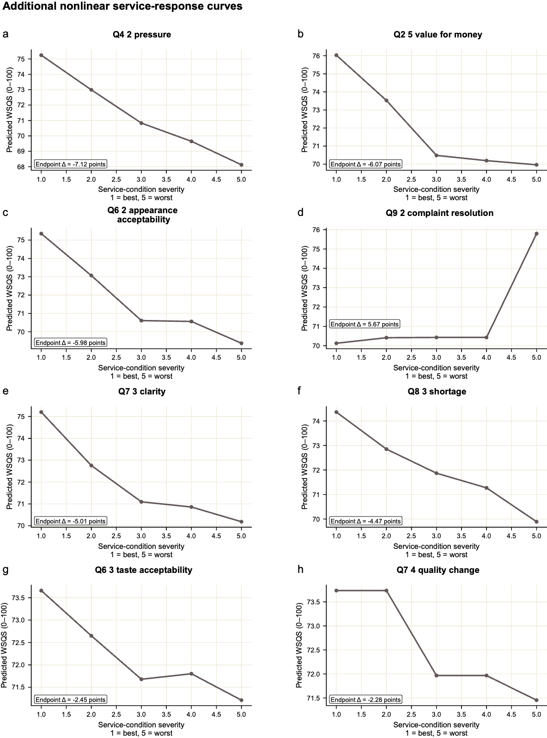
This figure extends the nonlinear-response analysis to additional service-support variables, including pressure, value for money, appearance acceptability, water clarity, shortage experience, quality change, disruption notice, and backup reliability. Values are plotted on the 0–100 reporting scale, with higher values indicating better predicted service quality.
S3.6. Interpretation safeguards
We used SHAP, priority-conditioned, and nonlinear-response analyses as predictive interpretation tools. They were not employed to identify any causal effects. Several safeguards were used to limit overinterpretation.
First, CORE-8 outcome-construction items were excluded from predictors. Second, the primary outcome was equal-weight WSQS, so stated priorities were not embedded in the dependent variable. Third, we interpreted grouped SHAP as block-level predictive attribution rather than a per-variable causal effect. Fourth, priority-conditioned curves were interpreted as model-based heterogeneity rather than causal preference interactions. Finally, we used nonlinear response curves to identify nonlinear or category-specific predictive patterns, not to estimate structural dose-response effects.
Together, these safeguards support the central interpretation that operational and institutional service-support conditions carry most of the predictable information in WSQS, while household context and stated priorities add smaller, nonzero, and interpretable contributions.
S3.7. Survey-question map, QID roles, and modeling use
The following table documents all survey questions referenced in WSQS construction, predictor screening, diagnostic tests, model interpretation, and robustness checks. Question wording is given in standardized English using the final cleaned question-book wording and response anchors. CORE-8 WSQS construction items were used to construct the primary equal-weight WSQS outcome and were excluded from all predictor sets. Diagnostic service-support variables, context variables, and stated-priority variables were used only as predictors or sensitivity variables, as indicated.
Supplementary Table S15. Survey-question map.
QID | Standardized survey question wording | Response scale / response anchors | Domain / construct | Corrected analysis role
Q1.1 | What is the main domestic water source or water-service arrangement used by your household? | Source/regime category, including municipality/corporation water, groundwater, tanker, commercial/canned water, and other sources | Source / regime | Main household-context predictor
Q1.7 | How important is overall water service quality to your household? | Stated priority / preference item | Overall service priority | Retained for sensitivity or descriptive use only; not part of corrected final M3 priority block
Q2.2 | How affordable is your household’s water service? | Very affordable to very unaffordable | Affordability | CORE-8 WSQS construction item; excluded from predictors
Q2.3 | What is your household’s monthly drinking-water cost category? | Cost categories, including non-measured or not-aware responses | Affordability / cost burden | Diagnostic service-support predictor
Q2.5 | How would you rate the value for money of your water service? | Excellent to very poor | Affordability / value for money | Diagnostic service-support predictor
Q2.8 | Does your household experience affordability-related disruption or cost stress during water-service problems? | No disruption, seasonal disruption, sometimes, often | Affordability disruption | Diagnostic service-support predictor
Q2.9 | How important is affordability when evaluating your household’s water service quality? | 0–10 stated priority scale; higher values indicate greater stated importance | Affordability priority | Stated-priority predictor; used in priority-weighted WSQS sensitivity
Q3.1 | How accessible is water for your household? | Very accessible to not accessible | Access | CORE-8 WSQS construction item; excluded from predictors
Q3.2 | How much travel time is required for your household to access or fetch water? | No travel to more than one hour | Access burden / travel time | Diagnostic service-support predictor
Q3.3 | How long does your household usually wait for water? | Zero waiting time to more than one hour | Access burden / waiting time | Diagnostic service-support predictor
Q3.5 | How available is corporation or municipal water to your household? | Available anytime, fixed timings, not accessible, or not used | Municipal/corporation water availability | Diagnostic service-support predictor
Q3.6 | What is the usual water-supply schedule or frequency for your household? | Continuous supply to every other week | Access / supply schedule | Diagnostic service-support predictor
Q3.9 | How important is access when evaluating your household’s water service quality? | 0–10 stated priority scale; higher values indicate greater stated importance | Access priority | Stated-priority predictor; used in priority-weighted WSQS sensitivity
Q4.1 | How reliable is your household’s water supply? | Always reliable to not reliable | Reliability | CORE-8 WSQS construction item; excluded from predictors
Q4.2 | How sufficient and consistent is your household’s water pressure? | Always sufficient to always low | Reliability / water pressure | Diagnostic service-support predictor
Q4.3 | How often does your household receive advance communication or announcement about water-service disruption? | Always to never; includes no communication stream | Reliability / disruption communication | Diagnostic service-support predictor, with communication-status indicator where non-invariant
Q4.4 | Does your household have backup water during water-service failure? | Sufficient backup, limited backup, no backup, or source unaffected | Reliability / backup availability | Diagnostic service-support predictor
Q4.5 | How important is reliability when evaluating your household’s water service quality? | 0–10 stated priority scale; higher values indicate greater stated importance | Reliability priority | Stated-priority predictor; used in priority-weighted WSQS sensitivity
Q5.1 | How efficient is your household’s water system or water service? | Very efficient to very inefficient | Efficiency | CORE-8 WSQS construction item; excluded from predictors
Q5.2 | Does your household experience minor or significant variations in water service? | No variation, minor variations, significant variations | Efficiency / service variation | Diagnostic service-support predictor
Q5.3 | How well maintained is the water infrastructure serving your household? | Well maintained to poorly maintained or not aware | Efficiency / infrastructure maintenance | Diagnostic service-support predictor
Q5.4 | How important is efficiency when evaluating your household’s water service quality? | 0–10 stated priority scale; higher values indicate greater stated importance | Efficiency priority | Stated-priority predictor; used in priority-weighted WSQS sensitivity
Q6.1 | Overall, how acceptable is your household’s water service? | Completely satisfied to completely dissatisfied | Acceptability / satisfaction | CORE-8 WSQS construction item; excluded from predictors
Q6.2 | How acceptable is the appearance of your household’s water? | Completely acceptable, somewhat acceptable, neutral, somewhat unacceptable, completely unacceptable | Acceptability / appearance | Diagnostic service-support predictor
Q6.3 | How acceptable is the taste of your household’s water? | Completely acceptable, somewhat acceptable, neutral, somewhat unacceptable, completely unacceptable | Acceptability / taste | Diagnostic service-support predictor
Q6.4 | How acceptable is the odor of your household’s water? | Completely acceptable, somewhat acceptable, neutral, somewhat unacceptable, completely unacceptable | Acceptability / odor | Diagnostic service-support predictor
Q6.5 | If given a choice, would your household prefer to switch to another water source or water-service system? | Categorical switching-preference responses | Switching preference / acceptability context | Retained as context/switching-preference item; not scored into WSQS
Q6.6 | How important is acceptability or satisfaction when evaluating your household’s water service quality? | 0–10 stated priority scale; higher values indicate greater stated importance | Acceptability priority | Stated-priority predictor; used in priority-weighted WSQS sensitivity
Q7.1 | How would you rate the perceived quality of your household’s water? | Excellent to very poor | Perceived quality | CORE-8 WSQS construction item; excluded from predictors
Q7.3 | How often is your household’s water clear? | Always clear to never clear | Water clarity | Diagnostic service-support predictor
Q7.4 | How has your household’s water quality changed over time? | Improved, remained the same, degraded | Quality change over time | Diagnostic service-support predictor
Q7.5 | How important is perceived water quality when evaluating your household’s water service quality? | 0–10 stated priority scale; higher values indicate greater stated importance | Quality priority | Stated-priority predictor; used in priority-weighted WSQS sensitivity
Q8.1 | How sufficient is the quantity of water available to your household? | Always sufficient to never sufficient | Quantity sufficiency | CORE-8 WSQS construction item; excluded from predictors
Q8.2 | What is the estimated quantity of water available to your household? | Liter-volume categories; includes “I don’t know” | Available quantity / volume | Diagnostic service-support predictor; liter-volume responses direction-checked so larger volume corresponds to lower severity
Q8.3 | How often does your household experience water shortages? | Never to always | Shortage frequency | Diagnostic service-support predictor
Q8.4 | Does your household experience seasonal variation in water quantity? | No variation, minor variations, significant variations | Seasonal quantity variation | Diagnostic service-support predictor
Q8.6 | How important is quantity sufficiency when evaluating your household’s water service quality? | 0–10 stated priority scale; higher values indicate greater stated importance | Quantity priority | Stated-priority predictor; used in priority-weighted WSQS sensitivity
Q9.1 | How would you rate provider or customer-service quality for your household’s water service? | Excellent to very poor; includes full in-house system where applicable | Customer service | CORE-8 WSQS construction item; excluded from predictors
Q9.2 | How often are your household’s water-service complaints resolved or responded to? | Always to never | Complaint resolution / responsiveness | Diagnostic service-support predictor
Q9.3 | How easy is it for your household to contact the water-service provider or responsible party? | Very easy to very difficult | Provider contact ease | Diagnostic service-support predictor
Q9.4 | Is your household aware of water-infrastructure upgrades or service improvements? | Yes, no, not aware | Infrastructure awareness / upgrades | Diagnostic service-support predictor
Q9.5 | How important is customer service when evaluating your household’s water service quality? | 0–10 stated priority scale; higher values indicate greater stated importance | Customer-service priority | Stated-priority predictor; used in priority-weighted WSQS sensitivity
Q15.17 | What is your household’s annual income category? | Income category | Household socioeconomic context | Main household-context predictor; ordered income encoding in primary model and categorical encoding in sensitivity analysis
Q15.10 | What is your household size? | Household size category or numeric value | Household composition | Main household-context predictor; numeric/capped encoding
Q15.14 | What type of dwelling does your household live in? | Individual house, apartment, temporary housing, other | Housing context | Main household-context predictor; categorical
Q15.2 | What is the respondent’s gender? | Female, male, choose not to specify, others | Demographic context | Sensitivity-only context variable; not included in main model
Q15.3 | What is the respondent’s age? | Open numeric age where available | Demographic context | Sensitivity-only context variable; not included in main model
S4. Sample coverage and external benchmark diagnostics
S4.1. Coverage framework and external reference data
The non-probability recruitment strategy was designed to capture heterogeneity in household water-service experiences and provision arrangements, rather than to reproduce Tamil Nadu's population distribution as detailed in the main methods section. We therefore evaluated sample coverage separately from the WSQS analysis by comparing selected observable household characteristics with independent state-level reference data and by characterizing the geographic and settlement environments represented in the survey.
These diagnostics were used to assess the breadth and composition of the observed sample, not to establish probability-based representativeness. We did not use external benchmarks for post-stratification, survey weighting, sample exclusion, WSQS construction, or model calibration. Instead, we used them to provide an independent reference for identifying where the study population overlaps with or differs from statewide distributions and for establishing the range of household and service environments over which the measurement and modeling analyses were evaluated.
The coverage analysis used 6,093 household records. The difference from the final QA-passed analytical sample of 6,145 households described in Section S1 reflects 52 records with respondent-entered latitude/longitude errors that prevented sufficiently reliable spatial characterization. The remaining location and survey information for these households was successfully validated, and the records were therefore retained in the primary WSQS analyses but excluded from the spatial coverage analysis.
Coverage was examined across household composition, housing tenure, asset ownership, geography, settlement context, population density, and primary domestic water provision. Variables were externally benchmarked only where the study and reference measures could be harmonized with reasonable conceptual consistency. Household size was compared with the Census of India 2011 Tamil Nadu household-size distribution, with NFHS-5 providing a more recent cross-check of average household size. Housing tenure was contextualized using the National Sample Survey (NSS), 76th Round and National Family Health Survey, Fifth Round (NFHS-5), and household car ownership was compared with NFHS-5 (Office of the Registrar General & Census Commissioner, India, 2011; National Statistical Office, 2019; IIPS & ICF, 2021). Geographic and settlement coverage were independently characterized using the Government of India All India Pincode Directory, the current Tamil Nadu district framework, and the Global Human Settlement Layer (Department of Posts, Government of India, 2026; Government of Tamil Nadu, 2026; Schiavina et al., 2023a,b).
Annual household income was not externally benchmarked because the principal recent official state-level datasets identified during benchmark selection measure household consumption expenditure rather than annual household income. These non-equivalent constructs were not directly compared.
Supplementary Table S16. Coverage measures, harmonization rules, and external reference data.
Coverage dimension | Study measure | Harmonization | External/reference data | Role in coverage assessment
Household composition | Household size, Q15.10 | Responses grouped as 1, 2, 3, 4, 5, 6, and 7+ persons for comparison with the statewide distribution | Census of India 2011, Tamil Nadu HH-01; NFHS-5 used as a more recent mean-household-size cross-check | Characterize household-size coverage and compositional differences
Housing tenure | Housing tenure, Q15.15 | Owned free and clear and owned with mortgage/loan combined as Owned; remaining responses classified as Rented or Other | NSS 76th Round, 2018; NFHS-5 Tamil Nadu ownership estimate used as a recent statewide ownership cross-check | Characterize housing-tenure coverage
Household asset ownership | Car ownership, Q15.13 | Literal response None treated as zero cars; households classified as No car or ≥1 car | NFHS-5 Tamil Nadu | Characterize variation in a major household asset
Geographic coverage | Household PIN code, Q15.1 | Internal whitespace removed before six-digit validation; valid PIN codes matched to postal state and district metadata; district names harmonized to current Tamil Nadu nomenclature | Government of India All India Pincode Directory; current Tamil Nadu district framework | Characterize geographic breadth and concentration
Settlement context | Validated Tamil Nadu PIN reference locations | PIN reference locations intersected with 2025 GHS-SMOD; detailed classes retained for QA and summarized as rural, suburban/peri-urban, urban cluster, and urban centre for reporting | European Commission Joint Research Centre GHS-SMOD R2023A, 2025 epoch | Independently characterize settlement-context breadth
Population-density context | Validated Tamil Nadu PIN reference locations | Local population density calculated from GHS-POP within the surrounding 3 × 3 raster neighbourhood | European Commission Joint Research Centre GHS-POP R2023A, 2025 epoch | Characterize the density gradient associated with sampled locations
Domestic water provision | Primary domestic water source, Q1.1 | Six observed provision categories retained: municipality/corporation, groundwater, lake/pond, tanker/truck, commercial/canned water, and other | NFHS-5 Tamil Nadu drinking-water-source distribution used only as contextual evidence | Characterize diversity of provision arrangements; no direct goodness-of-fit comparison because classifications are not equivalent
Note. PIN coordinates represent postal reference locations rather than exact household coordinates. NFHS-5 classifies the principal household drinking-water source, whereas Q1.1 records the primary domestic water-provision arrangement; the two measures were therefore not treated as directly equivalent.
S4.2. Household composition relative to external benchmarks
Household size was compared with the Census of India 2011 HH-01 distribution for Tamil Nadu (Office of the Registrar General & Census Commissioner, India, 2011). Study and Census responses were harmonized to categories of 1, 2, 3, 4, 5, 6, and 7+ household members. Category-specific differences were reported directly, and overall distributional similarity was summarized using total variation distance, $TVD = 1/2 Σₖ |pₖ - qₖ|$, where pₖ and qₖ denote the study and reference proportions in household-size category k. Distributional overlap was expressed as $1 - TVD$(Gibbs & Su, 2002). These quantities summarize categorical similarity and were not used as statistical tests of population equivalence.
The observed household-size distribution showed substantial overlap with the Census benchmark but was shifted toward larger households. Overall distributional overlap was 78.46%. One- and two-person households were less common than in the Census distribution, whereas four- and five-person households were more common, with the largest difference occurring among four-person households. NFHS-5 was used as a more recent temporal reference for average household size rather than as a substitute for the full Census distribution (IIPS & ICF, 2021).
Housing tenure showed closer agreement with the statewide external benchmark. Owned-free-and-clear and mortgage/loan ownership were combined as Owned, with remaining households classified as Rented or Other. Owner-occupied households comprised 67.19% of the study coverage sample compared with 66.4% in NFHS-5 Tamil Nadu (IIPS & ICF, 2021). The NSS 76th Round urban Tamil Nadu tenure distribution was included as a secondary structural comparator rather than as a statewide benchmark because it pertains specifically to urban households (National Statistical Office, 2019).
Car ownership showed a clearer compositional difference. The literal response None was coded as zero cars, and households were classified as having either no car or at least one car. One or more cars were reported by 24.16% of study households compared with 6.5% of Tamil Nadu households in NFHS-5 (IIPS & ICF, 2021). The benchmark analysis therefore identifies both dimensions of close correspondence, such as home ownership, and dimensions in which the study sample differs substantially from the statewide population distribution.
Supplementary Figure S6. Household composition and water-provision coverage relative to selected Tamil Nadu benchmarks.
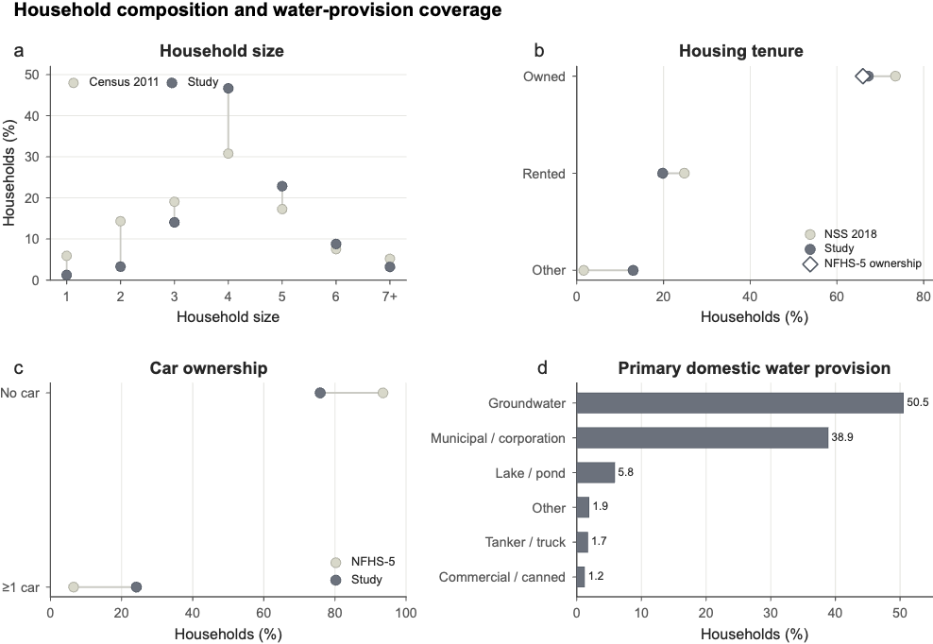
a, Household-size distribution in the study sample relative to the Census of India 2011 Tamil Nadu HH-01 benchmark. b, Housing-tenure composition relative to the NSS 76th Round urban Tamil Nadu distribution, with the NFHS-5 statewide house-ownership estimate included as a recent ownership reference. c, Household car ownership relative to NFHS-5 Tamil Nadu. d, Distribution of primary domestic water-provision arrangements reported in Q1.1. Note. External comparisons characterize observable overlap and divergence and are not tests of population representativeness. Water-provision categories are shown without a formal comparison with NFHS-5 because the two surveys measure different water-source constructs.
S4.3. Geographic reach and recruitment concentration
Household PIN codes were matched to the All India Pincode Directory (Department of Posts, Government of India, 2026). Postal district labels were subsequently harmonized to the current 38-district structure of Tamil Nadu using the Government of Tamil Nadu district framework (Government of Tamil Nadu, 2026). Unresolved district labels were retained as unmatched rather than reassigned on the basis of an assumed correspondence.
Of the 6,093 records included in the coverage analysis, 6,066 contained a valid six-digit PIN code, and 5,838 records were matched to Tamil Nadu. These records represented 632 unique Tamil Nadu PIN locations across 37 of the state's 38 current districts. The spatial footprint was broad, but recruitment was intentionally concentrated in the principal study geography, where field sampling was anchored in Salem, Karur, and Namakkal. These three districts accounted for 29.09%, 22.82%, and 21.75% of matched Tamil Nadu records, respectively, corresponding to 73.66% of the matched sample, while additional recruitment extended coverage across the rest of the state.
To distinguish geographic reach from the evenness of recruitment across districts, we summarized concentration using the effective number of districts, $Nₑ = 1 /\sum_{d}{p_{d}²}$, where $p_{d}$ denotes the proportion of matched observations in district d. This Hill-number representation converts the observed concentration into the equivalent number of equally represented districts (Hill, 1973). The effective number of districts was 5.28, despite observations being present in 37 districts. The maximum great-circle separation between matched PIN reference locations was 643.3 km. Together, these measures indicate broad geographic extension combined with concentrated recruitment in the principal fieldwork districts, rather than population-proportional statewide sampling.
Supplementary Table S17. Geographic matching, recruitment concentration, and spatial sensitivity diagnostics.
Diagnostic | Result | Interpretation
Coverage-analysis records | 6,093 | Records included in the demographic and spatial coverage analysis
Valid six-digit PIN records | 6,066 (99.6%) | Nearly complete usable PIN-code information
Invalid/non-standard PIN records | 27 (0.4%) | Small fraction excluded from PIN-based spatial characterization
Unique valid-format PIN codes | 784 | Postal-location breadth before restriction to Tamil Nadu
Records matched to Tamil Nadu | 5,838 | Records contributing to the Tamil Nadu geographic analysis
Unique matched Tamil Nadu PIN codes | 632 | Distinct matched postal locations
Current Tamil Nadu districts represented | 37/38 (97.4%) | Broad geographic footprint across the current district structure
Current district not represented | Chengalpattu | Only current district without a matched PIN location
Largest district share | Salem, 29.09% | Recruitment concentrated in a principal fieldwork district
Three largest districts | Salem, Karur and Namakkal, 73.66% | Most matched households were located in the principal study geography
Five largest districts | 81.06% | Remaining records formed a geographically dispersed long tail
Effective number of districts | 5.28 | Indicates substantial concentration despite broad nominal district coverage
Maximum PIN-centroid separation | 643.3 km | Large spatial extent across matched Tamil Nadu locations
Tamil Nadu PIN locations matched to GHSL | 632/632 (100%) | Complete settlement-context characterization for matched PIN locations
Detailed non-water GHS-SMOD classes represented | 7/7 | Full detailed non-water settlement spectrum represented
DEGURBA Level-1 classes represented | 3/3 | Rural areas, towns/semi-dense areas, and cities all represented
Four reporting-level settlement contexts represented | 4/4 | Rural, suburban/peri-urban, urban-cluster, and urban-centre environments represented
Exact-cell versus 3 × 3 GHS-SMOD agreement | 71.95% | Local classification sensitivity around postal reference locations
PIN reference coordinates intersecting a GHS-SMOD water cell | 1 | Negligible water-cell geolocation issue
S4.4. Settlement-context and population-density coverage
Settlement context was characterized independently using the 2025 epoch of the Global Human Settlement Layer GHS-SMOD R2023A (Schiavina, et al., 2023). GHS-SMOD implements the Degree of Urbanization framework using harmonized population and built-up-area information and provides a globally comparable classification of settlement environments (European Commission & Statistical Office of the European Union, 2021; Pesaresi et al., 2024).
All 632 matched Tamil Nadu PIN reference locations were assigned a GHS-SMOD class. The locations represented all seven detailed non-water settlement classes observed in the classification, all three Degree of Urbanization Level-1 classes, and all four aggregated reporting contexts used in this study: rural, suburban/peri-urban, urban cluster, and urban center. The settlement analysis therefore indicates that the study extends across the rural-to-urban gradient rather than being confined to a single settlement environment.
PIN coordinates correspond to postal reference locations rather than household GPS coordinates. To assess the sensitivity of settlement assignment to local spatial placement, the GHS-SMOD class at the coordinate-containing raster cell was compared with the modal class within the surrounding 3 × 3 raster neighborhood. Exact-cell and neighborhood-modal classifications agreed for 71.95% of matched locations. This measure is interpreted as a local spatial sensitivity diagnostic, rather than as a classification-accuracy statistic, because small shifts around a postal reference point can cross settlement-class boundaries without implying incorrect household geolocation.
Population-density context was characterized using the 2025 GHS-POP R2023A population grid (Schiavina et al., 2023b). Local population counts were summarized within the corresponding 3 × 3 raster neighborhood and divided by the geodesically calculated cell area to derive population density (people km⁻²). The resulting distribution was summarized across unique PIN locations rather than weighted by the number of survey households associated with each PIN. This provides an independent characterization of the density environments represented by the survey, without interpreting the resulting distribution as an estimate of Tamil Nadu's population distribution.
Supplementary Figure S7. Geographic and settlement-context breadth of the study sample.
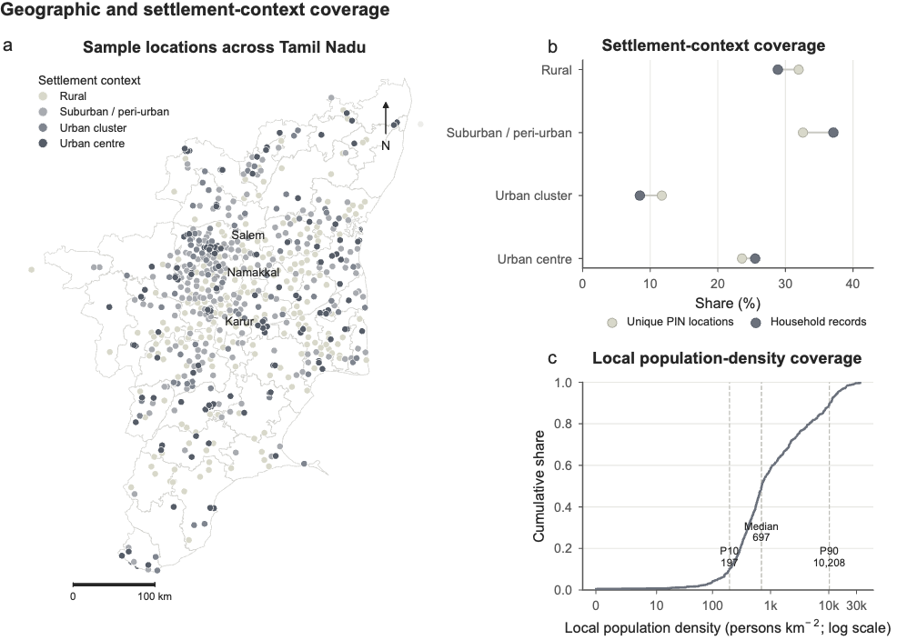
a, Matched Tamil Nadu PIN reference locations over the Tamil Nadu administrative outline, classified by 2025 GHS-SMOD settlement context. The coverage analysis included 632 unique matched Tamil Nadu PIN locations across 37 of the state's 38 current districts, with greater recruitment intensity in Salem, Karur, and Namakkal. b, Settlement-context distribution summarized by household records and by unique PIN locations. Reporting categories aggregate the detailed GHS-SMOD classification into rural, suburban/peri-urban, urban cluster, and urban centre. c, Empirical cumulative distribution of local GHS-POP population density across matched PIN locations using the surrounding 3 × 3 raster neighbourhood; vertical reference lines indicate the 10th percentile, median, and 90th percentile. PIN coordinates represent postal reference locations rather than exact household locations.
S4.5. Diversity of domestic water-provision arrangements
Primary domestic water provision was characterized using Q1.1, retaining the six provision arrangements observed in the study rather than collapsing provider, source, and delivery distinctions. Groundwater was the most common primary arrangement (50.52%), followed by municipality/corporation supply (38.86%), lake/pond water (5.84%), other sources (1.89%), tanker/truck delivery (1.69%), and commercial/canned water (1.20%). The dataset therefore includes households relying on formal network supply, self-supply, surface water, delivered water, commercial provision, and other arrangements.
NFHS-5 Tamil Nadu was used only to provide external context for the diversity of household water sources in the state (IIPS & ICF, 2021). No formal study-versus-NFHS distributional comparison was undertaken because the two instruments measure different constructs. Q1.1 records the household's primary domestic provision arrangement, incorporating provider, physical source, and delivery mechanism, whereas NFHS-5 classifies the principal drinking-water source. Treating these distributions as directly comparable would therefore impose equivalence across categories not designed to measure the same aspect of household water provision, so this approach was not retained.
S4.6. Implications for analytical scope
The combined benchmark and spatial diagnostics show that the study covers heterogeneous household and service environments while also exhibiting expected minor departures from the Tamil Nadu population distribution. Home ownership closely aligned with the recent statewide NFHS-5 benchmark, whereas household-size composition and, in particular, car ownership differed more substantially. Geographic coverage extended across 37 of 38 current districts and across the full rural-to-urban settlement spectrum represented by GHS-SMOD, though recruitment remained strongly concentrated in Salem, Karur, and Namakkal.
These additional coverage diagnostics support the maximum-variation sampling strategy we adopted by showing that the recruited households span substantial observed variation in household composition, geography, settlement context, and water-provision arrangements, while transparently documenting where the sample differs from statewide population distributions. Together, these diagnostics demonstrate broad observed coverage across the household, geographic, settlement, and water-provision conditions relevant to the study, without implying probability-based representativeness of Tamil Nadu. This distinction is consistent with the study's analytical objective. The WSQS analyses evaluate multidimensional service-quality measurement, heterogeneity in household service experience, and predictive relationships across contrasting service environments; they do not estimate population-weighted prevalence for Tamil Nadu.
No external benchmark or spatial dataset was used to reweight observations, modify WSQS values, or influence model fitting. The coverage analysis instead provides an independent empirical characterization of the domain over which the study's measurement and modeling results were evaluated and makes explicit the principal dimensions along which the non-probability sample differs from statewide reference populations.

References used in Supplementary
- Office of the Registrar General & Census Commissioner, India. HH-01: Normal households by household size (total), Tamil Nadu – 2011. Census of India 2011 Tables, PC11_HH01-33 (2011).
- International Institute for Population Sciences (IIPS) & ICF. National Family Health Survey (NFHS-5), 2019–21: Tamil Nadu. International Institute for Population Sciences, Mumbai (2021).
- National Statistical Office. Drinking Water, Sanitation, Hygiene and Housing Condition in India: NSS 76th Round, July–December 2018. NSS Report No. 584. Ministry of Statistics and Programme Implementation, Government of India, New Delhi (2019).
- Department of Posts, Government of India. All India Pincode Directory till last month. Open Government Data Platform India (2026).
- Government of Tamil Nadu. TN Districts. Government of Tamil Nadu (2026).
- Gibbs, A. L. & Su, F. E. On choosing and bounding probability metrics. Int. Stat. Rev. 70, 419–435 (2002).
- Hill, M. O. Diversity and evenness: a unifying notation and its consequences. Ecology 54, 427–432 (1973).
- Schiavina, M., Melchiorri, M. & Pesaresi, M. GHS-SMOD R2023A – GHS settlement layers, application of the Degree of Urbanisation methodology (stage I) to GHS-POP R2023A and GHS-BUILT-S R2023A, multitemporal (1975–2030). European Commission, Joint Research Centre (2023).
- Schiavina, M., Freire, S., Carioli, A. & MacManus, K. GHS-POP R2023A – GHS population grid multitemporal (1975–2030). European Commission, Joint Research Centre (2023).
- European Commission & Statistical Office of the European Union. Applying the Degree of Urbanisation: A Methodological Manual to Define Cities, Towns and Rural Areas for International Comparisons, 2021 Edition. Publications Office of the European Union, Luxembourg (2021).
- Pesaresi, M. et al. Advances on the Global Human Settlement Layer by joint assessment of Earth Observation and population survey data. Int. J. Digit. Earth 17, 2390454 (2024).

