Supplementary Materials

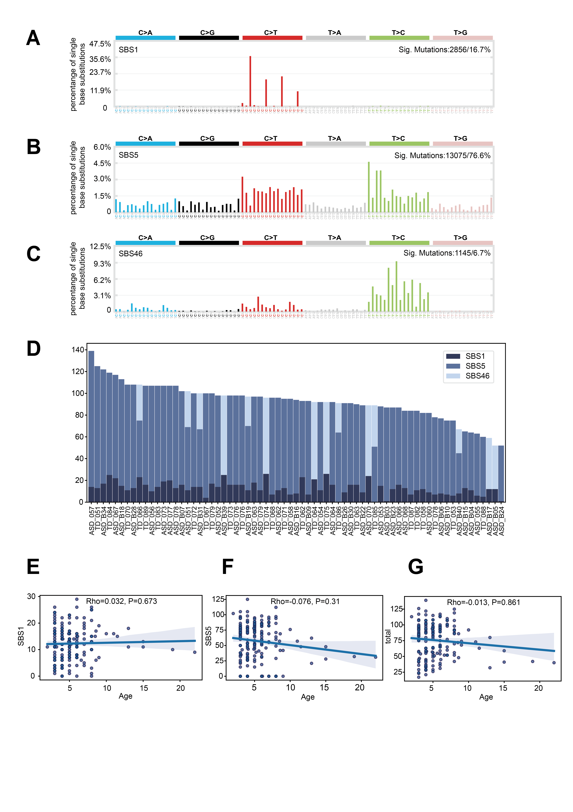
Fig. S 1.
Fig. Supplementary 1. Identification of mutational signatures of CHIPI and their correlation with age.(A-C),The 96-trinucleotide mutational profiles of the three extracted single base substitution (SBS) signatures: (A) SBS1, (B) SBS5, and (C) SBS46. (D), Contribution of the three mutational signatures to each sample in our cohort. The barplot represents the number of mutations attributed to each signature. (E-G). Spearman's correlation analysis between patient age and the (E) activity of SBS1, (F) activity of SBS5, and (G) total number of mutations. The best-fit lines (blue) are shown.

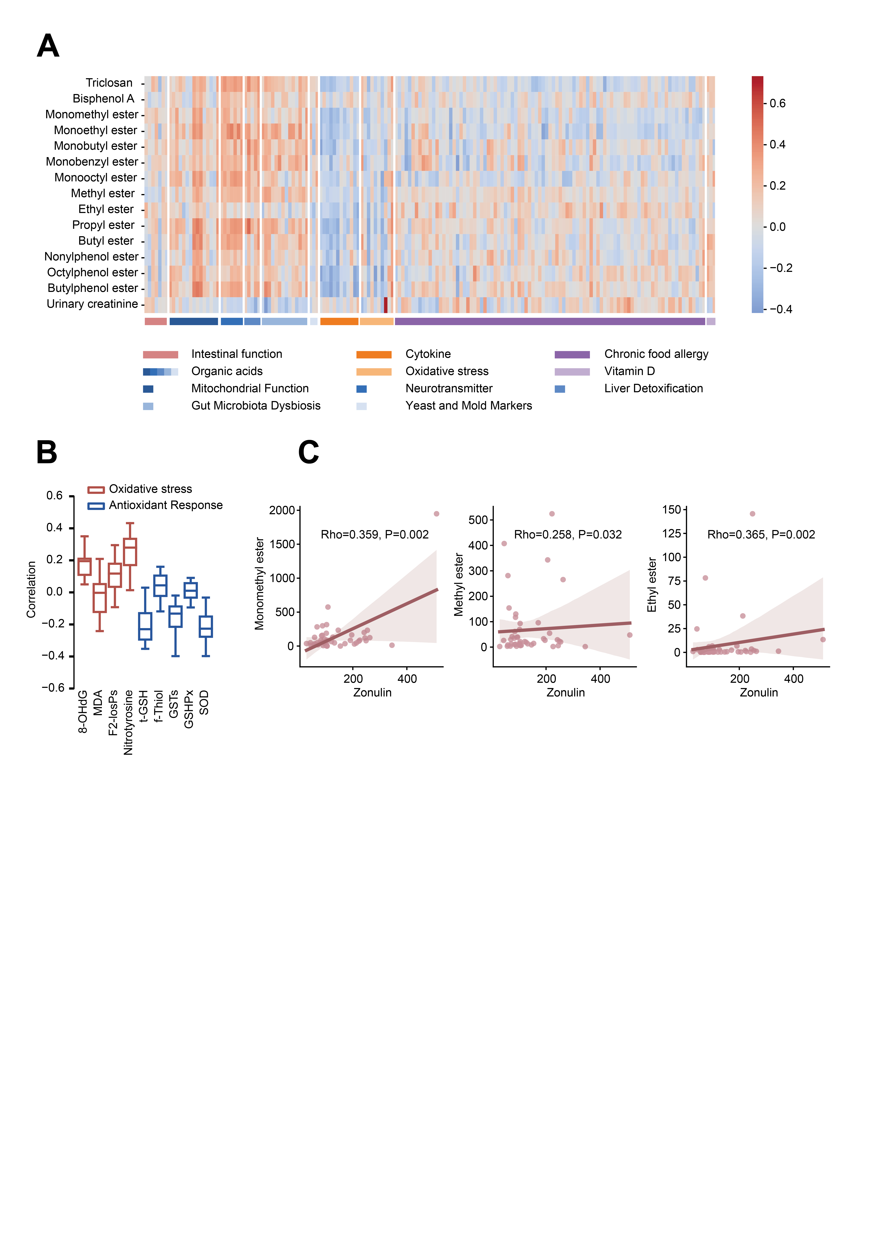
Fig. S2.
Fig. Supplementary 2. Identification of mutational signatures of CHIPI and their correlation with age.(A),The heatmap illustrates the associations between EDCs and various physiological indicators. The color bar represents the rho values derived from Spearman's rank correlation analyses, with red and blue indicating positive and negative correlations, respectively.(B),Box plot represents the overall correlations between the 14 EDCs and biomarkers of oxidative stress/antioxidant response.(C),Scatter plot illustrates the significant positive correlations between three EDCs and zonulin levels, as determined by Spearman's rank correlation analysis.

