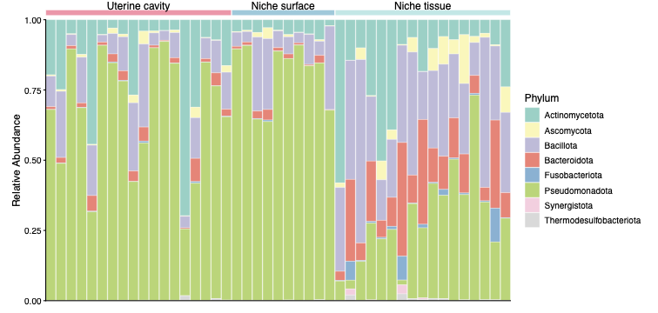
Fig. S1 Phylum-level microbial composition across CSD anatomical compartments. Relative abundance profiles of individual samples from the uterine cavity, niche surface, and niche tissue groups. Each bar represents one sample; taxa with a relative abundance > 0.5% were considered for visualization.
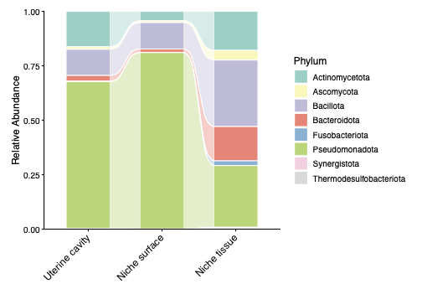
Fig. S2 Mean phylum-level microbial composition across CSD anatomical compartments. Mean relative abundance of the major phyla in the uterine cavity, niche surface, and niche tissue groups. Taxa with a relative abundance > 5% were considered for visualization.

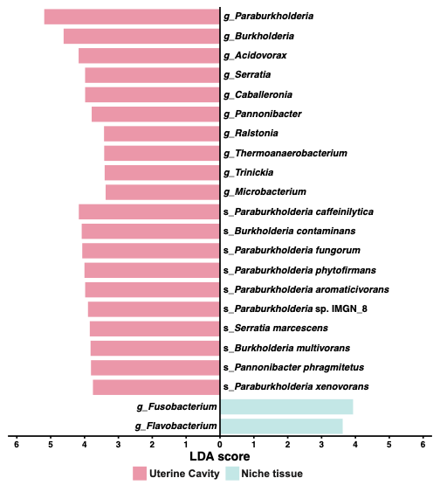
Fig. S3 LEfSe analysis of differential microbial taxa between the uterine cavity and niche tissue. Differential genera and species identified by LEfSe are shown according to LDA score. Taxa enriched in the uterine cavity and niche tissue are displayed on opposite sides of the plot. Genera and species are indicated by the prefixes “g_” and “s_”, respectively. FDR-adjusted P < 0.05 was considered significant, with an LDA score >3.0 used as the threshold for discriminative features.

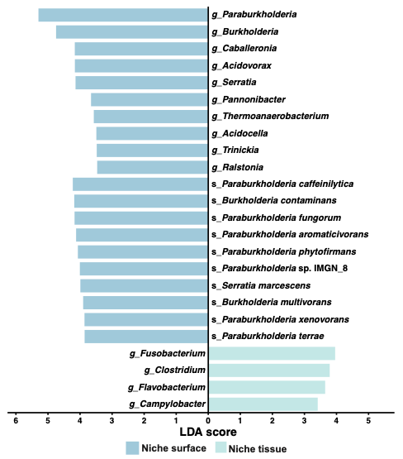
Fig. S4 LEfSe analysis of differential microbial taxa between the niche surface and niche tissue. Differential genera and species identified by LEfSe are shown according to LDA score. Taxa enriched in the niche surface and niche tissue are displayed on opposite sides of the plot. Genera and species are indicated by the prefixes “g_” and “s_”, respectively. FDR-adjusted P < 0.05 was considered significant, with an LDA score >3.0 used as the threshold for discriminative features.
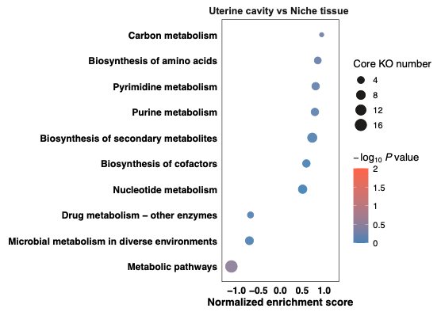
Fig. S5 KEGG pathway enrichment between the uterine cavity and niche tissue. GSEA of KEGG pathways comparing the uterine cavity and niche tissue. The x-axis represents the NES, with positive values indicating enrichment in niche tissue and negative values indicating enrichment in the uterine cavity. Dot color represents −log₁₀ P value, and dot size represents the number of core enrichment KOs.

