Supplement-1: Landslide verification in the field (Examples)
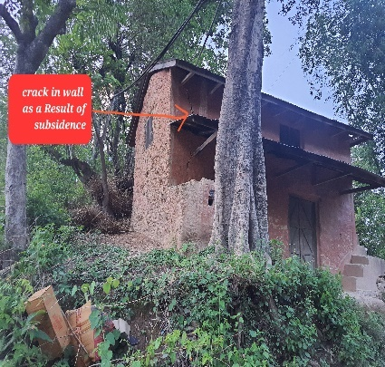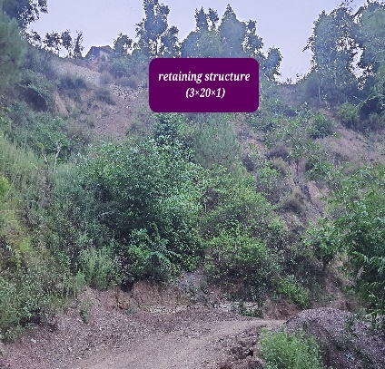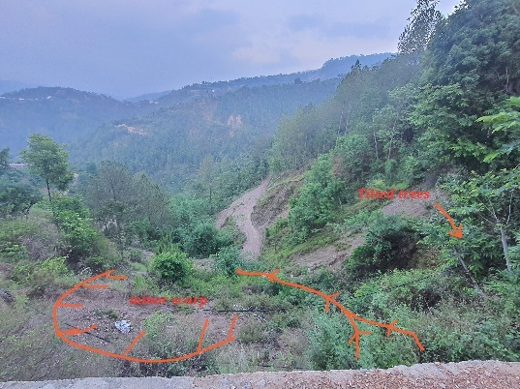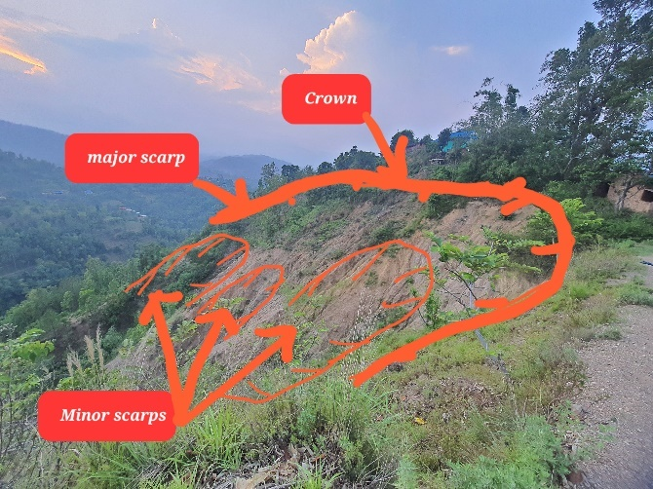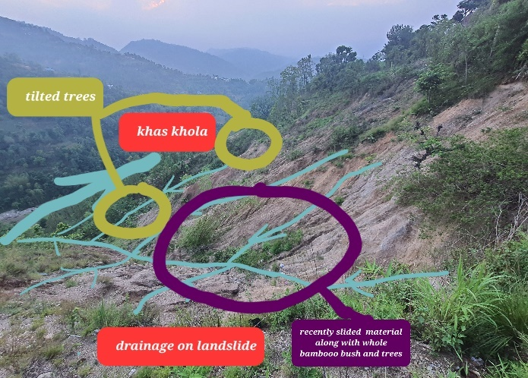
Fig: Sandhikharka municipality -7, Arghakhanchi
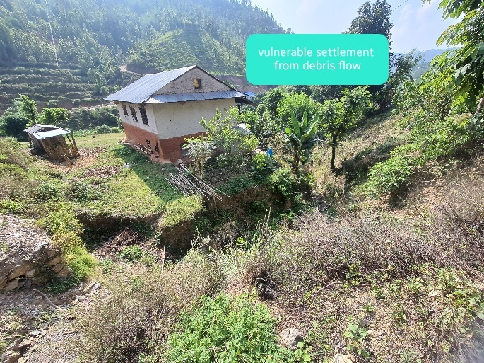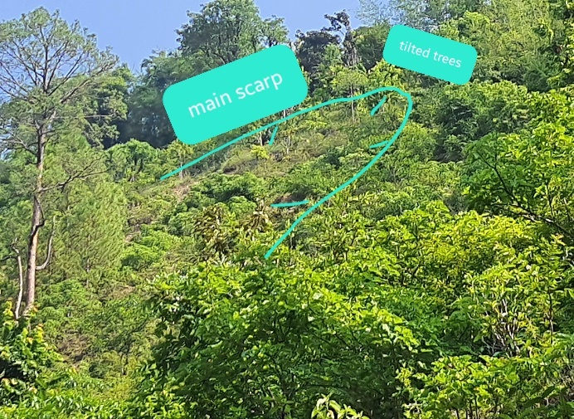
Photograph: Pratakhola, Bhumikasthan municipality -1, Arghakhanchi
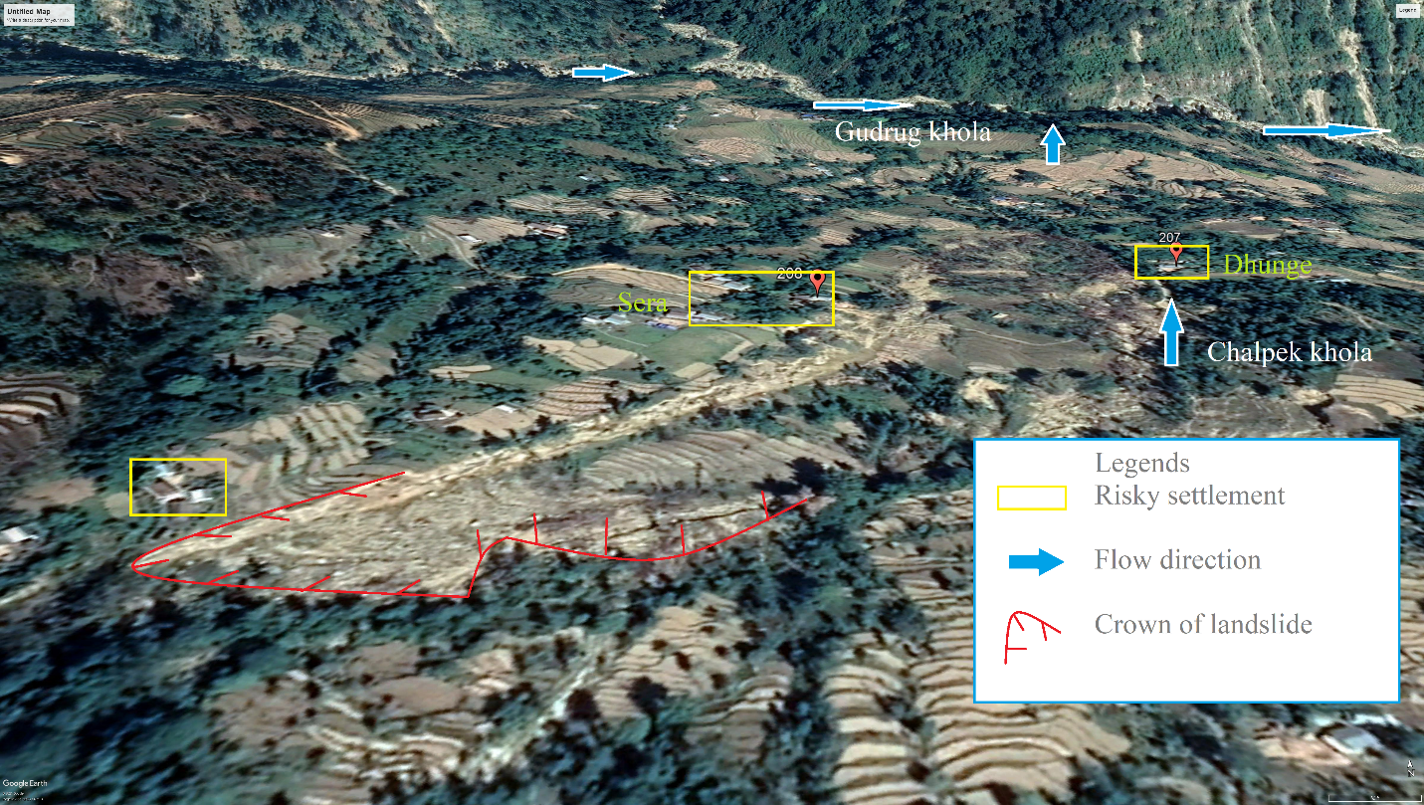
Photograph: Photograph showing regional sketch and settlement under risk.
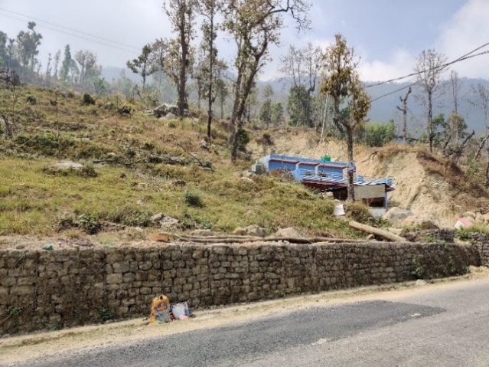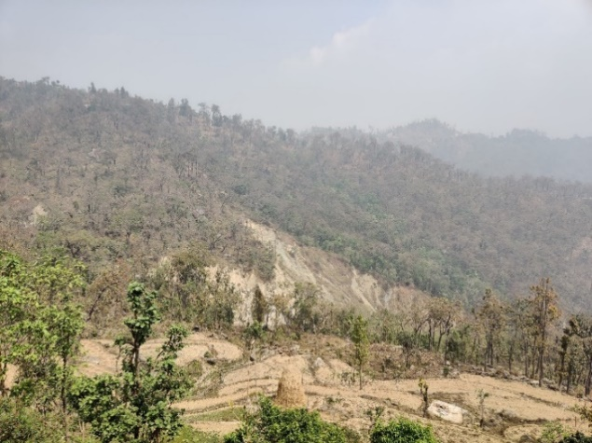
b.
a.
Photograph: Rajiya, Hile Khola, a. house located at colluvium deposit of past landslide and b. large landslide at downslope section, Sitganga Municipality-12, Argakhachi
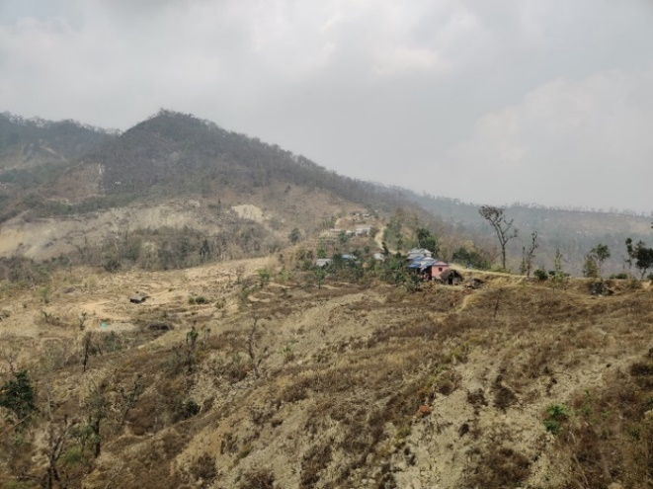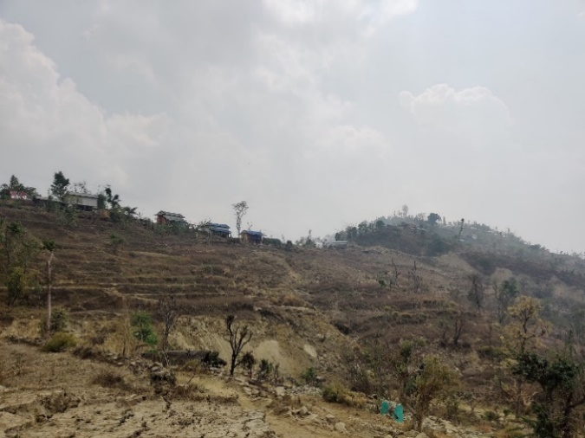
b.
a.
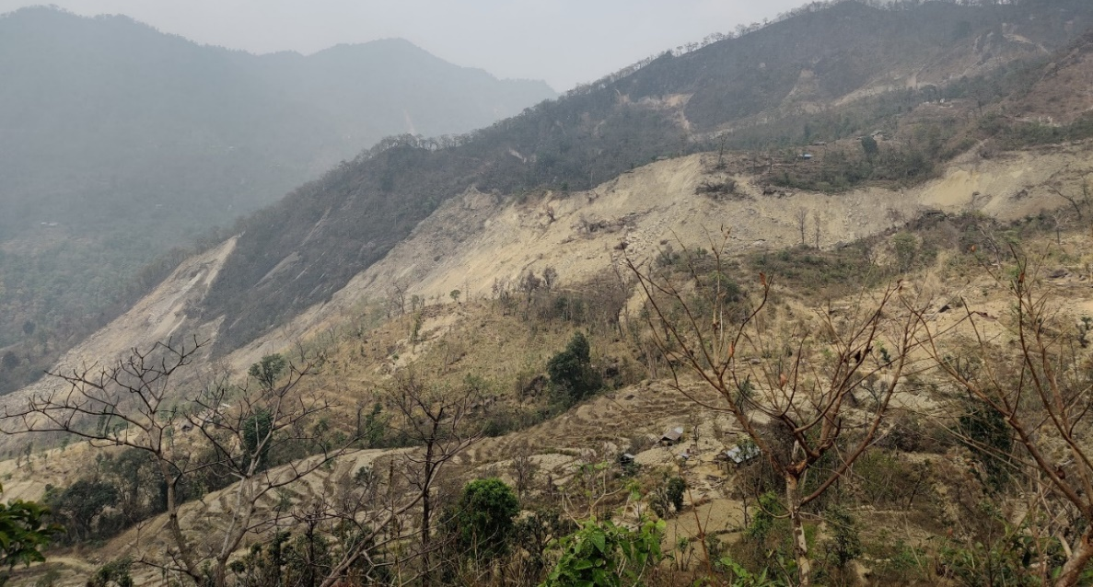
b.
Photograph: a. large scale dip slope landslide of Maidan, b. houses immediate to landslide crown, and c. close up look of landslide showing the houses located at landslide deposit. Sitganga Municipality, ArgakhachiMai Sitganga Municipality-12, Argakhachi

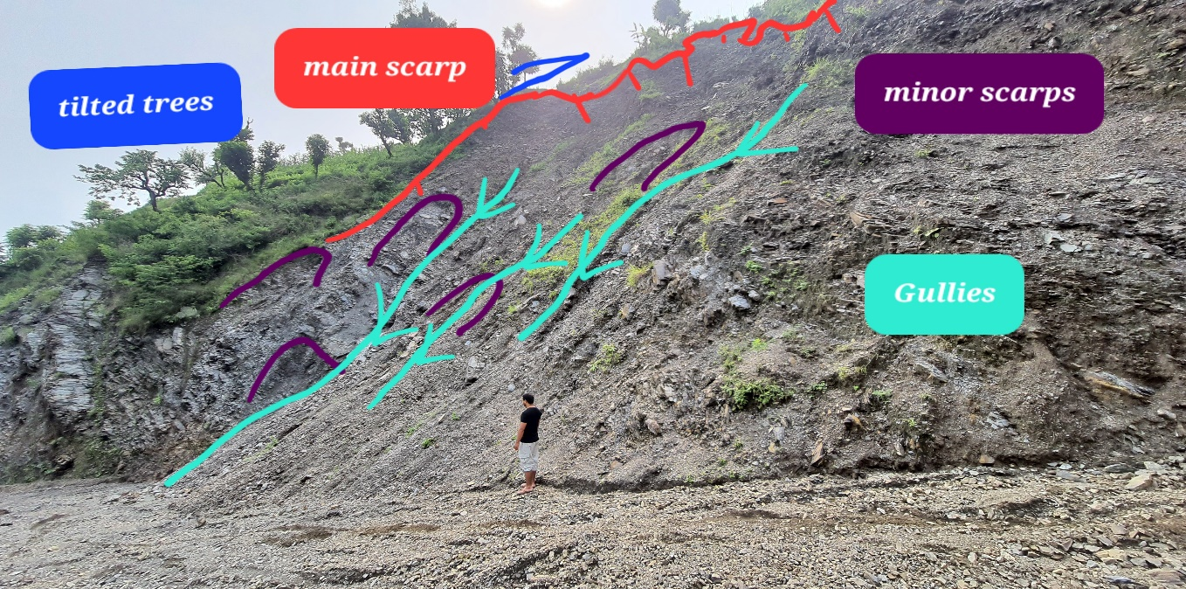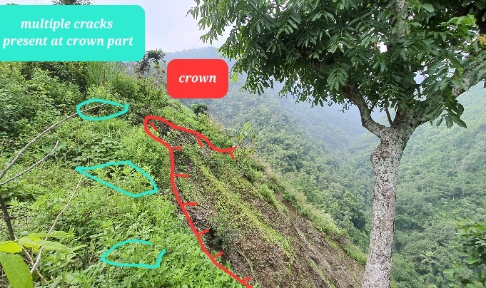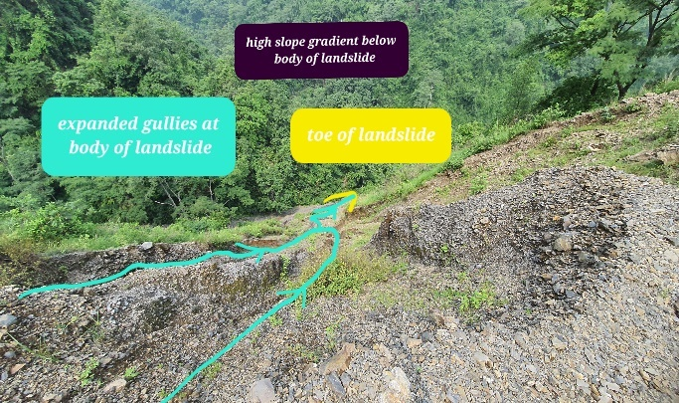
Photograph: Jaykhani Landslide, Kaligandaki-4, Gulmi
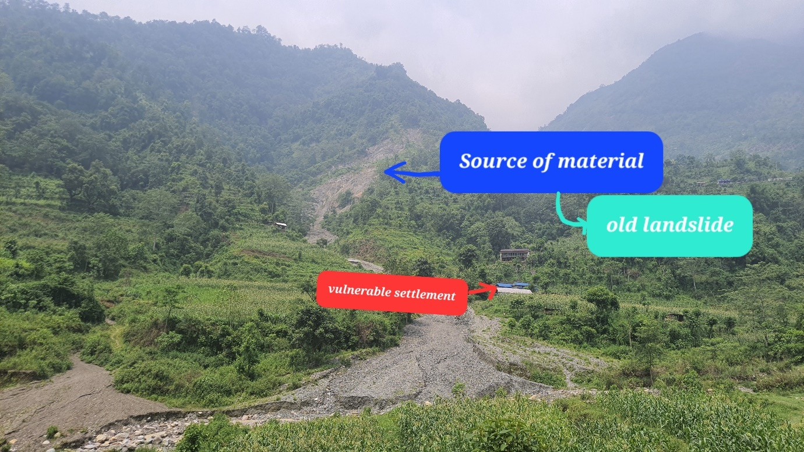
Photograph: Phurse Debris Flow, Kaligandaki rural municipality -4, Gulmi

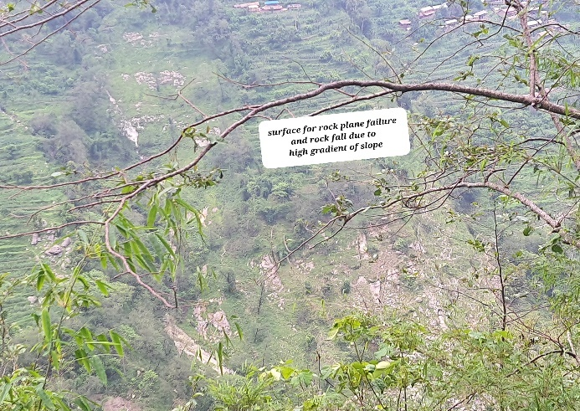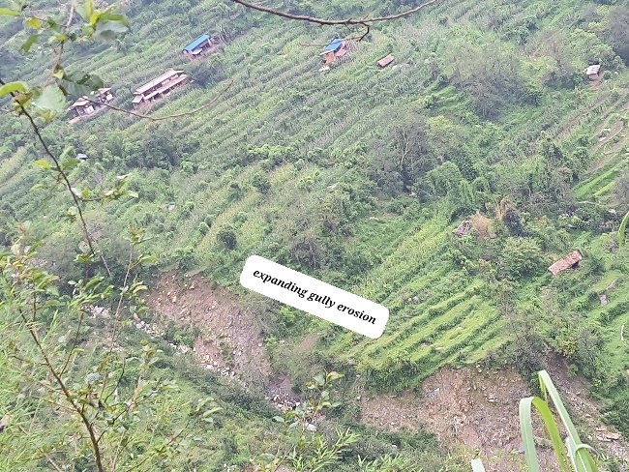
Photograph: Dunam karvanang landslide, Malika rural municipality -2. Gulmi
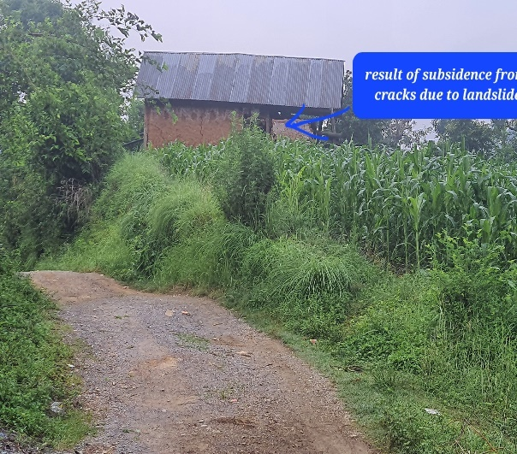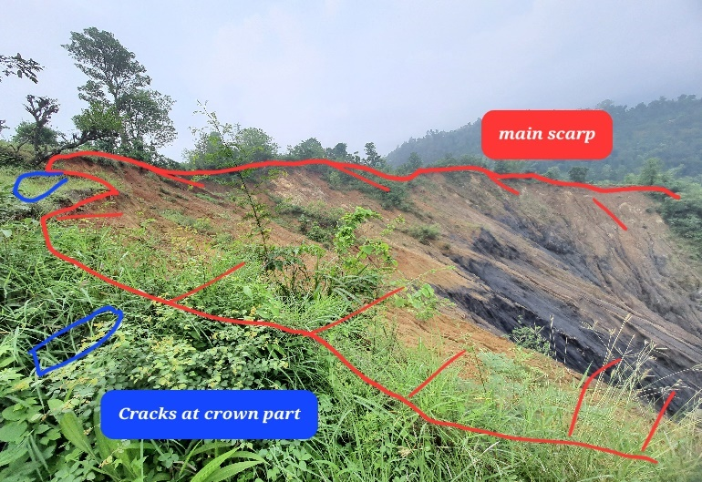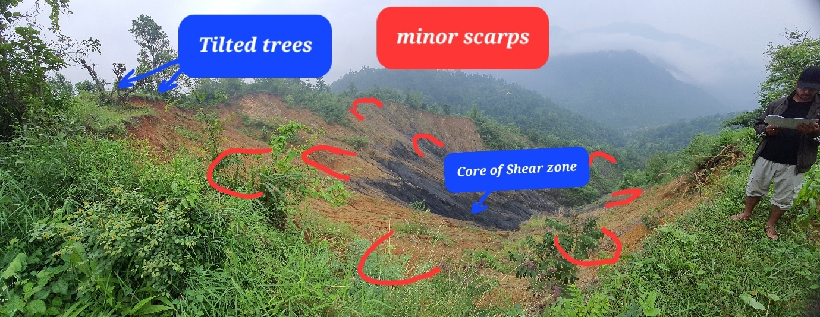
Photograph: Eksing landslide, Satyawati rural municipality -4, Gulmi

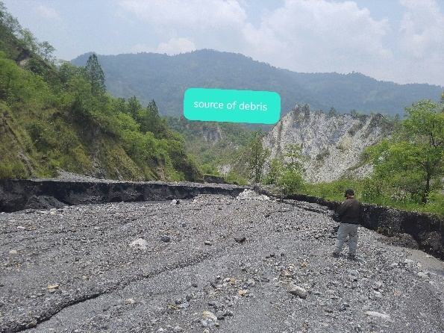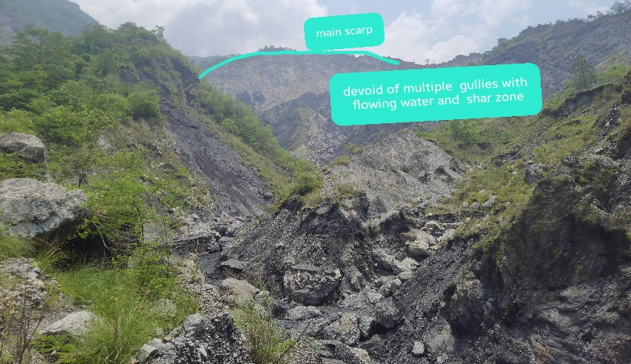
Photograph: Ullikhola landslide, flood and debris flow, Satyawati rural municipality -5, Gulmi
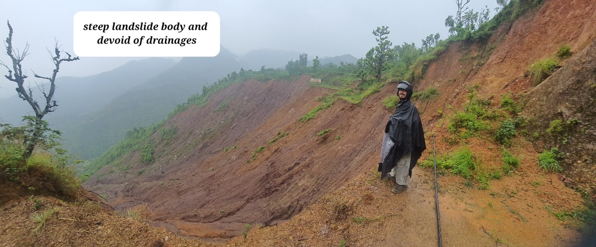
Photograph: Nsidi rural municipality -3, Palpa
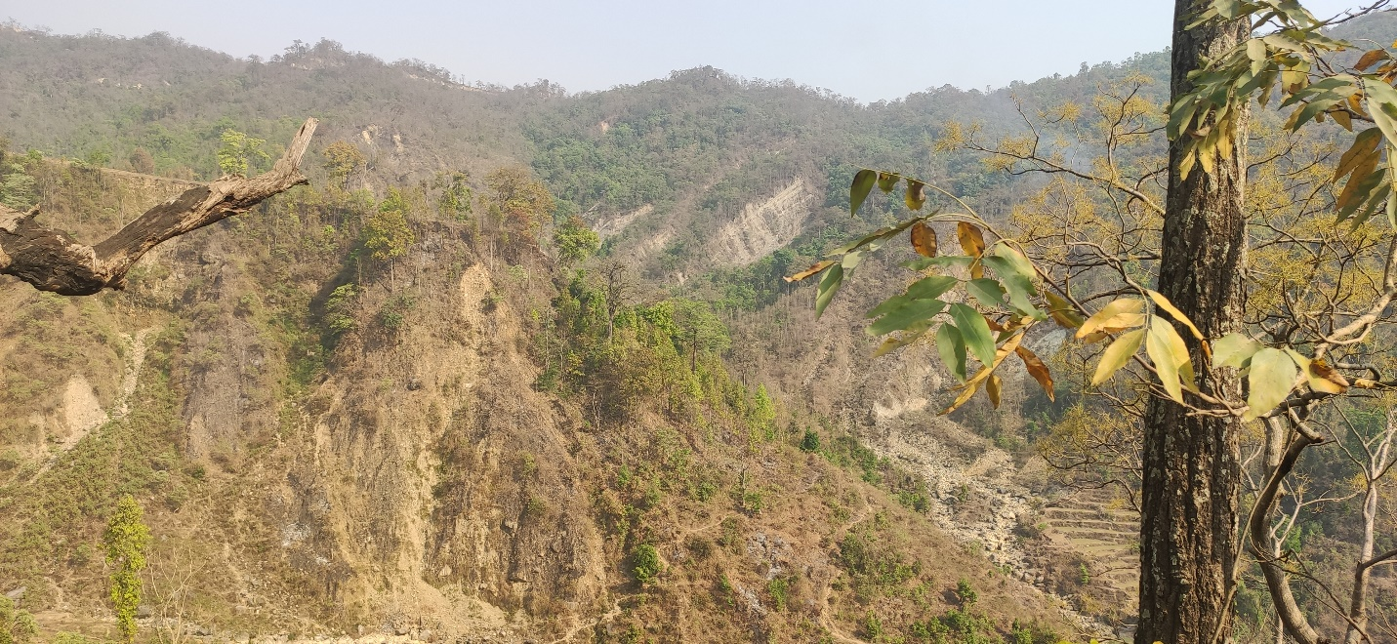
Photograph showing landslide of Dhorkhor and its gully expansion, Rainadevi Chhahara rural municipality-8, Palpa district
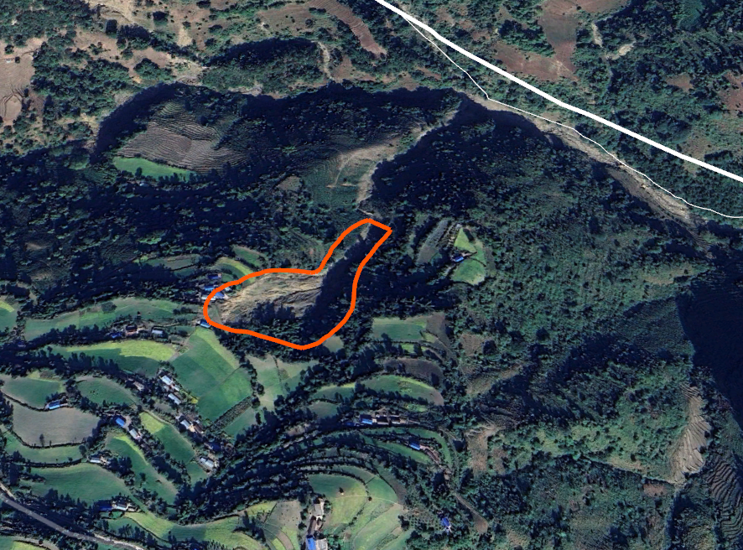
Photograph: Household risk from Debris flow, Kudule, Bangachuli RM-5, Dang
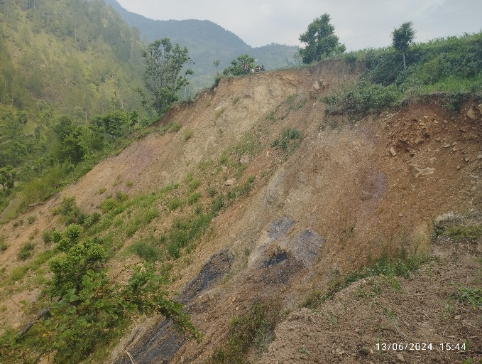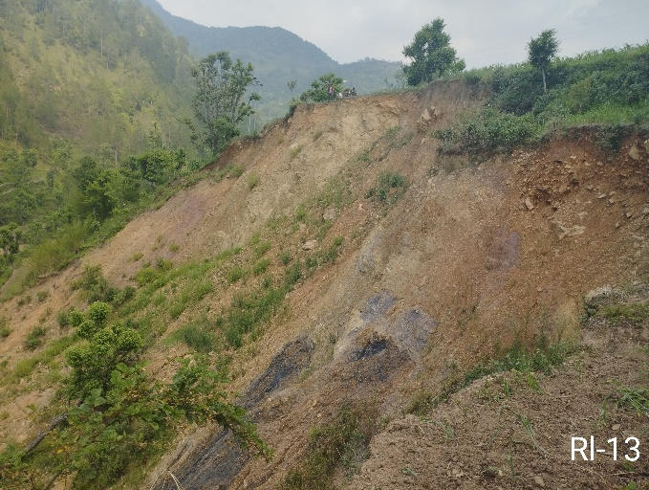
Photograph: 2-b Aathbise landslide, Sunilsmrti municipality-08 Rolpa
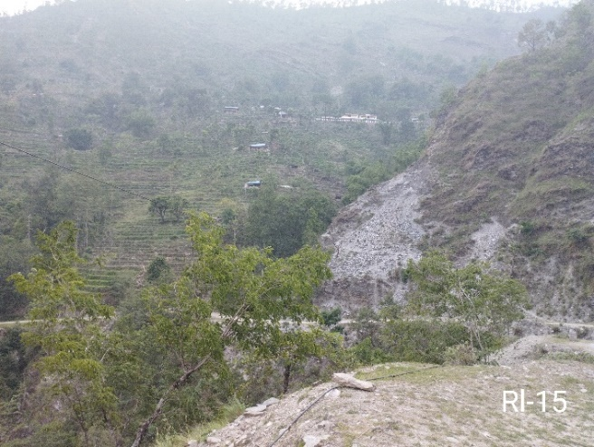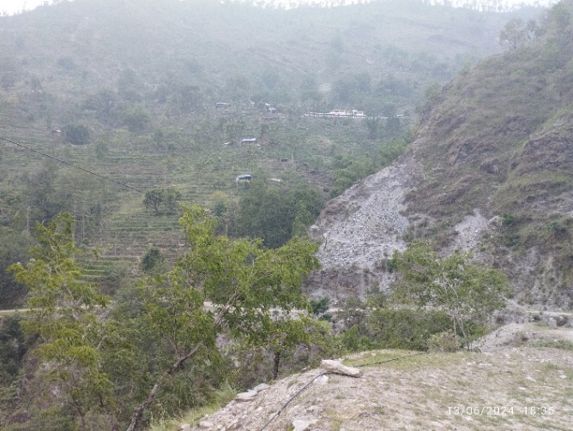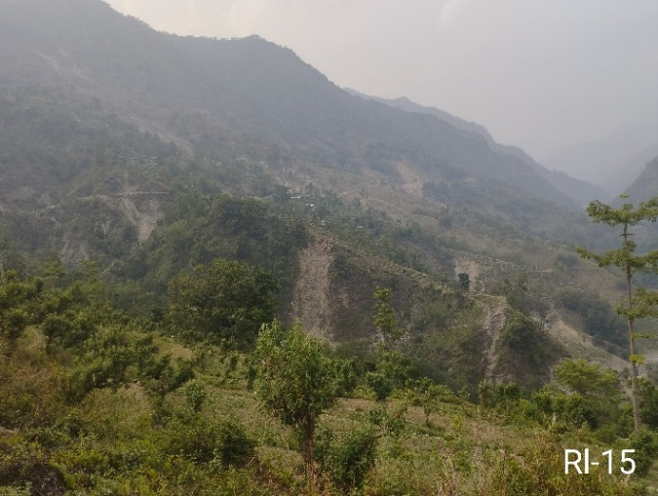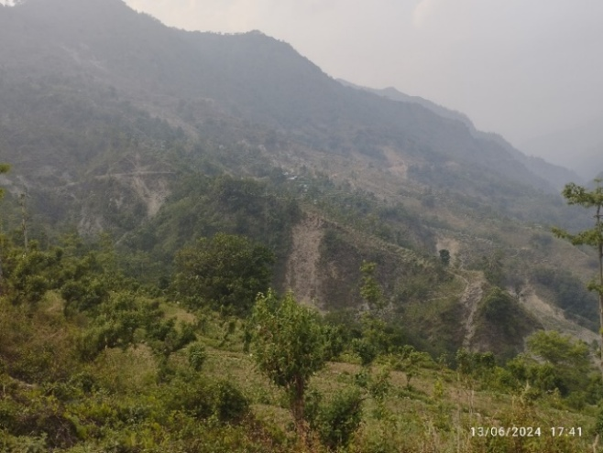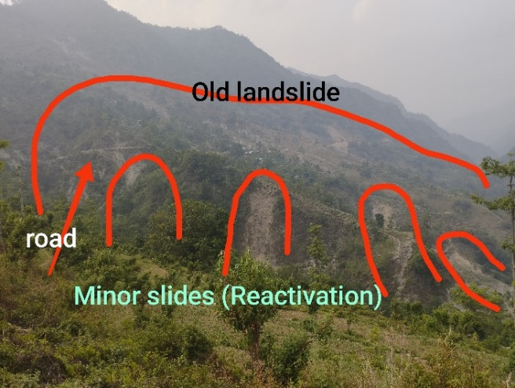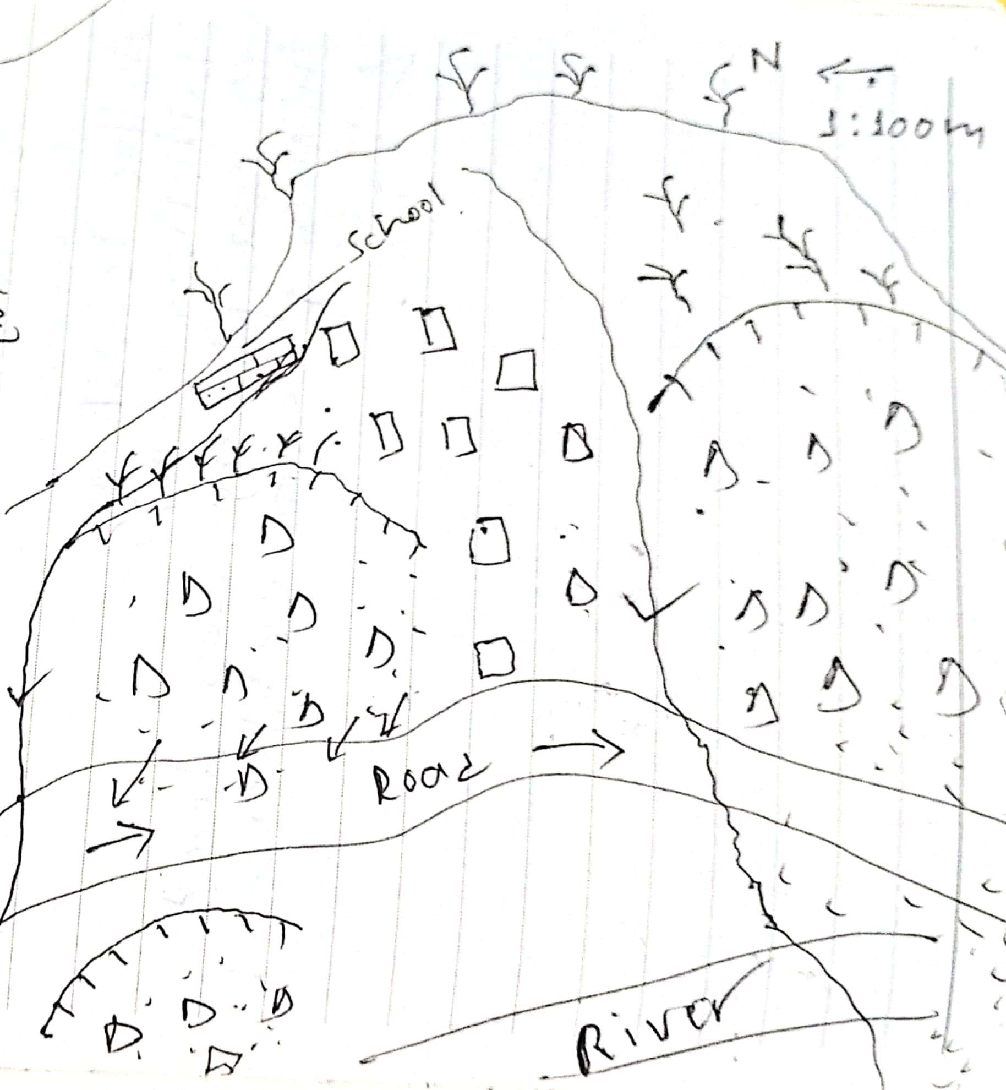
Photograph: 2-c Kasala gau landslide, Sunchhahari rural municipality-05

