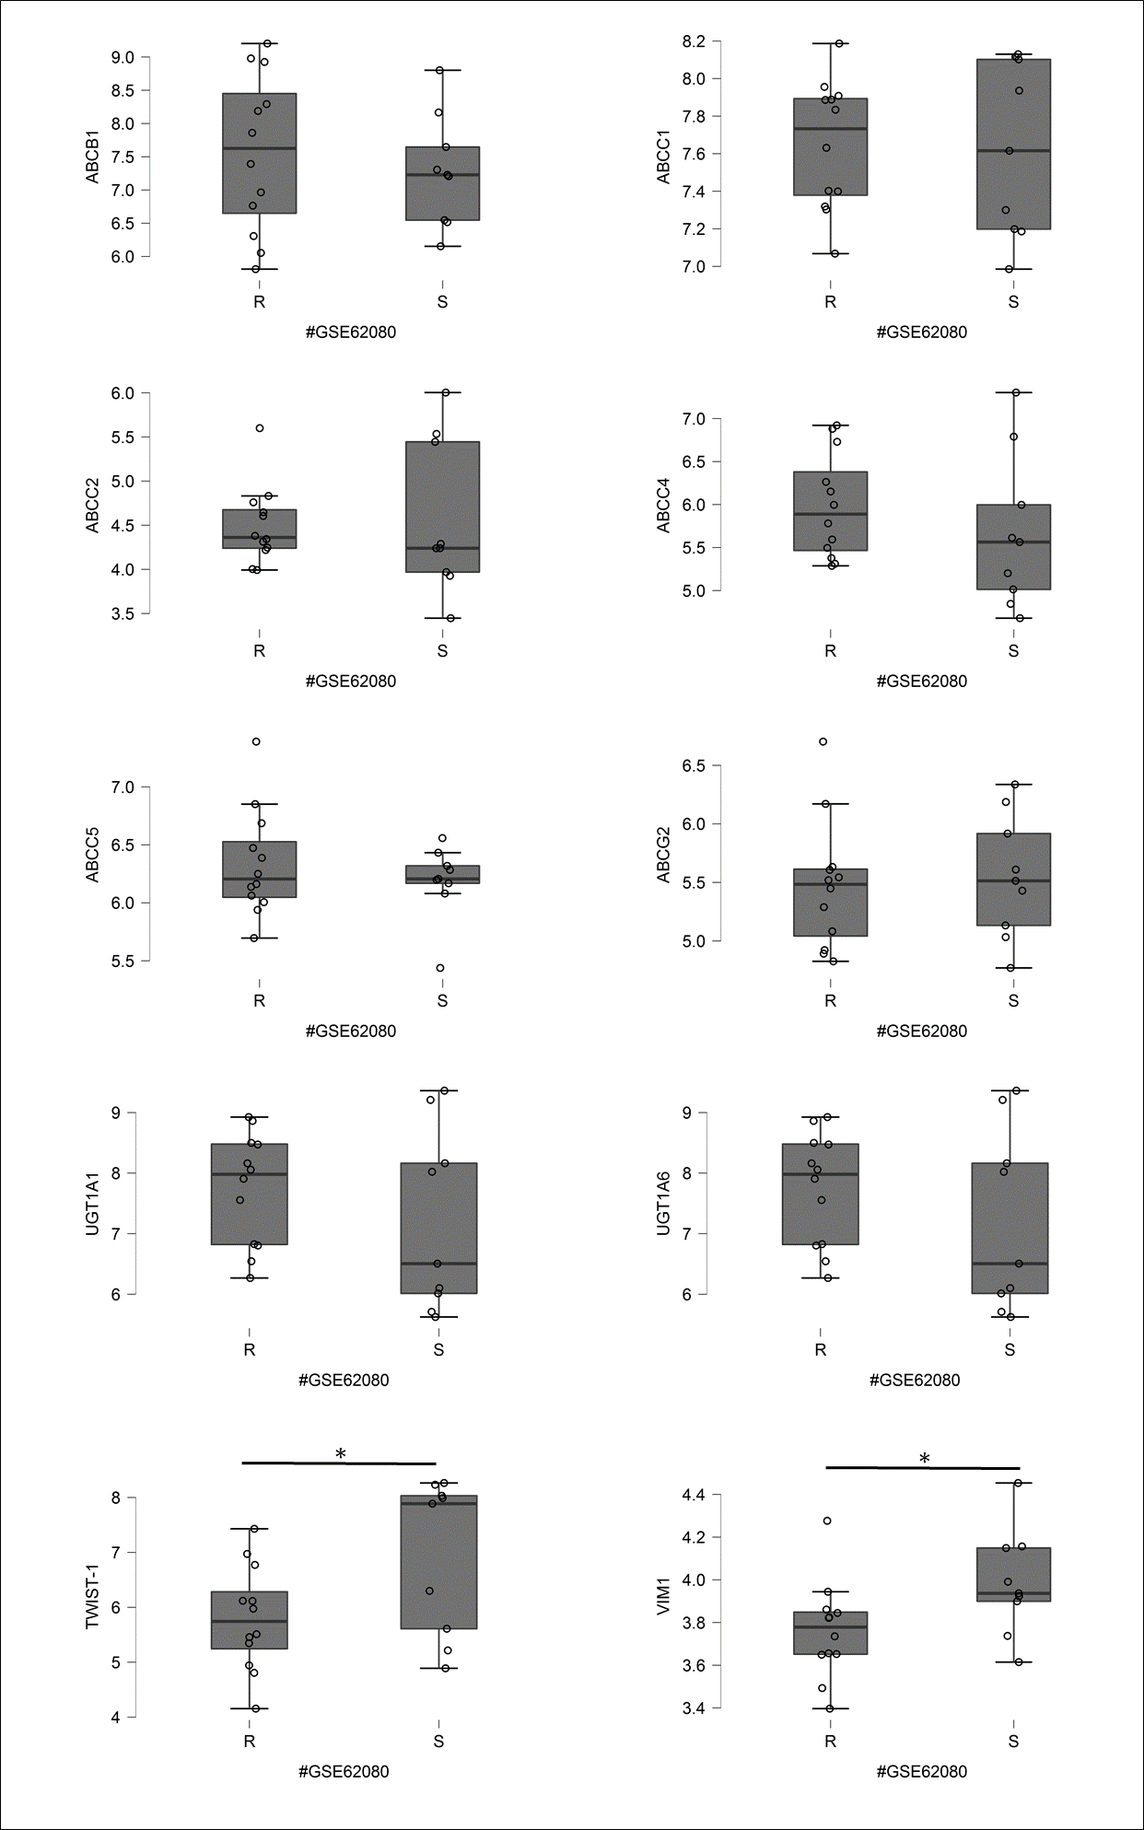 S1. mRNA expression level of ABC proteins, UGT1 variants, and EMT markers in patients treated with FOLFIRI regime. Data obtained from GEO database GSE62080. Patients treated with FOLFIRI were define as the responders/sensitive S) and non-responders / resistant R). Normality test (Shapiro-Wilk`s) followed by Mann-Whitney U test (for not normally distributed data) or T-test (for normally distributed data). * p>0.05, ** p> 0.005, ***p>0.001

