Supplementary Information
Neonatal Bilirubin Trajectory Phenotypes and Composite Adverse Outcomes: A Two-Database Latent-Class Analysis (MIMIC-III and PIC)

Supplemental Tables
Table S1. Model fit for class enumeration (k = 2-5).
k | BIC | AIC | No. of parameters | Min class proportion, % | Mean max posterior probability
2 | 19846.7 | 19788.5 | 9 | 26.2 | 0.909
3 | 18585.5 | 18501.4 | 13 | 10.6 | 0.806
4 | 18120.2 | 18010.2 | 17 | 6.8 | 0.773
5 | 17489.9 | 17354.1 | 21 | 2.2 | 0.785
The four-class model was selected per the pre-specified rule (best BIC among models satisfying minimum class proportion ≥5% and mean maximum posterior probability ≥0.7); the BIC-preferred five-class model was rejected because it produced classes comprising <5% of the population (for k = 5, class proportions were 2.2/2.9/34.4/53.6/7.0%, with two classes below the 5% threshold). Class proportions and posterior probabilities for each candidate k are shown to document this decision. The mean maximum posterior probability of the selected four-class model (0.773) was only modestly above the 0.7 threshold, indicating non-trivial classification uncertainty; posterior-probability-weighted assignment (S11) was performed as a sensitivity analysis.

Table S2. Apparent and optimism-corrected area under the ROC curve (200 bootstrap resamples).
Database | Model | Apparent AUC | Optimism | Corrected AUC
MIMIC-III | A: Trajectory | 0.827 | 0.007 | 0.820
MIMIC-III | B1: First value | 0.807 | 0.004 | 0.803
MIMIC-III | B2: Peak | 0.827 | 0.005 | 0.822
MIMIC-III | B3: Bhutani zone | 0.776 | 0.008 | 0.768
PIC | A: Trajectory | 0.604 | 0.025 | 0.579
PIC | B1: First value | 0.571 | 0.026 | 0.545
PIC | B2: Peak | 0.562 | 0.025 | 0.537
PIC | B3: Bhutani zone | 0.572 | 0.031 | 0.540
Corrected AUC = apparent AUC - optimism, estimated by internal bootstrap validation.

Table S3. Incremental discrimination of the trajectory model over single-point models: DeLong tests and continuous NRI/IDI.
Database | Comparison | AUC (A vs comparator) | DeLong P | NRI (95% CI) | IDI (95% CI)
MIMIC-III | A vs B1 | 0.827 vs 0.807 | 0.133 | 0.198 (0.074 to 0.337) | 0.017 (0.004 to 0.038)
MIMIC-III | A vs B2 | 0.827 vs 0.827 | 0.987 | -0.120 (-0.231 to 0.011) | -0.007 (-0.019 to 0.006)
MIMIC-III | A vs B3 | 0.827 vs 0.776 | <0.001 | 0.576 (0.459 to 0.687) | 0.042 (0.031 to 0.061)
PIC | A vs B1 | 0.604 vs 0.571 | 0.054 | 0.207 (0.100 to 0.318) | 0.007 (0.001 to 0.014)
PIC | A vs B2 | 0.604 vs 0.562 | 0.010 | 0.147 (0.026 to 0.253) | 0.009 (0.004 to 0.014)
PIC | A vs B3 | 0.604 vs 0.572 | 0.051 | 0.161 (0.056 to 0.267) | 0.009 (0.003 to 0.014)
DeLong tests were performed on apparent AUCs; optimism-corrected AUCs are reported in Table S2. NRI and IDI are continuous measures with bootstrap 95% confidence intervals; NRI is interpreted as secondary to AUC, calibration, and net-benefit comparisons because of its sensitivity to small risk shifts [33]. B1, first value; B2, peak; B3, Bhutani risk zone.

Table S4. Sensitivity analyses: adjusted OR (95% CI) for the composite outcome by trajectory class relative to the typical class (C2).
Sensitivity | Database | n | C1 | C3 | C4
S5: Excluding early-onset sepsis | MIMIC-III | 2931 | 0.77 (0.23–2.57)  0.671 | 7.39 (4.77–11.45)  <0.001 | 2.66 (1.81–3.91)  <0.001
S5: Excluding early-onset sepsis | PIC | 1782 | 1.42 (1.02–1.98)  0.037 | 2.42 (1.34–4.38)  0.003 | 1.82 (1.25–2.66)  0.002
S6: Excluding community-acquired bacteremia | MIMIC-III | 2948 | 0.78 (0.23–2.58)  0.679 | 7.45 (4.82–11.53)  <0.001 | 2.65 (1.80–3.89)  <0.001
S6: Excluding community-acquired bacteremia | PIC | 1784 | 1.45 (1.04–2.02)  0.027 | 2.46 (1.36–4.46)  0.003 | 1.89 (1.31–2.74)  <0.001
S7: Excluding CoNS from LOS | MIMIC-III | 2951 | 0.97 (0.29–3.27)  0.960 | 5.60 (3.43–9.14)  <0.001 | 2.28 (1.47–3.53)  <0.001
S7: Excluding CoNS from LOS | PIC | 1817 | 1.47 (1.06–2.03)  0.021 | 2.52 (1.40–4.52)  0.002 | 1.86 (1.28–2.69)  0.001
S8: Admission <72 h | MIMIC-III | 2860 | 0.78 (0.23–2.58)  0.679 | 7.45 (4.82–11.53)  <0.001 | 2.65 (1.80–3.89)  <0.001
S8: Admission <72 h | PIC | 1575 | 1.62 (1.15–2.29)  0.006 | 2.54 (1.35–4.76)  0.004 | 1.98 (1.33–2.95)  <0.001
S8: Admission <24 h | MIMIC-III | 2842 | 0.78 (0.23–2.58)  0.679 | 7.45 (4.82–11.53)  <0.001 | 2.65 (1.80–3.89)  <0.001
S8: Admission <24 h | PIC | 1129 | 1.52 (1.02–2.25)  0.039 | 2.40 (1.12–5.12)  0.024 | 2.17 (1.35–3.50)  0.001
S9: Excluding phototherapy (MIMIC-III) | MIMIC-III | 1026 | not estimable  (no events) | 10.10 (3.30–30.88)  <0.001 | 2.23 (0.73–6.82)  0.159
S11: Posterior-probability weighting | MIMIC-III | 11804 | 0.74 (0.32–1.73)  0.490 | 5.38 (3.50–8.28)  <0.001 | 1.98 (1.35–2.89)  <0.001
S11: Posterior-probability weighting | PIC | 7268 | 1.26 (0.93–1.72)  0.131 | 2.40 (1.36–4.24)  0.002 | 1.52 (1.08–2.12)  0.015
S14: Minimal adjustment (sex + age at admission) | MIMIC-III | 2951 | 1.00 (0.31–3.28)  0.996 | 15.59 (10.57–22.99)  <0.001 | 3.47 (2.40–5.01)  <0.001
S14: Minimal adjustment (sex + age at admission) | PIC | 1817 | 1.54 (1.12–2.12)  0.008 | 2.59 (1.45–4.60)  0.001 | 1.92 (1.33–2.77)  <0.001
S14: MIMIC-III + birth weight | MIMIC-III | 2735 | 0.99 (0.26–3.75)  0.992 | 1.23 (0.71–2.13)  0.467 | 0.98 (0.63–1.51)  0.912
S17: Excluding outcomes on days 0-7 | MIMIC-III | 2918 | not estimable  (no events) | 8.62 (5.40–13.78)  <0.001 | 2.77 (1.81–4.23)  <0.001
S17: Excluding outcomes on days 0-7 | PIC | 1731 | 1.23 (0.84–1.80)  0.289 | 1.77 (0.83–3.75)  0.138 | 1.65 (1.08–2.54)  0.021
S19: MIMIC-III + FiO2 | MIMIC-III | 1718 | 0.60 (0.18–2.04)  0.416 | 5.64 (3.51–9.08)  <0.001 | 2.17 (1.42–3.31)  <0.001
S35: Maturity-proxy subgroup (≥35-wk approximation) | MIMIC-III | 1283 | not estimable  (no events) | not estimable  (no events) | not estimable  (no events)
S35: Maturity-proxy subgroup (≥35-wk approximation) | PIC | 1309 | 2.02 (1.39–2.92)  <0.001 | 2.65 (1.42–4.95)  0.002 | 1.88 (1.20–2.94)  0.006
Cell values are OR (95% CI) and P. “not estimable (no events)” indicates complete separation (no composite events in that class within the subset); Firth penalized estimates are used where noted in the text. In MIMIC-III, all composite events occurred among infants admitted within the first 24 h of life, so S6 (excluding community-acquired bacteremia) and S8 (restricting to early admissions) removed only event-free infants; under quasi-complete separation the class estimates are therefore identical to the primary analysis to the precision shown. For S11 (posterior-probability weighting), n denotes the number of weighted rows (each infant contributes four weighted observations); the number of infants is unchanged (2,951 and 1,817). CoNS, coagulase-negative staphylococci; LOS, late-onset sepsis; FiO2, fraction of inspired oxygen.

Table S4b. S2 sensitivity: class-outcome associations after refitting the trajectory model on neonates with ≥2 bilirubin measurements (postnatal days 0-7).
Database | n | S2 class | OR (95% CI) | P
MIMIC-III | 3644 | Class 1 | 1.00 (0.35–2.86) | 0.999
MIMIC-III | 3644 | Class 2 | 2.68 (1.86–3.86) | <0.001
MIMIC-III | 3644 | Class 4 | 7.16 (4.75–10.80) | <0.001
PIC | 2078 | Class 1 | 1.55 (1.15–2.09) | 0.004
PIC | 2078 | Class 2 | 1.73 (1.20–2.50) | 0.003
PIC | 2078 | Class 4 | 2.35 (1.34–4.12) | 0.003
The ≥2-measurement analysis refits the trajectory model independently on the larger population (n = 3,644 MIMIC-III; n = 2,078 PIC; the cohort flow reports 2,079 infants with ≥2 measurements, of whom 2,078 entered the refit after excluding one infant whose measurements were all physiologically impossible values ≤0); class numbering therefore reflects this independent refit and is not directly comparable to the main C1-C4 labels. The reference is the largest class of the refit (class 3 in both databases). In both databases at least one class retained a strong association with the composite outcome (MIMIC-III OR up to 7.16; PIC OR 1.73-2.35), indicating that the primary results are not an artefact of the ≥3-measurement threshold.

Table S5. E-values for unmeasured confounding (S15).
Database | Class | OR | E-value (point estimate) | E-value (lower CI)
MIMIC-III | C1: Delayed high peak | 0.78 | - | -
MIMIC-III | C3: Persistently low | 7.45 | 14.39 | 9.11
MIMIC-III | C4: Rapid-rise early peak | 2.65 | 4.74 | 3.01
PIC | C1: Delayed high peak | 1.50 | 2.37 | 1.40
PIC | C3: Persistently low | 2.55 | 4.54 | 2.20
PIC | C4: Rapid-rise early peak | 1.90 | 3.20 | 1.95
E-value is the minimum strength of association (on the risk-ratio scale) that an unmeasured confounder would need to have with both the exposure and the outcome to fully explain away the observed OR.

Table S6. Per-database trajectory refitting versus the pooled four-class model.
Database | Classes (site-wise) | n | Composite events | Class agreement, % | Adjusted Rand index
MIMIC-III | 4 | 2951 | 211 | 36.7 | 0.227
PIC | 2 | 1817 | 315 | — | 0.247
Class agreement = proportion of infants assigned to the same class by the pooled and site-wise models. Site-wise refitting selected k = 4 in MIMIC-III and k = 2 in PIC; for PIC, where the class labels are not directly comparable across models with different k, class agreement is not meaningfully interpretable and only the adjusted Rand index is reported.

Table S7. Exploratory unsupervised-clustering validation of the latent classes (S16).
Database | n | k | ARI (k-means) | ARI (hierarchical) | Silhouette | Composite rate, LCMM | Composite rate, k-means
MIMIC-III | 2951 | 4 | 0.02 | -0.04 | 0.25 | 0.314,0.094,0.028,0.022 | 0.129,0.053,0.023,0.000
PIC | 1817 | 4 | 0.00 | -0.03 | 0.29 | 0.295,0.242,0.207,0.148 | 0.210,0.189,0.158,0.158
ARI, adjusted Rand index (0 = chance agreement; 1 = perfect agreement). Composite outcome rates are listed per class in ascending class order for each method.

Table S8. Calibration of the trajectory (A) and single-point (B1-B3) models: Brier score, Brier skill score, and bootstrap-optimism-corrected calibration intercept and slope.
Database | Model | Brier score | Brier skill, % | Corrected calibration intercept | Corrected calibration slope
MIMIC-III | A: Trajectory | 0.0581 | 12.5 | -0.107 | 0.949
MIMIC-III | B1: First value | 0.0584 | 12.1 | -0.071 | 0.963
MIMIC-III | B2: Peak | 0.0570 | 14.1 | -0.093 | 0.957
MIMIC-III | B3: Bhutani zone | 0.0606 | 8.8 | -0.179 | 0.913
PIC | A: Trajectory | 0.1392 | 2.9 | -0.369 | 0.756
PIC | B1: First value | 0.1402 | 2.2 | -0.403 | 0.735
PIC | B2: Peak | 0.1404 | 2.0 | -0.530 | 0.656
PIC | B3: Bhutani zone | 0.1405 | 2.0 | -0.528 | 0.655
Brier score = mean squared difference between the observed outcome and the predicted probability (null value = prevalence x (1 - prevalence), 0.0664 in MIMIC-III and 0.1433 in PIC). Brier skill score = 1 - Brier/null, the percentage improvement over the null model. Corrected calibration intercept (0 = no systematic miscalibration) and slope (1 = perfect calibration; <1 indicates over-optimism) were estimated by 100-resample bootstrap with out-of-sample recalibration. A decile calibration plot for the trajectory model is shown in Supplemental Figure S2.

Table S9. Decision-curve analysis: net benefit at selected threshold probabilities for the trajectory model (A) and single-point models (B1, first value; B2, peak; B3, Bhutani risk zone).
Database | Threshold | A | B1 | B2 | B3 | Treat all
MIMIC-III | 0.05 | 0.0443 | 0.0399 | 0.0421 | 0.0385 | 0.0226
MIMIC-III | 0.10 | 0.0291 | 0.0258 | 0.0293 | 0.0248 | -0.0317
MIMIC-III | 0.15 | 0.0180 | 0.0181 | 0.0201 | 0.0124 | -0.0924
MIMIC-III | 0.20 | 0.0132 | 0.0141 | 0.0143 | 0.0086 | -0.1606
MIMIC-III | 0.30 | 0.0060 | 0.0054 | 0.0076 | 0.0026 | -0.3264
PIC | 0.05 | 0.1299 | 0.1299 | 0.1299 | 0.1299 | 0.1299
PIC | 0.10 | 0.0815 | 0.0807 | 0.0815 | 0.0822 | 0.0815
PIC | 0.15 | 0.0402 | 0.0272 | 0.0187 | 0.0257 | 0.0275
PIC | 0.20 | 0.0176 | 0.0161 | 0.0158 | 0.0169 | -0.0333
PIC | 0.30 | 0.0051 | 0.0050 | 0.0035 | 0.0057 | -0.1809
Net benefit = (true positives / n) - (false positives / n) x (threshold / (1 - threshold)); treat-none net benefit is zero at all thresholds. At thresholds at or below the outcome prevalence, all strategies coincide with treat-all (e.g., PIC at 0.05), which is expected rather than a data error. Full curves for all models are shown in Figure 5.

Table S10. Maturity-proxy subgroup approximating the ≥35-week population in which the Bhutani nomogram is validated (S35): discrimination of the trajectory model (A) versus the Bhutani risk-zone model (B3).
Database | Proxy | n | Composite events | AUC (A) | AUC (B3) | DeLong P
MIMIC-III | birth weight >=2.0 kg (proxy for >=35 wk) | 1283 | 16 | 0.737 | 0.734 | 0.910
PIC | no preterm ICD code (term proxy) | 1309 | 231 | 0.637 | 0.600 | 0.064
Gestational age was unavailable in both final exports; maturity proxies were birth weight ≥2.0 kg in MIMIC-III and absence of a preterm ICD code in PIC. In MIMIC-III the composite-outcome event count in this subgroup was too small (16 events among 1,283 infants) for reliable class-level estimation, and the corresponding odds-ratio analyses are reported as not estimable in Table S4. In PIC (n = 1,309), all three non-reference classes remained significantly associated with the composite outcome (C1 OR 2.02 [1.39-2.92]; C3 OR 2.65 [1.42-4.95]; C4 OR 1.88 [1.20-2.94]; Table S4), and the trajectory model showed borderline-better discrimination than the Bhutani model (AUC 0.637 vs 0.600; DeLong p = 0.064).

Supplemental Figures
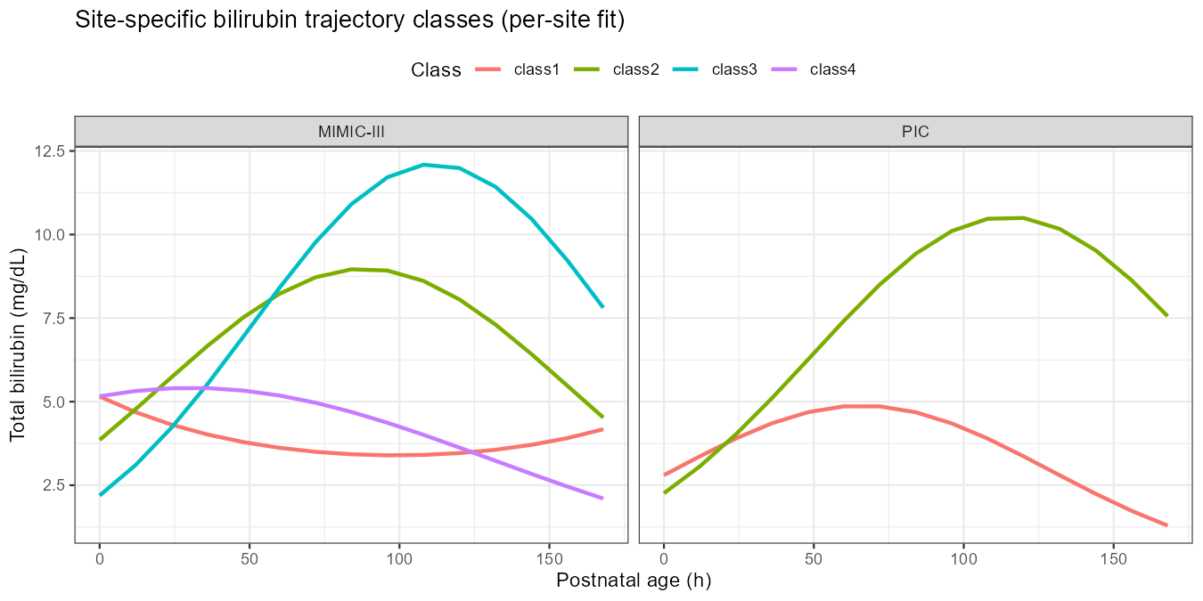
Figure S1. Trajectory curves from per-database model refitting: predicted total bilirubin (mg/dL; back-transformed from the log scale) by class for MIMIC-III and PIC.

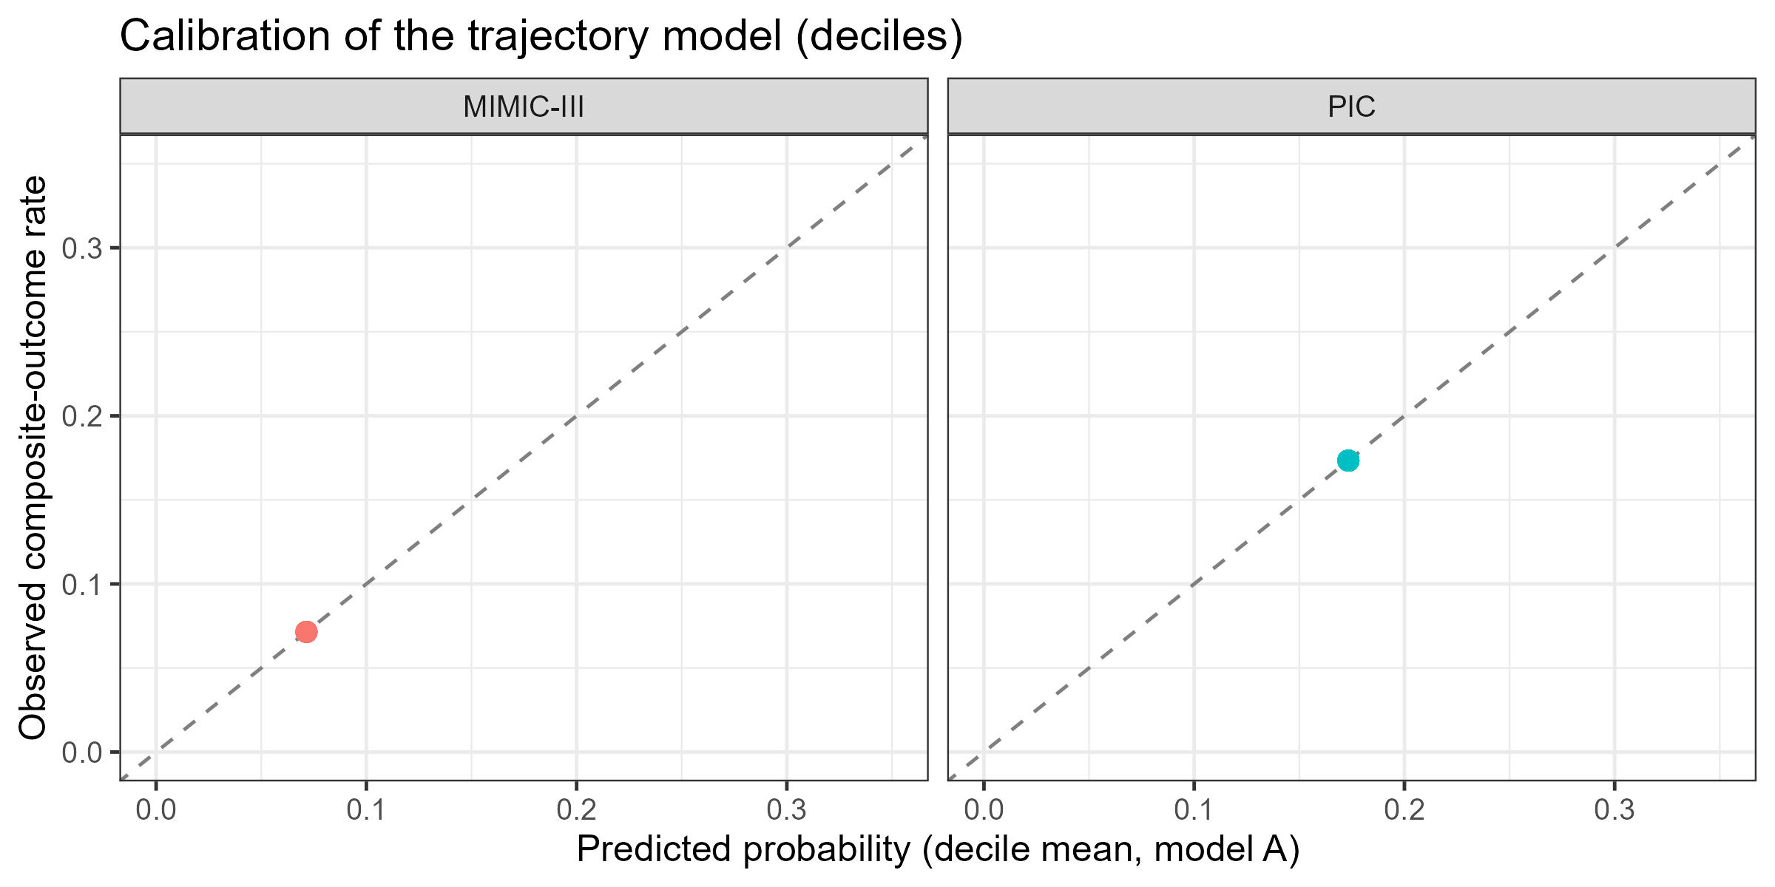
Figure S2. Decile calibration plot for the trajectory model (A) in MIMIC-III and PIC: observed composite-outcome rate versus mean predicted probability within deciles. Points near the diagonal indicate good calibration.

