Supplementary Figure 1. IGV review of clinically reported somatic variants with discrepant variant caller results. Variants missed by both Clair3 and ClairS-TO (A) or identified by ClairS-TO only (B–E). In all cases the number of reads and/or allele fraction seen in IGV may differ from that reported by Clair3 or ClairS-TO.

A. Pine, SETD2 p.R1459*, VAF not reported. IGV view of chr3:47,120,241–47,120,280; expanded view, unphased. The G>A substitution is supported by 3 of 24 reads and was called by neither Clair3 nor ClairS-TO.

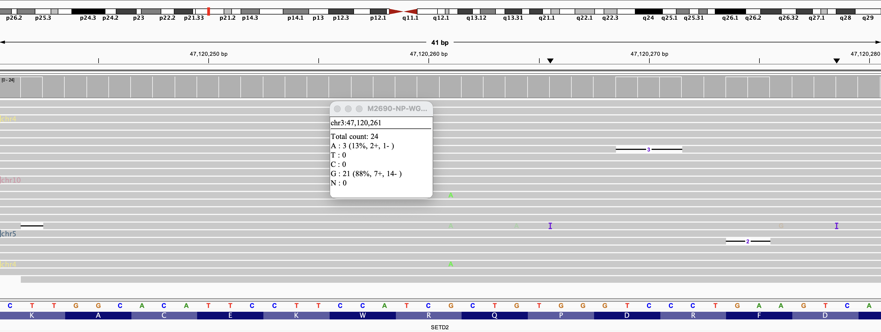

B. Pear, H3-3A p.K28M, VAF not reported. IGV view of chr1:226,064,414–226,064,453; squished view, phased view. The A>T substitution is supported by 24 of 100 reads (allele fraction 0.24) and assigned predominantly to haplotype 2, although approximately half of reads at this locus remained unphased. Called by ClairS-TO only.

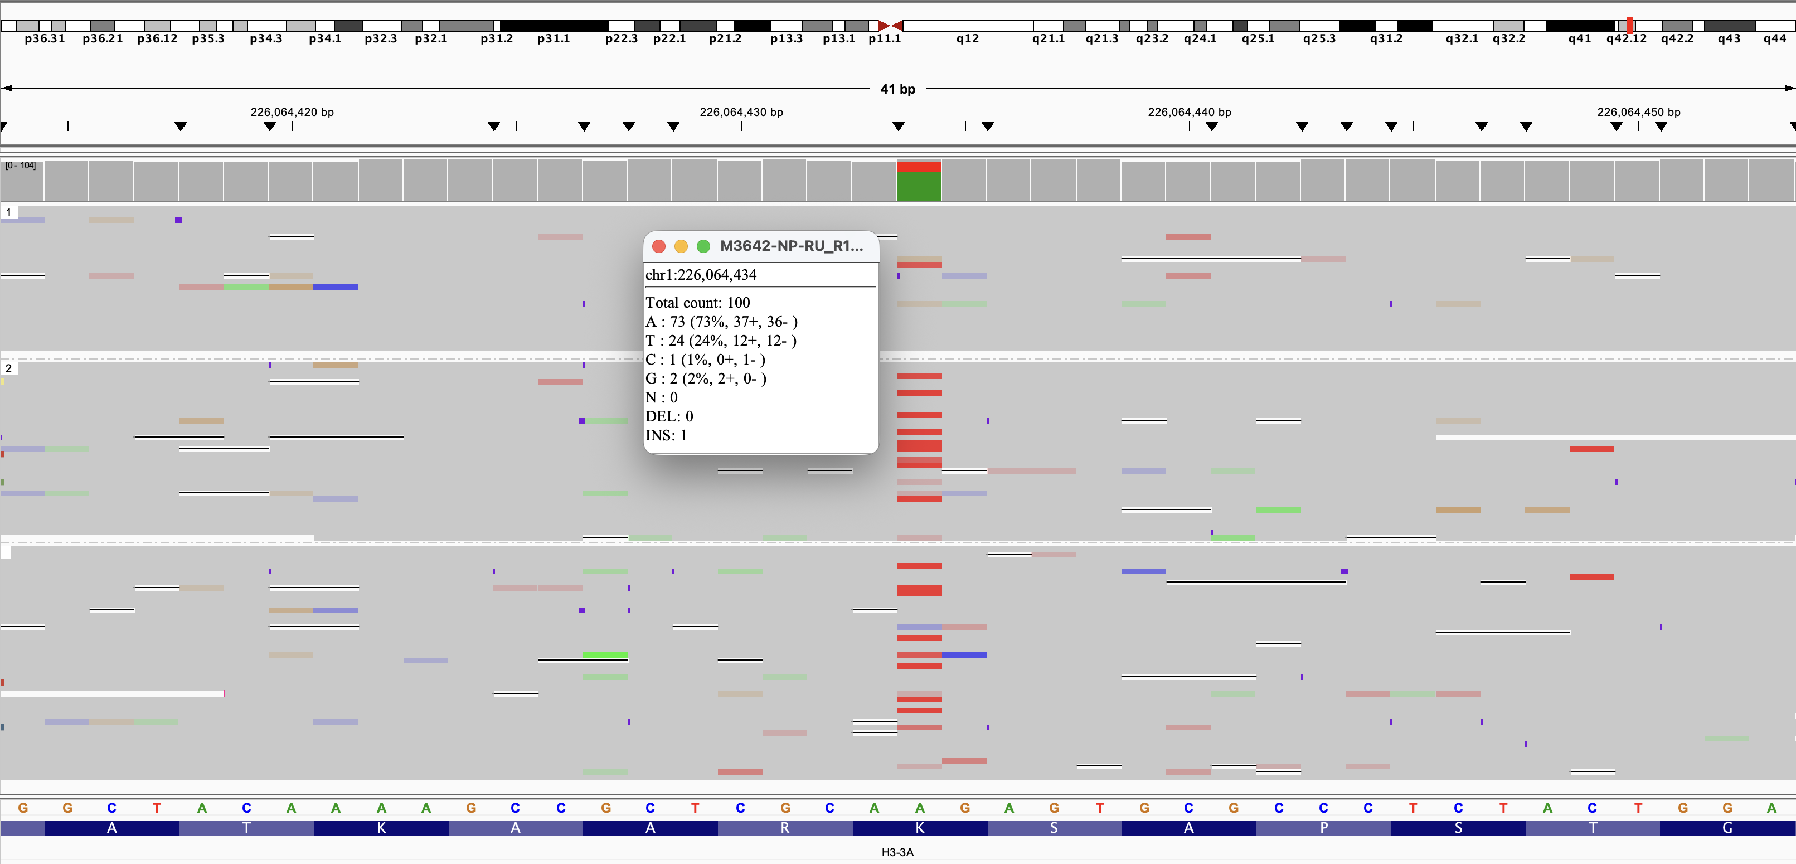

C. Cherry, IDH1 p.R132L, VAF 34%. IGV view of chr2:208,248,368–208,248,407; squished view, phased view. The C>A substitution is supported by 21 of 113 reads (allele fraction 0.19) and confined to haplotype 2. Called by ClairS-TO only.

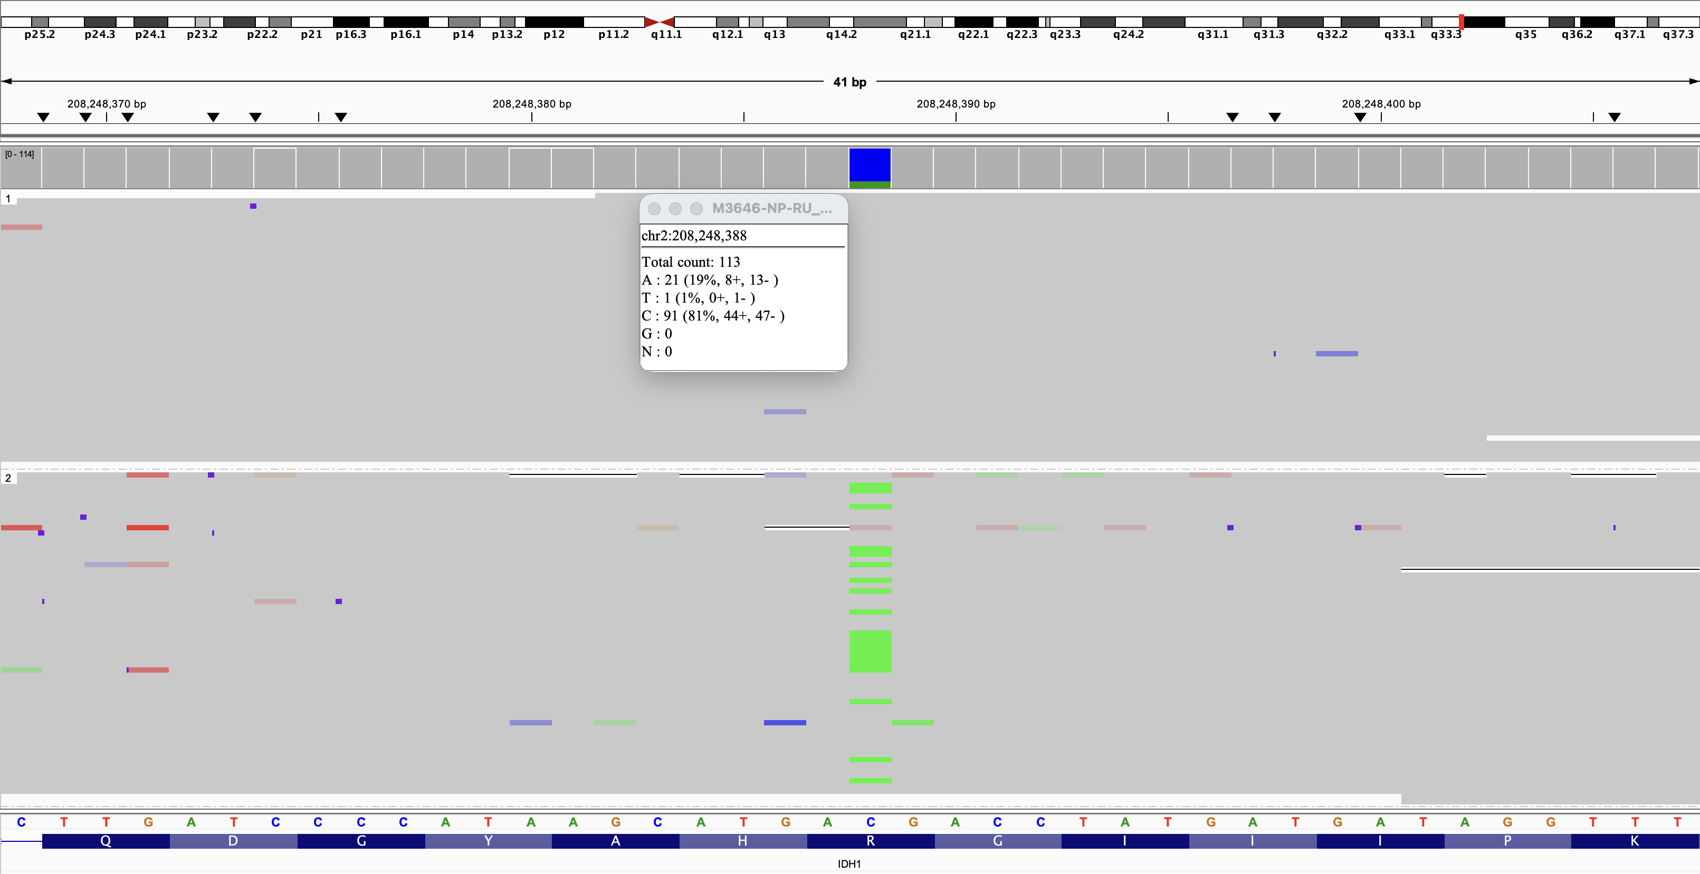

D. Cherry, TP53 p.R158H, VAF 36%. IGV view of chr17:7,675,119–7,675,158; squished view, phased view. The C>T substitution is supported by 25 of 142 reads (allele fraction 0.18) and confined to haplotype 2. Called by ClairS-TO only.

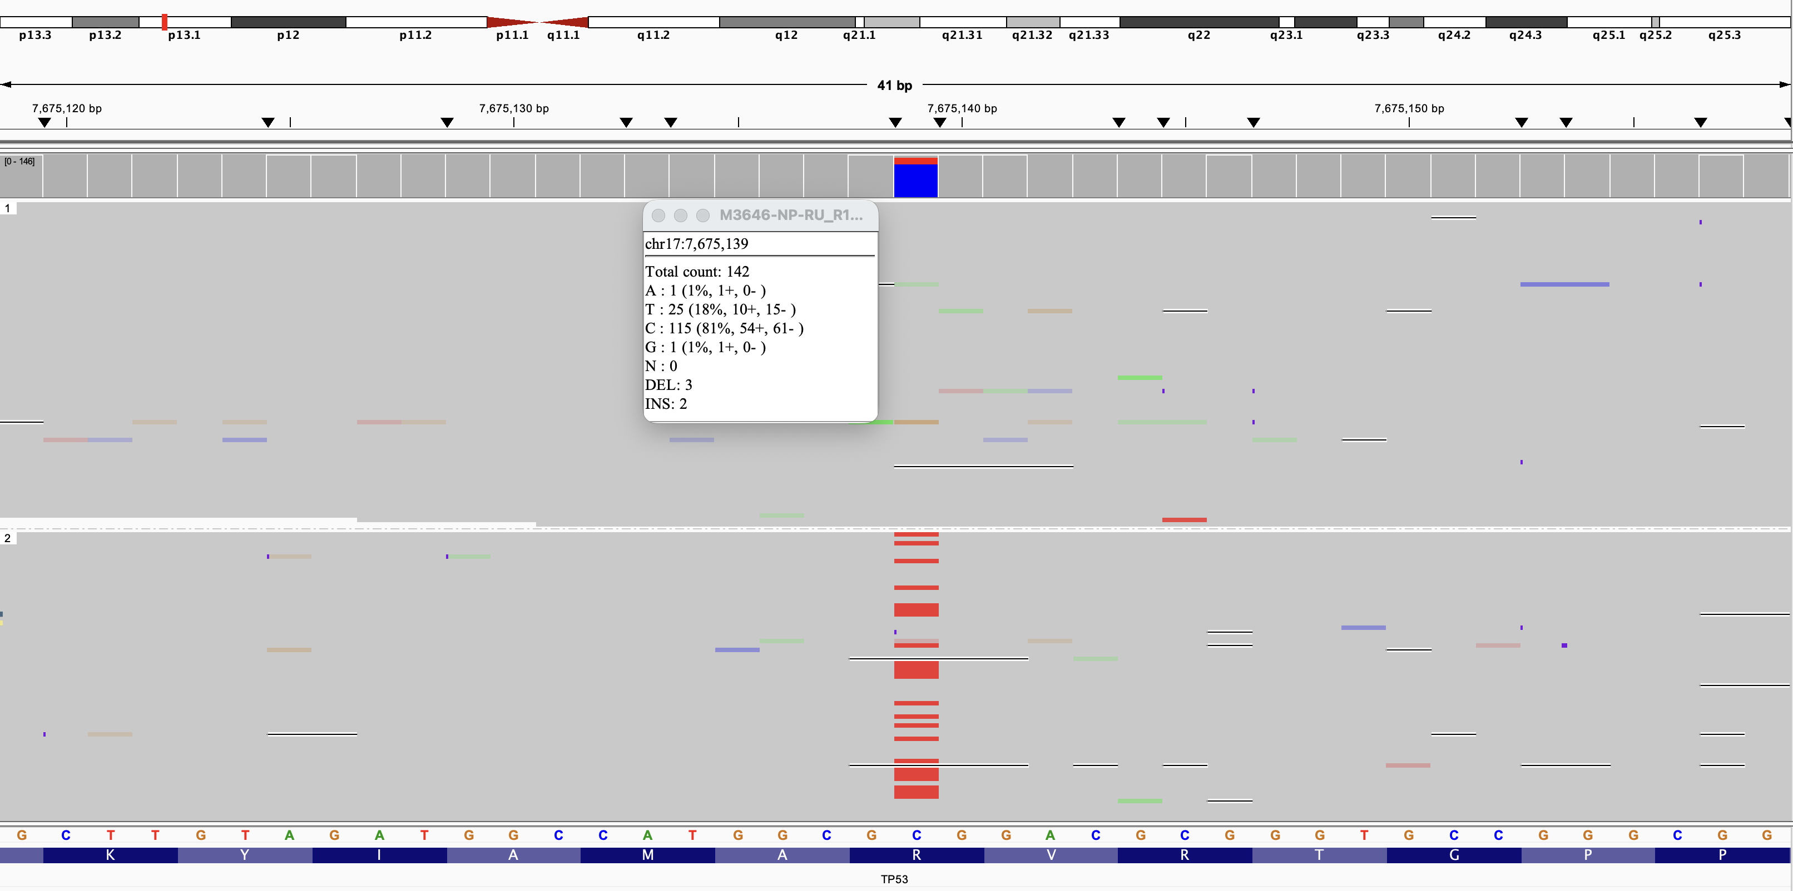

E. Ipe, TP53 p.G108Vfs*15, VAF 55%. IGV view of chr17:7,676,026–7,676,065; squished view, phased view. The 1 bp deletion is assigned predominantly to haplotype 2, with some reads remaining unphased. Called by ClairS-TO only. The low number of reads assigned to haplotype 1 likely indicates loss of that haplotype in the tumor.

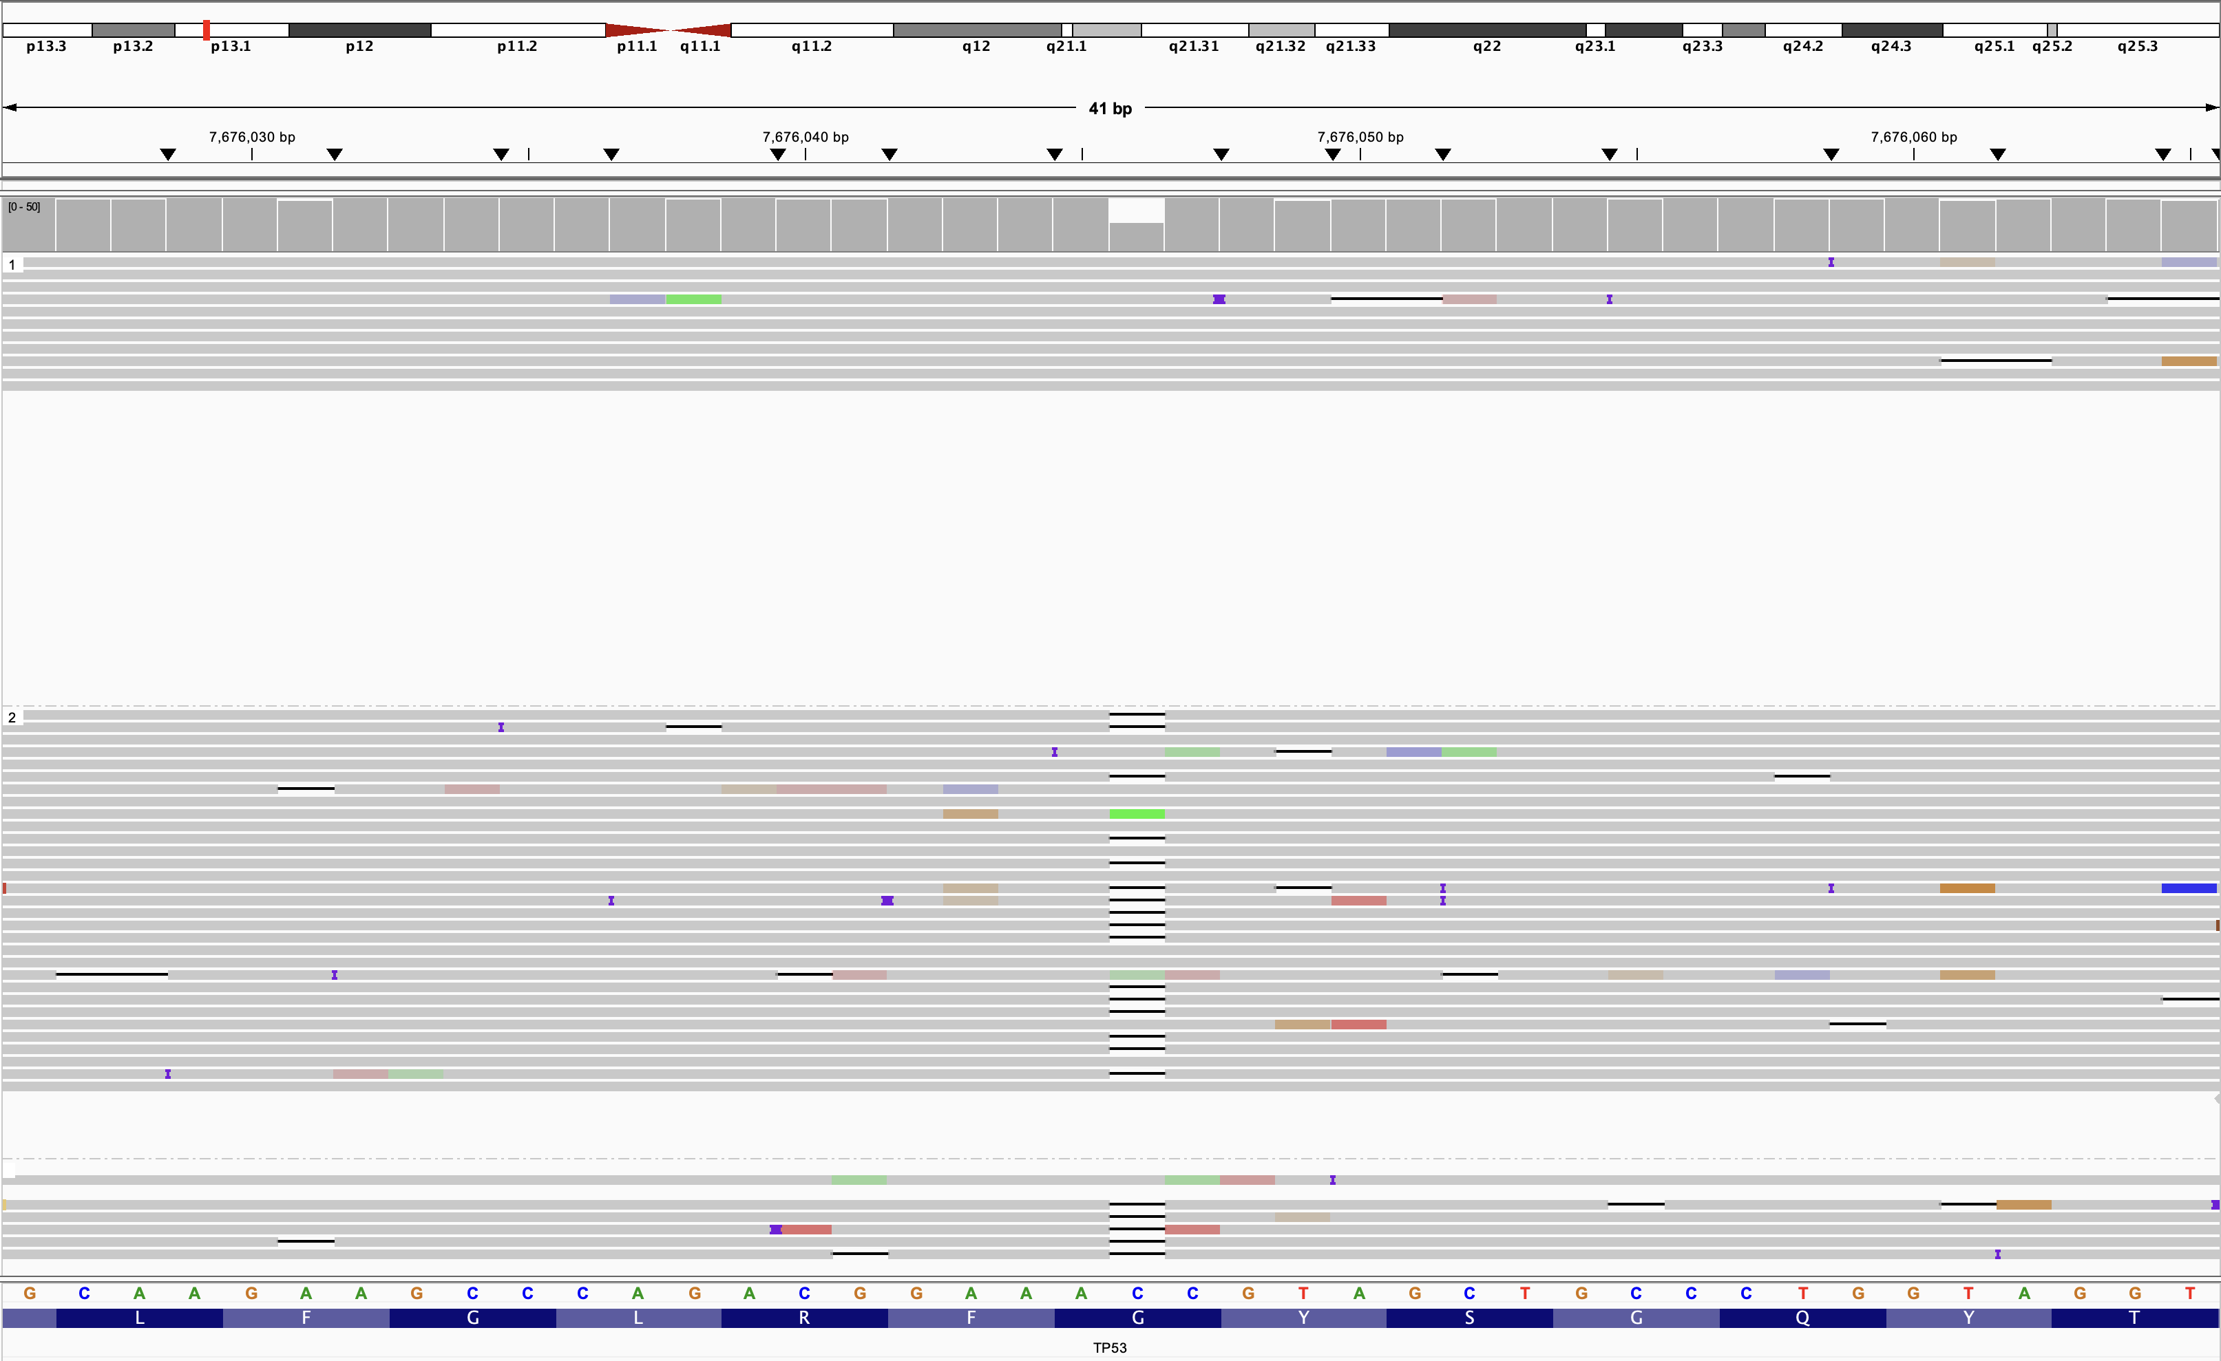

Supplementary Figure 2. Copy number variant profiles for all samples. Genome-wide copy number profiles generated by ichorCNA for all 23 samples for both wgLRS and AS. Each plot shows log2 ratio (y-axis) across all chromosomes (x-axis). For the six samples with both WGS and AS data, profiles from both sequencing approaches are shown. Samples are ordered as listed in Supplementary Table 8.

(a) Ash, wgLRS.

(b) Cedar, wgLRS.

(c) Pine, wgLRS.

(d) Aspen, wgLRS.

(e) Aspen, AS.

(f) Ginko, wgLRS.

(g) Ginko, AS.

(h) Hemlock, wgLRS.

(i) Hemlock, AS.

(j) Madrona, wgLRS.

(k) Madrona, AS.

(l) Maple, wgLRS.

(m) Maple, AS.

(n) Oak, wgLRS.

(o) Oak, AS.

(p) Apple, AS.

(q) Avocado, AS.

(r) Cherry, AS.

(s) Chestnut, AS.

(t) Coconut, AS.

(u) Fig, AS.

(v) Fir, AS.

(w) Ipe, AS.

(x) Lemon, AS.

(y) Orange, AS.

(z) Papaya, AS.

(aa) Peach, AS.

(ab) Pear, AS.

(ac) Plum, AS.

Supplementary Figure 3. QDNAseq plot for wgLRS (A) and AS (B) experiments for Madrona showing multiple copy gain and loss events not easily visualized in the ichorCNA output. Gains or losses are shown as deviation of copy number above or below zero but may not always be highlighted if the magnitude of the change is subtle.

A. CNV calling using wgLRS data.
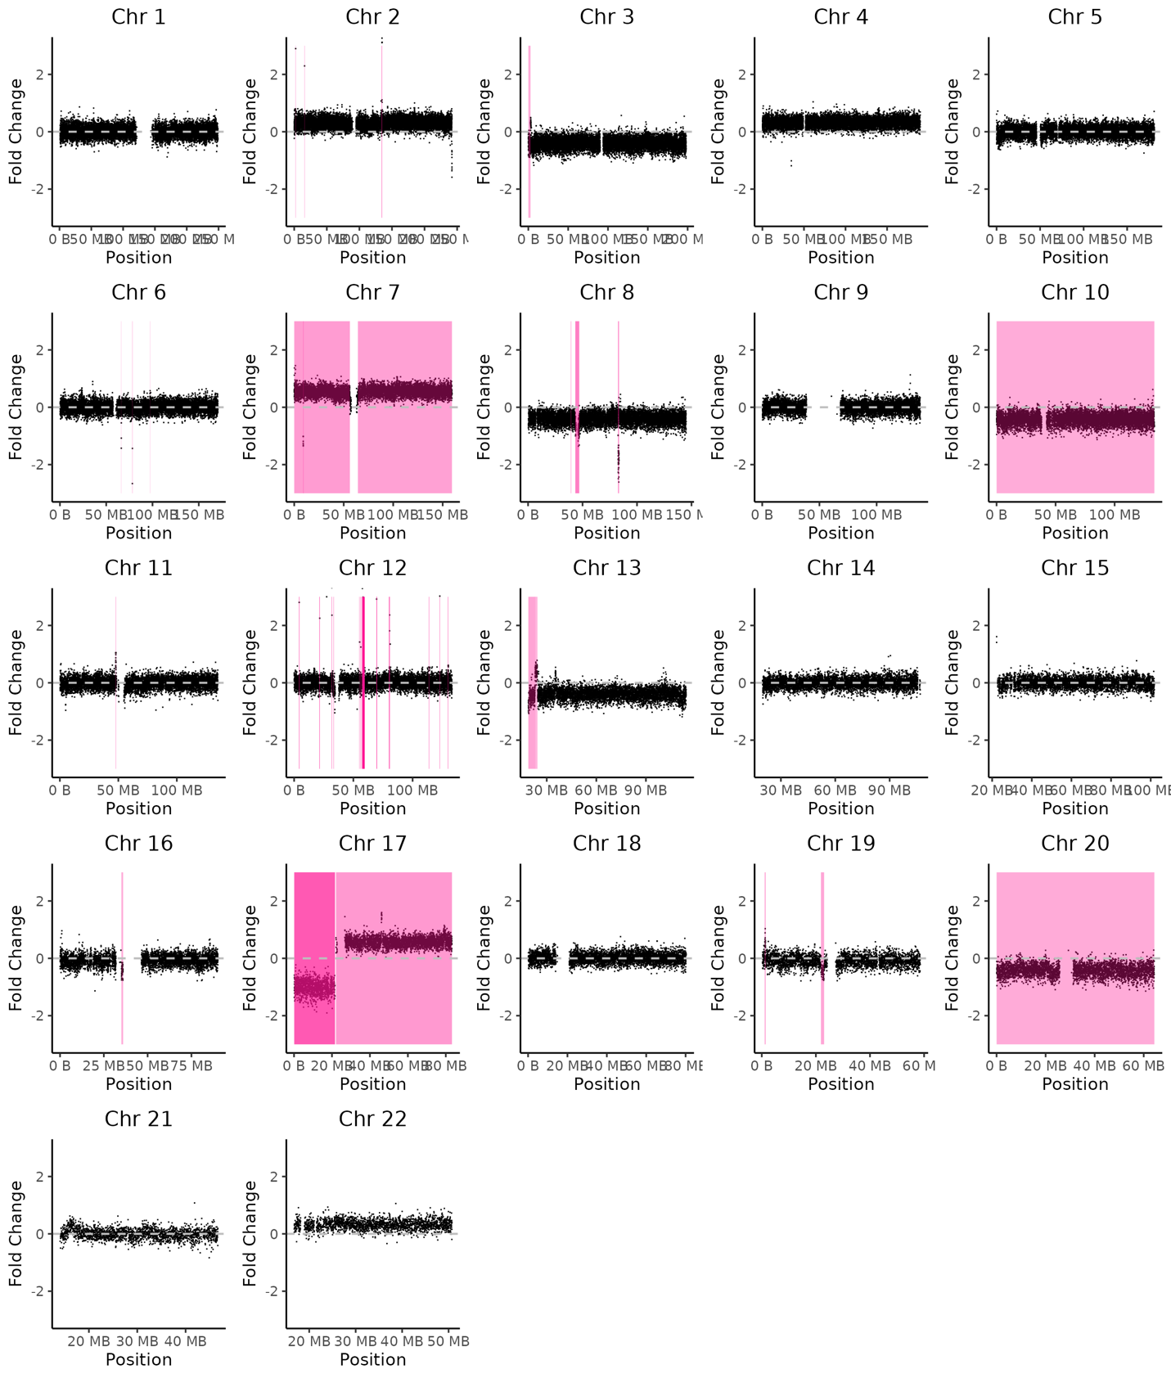

B. CNV calling using adaptive sampling.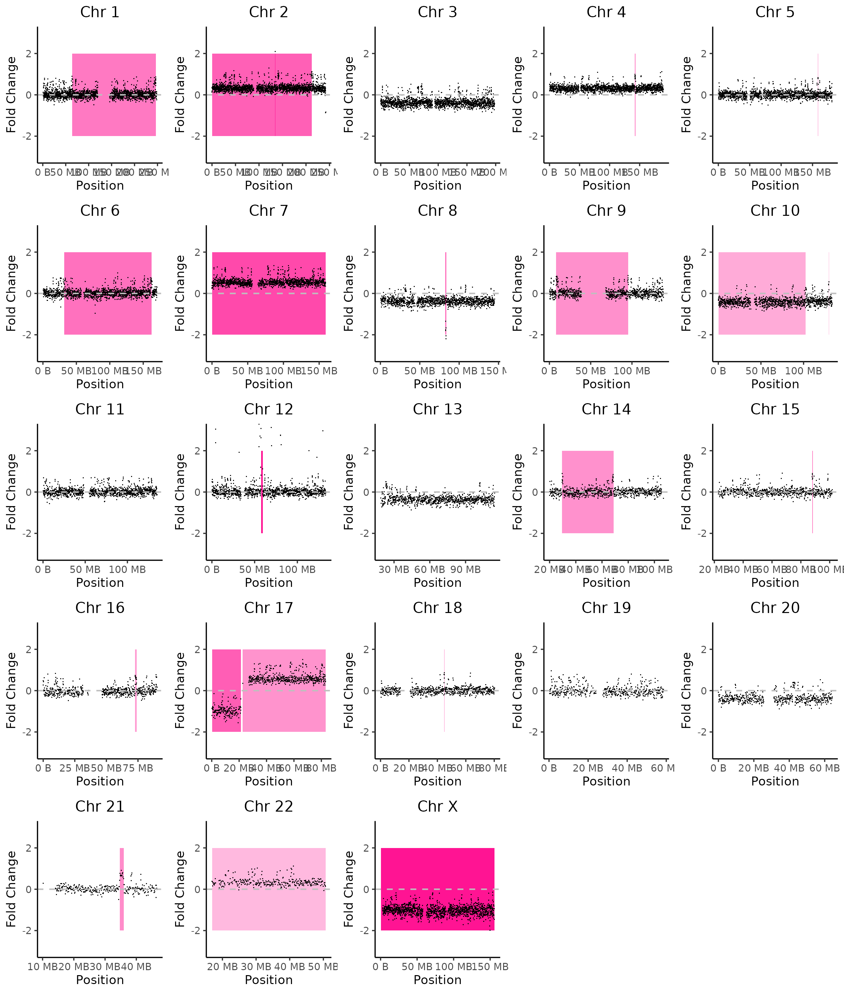

Supplementary Figure 4. Manual IGV review of all six clinically reported gene fusions. For each fusion, split reads and supplementary alignments spanning the rearrangement are shown at both breakpoint loci (GRCh38). (A–B) ZFTA::RELA in Apple. (C–D) KIAA1549::BRAF in Chestnut. (E–F) ZNF708::RB1 in Avocado. (G–H) LAMA2::ARID1B in Maple. (I–J) FANCE::ARID1B in Maple. (K) GSAP::KMT2C in Ginko, shows absence of supporting reads at the expected breakpoint positions in either wgLRS (32x) or AS (63x) data (only wgLRS view is shown), consistent with the fusion not being present in the tissue used for research sequencing.

A. ZFTA::RELA in Apple, ZFTA breakpoint. chr11:63,764,976–63,765,247.

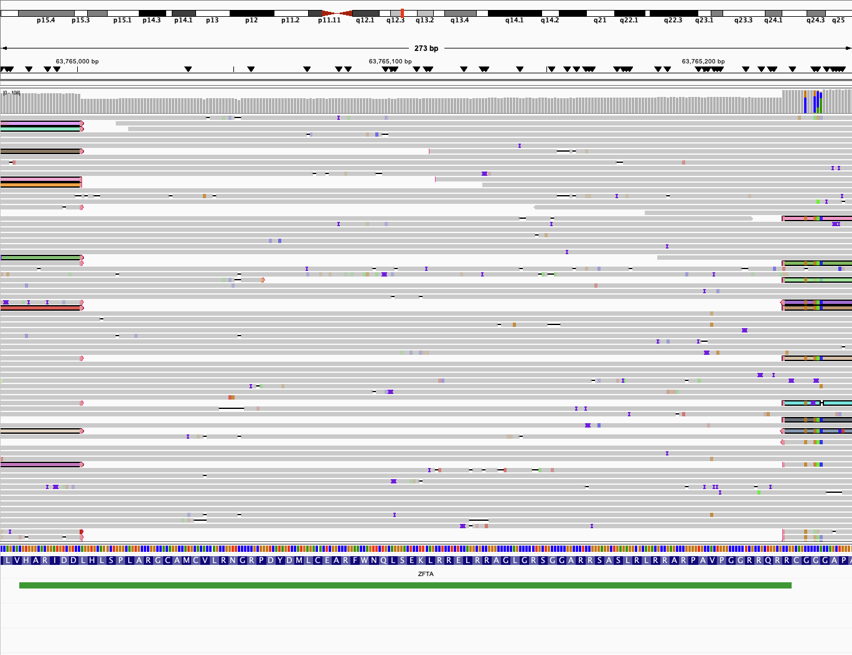

B. ZFTA::RELA in Apple, RELA breakpoint. chr11:65,662,551–65,663,707.

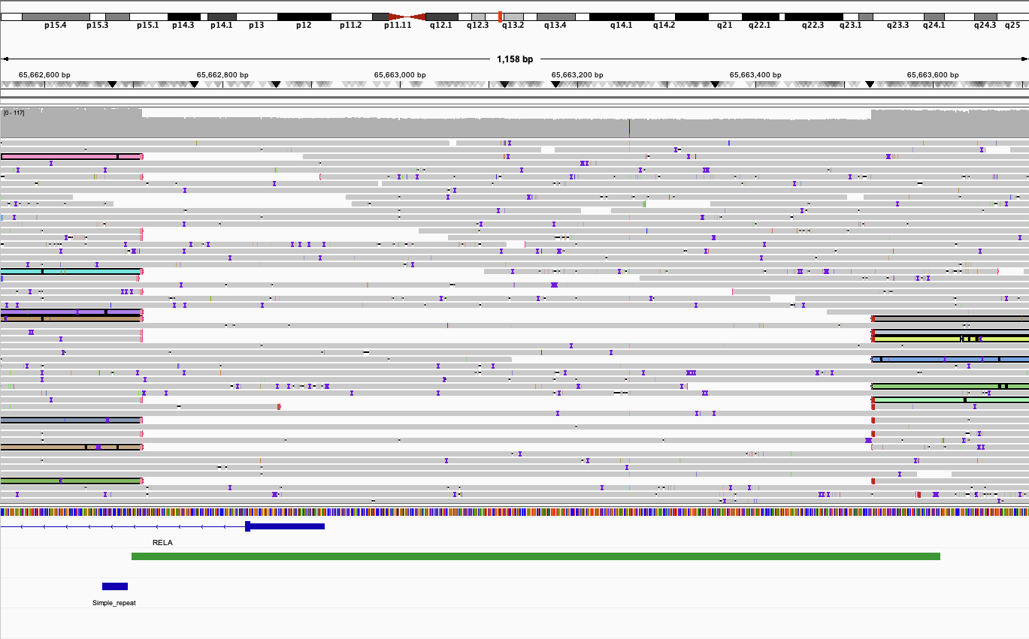

C. KIAA1549::BRAF in Chestnut, KIAA1549 breakpoint. chr7:138,855,173–138,855,486.

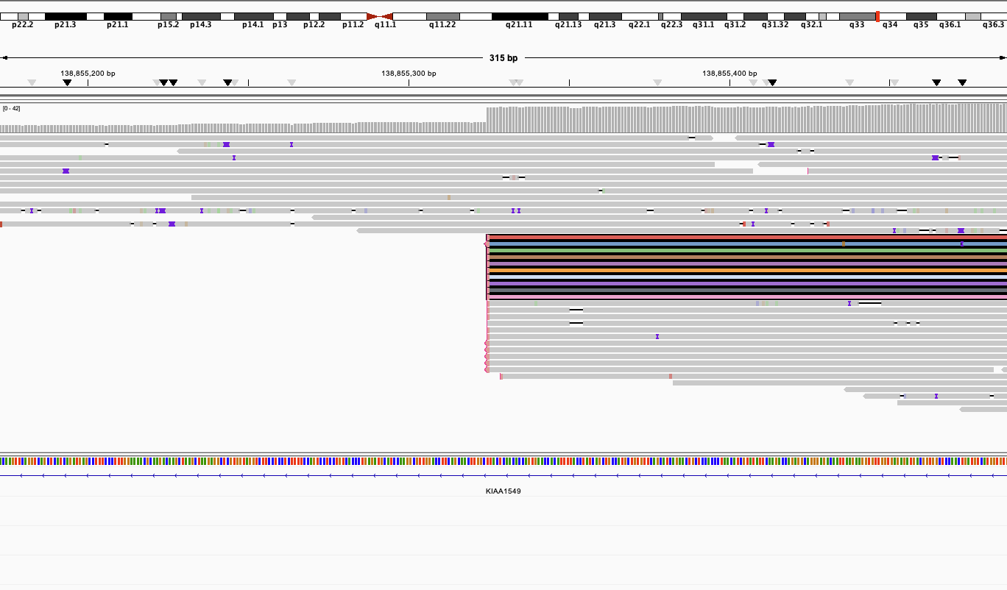

D. KIAA1549::BRAF in Chestnut, BRAF breakpoint. chr7:140,788,755–140,791,065.

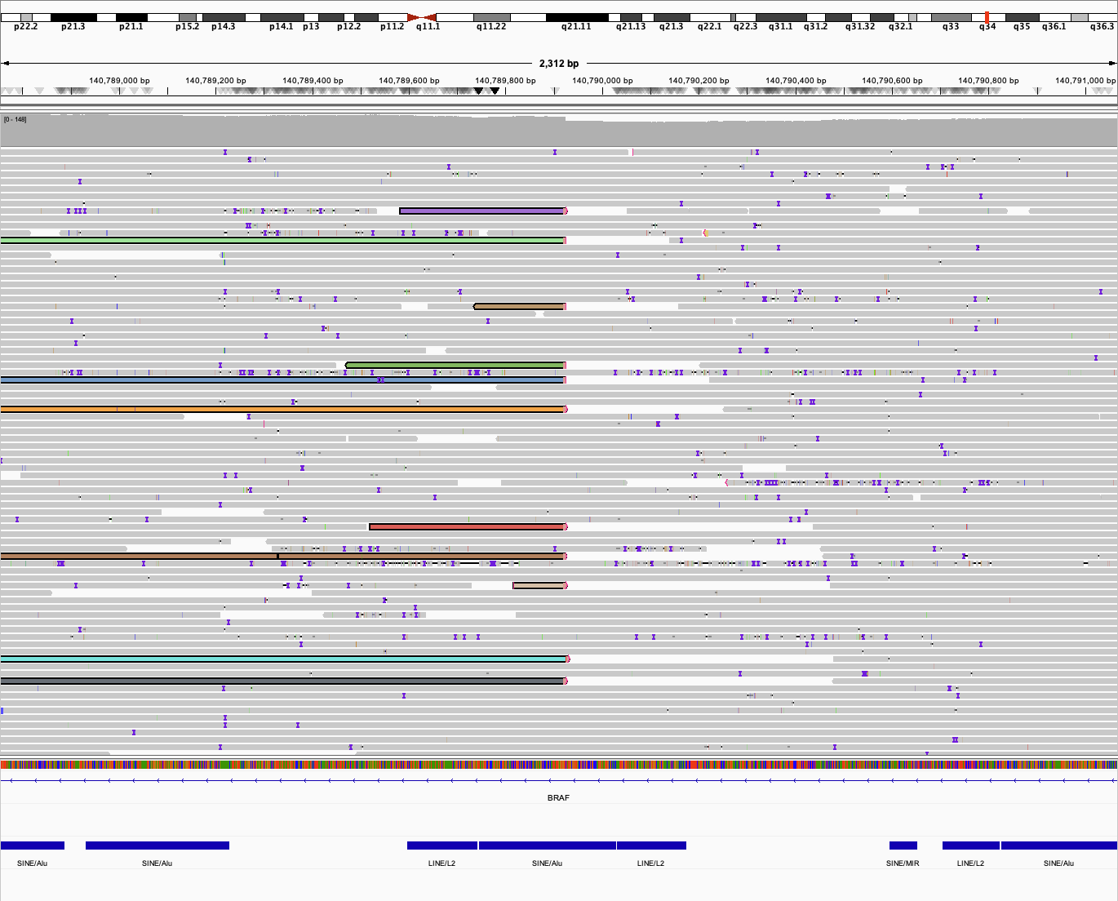

E. ZNF708::RB1 in Avocado, ZNF708 breakpoint. chr19:21,323,111–21,323,354.

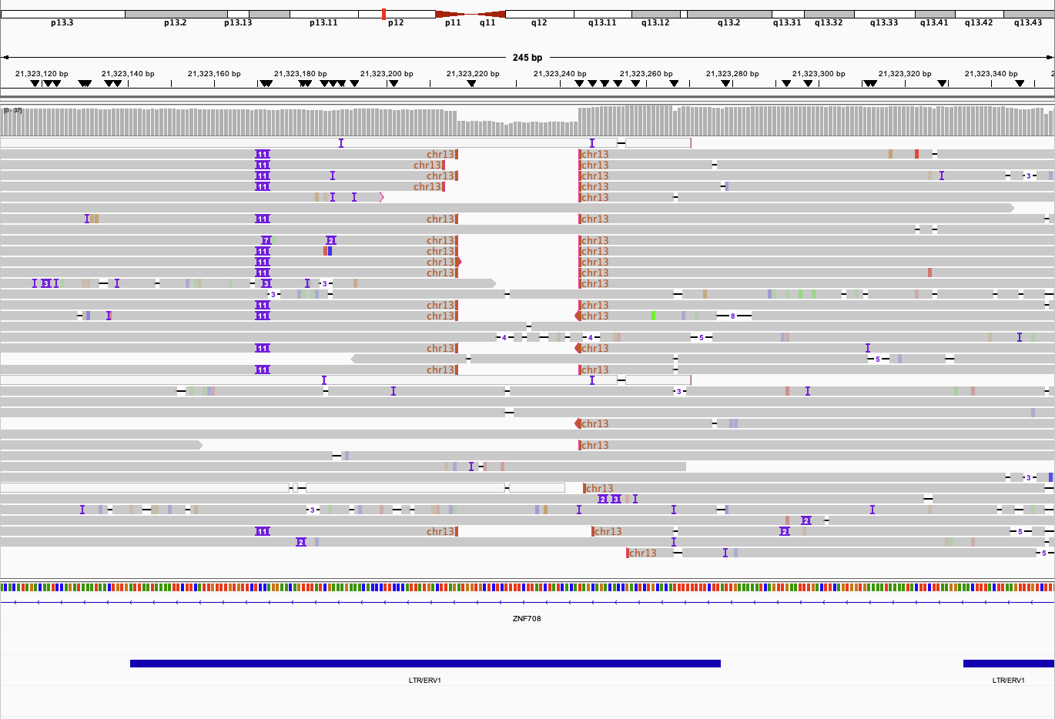

F. ZNF708::RB1 in Avocado, RB1 breakpoint. chr13:48,388,698–48,388,804.

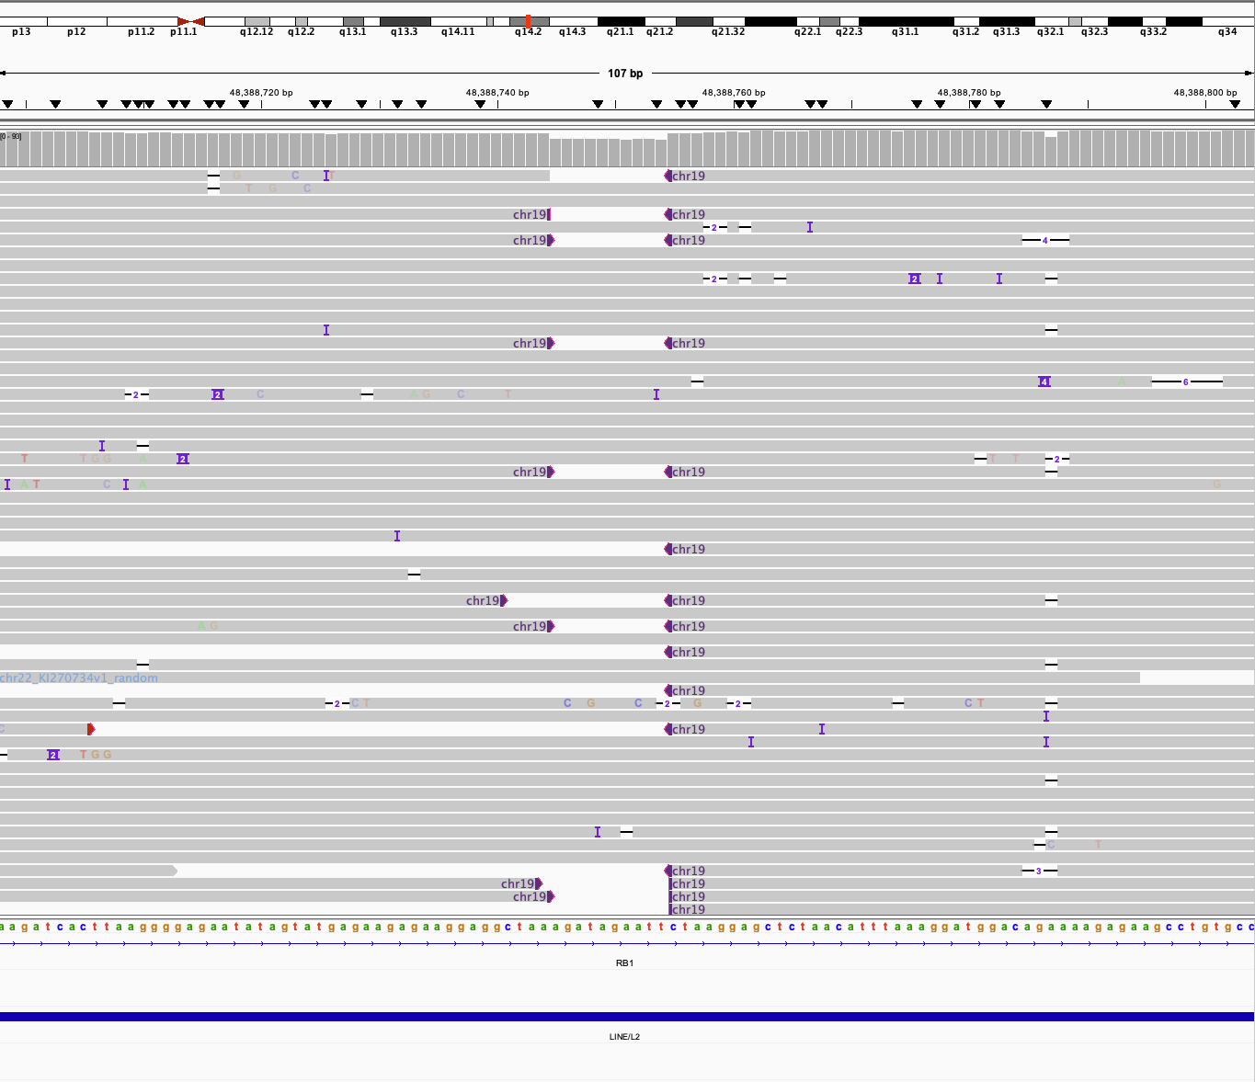

G. LAMA2::ARID1B in Maple, LAMA2 breakpoint. chr6:129,015,158–129,015,197.

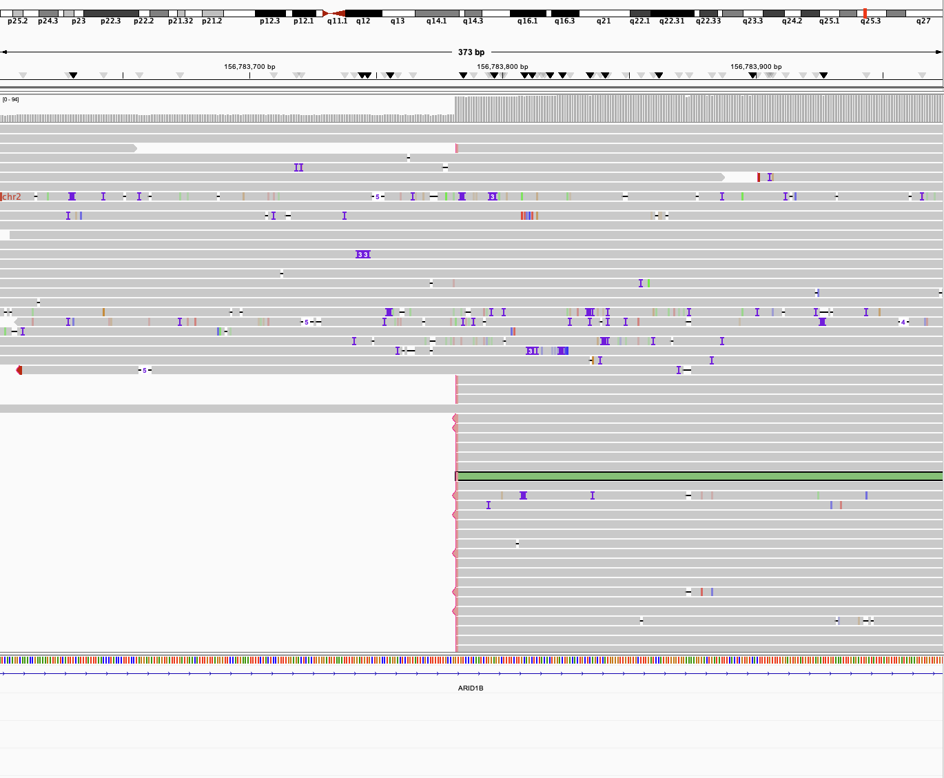

H. LAMA2::ARID1B in Maple, ARID1B breakpoint. chr6:156,783,602–156,783,973.

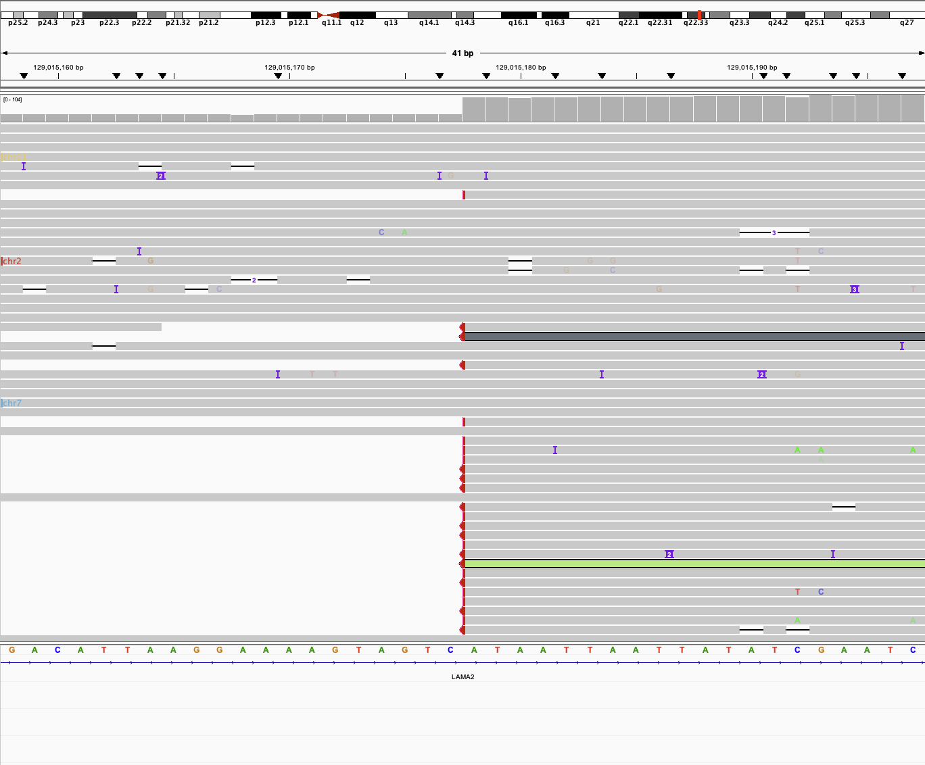

I. FANCE::ARID1B in Maple, FANCE breakpoint. chr6:35,456,909–35,456,976.

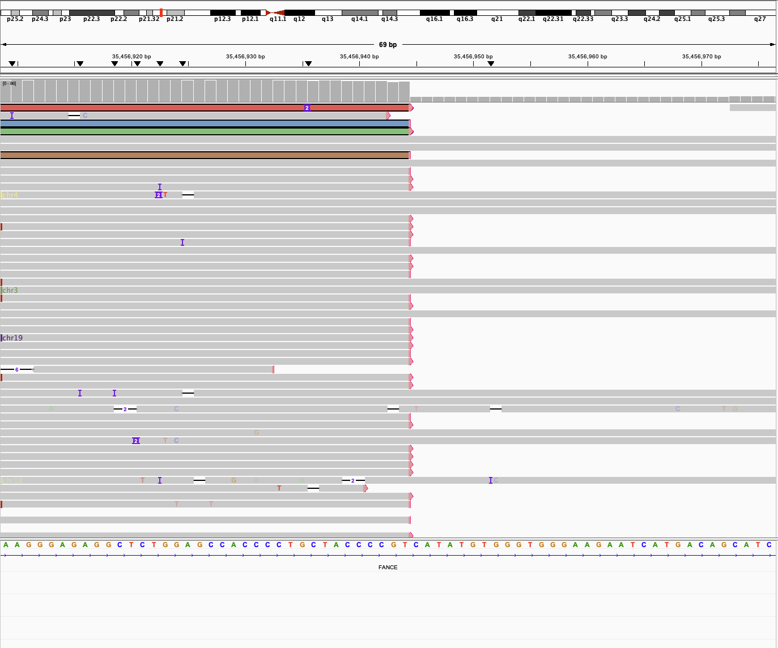

J. FANCE::ARID1B in Maple, ARID1B breakpoint. chr6:156,783,602–156,783,973.

K. GSAP::KMT2C in Ginko. No split or supplementary alignments were identified at the expected breakpoint positions in either wgLRS (32x) or AS (63x) data; the wgLRS view is shown. IGV shows no split or supplementary alignments which would indicate a rearrangement with KMT2C in this sample. IGV view is of chr7:77,308,751-77,418,349 (GRCh38).

