Extended Figures
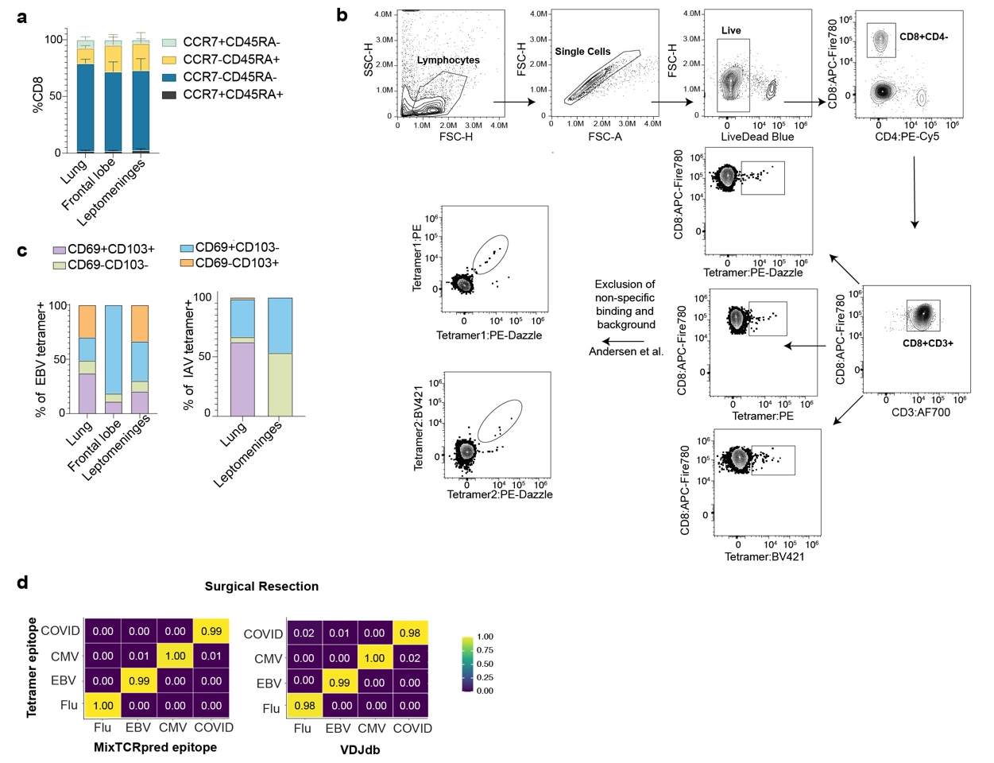
Extended Data Figure 1

Extended Data Figure 1. Identification of virus-specific CD8⁺ T cells. (a) CCR7 and CD45RA co-expression among CD8+ T cells across tissues (n=5; bars represent mean ± SEM). (b) Gating strategy for combinatorial tetramer staining. (c) CD69 and CD103 co-expression among EBV and IAV tetramer positive cells. Data points representing fewer than 10 tetramer positive cells were excluded (bars represent mean ± SEM). (d) Concordance between MixTCR- (left) and VDJdb (right) predicted tetramer defined viral specificity. Fractions are normalized within each MixTCR or VDJdb-predicted specificity.

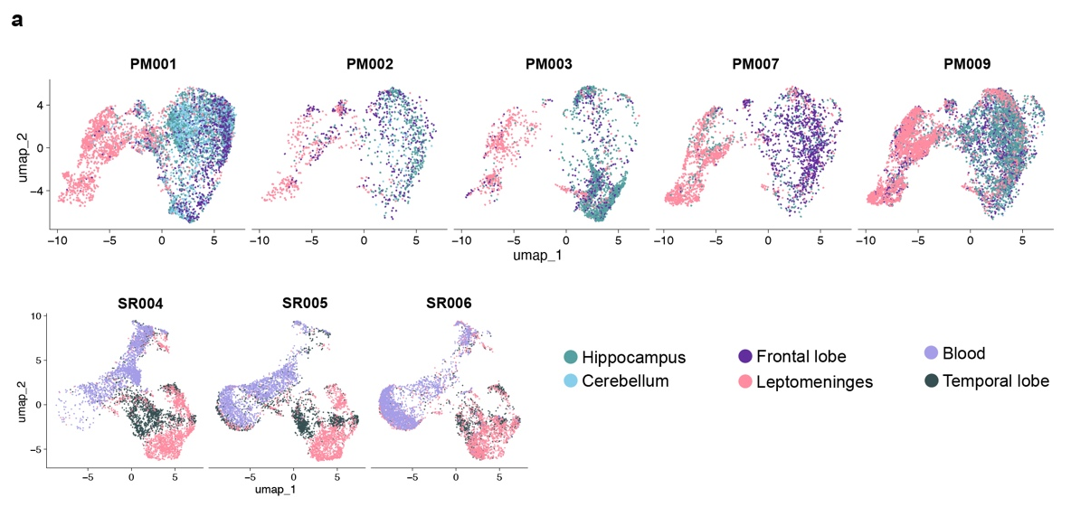
Extended Data Figure 2

Extended Data Figure 2. Donor level transcriptional variation of CNS CD8⁺T cells. (a) UMAP of CD8⁺ T cells colored by tissue of origin, faceted by individual donor for PM cohort (top) and SR cohort (bottom)

Extended Data Figure 3
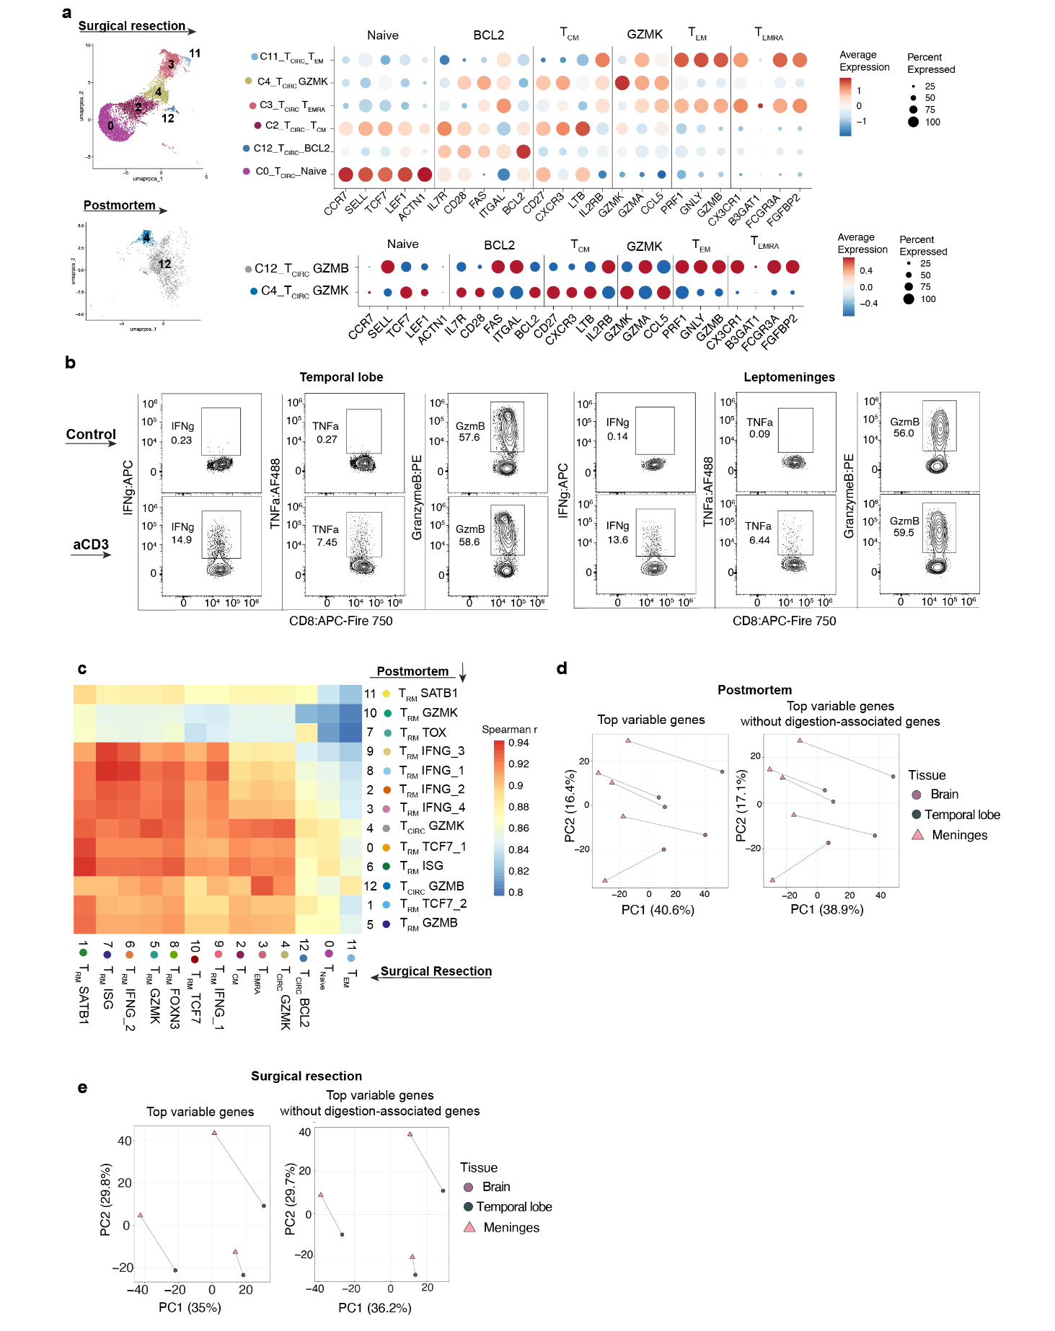

Extended Data Figure 3. Circulating CD8⁺ T cell clusters and transcriptional quality controls. (a) UMAP of circulating CD8⁺ T cell clusters from SR cohort (top) and PM cohort (bottom), with dot plots showing scaled expression of selected genes used to define cluster identities. Dot size represents percent of cells expressing each gene; color represents mean scaled expression. (b) Intracellular cytokine staining for granzyme B, IFNγ and TNFα in an unstimulated (top row) and anti-CD3 stimulated (bottom row) CD8⁺ T cells from temporal lobe and leptomeninges. Gated on live CD8⁺ T cells; n=1. (c) PCA analysis of pseudobulk transcriptomes before (left) and after (right) removal of collagenase digestion-associated genes. Each point represents one donor-tissue pseudobulk profile; lines connect matched tissues from the same donor. (d and e) Pseudobulk Spearman correlation heatmap showing pairwise concordance of gene expression between cluster from PM (d) and SR (e) cohorts.

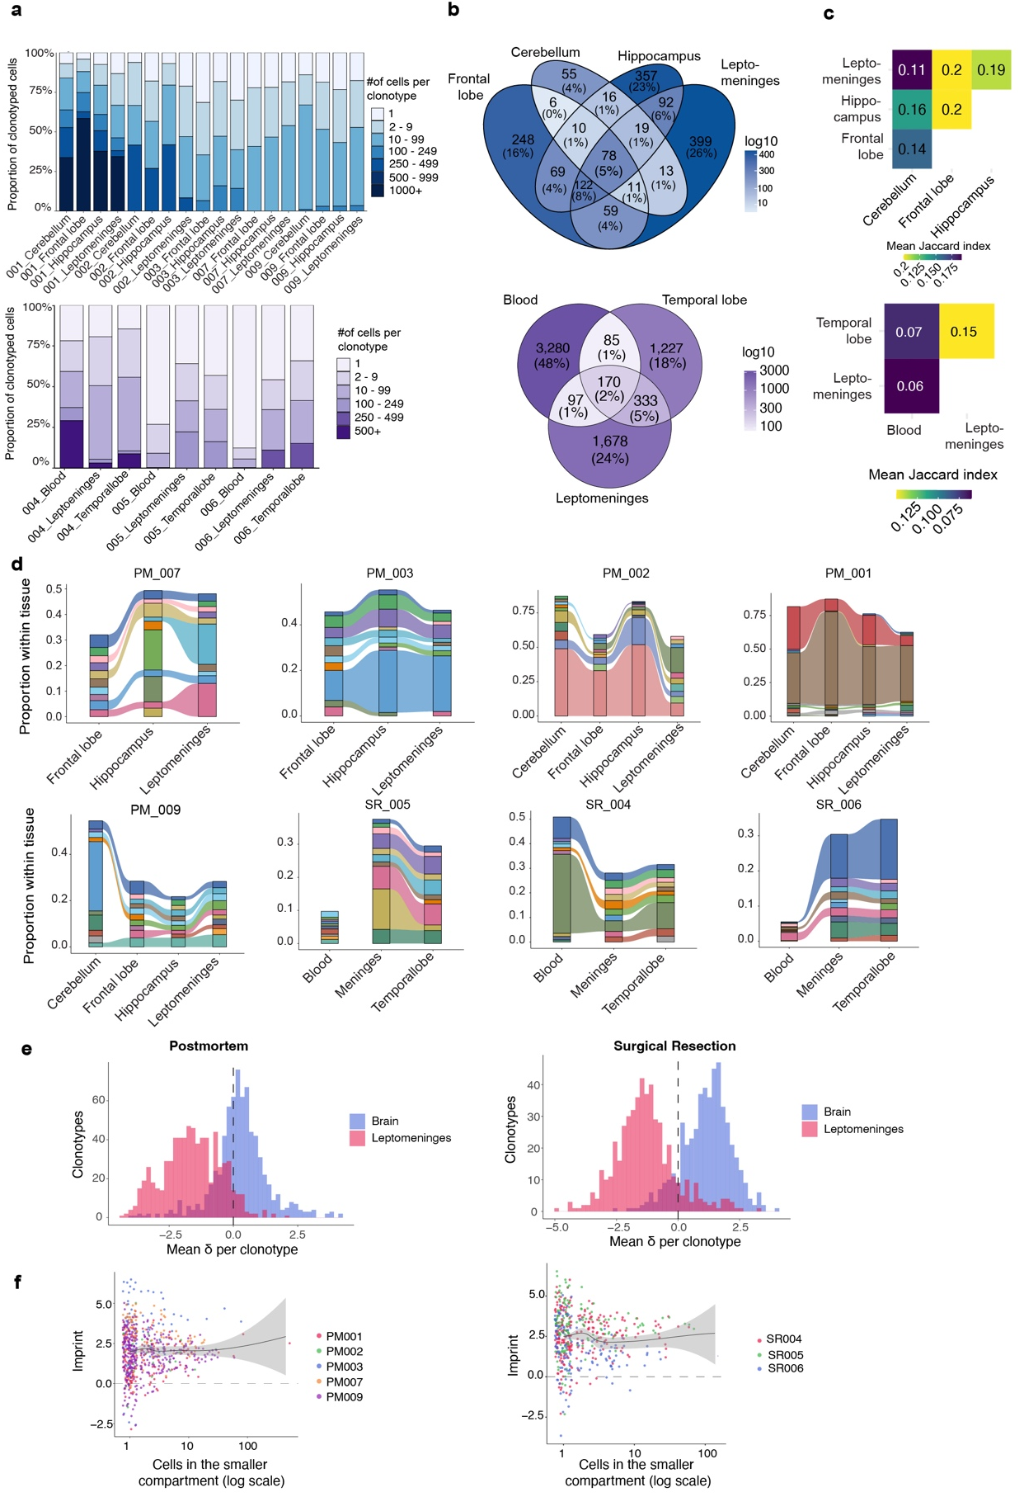
Extended Data Figure 4. Repertoire structure and clonal sharing across CNS regions.
(a) Proportion of clonotyped CD8⁺ T cells in patient-wide clone-size bins across tissues, shown by patient for PM (top) and SR (bottom). (b) Venn diagram showing overlap of T cell clonotypes across tissues or PM (top) and SR (bottom). (c) Jaccard overlap index heatmap showing pairwise clonal similarity between tissues in the PM cohort (top) and SR cohort (bottom). Values represent the mean Jaccard index across donors. (d) Alluvial plots showing the top 10 expanded clonotypes per donor, tracked across tissue compartments. Ribbon width is proportional to the number of cells belonging to each clonotype in each tissue. Colors represent individual clonotypes. (e) Polarization score (δ) of shared clonotypes by tissue compartment. For each clonotype with cells in both compartments, the mean δ of its parenchymal cells and of its meningeal cells is shown. (f) Regional imprinting score per shared clonotype versus the number of cells in its less-represented compartment (log scale); each point is one clonotype, colored by donor. Line, LOESS fit; shaded band, 95% confidence interval; dashed line, no imprinting. PM (left), SR (right).

