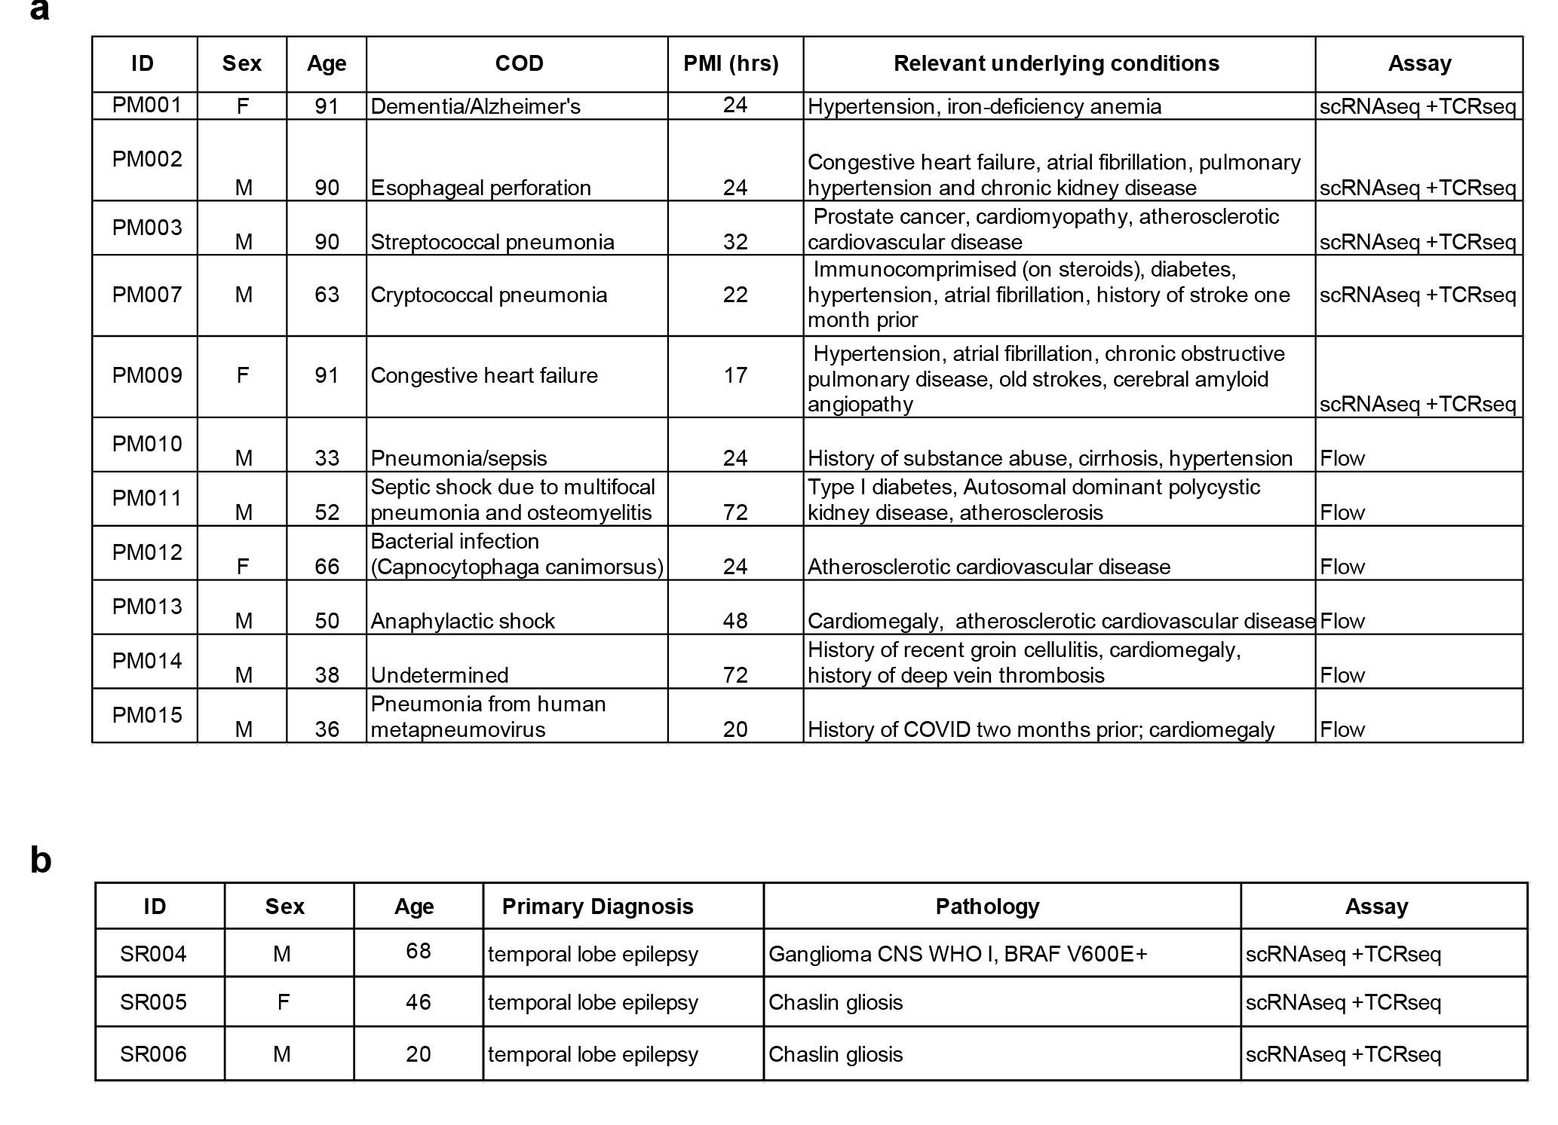
Table 1. Demographics and clinical characteristics of study donors. a) Post-mortem cohort; COD= cause of death, PMI= postmortem interval. b) Surgical resection cohort.

Table 2. Tissue distribution of T cells with VDJdb-matched TRB sequences across all tiers. (attached)
Table 3. High-confidence VDJdb-matched TCR clonotypes, tissue distribution and tetramer annotations (attached)

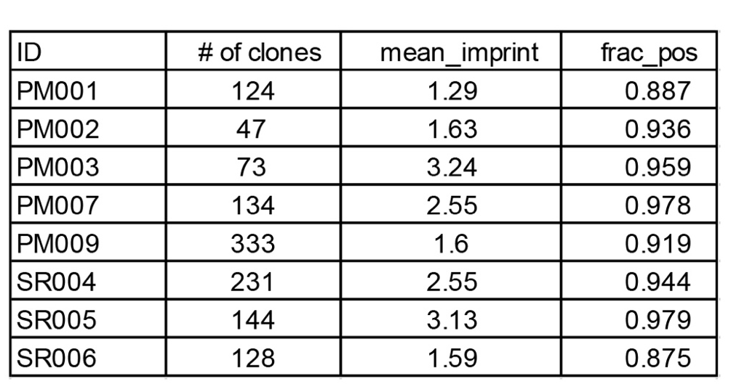

Table 4. Regional imprinting scores per donor.

