HDV RNA level shows a threshold pattern for liver disease progression but has limited prognostic value alone in chronic hepatitis D
Habiba Kamal^{1,2,3}, Ganbolor Jargalsaikhan^{4,5}, Sanjaasuren Enkhtaivan^{4,5}, Karin Lindahl^{1,2}, Bekhbold Dashtseren^{4,5}, Oyungerel Lkhagva-Ochir^{4,5}, Tuvshinjargal Ulziibadrakh^{4,5}, Andreas Bungert^{4,5}, Elisabetta Degasperi^{3,6}, Pietro Lampertico^{3,6,7}, Heiner Wedemeyer^{3,8,9,10},
Naranjargal B Dashdorj^{3,4} and Soo Aleman^{1,2,3}
Supplements:
Methods: Baseline variables and definitions, statistics
Figures:
S1. Study flowchart
S2. The distribution of HDV RNA levels by cirrhosis, age groups and sex at initial visit
S3: Comparison of time dependent area under receiver operating curve (AUROC) to predict cirrhosis and composite liver-related events using only HDV RNA summary measures vs adding age, alanine aminotransferase, gamma glutamyl transferase, platelets count and cirrhosis diagnosis to the model.
S4: Cumulative incidence of composite liver-events treating non-liver related death as a competing event. Statistical significance tested by Aalen-Johansen cumulative incidence estimator (Fine-Gray’s test).

Tables:
S1: Proportion of missed variables at baseline, and summary measures before and after imputation.
S2: Predictors of progression to cirrhosis in 1,870 patients by univariable and multivariable Cox regression model
S3: Change in longitudinal HDV RNA levels in 1,615 patients with ≥ 2 measurements spaced ≥ 6 months during study duration subgrouped by cirrhosis at baseline, HBeAg status and sex.

Methods:
Baseline variables and definitions
The baseline HDV RNA test was defined as the first measurement showing an HDV RNA level of ≥ 50 IU/mL. Demographic characteristics such as sex, birth date, body mass index (BMI), and laboratory parameters were ascertained from the center’s electronic database. BMI was calculated as weight (kg)/ (height [m])² and ≥23.0 kg/m² was defined as overweight or obese per recommendation for Asian populations [1]. Alcohol consumption was defined as any alcohol intake in the past year per patient’s self-report in the health surveys. Laboratory parameters included alanine aminotransferase (ALT), aspartate aminotransferase (AST), gamma-glutamyl transferase (GGT), total bilirubin, serum albumin, platelet count, lipid profile, and fasting blood glucose. Virological data included quantitative HBsAg, HBV DNA, anti-HBs, anti-HCV antibody, HCV RNA, HBeAg status, anti-HDV antibody, and quantitative HDV RNA levels.
The upper limit of normal (ULN) for biochemical tests, as per local laboratory reference, were defined as following: ALT of 41 IU/L for men and 31 IU/L for women, AST of 35 IU/L for men and 31 IU/L for women, GGT of 55 IU/L for men and 38 IU/L for women, serum triglyceride of 1.7 mmol/L, and serum low-density lipoproteins (LDL) of 2.6 mmol/L. The lower limit of normal (LLN) for serum high density lipoproteins (HDL) was 1.0 mmol/L for men and 1.3 mmol/L for women. Cardiometabolic risk factors (MRF) were defined as the presence of at least one of the following conditions: overweight or obesity, diabetes mellitus (as ever documented diagnosis or a fasting serum glucose ≥7.0 mmol/L or hemoglobin A1C ≥5.8 on ≥ one occasion), liver steatosis by controlled attenuation parameter (CAP) ≥ 248 decibel/meter (dB/m), dyslipidemia, hypertension and/or diagnosis of fatty liver disease [2].

Classification of fibrosis by LSM
Liver stiffness measurements (LSM) ranging from 2.0 to 75.0 kPa were obtained using transient elastography (Fibroscan®, Echosens) following local center protocol. LSM were considered reliable when success rate of measurements was ≥90% for at least 10 measurements and of the interquartile range (IQR) was ≤30% [3]. LSM cutoffs for fibrosis staging were no or minimal fibrosis (F0-F1) for LSM <6.0 kPa, F2 or moderate fibrosis for ≥6.0–<10.0 kPa, F3 or advanced fibrosis for LSM ≥10.0–<15.0 and LSM ≥15.0 kPa for F4 or cirrhosis [4].

Study definitions and ascertainment of outcome
The center registry at Liver Center, contained data on patient’s demographics, birthdate, sex, body mass index (BMI) dates of visits and comorbidities such as alcohol, smoking, hypertension, diabetes and previous and ongoing nucleos(t)ides analogues (NUCs). Diagnosis of HCC was verified radiologically and/or liver biopsy aligning with international guidelines. Liver cirrhosis was ascertained through clinical diagnosis, suggestive radiological findings, or LSM ≥15.0 and platelets count <150.000 cells/µL. Longitudinal LREs were identified from the center registry and supplemented by follow-up surveys conducted between January-June 2025. As cause of death was not systematically recorded, we considered death occurring within 180 days of a liver-related event, transplantation, or HCC diagnosis as a liver-related death. All other deaths were classified as non-liver-related deaths. Patients who could not be contacted were censored at the date of last documented visit.

Statistics
Sample size calculation

This was a retrospective cohort of all patients with CHD and available baseline HDV RNA identified between 2015 and 2025 (n=2,583). A formal sample size calculation was not performed as a priori given the retrospective study design. The adequacy of the sample was assessed post-hoc: with 287 events over a median follow-up of 7.3 years, and assuming a cumulative incidence of 15% and a hazard ratio of 2.0 between high- and low-risk HDV RNA categories based on published literature [5], the present study has 90% power to detect difference at a two-side α of 0.05, using the Schoenfeld method.

Missing data
Variables were imputed using multiple imputations by chained equations (MICE) with predictive mean matching (PMM) for continuous variables and logistic regression for binary variables. Thirty imputed datasets were generated, and results were pooled using Rubin's rules. The imputation model included baseline variables, follow-up time, and study outcomes. The proportion of missing data for each variable is reported in Table S1.
Results:
Characteristics of patients with HDV RNA <5 vs ≥5 log₁₀ IU/mL
Patients were dichotomized at 5 log₁₀ IU/mL, approximating the cohort median. Patients with HDV RNA levels ≥5 log₁₀ IU/mL constituted 58.1% of the patients. Both groups were comparable in age, sex distribution, however patients with ≥5 log₁₀ had lower BMI, less CMRF, and alcohol overconsumption. This group also had significantly higher ALT, AST, GGT, alfa fetoprotein (AFP), lower albumin, lower platelets count, higher prevalence of HBeAg+ (39.8% vs 34.0%, p<0.001), and higher quantitative HBsAg level (median 3.9 vs 3.6, p<0.001). Also, they had higher median LSM (8.2 vs 7.2 kPa, p<0.001), and slightly more baseline cirrhosis (24.9% vs 21.7%, p=0.07) compared to group <5 log₁₀ HDV RNA replication. (Table 1)

Figures:
Figure S1: study flowchart
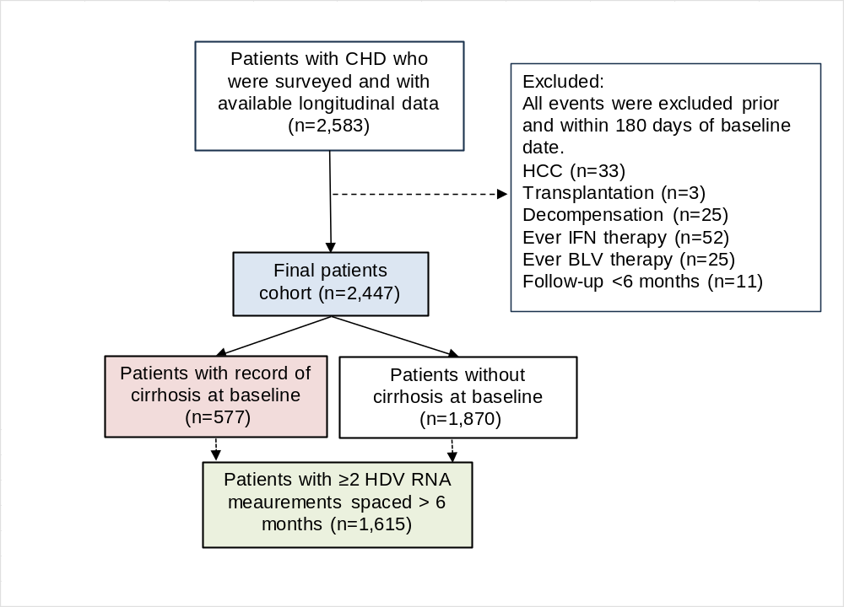
Abbreviations: CHD= chronic hepatitis D; HCC=hepatocellular carcinoma; IFN=interferon; BLV=Bulevirtide

Figure S2: The distribution of HDV RNA levels by cirrhosis, age groups and sex at initial visit
A | 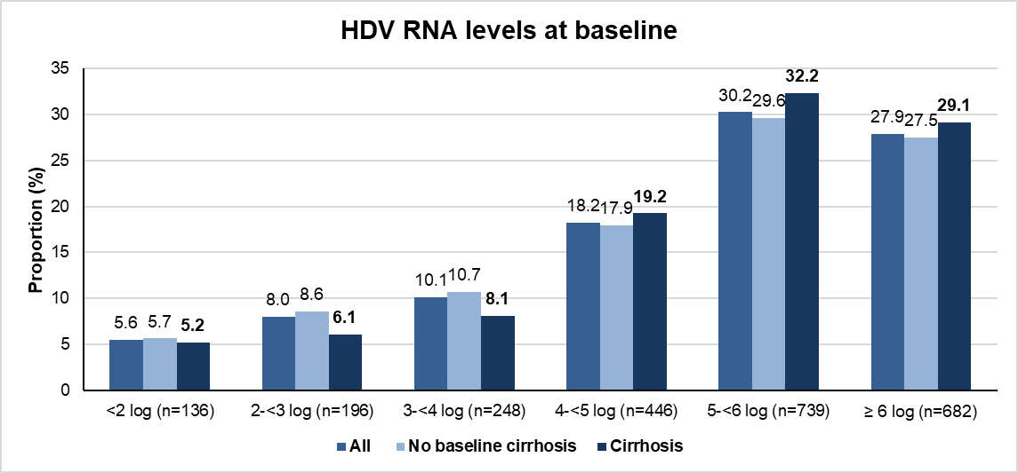  <1000 IU/mL or 3log; 13.6%
B | 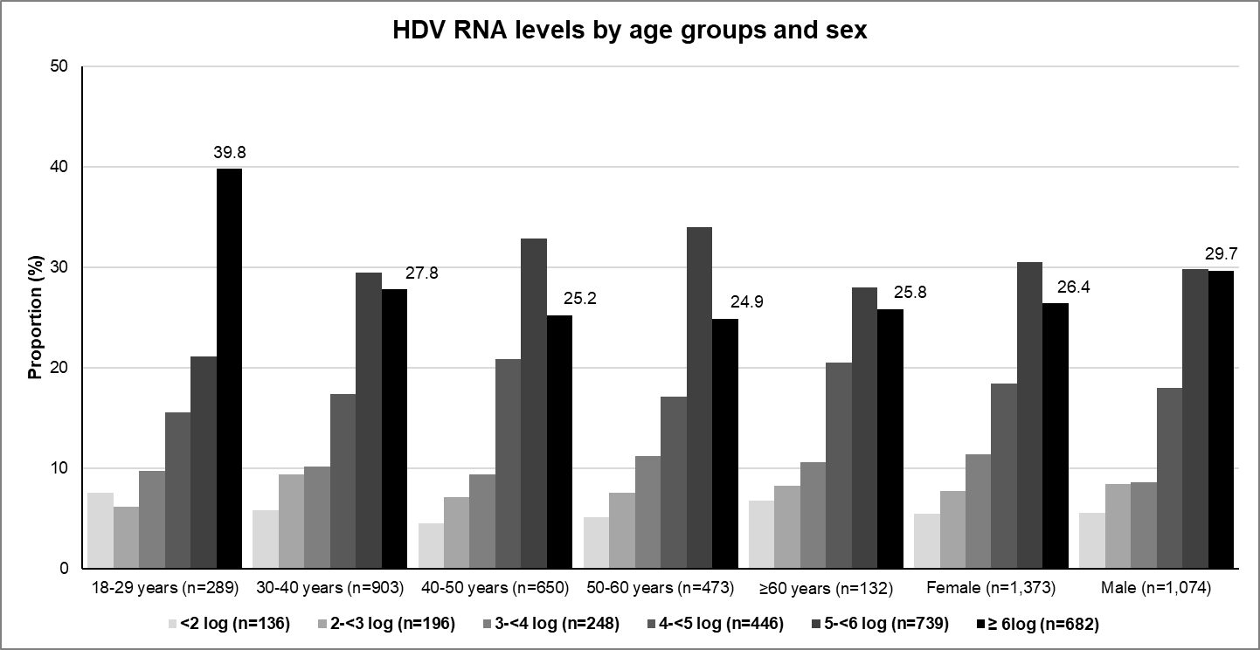  Age group distribution, p=0.001  Sex distribution, p=0.20
Difference tested by Pearson’s Chi-squared test. The proportion of patients with HDV RNA ≥6 log₁₀ IU/mL is highlighted.

Figure S3: Comparison of time dependent area under receiver operating curve (AUROC) to predict cirrhosis and composite liver-related events using only HDV RNA summary measures vs adding age, alanine aminotransferase, gamma glutamyl transferase, platelets count and cirrhosis diagnosis to the model.
A)
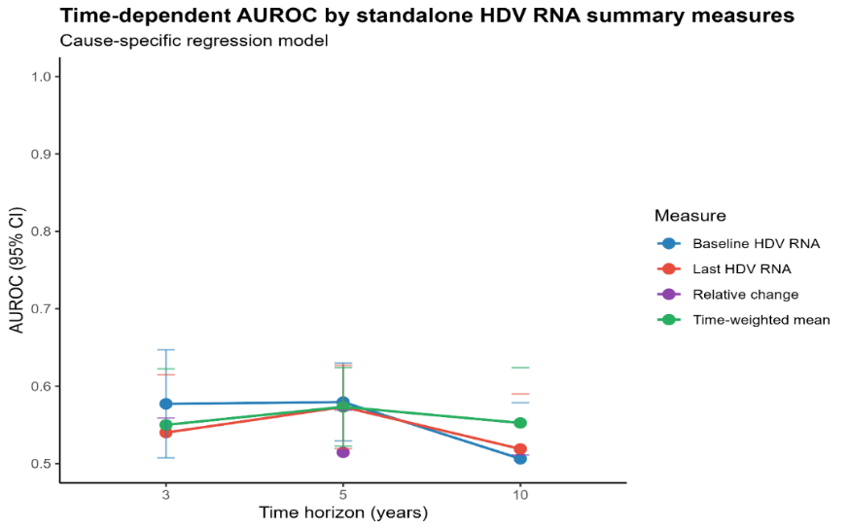
Time horizon | Optimal baseline HDV RNA log₁₀ IU/mL cutoff | Time-dependent AUC (95% CI) | Sensitivity (%) | Specificity (%) | Positive predictive value (%) | Negative predictive value (%) | Events correctly identified (%)
3-years | 5.240 | 61.2  (56.1-66.9) | 59.6  (53.8-65.1) | 50.2  (48.1-52.3) | 13.7  (11.9-15.7) | 90.3  (88.5-91.9) | 59.6% (171/287)
5-years | 4.034 | 57.8  (53.7-62.1) | 85.4  (80.8-89.0) | 25.4  (23.6-27.3) | 13.2  (11.7-14.8) | 92.9  (90.5-94.7) | 85.4% (245/287)
10-years | 3.39 | 53.0  (43.8-56.4) | 92.7  (89.1-95.2) | 17.4  (15.8-19.0) | 13.0  (11.6-14.5) | 94.7  (92.0-96.5) | 92.7% (266/287)

B)
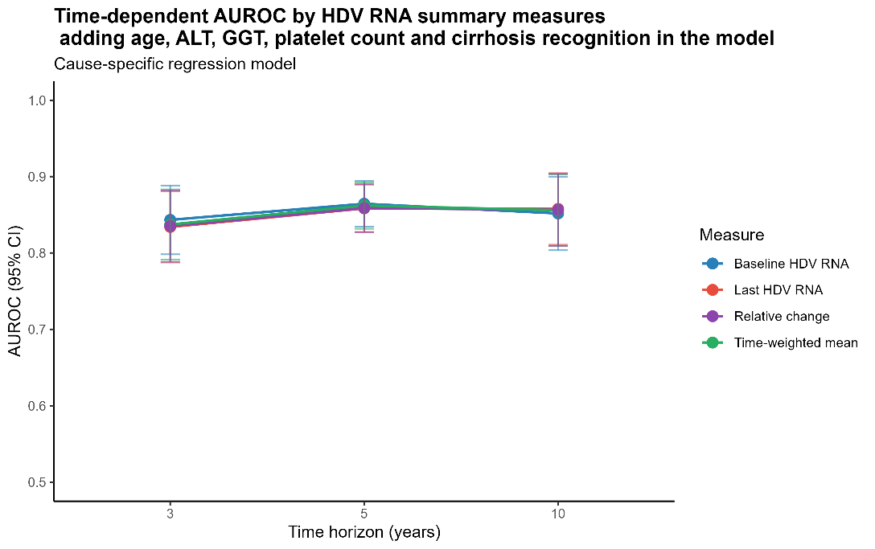
AUROC=area under receiver operating curve; ALT= alanine aminotransferase; GGT: gamma glutamyl transferase. Baseline=HDV RNA at initial test in 2,447 patients; last: last HDV RNA available in 1,615 patients. Relative change in 1,615 patients with ≥2 HDV RNA measurements spaced ≥6 months as last measurement - baseline measurement /baseline measurement *100. In all analysis HDV RNA measurement is log transformed.

Figure S4: Cumulative incidence of composite liver-events treating non-liver related death as a competing event. Statistical significance tested by Aalen-Johansen cumulative incidence estimator (Fine-Gray’s test).
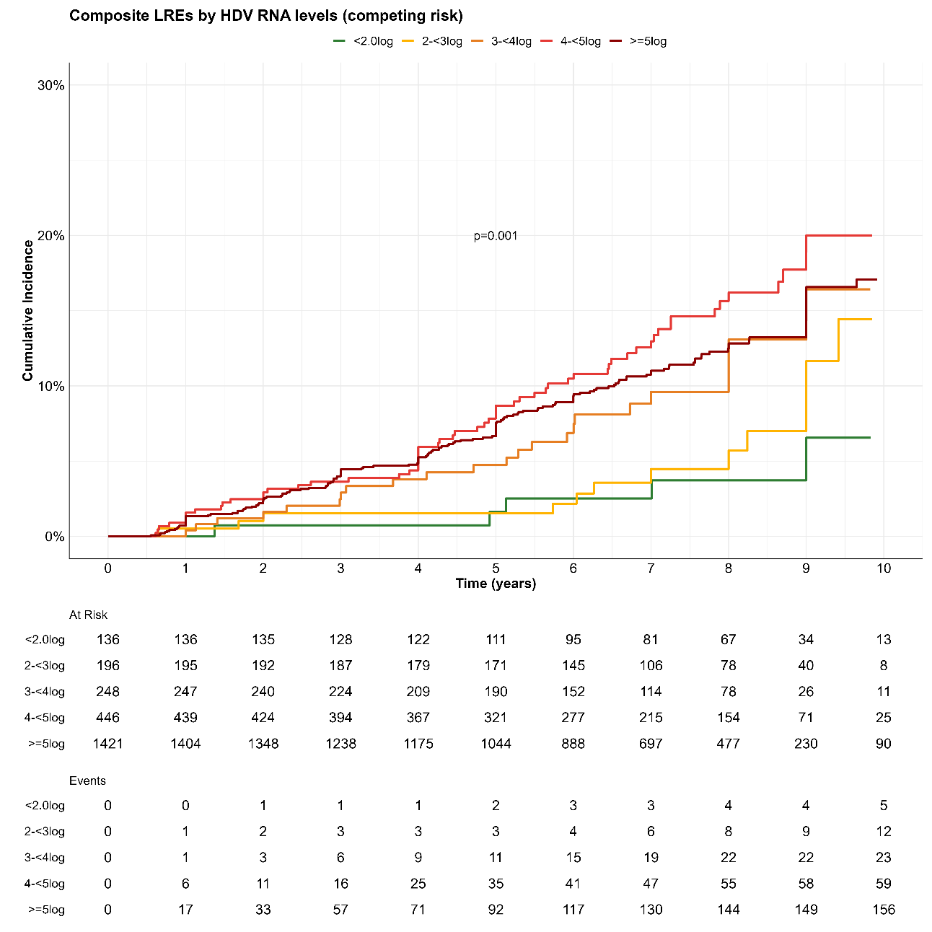
HDV RNA levels | Number at risk | Events | PYs | IR (95% CI)
<2log | 136 | 5 | 1,006.8 | 0.50 (0.16-1.16)
2-<3log | 196 | 12 | 1,416.8 | 0.85 (0.44-1.48)
3-<4log | 248 | 23 | 1,638.9 | 1.40 (0.89-2.11)
4-<5log | 446 | 59 | 2,973.1 | 1.98 (1.51-2.56)
≥5log | 1,421 | 163 | 9,487.5 | 1.72 (1.46-2.00)
All cohort (LREs) | 2,447 | 262 | 16,523.2 | 1.59 (1.40-1.79)
Non-liver related death | 2,447 | 25 | 16,523.2 | 0.15 (0.10-0.22)

Tables:
Table S1: Proportion of missed variables at baseline, and summary measures before and after imputation.
Characteristics | Imputed set (30 sets imputed n=73,410) | Original set, n = 2,447 | Available in | p-value
ALT, IU/L | 55.8 (34.8, 94.0) | 55.0 (34.2, 92.1) | 1,902 (77.7%) | 0.4
AST, IU/L | 41.4 (29.5, 63.0) | 41.0 (29.4, 62.3) | 1,901 (77.6%) | 0.5
GGT, IU/L | 38.5 (24.3, 65.5) | 38.0 (24.0, 64.0) | 1,669 (68.2%) | 0.4
Albumin, g/L | 42.0 (39.5, 44.4) | 42.0 (39.5, 44.4) | 1,769 (72.3%) | >0.9
Total bilirubin, μmol/L | 12.4 (9.0, 16.5) | 12.4 (9.0, 16.4) | 1,829 (74.7%) | 0.9
Platelets count, cells/µL | 201.0 (165.0, 239.0) | 200.0 (165.0, 238.0) | 1,977 (80.8%) | 0.8
HBeAg + | 27,089 (36.9%) | 203 (39.0%) | 521  (21.3%) | 0.3
HDV RNA IU/mL | 183,150.0  (12,546.0, 1,240,000.0) | 183,150.0  (12,547.5, 1,240,000.0) | 2,447  (100%) | na
HBsAg IU/mL | 6,488.5  (2,519.4, 11,670.9) | 6,524.9  (2,550.6, 11,681.7) | 1,942 (79.4%) | >0.9
HBV DNA IU/mL | 150.0  (15.0, 1,314.0) | 148.0 (15.0, 1,311.0) | 1,705 (69.7%) | >0.9
LSM kPa | 7.9 (5.9, 10.7) | 7.9 (5.9, 11.1) | 1,400 (57.2%) | 0.13
HDV RNA was not imputed but was used as a variable in the imputation (see Methods). Abbreviations: Abbreviations: BMI= body mass index; ALT=alanine aminotransferase; AST= aspartate aminotransferase; GGT=gamma glutamyl transferase; LSM=liver stiffness measurements; kPa= kilopascal.

Table S2: Predictors of progression to cirrhosis in 1,870 patients by univariable and multivariable Cox regression model
Predictor | Term | Univariable |  |  |  | Multivariable
Predictor | Term | HR | LCI | UCI | p-value | aHR | LCI | UCI | p-value
Age, years | Continuous | 1.04 | 1.03 | 1.05 | <0.001 | 1.03 | 1.01 | 1.04 | <0.001
Sex | male vs female | 1.31 | 1.00 | 1.70 | 0.05 | 1.00 | 0.76 | 1.32 | 0.989
BMI | Continuous | 1.01 | 0.98 | 1.03 | 0.72
DM | Yes, vs no | 0.87 | 0.53 | 1.42 | 0.57
Alcohol overconsumption | Yes, vs no | 0.84 | 0.52 | 1.35 | 0.47
Smoking | Yes, vs no | 0.90 | 0.65 | 1.24 | 0.52
CMRF | Yes ,vs no | 0.88 | 0.68 | 1.13 | 0.32
Prior NUC | Yes, vs no | 1.79 | 1.22 | 2.62 | 0.003 | 1.28 | 0.87 | 1.89 | 0.21
ALT IU/L | Continuous | 1.00 | 1.00 | 1.00 | <0.001
Elevated ALT > ULN | Yes, vs no | 2.05 | 1.45 | 2.90 | <0.001 | 1.19 | 0.83 | 1.71 | 0.33
Elevated ALT >2* ULN | Yes, vs no | 1.72 | 1.34 | 2.21 | <0.001 | 1.37 | 1.06 | 1.78 | <0.001
AST IU/L | Continuous | 1.00 | 1.00 | 1.01 | <0.001
GGT IU/L | Continuous | 1.01 | 1.00 | 1.01 | <0.001
Elevated GGT > ULN | Yes, vs no | 2.04 | 1.59 | 2.62 | <0.001 | 1.20 | 0.92 | 1.57 | 0.62
Elevated GGT > 2*ULN | Yes, vs no | 2.54 | 1.82 | 3.52 | <0.001 | 1.32 | 1.13 | 1.88 | <0.001
Albumin g/dl | Continuous | 0.96 | 0.94 | 0.98 | <0.001
Total bilirubin | Continuous | 1.01 | 0.99 | 1.02 | 0.35
Platelets count | Continuous | 0.98 | 0.98 | 0.98 | <0.001
Platelets count <150*10^9 cells/L | Yes, vs no | 11.77 | 9.15 | 15.14 | <0.001 | 8.07 | 6.19 | 10.52 | <0.001
HBeAg + | Yes, vs no | 1.16 | 0.90 | 1.49 | 0.26
HBsAg log₁₀ IU/mL | Continuous | 1.40 | 1.13 | 1.74 | 0.002 | 1.26 | 1.00 | 1.61 | 0.06
HBsAg ≥3 log₁₀ IU/mL | Yes, vs no | 2.31 | 1.39 | 3.84 | 0.001 | 1.51 | 1.21 | 2.54 | <0.001*
HBV DNA log₁₀ IU/mL | Continuous | 0.99 | 0.91 | 1.08 | 0.85
HDV RNA log₁₀ IU/mL | Continuous | 1.18 | 1.09 | 1.29 | <0.001 | 1.12 | 1.02 | 1.23 | <0.001
HDV RNA ≥3 log₁₀ IU/mL | Yes, vs no | 2.33 | 1.44 | 3.76 | <0.001 | 2.20 | 1.36 | 3.58 | <0.001*
HDV RNA ≥5 log₁₀ IU/mL | Yes, vs no | 1.63 | 1.25 | 2.13 | <0.001 | 1.33 | 1.21 | 1.77 | 0.04*
HDV RNA 2-<3 log₁₀ IU/mL | vs <2log | 2.41 | 0.79 | 7.34 | 0.120
HDV RNA 3-<4 log₁₀ IU/mL | vs <2log | 2.99 | 1.02 | 8.76 | 0.05
HDV RNA 4-<5 l log₁₀ IU/mL | vs <2log | 3.72 | 1.33 | 10.38 | 0.01
HDV RNA ≥5 log₁₀ IU/mL | vs <2log | 4.70 | 1.74 | 12.67 | 0.002
LSM kPa | Continuous | 1.33 | 1.27 | 1.40 | <0.001 | 1.22 | 1.16 | 1.28 | <0.001
LSM ≥10 kPa | Yes, vs no | 3.31 | 2.57 | 4.27 | <0.001 | 1.98 | 1.51 | 2.60 | <0.001*
Bold=statistical significance. Italic=tested in separate model. Abbreviations: HR=hazard ratio; aHR=adjusted hazard ratio; UCI=upper confidence interval; LCI= lower confidence interval; BMI= body mass index; ALT=alanine aminotransferase; AST= aspartate aminotransferase; GGT=gamma glutamyl transferase; ULN= upper limit of normal; LSM=liver stiffness measurements; CMRF=cardiometabolic risk factor; NUC=nucleotid(s)es analogues; FIB4=fibrosis 4 index; APRI=alanine aminotransferase to platelets ratio index.*introduced in separate model.

Table S3: Change in longitudinal HDV RNA levels in 1,615 patients with ≥ 2 measurements spaced ≥ 6 months during study duration subgrouped by cirrhosis at baseline, HBeAg status and sex
Changes | Stable (<1 log change) | ≥1 log increase | 1-<2 log decline | ≥2 log decline | Undetectable at last visit | p-value* (between group)
All (n=1,615) | 1,124 (69.6%) | 197 (12.2%) | 116 (7.2%) | 88 (5.4%) | 90 (5.6%) | <0.001
Cirrhosis (n=400) | 286 (71.5%) | 45 (11.3%) | 23 (5.8%) | 25 (6.3%) | 21 (5.3%) | 0.61
No cirrhosis (n=1, 215) | 838 (69.0%) | 152 (12.5%) | 93 (7.7%) | 63 (5.2%) | 69 (5.7%) | 0.61
HBeAg+ (n=596) | 415 (69.6%) | 68 (11.4%) | 48 (8.1%) | 41 (6.9%) | 24 (4.0%) | 0.05
HBeAg- (n=1,019) | 709 (69.6%) | 129 (12.7%) | 68 (6.7%) | 47 (4.6%) | 66 (6.5%) | 0.05
Male (n=704) | 489 (69.5%) | 75 (10.7%) | 52 (7.4%) | 39 (5.5%) | 49 (7.0%) | 0.14
Female (n=911) | 635 (69.7%) | 122 (13.4%) | 64 (7.0%) | 49 (5.4%) | 41 (4.5%) | 0.14
Number of composite liver-related events in all cohort | 236 (21.0%) | 39 (19.8%) | 26 (22.4%) | 18 (20.5%) | 12 (13.3%) | 0.51
*Pearson’s Chi-squared test. Median (interquartile range) between first and last HDV RNA measurement was 4.2 (2.1-8.5) years, median number of tests per patient 3 (1-3); total number of HDV RNA measurements= 4,720.
References:
1. Nishida C, Barba C, Cavalli-Sforza T, Cutter J, Deurenberg P, Darnton-Hill I, et al. Appropriate body-mass index for Asian populations and its implications for policy and intervention strategies. The Lancet. 2004;363:157–63. https://doi.org/10.1016/S0140-6736(03)15268-3.
2. He L, Zheng W, Liao Y, Kong W, Zeng T. Individuals with cardiometabolic risk factors are at higher risk for early-onset NAFLD. J Hepatol. 2024;81:e99–101. https://doi.org/10.1016/j.jhep.2024.04.027.
3. Castera L, Yuen Chan HL, Arrese M, Afdhal N, Bedossa P, Friedrich-Rust M, et al. EASL-ALEH Clinical Practice Guidelines: Non-invasive tests for evaluation of liver disease severity and prognosis. J Hepatol. 2015;63:237–64. https://doi.org/10.1016/j.jhep.2015.04.006.
4. Sandmann L, Degasperi E, Port K, Aleman S, Wallin JJ, Manuilov D, et al. Liver stiffness measurement as a noninvasive method for the diagnosis of liver cirrhosis in patients with chronic hepatitis D virus infection. Aliment Pharmacol Ther. 2024;00:1–10. https://doi.org/10.1111/APT.17878.
5. Mangia A, Squillante MM, Fraticelli F, Cavorsi MC, Paroni G, Zaffarano L, et al. HDV RNA Levels and Progression of Hepatitis Delta Infection: A 14 Year Follow Up Experience in Italy. Cells. 2023;12:1413. https://doi.org/10.3390/cells12101413.

