Supplemental 1

S1. Study design and dyad availability
Supplemental Table 1. Baseline characteristics, biomarker availability, event rates, and follow-up duration stratified by dyadic ECog report availability in the ADNI primary at-risk sample.
Cohort / Subgroup | Available dyad (Complete ECog) | Unavailable dyad (Missing ECog) | Overall primary cohort
Total N | 418 | 1225 | 1643
Age, mean (SD) | 71.29 (6.04) | 70.48 (7.71) | 70.69 (7.33)
Female, n (%) | 236 (56.5%) | 755 (61.7%) | 991 (60.4%)
Education (years), mean (SD) | 16.90 (2.35) | 16.35 (2.56) | 16.49 (2.52)
MMSE, mean (SD) | 29.16 (1.05) | 28.96 (1.21) | 29.01 (1.17)
APOE4 carrier, n/N_obs (%) | 138/417 (33.1%) | 231/716 (32.3%) | 369/1133 (32.6%)
APOE4 missing, n (%) | 1 (0.2%) | 509 (41.6%) | 510 (31.0%)
Centiloid amyloid, mean (SD) | 15.12 (28.33) | 18.24 (33.18) | 17.04 (31.43)
Centiloid missing, n (%) | 74 (17.7%) | 672 (54.9%) | 746 (45.4%)
Hippocampal volume (mm³), mean (SD) | 8182.28 (844.45) | 7932.68 (836.67) | 8027.45 (847.84)
Hippocampal volume missing, n (%) | 93 (22.2%) | 694 (56.7%) | 787 (47.9%)
Primary MCI or AD events, n (%) | 54 (12.9%) | 167 (13.6%) | 221 (13.5%)
Follow-up duration (years), median (IQR) | 7.00 (5.27–9.88) | 0.26 (0.00–2.51) | 1.24 (0.05–5.86)
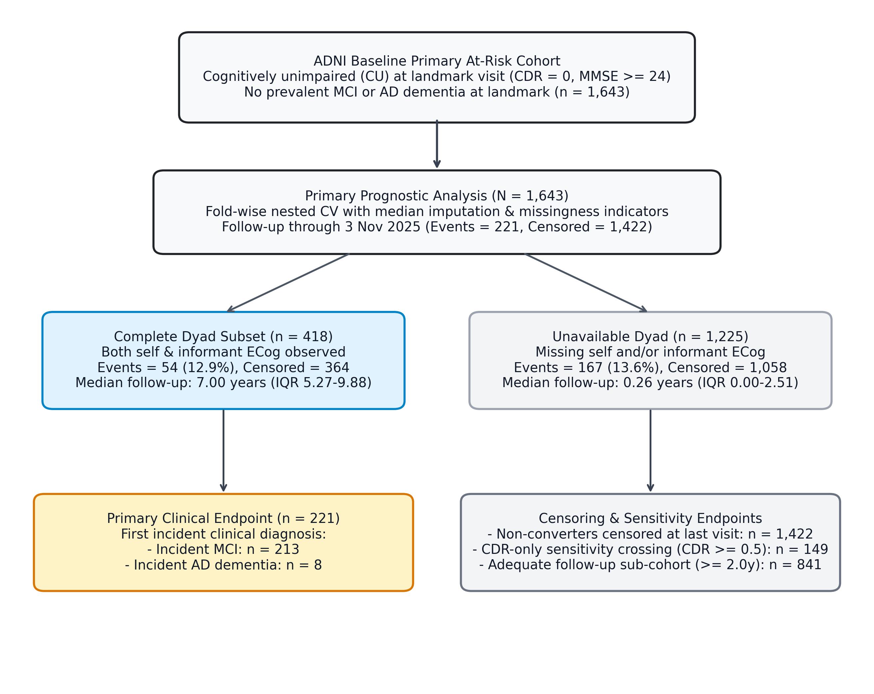
Supplemental Figure 1. ADNI participant flow and estimand architecture. Schematic flowchart illustrating the full at-risk cohort (N=1,643), the complete-dyad conditional subset (n=418), the primary clinical endpoint breakdown (n=221: 213 incident MCI, 8 incident AD dementia), and sensitivity endpoints.

S2. Cohort characteristics and missingness
Supplemental Table 2. ADNI baseline characteristics by primary event status (censored / no recorded MCI or AD diagnosis versus first recorded MCI or AD diagnosis). Continuous variables are mean (SD); categorical variables are n (%). Percentages are computed within the non-missing N for each column. Participants in the censored group had no recorded MCI or AD diagnosis during observed follow-up and may have had variable follow-up duration.
Characteristic | Censored / no recorded MCI or AD diagnosis | First recorded MCI or AD diagnosis
n (events) | 1422 (0) | 221 (221)
Age, years | 70.10 (7.27) | 74.47 (6.55)
Education, years | 16.53 (2.52) | 16.19 (2.52)
MMSE | 29.03 (1.16) | 28.88 (1.23)
APOE4 carrier, n (%) | 287 (31.4) | 82 (37.6)
Centiloid | 14.86 (29.36) | 32.02 (40.11)
Amyloid positive, n (%) | 167 (21.3) | 53 (46.5)
Hippocampal volume | 8064.07 (845.24) | 7759.71 (822.26)
ECog self total | 1.36 (0.33) | 1.65 (0.49)
ECog informant total | 1.17 (0.24) | 1.28 (0.29)
ECog dyadic mean | 1.27 (0.22) | 1.46 (0.31)
ECog dyadic gap | -0.20 (0.36) | -0.37 (0.52)
Supplemental Table 2 (continued). Predictor missingness by landmark-year band. ADNI phase was not a curated variable in the provided data; year band is a proxy for recruitment/assessment wave. Percent missing is the proportion of participants in each band with missing values for the listed variable.
Year band | n | Events (%) | ECog self missing % | ECog informant missing % | Centiloid missing % | Amyloid status missing % | Hippocampus missing % | APOE missing %
2005–2010 | 234 | 76 (32.5) | 85.0 | 85.5 | 99.6 | 99.6 | 99.6 | 0.0
2011–2014 | 434 | 80 (18.4) | 66.8 | 66.8 | 33.6 | 33.6 | 40.8 | 25.6
2015–2018 | 391 | 40 (10.2) | 45.3 | 46.3 | 31.2 | 31.2 | 33.8 | 24.6
2019–2022 | 154 | 16 (10.4) | 79.2 | 79.2 | 42.9 | 42.9 | 42.9 | 26.0
2023–2025 | 430 | 9 (2.1) | 100.0 | 100.0 | 41.6 | 50.7 | 41.6 | 61.2

S3. Exploratory post-hoc risk stratification
The figures in this section are descriptive post-hoc summaries of the locked out-of-fold risk scores. They are not primary performance estimates, are not used for clinical-utility or net-benefit claims, and should not be interpreted as formal probability calibration or decision-analytic support. Because hippocampal volume showed non-proportional hazards (Supplemental Table 7), post-hoc predicted probabilities and net-benefit curves are especially vulnerable to over-interpretation and are therefore not included. These analyses are illustrative only and should not be interpreted as evidence of clinical utility. As a purely descriptive illustration within the complete-dyad subset, referring the top-ranked 25% under the non-biomarker model (M0 plus dyadic ECog mean and dyad-availability indicator, excluding APOE4, amyloid-PET Centiloid values, and hippocampal volume) would have captured 48% of eventual progressors versus 33% under M2; these operating characteristics are derived from the locked complete-dyad analysis in this section. Top-percentile capture and the global C-index measure different quantities and can diverge in small selected subsets; these ranking statistics are uncalibrated, derive from a highly selected research cohort, and should not be extrapolated as expected screening yields. This is a mathematical description of ranking, not a validated screening threshold, and should not be interpreted as clinical benefit.
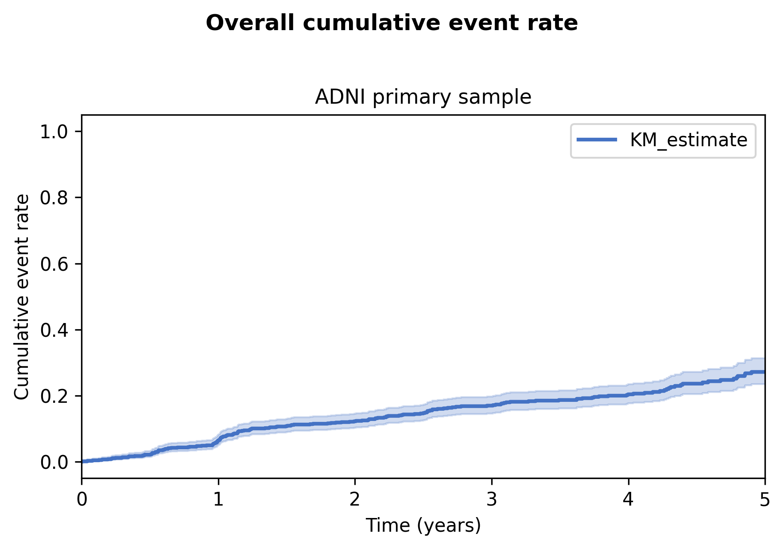
Supplemental Figure 2. Overall cumulative event rate in the ADNI primary sample. Shaded band: 95% confidence interval.
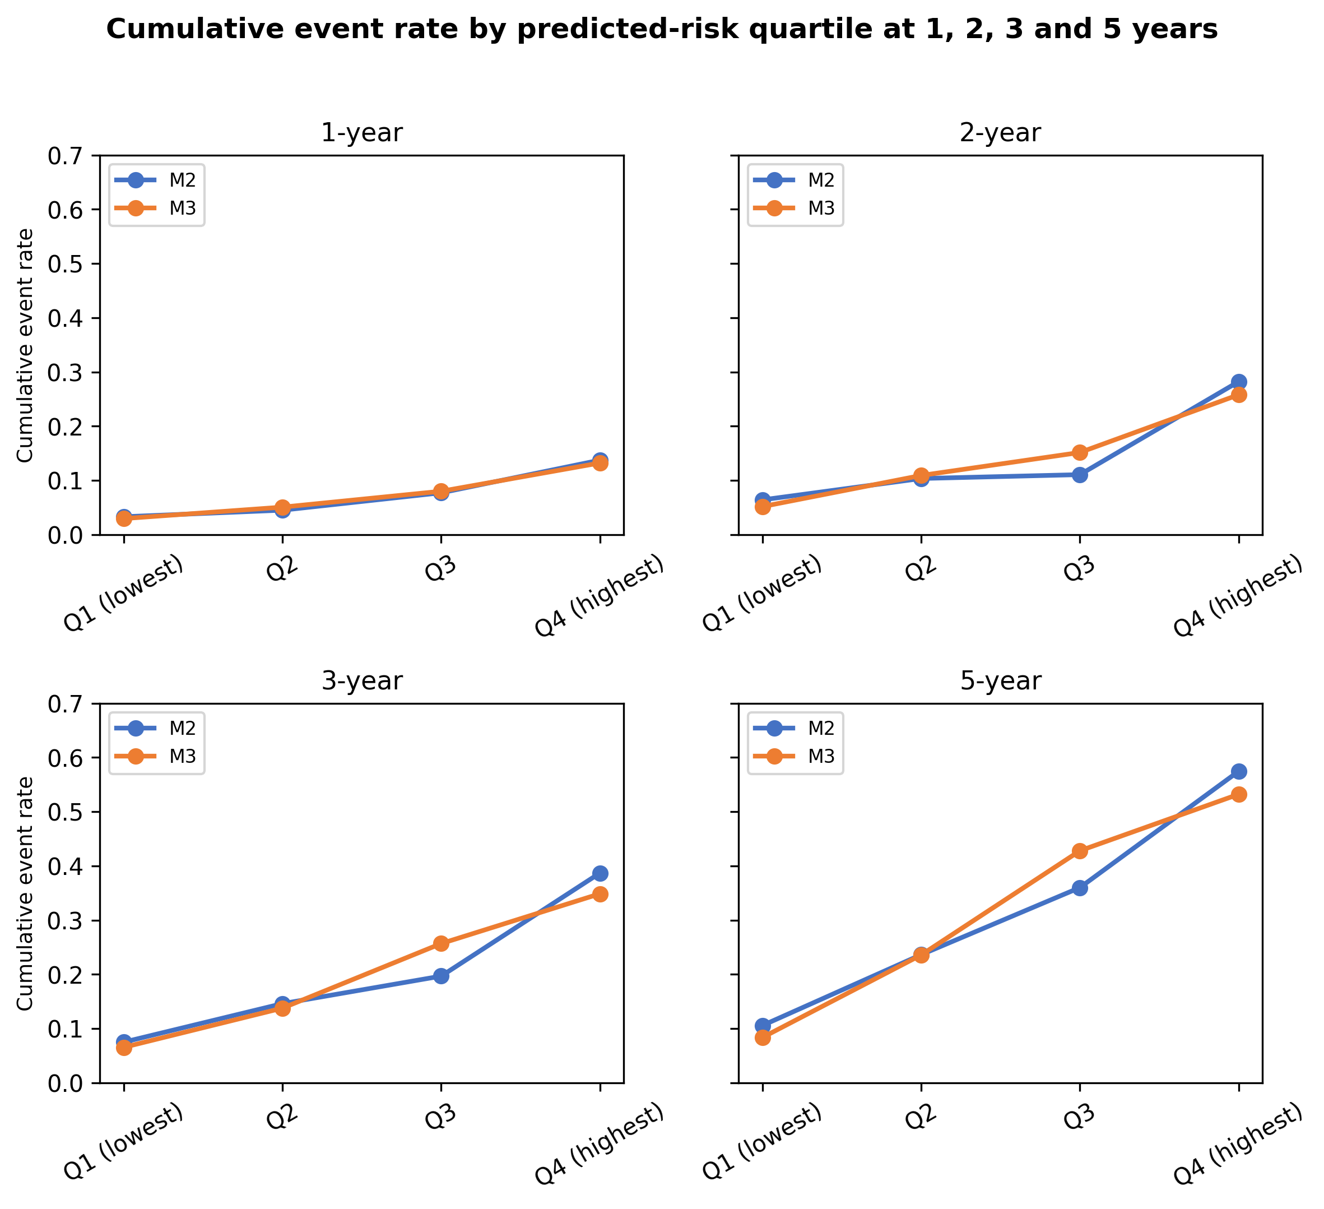
Supplemental Figure 3. Observed cumulative event rate by predicted-risk quartile at 1, 2, 3 and 5 years. For each horizon, quartiles are based on the predicted event probability from a post-hoc univariate Cox model fitted to the OOF risk score; higher quartiles correspond to higher predicted risk.

S4. Sensitivity analyses
Supplemental Table 3. Sensitivity analyses (reproduces main Table 3; provided for cross-reference during peer review). Minimum-follow-up analyses included participants with at least the specified duration of observed follow-up or an observed primary event before that threshold. The primary model hierarchy and M3-M2 contrast were prespecified; sensitivity analyses evaluating follow-up duration, protocol era, and dyad availability were conducted to assess the internal stability of the primary estimates. The M2-without-missingness row tests whether the conventional baseline is already influenced by biomarker missingness indicators. The M2-plus-availability row quantifies the increment from adding only the dyad-availability indicator to the conventional model. The ECog-beyond-availability row reports the increment from adding observed ECog scale scores to the availability-only model. The score-only row separates the ECog scale-score increment from the dyad-availability indicator. The IPCW row reports a censoring-robust analogue of the primary contrast. The complete-dyad M2-versus-M3 row has weak baseline models (M0 C-index 0.452, M2 C-index 0.535); an M0 C-index below 0.5 indicates that the small, highly selected complete-dyad subset is too atypical for the baseline model to reproduce its usual ranking, so those estimates are unstable and shown for completeness only.
Sensitivity / analysis | N | Events | Reference C-index | Extended-model C-index | Extended–Ref ΔC (95% CI)
Primary (raw, full sample) | 1643 | 221 | 0.680 | 0.758 | 0.078 (0.050 to 0.106)
M2 plus dyad-availability indicator | 1643 | 221 | 0.680 | 0.733 | 0.052 (0.023 to 0.082)
ECog scale-score contribution beyond dyad availability (M3 vs M2 + dyad availability) | 1643 | 221 | 0.733 | 0.758 | 0.026 (0.007 to 0.045)
M2 without missingness indicators | 1643 | 221 | 0.649 | 0.680 | 0.032 (0.008 to 0.058)
Score-only model (M3 without dyad-availability indicator vs M2) | 1643 | 221 | 0.680 | 0.690 | 0.010 (-0.004 to 0.024)
Uno's IPCW C-index (M3 vs M2) | 1643 | 221 | 0.687 | 0.792 | 0.105 (0.050 to 0.174)
Complete-dyad subset | 418 | 54 | 0.535 | 0.725 | 0.190 (0.091 to 0.293)
Minimum follow-up ≥0.5 years | 971 | 221 | 0.681 | 0.761 | 0.080 (0.051 to 0.109)
Protocol-era (landmark-year band) candidate variables | 1643 | 221 | 0.694 | 0.775 | 0.081 (0.052 to 0.113)

S5. Interval-censoring sensitivity
Supplemental Table 4. Interval-censoring sensitivity (first-event, midpoint, last-known-normal).
Analysis | N | Events | Reference C-index | M3 C-index | M3–Ref ΔC (95% CI)
Interval-censoring: first-event endpoint | 1643 | 221 | 0.680 | 0.758 | 0.078 (0.050 to 0.106)
Interval-censoring: midpoint | 1643 | 221 | 0.675 | 0.749 | 0.073 (0.047 to 0.100)
Interval-censoring: last-known-normal endpoint | 1643 | 221 | 0.698 | 0.752 | 0.054 (0.028 to 0.077)

S6. Hippocampal volume (MRI) availability
Supplemental Table 5. Hippocampal volume (MRI) availability and event rate in the ADNI primary sample. Hippocampal volume was derived from structural T1-weighted MRI, so MRI availability proxies hippocampal volume availability here. Availability was coded as 0 = unavailable/missing and 1 = available.
Hippocampal volume (MRI) availability | n | n_events | event_rate_pct
0 | 787 | 118 | 15
1 | 856 | 103 | 12

S7. Repeated nested-CV split stability
Supplemental Table 6. Repeat-level out-of-fold discrimination and incremental C-index contrasts across 10 independently generated stratified 5-fold outer partitions. Each repetition re-estimated preprocessing and inner 3-fold penalty selection; the contrasts are descriptive stability summaries, not independent hypothesis tests.
Repeat | Seed | M2 C-index | M3 C-index | M4 C-index | M3–M2 ΔC | M4–M3 ΔC
1 | 42 | 0.681 | 0.756 | 0.758 | 0.074 | 0.002
2 | 142 | 0.681 | 0.757 | 0.757 | 0.076 | 0.000
3 | 242 | 0.679 | 0.755 | 0.755 | 0.076 | 0.000
4 | 342 | 0.687 | 0.755 | 0.754 | 0.068 | -0.001
5 | 442 | 0.680 | 0.758 | 0.755 | 0.079 | -0.003
6 | 542 | 0.679 | 0.756 | 0.756 | 0.076 | 0.000
7 | 642 | 0.692 | 0.758 | 0.758 | 0.066 | 0.000
8 | 742 | 0.682 | 0.759 | 0.757 | 0.078 | -0.002
9 | 842 | 0.677 | 0.751 | 0.748 | 0.075 | -0.003
10 | 942 | 0.682 | 0.758 | 0.757 | 0.076 | -0.001
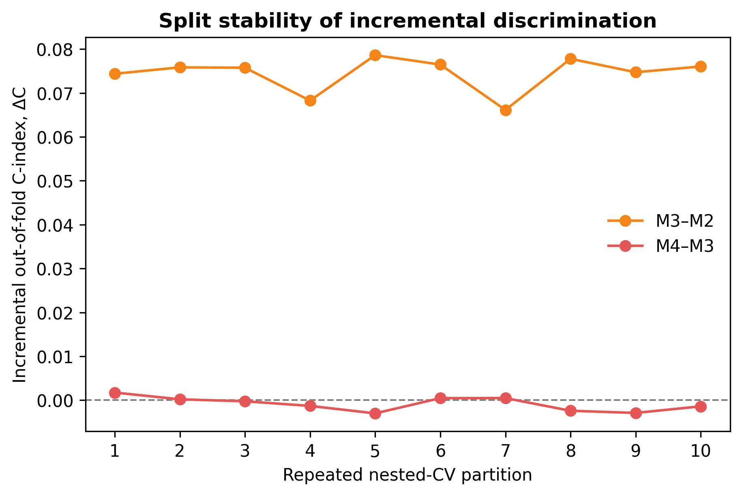
Supplemental Figure 4. Split stability of incremental discrimination across repeated nested cross-validation partitions. Points and connecting lines show repeat-level pooled out-of-fold ΔC estimates for M3–M2 and M4–M3; the dashed horizontal line denotes no incremental discrimination.

S8. Proportional-hazards diagnostics
Supplemental Table 7. Schoenfeld tests using the M3 and M4 predictor specifications (descriptive full-sample ridge-stabilized Cox fit). These are exploratory post-fit diagnostics from a descriptive full-sample Cox model with the same predictor specification, imputation, and coding as the primary elastic-net models; they are not a formal proof that the penalized nested-CV models satisfy proportional hazards.
model | Variable | test_statistic | degrees_of_freedom | p
M3 | Age | 0.820 | 1 | 0.365
M3 | Age missingness indicator | 0.000 | 1 | 1
M3 | APOE4 carrier status | 2.272 | 1 | 0.132
M3 | APOE4 carrier status missingness indicator | 0.122 | 1 | 0.726
M3 | Amyloid-PET Centiloid | 2.730 | 1 | 0.098
M3 | Amyloid-PET Centiloid missingness indicator | 0.002 | 1 | 0.962
M3 | Dyad availability | 2.197 | 1 | 0.138
M3 | Education | 0.650 | 1 | 0.420
M3 | Education missingness indicator | 0.015 | 1 | 0.902
M3 | Hippocampal volume | 3.988 | 1 | 0.046
M3 | Hippocampal volume missingness indicator | 0.006 | 1 | 0.937
M3 | Dyadic ECog mean | 1.932 | 1 | 0.165
M3 | MMSE | 1.124 | 1 | 0.289
M3 | MMSE missingness indicator | 0.000 | 1 | 1
M3 | Female sex | 2.212 | 1 | 0.137
M4 | Age | 0.753 | 1 | 0.386
M4 | Age missingness indicator | 0.000 | 1 | 1
M4 | APOE4 carrier status | 2.363 | 1 | 0.124
M4 | APOE4 carrier status missingness indicator | 0.120 | 1 | 0.729
M4 | Amyloid-PET Centiloid | 2.677 | 1 | 0.102
M4 | Amyloid-PET Centiloid missingness indicator | 0.005 | 1 | 0.945
M4 | Dyad availability | 2.093 | 1 | 0.148
M4 | Education | 0.618 | 1 | 0.432
M4 | Education missingness indicator | 0.015 | 1 | 0.902
M4 | Self–informant gap | 0.185 | 1 | 0.667
M4 | Hippocampal volume | 3.879 | 1 | 0.049
M4 | Hippocampal volume missingness indicator | 0.008 | 1 | 0.930
M4 | Dyadic ECog mean | 1.229 | 1 | 0.268
M4 | MMSE | 1.145 | 1 | 0.285
M4 | MMSE missingness indicator | 0.000 | 1 | 1
M4 | Female sex | 2.249 | 1 | 0.134
Supplemental Table 7 (continued). Global proportional-hazards test.
test | test_statistic | degrees_of_freedom | p_value | n_events | n_variables
proportional_hazard_test (rank) — M3 | 18.071 | 15 | 0.259 | 221 | 15
proportional_hazard_test (rank) — M4 | 17.340 | 16 | 0.364 | 221 | 16
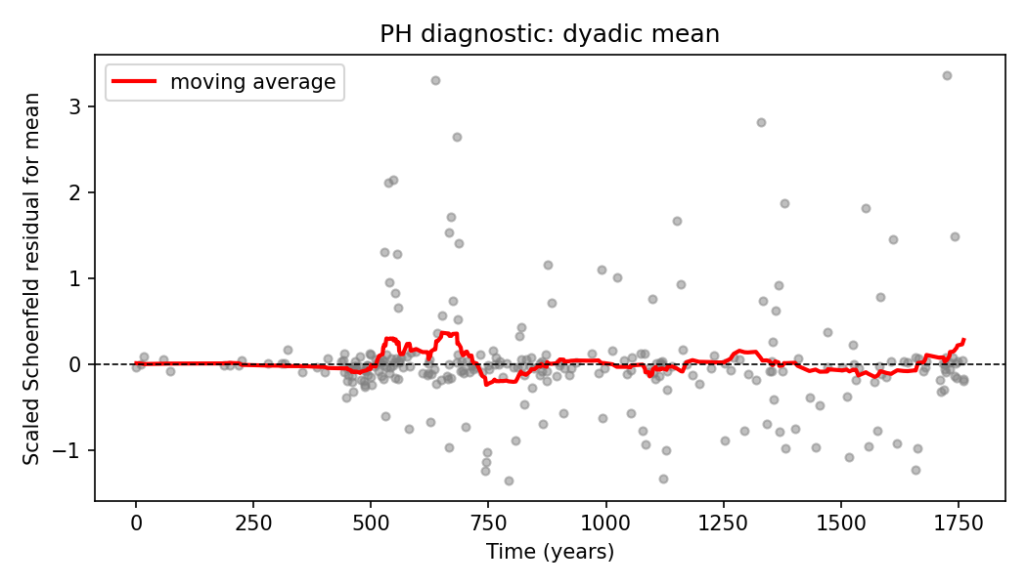
Supplemental Figure 5. Scaled Schoenfeld residual mean trajectory for the dyadic mean in the primary M3 model. A flat smooth line would support proportional hazards; a systematic trend suggests time-varying effects.

S9. Model and predictor dictionary
Supplemental Table 8. Model and predictor dictionary for the prespecified model hierarchy. Each model nests the preceding model. Continuous and binary predictors subject to missingness were median-imputed within the outer-training fold. Missingness indicators were included for age, education, MMSE, APOE4 carrier status, amyloid-PET Centiloid, and hippocampal volume. Female sex had one missing value and was median-imputed without a separate missingness indicator because of its negligible missingness. Dyadic ECog mean and self–informant gap were median-imputed when unavailable and accompanied by a dyad-availability indicator; no separate ECog score-missingness indicators were included.
model | feature | role | imputation
M0 | Age | predictor | median imputed within outer-training fold; missingness flag added automatically if missing
M0 | Female sex | predictor | median imputed within outer-training fold; no separate missingness indicator included (negligible missingness)
M0 | Education | predictor | median imputed within outer-training fold; missingness flag added automatically if missing
M0 | MMSE | predictor | median imputed within outer-training fold; missingness flag added automatically if missing
M0 | Age missingness indicator | missingness flag | indicator set to 1 when base variable is missing; median-imputed base used in base variable
M0 | Education missingness indicator | missingness flag | indicator set to 1 when base variable is missing; median-imputed base used in base variable
M0 | MMSE missingness indicator | missingness flag | indicator set to 1 when base variable is missing; median-imputed base used in base variable
M2 | Age | predictor | median imputed within outer-training fold; missingness flag added automatically if missing
M2 | Female sex | predictor | median imputed within outer-training fold; no separate missingness indicator included (negligible missingness)
M2 | Education | predictor | median imputed within outer-training fold; missingness flag added automatically if missing
M2 | MMSE | predictor | median imputed within outer-training fold; missingness flag added automatically if missing
M2 | APOE4 carrier status | predictor | median imputed within outer-training fold; missingness flag added automatically if missing
M2 | Amyloid-PET Centiloid | predictor | median imputed within outer-training fold; missingness flag added automatically if missing
M2 | Hippocampal volume | predictor | median imputed within outer-training fold; missingness flag added automatically if missing
M2 | Age missingness indicator | missingness flag | indicator set to 1 when base variable is missing; median-imputed base used in base variable
M2 | Education missingness indicator | missingness flag | indicator set to 1 when base variable is missing; median-imputed base used in base variable
M2 | MMSE missingness indicator | missingness flag | indicator set to 1 when base variable is missing; median-imputed base used in base variable
M2 | APOE4 carrier status missingness indicator | missingness flag | indicator set to 1 when base variable is missing; median-imputed base used in base variable
M2 | Amyloid-PET Centiloid missingness indicator | missingness flag | indicator set to 1 when base variable is missing; median-imputed base used in base variable
M2 | Hippocampal volume missingness indicator | missingness flag | indicator set to 1 when base variable is missing; median-imputed base used in base variable
M3 | Age | predictor | median imputed within outer-training fold; missingness flag added automatically if missing
M3 | Female sex | predictor | median imputed within outer-training fold; no separate missingness indicator included (negligible missingness)
M3 | Education | predictor | median imputed within outer-training fold; missingness flag added automatically if missing
M3 | MMSE | predictor | median imputed within outer-training fold; missingness flag added automatically if missing
M3 | APOE4 carrier status | predictor | median imputed within outer-training fold; missingness flag added automatically if missing
M3 | Amyloid-PET Centiloid | predictor | median imputed within outer-training fold; missingness flag added automatically if missing
M3 | Hippocampal volume | predictor | median imputed within outer-training fold; missingness flag added automatically if missing
M3 | Dyadic ECog mean | predictor | observed when a complete dyad is available; median-imputed score accompanied by the dyad-availability indicator (no separate score-missingness indicator)
M3 | Dyad availability | predictor | observed indicator (1 when both ECog reports are available, 0 otherwise); not imputed
M3 | Age missingness indicator | missingness flag | indicator set to 1 when base variable is missing; median-imputed base used in base variable
M3 | Education missingness indicator | missingness flag | indicator set to 1 when base variable is missing; median-imputed base used in base variable
M3 | MMSE missingness indicator | missingness flag | indicator set to 1 when base variable is missing; median-imputed base used in base variable
M3 | APOE4 carrier status missingness indicator | missingness flag | indicator set to 1 when base variable is missing; median-imputed base used in base variable
M3 | Amyloid-PET Centiloid missingness indicator | missingness flag | indicator set to 1 when base variable is missing; median-imputed base used in base variable
M3 | Hippocampal volume missingness indicator | missingness flag | indicator set to 1 when base variable is missing; median-imputed base used in base variable
M4 | Age | predictor | median imputed within outer-training fold; missingness flag added automatically if missing
M4 | Female sex | predictor | median imputed within outer-training fold; no separate missingness indicator included (negligible missingness)
M4 | Education | predictor | median imputed within outer-training fold; missingness flag added automatically if missing
M4 | MMSE | predictor | median imputed within outer-training fold; missingness flag added automatically if missing
M4 | APOE4 carrier status | predictor | median imputed within outer-training fold; missingness flag added automatically if missing
M4 | Amyloid-PET Centiloid | predictor | median imputed within outer-training fold; missingness flag added automatically if missing
M4 | Hippocampal volume | predictor | median imputed within outer-training fold; missingness flag added automatically if missing
M4 | Dyadic ECog mean | predictor | observed when a complete dyad is available; median-imputed score accompanied by the dyad-availability indicator (no separate score-missingness indicator)
M4 | Self–informant gap | predictor | observed when a complete dyad is available; median-imputed score accompanied by the dyad-availability indicator (no separate score-missingness indicator)
M4 | Dyad availability | predictor | observed indicator (1 when both ECog reports are available, 0 otherwise); not imputed
M4 | Age missingness indicator | missingness flag | indicator set to 1 when base variable is missing; median-imputed base used in base variable
M4 | Education missingness indicator | missingness flag | indicator set to 1 when base variable is missing; median-imputed base used in base variable
M4 | MMSE missingness indicator | missingness flag | indicator set to 1 when base variable is missing; median-imputed base used in base variable
M4 | APOE4 carrier status missingness indicator | missingness flag | indicator set to 1 when base variable is missing; median-imputed base used in base variable
M4 | Amyloid-PET Centiloid missingness indicator | missingness flag | indicator set to 1 when base variable is missing; median-imputed base used in base variable
M4 | Hippocampal volume missingness indicator | missingness flag | indicator set to 1 when base variable is missing; median-imputed base used in base variable

S10. Coefficient selection frequencies
Supplemental Table 9. Cross-fold elastic-net coefficient summary for the primary analysis.
model | predictor | n_folds_selected | n_folds_positive | n_folds_negative | median_std_coef | min_std_coef | max_std_coef | median_orig_coef | min_orig_coef | max_orig_coef
M0 | Age | 5 | 5 | 0 | 0.372 | 0.317 | 0.394 | 0.051 | 0.043 | 0.053
M0 | Age missingness indicator | 0 | 0 | 0 | 0.000 | 0.000 | 0.000 | 0.000 | 0.000 | 0.000
M0 | Education | 5 | 0 | 5 | -0.190 | -0.245 | -0.178 | -0.075 | -0.098 | -0.071
M0 | Education missingness indicator | 0 | 0 | 0 | 0.000 | 0.000 | 0.000 | 0.000 | 0.000 | 0.000
M0 | MMSE | 5 | 0 | 5 | -0.155 | -0.226 | -0.110 | -0.132 | -0.198 | -0.094
M0 | MMSE missingness indicator | 0 | 0 | 0 | 0.000 | 0.000 | 0.000 | 0.000 | 0.000 | 0.000
M0 | Female sex | 5 | 0 | 5 | -0.373 | -0.445 | -0.333 | -0.373 | -0.445 | -0.333
M2 | Age | 5 | 5 | 0 | 0.165 | 0.156 | 0.211 | 0.023 | 0.021 | 0.029
M2 | Age missingness indicator | 0 | 0 | 0 | 0.000 | 0.000 | 0.000 | 0.000 | 0.000 | 0.000
M2 | APOE4 carrier status | 5 | 5 | 0 | 0.182 | 0.136 | 0.367 | 0.182 | 0.136 | 0.367
M2 | APOE4 carrier status missingness indicator | 2 | 2 | 0 | 0.000 | 0.000 | 0.652 | 0.000 | 0.000 | 0.652
M2 | Amyloid-PET Centiloid | 5 | 5 | 0 | 0.212 | 0.168 | 0.248 | 0.009 | 0.007 | 0.011
M2 | Amyloid-PET Centiloid missingness indicator | 5 | 5 | 0 | 0.193 | 0.050 | 0.272 | 0.193 | 0.050 | 0.272
M2 | Education | 5 | 0 | 5 | -0.158 | -0.198 | -0.145 | -0.062 | -0.080 | -0.058
M2 | Education missingness indicator | 0 | 0 | 0 | 0.000 | 0.000 | 0.000 | 0.000 | 0.000 | 0.000
M2 | Hippocampal volume | 5 | 0 | 5 | -0.236 | -0.293 | -0.112 | 0.000 | 0.000 | 0.000
M2 | Hippocampal volume missingness indicator | 5 | 5 | 0 | 0.506 | 0.351 | 0.611 | 0.506 | 0.351 | 0.611
M2 | MMSE | 5 | 0 | 5 | -0.105 | -0.202 | -0.099 | -0.090 | -0.176 | -0.085
M2 | MMSE missingness indicator | 0 | 0 | 0 | 0.000 | 0.000 | 0.000 | 0.000 | 0.000 | 0.000
M2 | Female sex | 5 | 0 | 5 | -0.486 | -0.659 | -0.366 | -0.486 | -0.659 | -0.366
M3 | Age | 5 | 5 | 0 | 0.096 | 0.068 | 0.138 | 0.013 | 0.009 | 0.019
M3 | Age missingness indicator | 0 | 0 | 0 | 0.000 | 0.000 | 0.000 | 0.000 | 0.000 | 0.000
M3 | APOE4 carrier status | 4 | 4 | 0 | 0.172 | 0.000 | 0.289 | 0.172 | 0.000 | 0.289
M3 | APOE4 carrier status missingness indicator | 0 | 0 | 0 | 0.000 | 0.000 | 0.000 | 0.000 | 0.000 | 0.000
M3 | Amyloid-PET Centiloid | 5 | 5 | 0 | 0.144 | 0.111 | 0.196 | 0.006 | 0.005 | 0.008
M3 | Amyloid-PET Centiloid missingness indicator | 3 | 3 | 0 | 0.027 | 0.000 | 0.059 | 0.027 | 0.000 | 0.059
M3 | Dyad availability | 5 | 0 | 5 | -1.665 | -1.794 | -1.317 | -1.665 | -1.794 | -1.317
M3 | Education | 5 | 0 | 5 | -0.074 | -0.120 | -0.055 | -0.029 | -0.047 | -0.022
M3 | Education missingness indicator | 0 | 0 | 0 | 0.000 | 0.000 | 0.000 | 0.000 | 0.000 | 0.000
M3 | Hippocampal volume | 5 | 0 | 5 | -0.181 | -0.231 | -0.079 | 0.000 | 0.000 | 0.000
M3 | Hippocampal volume missingness indicator | 5 | 5 | 0 | 0.244 | 0.165 | 0.311 | 0.244 | 0.165 | 0.311
M3 | Dyadic ECog mean | 5 | 5 | 0 | 0.258 | 0.215 | 0.308 | 2.015 | 1.715 | 2.339
M3 | MMSE | 5 | 0 | 5 | -0.098 | -0.139 | -0.058 | -0.084 | -0.121 | -0.049
M3 | MMSE missingness indicator | 0 | 0 | 0 | 0.000 | 0.000 | 0.000 | 0.000 | 0.000 | 0.000
M3 | Female sex | 5 | 0 | 5 | -0.418 | -0.470 | -0.257 | -0.418 | -0.470 | -0.257
M4 | Age | 5 | 5 | 0 | 0.094 | 0.073 | 0.140 | 0.013 | 0.010 | 0.019
M4 | Age missingness indicator | 0 | 0 | 0 | 0.000 | 0.000 | 0.000 | 0.000 | 0.000 | 0.000
M4 | APOE4 carrier status | 4 | 4 | 0 | 0.094 | 0.000 | 0.384 | 0.094 | 0.000 | 0.384
M4 | APOE4 carrier status missingness indicator | 1 | 1 | 0 | 0.000 | 0.000 | 0.373 | 0.000 | 0.000 | 0.373
M4 | Amyloid-PET Centiloid | 5 | 5 | 0 | 0.144 | 0.112 | 0.209 | 0.006 | 0.005 | 0.009
M4 | Amyloid-PET Centiloid missingness indicator | 3 | 3 | 0 | 0.035 | 0.000 | 0.105 | 0.035 | 0.000 | 0.105
M4 | Dyad availability | 5 | 0 | 5 | -1.504 | -2.000 | -1.320 | -1.504 | -2.000 | -1.320
M4 | Education | 5 | 0 | 5 | -0.073 | -0.140 | -0.044 | -0.029 | -0.055 | -0.017
M4 | Education missingness indicator | 0 | 0 | 0 | 0.000 | 0.000 | 0.000 | 0.000 | 0.000 | 0.000
M4 | Self–informant gap | 4 | 0 | 4 | -0.021 | -0.030 | 0.000 | -0.108 | -0.148 | 0.000
M4 | Hippocampal volume | 5 | 0 | 5 | -0.158 | -0.259 | -0.058 | 0.000 | 0.000 | 0.000
M4 | Hippocampal volume missingness indicator | 5 | 5 | 0 | 0.220 | 0.122 | 0.296 | 0.220 | 0.122 | 0.296
M4 | Dyadic ECog mean | 5 | 5 | 0 | 0.207 | 0.172 | 0.301 | 1.658 | 1.342 | 2.358
M4 | MMSE | 5 | 0 | 5 | -0.112 | -0.139 | -0.053 | -0.096 | -0.121 | -0.044
M4 | MMSE missingness indicator | 0 | 0 | 0 | 0.000 | 0.000 | 0.000 | 0.000 | 0.000 | 0.000
M4 | Female sex | 5 | 0 | 5 | -0.312 | -0.571 | -0.254 | -0.312 | -0.571 | -0.254

S11. TRIPOD checklist
This study follows the Transparent Reporting of a multivariable prediction model for Individual Prognosis Or Diagnosis (TRIPOD) Statement. The completed checklist below maps each TRIPOD item to the relevant section or explains why it is not applicable. [39]
Supplemental Table 10. TRIPOD checklist for the ADNI prognostic model development and internal validation.
Item | Section / topic | Checklist item | Location / comment
1 | Title and abstract | Identify the study as developing and/or validating a multivariable prediction model, the target population, and the outcome to be predicted. | Title: exploratory prognostic modelling study in cognitively unimpaired ADNI participants; outcome: first recorded clinical diagnosis of MCI or AD dementia.
2 | Title and abstract | Provide a summary of objectives, study design, setting, participants, sample size, predictors, outcome, statistical analysis, results, and conclusions. | Structured Abstract.
3a | Introduction | Explain the medical context (diagnostic or prognostic) and rationale for developing or validating the multivariable prediction model, including references to existing models. | Introduction, paragraphs 1–2.
3b | Introduction | Specify the objectives, including whether the study describes the development or validation of the model or both. | Introduction, paragraph 2: internal development/validation in ADNI; no external validation.
4a | Methods | Describe the study design or source of data (e.g., randomized trial, cohort, or registry data), separately for the development and validation data sets, if applicable. | Methods/Study design: ADNI multi-site observational cohort.
4b | Methods | Specify the key study dates, including start of accrual; end of accrual; and, if applicable, end of follow-up. | Methods/Study design: ADNI data files were downloaded on 31 January 2026 and all available follow-up records in the snapshot through 3 November 2025 were eligible for analysis. Landmark visits were participant-specific and are reported in the ADNI data dictionary.
5a | Methods | Specify key elements of the study setting (e.g., primary care, secondary care, general population) including number and location of centres. | Methods/Study design: multi-site ADNI cohort in North America.
5b | Methods | Describe eligibility criteria for participants. | Methods/Study design: cognitively unimpaired at baseline, no prevalent MCI or AD; MMSE ≥24 and CDR=0 applied only to participants with recorded values.
5c | Methods | Give details of treatments received, if relevant. | N/A; observational cohort, no treatment assignment.
6a | Methods | Clearly define the outcome that is predicted by the prediction model, including how and when assessed. | Methods/Study design: first recorded clinical diagnosis of MCI or AD dementia after the landmark visit.
6b | Methods | Report any actions to blind assessment of the outcome to be predicted. | N/A; diagnoses are clinical assignments in ADNI.
7a | Methods | Clearly define all predictors used in developing or validating the multivariable prediction model, including how and when they were measured. | Methods/Predictors; Supplemental Table 8.
7b | Methods | Report any actions to blind assessment of predictors for the outcome and other predictors. | N/A; demographic and cognitive predictors were measured at the landmark visit. Biomarker predictors were selected as the closest available pre-event measurement within ±180 days of the landmark; therefore, they were temporally anchored to, but not necessarily measured exactly at, the landmark visit.
8 | Methods | Explain how the study size was arrived at. | Methods/Study design: n=1,643 determined by ADNI availability and prespecified inclusion criteria.
9 | Methods | Describe how missing data were handled (e.g., complete-case analysis, single imputation, multiple imputation) with details of any imputation method. | Methods/Predictors and Statistical analysis: fold-wise median imputation, missingness indicators.
10a | Methods | Describe how predictors were handled in the analyses. | Methods/Predictors and Statistical analysis: standardization, fold-wise imputation, penalty selection.
10b | Methods | Specify type of model, all model-building procedures (including any predictor selection), and method for internal validation. | Methods/Statistical analysis: elastic-net Cox, l1_ratio=0.5, lambda grid, nested 5x3 CV.
10c | Methods | For validation, describe how the predictions were calculated. | N/A for external validation; internal validation uses out-of-fold predictions (Methods/Statistical analysis).
10d | Methods | Specify all measures used to assess model performance and, if relevant, to compare multiple models. | Methods/Statistical analysis: C-index, paired bootstrap ΔC contrasts.
10e | Methods | Describe any model updating (e.g., recalibration) arising from the validation, if done. | N/A.
11 | Methods | Provide details on how risk groups were created, if done. | Supplemental Figure 3: quartiles of the predicted event probability from a post-hoc univariate Cox model fitted to the OOF risk score (descriptive).
12 | Methods | For validation, identify any differences from the development data in setting, eligibility criteria, outcome, and predictors. | N/A: no external validation; this is an ADNI internal cross-validation study.
13a | Results | Describe the flow of participants through the study, including the number of participants with and without the outcome. | Results/Supplemental Figure 1 and Table 1.
13b | Results | Describe the characteristics of the development data set and validation data set. | Table 1 reports the single ADNI sample used for internal development/validation.
14 | Results | Specify the final prediction model (e.g., regression formula or coefficients). | Not applicable as a single deployable model: this study reports internally validated out-of-fold performance from nested cross-validation rather than a single final clinical prediction equation. Supplemental Table 9 reports cross-fold coefficient-selection frequencies and coefficient ranges for transparency.
15 | Results | Report the prediction model performance measures. | Table 2, Figure 1, and primary results.
16 | Results | Report the results from any model updating (e.g., recalibration). | N/A.
17 | Results | Report the results of any evaluations of model performance in subgroups or sensitivity analyses. | Table 3 and Supplemental Tables.
18 | Discussion | Discuss the practical usefulness of the model in the intended population. | Discussion, paragraphs 1 and 3: clinical utility and deployment were not established.
19 | Discussion | Discuss the implications of the study for research and practice. | Discussion/Conclusion.
20 | Other information | Provide information about the availability of supplemental resources, such as study protocol, statistical code, and datasets. | Data and code availability; public repository; link provided on the title page; Supplemental 1.
21 | Other information | Describe sources of funding and other support and the role of funders. | Funding.
22 | Other information | Declare any conflicts of interest. | Conflicts of interest.

