Supplemental 1

S1. Cohort characteristics and missingness
Supplemental Table 1. ADNI baseline characteristics by primary event status (censored / no recorded MCI/AD diagnosis versus first recorded MCI/AD diagnosis). Continuous variables are mean (SD); categorical variables are n (%). Percentages are computed within the non-missing N for each column. Participants in the censored group had no recorded MCI/AD diagnosis during observed follow-up and may have had variable follow-up duration.
Characteristic | Censored / no recorded MCI/AD diagnosis | First recorded MCI/AD diagnosis
n (events) | 1474 (0) | 288 (288)
Age, years | 70.98 (7.90) | 75.45 (6.86)
Education, years | 16.53 (2.51) | 16.04 (2.64)
MMSE | 29.02 (1.16) | 28.72 (1.37)
APOE4 carrier, n (%) | 299 (31.4) | 110 (38.9)
Centiloid | 19.42 (36.98) | 35.71 (45.44)
Amyloid positive, n (%) | 147 (29.1) | 66 (47.8)
Hippocampal volume | 7853.47 (850.14) | 7490.29 (840.06)
ECog self total | 1.40 (0.39) | 1.56 (0.50)
ECog informant total | 1.19 (0.28) | 1.31 (0.31)
ECog dyadic mean | 1.30 (0.28) | 1.44 (0.31)
ECog dyadic gap | -0.21 (0.40) | -0.25 (0.55)
Supplemental Table 1 (continued). Predictor missingness by landmark-year band. ADNI phase was not a curated variable in the provided data; year band is a proxy for recruitment/assessment wave. Percent missing is the proportion of participants in each band with missing values for the listed variable.
Year band | n | Events (%) | ECog self missing % | ECog informant missing % | Centiloid missing % | Amyloid status missing % | Hippocampus missing % | APOE missing %
2005–2010 | 211 | 84 (39.8) | 99.1 | 99.1 | 73.9 | 73.9 | 78.7 | 0.0
2011–2014 | 312 | 73 (23.4) | 99.7 | 99.7 | 66.0 | 66.0 | 68.9 | 37.2
2015–2018 | 592 | 86 (14.5) | 31.8 | 32.6 | 34.5 | 34.5 | 35.8 | 16.7
2019–2022 | 184 | 28 (15.2) | 68.5 | 69.0 | 62.5 | 62.5 | 62.0 | 23.4
2023–2025 | 463 | 17 (3.7) | 95.7 | 95.7 | 94.6 | 94.6 | 94.8 | 57.9
Supplemental Table 1b. Baseline characteristics, biomarker availability, event rates, and follow-up duration stratified by dyadic ECog report availability in the ADNI primary at-risk sample.
Cohort / Subgroup | Available dyad (Complete ECog) | Unavailable dyad (Missing ECog) | Overall primary cohort
Total N | 477 | 1285 | 1762
Age, mean (SD) | 74.47 (7.49) | 70.69 (7.83) | 71.71 (7.91)
Female, n (%) | 261 (54.7%) | 785 (61.1%) | 1046 (59.4%)
Education (years), mean (SD) | 16.77 (2.43) | 16.34 (2.56) | 16.45 (2.54)
MMSE, mean (SD) | 29.06 (1.13) | 28.94 (1.22) | 28.97 (1.20)
APOE4 carrier, n/N_obs (%) | 157/476 (33.0%) | 252/760 (33.2%) | 409/1236 (33.1%)
APOE4 missing, n (%) | 1 (0.2%) | 525 (40.9%) | 526 (29.9%)
Centiloid amyloid, mean (SD) | 22.50 (36.19) | 23.69 (45.00) | 22.91 (39.48)
Centiloid missing, n (%) | 60 (12.6%) | 1059 (82.4%) | 1119 (63.5%)
Hippocampal volume (mm3), mean (SD) | 7863.01 (860.13) | 7619.39 (837.77) | 7781.54 (859.77)
Hippocampal volume missing, n (%) | 67 (14.0%) | 1079 (84.0%) | 1146 (65.0%)
Primary MCI/AD events, n (%) | 88 (18.4%) | 200 (15.6%) | 288 (16.3%)
Follow-up duration (years), median (IQR) | 3.86 (2.00–4.25) | 0.22 (0.00–2.13) | 0.96 (0.00–3.62)

S2. Sensitivity analyses
Supplemental Table 2. Sensitivity and diagnostic analyses. Minimum-follow-up analyses included participants with at least the specified duration of observed follow-up or an observed primary event before that threshold. The primary model hierarchy and M3–M2 contrast were prespecified; sensitivity analyses evaluating follow-up duration, protocol era, and dyad availability were conducted to test the robustness of the primary estimates. The biomarker-naive gatekeeping rows compare the clinical baseline (M0) against M0 plus the dyadic ECog mean and dyad-availability indicator; these were exploratory analyses evaluating the questionnaire as a low-cost front-end screen. In the complete-dyad gatekeeping row the availability indicator is constant, so the contrast reflects ECog score content alone.
Sensitivity / analysis | N | Events | Reference C-index | M3 C-index | M3–Ref ΔC (95% CI)
Primary (raw, full sample) | 1762 | 288 | 0.682 | 0.692 | 0.010 (-0.003 to 0.024)
M2 + dyad availability vs M3 | 1762 | 288 | 0.678 | 0.692 | 0.013 (0.001 to 0.028)
Biomarker-naive gatekeeping (M0 + dyadic ECog vs M0) | 1762 | 288 | 0.635 | 0.678 | 0.044 (0.023 to 0.064)
Biomarker-naive gatekeeping, complete dyads (M0 + ECog mean vs M0) | 477 | 88 | 0.646 | 0.674 | 0.028 (-0.021 to 0.082)
Residualised dyadic scores | 1762 | 288 | 0.682 | 0.691 | 0.009 (-0.003 to 0.024)
Complete-dyad subset | 477 | 88 | 0.663 | 0.691 | 0.028 (-0.006 to 0.064)
Minimum follow-up ≥0.5 years | 979 | 288 | 0.685 | 0.696 | 0.011 (-0.002 to 0.025)
Minimum follow-up ≥2.0 years | 816 | 288 | 0.706 | 0.715 | 0.008 (-0.004 to 0.021)
Protocol-era (landmark-year band) candidate variables | 1762 | 288 | 0.697 | 0.699 | 0.002 (-0.013 to 0.018)
Interval-censoring: first-event endpoint | 1762 | 288 | 0.682 | 0.692 | 0.010 (-0.003 to 0.024)
Interval-censoring: midpoint | 1762 | 288 | 0.689 | 0.7 | 0.011 (-0.001 to 0.024)
Interval-censoring: last-known-normal endpoint | 1762 | 288 | 0.748 | 0.752 | 0.003 (-0.006 to 0.013)
CDR-only endpoint (first CDR global ≥0.5) | 1762 | 124 | 0.657 | 0.681 | 0.024 (-0.008 to 0.061)

S3. Proportional-hazards diagnostics
Supplemental Table 3. Variable-specific Schoenfeld tests for the primary M3 and M4 Cox models. These are exploratory post-fit diagnostics from a descriptive full-sample Cox model with the same predictor specification, imputation, and coding as the primary elastic-net models; they are not a formal proof that the penalized nested-CV models satisfy proportional hazards.
model | Variable | test_statistic | degrees_of_freedom | p | -log2(p)
M3 | age | 0.0474007675764002 | 1 | 0.8276494822271117 | 0.2729081934912608
M3 | age_missing | 6.281730802776384e-36 | 1 | 1.0 | -0.0
M3 | apoe4_carrier | 0.7806494002886152 | 1 | 0.3769426036686661 | 1.40758323109255
M3 | apoe4_carrier_missing | 0.5505780923335221 | 1 | 0.4580815821027951 | 1.1263235367097362
M3 | centiloid | 0.2219403467615094 | 1 | 0.6375654320708624 | 0.6493546843981942
M3 | centiloid_missing | 0.0139820182506104 | 1 | 0.9058730720871117 | 0.1426191760715208
M3 | dyad_available | 11.021958802301466 | 1 | 0.0009003887572782 | 10.117164336884558
M3 | education | 2.202248913938165 | 1 | 0.1378095539769618 | 2.859252185093443
M3 | education_missing | 0.0316425624680121 | 1 | 0.8588144187300357 | 0.2195816819211194
M3 | hippocampus | 0.2897289330046969 | 1 | 0.5903942887362121 | 0.7602493295388456
M3 | hippocampus_missing | 0.9673272959871594 | 1 | 0.3253476492728976 | 1.6199459649906125
M3 | mean | 1.4905668438902164 | 1 | 0.2221285316461962 | 2.170533380882369
M3 | mmse | 1.6725871938205548 | 1 | 0.1959123592541765 | 2.3517196810885523
M3 | mmse_missing | 4.582725612986456e-33 | 1 | 1.0 | -0.0
M3 | sex_female | 2.1443004074549488 | 1 | 0.1431002551216871 | 2.8049018507580388
M4 | age | 0.0689314915391047 | 1 | 0.7928989265640864 | 0.3347911223229542
M4 | age_missing | 6.943658193792669e-34 | 1 | 1.0 | -0.0
M4 | apoe4_carrier | 0.769349271744213 | 1 | 0.3804184356168939 | 1.3943409319470492
M4 | apoe4_carrier_missing | 0.5522752585420287 | 1 | 0.4573895121980956 | 1.1285048093154486
M4 | centiloid | 0.2372513682041848 | 1 | 0.6261984079590552 | 0.6753082543004243
M4 | centiloid_missing | 0.0147776129103278 | 1 | 0.9032449551374856 | 0.1468108030413865
M4 | dyad_available | 11.188770425607792 | 1 | 0.0008229386036245 | 10.246927578976022
M4 | education | 2.28719802872916 | 1 | 0.1304452252688289 | 2.938483957225299
M4 | education_missing | 0.0316761420965738 | 1 | 0.8587403115622777 | 0.2197061775678659
M4 | gap | 4.12836147641181e-06 | 1 | 0.9983788297662946 | 0.0023407521485358
M4 | hippocampus | 0.2984725362766263 | 1 | 0.5848415915951637 | 0.7738821812467848
M4 | hippocampus_missing | 0.9696071013452582 | 1 | 0.3247781862292935 | 1.622473357917419
M4 | mean | 1.252176768502733 | 1 | 0.2631371332070024 | 1.9261132427596308
M4 | mmse | 1.6521677029853223 | 1 | 0.1986641517510685 | 2.3315965280715525
M4 | mmse_missing | 2.16214349625352e-32 | 1 | 1.0 | 1.6017132519074588e-16
M4 | sex_female | 2.18850990448308 | 1 | 0.139043773116155 | 2.846388957866172
Supplemental Table 3 (continued). Global proportional-hazards test.
test | test_statistic | degrees_of_freedom | p_value | n_events | n_variables
proportional_hazard_test (rank) — M3 | 21.43491157807588 | 15 | 0.1234997359276005 | 288 | 15
proportional_hazard_test (rank) — M4 | 21.51116774132788 | 16 | 0.1596880774372378 | 288 | 16
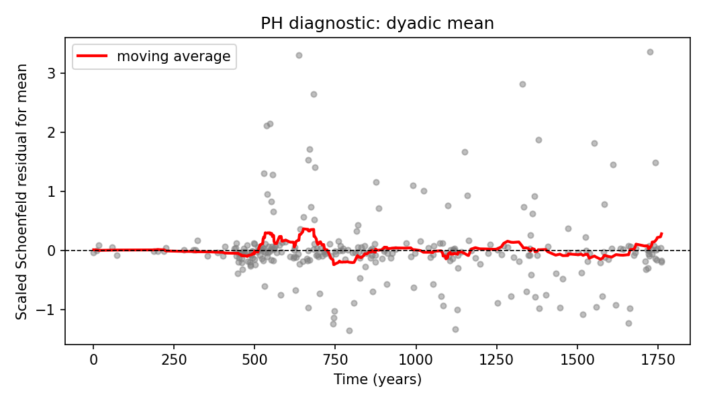
Supplemental Figure 1. Scaled Schoenfeld residual mean trajectory for the dyadic mean in the primary M3 model. A flat smooth line would support proportional hazards; a systematic trend suggests time-varying effects.

S4. Exploratory post-hoc risk stratification
The figures in this section are descriptive post-hoc summaries of the locked out-of-fold risk scores. They are not primary performance estimates, are not used for clinical-utility or net-benefit claims, and should not be interpreted as formal probability calibration or decision-analytic support. Because the dyad-availability indicator violated the proportional-hazards assumption, predicted probabilities and net-benefit curves are especially vulnerable to over-interpretation and are therefore not included.
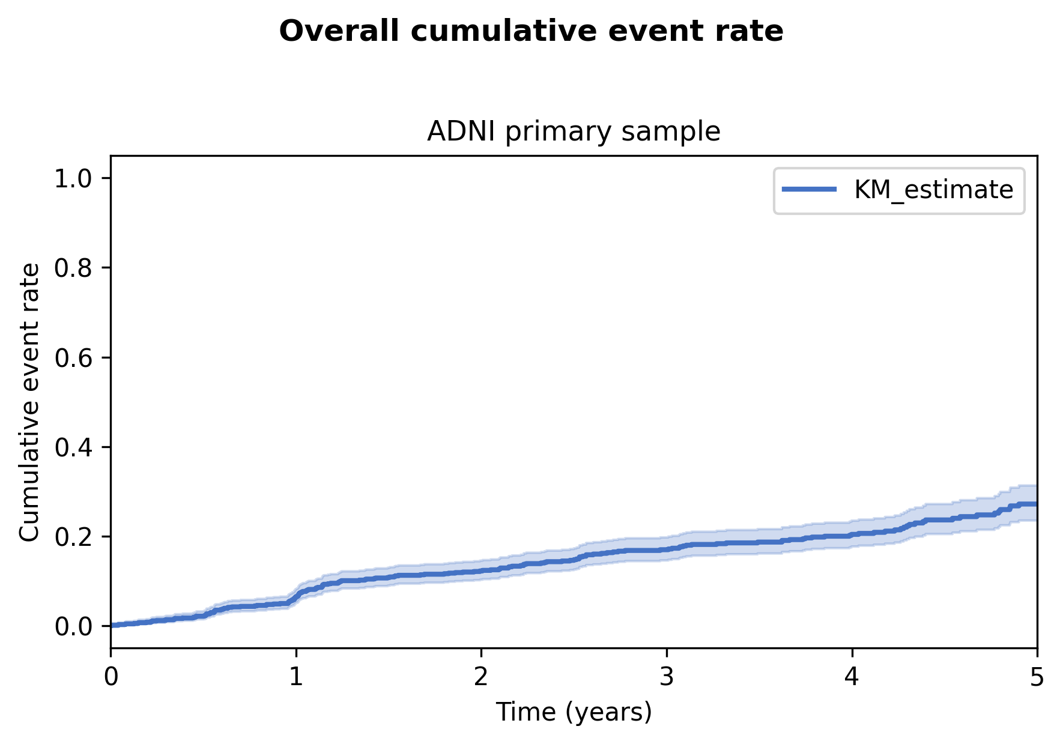
Supplemental Figure 2. Overall cumulative event rate in the ADNI primary sample. Shaded band: 95% confidence interval.
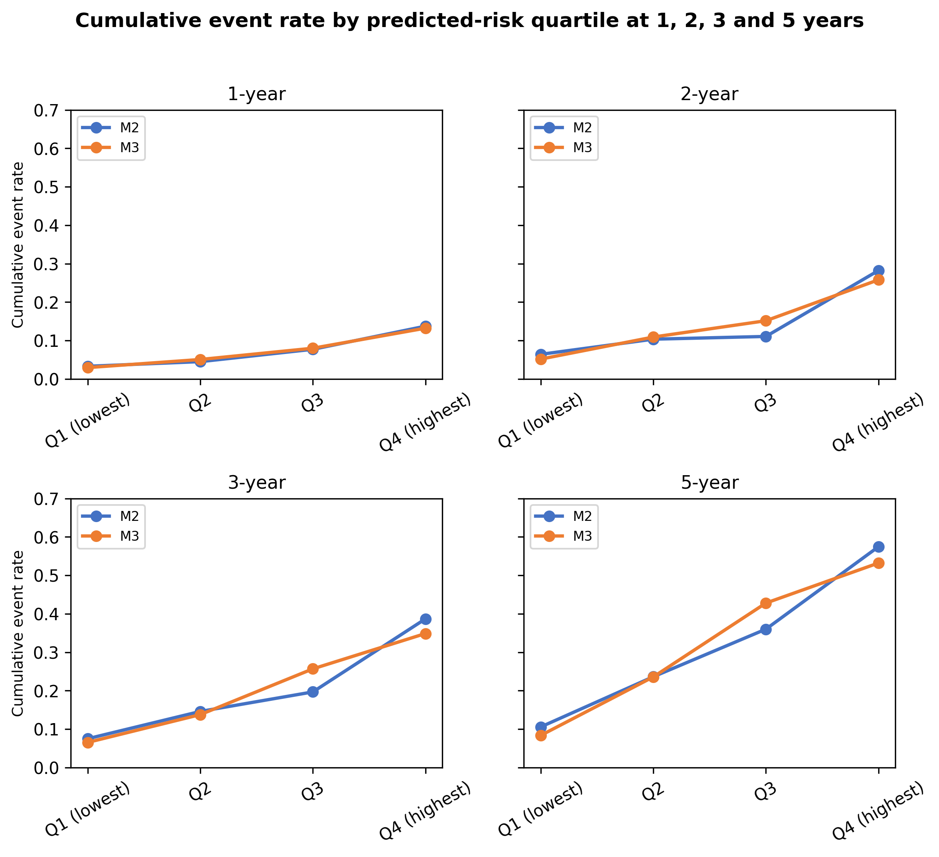
Supplemental Figure 3. Observed cumulative event rate by predicted-risk quartile at 1, 2, 3 and 5 years. For each horizon, quartiles are based on the predicted event probability from a post-hoc univariate Cox model fitted to the OOF risk score; higher quartiles correspond to higher predicted risk.

S5. Interval-censoring sensitivity
Supplemental Table 4. Interval-censoring sensitivity (first-event, midpoint, last-known-normal).
Analysis | N | Events | Reference C-index | M3 C-index | M3–Ref ΔC (95% CI)
Interval-censoring: first-event | 1762 | 288 | 0.682 | 0.692 | 0.010 (-0.003 to 0.024)
Interval-censoring: midpoint | 1762 | 288 | 0.689 | 0.700 | 0.011 (-0.001 to 0.024)
Interval-censoring: last-known-normal | 1762 | 288 | 0.748 | 0.752 | 0.003 (-0.006 to 0.013)

S6. Coefficient selection frequencies
Supplemental Table 5. Cross-fold elastic-net coefficient summary for the primary analysis.
model | predictor | n_folds_selected | n_folds_positive | n_folds_negative | median_std_coef | min_std_coef | max_std_coef | median_orig_coef | min_orig_coef | max_orig_coef
M0 | age | 5 | 5 | 0 | 0.1809771298459067 | 0.1560046692034719 | 0.2134295397094743 | 0.0229974695491039 | 0.0196423665199981 | 0.0270901405785268
M0 | age_missing | 0 | 0 | 0 | 0.0 | 0.0 | 0.0 | 0.0 | 0.0 | 0.0
M0 | education | 5 | 0 | 5 | -0.0662011337929723 | -0.1124515918789597 | -0.0513229297678709 | -0.0263890828235212 | -0.044485256771133 | -0.0200756223642498
M0 | education_missing | 0 | 0 | 0 | 0.0 | 0.0 | 0.0 | 0.0 | 0.0 | 0.0
M0 | mmse | 5 | 0 | 5 | -0.246365840010425 | -0.2740759618157239 | -0.2145130164556065 | -0.2089175296084877 | -0.2307073307521553 | -0.176881452588826
M0 | mmse_missing | 0 | 0 | 0 | 0.0 | 0.0 | 0.0 | 0.0 | 0.0 | 0.0
M0 | sex_female | 5 | 0 | 5 | -0.2856954596378235 | -0.3519337888105174 | -0.2478170996976196 | -0.2856954596378235 | -0.3519337888105174 | -0.2478170996976196
M2 | age | 5 | 5 | 0 | 0.1811272931118143 | 0.1617865019518418 | 0.1966624507646791 | 0.0230165513808141 | 0.0203703503590759 | 0.0249619309725582
M2 | age_missing | 0 | 0 | 0 | 0.0 | 0.0 | 0.0 | 0.0 | 0.0 | 0.0
M2 | apoe4_carrier | 5 | 5 | 0 | 0.3190116857565979 | 0.1934653125752196 | 0.3843391914230583 | 0.3190116857565979 | 0.1934653125752196 | 0.3843391914230583
M2 | apoe4_carrier_missing | 2 | 2 | 0 | 0.0 | 0.0 | 0.7923599639177499 | 0.0 | 0.0 | 0.7923599639177499
M2 | centiloid | 5 | 3 | 2 | 0.0187485577607159 | -0.0141230492129512 | 0.0598742066290943 | 0.0007388790159312 | -0.0005639498432711 | 0.0023327753725347
M2 | centiloid_missing | 5 | 5 | 0 | 0.4534242727740412 | 0.2972277152230021 | 0.5395859657845871 | 0.4534242727740412 | 0.2972277152230021 | 0.5395859657845871
M2 | education | 5 | 0 | 5 | -0.0626466508298408 | -0.0909496245079224 | -0.0212161598810449 | -0.0244269028538651 | -0.035979191862646 | -0.0082989731045721
M2 | education_missing | 0 | 0 | 0 | 0.0 | 0.0 | 0.0 | 0.0 | 0.0 | 0.0
M2 | hippocampus | 5 | 0 | 5 | -0.06817544820643 | -0.1285404314058032 | -0.0153270723070049 | -0.0001319248746439 | -0.000249794131057 | -3.090042685728533e-05
M2 | hippocampus_missing | 5 | 5 | 0 | 0.3335905336868029 | 0.1696586750882759 | 0.525298367844825 | 0.3335905336868029 | 0.1696586750882759 | 0.525298367844825
M2 | mmse | 5 | 0 | 5 | -0.2178370947007424 | -0.2436462419740971 | -0.1754391162107588 | -0.1825861297270075 | -0.2050926821938196 | -0.1446622038559648
M2 | mmse_missing | 0 | 0 | 0 | 0.0 | 0.0 | 0.0 | 0.0 | 0.0 | 0.0
M2 | sex_female | 5 | 0 | 5 | -0.3045926704397217 | -0.4236609891982139 | -0.2310211892916577 | -0.3045926704397217 | -0.4236609891982139 | -0.2310211892916577
M3 | age | 5 | 5 | 0 | 0.1626506269630871 | 0.1618018786015164 | 0.1853413486372397 | 0.0206472701860039 | 0.0203787683855696 | 0.023524968457652
M3 | age_missing | 0 | 0 | 0 | 0.0 | 0.0 | 0.0 | 0.0 | 0.0 | 0.0
M3 | apoe4_carrier | 5 | 5 | 0 | 0.3489618541605322 | 0.2147751190585266 | 0.4059799522901691 | 0.3489618541605322 | 0.2147751190585266 | 0.4059799522901691
M3 | apoe4_carrier_missing | 2 | 2 | 0 | 0.0 | 0.0 | 0.7889637376222726 | 0.0 | 0.0 | 0.7889637376222726
M3 | centiloid | 5 | 3 | 2 | 0.0114693626939545 | -0.0303687580044768 | 0.0516567251827244 | 0.0004520065771898 | -0.0012126599616504 | 0.0020126118259661
M3 | centiloid_missing | 5 | 5 | 0 | 0.4492301684657275 | 0.2996900854183866 | 0.5494982065368641 | 0.4492301684657275 | 0.2996900854183866 | 0.5494982065368641
M3 | dyad_available | 4 | 0 | 4 | -0.0505861449414228 | -0.0896673453227673 | 0.0 | -0.0505861449414228 | -0.0896673453227673 | 0.0
M3 | education | 5 | 0 | 5 | -0.0442943670750415 | -0.0706543902093441 | -0.0188997770261684 | -0.0172710621746454 | -0.0281642390130439 | -0.0075320426644294
M3 | education_missing | 0 | 0 | 0 | 0.0 | 0.0 | 0.0 | 0.0 | 0.0 | 0.0
M3 | hippocampus | 5 | 0 | 5 | -0.0763505306197177 | -0.1274763508438732 | -0.0068733026658941 | -0.000147744304526 | -0.0002477262907951 | -1.3857048628809416e-05
M3 | hippocampus_missing | 5 | 5 | 0 | 0.3732202760197303 | 0.1735924902921851 | 0.5705903267883918 | 0.3732202760197303 | 0.1735924902921851 | 0.5705903267883918
M3 | mean | 5 | 5 | 0 | 0.1690780194550025 | 0.1454688871890993 | 0.2048600792441895 | 1.123069019726282 | 0.902340254466238 | 1.3226554861305109
M3 | mmse | 5 | 0 | 5 | -0.2219429412204911 | -0.2540478563335813 | -0.1852455496296855 | -0.187410768129871 | -0.2138483887085096 | -0.1527483154426448
M3 | mmse_missing | 0 | 0 | 0 | 0.0 | 0.0 | 0.0 | 0.0 | 0.0 | 0.0
M3 | sex_female | 5 | 0 | 5 | -0.2766178760612098 | -0.3953265763253217 | -0.1954052480009055 | -0.2766178760612098 | -0.3953265763253217 | -0.1954052480009055
M4 | age | 5 | 5 | 0 | 0.1645998449365838 | 0.1480791487285698 | 0.1934441586057245 | 0.0209163440979497 | 0.0187975309397738 | 0.0245534402494487
M4 | age_missing | 0 | 0 | 0 | 0.0 | 0.0 | 0.0 | 0.0 | 0.0 | 0.0
M4 | apoe4_carrier | 5 | 5 | 0 | 0.307416830783691 | 0.2147751190585266 | 0.3574972752231547 | 0.307416830783691 | 0.2147751190585266 | 0.3574972752231547
M4 | apoe4_carrier_missing | 1 | 1 | 0 | 0.0 | 0.0 | 0.7940154803508224 | 0.0 | 0.0 | 0.7940154803508224
M4 | centiloid | 5 | 3 | 2 | 0.0122656316612632 | -0.0190155319314179 | 0.0507075770206529 | 0.000483387467309 | -0.000759312390033 | 0.001975631804317
M4 | centiloid_missing | 5 | 5 | 0 | 0.4383597161045524 | 0.2887795119192367 | 0.5494982065368641 | 0.4383597161045524 | 0.2887795119192367 | 0.5494982065368641
M4 | dyad_available | 3 | 0 | 3 | -0.0505861449414228 | -0.0902408831593306 | 0.0 | -0.0505861449414228 | -0.0902408831593306 | 0.0
M4 | education | 5 | 0 | 5 | -0.0409945200572671 | -0.0611858654711724 | -0.0169993713670237 | -0.0159844005340299 | -0.024204805737022 | -0.0067746825916316
M4 | education_missing | 0 | 0 | 0 | 0.0 | 0.0 | 0.0 | 0.0 | 0.0 | 0.0
M4 | gap | 4 | 4 | 0 | 0.0696280604514976 | 0.0 | 0.0932085018688263 | 0.3081591340970365 | 0.0 | 0.4245371879834184
M4 | hippocampus | 5 | 0 | 5 | -0.0650550343471312 | -0.1308743755081311 | -0.0127294766099282 | -0.0001282019293809 | -0.0002543297120614 | -2.5663496135321253e-05
M4 | hippocampus_missing | 5 | 5 | 0 | 0.3732202760197303 | 0.1855969571877286 | 0.5786133830830539 | 0.3732202760197303 | 0.1855969571877286 | 0.5786133830830539
M4 | mean | 5 | 5 | 0 | 0.178392582744846 | 0.170796081137983 | 0.2170029077579449 | 1.1849392586658087 | 1.0924766586195525 | 1.4151357284066048
M4 | mmse | 5 | 0 | 5 | -0.2219429412204911 | -0.2551148145787997 | -0.1827940797012176 | -0.1877520422342777 | -0.2147465159545022 | -0.1507269016884125
M4 | mmse_missing | 0 | 0 | 0 | 0.0 | 0.0 | 0.0 | 0.0 | 0.0 | 0.0
M4 | sex_female | 5 | 0 | 5 | -0.2609153362662313 | -0.394315516130946 | -0.1954052480009055 | -0.2609153362662313 | -0.394315516130946 | -0.1954052480009055

S7. MRI availability
Supplemental Table 6. MRI availability and event rate in the ADNI primary sample. Missing MRI was coded as has_mri=0, so the 'missing' row is redundant and omitted.
has_mri | n | n_events | event_rate_pct
0 | 1146 | 166 | 14.49
1 | 616 | 122 | 19.81

S8. TRIPOD checklist
This study follows the Transparent Reporting of a multivariable prediction model for Individual Prognosis Or Diagnosis (TRIPOD) Statement. The completed checklist below maps each TRIPOD item to the relevant section or explains why it is not applicable.
Supplemental Table 7. TRIPOD checklist for the ADNI prognostic model development and internal validation.
Item | Section / topic | Checklist item | Location / comment
1 | Title and abstract | Identify the study as developing and/or validating a multivariable prediction model, the target population, and the outcome to be predicted. | Title: exploratory prognostic modelling study in cognitively normal ADNI participants; outcome: first recorded clinical diagnosis of MCI or AD dementia.
2 | Title and abstract | Provide a summary of objectives, study design, setting, participants, sample size, predictors, outcome, statistical analysis, results, and conclusions. | Structured Abstract.
3a | Introduction | Explain the medical context (diagnostic or prognostic) and rationale for developing or validating the multivariable prediction model, including references to existing models. | Introduction, paragraphs 1–2.
3b | Introduction | Specify the objectives, including whether the study describes the development or validation of the model or both. | Introduction, paragraph 2: internal development/validation in ADNI; no external validation.
4a | Methods | Describe the study design or source of data (e.g., randomized trial, cohort, or registry data), separately for the development and validation data sets, if applicable. | Methods/Study design: ADNI multi-site observational cohort.
4b | Methods | Specify the key study dates, including start of accrual; end of accrual; and, if applicable, end of follow-up. | Methods/Study design: ADNI data files were downloaded on 31 January 2026 and all available follow-up records in the snapshot through 3 November 2025 were eligible for analysis. Landmark visits were participant-specific and are reported in the ADNI data dictionary.
5a | Methods | Specify key elements of the study setting (e.g., primary care, secondary care, general population) including number and location of centres. | Methods/Study design: multi-site ADNI cohort in North America.
5b | Methods | Describe eligibility criteria for participants. | Methods/Study design: cognitively normal at baseline, no prevalent MCI/AD, MMSE ≥24, CDR=0.
5c | Methods | Give details of treatments received, if relevant. | N/A; observational cohort, no treatment assignment.
6a | Methods | Clearly define the outcome that is predicted by the prediction model, including how and when assessed. | Methods/Study design: first recorded clinical diagnosis of MCI or AD dementia after the landmark visit.
6b | Methods | Report any actions to blind assessment of the outcome to be predicted. | N/A; diagnoses are clinical assignments in ADNI.
7a | Methods | Clearly define all predictors used in developing or validating the multivariable prediction model, including how and when they were measured. | Methods/Predictors and Model dictionary.
7b | Methods | Report any actions to blind assessment of predictors for the outcome and other predictors. | N/A; all predictors were measured at the landmark visit, before the outcome.
8 | Methods | Explain how the study size was arrived at. | Methods/Study design: n=1,762 determined by ADNI availability and prespecified inclusion criteria.
9 | Methods | Describe how missing data were handled (e.g., complete-case analysis, single imputation, multiple imputation) with details of any imputation method. | Methods/Predictors and Statistical analysis: fold-wise median imputation, missingness indicators.
10a | Methods | Describe how predictors were handled in the analyses. | Methods/Predictors and Statistical analysis: standardization, residualisation sensitivity.
10b | Methods | Specify type of model, all model-building procedures (including any predictor selection), and method for internal validation. | Methods/Statistical analysis: elastic-net Cox, l1_ratio=0.5, lambda grid, nested 5x3 CV.
10c | Methods | For validation, describe how the predictions were calculated. | N/A for external validation; internal validation uses out-of-fold predictions (Methods/Statistical analysis).
10d | Methods | Specify all measures used to assess model performance and, if relevant, to compare multiple models. | Methods/Statistical analysis: C-index, paired bootstrap ΔC contrasts.
10e | Methods | Describe any model updating (e.g., recalibration) arising from the validation, if done. | N/A.
11 | Methods | Provide details on how risk groups were created, if done. | Supplemental Figure 3: quartiles of the OOF linear risk score (post-hoc descriptive).
12 | Methods | For validation, identify any differences from the development data in setting, eligibility criteria, outcome, and predictors. | N/A: no external validation; this is an ADNI internal cross-validation study.
13a | Results | Describe the flow of participants through the study, including the number of participants with and without the outcome. | Results/Figure 1 and Table 1.
13b | Results | Describe the characteristics of the development data set and validation data set. | Table 1 reports the single ADNI sample used for internal development/validation.
14 | Results | Specify the final prediction model (e.g., regression formula or coefficients). | Supplemental Table 5 reports cross-fold elastic-net coefficients.
15 | Results | Report the prediction model performance measures. | Table 2, Figure 2, and primary results.
16 | Results | Report the results from any model updating (e.g., recalibration). | N/A.
17 | Results | Report the results of any evaluations of model performance in subgroups or sensitivity analyses. | Table 3 and Supplemental Tables.
18 | Discussion | Discuss the practical usefulness of the model in the intended population. | Discussion, paragraphs 1 and 3: clinical utility and deployment were not established.
19 | Discussion | Discuss the implications of the study for research and practice. | Discussion/Conclusion.
20 | Other information | Provide information about the availability of supplemental resources, such as study protocol, statistical code, and datasets. | Data and code availability; Zenodo DOI; Supplemental 1.
21 | Other information | Describe sources of funding and other support and the role of funders. | Funding.
22 | Other information | Declare any conflicts of interest. | Conflicts of interest.

S9. Repeated nested-CV split stability
Supplemental Table 8. Repeat-level out-of-fold discrimination and incremental C-index contrasts across 10 independently generated stratified 5-fold outer partitions. Each repetition re-estimated preprocessing and inner 3-fold penalty selection; the contrasts are descriptive stability summaries, not independent hypothesis tests.
repeat | seed | M2_c_index | M3_c_index | M4_c_index | M3_minus_M2_delta | M4_minus_M3_delta
1.0 | 42.0 | 0.6633971004667782 | 0.6755361594248953 | 0.6863688042426682 | 0.012139058958117 | 0.0108326448177729
2.0 | 142.0 | 0.6806488288173774 | 0.6956973073745313 | 0.6946168675719764 | 0.0150484785571538 | -0.0010804398025549
3.0 | 242.0 | 0.6728103439753123 | 0.6841726161472788 | 0.6803663608951408 | 0.0113622721719665 | -0.0038062552521379
4.0 | 342.0 | 0.675401987161833 | 0.6889110155427974 | 0.6895818768581093 | 0.0135090283809644 | 0.0006708613153119
5.0 | 442.0 | 0.6661229159163613 | 0.6812278880579624 | 0.6768355118671836 | 0.0151049721416011 | -0.0043923761907788
6.0 | 542.0 | 0.6746675705640178 | 0.6799920908981774 | 0.6809524818337818 | 0.0053245203341595 | 0.0009603909356044
7.0 | 642.0 | 0.6803522374990291 | 0.6892076068611458 | 0.6867501359376875 | 0.0088553693621167 | -0.0024574709234582
8.0 | 742.0 | 0.6850200199139885 | 0.6902033062870297 | 0.691502658729318 | 0.0051832863730412 | 0.0012993524422882
9.0 | 842.0 | 0.6877740821557952 | 0.6944191400264107 | 0.6912766843915288 | 0.0066450578706155 | -0.0031424556348819
10.0 | 942.0 | 0.6829085721952701 | 0.6931621577724579 | 0.6892358536533695 | 0.0102535855771878 | -0.0039263041190884
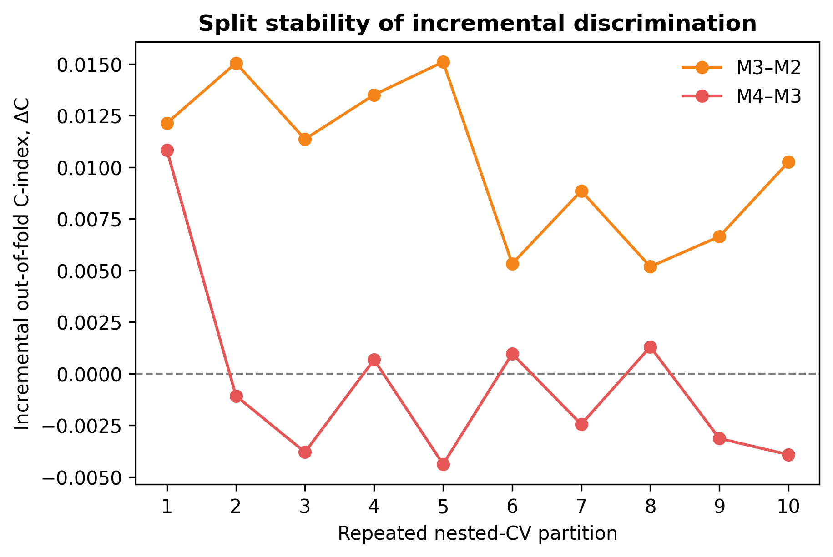
Supplemental Figure 4. Split stability of incremental discrimination across repeated nested cross-validation partitions. Points and connecting lines show repeat-level pooled out-of-fold ΔC estimates for M3–M2 and M4–M3; the dashed horizontal line denotes no incremental discrimination.

