Supplementary material

Table 1. Patients’ details, who donated synovium for IHC staining studies (mean ± SD)
General information | RA (n=20) | OA (n=17) | p value
Male: female | 8:12 | 5:12 | > 0.05
Age (years) | 50.5 ± 13.5 | 60.6 ± 8.9 | < 0.001
ESR (mm/h) | 79.4 ± 46.9 | 39.4 ± 26.1 | < 0.001
CRP (mg/L) | 27.3 ± 4.70 | 8.70 ± 4.30 | < 0.05

Table 2. General information of participants, who donated sera (mean ± SD)
General information | HC (n = 12) | OA (n = 20) | RA (n = 61) | p value
Gender (female: male) | 9:3 | 12:8 | 53: 17 | > 0.05
Age (years) | 49.8 ± 15.6 | 53.5 ± 12.0 | 51.2 ± 12.6 | > 0.05
ESR (mm/h) |  | 37.8 ± 29.3 | 86.5 ± 50.5 | < 0.01
CRP (mg/L) |  | 5.13 ± 7.19 | 19.1 ± 13.63 | < 0.05

Table 3. Primer sequences
Gene name | 5’ - 3’ | 3’ - 5’
GAPDH | CAATGACCCCTTCATTGACC | GACAAGCTTCCCGTTCTCAG
TNF-ɑ | GGCCCGACTATCTCGACTTTG | CGTTTGGGAAGGTTGGATGTT
IL-6 | CCTGAACCTTCCAAAGATGGC | TTCACCAGGCAAGTCTCCTCA
MMP1 | AAAATTACACGCCAGATTTGCC | GGTGTGACATTACTCCAGAGTTG
MMP3 | TGAAATTGGCCACTCCCTGG | GGAACCGAGTCAGGTCTGTG
MMP9 | TGTACCGCTATGGTTACACTCG | GGCAGGGACAGTTGCTTCT
AMPK-ɑ | TTGAAACCTGAAAATGTCCTGCT | GGTGAGCCACAACTTGTTCTT
ACAN | CCCCTGCTATTTCATCGACCC | GACACACGGCTCCACTTGAT
Cyclin-D1 | GCTGCGAAGTGGAAACCATC | CCTCCTTCTGCACACATTTGAA
Ki-67 | CGTCCCAGTGGAAGAGTTGT | CGACCCCGCTCCTTTTGATA

Table 4. Management of NC, si-HAPLN1 and rHAPLN1
Groups | siRNA |  | rHAPLN1
Groups | si-Control | si-HAPLN1 | 0 ng/ml | 50 ng/ml
NC | + | - | + | -
si-HAPLN1 | - | + | + | -
rHAPLN1 | + | - | - | +

Figure 1. Plasma HAPLN1 levels negatively correlated with disease course other than disease activity. (A) Plasma HAPLN1 levels negatively correlated with disease course (r = -0.311, p = 0.038); (B) Patients with less disease course showed higher HAPLN1 levels; (C) HAPLN1 levels positively correlated with plasma AMPK levels (r = 0.693, p < 0.0001); (D-E) Plasma HAPLN1 levels showed no correlation with other indexes like ESR and CRP; and no differences between disease course less or longer than 3 years on ESR and CRP. *p < 0.05; ns, not significant.
Figure 2. Silencing or over-expression of HAPLN1 in RA-FLS. (A) All the three si-HAPLN1s designed and transfected showed significant inhibitory effect on the expression of HAPLN1 mRNA in RA-FLSs. (B) Over-expression plasmid vector (HAPLN1^{OE}) has significantly up-regulated the expression of HAPLN1 mRNA in RA-FLSs. **p < 0.01; ****p < 0.00001.

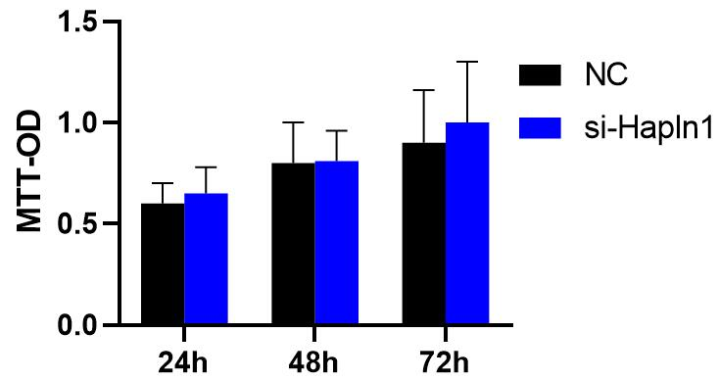
Figure 3. Transfection of si-HAPLN1 in RA-FLSs did not show any significant effect on FLSs proliferation.
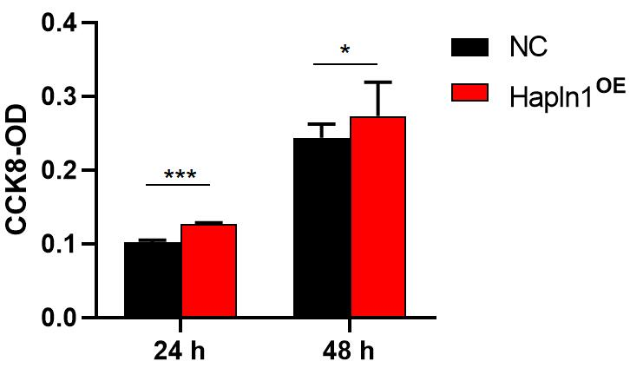
Figure 4. HAPLN1 over-expression in RA-FLSs has significantly increased proliferation activity of FLSs. *p < 0.05; ***p < 0.001.

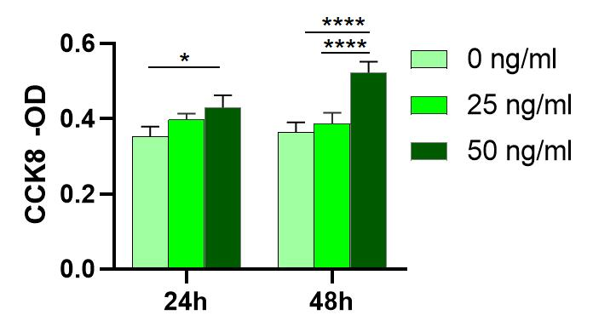
Figure 5. FLSs proliferation was increased by rHAPLN1. *p < 0.05; ****p < 0.0001.
Figure 6. Correlation of mRNA expression levels in untreated RA-FLSs. (A) Cor function in R language was used to analyze Pearson correlation coefficient between each data set. (B-D) AMPK-ɑ positively correlated with HAPLN1, TGF-β, and ACAN. (E-G) HAPLN1 has a positive correlation with Fibronection, TGF-β and IL-6.
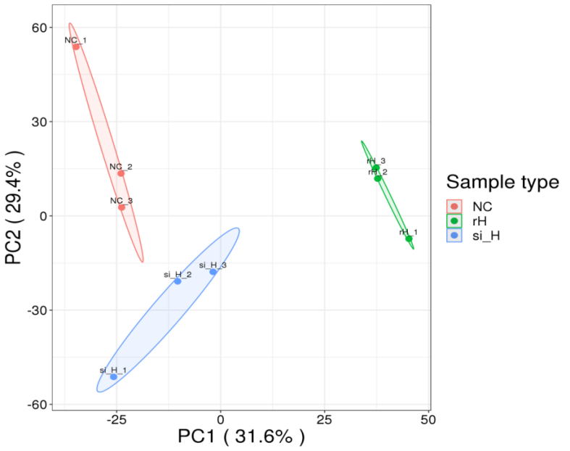
Figure 7. Quantitative protein principal component analysis (PCA) of all the sample results are shown. Higher aggregation degree between the repeated samples indicates better quantitative repeatability. NC, negative control; rH, recombinant HAPLN1; si_H; si-HAPLN1.
Figure 8. KEGG pathways enriched based on up-regulated DEGs in rHAPLN1 treated RA-FLSs.

Figure 9. KEGG pathways enriched based on down-regulated DEGs in si-HAPLN1 transfected RA-FLSs.

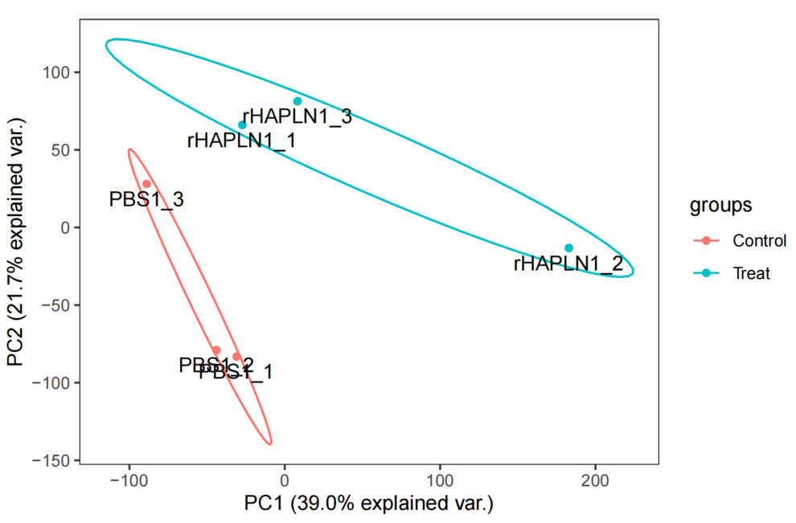
Figure 10. The principal component analysis (PCA) of all the sample results are shown. Higher aggregation degree between the repeated samples indicates better quantitative repeatability.

Figure 11. GSEA analysis shows pathways affected by up-regulated DEGs in rHAPLN1 treated RA-FLSs. Pathways affected include extracellular matrix structural constituent, alpha actin binding, metalloaminopeptidase activity, proteoglycan binding, focal adhesion, regulation of protein exit from endoplasmic reticulum, lipid translocation, regulation of androgen receptor signaling pathway, retrograde axonal transport, dendritic spine development, peptide cross linking, insulin like growth factor receptor signaling pathway etc.

