Supplementary Materials

Table S1. Tumor, socioeconomic, and demographic characteristics by radiation receipt.
Table S2. Sensitivity analysis of overall survival treating radiotherapy receipt as a time-varying exposure.
Figure S1. Covariate balance across treatment groups, measured by standardized mean differences before and after overlap weighting, for prespecified survival comparisons: (A) BCS+RT and Mx−RT, (B) RT and no RT among BCS patients, and (C) RT and no RT among PMRT-indicated mastectomy patients.
Figure S2. Distribution of estimated propensity scores before and after overlap weighting for prespecified survival comparisons: (A–B) BCS+RT versus Mx−RT, (C–D) RT and no RT among BCS patients, and (E–F) RT and no RT among PMRT-indicated mastectomy patients.
Figure S3. Unweighted Kaplan-Meier curves comparing overall survival between patients receiving BCS+RT and Mx−RT.
Figure S4. Unweighted Kaplan-Meier curves comparing overall survival and adjuvant RT among patients who received BCS.
Figure S5. Unweighted Kaplan-Meier curves comparing overall survival and adjuvant RT among PMRT-indicated mastectomy patients.
Figure S6. Adjusted marginal probabilities of radiotherapy receipt by age group.

Table S1. Tumor, socioeconomic, and demographic characteristics by radiation receipt.
 | RT use¹  N = 988,164  no. of death = 134,492 | No RT use¹  N = 469,079  no. of death = 102,502 | p-value²
Age at diagnosis | 60 (51, 68) | 62 (50, 74) | <0.001
Median follow-up (years) | 6.2 (3.6, 9.8) | 5.8 (3.2, 9.4) | <0.001
Race/ethnicity |  |  | <0.001
NH White | 761,731 (77.1%) | 364,245 (77.7%)
NH Black | 110,414 (11.2%) | 48,638 (10.4%)
Hispanic | 60,323 (6.1%) | 28,642 (6.1%)
NH Asian | 37,750 (3.8%) | 19,024 (4.1%)
NH American Indian | 3,028 (0.3%) | 1,517 (0.3%)
NH Pacific Islander | 997 (0.1%) | 507 (0.1%)
Other/unknown | 13,921 (1.4%) | 6,506 (1.4%)
Tumor size (cm) | 1.60 (1.00, 2.60) | 1.70 (1.10, 2.70) | <0.001
Positive lymph nodes |  |  | <0.001
0 | 649,949 (65.8%) | 332,891 (71.0%)
1-3 | 215,357 (21.8%) | 76,067 (16.2%)
4-9 | 63,087 (6.4%) | 11,166 (2.4%)
≥10 | 26,999 (2.7%) | 5,566 (1.2%)
Positive (unknown) | 6,926 (0.7%) | 1,729 (0.4%)
Unknown | 25,846 (2.6%) | 41,660 (8.9%)
Histology |  |  | <0.001
Ductal | 784,153 (79.4%) | 358,329 (76.4%)
Lobular | 161,109 (16.3%) | 84,021 (17.9%)
Other | 42,902 (4.3%) | 26,729 (5.7%)
Tumor grade |  |  | <0.001
Well diff. | 217,650 (22.0%) | 101,119 (21.6%)
Moderately diff. | 408,203 (41.3%) | 195,755 (41.7%)
Poorly diff. | 257,085 (26.0%) | 128,588 (27.4%)
Other/unknown | 105,226 (10.6%) | 43,617 (9.3%)
Lymphovascular invasion |  |  | <0.001
Not Present | 569,498 (57.6%) | 280,012 (59.7%)
Present/Identified | 146,682 (14.8%) | 52,335 (11.2%)
N/A or Unknown | 271,984 (27.5%) | 136,732 (29.1%)
Breast cancer subtype |  |  | <0.001
HR+/HER2- | 616,802 (62.4%) | 274,126 (58.4%)
HR+/HER2+ | 78,756 (8.0%) | 37,711 (8.0%)
HR-/HER2+ | 28,603 (2.9%) | 16,252 (3.5%)
Triple Negative | 93,898 (9.5%) | 46,100 (9.8%)
Unknown | 170,105 (17.2%) | 94,890 (20.2%)
Charlson Comorbidity Index |  |  | <0.001
0 | 836,010 (84.6%) | 379,903 (81.0%)
1 | 117,253 (11.9%) | 64,376 (13.7%)
2 | 23,892 (2.4%) | 16,014 (3.4%)
≥3 | 11,009 (1.1%) | 8,786 (1.9%)
Year of diagnosis |  |  | <0.001
2004-2007 | 69,043 (7.0%) | 37,222 (7.9%)
2008-2011 | 190,312 (19.3%) | 97,913 (20.9%)
2012-2015 | 246,413 (24.9%) | 121,223 (25.8%)
2016-2021 | 482,396 (48.8%) | 212,721 (45.3%)
Urban rural status |  |  | <0.001
Metro | 815,378 (82.5%) | 382,372 (81.5%)
Urban | 122,607 (12.4%) | 61,548 (13.1%)
Rural | 18,320 (1.9%) | 9,333 (2.0%)
Unknown | 31,859 (3.2%) | 15,826 (3.4%)
Geographic region |  |  | <0.001
Northeast | 201,827 (20.4%) | 77,076 (16.4%)
South | 330,778 (33.5%) | 180,393 (38.5%)
Midwest | 234,452 (23.7%) | 104,494 (22.3%)
West | 170,346 (17.2%) | 75,561 (16.1%)
Unknown | 50,761 (5.1%) | 31,555 (6.7%)
Treatment facility size |  |  | <0.001
100–499 cases/year | 69,390 (7.0%) | 33,103 (7.1%)
≥500 cases/year | 393,396 (39.8%) | 184,061 (39.2%)
Academic program³ | 272,462 (27.6%) | 124,402 (26.5%)
Others | 252,916 (25.6%) | 127,513 (27.2%)
Primary payer |  |  | <0.001
Private/Managed | 553,324 (56.0%) | 222,836 (47.5%)
Medicaid | 66,818 (6.8%) | 29,124 (6.2%)
Medicare | 328,869 (33.3%) | 198,781 (42.4%)
Other/Unknown | 39,153 (4.0%) | 18,338 (3.9%)
Income⁴ |  |  | <0.001
Low Income (<$46K) | 116,675 (11.8%) | 62,811 (13.4%)
Lower-Mid ($46K-$57K) | 169,441 (17.1%) | 85,231 (18.2%)
Upper-Mid ($57K-$74K) | 203,720 (20.6%) | 97,987 (20.9%)
High Income ($74K+) | 362,651 (36.7%) | 161,955 (34.5%)
Unknown | 135,677 (13.7%) | 61,095 (13.0%)
Crowfly distance (miles)⁵ |  |  | <0.001
≤5 | 250,654 (25.4%) | 114,862 (24.5%)
5–10 | 211,606 (21.4%) | 95,945 (20.5%)
11–25 | 249,915 (25.3%) | 117,086 (25.0%)
26–50 | 91,873 (9.3%) | 49,288 (10.5%)
>50 | 58,210 (5.9%) | 35,602 (7.6%)
Unknown | 125,906 (12.7%) | 56,296 (12.0%)
Chemotherapy use |  |  | <0.001
No/unknown | 528,185 (53.5%) | 301,805 (64.3%)
Yes | 459,979 (46.5%) | 167,274 (35.7%)
Hormone therapy use |  |  | <0.001
No/unknown | 231,919 (23.5%) | 175,309 (37.4%)
Yes | 756,245 (76.5%) | 293,770 (62.6%)
Immunotherapy use |  |  | <0.001
No/unknown | 901,291 (91.2%) | 433,439 (92.4%)
Yes | 86,873 (8.8%) | 35,640 (7.6%)
Abbreviations: NH, Non-Hispanic.
¹Median (Q1, Q3); n (%).
²Kruskal-Wallis rank sum test; Pearson's Chi-squared test.
³Academic/research programs treating ≥500 cases/year.
⁴Median household income for each patient's area of residence, estimated using 2020 American Community Survey data and adjusted for 2020 inflation.
⁵The great circle distance between the patient's residence and the case-reporting hospital.

Table S2. Sensitivity analysis of overall survival treating radiotherapy receipt as a time-varying exposure.
Cohort | Time-varying Exposure | Adjusted HR (95% CI)
BCS patients | RT vs. no/not-yet RT | 0.67 (0.66–0.68)
Mx patients indicated for PMRT | PMRT vs. no/not-yet PMRT | 0.97 (0.95–0.98)
*Hazard ratios estimated using time-varying Cox proportional hazards models; adjusted for age, race/ethnicity, tumor size, number of positive lymph nodes, histology, tumor grade, lymphovascular invasion, breast cancer receptor, Charlson-Deyo score, year of diagnosis group, urban/rural status, region, facility level, insurance, income, distance from home to treatment facility, chemotherapy use, hormone therapy use, and immunotherapy use.
Figure S1. Covariate balance across treatment groups, measured by standardized mean differences before and after overlap weighting, for prespecified survival comparisons: (A) BCS+RT and Mx−RT, (B) RT and no RT among BCS patients, and (C) RT and no RT among PMRT-indicated mastectomy patients. The standardized mean difference (SMD) is a measure of covariate imbalance between treatment groups; larger SMDs indicate greater differences in the covariate across treatment groups (worse balance). A SMD < 0.10 is commonly considered acceptable balance (the threshold is marked by the horizontal dashed line). Red points are SMDs before overlap weighting and blue points after.
A

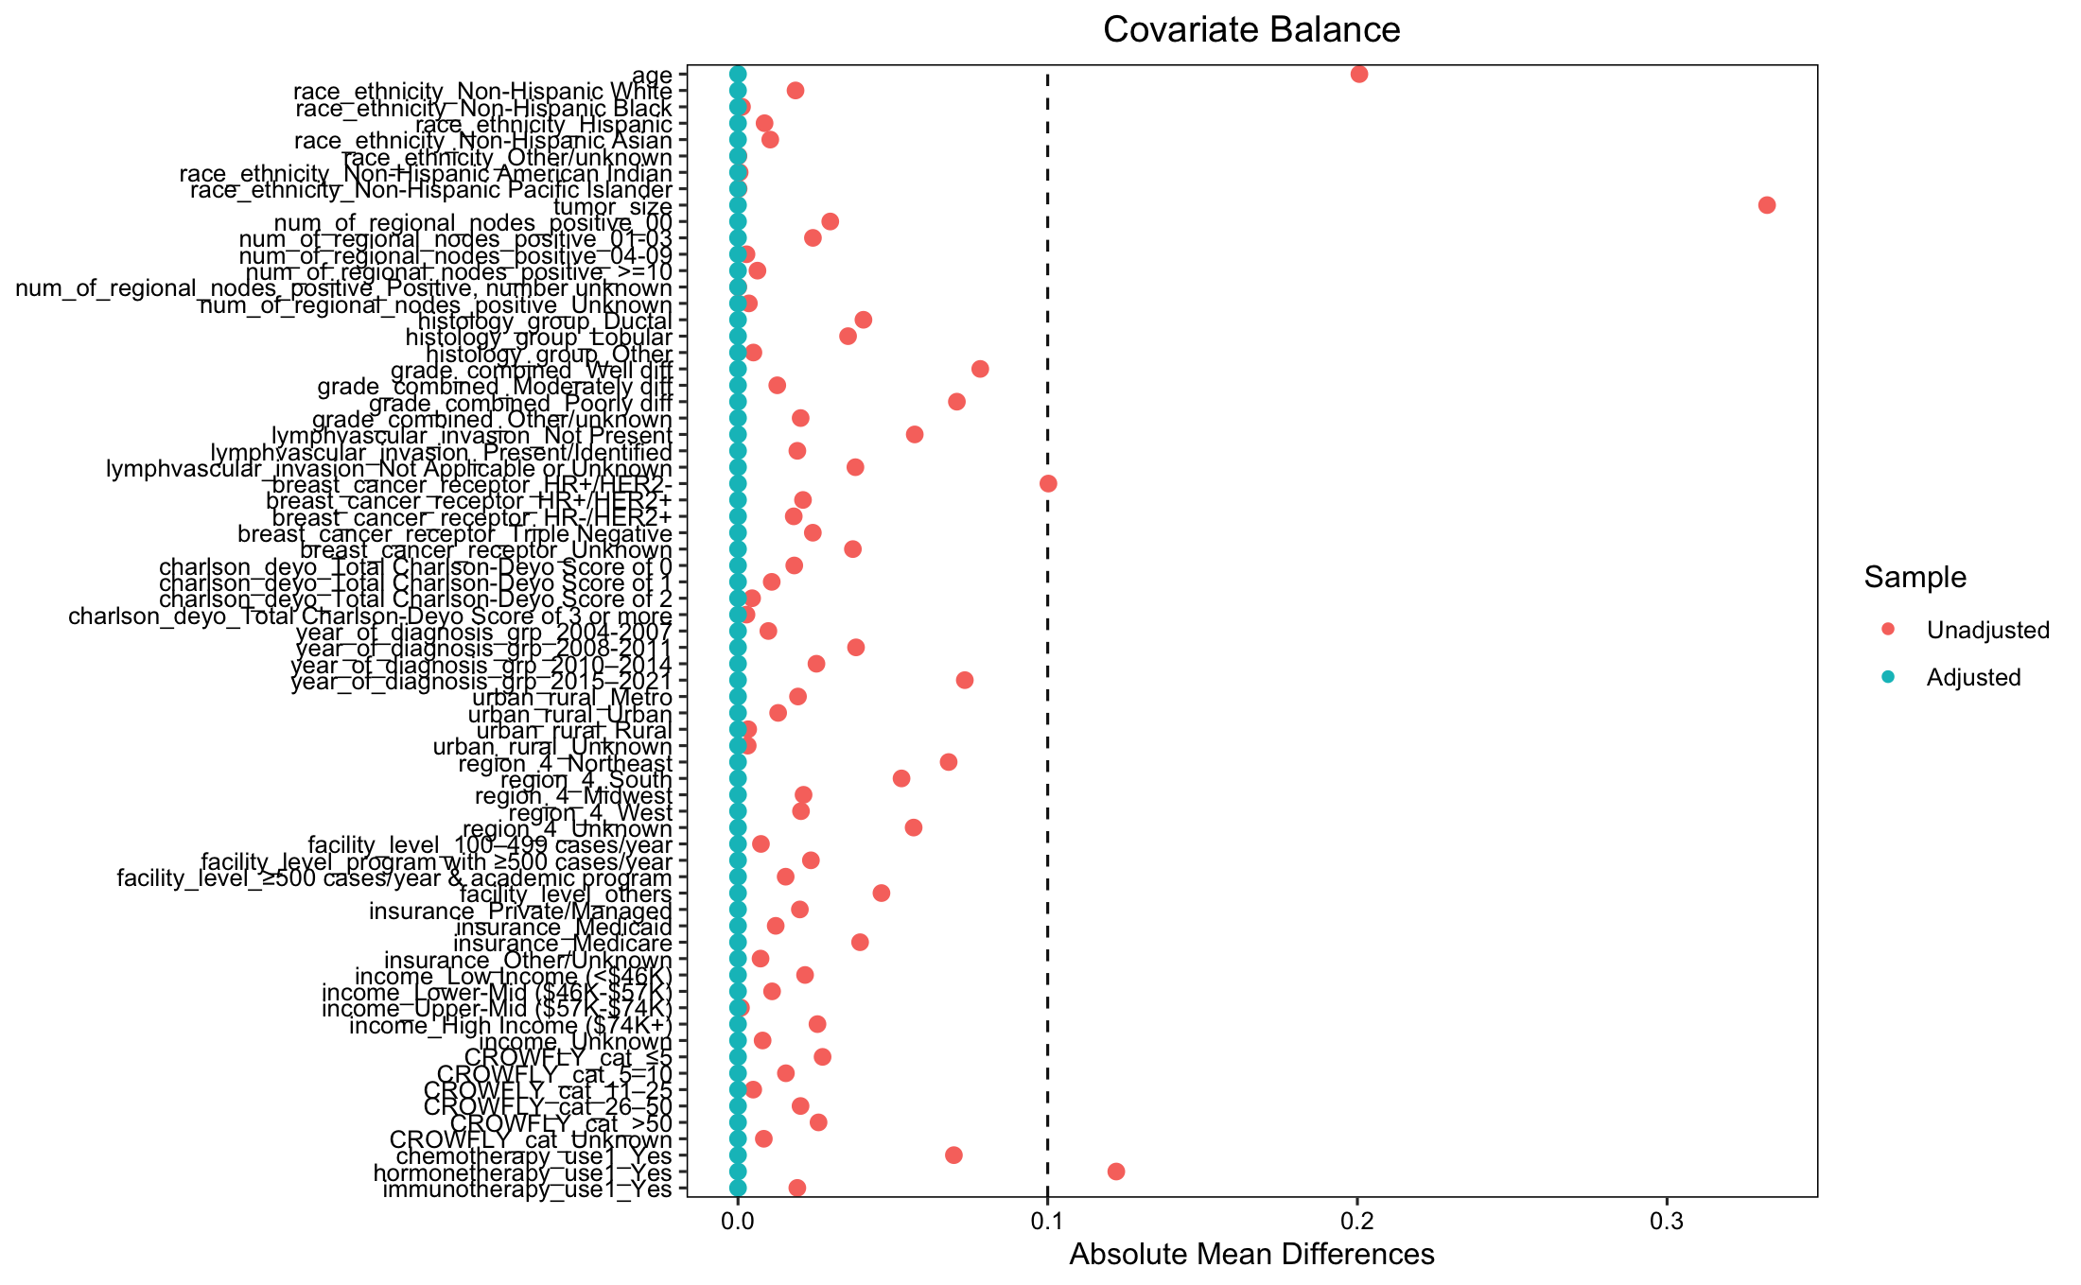

B
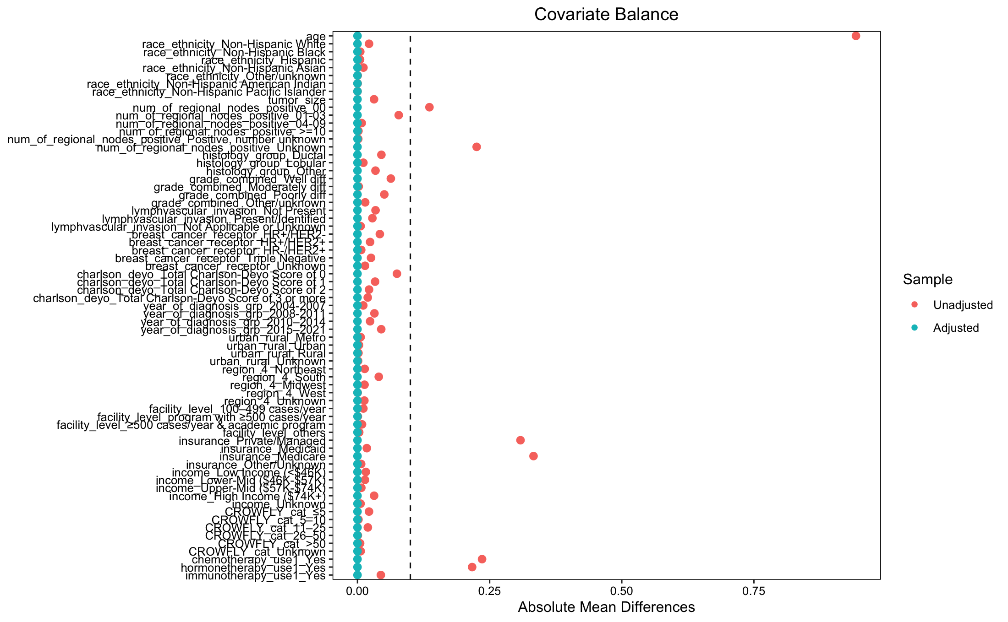

C
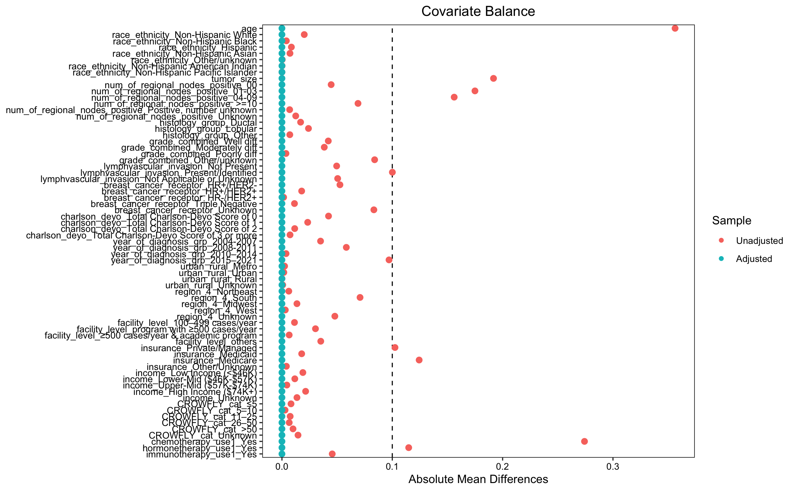

Figure S2. Distribution of estimated propensity scores before and after overlap weighting for prespecified survival comparisons: (A–B) BCS+RT versus Mx−RT, (C–D) RT and no RT among BCS patients, and (E–F) RT and no RT among PMRT-indicated mastectomy patients. For each comparison, the left panel shows the propensity score distribution before overlap-weighting and the right panel shows the distribution after.
B
A

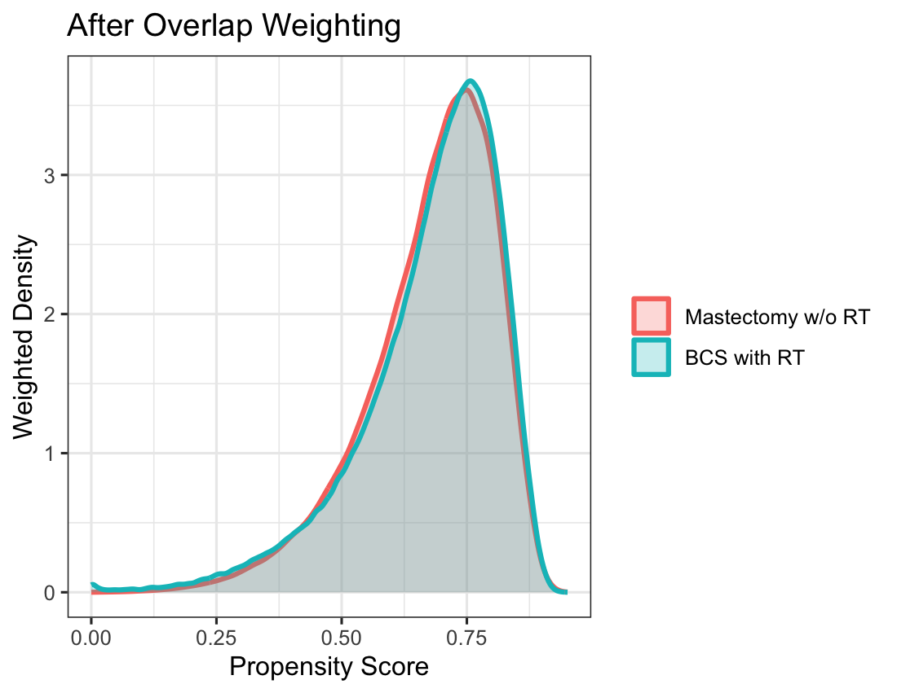
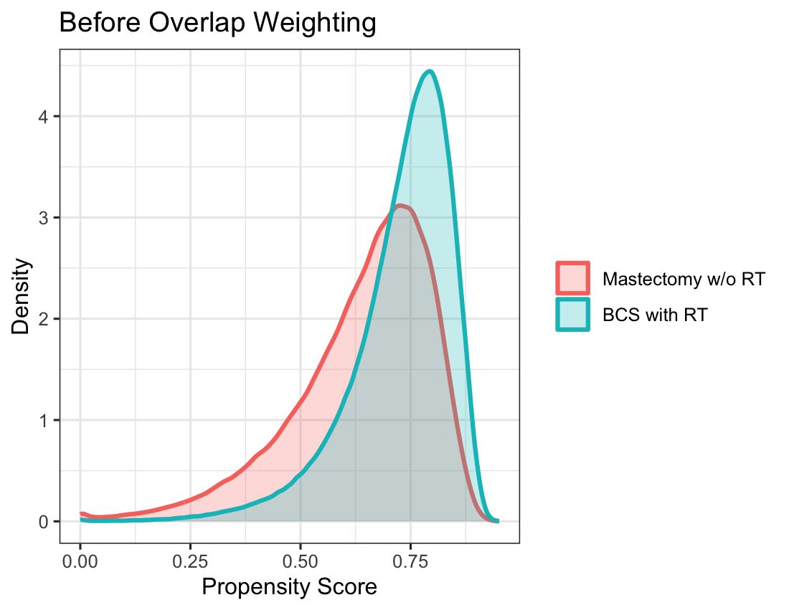

D
C

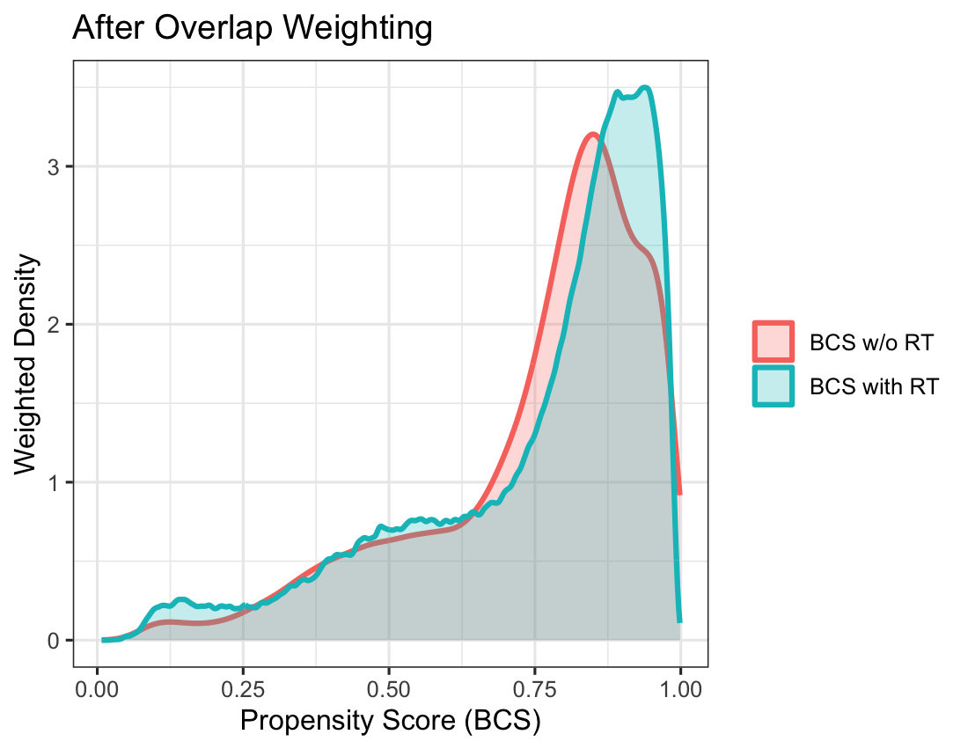
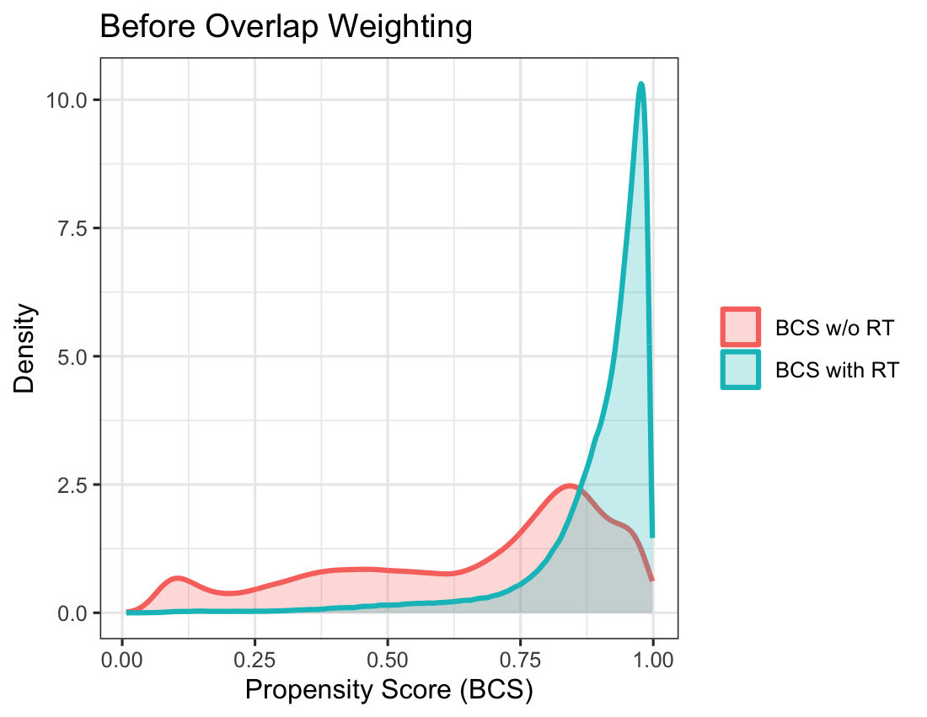

F
E

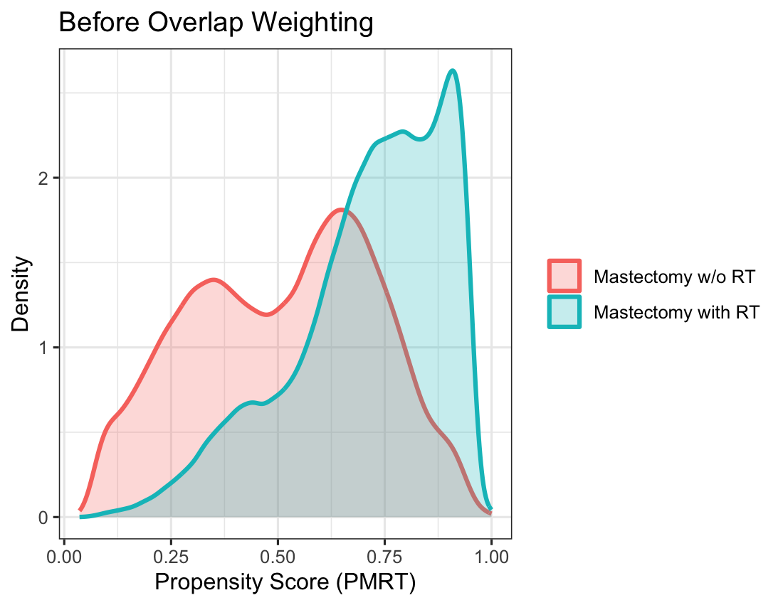
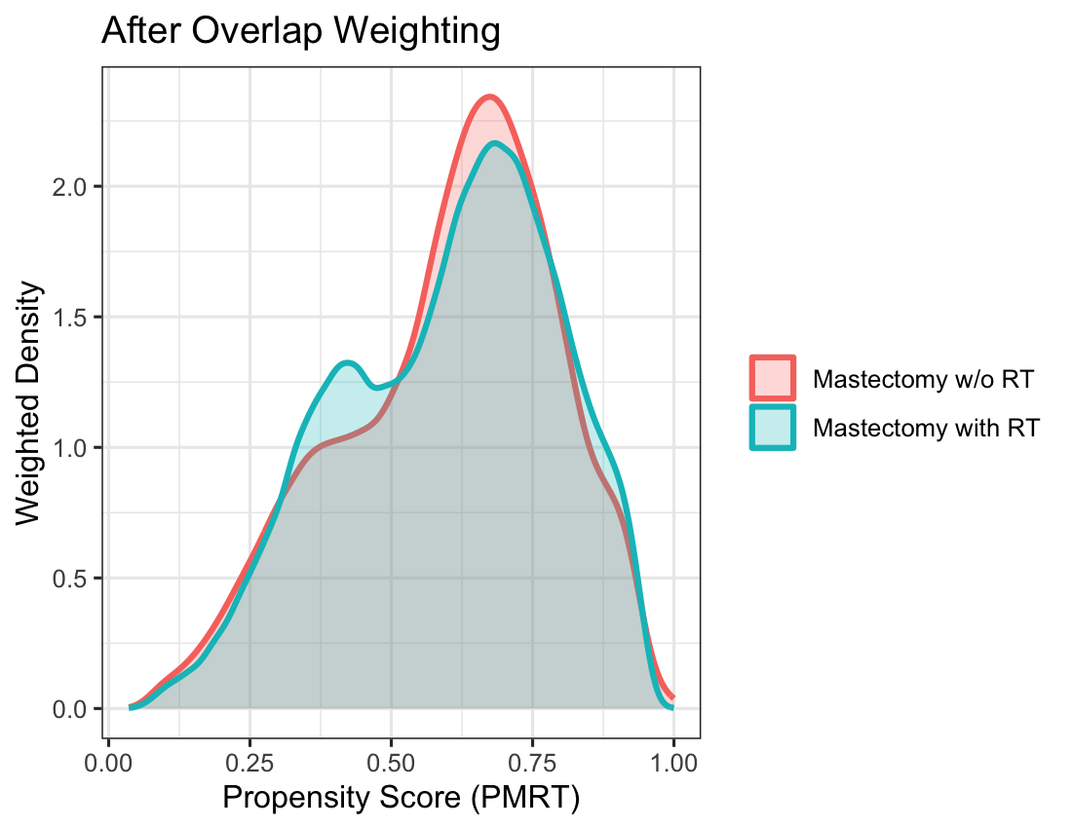

Figure S3. Unweighted Kaplan-Meier curves comparing overall survival between patients receiving BCS+RT and Mx−RT. Numbers at risk represent unweighted patient counts.

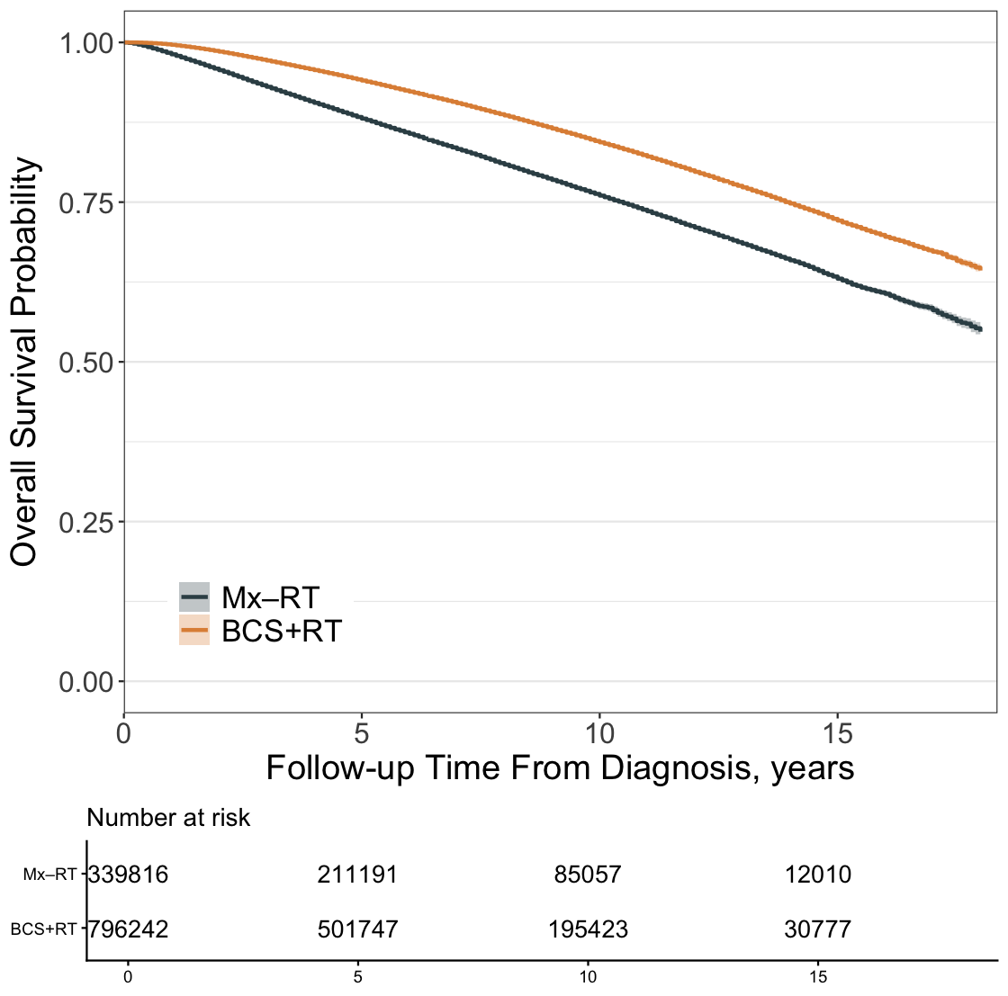

Figure S4. Unweighted Kaplan-Meier curves comparing overall survival and adjuvant RT among patients who received BCS. Numbers at risk represent unweighted patient counts.

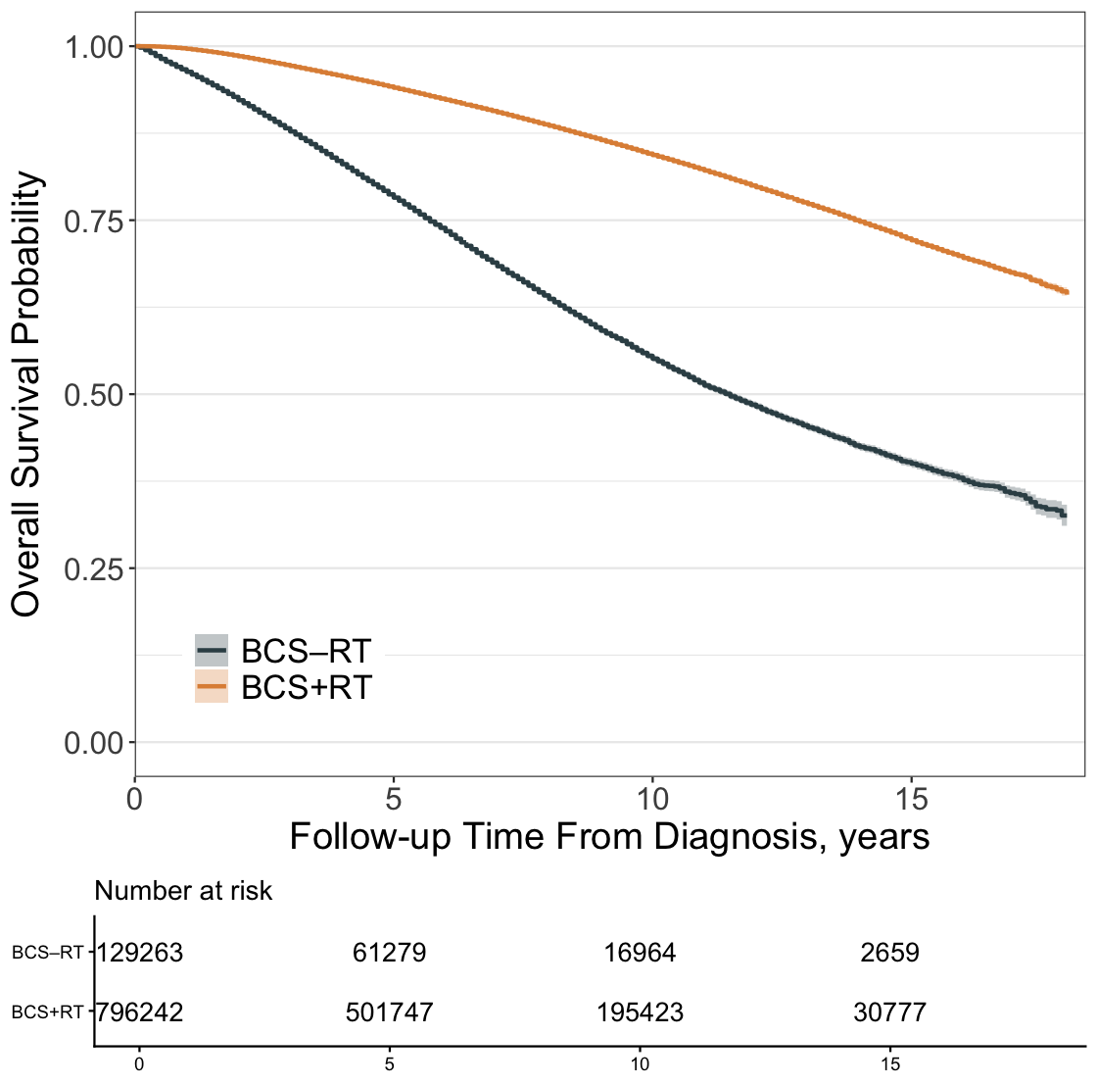

Figure S5. Unweighted Kaplan-Meier curves comparing overall survival and adjuvant RT among PMRT-indicated mastectomy patients. Numbers at risk represent unweighted patient counts.

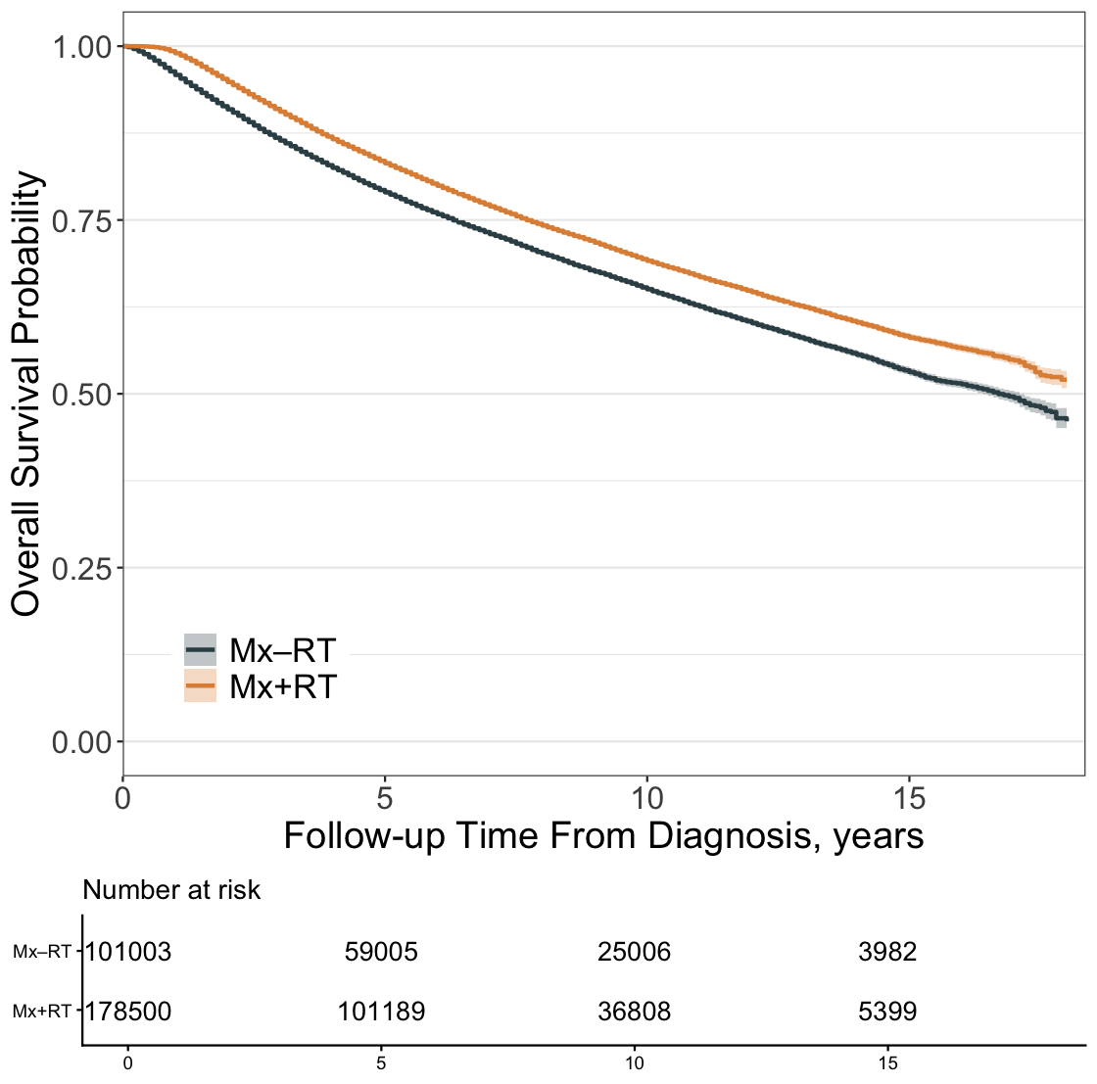

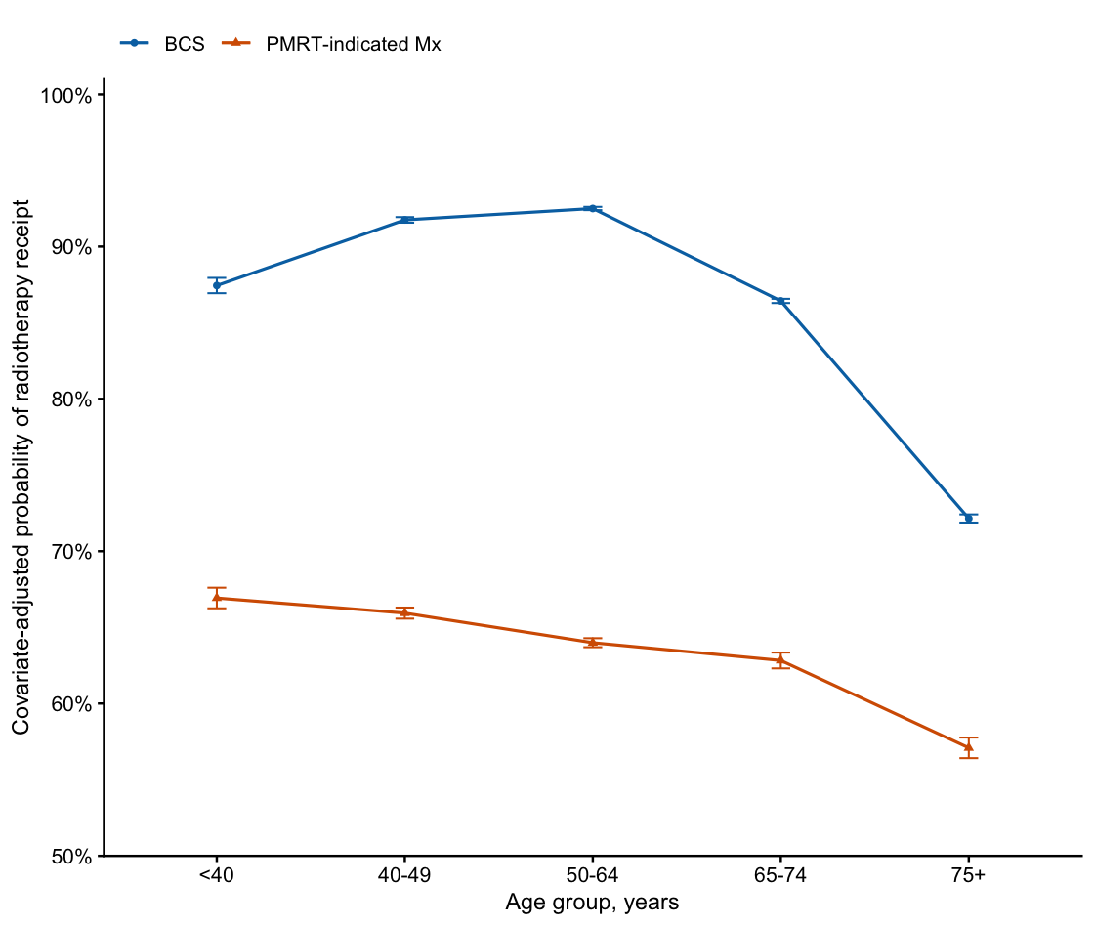
Figure S6. Covariate-adjusted marginal probabilities of radiotherapy receipt by age group. Marginal probabilities were estimated using multivariable logistic regressions for the BCS and PMRT-indicated cohorts, standardized over each cohort’s empirical cohort distribution. Models adjusted for race/ethnicity, tumor size, number of positive lymph nodes, histology, tumor grade, lymphovascular invasion, breast cancer receptor, Charlson-Deyo score, year of diagnosis group, urban/rural status, region, facility level, insurance, income, distance from home to treatment facility, chemotherapy use, hormone therapy use, and immunotherapy use. Error bars indicate 95% CI.

