Additional File 4. Collective LOD Analysis of Published Families with Dominant Insulin Resistance Associated with Heterozygous Extracellular INSR Variants

Family Selection and Curation
6 multiplex families (n = 31 individuals) were identified in published literature who were reported to exhibit insulin resistance (IR) inherited as an autosomal dominant trait associated with a heterozygous extracellular (EC) INSR variant (1-6) (Appendix Figure 1). Clinical and biochemical evidence for affectedness was reviewed and adjudicated on for all individuals (Appendix Table 2).
LOD Score Model
Analysis used two-point parametric LOD scores computed per family using a dominant model at the INSR locus, with the rare INSR variant is the marker, summed across families to produce a combined Z(θ) curve. f was defined as the probability that a heterozygous carrier (W/M) was clinically affected (penetrance), and f_p the probability that a non-carrier (W/W) is clinically affected (phenocopy rate). For each individual i, the likelihood under linkage (θ = 0 to 0.5) was computed as the ratio of likelihoods under linkage vs. no linkage:
Z_family(θ) = Σ_i log10[ L_i(θ) / L_i(θ = 0.5)]
where L_i(θ) is the joint probability of the observed genotype and phenotype of individual i given recombination fraction θ. Probands and married-in spouses were excluded from the summation.
In initial calculations f was set by default at 0.85 (i.e. 85% of W/M individuals display clinically detectable IR by adulthood), f_p at 0.001 (i.e. assuming no phenocopies among non-carriers), and θ was tested at 0, 0.01, 0.05, 0.1, 0.2, 0.3, and 0.4. Individuals with uncertain affectedness status were dropped from the likelihood.
Combined LOD and Heterogeneity Test
The combined LOD across families was computed as the sum of per-family LOD scores at each θ. To allow for the possibility that not all families segregate linked variants the admixture (heterogeneity) LOD or HLOD was also computed:
HLOD(θ) = Σ_families log10[ α.10^{Z_family(θ)} + (1 − α) ]
where α is the proportion of families with linked variants. The HLOD is maximised over α in [0, 1] at each θ, and the value α̂ that maximises HLOD is reported.
Joint penetrance × phenocopy sensitivity analysis
The two-point LOD score depends on two parameters not directly identifiable from the pedigree data, namely carrier penetrance f and the phenocopy rate f_p (the probability that a non-carrier is scored as affected). To test whether the primary result was an artefact of a single, arbitrarily chosen (f, f_p) pair, we performed two-dimensional sensitivity analysis, evaluating the combined LOD score at recombination fraction θ = 0 over a 7×7 grid defined by
f ∈ {0.50, 0.60, 0.70, 0.80, 0.85, 0.90, 0.95}
f_p ∈ {0.001, 0.01, 0.02, 0.05, 0.10, 0.15, 0.20}
The point (f, f_p) = (0.85, 0.001) was the reference cell corresponding to parameters in the primary analysis. For each cell the per-family log₁₀-likelihood ratio under a dominant model with the INSR mutation as the marker was computed, and summed over the 6 families to obtain Z_{combined}(f, f_p) at θ=0. The same implementation in the primary analysis was applied without modification.
Because Z_{combined} is a monotonically decreasing function of f_p at fixed f, for each f we located the phenocopy rate at which the combined LOD crosses the genome-wide significance threshold (Z = 3.3) and the suggestive-linkage threshold (Z = 3.0) by univariate bisection on f_p. Root-finding used Brent's method (scipy.optimize.brentq) on the interval [10⁻⁶, 0.499] with absolute tolerance x_{tol} = 10⁻⁶. The two crossing points are reported per f in the threshold-crossings table and, at the reference penetrance f = 0.85, correspond to f_p = 0.155 (Z = 3.3) and 0.201 (Z = 3.0). All computations were performed in Python.

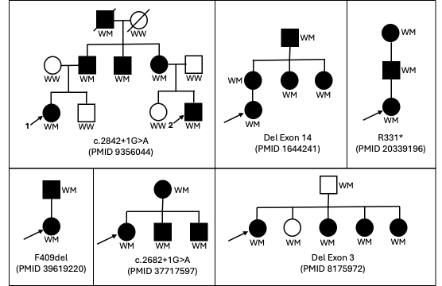
Appendix Figure 1. Six published INSR families with rare heterozygous extracellular variants. Square = male, circle = female, filled = clinically affected, open = unaffected, arrow = proband, diagonal slash = deceased, W = wild-type allele, M = mutant allele. In the first kindred the two probands are numbered 1 and 2.

Results
All variants in the families reported were predicted loss-of-function EC variants, including three exon-skipping splice or deletion alleles, one nonsense allele, one missense in-frame deletion, and one canonical splice-site variant (Appendix Figure 1).
Affectedness basis
Appendix Table 1 documents the basis on which each non-proband individual was classified as affected or unaffected, based on the underlying source publications. Of note, the reported “unaffected” label was retained for the variant-carrying father in the family with exon 3 deletion, although in fact his fasting plasma insulin exceeded the Fenland-derived sex- and BMI-specific 95th centile. The “unaffected” designation is thus arguable.
LOD score analysis
Appendix Table 2 shows the per-family two-point LOD scores for each of seven θ values from 0 to 0.4, the per-family Z_max, and the θ at which Z_max was attained. Because the INSR variants themselves are the markers, the only biological meaningful θ in this analysis is θ = 0 — in other words, as the marker and disease locus are the same, no recombination between them is physically possible. The θ > 0 columns of the LOD table are retained only to demonstrate curve shape (confirming that the maximum sits at θ = 0 in each informative family).
The family with the exon 3 deletion (5) yielded a slightly negative LOD at θ = 0 as 2 of the 6 carriers (father and one sister) were reported unaffected, which under the f = 0.85 model is mildly improbable; the family becomes weakly positive at θ ≥ 0.1. Were the father to be designated affected, then the family becomes positive at every value of θ in the tabulated range (Z = +0.62 at θ = 0, rising to Z_max ≈ +0.64 at θ ≈ 0.06 and remaining positive out to θ = 0.499), shifting its peak evidence from a broad, weak maximum at θ ≈ 0.29 (Z_max ≈ 0.13) to a much sharper peak near the disease locus. The 0.88 unit gain propagates into the combined statistic (Z_combined 4.42 → 5.31) and roughly doubles the family's phenocopy tolerance in the joint sensitivity analysis described below.
Given default assumptions of 85% penetrance (f = 0.85) and the probability of a phenocopy of 0.1% (f_p = 0.001), the maximum sum of the per family LOD scores was 4.663 at a θ of 0, and remained comfortably above the conventional significance threshold for linage of 3.3 at all tested values of θ up to 0.3. Moreover the heterogeneity-corrected admixture LOD (HLOD) was nearly identical at all θ values, with α̂ = 0.999, indicating that the maximum-likelihood estimator favours essentially complete homogeneity (i.e., all 6 families segregate linked variants). This is consistent with the prior knowledge that all 6 families are reported as harbouring rare loss-of-function variants in the EC domain.
Joint penetrance × phenocopy sensitivity analysis
We then conducted analysis of the sensitivity of the combined LOD score to difference levels of penetrance (f) and phenocopy rate (f_p), the latter likely to be particularly important for the phenotype of IR given the wide range of insulin sensitivity seen in the general population. The grid generated by the joint sensitivity analysis is shown as a heatmap in Appendix Figure 2. The analysis showed that the significance of the combined LOD score was robust to a wide range of penetrance and phenocopy rates. Thus, even at a phenocopy rate as high as 15%, the combined LOD score exceeded 3.3 for a range of penetrance values between 0.6 and 0.85. This makes it very unlikely that the significant combined LOD score is attributable to population background rates of IR, or to false assumptions about penetrance.

Reference | Individual | Classification | Basis for affection status
(5) | Father (W/M) | Unaffected* | Reported normal glucose tolerance; BMI 25 kg/m^2, FPI 90 pmol/l at 48 years old (> 95% in Fenland)
(5) | Sister 1 (W/M) | Unaffected | pre-pubertal (age 6); BMI 27 kg/m^2; FPI 774 pmol/L; 12 years old (>> 95th centile in NHANES)
(5) | Sister 2 (W/M) | Affected | Type A IR, AN; BMI 30 kg/m^2; FPI 372 pmol/L; 18 years old (>> 95th centile in NHANES)
(5) | Sister 3 (W/M) | Affected | Type A IR, AN; BMI 32 kg/m^2; FPI 774 pmol/L; 20 years old (>> 95% in NHANES and Fenland)
(5) | Sister 4 (W/M) | Affected | Type A IR; BMI 29 kg/m^2; FPI 366 pmol/L; 23 years old (>> 95% in Fenland)
(6) | Grandfather (W/M) | Affected | DM (deceased)
(6) | Grandmother (W/W) | Excluded | Uncertain status
(6) | Father of proband 1 (W/M) | Affected | 39 years old; BMI 25.1 kg/m^2; OGTT insulin at 0 and 120 mins: 150 and 1810 pmol/L respectively
(6) | Uncle (W/M) | Affected | IR/DM at 41 years old; BMI 21.3 kg/m^2; OGTT insulin at 0 and 120 mins: 180 and 1,010 pmol/L respectively
(6) | Mother of proband 2 (W/M) | Affected | DM with HA at 35 years old; BMI 23.9 kg/m^2; OGTT insulin at 0 and 120 mins: 300 and 830 pmol/L respectively PCPI 830 pmol/L
(6) | Brother of proband 1 (W/W) | Unaffected | 14 years old; BMI 17.6 kg/m^2; OGTT insulin at 0 and 120 mins: 55 and 270 pmol/L respectively
(6) | Sister of proband 2 (W/W) | Unaffected | 13 years old; BMI 20.7 kg/m^2; OGTT insulin at 0 and 120 mins: 120 and 325 pmol/L respectively
(7) | Mother (W/M) | Affected | 41 years old; BMI 23.4 kg/m^2; OGTT insulin at 0 and 120 mins: 93 and 531 pmol/L respectively (both >95th centile in Fenland)
(7) | Aunt 1 (W/M) | Affected | 40 years old; BMI 23.3 kg/m^2; 101/826 (both >95th centile in Fenland)
(7) | Aunt 2 (W/M) | Affected | 39 years old; BMI 23.6 kg/m^2; 72/768 (both >95th centile in Fenland)
(7) | Grandfather (W/M) | Affected | 65 years old; BMI 21.4 kg/m^2; OGTT insulin at 0 and 120 mins: 29 and 435 pmol/L respectively (120 min value >95th centile in Fenland)
(3) | Father (W/M) | Affected | 40 years old; BMI 21.8 kg/m^2; OGTT insulin at 0 and 120 mins: 70 and 767 pmol/L respectively (both >95th centile in Fenland); raised Insulin:C-peptide molar ratio
(3) | Grandmother (W/M) | Affected | 66 years old; BMI 21.6 kg/m^2; DM for many years; FPI 209 pmol/L; raised Insulin:C-peptide molar ratio
(2) | Mother (W/M) | Affected | 41 years old; BMI 23.4 kg/m^2, FPI 98 pmol/L (>95th centile in Fenland)
(2) | Brother1 (W/M) | Affected | 9 years old; BMI 25.4 kg/m^2, FPI 250 pmol/L (>>95th centile in IDEFICS)
(2) | Brother2 (W/M) | Affected | 7 years old; BMI 23.4 kg/m^2, FPI 180 pmol/L (>>95th centile in IDEFICS)
(1) | Father (W/M) | Affected | IR and DM (qualitative report)
Supplementary Appendix Table 1. Evidence for Affectedness of Family Members Assessed. Italicised rows are excluded from the LOD computation as married-in spouses or individuals with uncertain phenotype in the source information. BMI = Body Mass Index; FPI = Fasting Plasma Insulin; OGTT = oral glucose tolerance test; DM = diabetes mellitus; IR = insulin resistance; HA = hyperandrogenism; *The “unaffected” label from the original publication is preserved for this individual, though in fact the fasting plasma insulin exceeds the Fenland-derived sex- and BMI-specific 95% centile. This is thus a conservative assessment,

Reference | θ=0 | θ=0.01 | θ=0.05 | θ=0.1 | θ=0.2 | θ=0.3 | θ=0.4 | Z_max | θ_max
(5) | -0.265 | -0.230 | -0.115 | -0.012 | 0.102 | 0.133 | 0.098 | 0.133 | 0.30
(6) | 1.923 | 1.894 | 1.777 | 1.624 | 1.293 | 0.921 | 0.496 | 1.923 | 0.00
(4) | 1.202 | 1.185 | 1.113 | 1.019 | 0.815 | 0.583 | 0.316 | 1.202 | 0.00
(3) | 0.601 | 0.592 | 0.556 | 0.510 | 0.407 | 0.292 | 0.158 | 0.601 | 0.00
(2) | 0.902 | 0.888 | 0.835 | 0.764 | 0.611 | 0.438 | 0.237 | 0.902 | 0.00
(1) | 0.300 | 0.296 | 0.278 | 0.255 | 0.204 | 0.146 | 0.079 | 0.300 | 0.00
SUM | 4.663 | 4.626 | 4.445 | 4.160 | 3.433 | 2.512 | 1.384 | 4.663 | 0.00
Supplementary Appendix Table 2. Per-family two-point LOD scores Z(θ). f was set to 0.85, and phenocopy rate to 0.001. The bottom row is the sum across families.

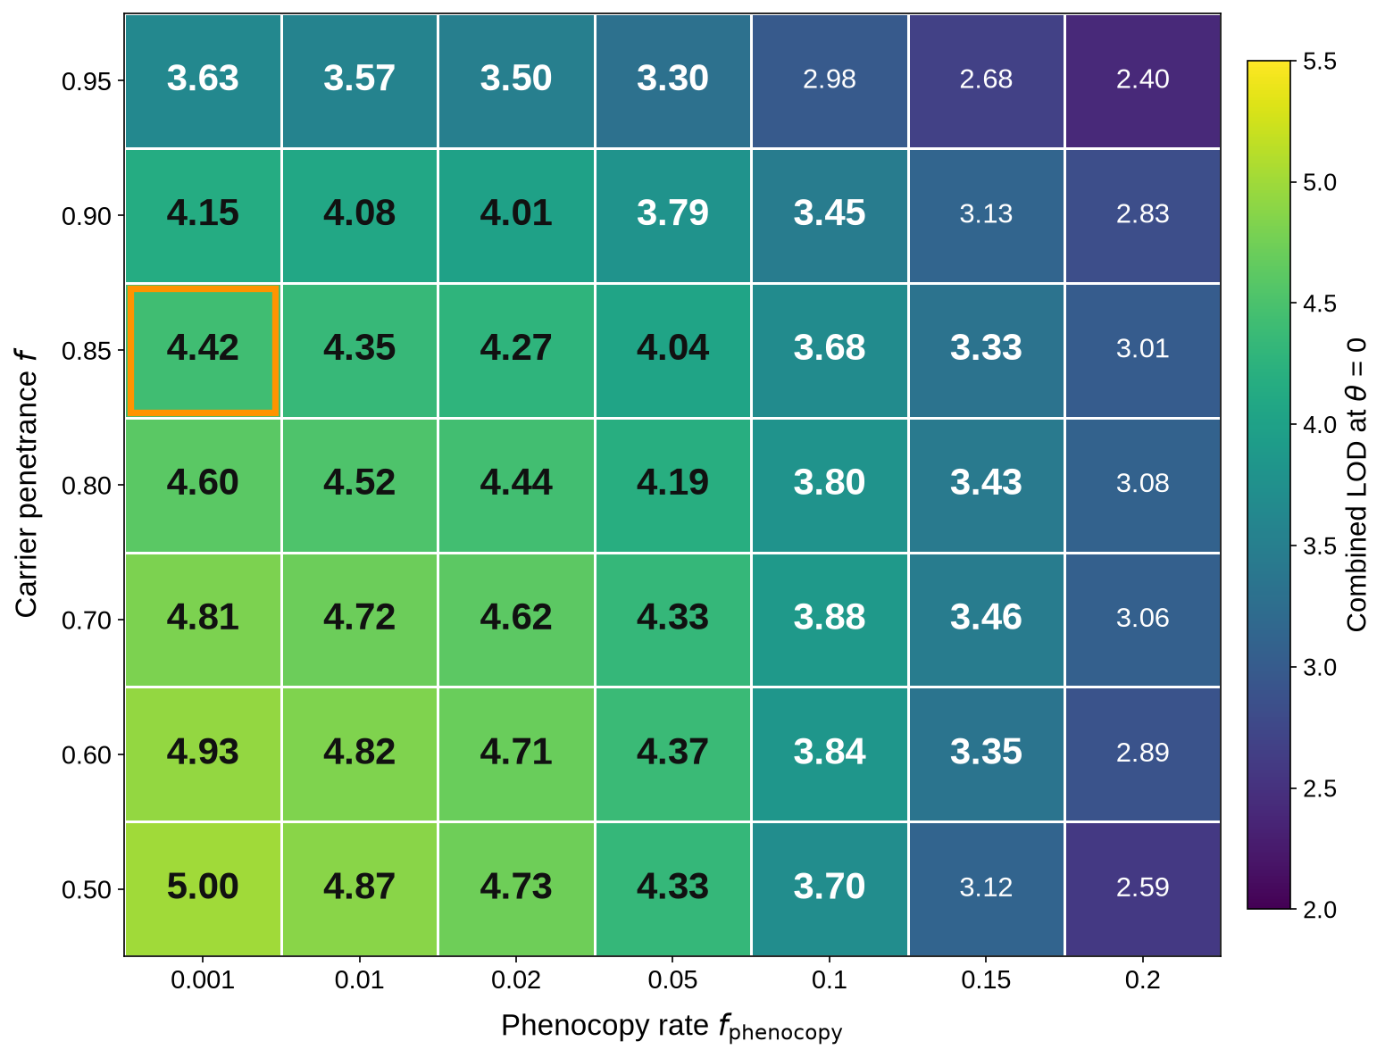
Supplementary Appendix Figure 2. Heatmap showing results of combined penetrance and phenocopy sensitivity analysis. Cells whose combined Z rounds to ≥ 3.30 at two decimal places are emphasised in bold

Supplementary References
1. Song Y, Lei W, Huang Q, Zhang J, Zhang Q, Chen L, et al. A New Heterozygous Variant of c.1225_1227delTTC (p.Phe409del) in Insulin Receptor Gene Associated with Severe Insulin Resistance and Hyperandrogenemia in an Adolescent Female with Type A Severe Insulin Resistance Syndrome. Diabetes, metabolic syndrome and obesity : targets and therapy. 2024;17:4389-96.
2. Calcaterra V, Zuccotti G, Mari A, Iafusco F, Maione G, Iafusco D, et al. Can obesity exacerbate hyperinsulinaemia in the presence of the mutation of an insulin receptor gene? Clinical obesity. 2023;13(6):e12619.
3. Takahashi I, Yamada Y, Kadowaki H, Horikoshi M, Kadowaki T, Narita T, et al. Phenotypical variety of insulin resistance in a family with a novel mutation of the insulin receptor gene. Endocrine journal. 2010;57(6):509-16.
4. Shimada F, Suzuki Y, Taira M, Hashimoto N, Nozaki O, Makino H, et al. Abnormal messenger ribonucleic acid (mRNA) transcribed from a mutant insulin receptor gene in a patient with type A insulin resistance. Diabetologia. 1992;35(7):639-44.
5. Wertheimer E, Litvin Y, Ebstein RP, Bennet ER, Barbetti F, Accili D, et al. Deletion of exon 3 of the insulin receptor gene in a kindred with a familial form of insulin resistance. The Journal of clinical endocrinology and metabolism. 1994;78(5):1153-8.
6. Magré J, Karayanni C, Hadjiathanasiou CG, Desbois-Mouthon C, Meier M, Vigouroux C, et al. Dominant transmission of insulin resistance in a type A family resulting from a heterozygous nonsense mutation in the insulin receptor gene and associated with decreased mRNA level and insulin binding sites. Diabetes. 1997;46(11):1901-3.
7. Shimada F, Taira M, Suzuki Y, Hashimoto N, Nozaki O, Taira M, et al. Insulin-resistant diabetes associated with partial deletion of insulin-receptor gene. Lancet (London, England). 1990;335(8699):1179-81.

