Supplementary Information
Preparation of dual Z-scheme Bi₂MoO₆/ZnSnO₃/ZnO heterostructure photocatalyst for efficient visible light degradation of organic pollutants
Journal of Inorganic and Organometallic Polymers and Materials
Yuanyingxue Gaoª Li Li^{a, b*} Wenlin Zuª Yingru Sunª Jiahui Guan^{b} Yanzhen Caoª
Haixia Yuª Wenzhi Zhang^{a*}
ªCollege of Chemistry and Chemical Engineering, Qiqihar University, Qiqihar 161006, PR China
^{b}College of Materials Science and Engineering, Qiqihar University, Qiqihar 161006, PR China

Experimental sections
Chemical reagent
All the chemicals needed in this experiment were analytical reagents and were used directly without further purification. Bismuth pentahydrate, zinc acetate, sodium molybdate, tin chloride, and sodium hydroxide were purchased from Tianjin Kaitong Chemical Reagent Co., Ltd. Isopropyl alcohol (IPA), benzoquinone (BQ), ethylenediaminetetraacetic acid disodium (EDTA-2Na), congo red (CR), methyl orange (MO), methylene blue (MB), crystal violet (CV) and tetracycline hydrochloride (TC) were purchased from Tianjin Guangfu Fine Chemical Research Institute. Ethylene glycol and absolute ethanol were purchased from Kaitong Chemical Reagent Co. Ltd., Tianjin, China. Sodium sulfide was purchased from New Jersey. The water used for the experiments was deionized water.
Preparation of Bi₂MoO₆/ZnSnO₃/ZnO composite
Synthesis of ZnO: An amount of zinc acetate was added to 60 mL deionized water and stirred for 30 min to dissolve it completely. A total of 2.4 g of sodium hydroxide was added and stirred for 10 min. The synthesis was carried out in a Teflon reactor. The reaction temperature was 160 ℃, and the reaction time was 11 h. The product was washed several times with deionized water and ethanol, followed by drying at 60 °C for 12 h to obtain pure ZnO.
Synthesis of ZnSnO₃/ZnO: Certain amounts of tin chloride and zinc acetate were dissolved in 30 mL deionized water and stirred for 15 min, and then the two solutions were mixed. Afterward, 30 mL (0.2 M) NaOH solution was added. After complete dissolution, the mixed solution was transferred into a Teflon autoclave and heated at 130 ℃ for 6 h. The product was washed several times with deionized water and ethanol, followed by drying at 60 °C for 12 h to obtain ZnSnO₃/ZnO.
Synthesis of Bi₂MoO₆/ZnSnO₃/ZnO composite: A certain amount of bismuth nitrate pentahydrate and sodium molybdate were dissolved in 20 mL of ethylene glycol, and ZnSnO₃/ZnO was further dissolved in 10 mL ethylene glycol; the two solutions were mixed after stirring well. After complete dissolution, the mixed solution was poured into a Teflon autoclave and heated in an oven at 160 °C for 6 h. The product was washed several times with deionized water and ethanol, followed by drying at 60 °C for 12 h to obtain the Bi₂MoO₆/ZnSnO₃/ZnO composite.
Characterization
The X-ray diffraction (XRD) analysis of the sample used a German Bruker-AXS (D8) X-ray diffractometer (Cu target Ka radiation (λ=0.15406 nm), tube voltage 60 kV, tube current 80 mA, scanning range 10°–90°). XPS determination of the materials was performed using a VG-ADES400 X-ray photoelectron spectrometer (Mg K-ADES original residual gas pressure was less than 10⁻⁸ Pa). SEM-EDS analysis of the sample was performed using a Hitachi S-4700 scanning electron microscope, the working voltage of 5 kV. The specific surface area and pore size of the material were determined by using a model 3H-2000 instrument and pore size analyzer (Beijing Beishide Instrument Co., Ltd.). The UV–visible diffuse reflectance absorption spectroscopy (UV–vis/DRS) of the sample was carried out on a TU-1901 ultraviolet visible dual-beam spectrophotometer (integral sphere) manufactured by Beijing General Analysis Co., Ltd. The transmission electron microscopy and high-resolution transmission electron microscopy (TEM and HR-TEM) of the sample were performed using Hitachi H-7650 from Hitachi, Japan and JEM-2100F of JEOL of JEOL (acceleration voltage of 200 kV). The photoluminescence (PL) of the sample was tested by a model F-7000 photoluminescence spectrometer (Hitachi, Japan). Electrochemical impedance tests and transient photocurrent response tests were carried out using a photoelectrochemical test system of PEC-1000 model manufactured by Beijing Pofila company.
Photocatalytic performance experiments
(1) Multi-mode photocatalytic degradation experiments:
The photocatalytic activities of different samples were evaluated under UV, visible, and simulated sunlight irradiation with crystal violet dye as the main model molecule. A 125 W high-pressure mercury lamp (at 313 nm from the main emission line) was used as the UV light source, a 400 W xenon lamp as the visible light source (maximum emission wavelength over 410 nm), and a 1000 W xenon lamp as the simulated daily light source (main emission wavelength close to the solar spectrum). In the photocatalytic experiments, the photocatalytic activities of the samples were determined by the concentration change of crystal violet (CV) aqueous solution (50 mg L⁻¹). The catalysts used were uniformly 0.15 g under multimodal light, and the samples were uniformly dissolved in 90 mL of the reaction solution. The maximum absorbance values of dye and tetracycline hydrochloride were measured by a TU-1901 double beam UV–vis spectrophotometer.
(2) Trapping experiments:
Various capture agents were used to capture the active species during the reaction to determine the possible reaction mechanism. The operation steps were consistent with the photocatalytic performance study, and the captured agents added were ethylenediaminetetraacetic acid disodium (EDTA-2Na), p-benzoquinone (BQ), and isopropanol alcohol (IPA).

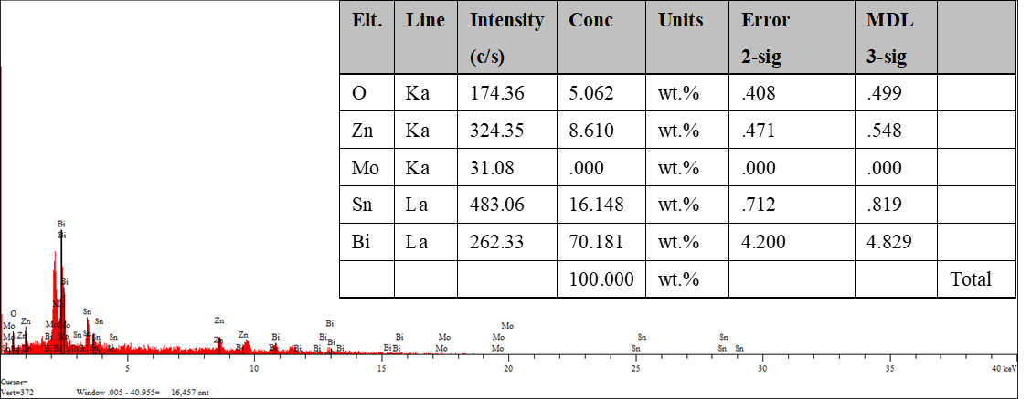
Fig S1 EDS of each element in the composite.

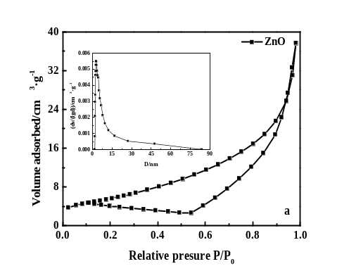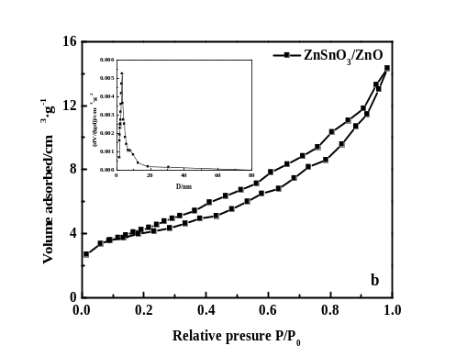
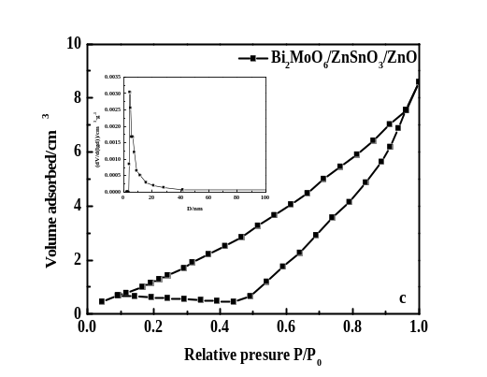
Fig S2 N₂ adsorption–desorption isotherms of (a) pure ZnO, (b) ZnSnO₃/ZnO, (c) Bi₂MoO₆/ZnSnO₃/ZnO (The illustration is the pore size distribution curve).

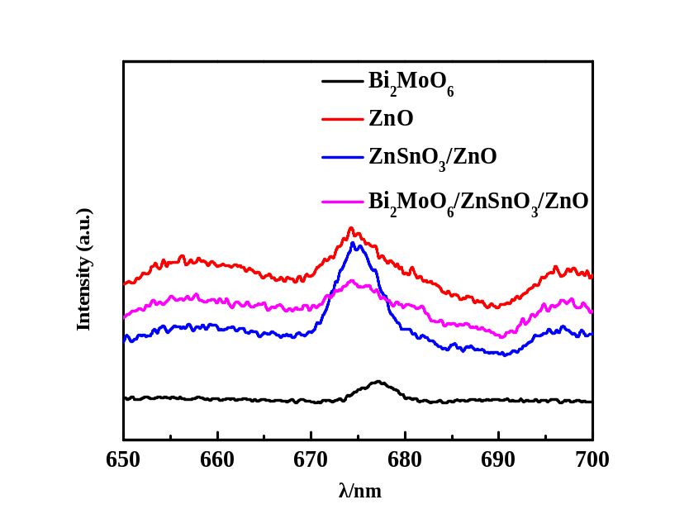
Fig S3 Photoluminescence spectra of different samples (excitation: 500 nm).

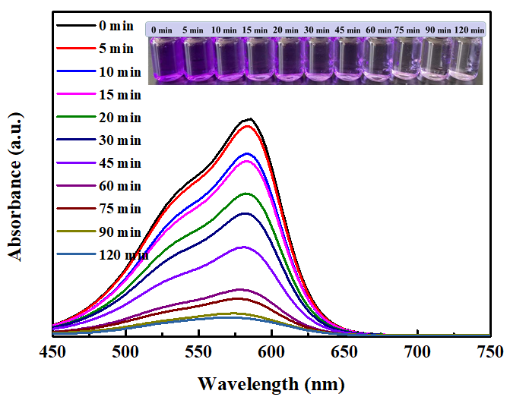
Fig S4 The UV–vis absorbance spectra of CV at different degradation times with 0.15 g Bi₂MoO₆/ZnSnO₃/ZnO (Inset: photographs of CV are degraded at different times; the initial concentration of CV is 50 mg·L⁻¹).

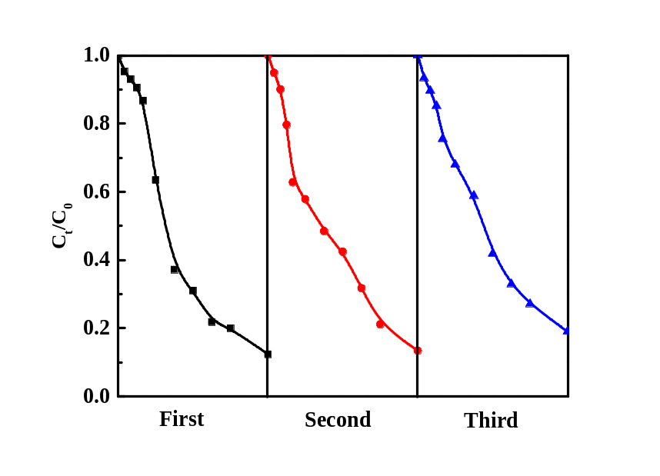
Fig S5 Cyclic experimental results of Bi₂MoO₆/ZnSnO₃/ZnO composite
under UV light irradiation.

Table S1 The BET specific surface area (S_{BET}), average pore diameter and pore volume
of different samples.
Sample | S_{BET}/(m²·g^{–1}) | D/nm | V_{total}/(cm³·g^{–1})
ZnO | 7.24 | 2.9 | 0.0143
ZnSnO₃/ZnO | 15.58 | 3.2 | 0.0216
Bi₂MoO₆/ZnSnO₃/ZnO | 21.03 | 4.23 | 0.0633

Table S2 The chemical names, chemical structures and m/z values of
de-methylated intermediates of CV.
Chemical name | Structure | m/z
Crystal violet | 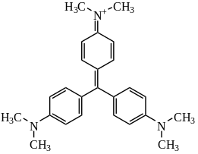 | 372
N-(4-(4-(dimethylamino) phenyl) methylene) cyclohexanone-2,5-diethylenetriamine-1-ylidene) | 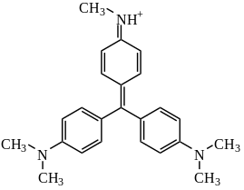 | 358
N-((1z, 4z) 4-(dimethylamino) phenyl) (4-methylamino) phenyl) methylene) cyclohexanone-2,5-diethylenetriamine-1-ylidene | 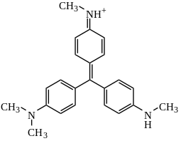 | 344
N-((1z, 4z) 4-(dimethylamino) phenyl) (4-methylamino) phenyl) methylene) cyclohexanone-2,5-diethylenetriamine-1-ylidene | 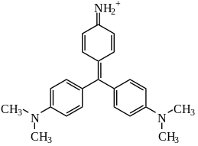 | 344
4-(4-(dimethylamino) phenyl) methylene) cyclohexanone-2,5-diethylenetriamine-1-imine ion | 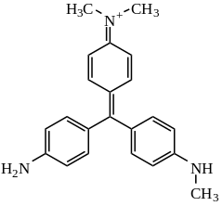 | 330
N-(4-((4-aminobenzene) (4-(methylamino) phenyl) methylene) cyclohexanone-2,5-diethylenetriamine-1-subunit)-N | 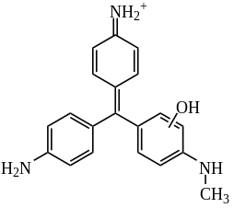 | 318

Appendix Table S2
Chemical name | Structure | m/z
4-(diphenylmethylene) cyclohexanone-2,5-diethylenetriamine-1-imine ion | 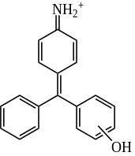 | 274
Terephthalic acid | 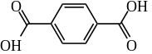 | 166
Benzoic acid | 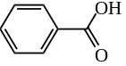 | 122

﹡Corresponding author: Li Li, Female, Ph.D., Professor, Doctoral tutor, mainly engaged in the preparation and photocatalytic properties of nanocomposites, +86 0452-2738867. E-mail: qqhrll@163.com; qqhrlili@126.com (L. Li).

