Supplementary Information

Supplementary Methods S1: Prognosis-locked AAL-axis replication
This analysis was predefined as an exploratory clinical relevance supplement. Its purpose was to test whether the cross-modal coupling patterns identified in the MCS–UWS clinical-state contrast could differentiate three-month clinical outcome within the same cohort. Because the prognosis analysis was not used to select or redefine ROIs, nodes, or directional hypotheses, null or directionally inconsistent results retain interpretive value.
Node selection (locked before prognosis evaluation): Three nodes were selected based on the original MCS–UWS clinical-state contrast and prior GM/LOO robustness evidence: (i) right inferior parietal lobule (IPL), PET–ReHo, original MCS–UWS direction MCS > UWS, prognosis hypothesis Good > Poor; (ii) left middle/superior occipital, PET–ReHo, original direction UWS > MCS, prognosis hypothesis Good < Poor; (iii) right postcentral/precentral (sensorimotor), PET–fALFF, original direction UWS > MCS, prognosis hypothesis Good < Poor. Primary ROIs were defined using AAL3v2 cortical regions. The original GM/LOO-supported clusters were retained as spatially restricted sensitivity regions for secondary analysis.
Outcome definition: Good outcome was defined as a ≥3-point CRS-R increase from baseline to three-month follow-up, or a shift from UWS to MCS. Poor outcome comprised all remaining patients. Final counts: good = 12, poor = 17.
Statistical analysis: At each voxel, across-subject Spearman rank correlation was computed separately within the good-outcome and poor-outcome groups. Group differences were quantified using Fisher z-transformed correlation differences. The ROI summary statistic was the unthresholded mean z-difference across voxels within the ROI. Each node was oriented so that positive values indicated the same direction as the original MCS–UWS result. Node effects were standardized against clinical-state-stratified permutation null distributions (10,000 permutations). The three-node axis was computed as the equal-weight average of the standardized node effects. Node inference used two-sided max-T correction across the three locked nodes. Axis inference used two-sided empirical p values against the permutation null.
Boundary conditions: (i) This is a same-cohort exploratory replication, not an independent external replication. (ii) ROIs, node signs, and thresholds were locked before prognosis evaluation. (iii) Uncorrected trends do not substitute for max-T corrected node p values or axis permutation p values. (iv) Original-cluster results indicate local spatial sensitivity only; AAL results address whether the broader mechanistic axis generalizes to prognosis.

Supplementary Results S1: Prognosis-locked AAL-axis replication
Primary AAL axis: The standardized three-node AAL axis effect was −0.08 (stratified permutation p = 0.860, two-sided), indicating no association with three-month outcome.
Node-level results (AAL regions): Right IPL (PET–ReHo): standardized effect = +1.144, uncorrected p = 0.260, max-T corrected p = 0.593, direction consistent = yes, LOO retention = 100.0%. Left occipital (PET–ReHo): standardized effect = −0.775, uncorrected p = 0.454, max-T corrected p = 0.826, direction consistent = no, LOO retention = 0.0%. Right sensorimotor (PET–fALFF): standardized effect = −0.601, uncorrected p = 0.564, max-T corrected p = 0.915, direction consistent = no, LOO retention = 3.4%.
Sensitivity analyses: Original-cluster axis: effect = −0.28, p = 0.644. Region-mean AAL axis: p = 0.850. Region-mean cluster axis: p = 0.758.
Interpretation: The null prognosis result supports the pre-specified interpretation that clinical state (MCS versus UWS) and short-term recovery trajectory (good versus poor outcome) may reflect partly dissociable statistical dimensions of metabolic–functional organization in this cohort.
Supplementary Methods S2: Locked-ROI prognostic models, prognosis-group replication, and continuous CRS-R interaction
Three-month outcome was defined using a locked composite rule. Participants were classified as having a favorable outcome if the CRS-R total score increased by at least 3 points or if the source clinical state changed from UWS at baseline to MCS at follow-up (n = 12); the remaining participants were classified as having an unfavorable outcome (n = 17). Exact follow-up dates were not available in the source records; the 90 ± 30-day timing criterion could therefore not be verified, and the assessment is described as nominally 3 months. The single discordant baseline clinical-state label (sub-pDOC005) was excluded in a sensitivity analysis.
Three nested ROI sets were fixed before examining outcome: right inferior parietal lobule PET–ReHo (tier 1); tier 1 plus left middle/superior occipital PET–ReHo (tier 2); and tier 2 plus right postcentral/precentral PET–fALFF (tier 3). Cerebellar, mixed visual–cerebellar, thalamic, and cortical clusters lacking adequate gray-matter support were excluded. For each participant and ROI, spatial Pearson correlation was computed across voxels between the two modality maps and transformed using Fisher’s z. The complete tiered-model, incremental-permutation, bootstrap, and ROI–CRS association workflow was repeated using within-subject spatial Spearman correlation as a metric-definition sensitivity analysis.
Fixed L2-penalized logistic regression models (C = 1) were evaluated by leave-one-out cross-validation, with standardization fitted within each training fold. Models included clinical variables alone (baseline CRS-R and clinical state), locked ROI features alone, clinical plus ROI features, leave-one-ROI-out ablations, and global-coupling comparators. Performance was summarized by ROC AUC, balanced accuracy, sensitivity, specificity, and Brier score. Significance was assessed with 5,000 clinical-state-stratified outcome-label permutations. Incremental ROI value was additionally tested by permuting the locked ROI feature rows within clinical-state strata while retaining clinical predictors. Paired bootstrap resampling (5,000 samples) quantified uncertainty. Associations with baseline CRS-R used Spearman correlation; associations with 3-month and change scores used partial Spearman correlation controlling baseline CRS-R and clinical state; the nine ROI–endpoint tests were corrected using Benjamini–Hochberg FDR.
The original cross-subject Spearman framework was repeated after replacing MCS and UWS with favorable/unfavorable outcome. Within each prognosis group and voxel, Spearman correlation was computed for PET–ReHo, PET–fALFF, and ReHo–fALFF, and group differences were standardized using the difference between Fisher-transformed correlations. Outcome labels were permuted 5,000 times within clinical-state strata, with ranks recomputed within each permuted group. Positive and negative clusters were formed separately using a two-sided p < 0.01 cluster-forming threshold and 26-neighbor connectivity; cluster mass was the sum of absolute standardized statistics, and family-wise error was controlled using the maximum cluster mass from each permutation. The legacy fixed k = 257 display threshold was not used. Original and prognosis clusters were matched one-to-one within modality pair and effect direction using a locked score combining original-cluster overlap (60%), Dice coefficient (25%), and centroid proximity (exp(−distance/20 mm); 15%).
For each modality pair and voxel, rank-transformed data were fitted using Y ~ X + CRS-R + X×CRS-R + covariates. Baseline models controlled baseline clinical state; nominal 3-month and change-score models controlled baseline CRS-R and clinical state. The interaction term tested whether cross-modal coupling varied continuously with CRS-R. Freedman–Lane permutations of reduced-model residuals were performed within clinical-state strata (5,000 permutations). Positive and negative clusters were formed separately at two-sided p < 0.01 and corrected using maximum cluster-mass FWER.
Supplementary Results S2: Locked-ROI outcome analyses
The locked tier-3 ROI model did not show significant prognostic performance (AUC = 0.515, permutation p = 0.295), and adding ROI features to clinical variables was not supported by the clinical-state-stratified feature-permutation test (p = 0.417). Replacing the primary spatial Pearson/Fisher-z metric with within-subject spatial Spearman correlation produced a clinical-plus-tier-3 AUC of 0.456 and an incremental feature-permutation p of 0.279. No ROI–CRS-R association survived Benjamini–Hochberg correction (0/9 tests); the right IPL PET–ReHo coupling showed uncorrected positive associations with nominal 3-month CRS-R (ρ = 0.423, p = 0.028) and CRS-R change (ρ = 0.445, p = 0.020) that did not survive correction. The prognosis-group voxelwise analysis yielded no cluster-mass FWER-significant clusters across the three modality pairs, and the original clinical-state-related clusters showed low spatial overlap under prognosis grouping (Table S5). The continuous CRS-R interaction analyses yielded one FWER-significant cluster across the nine endpoint-by-modality tests: a positive nominal 3-month CRS-R × PET–fALFF interaction (k = 1426 voxels; centroid MNI (−24.5, 6.3, 32.8); cluster-mass FWER p = 0.0070). This cluster overlapped the original left lateral sensorimotor/supramarginal cluster by only 21/430 voxels (4.9%) with a 31.3-mm centroid displacement and is therefore reported as a newly observed exploratory continuous-outcome cluster, not as a replication of the original MCS–UWS clinical-state cluster. All analyses in Sections S1–S2 constitute exploratory internal robustness assessment within the same cohort and do not establish an independently replicated prognostic biomarker.

Supplementary Methods S3: Gray-matter-mask and leave-one-subject-out sensitivity analyses
To test whether tissue-class structure influenced coupling estimates, sensitivity analyses used the same legacy PreparedData PET, ReHo, and fALFF maps as the primary analysis. The SPM12 OldSeg gray-matter probability template was thresholded at 0.10, 0.20, 0.30, and 0.50. In the primary mask-first path, each threshold was intersected with the common valid mask before PET, ReHo, and fALFF were z-standardized within that restricted mask. A companion mask-late path applied each GM mask after common-mask z-standardization. The historical cluster-extent calibration was repeated for each search volume using 10,000 Monte Carlo simulations, 6-mm FWHM smoothness, one-tailed voxel probability 0.025 for each sign, 2-mm voxels, and 6-neighbor connectivity. The resulting mask-specific extents were k ≥ 235, 224, 212, and 178 for GM thresholds 0.10, 0.20, 0.30, and 0.50, respectively; the common-mask calibration (k = 260) closely reproduced the historical k = 257. Baseline GM analyses used 100 label permutations per condition and are interpreted as sensitivity checks rather than confirmatory inference.
Small-sample stability was assessed with 29 leave-one-subject-out reruns. In each rerun, one pDOC participant was removed and voxel-wise MCS and UWS Spearman coupling and standardized Zdiff maps were recomputed. Original and rerun clusters were matched one-to-one within modality pair and direction using overlap, Dice, target purity, and centroid distance. We recorded same-location retention, overlap with the evaluable reference core, extent retention, and displacement. Common-mask LOO stability summaries use all 29 observed reruns; GM-restricted LOO permutation maps used 20 label permutations per rerun to limit computation. These outputs assess sensitivity to individual participants and mask definition; they are not independent corrected significance tests.

Supplementary Results S3: Gray-matter and leave-one-out sensitivity of the exploratory MCS–UWS clinical-state topology
Two complementary analyses evaluated tissue-composition and small-sample sensitivity using the legacy prepared maps (Table S7; Figures S11–S14). Across GM probability thresholds of 0.10, 0.20, 0.30, and 0.50 and both z-standardization pathways, no modality pair yielded FDR- or max-stat/FWER-corrected voxels in the low-permutation GM sensitivity runs. The right inferior parietal and left middle/superior occipital PET–ReHo locations were retained across all GM thresholds and both pathways. The right inferior temporal/occipital PET–ReHo location was retained in most conditions, whereas the left IPL, posterior midline, left lateral sensorimotor/supramarginal, and left fusiform descriptions were GM-sensitive. The right postcentral/precentral PET–fALFF location was retained in most conditions but not at GM ≥ 0.50; the anterior-insula result was pathway-sensitive. Cerebellar, mixed visual–cerebellar, and thalamic/subcortical clusters were interpreted only within their actual anatomical scope. In 29 common-mask leave-one-subject-out reruns, same-location retention was 100.0% for right IPL (median overlap 0.906) and 89.7% for left occipital cortex (median overlap 0.868). Several other clusters were also LOO-stable but failed GM robustness, showing that they were not driven solely by one participant while their focal tissue-specific interpretation remained uncertain. The GM-restricted LOO permutations used a reduced 20 permutations per run and are treated as stability diagnostics, not corrected inferential evidence.

Supplementary Methods S4: From-raw dual-space reprocessing and registration audit
The from-raw branch re-ran preprocessing, registration, ReHo/fALFF estimation, and statistical analysis from the original time series; consequently, differences from the legacy results cannot be attributed to registration alone. The pipeline comprised the following locked gates. (1) Orientation gating: the original NIfTI orientation was retained, and axis-swapped candidates were generated only when physical anatomical overlay failed; header axis codes (e.g., LAS, ASL) were used only as hints, and the final decision was based on three-view anatomical overlap with left/right markers. (2) PET-to-T1: SPM12 normalized mutual information 6-DOF rigid coregistration (sep = [4 2], 12 iterations with tol = 0.02, estimation fwhm = [6 6]); the 6-mm setting was used only for the registration objective function, not for smoothing of result maps. (3) BOLD-to-T1: the primary analysis used the per-subject locked matrices reviewed on 29 July 2026; the re-estimated NMI branches for pDOC002 and pDOC003 served as negative controls. (4) T1-to-MNI: SPM Unified Segmentation normalization of the high-resolution T1 was retained for most participants; a hybrid route—preserving the native SPM PET/BOLD-to-T1 coregistration while replacing only the T1-to-MNI step with full-SyN—was applied to sub-pDOC002, sub-pDOC018, and sub-pDOC027, in whom a global tilt was evident and the full-SyN improvement was anatomically reasonable.
(5) Dual space: forward-MNI outputs supported the common-voxel Figure 1/3-style maps and a comparable Figure S20 analysis; a native-atlas branch projected the ICV/GM/AAL116 atlases onto each participant’s native T1 2-mm grid for global, ROI, and AAL sensitivity analyses and does not replace the voxel-wise maps. (6) Field of view: superior brain regions missing from the native EPI cannot be recovered by normalization; a per-subject valid-support mask was generated, and missing regions were excluded (not zero-filled) from z-scoring and group statistics. (7) Temporal windows: pDOC acquisitions comprised 200 volumes, of which 190 remained after discarding the first 10; clinical reference acquisitions comprised 240 volumes and were locked to the first 200 before discarding the first 10, yielding the same final 190 volumes.

Supplementary Results S4: Registration gate, from-raw statistics, and cluster-position comparison
All 39 participants completed from-raw fMRI preprocessing and dual-space outputs. The combined registration gate rated 22 participants as pass and 17 as pass_with_caution, with no failures. Full-SyN was not uniformly superior: sub-REF005 showed greater global tilt and sub-pDOC020 showed implausible ventricular compression under full-SyN, and both retained SPM normalization. For pDOC002, the locked versus re-estimated BOLD-to-T1 transforms showed an MNI valid-mask Dice of 0.986, ReHo r = 0.990, and fALFF r = 0.977; for pDOC003, mask Dice was 0.982, ReHo r = 0.918, and fALFF r = 0.921. The superior oblique slab boundary persisted under both rigid methods, supporting an origin in the original acquisition coverage boundary rather than recoverable misregistration.
All 17 final validation items passed, indicating complete files, workflows, and statistical outputs rather than positive primary findings. Unimodal reruns yielded 7 PET, 4 ReHo, and 4 fALFF display-level clusters. Whole-brain coupling again did not separate MCS from UWS (PET–ReHo p = 0.337, PET–fALFF p = 0.571, ReHo–fALFF p = 0.300). Voxel-wise coupling yielded 8 PET–ReHo, 3 PET–fALFF, and 2 ReHo–fALFF display-level clusters, with zero FDR-significant and zero max-stat/FWER-significant voxels for all three modality pairs. After excluding six participants with clearly insufficient field of view (n = 23), all three pairs still showed zero FDR- and zero max-stat/FWER-significant voxels. In the GM mask-first analyses, all pairs had zero FDR-significant voxels; PET–ReHo showed a single max-stat/FWER-significant voxel at GM 0.30 and at GM 0.50, which does not constitute stable cluster evidence. The native-AAL branch showed only one parcel (right postcentral, PET–fALFF at GM 0.50) reaching a single-parcel max-stat/FWER p = 0.0406 with FDR q = 0.159, a native/parcel-level sensitivity rather than a voxel-wise replication.
From-raw leave-one-subject-out reruns used 1,000 label permutations per run (the primary maps used 5,000). All 13 from-raw display clusters retained their direction in 100% of the 29 reruns; network-position retention ranged from 55.2% to 100%. Direction retention indicates that the MCS > UWS or UWS > MCS sign did not reverse and does not imply exact spatial reproduction of the original cluster (for example, PET–ReHo cluster 1 showed 55.2% network-position retention with a median peak distance of 36.4 mm, whereas cluster 2 showed 100% retention with a median peak distance of 2 mm). These reruns support that most candidate topologies are not driven by a single participant, but they cannot support exact positional stability of every cluster.
Comparison with the legacy display maps used the same 2-mm MNI grid, two-sided raw p < 0.05, k ≥ 257 voxels, and 6-neighbor connectivity (Table S8; Figures S17–S19). The from-raw rebuild showed partial topological continuity with the legacy display maps but poor exact cluster replication. Seven of 22 legacy clusters had any same-direction voxel overlap with a from-raw cluster, whereas 10 of 13 from-raw clusters overlapped some legacy territory. Only two legacy clusters reached the descriptive strong-overlap criterion of Dice ≥ 0.50. Because the from-raw branch rebuilt preprocessing, feature estimation, registration, masking, and statistics together, these differences cannot be attributed to registration alone. This branch constitutes a same-cohort sensitivity and reproducibility audit, not an external replication.
Table S1. Subject-level Fisher-z whole-brain spatial coupling coefficients underlying Figure S20.
Subject | Group | PET–ReHo | PET–fALFF | ReHo–fALFF
sub-pDOC001 | UWS | 0.090134 | 0.314711 | 0.408415
sub-pDOC002 | UWS | 0.241079 | 0.354099 | 0.592368
sub-pDOC003 | MCS | 0.347686 | 0.354458 | 0.526013
sub-pDOC004 | MCS | 0.265805 | 0.292106 | 0.767214
sub-pDOC005 | UWS | 0.380547 | 0.513735 | 1.084434
sub-pDOC006 | UWS | 0.416809 | 0.403179 | 0.418666
sub-pDOC007 | MCS | 0.502474 | 0.484297 | 0.931888
sub-pDOC008 | UWS | 0.513857 | 0.499143 | 0.871010
sub-pDOC009 | UWS | 0.122653 | 0.102349 | 1.054211
sub-pDOC010 | MCS | 0.374452 | 0.457216 | 0.548711
sub-pDOC011 | MCS | 0.485567 | 0.291805 | 0.608504
sub-pDOC012 | MCS | 0.496098 | 0.338309 | 0.747455
sub-pDOC013 | MCS | 0.433281 | 0.390771 | 0.666351
sub-pDOC014 | UWS | 0.271822 | 0.178242 | 0.994982
sub-pDOC015 | UWS | 0.153396 | 0.277498 | 0.692988
sub-pDOC016 | UWS | 0.125609 | 0.475680 | 0.413371
sub-pDOC017 | MCS | -0.025551 | 0.224430 | 0.667256
sub-pDOC018 | UWS | 0.388575 | 0.353071 | 0.757704
sub-pDOC019 | UWS | 0.427563 | 0.238572 | 0.881353
sub-pDOC020 | UWS | 0.583143 | 0.517781 | 1.388972
sub-pDOC021 | UWS | 0.679648 | 0.584730 | 1.308697
sub-pDOC022 | UWS | 0.579615 | 0.681027 | 0.994624
sub-pDOC023 | MCS | 0.416353 | 0.495277 | 0.485159
sub-pDOC024 | MCS | 0.133291 | 0.144621 | 0.752728
sub-pDOC025 | UWS | 0.223728 | 0.188709 | 0.978074
sub-pDOC026 | UWS | 0.286667 | 0.386036 | 0.696427
sub-pDOC027 | MCS | 0.106121 | 0.229522 | 0.663738
sub-pDOC028 | MCS | 0.419811 | 0.564297 | 1.087068
sub-pDOC029 | UWS | 0.480292 | 0.402930 | 0.420017
sub-REF001 | clinical reference | 0.586256 | 0.459059 | 0.896110
sub-REF002 | clinical reference | 0.435178 | 0.576027 | 0.818275
sub-REF003 | clinical reference | 0.173944 | 0.276378 | 0.708493
sub-REF004 | clinical reference | 0.657897 | 0.571345 | 1.179143
sub-REF005 | clinical reference | 0.112282 | 0.351756 | 0.727335
sub-REF006 | clinical reference | 0.838030 | 0.781319 | 1.403066
sub-REF007 | clinical reference | 0.504268 | 0.607425 | 1.033229
sub-REF008 | clinical reference | 0.760188 | 0.658181 | 1.160861
sub-REF009 | clinical reference | 0.359620 | 0.311031 | 0.572209
sub-REF010 | clinical reference | 0.292973 | 0.420399 | 0.514957
Table S2. Locked tiered regions of interest for outcome analyses.
Tier | ROI | Modality pair | Original cluster | Voxels | Location
1 | roi01_right_ipl_pet_reho | PET–ReHo | #1 | 500 | Right inferior parietal lobule (IPL)
2 | roi07_left_occipital_pet_reho | PET–ReHo | #7 | 438 | Left middle / superior occipital gyrus
3 | roi12_right_sensorimotor_pet_falff | PET–fALFF | #12 | 376 | Right postcentral / precentral gyrus
Table S3. Leave-one-out cross-validated prognostic model performance (5,000 clinical-state-stratified permutations; 5,000 paired bootstrap samples).
Model | AUC | Balanced accuracy | Sensitivity | Specificity | Brier score | Permutation p (AUC)
Clinical base | 0.294 | 0.324 | 0.000 | 0.647 | 0.286 | 0.610
ROI tier 1 | 0.338 | 0.441 | 0.000 | 0.882 | 0.274 | 0.474
ROI tier 2 | 0.235 | 0.412 | 0.000 | 0.824 | 0.295 | 0.742
ROI tier 3 | 0.515 | 0.520 | 0.333 | 0.706 | 0.278 | 0.295
Clinical plus ROI tier 3 | 0.387 | 0.490 | 0.333 | 0.647 | 0.308 | 0.567
Global coupling only | 0.539 | 0.490 | 0.333 | 0.647 | 0.267 | 0.246
Clinical plus global coupling | 0.446 | 0.449 | 0.250 | 0.647 | 0.304 | 0.417
Table S4. Associations between locked-ROI spatial coupling and CRS-R endpoints (nine tests corrected by Benjamini–Hochberg FDR).
ROI | Endpoint | Analysis | ρ | 95% CI | p | BH-FDR q
Right IPL PET–ReHo | Baseline CRS-R | Spearman | 0.312 | [−0.098, 0.657] | 0.0991 | 0.2230
Right IPL PET–ReHo | 3-month CRS-R | Partial Spearman | 0.423 | [0.002, 0.741] | 0.0278 | 0.0834
Right IPL PET–ReHo | Δ CRS-R | Partial Spearman | 0.445 | [0.010, 0.730] | 0.0200 | 0.0834
Left occipital PET–ReHo | Baseline CRS-R | Spearman | −0.088 | [−0.440, 0.324] | 0.6509 | 0.8369
Left occipital PET–ReHo | 3-month CRS-R | Partial Spearman | −0.050 | [−0.422, 0.326] | 0.8061 | 0.8726
Left occipital PET–ReHo | Δ CRS-R | Partial Spearman | 0.032 | [−0.314, 0.387] | 0.8726 | 0.8726
Right sensorimotor PET–fALFF | Baseline CRS-R | Spearman | −0.486 | [−0.751, −0.080] | 0.0075 | 0.0677
Right sensorimotor PET–fALFF | 3-month CRS-R | Partial Spearman | 0.236 | [−0.156, 0.584] | 0.2357 | 0.3536
Right sensorimotor PET–fALFF | Δ CRS-R | Partial Spearman | 0.260 | [−0.138, 0.640] | 0.1899 | 0.3419
Table S5. Spatial matching of the original clinical-state-related clusters under prognosis-group replication (cluster-mass FWER).
# | Modality pair | Original location | Direction-consistent | Original-cluster overlap | Dice | Centroid displacement | Cluster FWER p
1 | PET–ReHo | Right inferior parietal lobule (IPL) | 32% | 0.0% | 0.00 | 11.6 mm | 0.999
2 | PET–ReHo | Left inferior parietal lobule (IPL) | 72% | 2.3% | 0.05 | 2.6 mm | 1.000
3 | PET–ReHo | Left superior cerebellar peduncle / lateral thalamic extension | 72% | 0.0% | 0.00 | 11.9 mm | 1.000
5 | PET–ReHo | Right precuneus / posterior cingulate extension | 41% | 0.0% | 0.00 | 41.3 mm | 1.000
6 | PET–ReHo | Left cerebellar Crus I/II | 27% | 0.0% | 0.00 | 19.6 mm | 1.000
7 | PET–ReHo | Left middle / superior occipital gyrus | 17% | 0.0% | 0.00 | 20.0 mm | 1.000
8 | PET–ReHo | Right cerebellar lobule VI / lingual gyrus | 9% | 0.0% | 0.00 | 18.3 mm | 1.000
9 | PET–ReHo | Right cerebellar Crus I / lingual gyrus | 9% | 0.0% | 0.00 | 29.5 mm | 1.000
10 | PET–ReHo | Right inferior temporal / inferior occipital gyrus | 13% | 0.0% | 0.00 | 33.8 mm | 1.000
11 | PET–ReHo | Left fusiform gyrus | 63% | 0.0% | 0.00 | 16.4 mm | 1.000
4 | PET–fALFF | Left lateral sensorimotor cortex / supramarginal gyrus | 65% | 0.0% | 0.00 | 8.5 mm | 1.000
12 | PET–fALFF | Right postcentral / precentral gyrus | 50% | 0.0% | 0.00 | 17.6 mm | 1.000
13 | PET–fALFF | Right cerebellar lobules IV–V / vermis | 23% | 0.0% | 0.00 | 30.9 mm | 1.000
14 | PET–fALFF | Left anterior insula | 1% | 0.0% | 0.00 | 16.8 mm | 1.000
Table S6. Continuous CRS-R × coupling voxelwise interaction summary across the nine endpoint-by-modality tests.
Endpoint | Modality pair | df | Cluster-forming |t| | Candidate clusters | FWER p < 0.05 clusters
Baseline CRS-R | PET–ReHo | 24 | 2.797 | 173 | 0
Baseline CRS-R | PET–fALFF | 24 | 2.797 | 143 | 0
Baseline CRS-R | ReHo–fALFF | 24 | 2.797 | 210 | 0
3-month CRS-R | PET–ReHo | 23 | 2.807 | 191 | 0
3-month CRS-R | PET–fALFF | 23 | 2.807 | 174 | 1
3-month CRS-R | ReHo–fALFF | 23 | 2.807 | 216 | 0
Δ CRS-R | PET–ReHo | 23 | 2.807 | 186 | 0
Δ CRS-R | PET–fALFF | 23 | 2.807 | 138 | 0
Δ CRS-R | ReHo–fALFF | 23 | 2.807 | 175 | 0
Table S7. Cluster-specific gray-matter-mask and leave-one-subject-out sensitivity of the exploratory MCS–UWS clinical-state topology.
No. | Pair and direction | Original location | GM sensitivity | LOO retention | Integrated interpretation
1 | PET-ReHo; MCS > UWS | Right inferior parietal lobule (IPL) | retained across all GM thresholds and both pathways; display-level only | 100.0% same-location; median overlap 0.906 | retain as display-level focal location; supported by both all-threshold GM and LOO
2 | PET-ReHo; MCS > UWS | Left inferior parietal lobule (IPL) | partly retained but threshold/pathway sensitive; downgrade focal wording | 93.1% same-location; median overlap 0.868 | LOO-stable under common mask but GM-sensitive; downgrade focal wording
3 | PET-ReHo; MCS > UWS | Left superior cerebellar peduncle / lateral thalamic extension | scope-limited; do not use as cortical-GM stability evidence | 96.6% same-location; median overlap 0.891 | scope-limited; LOO may be described within original mask, but not as cortical-GM evidence
4 | PET-fALFF; MCS > UWS | Left lateral sensorimotor cortex / supramarginal gyrus | GM-sensitive; downgrade or remove focal wording; no A/B retention at GM 0.50 | 93.1% same-location; median overlap 0.853 | LOO-stable under common mask but not GM-robust; downgrade or remove focal conclusion
5 | PET-ReHo; UWS > MCS | Right precuneus / posterior cingulate extension | partly retained but threshold/pathway sensitive; downgrade focal wording; no A/B retention at GM 0.50 | 93.1% same-location; median overlap 0.823 | LOO-stable under common mask but GM-sensitive; downgrade focal wording
6 | PET-ReHo; UWS > MCS | Left cerebellar Crus I/II | scope-limited; do not use as cortical-GM stability evidence | 100.0% same-location; median overlap 0.849 | scope-limited; LOO may be described within original mask, but not as cortical-GM evidence
7 | PET-ReHo; UWS > MCS | Left middle / superior occipital gyrus | retained across all GM thresholds and both pathways; display-level only | 89.7% same-location; median overlap 0.868 | retain as display-level focal location; supported by both all-threshold GM and LOO
8 | PET-ReHo; UWS > MCS | Right cerebellar lobule VI / lingual gyrus | scope-limited; do not use as cortical-GM stability evidence | 96.6% same-location; median overlap 0.811 | scope-limited; LOO may be described within original mask, but not as cortical-GM evidence
9 | PET-ReHo; UWS > MCS | Right cerebellar Crus I / lingual gyrus | scope-limited; do not use as cortical-GM stability evidence | 65.5% same-location; median overlap 0.845 | scope-limited; LOO may be described within original mask, but not as cortical-GM evidence
10 | PET-ReHo; UWS > MCS | Right inferior temporal / inferior occipital gyrus | retained in most GM conditions with isolated pathway sensitivity; display-level only | 86.2% same-location; median overlap 0.921 | cautiously retain as display-level location; disclose isolated GM pathway sensitivity
11 | PET-ReHo; UWS > MCS | Left fusiform gyrus | GM-sensitive; downgrade or remove focal wording | 65.5% same-location; median overlap 0.874 | LOO and/or GM unstable; downgrade or remove focal conclusion
12 | PET-fALFF; UWS > MCS | Right postcentral / precentral gyrus | mostly retained but strict-threshold or pathway-sensitive; cautious display-level wording; no A/B retention at GM 0.50 | 96.6% same-location; median overlap 0.875 | cautious display-level mention only; disclose strict-threshold/pathway outlier
13 | PET-fALFF; UWS > MCS | Right cerebellar lobules IV-V / vermis | scope-limited; do not use as cortical-GM stability evidence | 79.3% same-location; median overlap 0.741 | scope-limited; LOO may be described within original mask, but not as cortical-GM evidence
14 | PET-fALFF; UWS > MCS | Left anterior insula | mostly retained but strict-threshold or pathway-sensitive; cautious display-level wording | 79.3% same-location; median overlap 0.905 | cautious display-level mention only; disclose strict-threshold/pathway outlier
Table S8. Cluster-position comparison between the legacy and from-raw reprocessed display maps (same 2-mm MNI grid, two-sided raw p < 0.05, k ≥ 257 voxels, 6-neighbor connectivity).
Pair | Legacy clusters | From-raw clusters | Legacy clusters with same-direction voxel overlap | From-raw clusters with overlap | Legacy strong overlap (Dice ≥ 0.50) | Interpretation
PET–ReHo | 10 | 8 | 5 | 7 | 1 | Highest continuity, but most legacy clusters were not the same spatial objects
PET–fALFF | 4 | 3 | 1 | 1 | 1 | Only the left lateral sensorimotor cluster showed strong overlap
ReHo–fALFF | 8 | 2 | 1 | 2 | 0 | Most legacy clusters were not reproduced in the same thresholded space
Total | 22 | 13 | 7 | 10 | 2 | Partial topological continuity but poor exact cluster replication
Note. Representative matches: legacy right inferior temporal/occipital PET–ReHo cluster versus the from-raw cluster, Dice = 0.669, peak distance = 3.46 mm (strong overlap); legacy left lateral sensorimotor/supramarginal PET–fALFF cluster, Dice = 0.559, peak distance = 2.83 mm (strong overlap); legacy right inferior parietal PET–ReHo cluster versus the from-raw right parietal cluster, Dice = 0.131, peak distance = 11.66 mm (trace overlap); legacy deep/thalamic-contribution PET–ReHo cluster, Dice = 0.462, peak distance = 10.77 mm (partial overlap); legacy posterior midline cluster, Dice = 0.318, peak distance = 35.94 mm (partial spatial continuity without peak reproduction).

Supplementary Figure Legends
Figure S1. Locked anatomical regions used for prognosis replication. The primary analysis used AAL3v2 cortical regions (teal), whereas the GM/LOO-supported clusters from the original MCS–UWS clinical-state contrast were retained as spatially restricted sensitivity regions (coral). The three nodes and their directional hypotheses were fixed before evaluating prognosis labels.
Figure S2. Prognosis replication of the locked PET–fMRI coupling axis. (A) Node effects were oriented so that positive values indicate the same direction as the original MCS–UWS result. Values are standardized against clinical-state-stratified permutation null distributions; node p values are two-sided max-T corrected across the three locked nodes. (B) Null distributions and observed values for the equal-weight three-node axis. (C) Fraction of ROI voxels with the expected direction. (D) Direction retention after leaving out each participant once. Outcome labels were permuted 10,000 times within baseline clinical-state strata.
Figure S3. Spatial comparison of clinical-state-related and prognosis-related coupling differences. Unthresholded standardized Fisher z-difference maps are displayed within the locked AAL3v2 regions. The left column reproduces the original MCS-minus-UWS contrast in the locked dataset; the right column shows the good-minus-poor prognosis contrast. Teal and coral lines mark the AAL and original-cluster boundaries, respectively. Identical color limits permit direct comparison across contrasts and nodes.
Figure S4. Regional-mean sensitivity and leave-one-out diagnostics. (A–C) Descriptive cross-subject associations between regional mean PET and regional mean ReHo/fALFF values, stratified by three-month outcome. (D) Distribution of sign-oriented node effects after leaving out each participant. (E) Corresponding distribution of the equal-weight three-node axis. Regional-mean analyses are sensitivity analyses; primary inference is based on voxelwise z-difference summaries within locked ROIs.
Figure S5. Leave-one-out cross-validated prognosis performance for the locked clinical, ROI, combined, ablation, and global-coupling models. Points show ROC AUC and bars show paired bootstrap 95% confidence intervals. The dashed line indicates chance-level AUC = 0.5. All standardization was performed within training folds.
Figure S6. Associations between locked-ROI spatial coupling and baseline, nominal 3-month, and change in CRS-R. Points show Spearman or covariate-adjusted partial Spearman coefficients; bars show bootstrap 95% confidence intervals. Multiplicity was controlled over all nine ROI–endpoint tests using Benjamini–Hochberg FDR.
Figure S7. Original MCS–UWS clinical-state cross-modal coupling clusters and prognosis-group coupling differences. The original panels show the legacy raw p < 0.05, k ≥ 257 display maps. Prognosis panels show voxels exceeding the two-sided p < 0.01 cluster-forming threshold; black outlines indicate clusters surviving maximum cluster-mass FWER p < 0.05. Warm colors indicate MCS > UWS or favorable > unfavorable outcome, and cool colors indicate the reverse contrast.
Figure S8. Original clinical-state-related clusters under prognosis-group replication. Rows identify the original anatomical clusters. Columns summarize direction retention, direction-consistent raw-p extent, overlap, Dice coefficient, centroid displacement, volume ratio, and cluster-mass FWER p. Color intensity is a descriptive display only; inferential replication requires cluster-mass FWER p < 0.05.
Figure S9. Continuous CRS-R modulation of voxelwise cross-modal coupling. Rows show baseline, nominal 3-month, and change scores; columns show PET–ReHo, PET–fALFF, and ReHo–fALFF. Colored voxels exceed the two-sided p < 0.01 interaction cluster-forming threshold; black outlines indicate cluster-mass FWER p < 0.05. Positive values indicate stronger coupling with higher CRS-R.
Figure S10. Continuous CRS-R interactions summarized within the original MCS–UWS clinical-state clusters. Cells show mean interaction t and the fraction of voxels retaining the direction expected from the original MCS and UWS contrast. Asterisks identify spatially matched clusters surviving cluster-mass FWER p < 0.05.
Figure S11. Gray-matter sensitivity across probability thresholds. Panels summarize mask contraction, mask-specific AlphaSim-like cluster extents, geometric coverage of the cortical article clusters, retained cluster extent, overlap after accounting for mask geometry, centroid displacement, and the proportion of cortical clusters retained. Blue denotes mask-first z-standardization; orange denotes common-mask z-standardization followed by GM restriction.
Figure S12. Anatomical localization and all-condition correspondence of cortical GM-eligible clusters. Orthogonal slices show original article-named clusters, and the matrix summarizes correspondence across four GM thresholds and two z-standardization pathways. Symbol size represents retained extent, color represents overlap with the evaluable original core, and marker type denotes displacement or absence of a same-direction match.
Figure S13. Leave-one-subject-out stability of every article-named cluster. Panels show same-location and partial spatial retention rates, median and 10th–90th percentile overlap, retained extent, and centroid displacement across 29 reruns. PET–ReHo and PET–fALFF clusters are shown separately; unmatched reruns count as failures.
Figure S14. Run-by-run leave-one-subject-out stability. Heatmaps show overlap with the original cluster and matched-cluster extent for each left-out participant and each article-named cluster. Missing same-direction matches are marked explicitly.
Figure S15. Registration method-selection example: sub-pDOC002. Full-SyN corrected a global tilt, and this participant entered the hybrid branch (native SPM PET/BOLD-to-T1 coregistration retained; T1-to-MNI replaced by full-SyN).
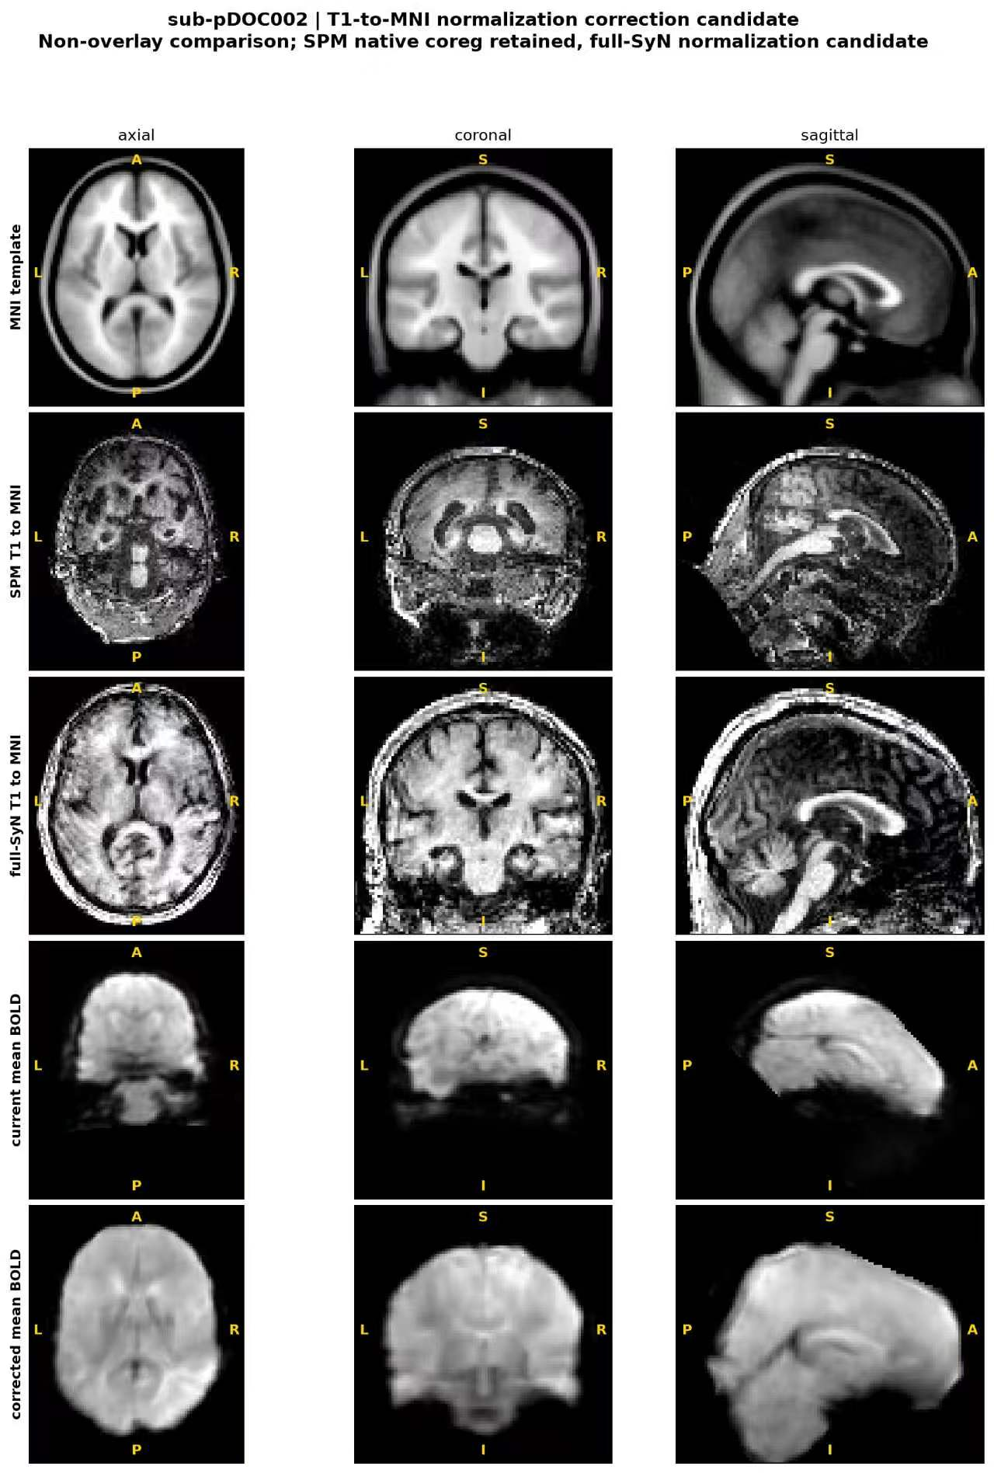
Figure S16. Registration method-selection example: sub-pDOC020. Full-SyN produced implausible ventricular compression, and SPM normalization was retained.
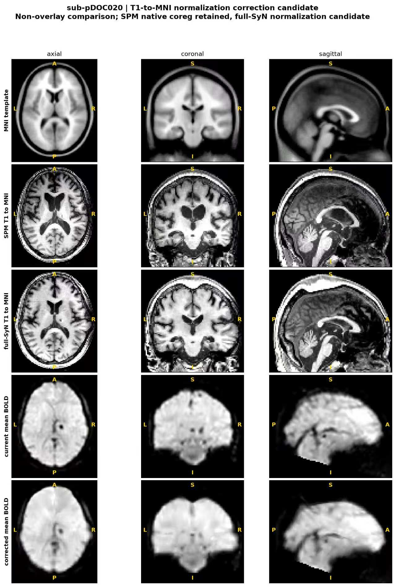
Figure S17. Legacy versus from-raw PET–ReHo display clusters. Red denotes legacy clusters, cyan denotes from-raw clusters, and yellow denotes exact voxel overlap.
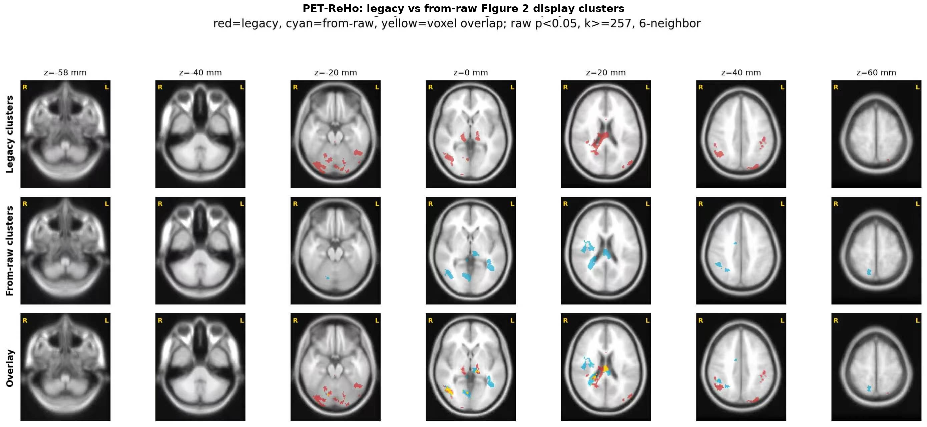
Figure S18. Legacy versus from-raw PET–fALFF display clusters. Red denotes legacy clusters, cyan denotes from-raw clusters, and yellow denotes exact voxel overlap.
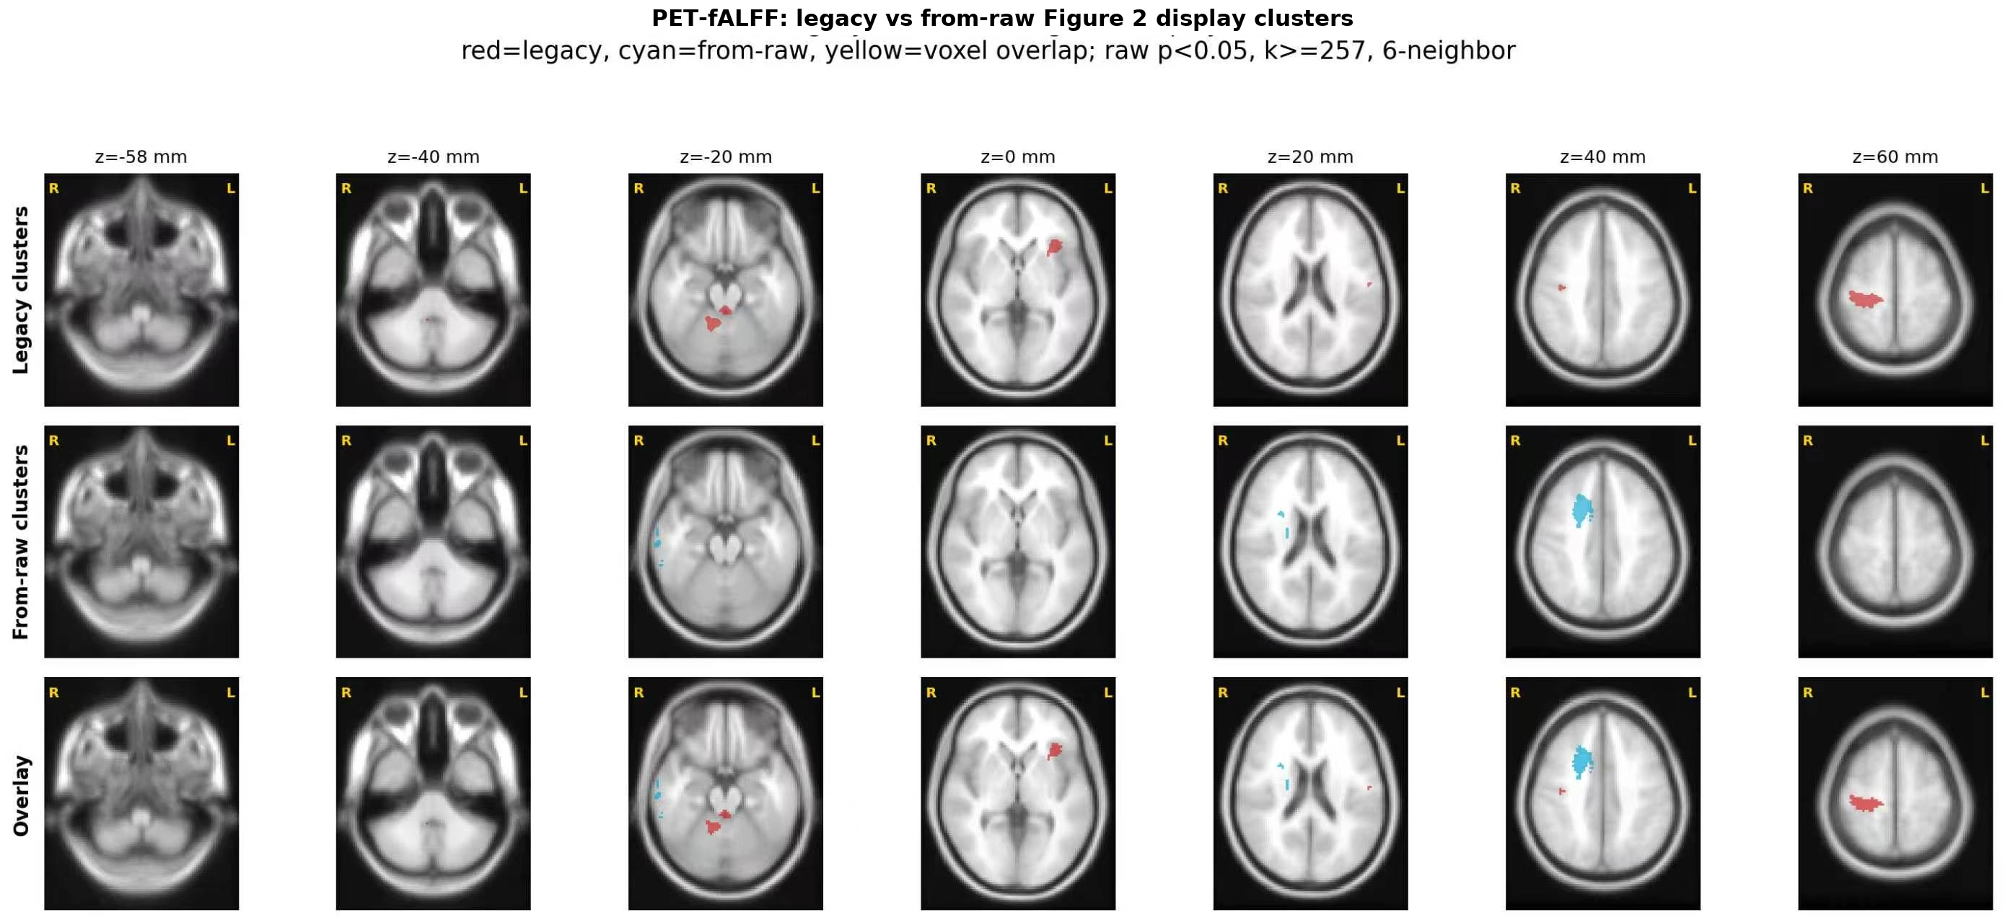
Figure S19. Legacy versus from-raw ReHo–fALFF display clusters. Red denotes legacy clusters, cyan denotes from-raw clusters, and yellow denotes exact voxel overlap.
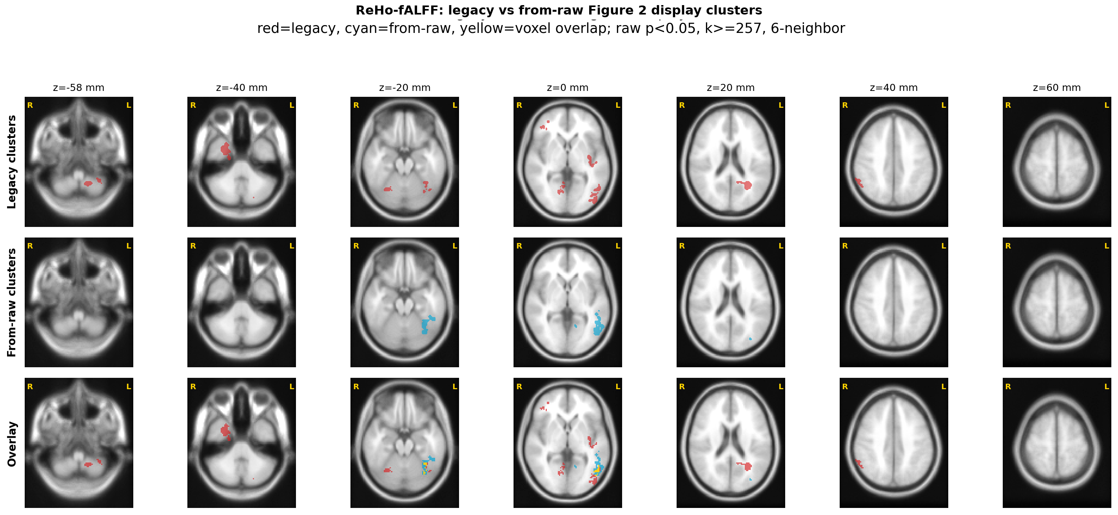
Figure S20. Whole-brain cross-modal coupling magnitude does not separate MCS from UWS. Violin plots with embedded boxplots and individual data points show within-subject Pearson spatial coupling coefficients across all valid voxels in the common analysis mask (238,955 voxels; Fisher r-to-z transformed) for PET–ReHo, PET–fALFF, and ReHo–fALFF. PET–fALFF coupling was higher in the preserved-consciousness clinical reference group (labelled NC in the legacy figure) than in MCS in a secondary uncorrected comparison (p = 0.044), but MCS and UWS did not differ for any modality pair.
