Supplementary Information
Low-Cost Camera-Based Automated Blink Analysis in Pediatric Frequent Blinking: a Proof-of-Concept Functional Evaluation
Supplementary Figure S1
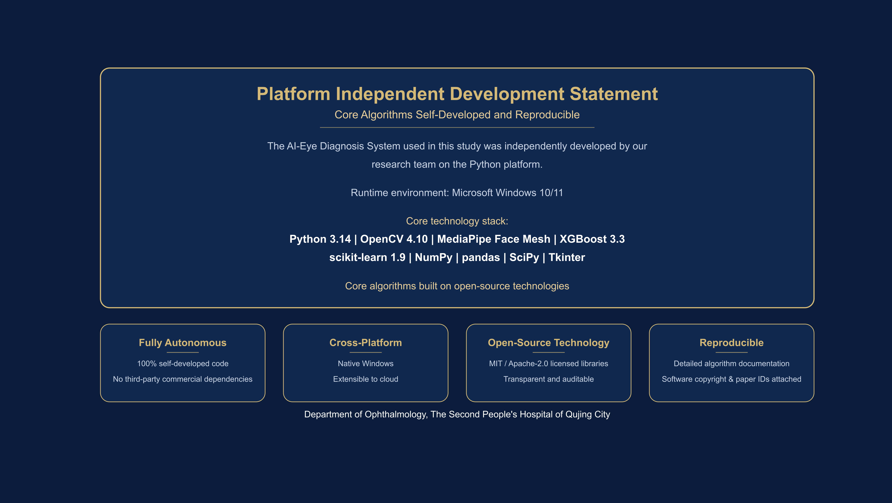
Supplementary Figure S1. Technology stack and platform-independence statement of the AI-Eye Diagnosis System. The system was developed independently by the authors on the Python platform (core algorithms self-developed and reproducible). Runtime environment: Microsoft Windows 10/11; core technology stack: Python 3.14, OpenCV 4.10, MediaPipe Face Landmarker, XGBoost 3.3, scikit-learn 1.9, NumPy, pandas, SciPy, and Tkinter. The figure summarizes four properties of the implementation: fully autonomous (100% self-developed code; no third-party commercial dependencies), cross-platform (native Windows; extensible to cloud), open-source technology (MIT/Apache-2.0 licensed libraries; transparent and auditable), and reproducible (detailed algorithm documentation; software copyright and paper IDs attached).
Supplementary Table S1. Module self-validation items (Layer 1). All eight items passed in the headless environment.
# | Item | Description
1 | Syntax compilation | Application code compiles without syntax errors in the headless environment
2 | Module import integrity | All required modules (OpenCV, MediaPipe, XGBoost, scikit-learn, Tkinter-independent core) import successfully
3 | Detector initialization | MediaPipe FaceLandmarker initializes without camera input
4 | Open-eye EAR | EAR computed on an open-eye image = 0.3000
5 | Closed-eye EAR | EAR computed on a closed-eye image = 0.0125
6 | Open/closed discriminability | Discriminative margin between open-eye and closed-eye EAR exceeds 20-fold
7 | Blank-image robustness | No landmarks or detections reported on a blank image
8 | Synthetic face detection | Detection and EAR computation succeed on a synthetic face image

Supplementary Table S2. Full four-class probability output and predicted class for the five camera-based sessions (Table 3 of the main text). Probabilities (p) are ordered as Normal, Dry eye disease (DED), Allergic conjunctivitis (AC), Tic disorder (TD), as produced by the XGBoost classifier.
Session | Duration (s) | Blink freq. (blinks/min) | Complete blink rate (%) | Rubbing freq. (events/min) | CV of IBI | EAR amplitude | p(Normal) | p(DED) | p(AC) | p(TD) | Predicted class | Confidence
P1787733805 | 26.4 | 20.47 | 55.56 | 4.55 | 0.2972 | 0.1128 | 0.0041 | 0.2979 | 0.6952 | 0.0029 | AC | 0.6952
P1787813470 | 22.2 | 8.09 | 0.00 | 2.70 | 0.7288 | 0.0953 | 0.0165 | 0.8690 | 0.0306 | 0.0839 | DED | 0.8690
P1787813528 | 15.4 | 7.77 | 100.00 | 0.00 | 0.0000 | 0.1155 | 0.9911 | 0.0039 | 0.0024 | 0.0026 | Normal | 0.9911
P1787821956 | 8.8 | 54.54 | 87.50 | 0.00 | 1.1972 | 0.2179 | 0.0021 | 0.0023 | 0.0030 | 0.9927 | TD | 0.9927
P1787826502 | 18.3 | 19.66 | 83.33 | 0.00 | 1.0487 | 0.1921 | 0.0091 | 0.0091 | 0.0159 | 0.9658 | TD | 0.9658
IBI, inter-blink interval; CV, coefficient of variation; EAR, eye aspect ratio.
Supplementary Table S3. Threshold sensitivity analysis. For each session, the onset threshold was varied over ±20% of the default (0.56, 0.63, 0.70, 0.77, and 0.84 × baseline) with the completeness threshold held at 0.5 × baseline (panels a–b), and the completeness threshold was varied over ±20% (0.40, 0.45, 0.50, 0.55, and 0.60 × baseline) with the onset threshold held at 0.7 × baseline (panel c). Event detection and parameter extraction were recomputed for every combination with the same pipeline that generated Table 3.
(a) Blink event counts across onset-threshold levels (completeness threshold 0.5 × baseline).
Session | 0.56 | 0.63 | 0.70 | 0.77 | 0.84
P1787733805 | 6 | 8 | 9 | 10 | 11
P1787813470 | 0 | 0 | 3 | 6 | 7
P1787813528 | 2 | 2 | 2 | 4 | 6
P1787821956 | 8 | 7 | 8 | 6 | 3
P1787826502 | 6 | 6 | 6 | 6 | 4
(b) Complete-blink rate (%) across onset-threshold levels. — indicates fewer than two events detected, for which parameters were not computed.
Session | 0.56 | 0.63 | 0.70 | 0.77 | 0.84
P1787733805 | 83.33 | 62.50 | 55.56 | 50.00 | 45.45
P1787813470 | — | — | 0.00 | 0.00 | 0.00
P1787813528 | 100.00 | 100.00 | 100.00 | 50.00 | 33.33
P1787821956 | 100.00 | 100.00 | 87.50 | 83.33 | 66.67
P1787826502 | 83.33 | 83.33 | 83.33 | 83.33 | 75.00
(c) Complete-blink rate (%) across completeness-threshold levels (onset threshold 0.7 × baseline). Blink event counts were unchanged (9, 3, 2, 8, and 6 for the five sessions respectively) because the onset threshold was held constant.
Session | 0.40 | 0.45 | 0.50 | 0.55 | 0.60
P1787733805 | 44.44 | 55.56 | 55.56 | 88.89 | 100.00
P1787813470 | 0.00 | 0.00 | 0.00 | 0.00 | 0.00
P1787813528 | 0.00 | 50.00 | 100.00 | 100.00 | 100.00
P1787821956 | 87.50 | 87.50 | 87.50 | 87.50 | 100.00
P1787826502 | 66.67 | 66.67 | 83.33 | 100.00 | 100.00
Within ±10% of the default thresholds (0.63/0.77 and 0.45/0.55), blink counts changed by at most two events in four of the five sessions; session P1787813470, whose blinks sit near the detection margin, was the exception. The two-blink session (P1787813528) showed a 50-percentage-point swing in complete-blink rate between adjacent completeness-threshold levels (0% at 0.40 × baseline to 100% at 0.50 × baseline), an artefact of its small denominator.
Supplementary Table S4. Frame-rate sensitivity analysis. The two sessions recorded at 28–30 fps were decimated by time-uniform linear interpolation to 15, 10, and 7.5 fps, and event detection and parameter extraction were recomputed on each decimated series with the same pipeline that generated Table 3. Decimation isolates the effect of frame rate on the detection logic; it does not reproduce native low-frame-rate acquisition.
(a) Session P1787821956 (original 30.0 fps).
Frame rate | Frames | Blink count | Complete-blink rate (%) | Mean blink amplitude
Original (30.0 fps) | 264 | 8 | 87.50 | 0.2179
15 fps | 133 | 6 | 83.33 | 0.1837
10 fps | 89 | 6 | 50.00 | 0.1454
7.5 fps | 67 | 3 | 66.67 | 0.1499
(b) Session P1787826502 (original 28.5 fps).
Frame rate | Frames | Blink count | Complete-blink rate (%) | Mean blink amplitude
Original (28.5 fps) | 523 | 6 | 83.33 | 0.1921
15 fps | 276 | 5 | 60.00 | 0.1623
10 fps | 184 | 4 | 25.00 | 0.1230
7.5 fps | 138 | 2 | 50.00 | 0.1373
At 15 fps, blink counts fell by at most two events relative to the original recordings, with moderate amplitude attenuation (0.218 → 0.184 and 0.192 → 0.162); decimation to 7.5 fps missed more than half of the events in both sessions. A minimum deployment frame rate of ≥15 fps is therefore recommended.
Supplementary Table S5. Comparison with prior video-based blink and tic analysis work.
Study | Population | Method | Output | Relation to present work
Conelea et al. 2023 [15] | Adolescents and adults with Tourette syndrome | Computer vision + deep learning on clinical videos | Automated eye tic event quantification | Event-level tic detection with deep model; no four-class etiology output; GPU-oriented
Xu et al. 2025 [18] | Patients with tic disorders | Multi-phase video learning | Tic disorder diagnosis from videos | Diagnostic task via deep video models; different evaluation paradigm
Hong et al. 2024 [19] | Challenging imaging conditions | Dual-embedding video vision transformer | Robust blink event detection | Event-level detection; deep architecture; no clinical parameter output
Xu et al. 2025 [21] | Adults with dry eye symptoms | Smartphone-based blink training application | Blink training; dry eye signs/symptoms | Therapeutic application on consumer phones; no four-class classification
Hafsi et al. 2026 [25] | Parkinson's disease | Video-derived blink features; multi-class classification | Multi-class classification of PD | Adult neurological population; disease-classification focus
Wu et al. 2025 [22] | Children wearing orthokeratology lenses | Deep learning blink analysis | Blink characteristics; relation to tear film stability | Single-condition characterization; orthokeratology context
Distinguishing features of the present system relative to this body of work are its four-class, etiology-oriented output and its reliance on a consumer-grade camera with CPU-only operation, as discussed in the main text (Comparison with prior work).

