Supplemental Information

Methods

Clinician Review
Transcripts were sampled using a stratified probability design spanning all 16 combinations of safety-agent classification—No, Possible, Non-Immediate, or Immediate Suicidal Ideation Risk—and the most-proximate self-report risk level—No Risk, Self-Harm Risk, Non-Immediate Risk, or Immediate Risk. Rare and high-risk strata were sampled at substantially higher rates than their prevalence in the population, including complete review of some of the smallest strata. The dominant no-risk stratum was sampled at a lower rate. Selection weights were calculated as the number of conversations in each stratum divided by the number sampled from that stratum and were used to construct the primary design-based estimates.
Safety Agent Classifier
Each conversation was categorized into four mutually exclusive levels based on the following structured, severity-based rubric. Immediate Suicidal Ideation Risk was assigned when any high-acuity indicator was present, including recent (≤ 72 hours) self-harm attempts or preparatory behaviors, command hallucinations promoting self-harm, or clear intent to die, a plan, method or means, or short timeframe (e.g., that day). Non-Immediate Suicidal Ideation Risk was assigned when users expressed suicidal thoughts without any intent to die, plan, method or means, short timeframe, or recent self-harm behavior, and were able to engage in conversation about risk without signs of acute crisis. Possible Suicidal Ideation Risk captured cases with any ambiguous or indirect indicators—such as non-suicidal self-injury, coded or euphemistic references to death, existential hopelessness tied to life itself, or mixed/uncertain signals. No Suicidal Ideation Risk was assigned when users showed no evidence of suicidal thoughts, intent, or behavior, and distress was limited to non-suicidal expressions of overwhelm or fatigue. Disclaimers (e.g., “not suicidal”) did not override Immediate or Non-Immediate Suicidal Ideation classifications; non-suicidal self-injury alone defaulted to Possible; and farewells or preparatory behaviors were categorized as Immediate when time-bound and otherwise as Possible or Non-Immediate Suicidal Ideation based on context. When uncertainty existed between Non-Immediate Suicidal Ideation and Possible, or when language was otherwise ambiguous, the rating defaulted to Possible pending clarification, and the chatbot asked clarifying questions with the aim of resolving the classification into one of the other three ratings. Classification followed a “highest-severity” decision rule, such that any signal indicative of imminent danger overrode lower-level classifications and the conversation as a whole was classified according to the highest-risk level reached by any single message. Any conversation scoring Non-Immediate Suicidal Ideation Risk or Immediate Suicidal Ideation Risk was escalated. Thus, the primary operational cutoff was escalation, reflecting the system’s actual triage behavior. As a secondary, more conservative cutpoint, we also examined No Risk vs. any risk level (Possible, Non-Immediate, or Immediate) (Supplemental Table 1).
Results

Self-Report Assessment Risk
Based on the assessments taken closest in time to Guided Intake, the majority of users (83.8%; n=25,579) were classified as No Suicidal Ideation Risk, 10.8% (n=3,304) Possible Suicidal Ideation Risk, 4.9% (n=1,490) Non-Immediate Suicidal Ideation Risk, and 0.5% (n=159) were Immediate Suicidal Ideation Risk. Note that despite sharing labels, the self-report assessments and agent classification measured different constructs: explicit, prompted disclosure vs. spontaneous disclosure. Importantly, when completing these assessments, members were asked specifically to rate suicide ideation. This is in contrast to the Guided Intake, during which the chatbot did not routinely ask about suicidal ideation as part of each conversation but responded to indicators of risk if spontaneously disclosed by the user.
When comparing the safety agent classification with risk levels from recent self-report assessments, overall concordance was 80.9% [95% CI, 80.4–81.3%], though this estimate reflects substantial class imbalance, with the majority of conversations classified as No Suicidal Ideation Risk by both methods. Agreement between assessment-assigned and agent-assigned risk was low (Cohen's κ=0.09 [0.07–0.10]; weighted κ=0.16 [0.14–0.18]). When risk was dichotomized (any risk vs. no risk), sensitivity was 12.6% [11.6–13.5%] and specificity was 94.9% [94.7–95.2%].
Weighted vs. unweighted clinician-agent agreement
Supplemental Figure 1 shows the full four-level confusion matrix (clinician rating as reference, agent classification in columns) under the primary design-based weighting (A) alongside the naive estimate obtained by simply using raw, unweighted proportions from the 400 reviewed transcripts (B). Because the review sample deliberately oversampled rare and high-risk strata relative to their true frequency in the population, the unweighted estimate substantially understates real-world performance on two of the three headline metrics: specificity falls from 99.7% (weighted) to 90.6% (unweighted), and overall four-level agreement falls from 95.5% to 74.0%, since low-risk conversations—which the agent classifies correctly the vast majority of the time—are undersampled relative to their true ~93.7% share of the population. Sensitivity is comparatively stable across the two (93.2% weighted vs. 94.3% unweighted). This comparison illustrates why treating the stratified review sample as if it were a simple random sample would materially misrepresent the agent's real-world performance, and underscores the necessity of the inverse-probability weighting used throughout the primary analysis.
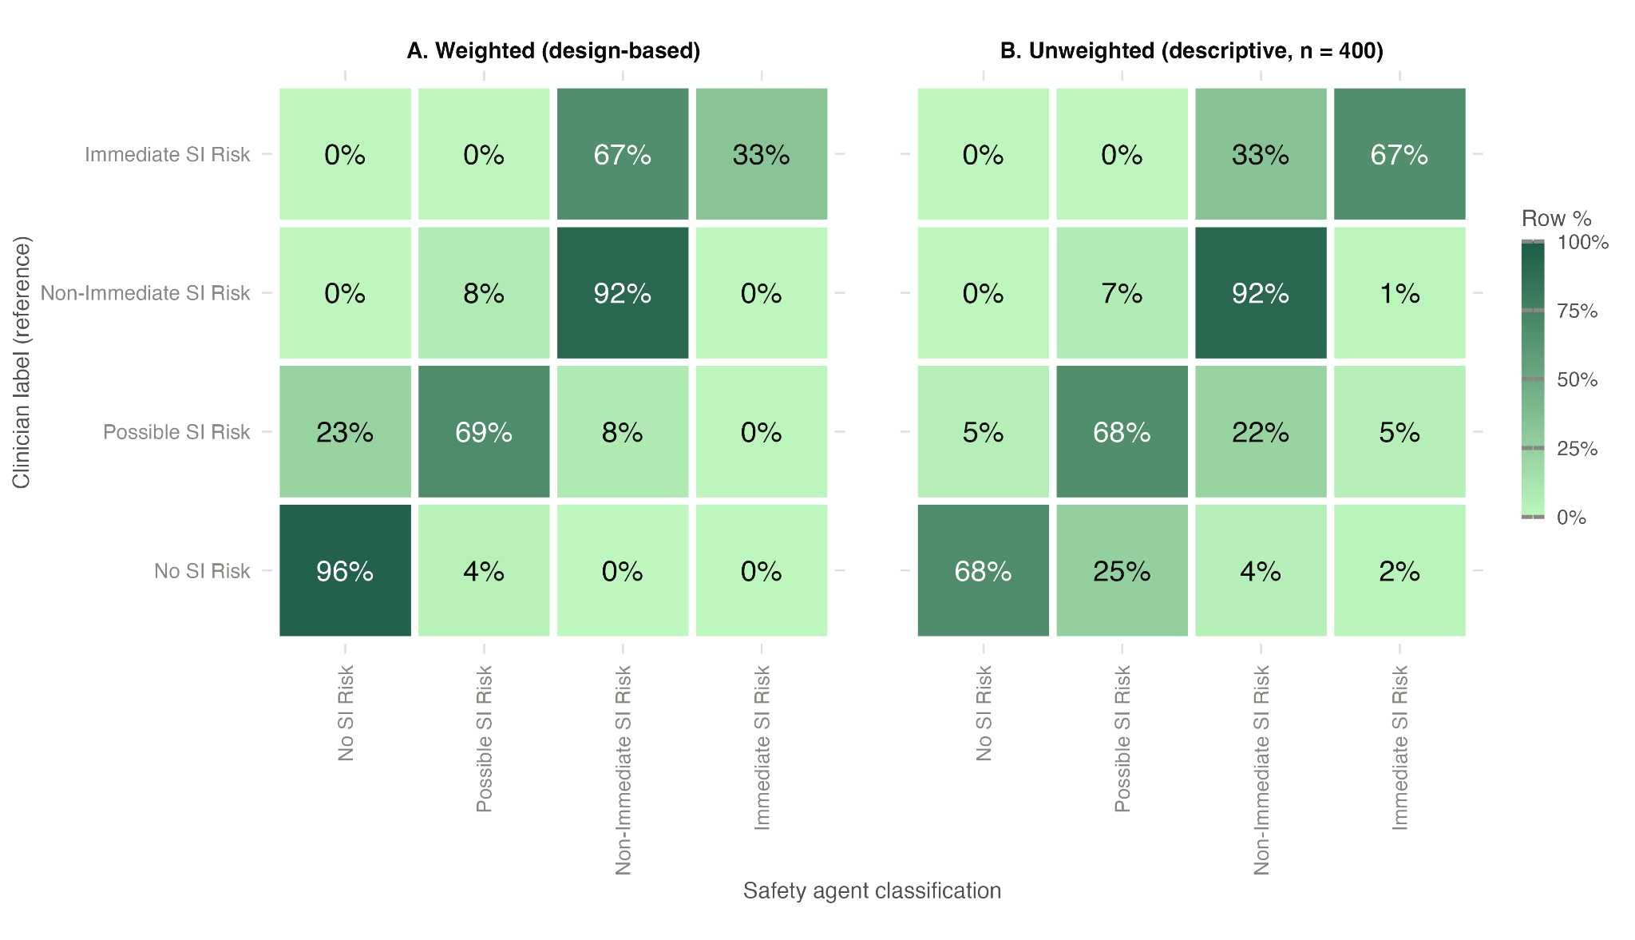
Supplemental Figure 1: Weighted (stratified designed based) and unweighted estimates of clinician-agent agreement. Each row cell corresponds to the percent of transcripts clinicians rated at a given level and the % the agent classified at each level (rows sum to 100%).

Secondary Cutpoint: No Risk vs. Any Risk
As a secondary, more conservative cutpoint, we also evaluated agreement between the agent and clinicians using No Risk vs. any risk level (Possible, Non-Immediate, or Immediate) rather than the primary escalation threshold (Non-Immediate or Immediate) reported in Table 2 (Main Text). Under this broader cutpoint, weighted sensitivity was 87.6% (95% CI, 71.5–100.0%) and specificity was 96.1% (95.6–96.6%); positive predictive value was 39.2% (31.5–47.9%) and negative predictive value was 99.6% (99.0–100.0%). The markedly lower PPV relative to the primary escalation cutpoint (80.9%) reflects that this broader threshold captures a much larger, lower-specificity population, including many Possible Suicidal Ideation Risk conversations that clinicians did not judge as warranting escalation. Because overall agreement and quadratic-weighted kappa are computed across the full four-level scale rather than a specific cutpoint, these values (95.5%; κ=0.718) are identical to the primary analysis reported in Table 2 and are not repeated here. Unweighted (descriptive, n=400) estimates under this cutpoint are reported alongside the weighted estimates in Supplemental Table 1 for comparison.

Supplemental Table 1. Performance of an LLM-based safety agent (No Risk vs. Any Risk Cutoff) compared to blinded clinical review.
Metric | Weighted (design-based) | Unweighted (descriptive, n=400)
Sensitivity | 87.5% (71.3–100.0%) | 98.8% (96.8–100%)
Specificity | 96.1% (95.6–96.6%) | 68.5% (62.2–74.5%)
Positive predictive value | 39.2% (31.3–47.6%) | 68.1% (62.3–74.0%)
Negative predictive value | 99.6% (99.0–100.0%) | 98.8% (96.8–100%)

