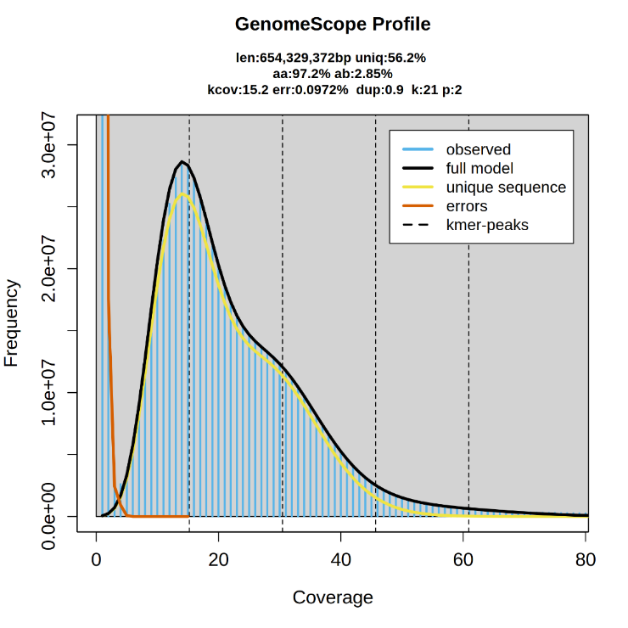
Figure S1. GenomeScope-based estimation of genome characteristics in P. brevitarsis based on the 21-mer frequency distribution. The distribution derived from Illumina short reads was fitted using GenomeScope 2.0 to estimate genome size, heterozygosity, and repeat content.

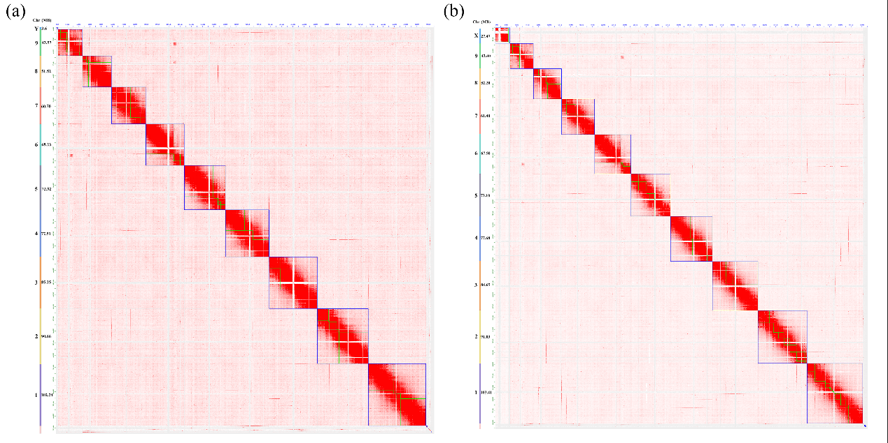
Figure S2. Hi-C interaction maps showing chromosome-scale scaffolding of the original Hap1 and Hap2 assemblies prior to integration of sex-linked contigs. (a) Hap1. (b) Hap2.

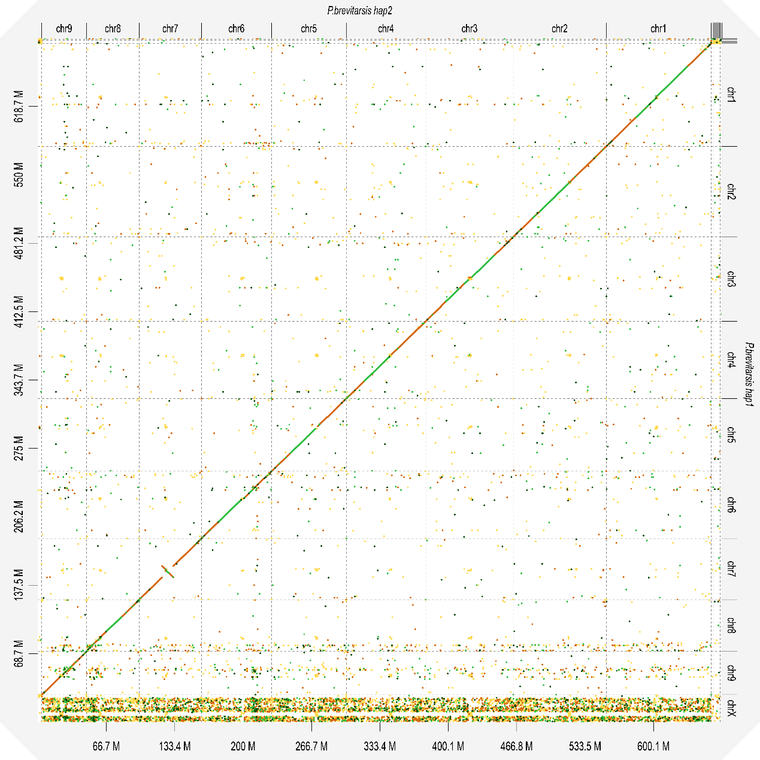
Figure S3. Whole-genome sequence alignment between the Hap1 and Hap2 assemblies. The D-GENIES dot plot show genome-wide sequence correspondence between the two assemblies.
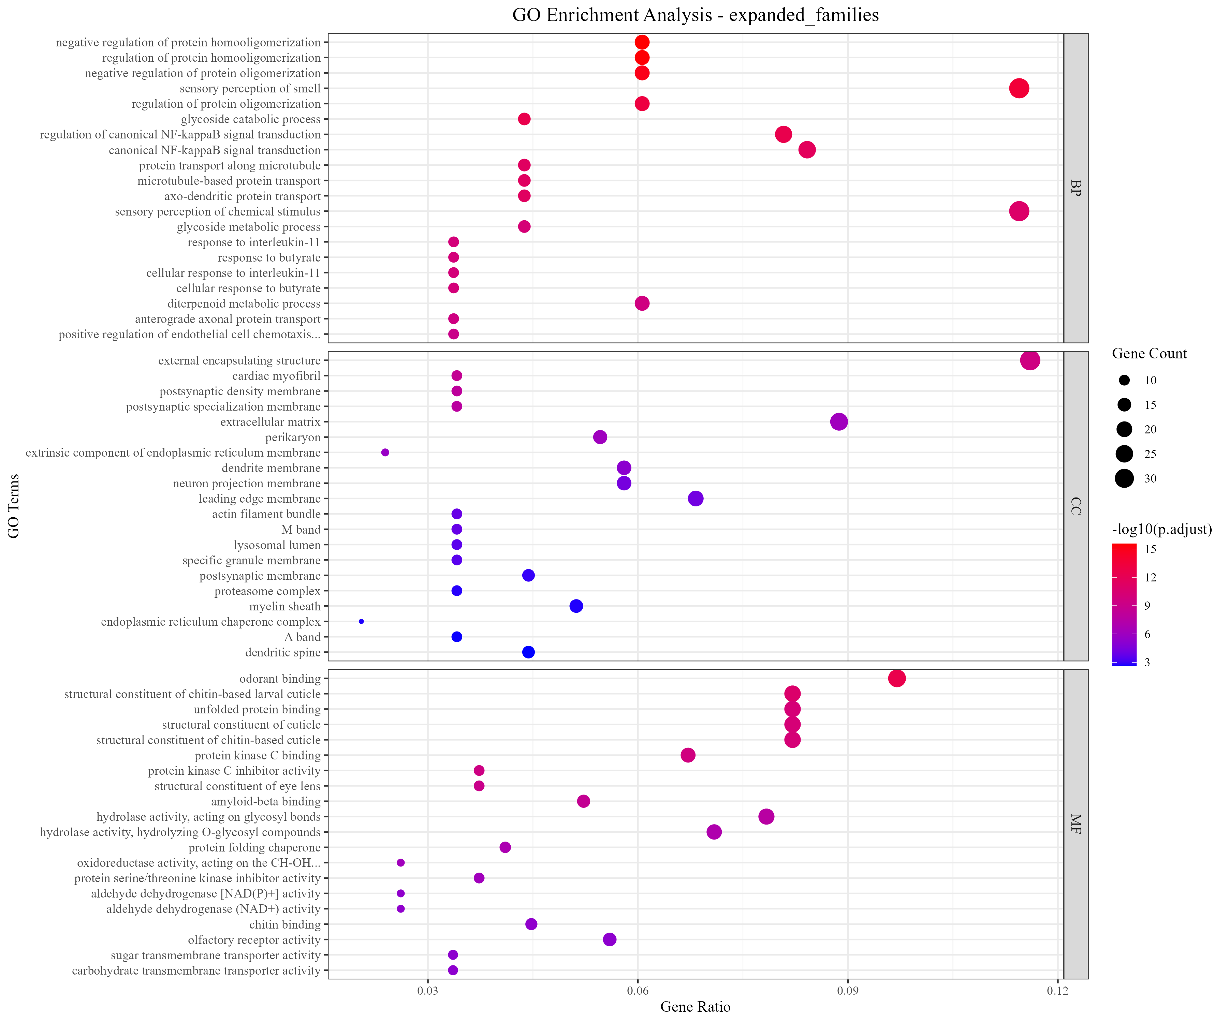
Figure S4. GO enrichment analysis of significantly expanded gene families. Dot plot showing significantly enriched GO terms (q-value < 0.05) in three categories: biological process (BP), molecular function (MF), and cellular component (CC). The vertical axis shows GO term descriptions and the horizontal axis shows the gene ratio. Dot size indicates the number of genes associated with each GO term, and dot color corresponds to different −log10 (adjusted P value) ranges.
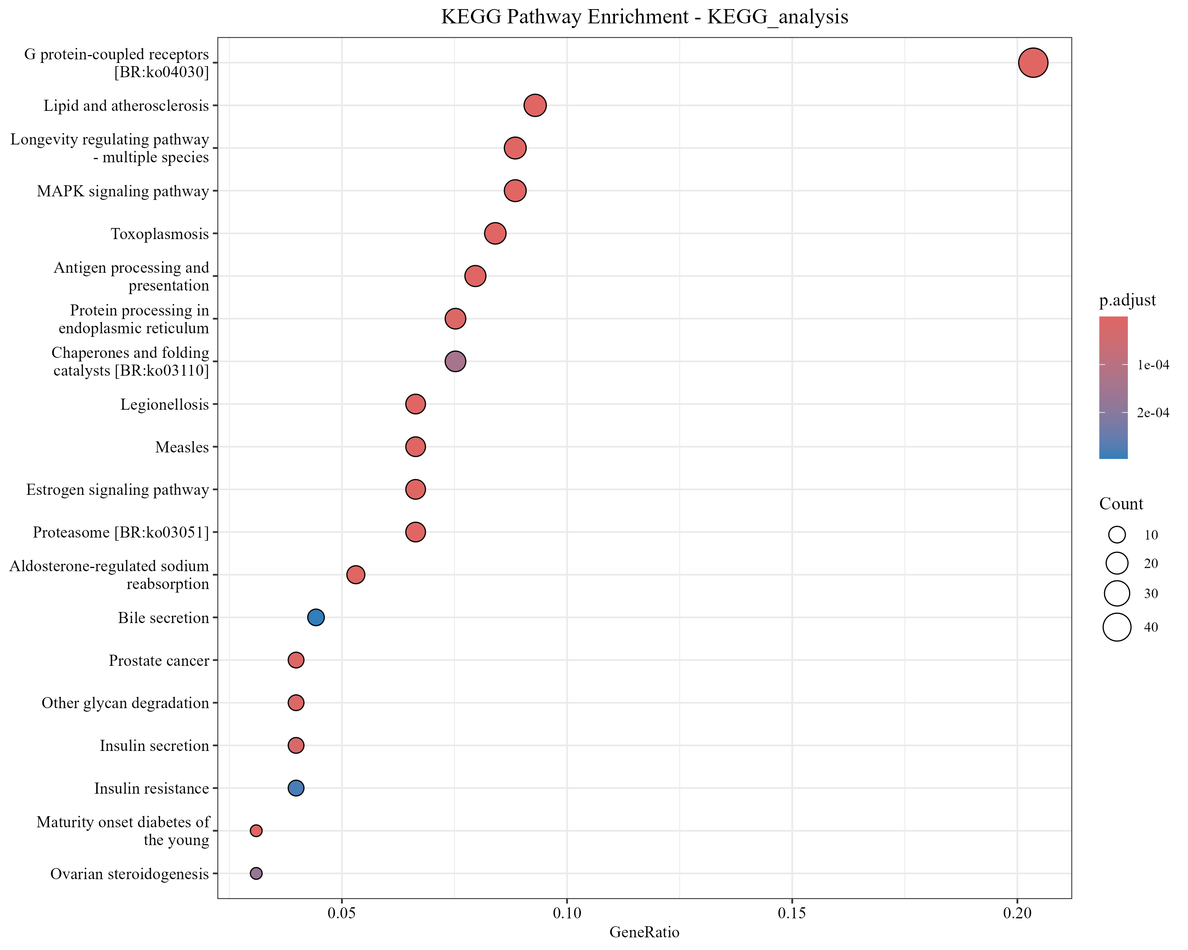
Figure S5. KEGG enrichment analysis of significantly expanded gene families. Dot plot showing significantly enriched KEGG pathways in expanded gene families. The vertical axis shows pathway names and the horizontal axis shows the gene ratio. Dot size indicates the number of genes associated with each pathway, and dot color corresponds to different adjusted P value ranges.

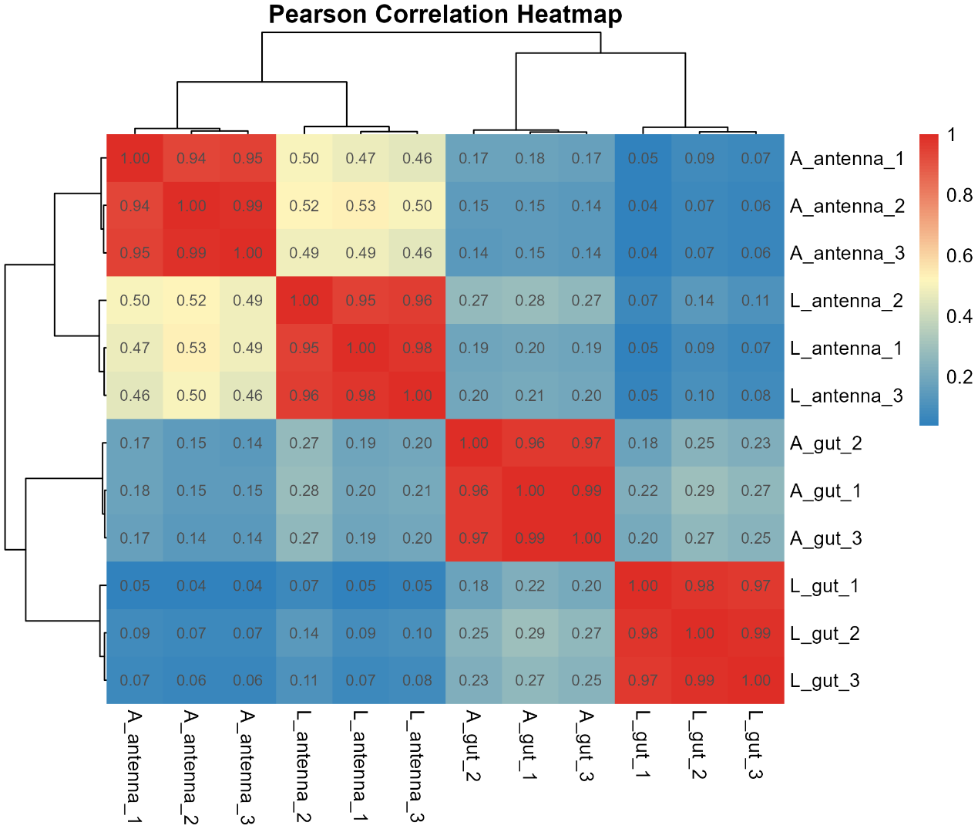
Figure S6. Pearson correlation heatmap of transcriptome samples from P. brevitarsis, showing the relationships among biological replicates and sample groups based on gene expression profiles. A_gut, adult midgut; L_gut, larval midgut; A_antenna, adult antenna; L_antenna, larval antenna.
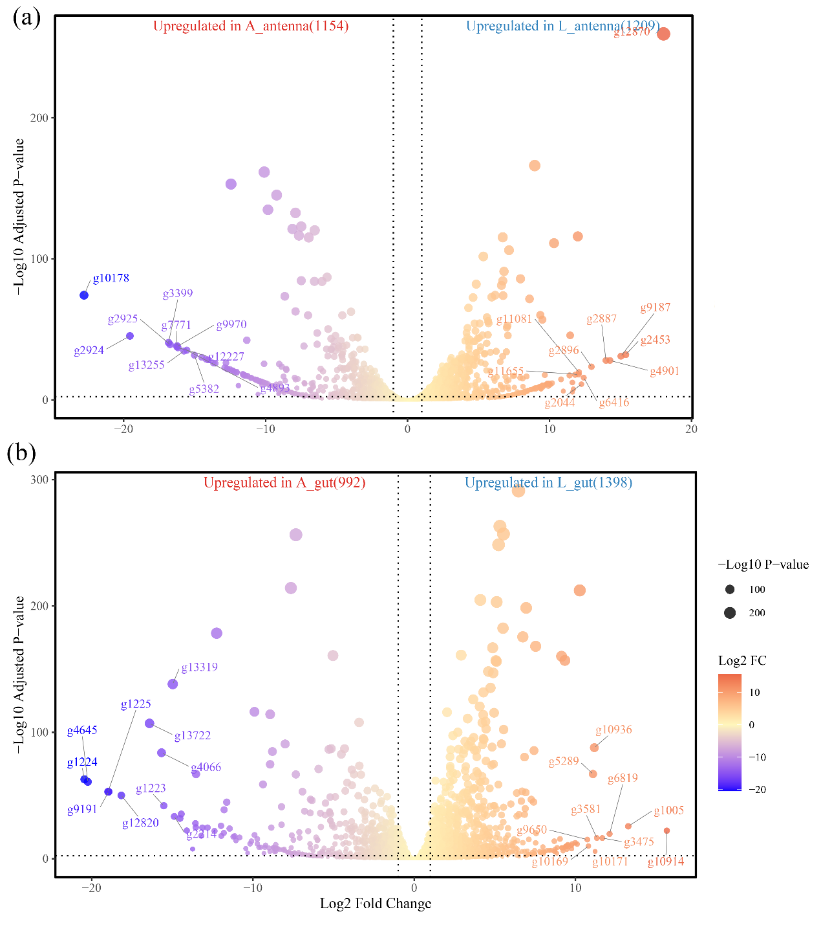
Figure S7. Differential gene expression between larval and adult tissues in P. brevitarsis. (A) Volcano plot of DEGs in antennae. (B) Volcano plot of DEGs in midgut. A_gut, adult midgut; L_gut, larval midgut; A_antenna, adult antenna; L_antenna, larval antenna.

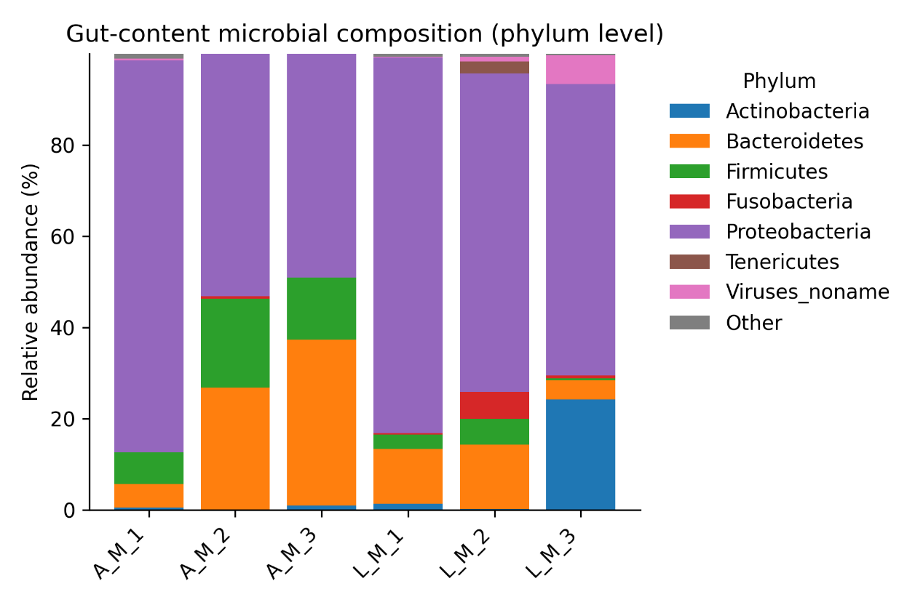
Figure S8. Phylum-level taxonomic composition of gut-content metagenomes. Stacked bars show the relative abundance of major microbial phyla in three adult and three larval biological replicates. A_M, adult gut-content metagenome; L_M, larval gut-content metagenome.

