Supplementary Information
Dual-endoscope-assisted retrograde ureteral stenting after kidney transplantation: a case series and historical meta-analysis
Zikai Fang¹ · Heyu Guo¹ · Zihuan Xia¹ · Jun Xue¹ · Jixian Liu¹ · Kangyu Liu¹ · Xi Chen¹ · Hongdi Cao² · Jing Luo² · Ming Gu¹ · Qingyi Zhu¹ · Ming Zheng¹* · Baixin Shen¹*†
*Corresponding authors.
†Baixin Shen is the primary corresponding author and the designated contact for manuscript submission.

Supplementary Methods
Searches covered PubMed/MEDLINE, Embase, the Cochrane Library, and CNKI from database inception to 30 April 2026. Concepts included kidney transplantation, transplant ureter, ureteral obstruction or stricture, urolithiasis, urinary leakage, retrograde access, ureteroscopy, cystoscopy, catheterisation, and ureteral stenting.
Full search strategies:
PubMed/MEDLINE：
("Kidney Transplantation"[Mesh] OR "Kidney Transplantation/adverse effects"[Mesh] OR kidney transplant*[tiab] OR renal transplant*[tiab] OR kidney allograft*[tiab] OR renal allograft*[tiab] OR transplant kidney[tiab] OR transplanted kidney[tiab] OR allograft kidney[tiab] )
AND ( "Ureteral Obstruction"[Mesh] OR "Ureteral Calculi"[Mesh] OR "Urinary Fistula"[Mesh] OR "Lymphocele"[Mesh] OR "Hydronephrosis"[Mesh] OR ureter* stricture*[tiab] OR ureter* stenosis[tiab] OR ureteric stricture*[tiab] OR ureteric stenosis[tiab] OR ureter* obstruct*[tiab] OR ureteric obstruct*[tiab] OR transplant ureter* complication*[tiab] OR transplant ureter* obstruction[tiab] OR allograft ureter* complication*[tiab] OR allograft ureter* obstruction[tiab] OR ureteroneocystostomy stricture*[tiab] OR ureterovesical anastomotic stricture*[tiab] OR anastomotic stricture*[tiab] OR ureteral calcul*[tiab] OR ureteric calcul*[tiab] OR urinary leak*[tiab] OR urine leak*[tiab] OR urinary fistula*[tiab] OR anastomotic leak*[tiab] OR lymphocele*[tiab] OR ureter* compression[tiab] OR ureteric compression[tiab] OR extrinsic compression[tiab] OR hydronephrosis[tiab] OR pelviureteric obstruct*[tiab])
AND ( "Stents"[Mesh] OR "Cystoscopy"[Mesh] OR "Ureteroscopy"[Mesh] OR retrograde[tiab] OR retrograde stent*[tiab] OR retrograde ureteral stent*[tiab] OR retrograde ureteric stent*[tiab] OR ureteral stent placement[tiab] OR ureteric stent placement[tiab] OR ureteral stent insertion[tiab] OR ureteric stent insertion[tiab] OR double J stent[tiab] OR double-J stent[tiab] OR DJ stent[tiab] OR JJ stent[tiab] OR cystoscopic stent placement[tiab] OR ureteroscopic stent placement[tiab] OR flexible ureteroscopy[tiab] OR cystoscop*[tiab] OR ureteroscop*[tiab] OR endourolog*[tiab] )

Cochrane Library: via Search manager
#1 [mh "Kidney Transplantation"]
OR (kidney transplant*):ti,ab,kw
OR (renal transplant*):ti,ab,kw
OR (kidney allograft*):ti,ab,kw
OR (renal allograft*):ti,ab,kw
OR (transplanted kidney):ti,ab,kw
OR (transplant kidney):ti,ab,kw
OR (allograft kidney):ti,ab,kw

#2 [mh "Ureteral Obstruction"]
OR [mh "Ureteral Calculi"]
OR [mh "Urinary Fistula"]
OR [mh "Lymphocele"]
OR [mh "Hydronephrosis"]
OR (ureteral stricture*):ti,ab,kw
OR (ureteric stricture*):ti,ab,kw
OR (ureteral obstruction*):ti,ab,kw
OR (ureteric obstruction*):ti,ab,kw
OR (ureteral stenosis):ti,ab,kw
OR (ureteric stenosis):ti,ab,kw
OR (anastomotic stricture*):ti,ab,kw
OR (ureteral complication*):ti,ab,kw
OR (ureteric complication*):ti,ab,kw
OR (ureteral fistula*):ti,ab,kw
OR (urine leak*):ti,ab,kw
OR (urinary leak*):ti,ab,kw
OR (urinary leakage*):ti,ab,kw
OR (urinary fistula*):ti,ab,kw
OR (anastomotic leak*):ti,ab,kw
OR (ureteral stone*):ti,ab,kw
OR (ureteral calculi):ti,ab,kw
OR (ureteric calcul*):ti,ab,kw
OR (lymphocele*):ti,ab,kw
OR (hydronephrosis):ti,ab,kw
OR (ureteroneocystostom*):ti,ab,kw
OR (ureterovesical anastomotic stricture*):ti,ab,kw

#3 [mh "Cystoscopy"]
OR [mh "Ureteroscopy"]
OR [mh "Endourology"]
OR [mh "Stents"]
OR (retrograde):ti,ab,kw
OR (retrograde stent*):ti,ab,kw
OR (retrograde ureteral stent*):ti,ab,kw
OR (retrograde ureteric stent*):ti,ab,kw
OR (cystoscop*):ti,ab,kw
OR (ureteroscop*):ti,ab,kw
OR (endourolog*):ti,ab,kw
OR (stent*):ti,ab,kw
OR (double-j):ti,ab,kw
OR (double j):ti,ab,kw
OR (DJ stent):ti,ab,kw
OR (JJ stent):ti,ab,kw
OR (ureteral stent placement):ti,ab,kw
OR (ureteric stent placement):ti,ab,kw
OR (ureteral stent insertion):ti,ab,kw
OR (ureteric stent insertion):ti,ab,kw
OR (cystoscopic stent placement):ti,ab,kw
OR (ureteroscopic stent placement):ti,ab,kw

#4 #1 AND #2 AND #3
Embase：('kidney transplantation'/exp OR 'kidney transplant*':ti,ab,kw OR 'renal transplant*':ti,ab,kw OR 'kidney allograft*':ti,ab,kw OR 'renal allograft*':ti,ab,kw)
AND ('ureter obstruction'/exp OR 'ureter stenosis'/exp OR 'ureter stone'/exp OR 'urinary fistula'/exp OR 'lymphocele'/exp OR 'ureteral stricture*':ti,ab,kw OR 'ureteral obstruction*':ti,ab,kw OR 'anastomotic stricture*':ti,ab,kw OR 'ureteral complication*':ti,ab,kw OR 'ureteral fistula*':ti,ab,kw OR 'urine leak*':ti,ab,kw OR 'urinary leakage':ti,ab,kw OR 'ureteral stone*':ti,ab,kw OR 'ureteral calculi':ti,ab,kw OR 'lymphocele*':ti,ab,kw OR 'hydronephrosis':ti,ab,kw)
AND ('cystoscopy'/exp OR 'ureteroscopy'/exp OR 'ureter stent'/exp OR 'retrograde':ti,ab,kw OR 'transurethral':ti,ab,kw OR 'cystoscop*':ti,ab,kw OR 'ureteroscop*':ti,ab,kw OR 'endourolog*':ti,ab,kw OR 'stent*':ti,ab,kw OR 'double-j':ti,ab,kw OR ('double' NEXT/1 'j'):ti,ab,kw OR 'dj stent':ti,ab,kw OR 'balloon dilation':ti,ab,kw)

CNKI:SU=('移植肾' + '肾移植' + '肾脏移植') * ('输尿管支架' + '双J管' + 'DJ管' + '支架管') * ('逆行' + '输尿管镜' + '膀胱镜')

Supplementary Figures
Fig. S1 Random-effects meta-analysis of reported cure of ureteral stricture after retrograde or antegrade stenting. Study-specific cure definitions and reported denominators were retained. The extracted data combine both access routes and do not provide a retrograde-only estimate.
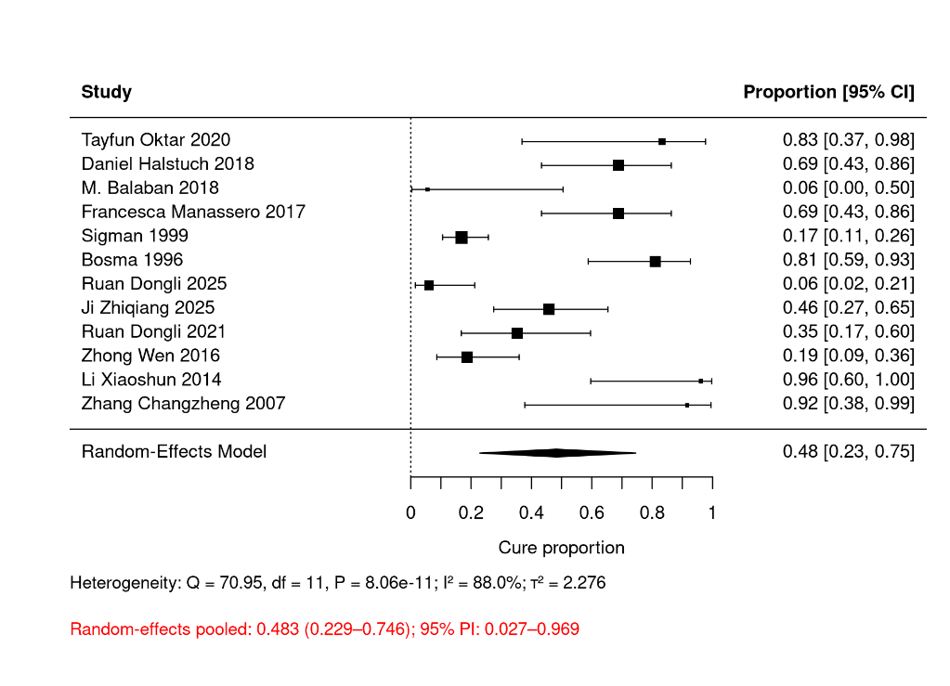

Fig. S2 Random-effects meta-analysis of first-attempt success for stone-related obstruction
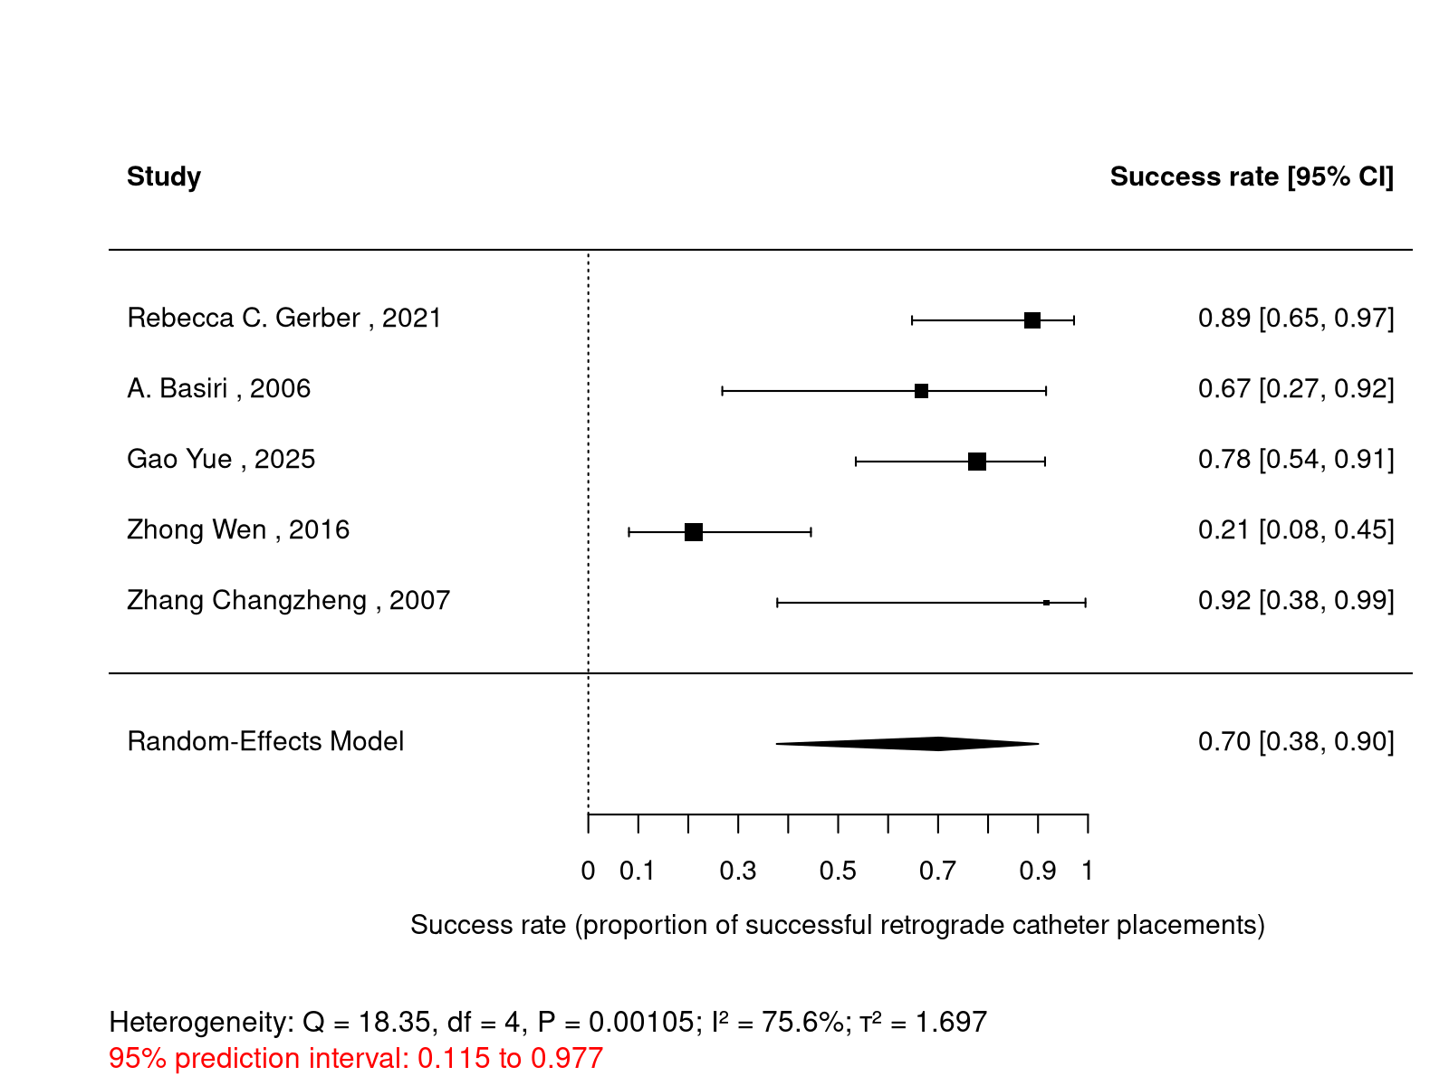
Fig. S3 Random-effects meta-analysis of first-attempt success for ureteral stricture
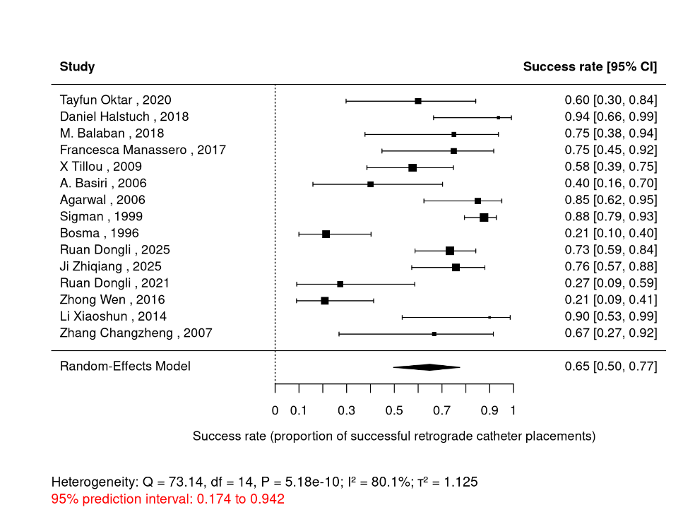

Fig. S4 Random-effects meta-analysis of retrograde success for urinary leakage
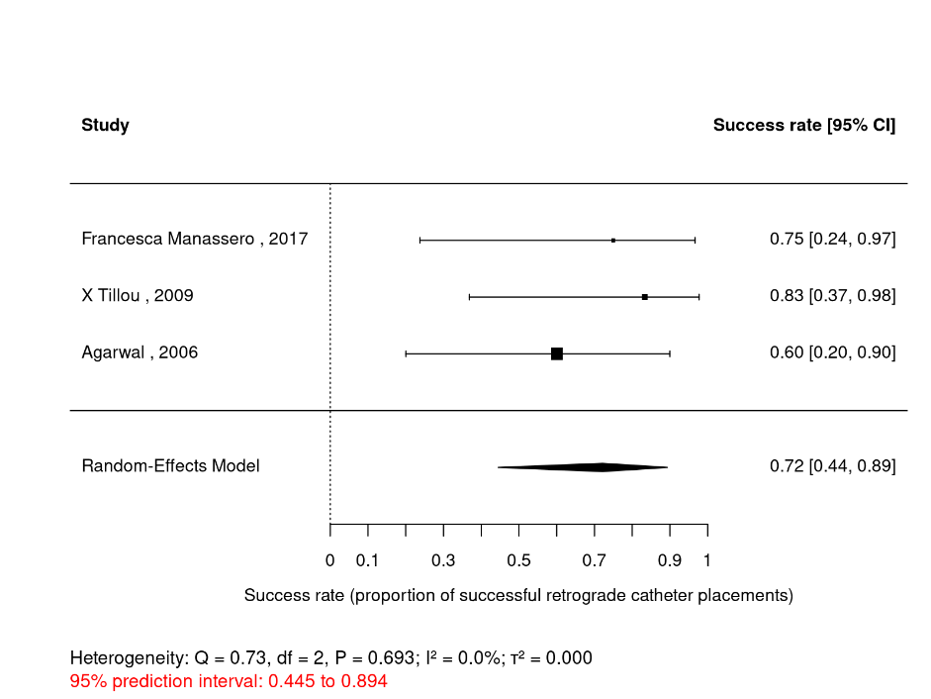

Supplementary Tables
Table S1A Characteristics of studies included in the meta-analysis
Study | Design | Country | Indication | Time to complication | Retrograde method | Follow-up | Operation time
Rebecca C. Gerber 2021 | Case series | USA | Kidney or ureteral stones | NR | flexible ureteroscope and semi-rigid ureteroscopes | 12-138months | Average: 76.44min
Tayfun Oktar 2020 | Case series | Turkey | Ureterovesical anastomotic stricture | NR | Retrograde | NR | NR
Daniel Halstuch 2018 | Case series | Israel | Ureteral stricture | NR | Cystoscopy Retrograde with Ureteroscopic flexible sheath | Median follow-up:58 months | Average: 24min
M. Balaban 2018 | Case series | Turkey | Ureteral stricture | ≤3months: 5cases; >3 months: 3cases | Cystoscopy Retrograde | Median follow-up:41months (13-60months) | Median 28 minutes (24–42 min)
Francesca Manassero 2017 | Case series | Italy | Ureteral leakage; Ureteral stricture | Average 96 days (±84.2, 4–298 days); early onset: 37 days late onset :183 days. | Rigid cystoscopy Retrograde with 5F Cobra Stents | NR | NR
X Tillou 2009 | Case series | USA | Ureteral stricture; Ureteral leakage; | NR | Rigid cystoscopy Retrograde | NR | NR
A. Basiri 2006 | Case series | Iran | Ureteral stones; Ureterovesical anastomotic stricture | NR | Cystoscopy and ureteroscopes Retrograde | Median follow-up:39months (3-80months) | NR
Agarwal 2006 | Case series | USA | Ureteral leakage; Ureteral stricture | Urinary leakage: average 16.8 days; obstruction: average 48 months | Rigid cystoscope and flexible cystoscope | NR | Average: 42min
Gerrard 2005 | Case series | USA | Ureteral stricture | NR | Rigid cystoscope and flexible cystoscope | NR | NR
Sigman 1999 | Case series | USA | Ureteral stricture | Average 46 days (18–420 days) | First retrograde pyelography and then cystoscopy Retrograde | NR | Average: 47min(13-108 min)
Bosma 1996 | Case series | Netherlands | Ureteral stricture | 12 cases in the early stage (≤4 weeks); 10 cases within 3 months; 9 cases later. | First retrograde pyelography and then cystoscopy Retrograde | NR | NR
Gao Yue 2025 | Case series | China | Kidney or ureteral stones | average 65.2months (2-228 months) | Ureteroscopes retrograde with Ureteroscopic flexible sheath | NR | Average: 98min(52-157 min)
Ruan Dongli 2025 | Case series | China | Ureteral stricture | average 4months (3-10 months) | Ureteroscopes retrograde with 5F Cobra Stents | NR | NR
Ji Zhiqiang 2025 | Case series | China | Ureteral stricture | average 2.28months | Ureteroscopes retrograde | NR | NR
Ruan Dongli 2021 | Case series | China | Ureteral stricture | 1-20months | Ureteroscopes retrograde with 5F Cobra Stents | 12-66 months | 2.5-8h
Zhong Wen 2016 | Case series | China | Ureteral stricture; Kidney or ureteral stones | average 15months (2-24 months) | Ureteroscopes retrograde with 5F Cobra Stents | NR | Average: 72min(45-95 min)
Li Xiaoshun 2014 | Case series | China | Ureteral stricture | 9 months:2 cases 12-48months:9 cases 48months:1 case | Ureteroscopes retrograde | NR | NR
Zhang Changzheng 2007 | Case series | China | Ureteral stricture; Ureteral stones | NR | Prone position Ureteroscopes retrograde | NR | NR

Table S1B Outcome data extracted from included studies
Study | All procedures, n | Successful procedures, n | Stent placements for stricture, n† | Cured strictures after stent placement, n† | First attempts, n | Successful first attempts, n
Rebecca C. Gerber 2021 | 18 | 16 | NR | NR | 18 | 16
Tayfun Oktar 2020 | 10 | 6 | 6 | 5 | 10 | 6
Daniel Halstuch 2018 | 32 | 31 | 16 | 11 | 16 | 15
M. Balaban 2018 | 52 | 50 | 8 | 0 | 8 | 6
Francesca Manassero 2017 | 16 | 12 | 16 | 11 | 16 | 12
X Tillou 2009 | 32 | 20 | NR | NR | 32 | 20
A. Basiri 2006 | 16 | 8 | NR | NR | 16 | 8
Agarwal 2006 | 25 | 20 | NR | NR | 25 | 20
Gerrard 2005 | 79 | 51 | NR | NR | NR | NR
Sigman 1999 | 97 | 85 | 95 | 16 | 97 | 85
Bosma 1996 | 28 | 6 | 21 | 17 | 28 | 6
Gao Yue 2025 | 18 | 14 | NR | NR | 18 | 14
Ruan Dongli 2025 | 45 | 33 | 33 | 2 | 45 | 33
Ji Zhiqiang 2025 | 29 | 22 | 24 | 11 | 29 | 22
Ruan Dongli 2021 | 11 | 3 | 17 | 6 | 11 | 3
Zhong Wen 2016 | 43 | 9 | 32 | 6 | 43 | 9
Li Xiaoshun 2014 | 10 | 9 | 12 | 12 | 10 | 9
Zhang Changzheng 2007 | 11 | 9 | 5 | 5 | 11 | 9
NR, not reported. Exchanges are included only in the all-procedure columns.
† The stricture columns are not limited to retrograde procedures; they include all ureteral-stricture stent placements (retrograde or antegrade) and all strictures cured after either approach. These columns were used only for the separate stricture-cure analysis (Fig. S1), not for the retrograde technical-success analyses. They do not provide a retrograde-only cure estimate and are not directly comparable with institutional clinical cure across all indications.

Table S2 Baseline donor and recipient characteristics
Characteristic | Value
Donor characteristics
Donation type, DCD | 28 (100)
Donor age, years, mean | 37.4
Graft laterality
Left | 15
Right | 14
Bilateral kidney transplant | 1
Recipient characteristics
Age at diagnosis of ureteral complication, years, mean (range) | 43.4 (18–66)
Sex
Male | 16 (57.1)
Female | 12 (42.9)
Time from transplantation to diagnosis, days, median (range) | 67.5 (19–639)
Primary renal disease
Hypertensive nephropathy | 8 (28.6)
IgA nephropathy | 5 (17.9)
Lupus nephritis | 2 (7.1)
Kidney tumor | 1 (3.6)
Henoch–Schönlein purpura nephritis | 1 (3.6)
Diabetic nephropathy | 1 (3.6)
Drug-induced nephropathy | 1 (3.6)
Not recorded at our center | 9 (32.1)
Ureteral anastomosis
Extravesical ureteroneocystostomy (Lich–Gregoire) with JJ stent | 28 (100)
Immunosuppressive regimen
Tacrolimus + MMF + corticosteroids | 26 (92.9)
Corticosteroids + MMF + tacrolimus + ATG | 2 (7.1)
Type of ureteral complication
Ureterovesical anastomotic stricture | 15 (53.6)
Mid-ureteral stricture | 1 (3.6)
Upper-ureteral stricture | 1 (3.6)
Ureteral stone | 6 (21.4)
Perirenal lymphocele compressing the ureter | 4 (14.3)
Ureterovesical anastomotic urinary fistula | 1 (3.6)
Clinical presentation
Elevated serum creatinine (asymptomatic) | 6 (21.4)
Urinary tract infection | 7 (25.0)
Bacterial pneumonia | 3 (10.7)
Oliguria or anuria | 6 (21.4)
Gross hematuria | 1 (3.6)
Poor wound healing of the graft incision | 1 (3.6)
Diagnostic modality
Pelvic CT showing hydronephrosis | 15 (53.6)
MRI of the pelvis or MR urography (MRU) | 9 (32.1)
Cyst puncture fluid analysis | 2 (7.1)
Abdominal ultrasonography | 1 (3.6)
Drain fluid creatinine measurement | 1 (3.6)

Table S3 Joanna Briggs Institute critical appraisal of included case series
Study | Q1 | Q2 | Q3 | Q4 | Q5 | Q6 | Q7 | Q8 | Q9 | Q10 | Yes count
Oktar 2020 | Y | UC | Y | Y | Y | Y | Y | Y | Y | UC | 8/10
Manassero 2017 | Y | Y | Y | UC | UC | Y | Y | Y | Y | Y | 8/10
Agarwal 2006 | Y | Y | Y | UC | UC | N | Y | Y | Y | Y | 7/10
Tillou 2009 | Y | Y | Y | UC | UC | Y | Y | Y | Y | Y | 8/10
Sigman 1999 | Y | Y | Y | Y | Y | Y | Y | Y | Y | UC | 9/10
Gerber 2021 | Y | Y | Y | Y | Y | Y | Y | Y | Y | UC | 9/10
Balaban 2018 | Y | Y | Y | N | Y | Y | Y | Y | Y | UC | 8/10
Halstuch 2018 | Y | Y | Y | N | UC | Y | Y | Y | Y | UC | 7/10
Basiri 2006 | Y | Y | Y | Y | Y | UC | Y | Y | Y | UC | 8/10
Gerrard 2005 | Y | UC | UC | Y | Y | Y | Y | Y | Y | Y | 8/10
Bosma 1996 | Y | Y | Y | Y | Y | Y | Y | Y | Y | N | 9/10
Zhang CZ 2007 | Y | Y | Y | UC | Y | Y | Y | Y | Y | N | 8/10
Ruan DL 2021 | Y | Y | Y | Y | Y | Y | Y | Y | Y | Y | 10/10
Ruan DL 2025 | Y | Y | Y | UC | Y | Y | Y | Y | Y | Y | 9/10
Gao Y 2025 | Y | Y | Y | UC | Y | Y | Y | Y | Y | UC | 8/10
Li XS 2014 | Y | Y | Y | UC | Y | Y | Y | Y | Y | UC | 8/10
Zhong W 2016 | Y | Y | Y | UC | Y | Y | Y | Y | Y | Y | 9/10
Ji ZQ 2025 | Y | Y | Y | Y | UC | Y | Y | Y | Y | Y | 9/10
Y, yes; N, no; UC, unclear. Item-level judgements are reported without imposing an unsupported summary category.

Table S4A Patient-level renal-function measurements
ID | Sex | Cr pre | Cr d1 | Cr d3 | Cr d7 | Cr d10 | Cr m1 | Urea pre | Urea d1 | Urea d3 | Urea d7 | Urea d10 | Urea m1
1 | male | 107 | 144 | 123 | 142 | 125 | 156 | 10.93 | 9.76 | 10.1 | 10.96 | 11.09 | 11.92
2 | male | 222 | 216.8 | 166 | 203 | 147 | 142 | 22.56 | 22.03 | 18 | 21.47 | 14.46 | 9.53
3 | male | 123 | 107.4 | 105 | 100 | 109 | 115.6 | 10.09 | 5.73 | 7.28 | 7.11 | 8.54 | 7.42
4 | male | 313 | 198 | 160 | 148 | 167 | NR | 10.99 | 7.29 | 5.42 | 4.82 | 9.44 | NR
5 | male | 149 | 133 | 163 | 159 | 145 | 180 | 4.32 | 4.47 | 5 | 5.64 | 5.4 | 7.47
6 | female | 85 | 77 | NR | 75.8 | 80.3 | 69.1 | 9.55 | 5.04 | NR | 11.12 | 10.56 | 8.61
7 | female | 124.6 | 95 | 93 | 87 | 99 | 99.1 | 14.84 | 10.97 | 10 | 11.27 | 15.61 | 14.62
8 | male | 160 | 104 | 122 | 125 | 114.7 | 112.8 | 25.22 | 17.14 | 18 | 17.1 | 18.55 | 12.16
9 | male | 67 | 63 | 68 | 68 | NR | 65.6 | 6.63 | 4.16 | 5.34 | 7 | NR | 5.85
10 | male | 154 | NR | 182 | 137 | 122 | 111.6 | 11.6 | NR | 9.67 | 8.01 | 5.9 | 8.41
11 | male | 123 | 137 | 137 | 138.9 | 136.7 | 129.9 | 7.62 | 8.17 | 8.87 | 11.87 | 11.95 | 9.37
12 | female | 93.9 | 103 | NR | 93 | NR | NR | 10.34 | 7.73 | NR | 8.11 | NR | NR
13 | male | 166 | 166 | 172 | 173 | 169 | 207.9 | 6.51 | 9.11 | 7.78 | 7.95 | 8.97 | 12.97
14 | female | 116.3 | 116 | NR | 95.9 | 96.5 | 120.8 | 11.31 | 8.93 | NR | 8.13 | 7.77 | 10.71
15 | female | 291 | 279 | 229 | 179 | 215 | 146 | 24.82 | 21.88 | 19.93 | 18.51 | 21.88 | 5.31
16 | male | 761 | 532 | 657 | 491 | 428 | 162.6 | 46.51 | 32.09 | 32.79 | 22.22 | 15.37 | 15.29
17 | female | 79 | 68 | 71 | 101.5 | 80.4 | NR | 8.92 | 6.06 | 11.65 | 11.22 | 10.54 | NR
18 | female | 73 | 64 | 80.3 | NR | 84 | 77.7 | 13.58 | 6.77 | 15.51 | NR | 10.06 | 6.22
19 | female | 303 | 215 | 171.7 | NR | NR | 162.4 | 31.71 | 20 | 12.37 | NR | NR | 9.93
20 | female | 406 | 378 | 369 | 315 | 310 | 236.3 | 22.65 | 19.01 | 16.17 | 12.99 | 13.91 | 16.78
21 | male | 252 | 225 | 134 | 127 | 106 | 118.9 | 15.62 | 12.55 | 6.07 | 16.2 | 12.06 | 9.55
22 | female | 157 | 75 | 73.3 | 72 | 77 | 75 | 10.72 | 3.8 | 5.08 | 5.1 | 5.91 | 5.2
23 | male | 233 | 222.5 | 226 | 186 | 165 | 156.6 | 26.58 | 22.7 | 21.39 | 18.16 | 16.99 | 14.79
24 | male | 277 | 245 | 218 | 214 | 197 | 145 | 16.4 | 15.55 | 14.93 | 11.93 | 11.43 | 10.37
25 | male | 114 | 112 | 75 | 78 | 82 | 99.8 | 24.2 | 22.37 | 6.84 | 12.93 | 13.54 | 18.02
26 | female | 197 | 188 | 159 | 136 | 138 | 124 | 14.79 | 12.56 | 11.91 | 11.74 | 10.88 | 10.15
27 | female | 158 | 145 | 143 | 139 | 130 | 113 | 9.14 | 8.11 | 9.32 | 8.78 | 8.2 | 7.99
28(failed) | male | 135 |  |  |  |  |  | 7.67
Cr, serum creatinine (µmol/L); urea, blood urea nitrogen (mmol/L); pre, preoperative; d, postoperative day; m1, postoperative month 1.

Table S4B Patient-level clinical characteristics and follow-up
ID | Sex | Ureteral complication | Transplant to diagnosis, days | Follow-up, days | Procedure duration, min | Clinical remarks
1 | male | Ureteral stricture | 112 | 1224 | 41 | Ureteral stent replacement is needed
2 | male | Ureteral leakage | 45 | 1097 | 18 | cured
3 | male | lymphocele | 117 | 1062 | 32 | cured
4 | male | Ureteral stones | 639 | 989 | 64 | First stage: stent placement; second stage:lithotripsy,then cured
5 | male | Ureteral stricture | 60 | 950 | 34 | Ureteral stent replacement is needed
6 | female | Ureteral stricture | 95 | 916 | 41 | cured
7 | female | Ureteral stricture | 50 | 895 | 36 | cured
8 | male | Ureteral stricture | 23 | 877 | 31 | cured
9 | male | Ureteral stones | 115 | 808 | 44 | cured
10 | male | Ureteral stricture | 62 | 782 | 24 | cured
11 | male | lymphocele | 63 | 772 | 26 | cured
12 | female | Ureteral stricture | 94 | 679 | 30 | cured
13 | male | lymphocele | 135 | 679 | 34 | cured
14 | female | Ureteral stones | 45 | 656 | 51 | cured
15 | female | lymphocele | 40 | 645 | 17 | cured
16 | male | Ureteral stones | 20 | 601 | 55 | cured
17 | female | Ureteral stones | 19 | 519 | 31 | First stage:stent placement:second stage:lithotripsy,ultimately resulting in ureteral stricture and stent replacement.
18 | female | Ureteral stricture | 215 | 460 | 25 | cured
19 | female | Ureteral stricture | 86 | 476 | 23 | Ureteral stent replacement is needed(2 times)
20 | female | Ureteral stricture | 91 | 448 | 25 | Ureteral stent replacement is needed
21 | male | Ureteral stricture | 66 | 535 | 14 | Ureteral stent replacement is needed
22 | female | Ureteral stricture | 40 | 345 | 37 | cured
23 | male | Ureteral stricture | 20 | 323 | 16 | Ureteral stent replacement is needed
24 | male | Ureteral stricture | 77 | 116 | 44 | cured
25 | male | Ureteral stricture | 28 | 146 | 67 | Ureteral stent replacement is needed
26 | female | Ureteral stricture | 240 | 30 | 53 | cured
27 | female | Ureteral stricture | 137 | 464 | 21 | cured
28(failed) | male | Ureteral stones | 69 | / | / | Retrograde access failed because of a calculus obstructing the ureteric reimplantation orifice; open ureterovesical reimplantation was subsequently performed.
The duplicate source column labelled 'Remarks' that repeated procedure duration was omitted during formatting.

