A Liquid Phase to Destabilize Nanoconfined LiBH₄/LiH: the LiCl/KCl Eutectic.
Supplementary information

Fig. S1 SEM observation of several ^{w}R_{E}⁰ carbon shards.
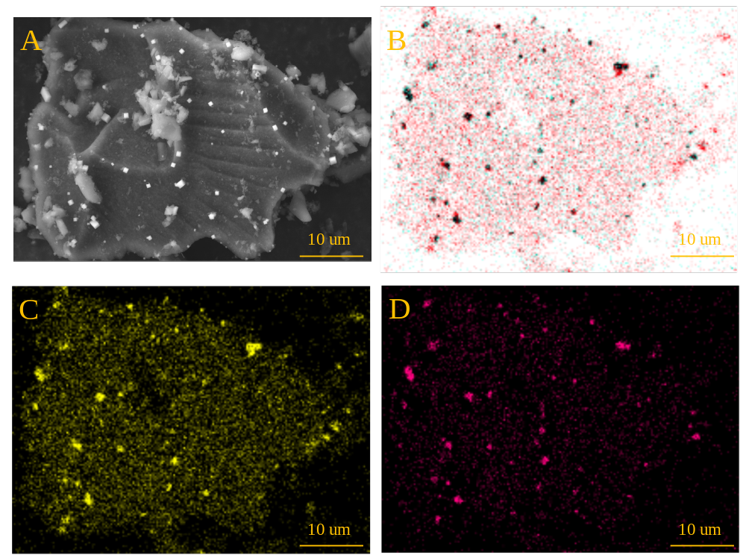
Fig. S2. SEM observation of individual ^{w}R_{E}⁰ carbon shard (A). Localisation of the LiCl (red) and KCl (black) crystals (B), obtained from the differences between Cl (C) and K (D) EDS elemental mapping. If Cl is observed while K is absent, it should be attributed to the LiCl species.
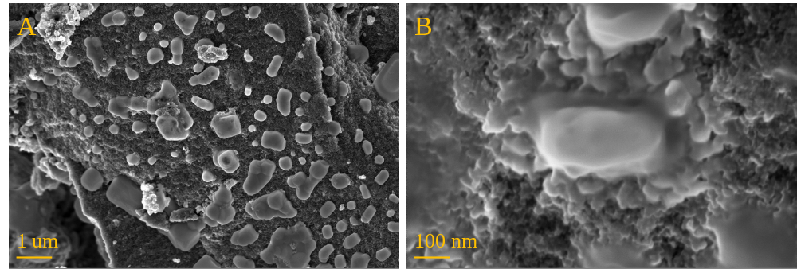
Fig. S3 SEM observation of ^{w}R_{E}⁵⁶.
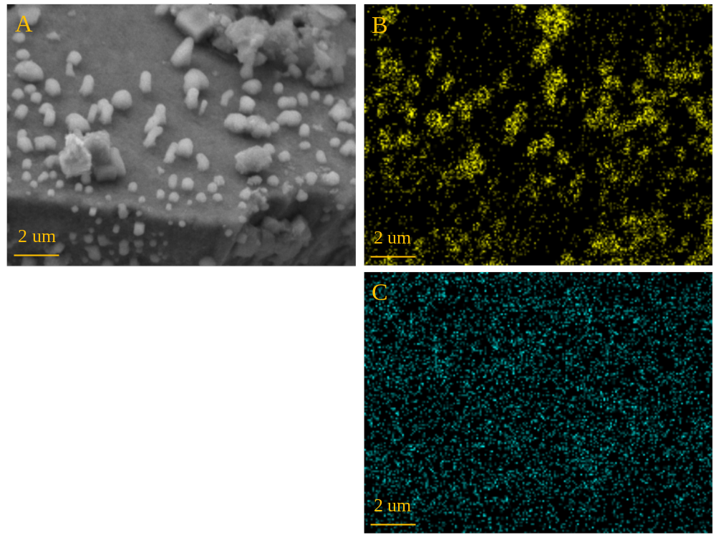
Fig. S4 SEM observation of ^{w}R_{E}⁵⁶ (A) with K (B) and Cl (C) EDS elemental mapping.

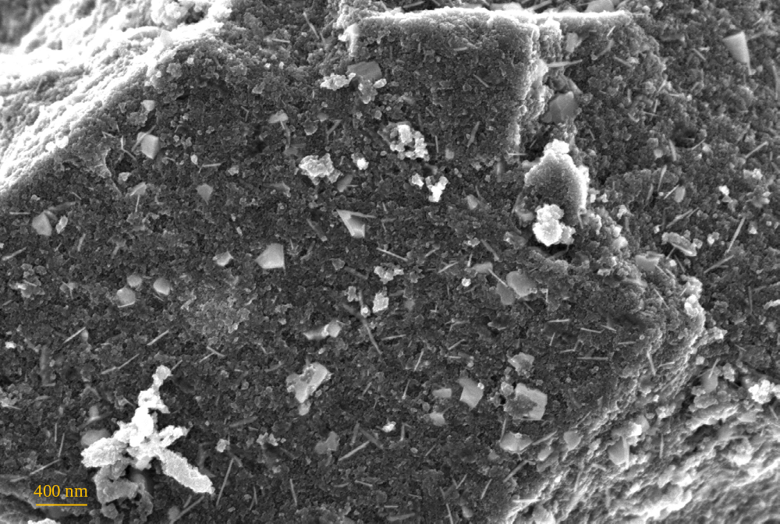
Fig. S5 SEM observation of c-^{w}R_{E}⁵⁶.
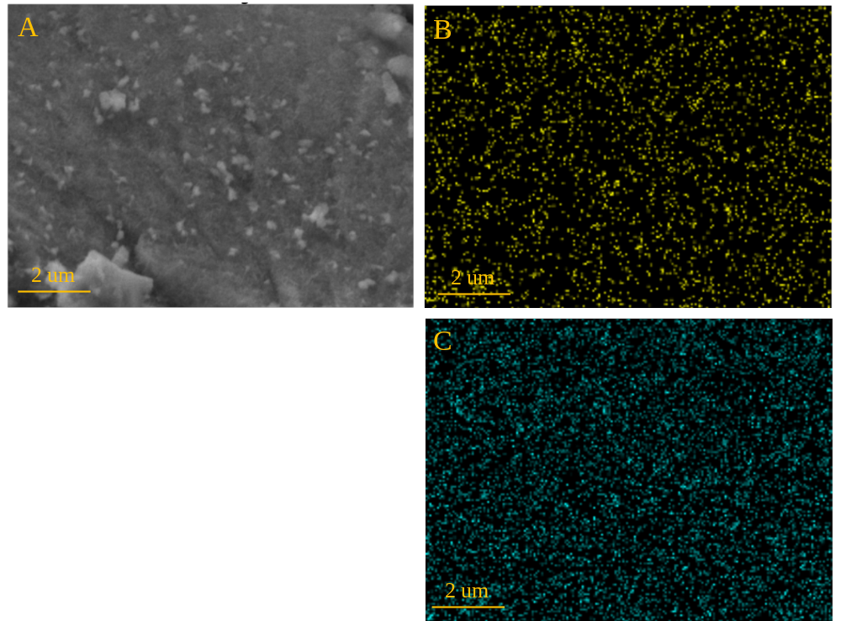
Fig. S6 SEM observation of c-^{w}R_{E}⁵⁶ (A) with K (B) and Cl (C) EDS elemental mapping.

