Supplementary Information

Algoriphagus limicola sp. nov., isolated from marine mud: genome-based taxonomy and carotenoid-associated features

Eunseo Cho · Yuna Park · Jung-Sook Lee · Jung-Hoon Yoon · Wonyong Kim

Fig. S1. Maximum-likelihood tree inferred under the Tamura–Nei model from 16S rRNA gene sequences, showing the position of CAU 1675ᵀ among related taxa. Echinicola pacifica DSM 19836ᵀ (MT758060) was used as the outgroup. Bootstrap values ≥50% from 1,000 replicates are shown. Bar, 0.05 substitutions per site.
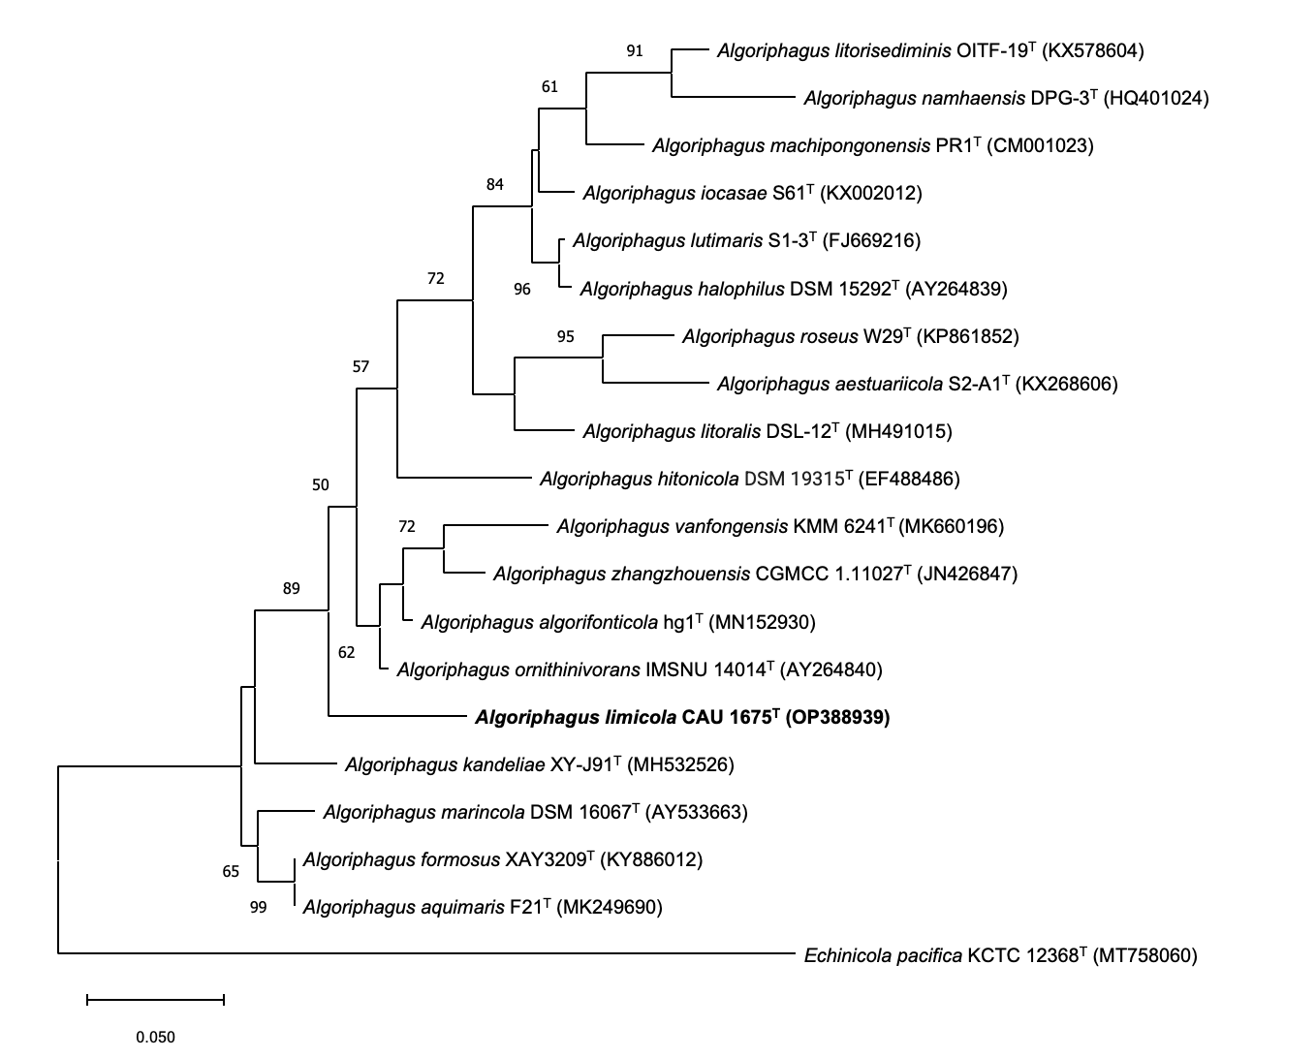

Fig. S2. Maximum-parsimony tree based on 16S rRNA gene sequences, showing the position of CAU 1675ᵀ among related taxa. Echinicola pacifica DSM 19836ᵀ (MT758060) was used as the outgroup. Bootstrap values ≥50% from 1,000 replicates are shown.
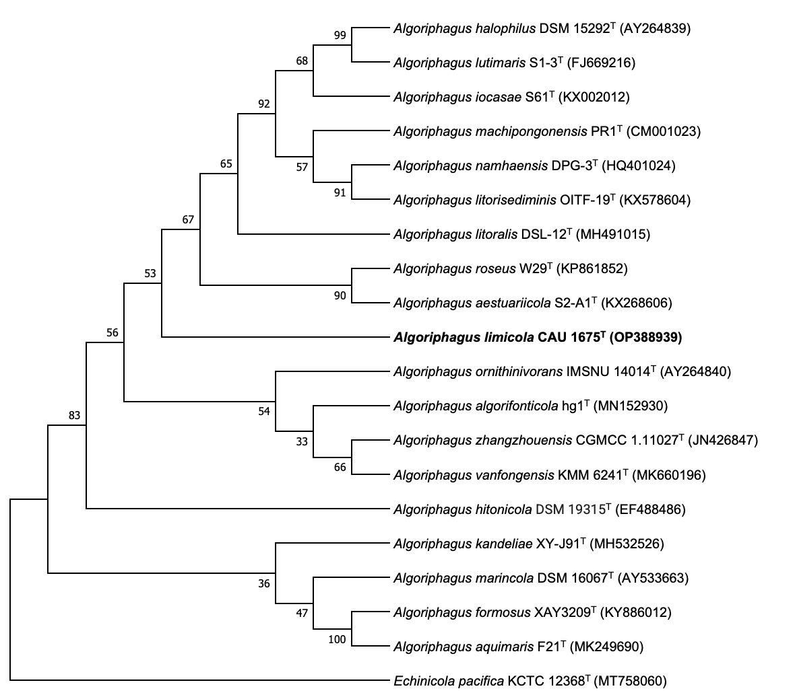

Fig. S3. Split heat map of pairwise ANIb and AAI values among CAU 1675ᵀ and four related type strains. The upper triangle shows ANIb values and the lower triangle shows AAI values.
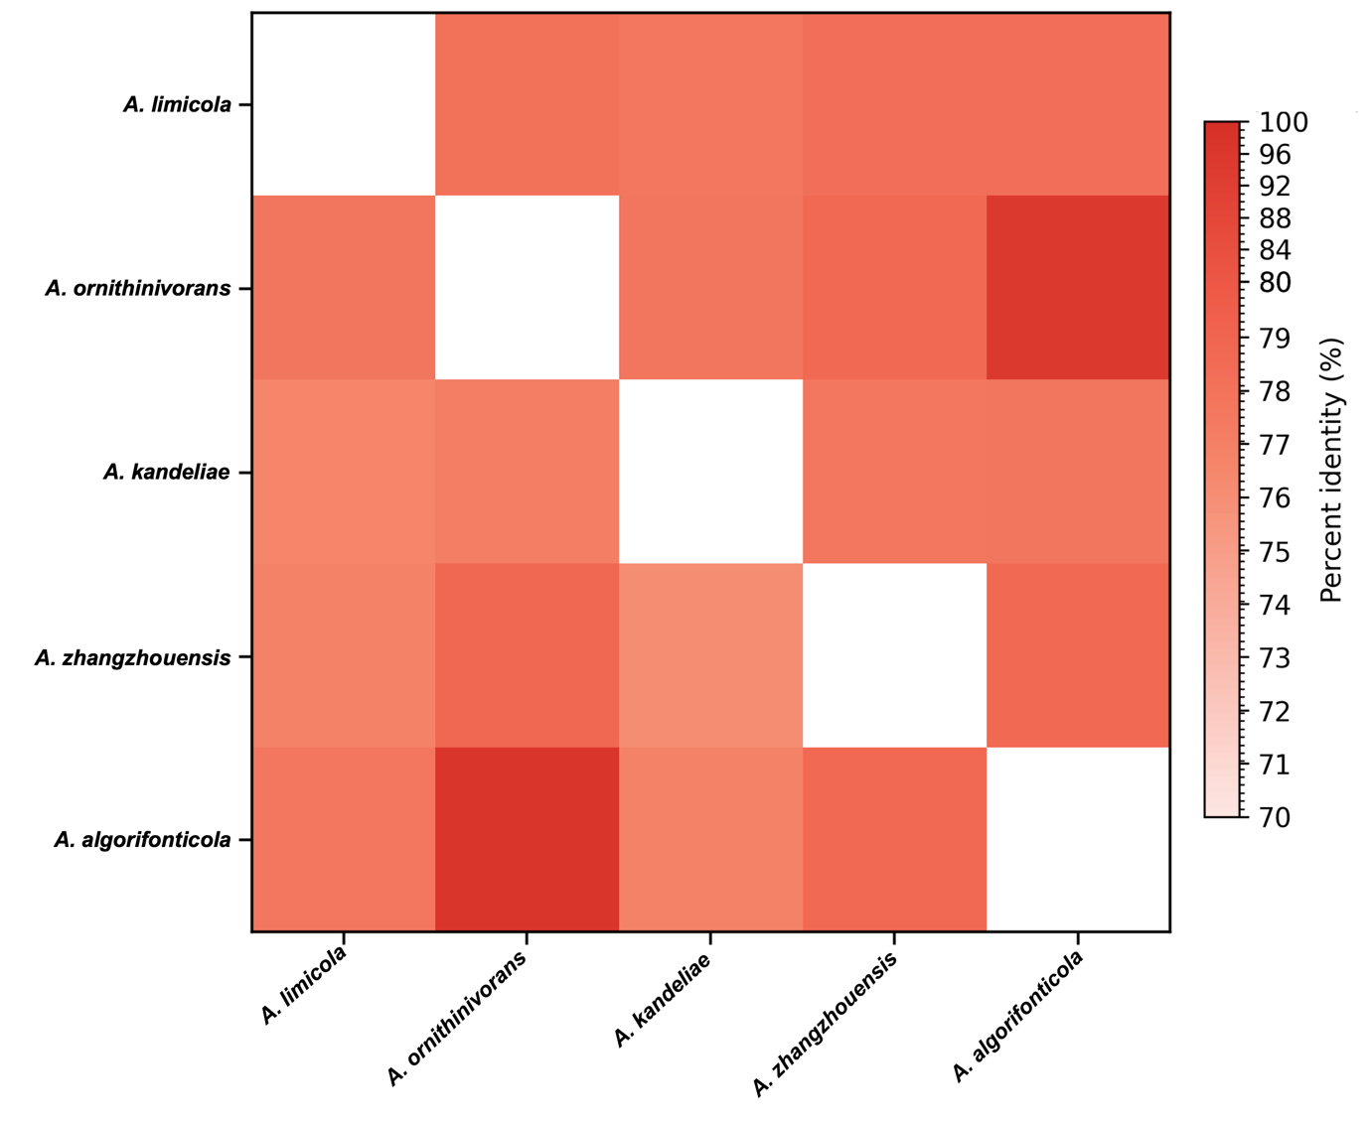

Fig. S4. RAST subsystem annotation of the CAU 1675ᵀ genome, showing subsystem coverage, category distribution and feature counts.
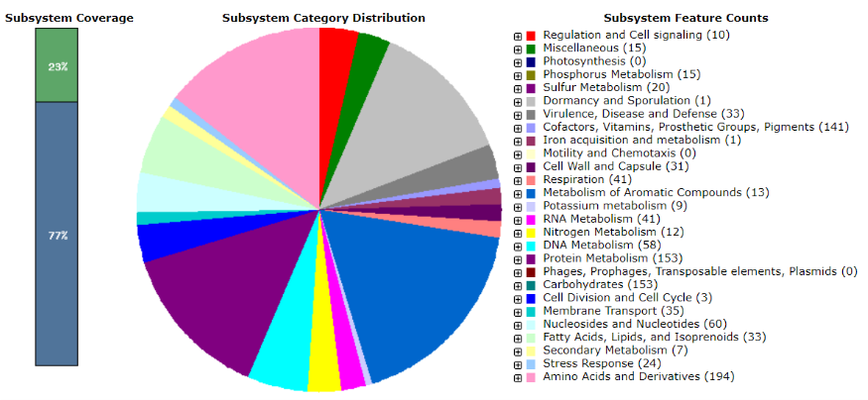

Fig. S5. antiSMASH-based analysis of terpene-associated biosynthetic gene clusters in CAU 1675ᵀ. (A) Predicted biosynthetic gene clusters, including terpene/terpene-precursor and RRE-containing regions. (B, C) Comparison of the carotenoid-associated terpene region with Algoriphagus sp. KK10202C. (D) Putative pathway products inferred from antiSMASH and BlastKOALA annotations.
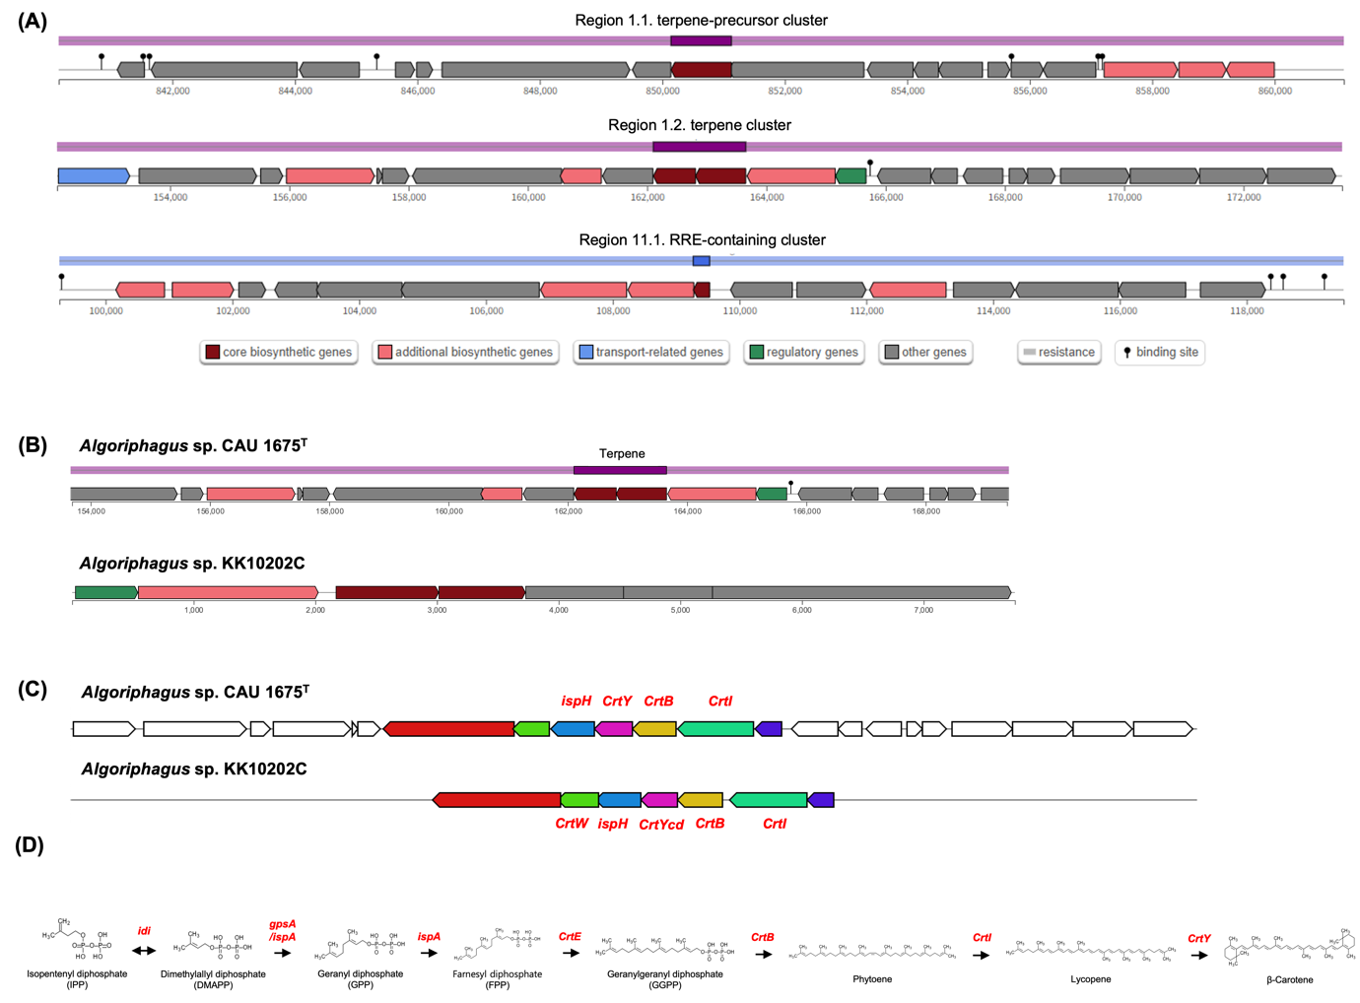

Fig. S6. Distribution of predicted proteins from CAU 1675ᵀ among COG functional categories.
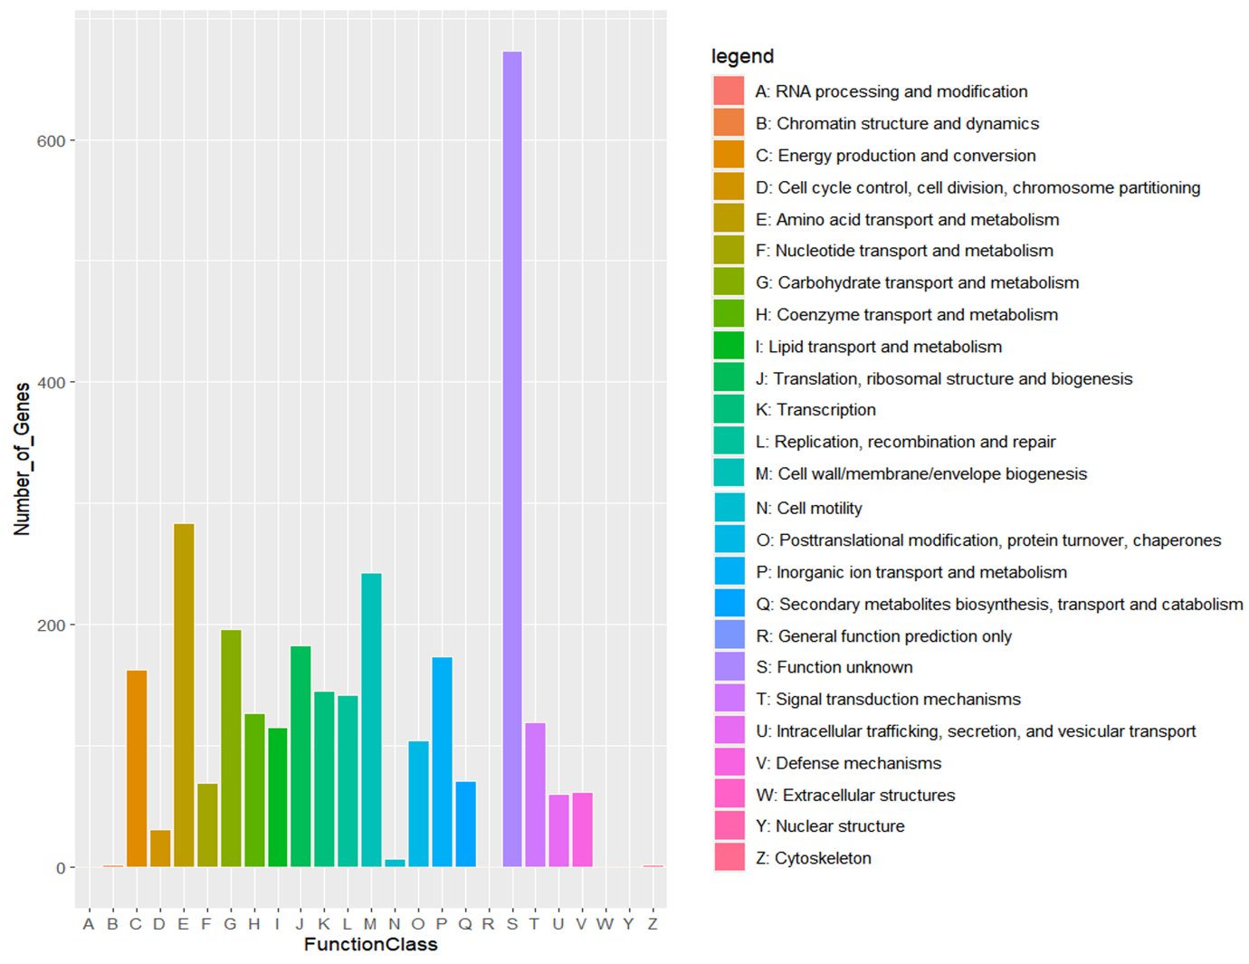

Fig. S7. Orthologous gene clusters shared among CAU 1675ᵀ and four related Algoriphagus type strains, visualised with OrthoVenn3.
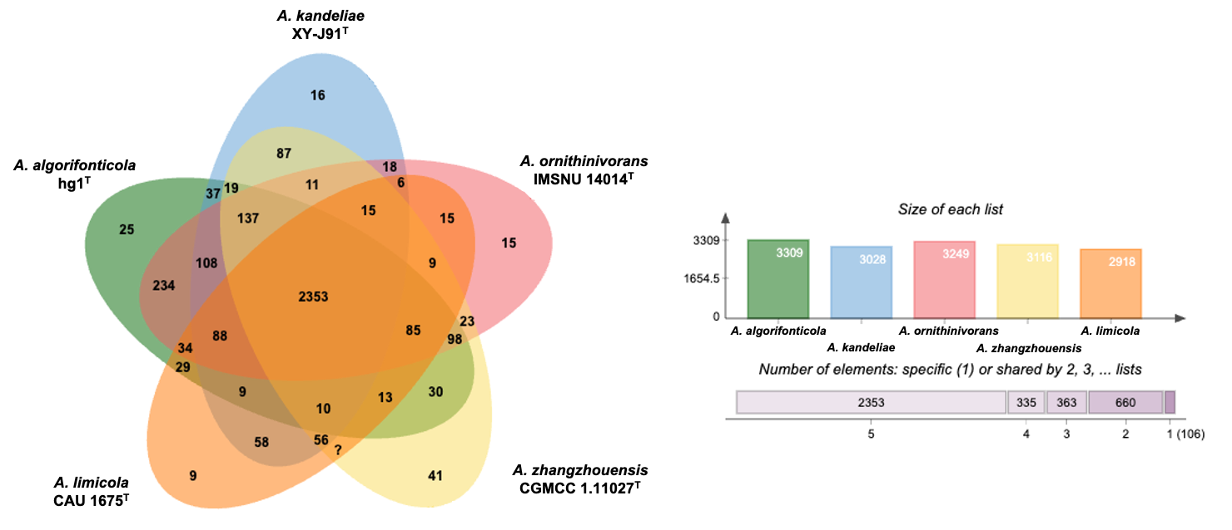

Fig. S8. UV–visible absorption spectrum (230–800 nm) of the methanolic cell extract of CAU 1675ᵀ. The absorption maximum is 476 nm, consistent with a carotenoid-type pigment.
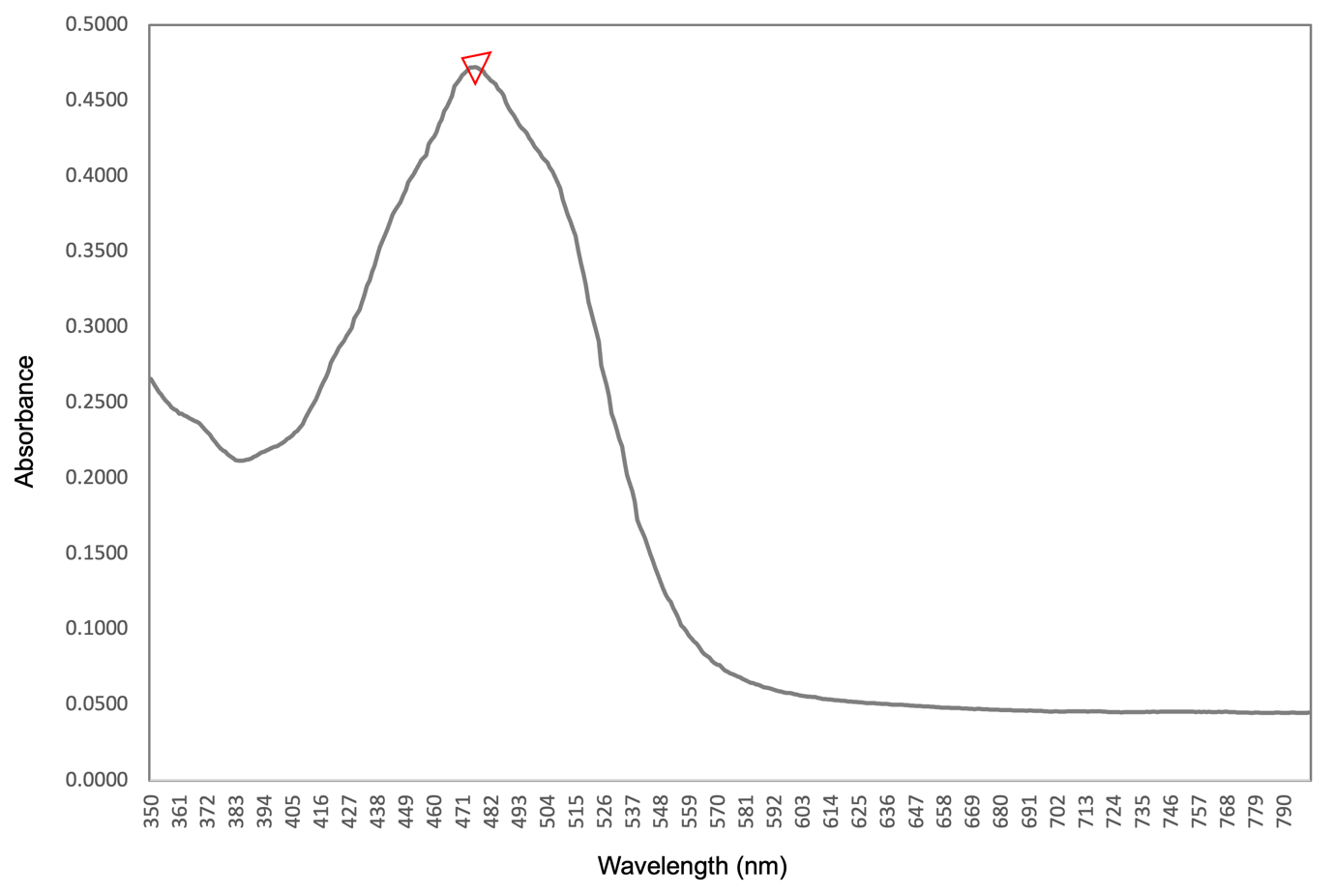

Fig. S9. Transmission electron micrograph of CAU 1675ᵀ grown on marine agar for 3 days at 30 °C. Bar, 200 nm.
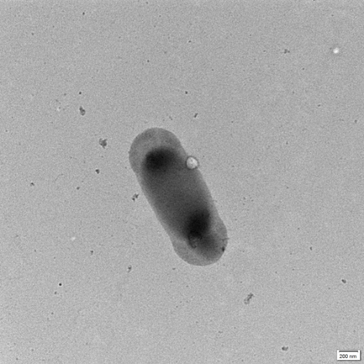

Fig. S10. Disc diffusion assay of CAU 1675ᵀ. Discs: (A) clindamycin, 2 μg; (B) erythromycin, 15 μg; (C) chloramphenicol, 30 μg; (D) ampicillin, 10 μg; (E) tetracycline, 30 μg; (F) vancomycin, 30 μg; (G) kanamycin, 30 μg; (H) streptomycin, 10 μg.
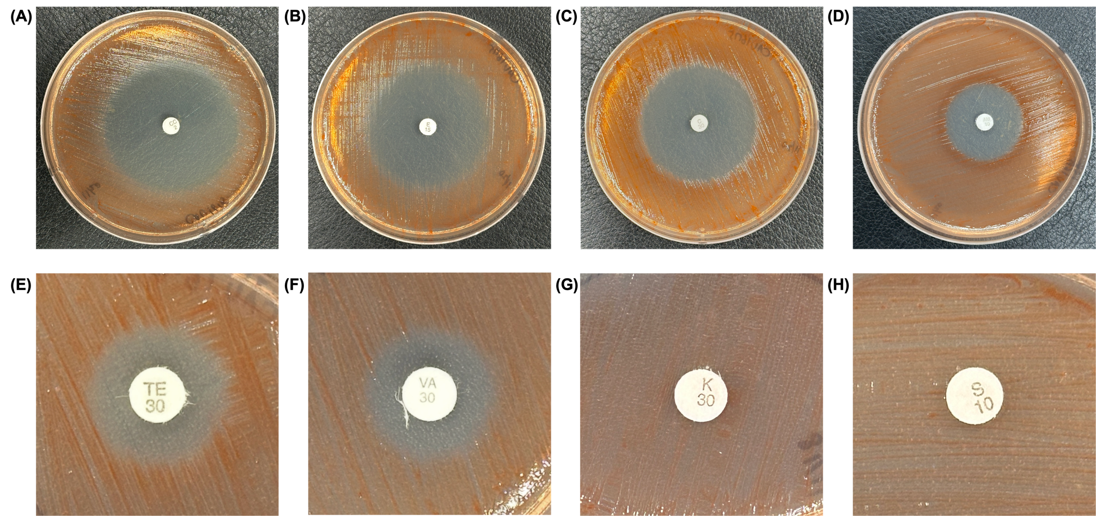

Supplementary tables

Table S1. ANIb, dDDH and AAI values (%) between CAU 1675ᵀ and four related type strains. Strains: 1, A. ornithinivorans IMSNU 14014ᵀ; 2, A. kandeliae XY-J91ᵀ; 3, A. zhangzhouensis CGMCC 1.11027ᵀ; 4, A. algorifonticola hg1ᵀ.
Values (%) | 1 | 2 | 3 | 4
ANIb | 72.5 | 71.8 | 72.1 | 72.5
dDDH | 17.2 | 16.7 | 17.0 | 16.9
AAI | 77.8 | 76.6 | 76.9 | 77.6

Table S2. RAST subsystem feature counts for CAU 1675ᵀ and four related Algoriphagus type strains. Strains: 1, CAU 1675ᵀ; 2, A. ornithinivorans IMSNU 14014ᵀ; 3, A. kandeliae XY-J91ᵀ; 4, A. zhangzhouensis CGMCC 1.11027ᵀ; 5, A. algorifonticola hg1ᵀ.
Subsystem feature counts | 1 | 2 | 3 | 4 | 5
Cofactors, vitamins, prosthetic groups, pigments | 141 | 140 | 138 | 140 | 145
Cell wall and capsule | 31 | 31 | 34 | 31 | 33
Virulence, disease and defence | 33 | 31 | 31 | 31 | 36
Potassium metabolism | 9 | 10 | 10 | 10 | 10
Photosynthesis | 0 | 0 | 0 | 0 | 0
Miscellaneous | 15 | 17 | 16 | 18 | 15
Phages, prophages, transposable elements, plasmids | 0 | 0 | 0 | 0 | 0
Membrane transport | 35 | 37 | 41 | 37 | 13
Iron acquisition and metabolism | 1 | 0 | 1 | 0 | 4
RNA metabolism | 41 | 39 | 40 | 39 | 43
Nucleosides and nucleotides | 33 | 60 | 58 | 60 | 59
Protein metabolism | 153 | 149 | 117 | 149 | 151
Cell division and cell cycle | 3 | 3 | 3 | 3 | 3
Motility and chemotaxis | 0 | 0 | 0 | 0 | 0
Regulation and cell signalling | 10 | 13 | 13 | 13 | 14
Secondary metabolism | 7 | 7 | 6 | 7 | 7
DNA metabolism | 58 | 59 | 49 | 59 | 63
Fatty acids, lipids and isoprenoids | 33 | 26 | 25 | 26 | 26
Nitrogen metabolism | 12 | 13 | 13 | 13 | 13
Dormancy and sporulation | 1 | 1 | 1 | 1 | 1
Respiration | 41 | 41 | 48 | 41 | 46
Stress response | 24 | 21 | 22 | 21 | 21
Metabolism of aromatic compounds | 13 | 12 | 14 | 12 | 14
Amino acids and derivatives | 194 | 200 | 194 | 200 | 203
Sulfur metabolism | 20 | 16 | 12 | 16 | 12
Phosphorus metabolism | 15 | 15 | 18 | 15 | 15
Carbohydrates | 153 | 125 | 158 | 125 | 125

Table S3. Putative secondary-metabolite biosynthetic gene clusters predicted in the CAU 1675ᵀ genome using antiSMASH version 8.0.4.
Region | Contig | From | To | Type | Most similar cluster | No. of genes (core/additional/regulatory/transport/other)
1.1 | Contig 1 | 152,105 | 173,654 | terpene | carotenoid | 2/3/1/1/15
1.2 | Contig 1 | 840,143 | 861,129 | terpene-precursor | – | 1/3/0/0/14
11.1 | Contig 2 | 99,271 | 119,528 | RRE-containing | – | 1/5/0/0/10

Table S4. Comparative CAZyme profiles of CAU 1675ᵀ and four related Algoriphagus type strains. Strains: 1, CAU 1675ᵀ; 2, A. ornithinivorans IMSNU 14014ᵀ; 3, A. kandeliae XY-J91ᵀ; 4, A. zhangzhouensis CGMCC 1.11027ᵀ; 5, A. algorifonticola hg1ᵀ.
No. | GHs | GTs | PLs | CEs | CBMs | AAs | Total
1 | 102 | 62 | – | 26 | 29 | 10 | 229
2 | 98 | 86 | 2 | 18 | 23 | 9 | 236
3 | 92 | 88 | – | 22 | 26 | 10 | 238
4 | 130 | 89 | 3 | 25 | 38 | 14 | 299
5 | 94 | 75 | – | 18 | 26 | 9 | 222
average | 103.2 | 80.0 | 1.0 | 21.8 | 28.4 | 10.4 | 250.3

