Alternative Clustering approaches
Minimum spanning trees generated without inclusion of hsp65 sequence data (Figure S1) exhibited reduced discriminatory resolution, resulting in the clustering of isolates with different hsp65 codes despite these representing distinct strain types. Inclusion of hsp65 sequence data therefore improved strain differentiation and cluster separation.
An alternative MST based on epidemiological clustering criteria and predefined allelic distance thresholds (Figure S2) grouped related strain types into broader clusters. Despite differences in cluster composition, the overall population structure remained consistent across all approaches, with a small number of dominant lineages coexisting alongside numerous rare strain types.
The composition of epidemiological clusters is provided in Additional File 1: Table S4.
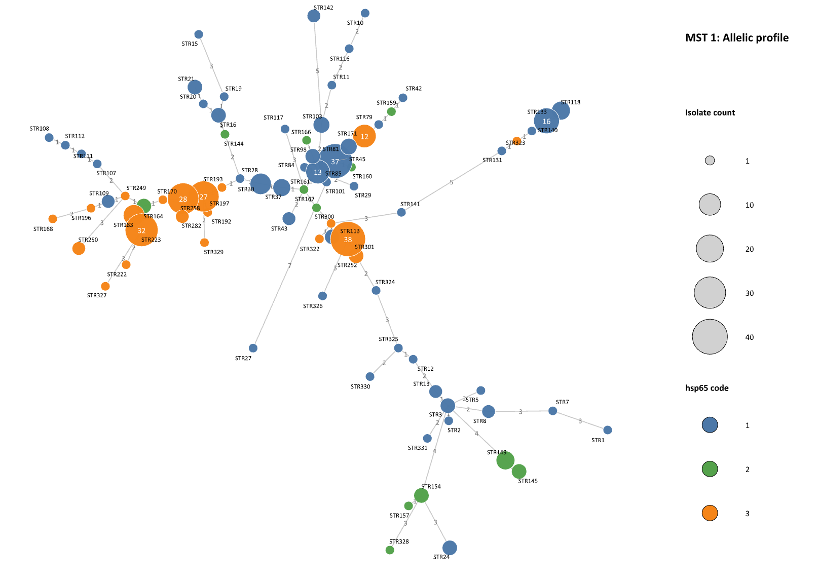
Figure S1. Minimum spanning tree (MST) of MAH isolates based on VNTR allelic profiles without inclusion of hsp65. Each node represents a strain type, and node size reflects the number of isolates. Edges indicate allelic differences between strain types. Compared to Figure 3, exclusion of hsp65 results in reduced discriminatory resolution, with partial merging of strain types into larger clusters
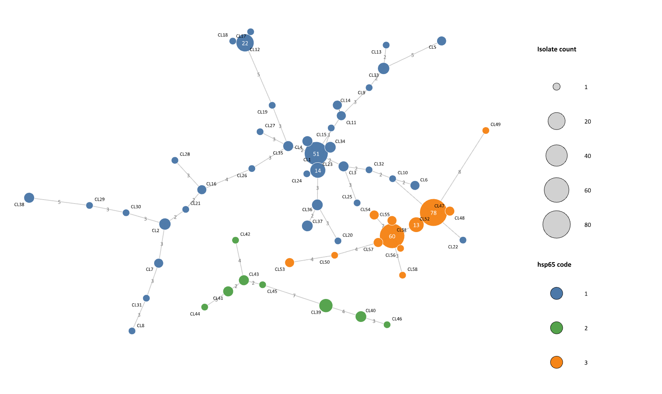
Figure S2. Minimum spanning tree (MST) of MAH isolates based on epidemiological clustering using predefined allelic distance thresholds (≤1 allelic difference for isolates collected between 2020–2022 and ≤2 for comparisons involving 2015 isolates). Distances are calculated based on a representative profile within the cluster. Each node represents a cluster type, and node size reflects the number of isolates. Clustering results in grouping of genetically related strain types into broader clusters, facilitating epidemiological interpretation while reducing fine-scale genetic resolution.

