Appendix 4: Remote Patient Monitoring Patient Materials
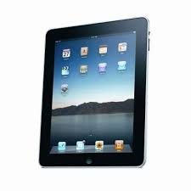

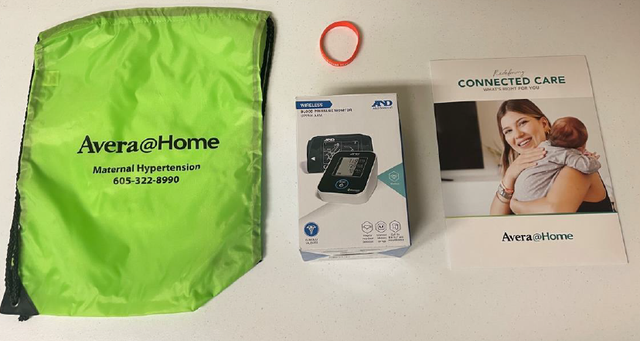
Hypertension identification bracelet
Bag to carry all materials
Blood pressure education material
Bluetooth blood pressure cuff
Tablet if patient does not have a compatible device

