Projection of Droughts in Amu Darya River basin for Shared Socioeconomic Pathways

Obaidullah Salehie ^{1,2}, Mohammed Magdy Hamed ³, Tarmizi bin Ismail ¹, Shamsuddin Shahid¹

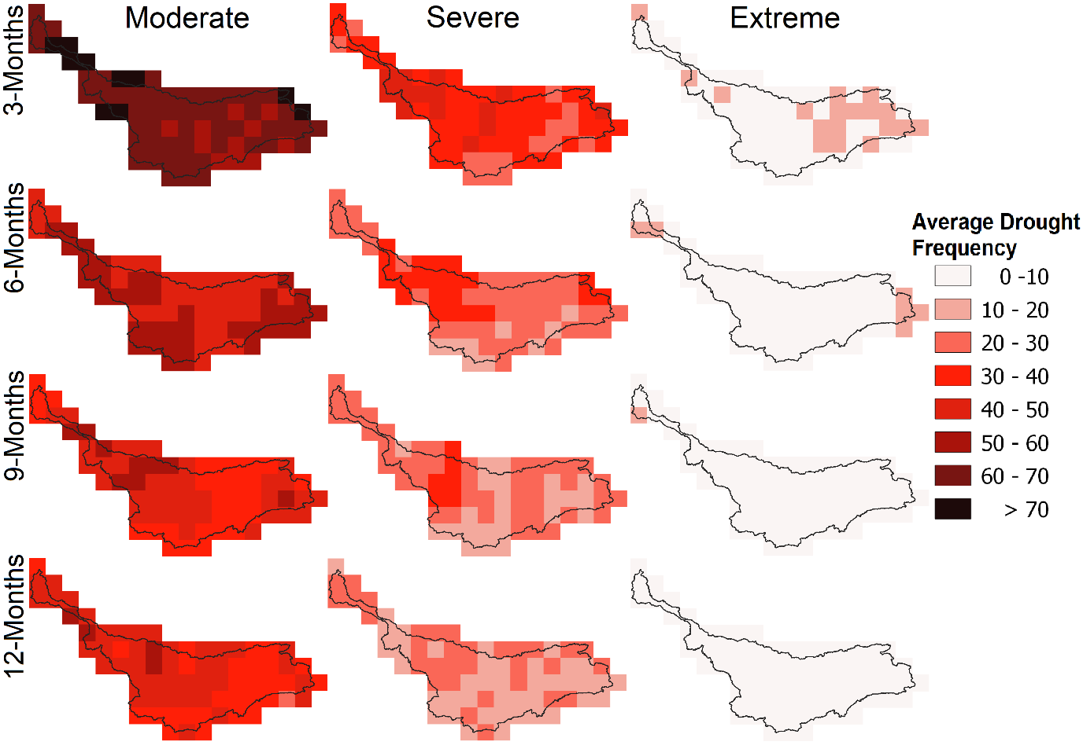
Figure S-1. Average drought frequency estimated for CMCC-ESM2 for the historical period (1975-2014).

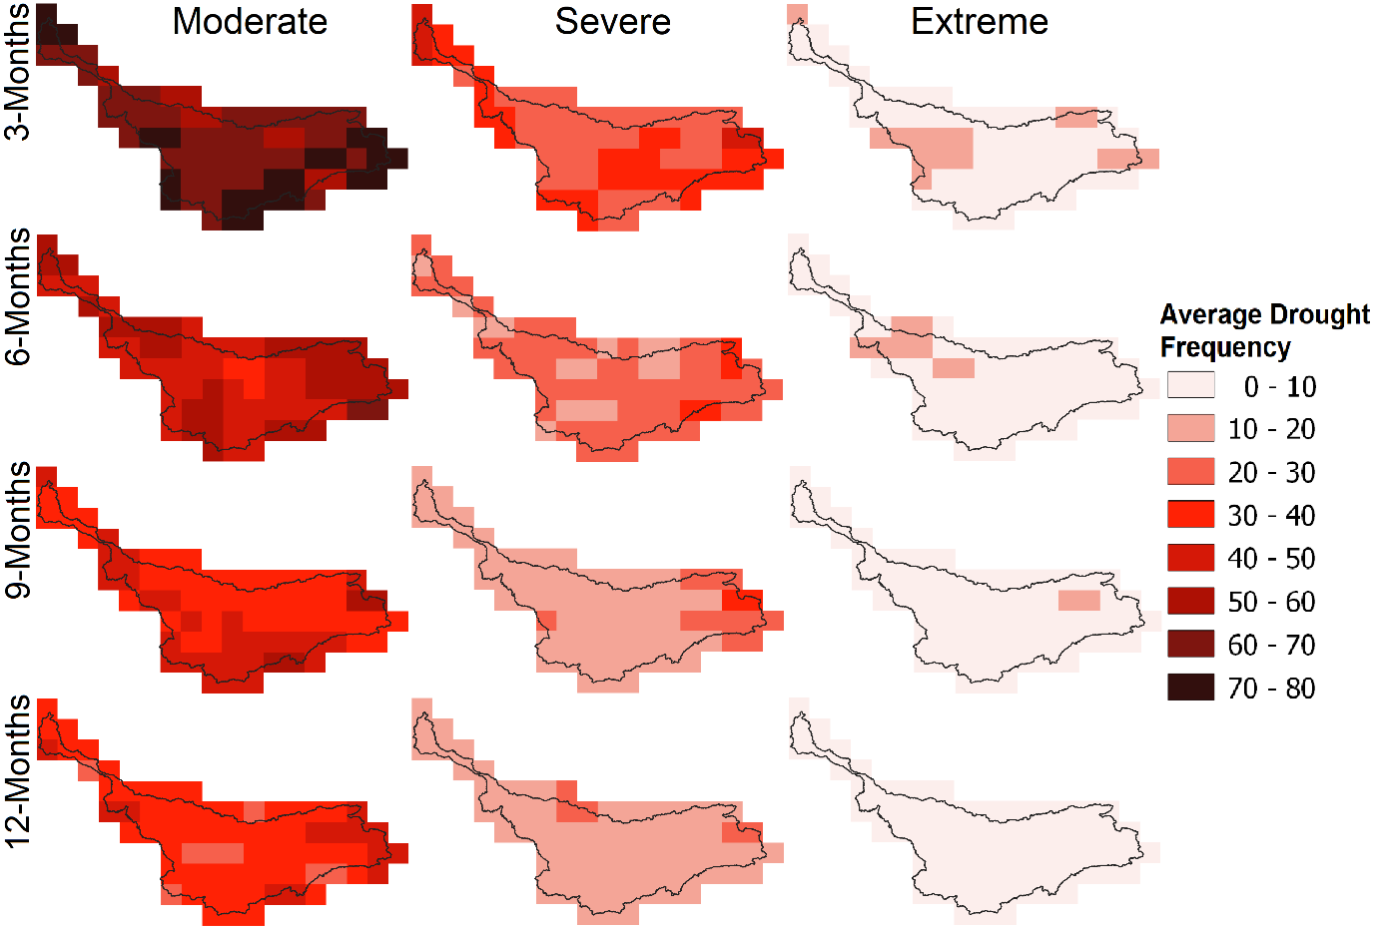
Figure S-2. Average drought frequency estimated for INM-CM4-8 for the historical period (1975-2014).

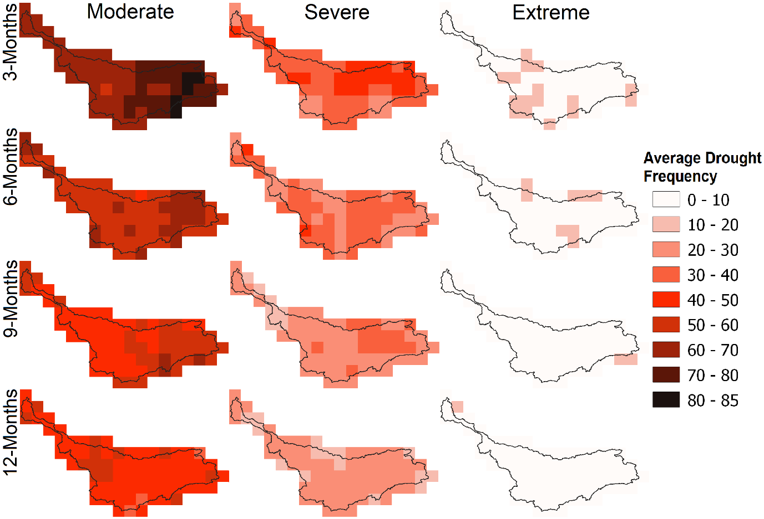
Figure S-3. Average drought frequency estimated for MPI-ESM1-2-LR for the historical period (1975-2014).

Table S-1. General circulation models (GCMs) used in this study.
No | Model name | Institution | Country | Resolution
1 | ACCESS-CM2 | Australian Community Climate and Earth System Simulator coupled model | Australia | 1.2°×1.8°
2 | ACCESS-ESM1-5 | Australian Community Climate and Earth System Simulator (ACCESS) and Earth System Model (ESM) | Australia | 1.2°×1.8°
3 | AWI-CM-1-1-MR | Alfred Wegener Institute Climate Model | Germany | 0.9°×0.9°
4 | BCC-CSM2-MR | Beijing Climate Center climate system model version 2 | China | 1.1°×1.1°
5 | CanESM5 | Canadian Earth System Model version 5 | Canada | 2.8°×2.8°
6 | CMCC-CM2-SR5 | Euro-Mediterranean Centre on Climate Change coupled climate model (standard configuration) | Europe | 1°×1°
7 | CMCC-ESM2 | Fondazione Euro-Mediterranean Center on Climate Change | Italy | 0.9°×0.9°
8 | EC-Earth3 | EC-Earth consortium | Europe | 0.7°×0.7°
9 | EC-Earth3-Veg | EC-Earth consortium | Europe | 0.7°×0.7°
10 | EC-Earth3-Veg-LR | EC-Earth consortium | Europe | 0.7°×0.7°
11 | FGOALS-g3 | Chinese Academy of Sciences-Flexible Global Ocean-Atmosphere-Land System Model Grid-Point Version 3 | China | 2.3°×2.0°
12 | GFDL-ESM4 | Geophysical Fluid Dynamics Laboratory | USA | 1.0°×1.3°
13 | INM-CM4-8 | Institute for Numerical Mathematics | Russia | 1.5°×2.0°
14 | INM-CM5-0 | Institute for Numerical Mathematics | Russia | 1.5°×2.0°
15 | IPSL-CM6A-LR | Institute Pierre-Simon Laplace | France | 1.3°×2.5°
16 | MIROC6 | Model for Interdisciplinary Research on Climate Version 6 | Japan | 1.4°×1.4°
17 | MPI-ESM1-2-HR | Max Planck Institute Earth System Model | Germany | 0.94°×0.94°
18 | MPI-ESM1-2-LR | Max Planck Institute Earth System Model | Germany | 1.875°×1.86°
19 | MRI-ESM2-0 | Meteorological Research Institute Earth System Model Version 2.0 | Japan | 1.125°×1.125°

