Supplementary Information
A Wearable IDC-Based Capacitive Sensing Belt for Real-Time Respiratory Monitoring and Weekly Athletic Performance Evaluation
Junaid Saddiqi¹*,Kasumawati binti Lias ¹*, Muzamil Ayoub¹
¹ University of Malaysia Sarawak Faculty of Engineering: Universiti Malaysia Sarawak Fakulti Kejuruteraan
*E-mails: 25020243@siswa.unimas.my , lkasumawati@unimas.my
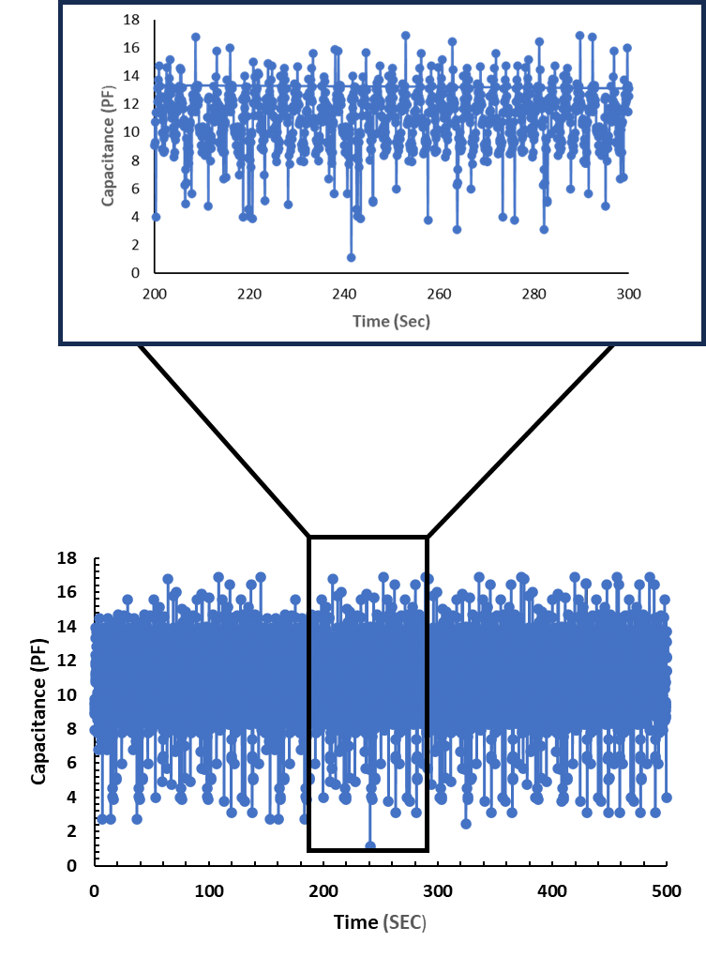

Fig. S1 500-second continuous respiratory signal showing stable and consistent breathing patterns.

Table S1: Comparative Analysis of Wearable Respiratory Monitoring Systems, Including Sensor Modalities, Limitations, and Proposed Improvements
Reference Study | Sensor Type | Working Principle | Motion Artifact Handling | Sensitivity / Characterization | Setup | Limitation | Overcoming Strategy in proposed study
Kim and Kim – 2024[1] | Embroidered textile capacitive sensor + 1D CNN | Capacitive breathing signal classification using deep learning | Partially handled using ML filtering, still affected in motion similarity cases | ~45 kHz feature-based classification, accuracy dataset-dependent | Controlled lab, limited subjects | Requires large labeled dataset; poor generalization in motion-similar patterns | The proposed system avoids heavy ML dependency and uses real-time capacitive modeling with adaptive filtering, improving robustness in dynamic motion conditions
Honda et al. – 2022[2] | Flexible humidity sensor (ZnIn₂S₄) | Exhaled breath humidity variation detection | Poor robustness under ambient humidity changes | Long-term stability (>150 h), humidity sensitivity | Mask-based wearable | Strong environmental dependency (humidity and ambient variation) | Proposed study removes environmental dependency by using diaphragm motion based capacitive sensing instead of humidity variation
MAIN Shirt – 2014[3] | Magnetic induction textile sensor | Eddy current change due to chest expansion | Highly sensitive to posture and motion artifacts | Chest displacement-dependent signal variation | Shirt-based system | Strong posture and body movement sensitivity | The proposed belt design focuses on localized diaphragm motion, reducing posture dependency and improving stability during movement
PVDF Nasal Sensor – 2013[4] | Piezoelectric PVDF film | Airflow-induced deformation → electrical output | Sensitive to facial motion and placement errors | Moderate accuracy vs RIP system | Clinical setup | Invasive placement and unstable positioning | The proposed wearable belt is non-facial and torso-based, improving comfort and reducing placement sensitivity
Smart Clothing (ECG + impedance) – 2018[5] | ECG + bioimpedance + IMU fusion | Chest impedance changes for respiration estimation | Partially reduced using sensor fusion, still motion affected | Multi-modal signal processing improves accuracy | Wearable garment | Complex multi-sensor system requiring calibration | This uses a single-sensor capacitive system, reducing complexity while maintaining reliable respiration tracking
IMU-Based System – 2023[6] | IMU (accelerometer + gyroscope) | Motion-based respiratory estimation | Strong motion artifact sensitivity and posture variation | Moderate estimation accuracy after filtering | Wireless wearable | Indirect measurement with strong motion contamination | The proposed system directly measures diaphragm displacement via capacitance, improving physiological specificity and reducing motion interference
Proposed Work | IDC-based capacitive wearable belt | Diaphragm motion → fringing electric field variation | Threshold-based filtering + real-time artifact suppression | High linearity (R² = 0.98561), sensitivity = 1.1846 pF/N, low hysteresis, stable repeatability | Real-time wearable system | — | Integrates motion-robust capacitive sensing, direct physiological measurement, and adaptive filtering to eliminate major limitations of prior works in a single unified system

References:
[1] J. Kim and J. Kim, “Deep Learning Integration for Normal Breathing Classification Using a Flexible Fiber Sensor,” Processes, vol. 12, no. 12, Nov. 2024, doi: 10.3390/pr12122644.
[2] S. Honda, H. Hara, T. Arie, S. Akita, and K. Takei, “A wearable, flexible sensor for real-time, home monitoring of sleep apnea,” iScience, vol. 25, no. 4, p. 104163, Mar. 2022, doi: 10.1016/j.isci.2022.104163.
[3] D. Teichmann, A. Kuhn, S. Leonhardt, and M. Walter, “The MAIN Shirt: A Textile-Integrated Magnetic Induction Sensor Array,” Sensors, vol. 14, no. 1, pp. 1039–1056, Jan. 2014, doi: 10.3390/s140101039.
[4] G. Roopa Manjunatha, K. Rajanna, D. R. Mahapatra, M. M. Nayak, U. M. Krishnaswamy, and R. Srinivasa, “Polyvinylidene fluoride film based nasal sensor to monitor human respiration pattern: an initial clinical study,” J. Clin. Monit. Comput., vol. 27, no. 6, pp. 647–657, Dec. 2013, doi: 10.1007/s10877-013-9486-x.
[5] C.-L. Shen et al., “Respiratory Rate Estimation by Using ECG, Impedance, and Motion Sensing in Smart Clothing,” J. Med. Biol. Eng., vol. 37, no. 6, pp. 826–842, 2017, doi: 10.1007/s40846-017-0247-z.
[6] A. Angelucci and A. Aliverti, “An IMU-Based Wearable System for Respiratory Rate Estimation in Static and Dynamic Conditions,” Cardiovasc. Eng. Technol., vol. 14, no. 3, pp. 351–363, 2023, doi: 10.1007/s13239-023-00657-3.

