Supplementary Methods
SM1. Structural variant calling: containers and per-caller settings
Both callers were run inside Docker containers, an in-house SpeedSeq image (tag 1.1, derived from SpeedSeq v0.1.2 with missing runtime dependencies restored) and dceoy/manta (v1.6.0), orchestrated by a Snakemake workflow, with per-sample read-group, splitter and discordant BAMs prepared by speedseq align. SpeedSeq was supplied with a BED file (speedseq sv -x exclude_non_main_chroms.bed) to omit auxiliary and unplaced reference sequences from calling.
SM2. Repeat annotation and exclusion resources
Because no species-specific transposable-element annotation was available for ETH_CapCap1, a de novo repeat library was built with RepeatModeler v2.0.7 (Flynn et al. 2020) and used to annotate repetitive content with RepeatMasker v4.2.1 (Smit et al. 2013–2015); the output was converted to merged BED intervals. Two independent exclusion resources were defined. First, putative centromeric and telomeric regions were inferred from tandem-repeat density alone: TRF v4.10.0-rc.2 (parameters 2 7 7 80 10 50 500) was run genome-wide, tandem-repeat density was computed in 100-kb windows, and windows at or above the genome-wide 95th percentile were merged into an exclusion BED covering 155.7 Mb (4.9% of the assembly). Second, a genome-wide repeat-exclusion BED was derived from the full RepeatMasker annotation, including simple repeats and low-complexity sequence, covering 1,432.7 Mb (45.0% of the assembly). Prior to per-sample consensus merging, Manta and SpeedSeq VCFs were filtered against the centromere/telomere BED using a ≥ 50% breakpoint-overlap rule with 200-bp symmetric windows around each breakpoint (Cameron et al. 2019; Stuart et al. 2023).
SM3. Inversion normalisation
Because Manta encodes inversions as paired BND (breakend) records rather than canonical SVTYPE=INV entries, Manta's convertInversion.py script (implemented in our pipeline as convert_inversions_sv.py) was applied to each Manta VCF, converting matched breakend pairs into proper INV records. This harmonised the inversion representation between Manta and SpeedSeq/LUMPY and allowed type-aware merging in the consensus step.
SM4. Per-sample filtering
Manta calls were restricted to variants flagged PASS by the caller (bcftools view -f PASS). SpeedSeq/LUMPY calls were filtered with bcftools v1.21 (Danecek et al. 2021) to retain variants with sample read depth ≥ 5 (FMT/DP ≥ 5) and to exclude homozygous-reference genotypes (GT != "0/0"). Before cross-caller merging, variants whose breakpoints overlapped centromeric or telomeric exclusion intervals (TRF-derived BED; ≥ 50% breakpoint overlap) were removed separately for each caller.
SM5. Per-sample cross-caller consensus
Cross-caller consensus was performed separately for heterozygous (0/1) and homozygous-alternate (1/1) calls, ensuring that genotype class was preserved through merging rather than inferred post hoc from discordant caller genotypes. Genotype-stratified VCFs were merged across the two callers with SURVIVOR v1.0.7 (Jeffares et al. 2017), requiring support from both Manta and SpeedSeq with matching SV type and strand orientation, breakpoints within 1 kb, and a minimum variant length of 30 bp (SURVIVOR merge <list> 1000 2 1 1 0 30; the second parameter, 2, requires support from both callers). Heterozygous and homozygous-alternate consensus calls, each already representing two-caller consensus, were then combined into a single per-sample consensus VCF using a support threshold of 1 (SURVIVOR merge <list> 1000 1 1 1 0 30), which recombines the two genotype-stratified sets without re-imposing the two-caller requirement.
SM6. Population-level merging and filtering
Per-sample consensus VCFs were merged across individuals with SURVIVOR v1.0.7 using the same breakpoint distance (1 kb), SV-type and strand-matching, and minimum length (30 bp) criteria, but requiring support from only one sample (SURVIVOR merge cohort.list 1000 1 1 1 0 30), producing a multi-sample call set (cohort.unfiltered.vcf; 54 samples). Four individuals were excluded from cohort merging (LME0125, LME1467, LME1469, LME4650). In the merged VCF, inter-contig breakends are labelled SVTYPE=TRA by SURVIVOR; we treat these as breakend (BND) calls rather than validated chromosomal translocations. Missing genotypes were retained as ./. in the cohort VCF. Variants whose genomic intervals overlapped RepeatMasker-annotated repetitive elements were removed (cohort.no_repeats.vcf; 5,830 variants retained from 37,814 input records). An alternative mask excluding only simple repeats and low-complexity sequence (cohort.no_simple_repeats.vcf; 7,593 variants) was evaluated in exploratory runs but was not used for the final structure figures.
SM7. Bioinformatic pipeline parameters. fastp: sliding-window Q20, -q 20 -u 30 -l 50, poly-G clipping (-g). Read groups: ID = flowcell.lane; SM = sample; LB = sample; PL = ILLUMINA; PU = flowcell.lane. Joint genotyping: GenomicsDBImport with a batch size of 25 samples and eight reader threads. Variant IDs: PLINK --set-all-var-ids @:#:$r:$r:a. ROH: recombination rate 1.2 × 10⁻⁸, HW-to-autozygosity transition probability 6.7 × 10⁻⁸, indels excluded.
SM8. Structural-variant PCA, ADMIXTURE and DAPC — full parameters.
PCA: because PLINK's --pca handles symbolic SV records poorly, PCA was performed in R; the imputed sample-by-variant dosage matrix was centred (not scaled) and analysed with prcomp() (base stats), and the first two PCs were plotted in ggplot2 (Wickham 2016) with colours/shapes matching the SNP analysis.
ADMIXTURE: the imputed dosage matrix (1,027 loci) was converted to PLINK binary format (PLINK v1.9; Purcell et al. 2007; Chang et al. 2015). Unsupervised estimation was run for K = 1–10 with 10 replicates per K (different seeds); the optimal K was chosen by lowest five-fold cross-validation error (--cv=5), and Q matrices from the best-likelihood replicate were retained. Bar plots were generated in R with individuals ordered by country.
DAPC: for SNPs, the LD-pruned set was imported with read.PLINK() as a genlight object and evenly subsampled to ~110,000 loci; for SVs the imputed 0/1/2 dosage matrix was imported directly. The optimal number of unsupervised clusters was inferred with find.clusters() by BIC (K = 3 for SNPs; K = 2 for SVs). Supervised DAPC used country of origin as a priori groups (n.da = 2); the number of retained PCs was selected by α-score optimisation (optim.a.score(); n.pca = 5 for SNPs), and a conservative n.pca = 5 was applied where α-score optimisation was undefined on the sparse SV matrix. xvalDapc() was not run for the final figures. Robustness was assessed at 70%, 80% and 90% per-locus missingness and on a strict 65-locus panel (≤ 30% missingness).
SM9. SNP population-genomic analyses — parameters. π was computed with VCFtools --window-pi 10000 (per-site diversity summed and divided by window width, including monomorphic sites; population-level π = mean across windows). The PLINK 2 --het inbreeding coefficient was F = (O − E)/(N − E), with O and E the observed and expected numbers of homozygous genotypes per individual under Hardy–Weinberg expectations. HWE departures (--hardy) were inspected at three p-value thresholds (1×10⁻², 1×10⁻³, 1×10⁻⁶) to assess filter adequacy. ADMIXTURE Q-matrices were visualised as CLUMPAK-aligned ancestry proportions; sample-to-population assignment for F~ST~ was read from the project metadata file by the workflow's 01_fst_pairwise.sh script. The Mantel statistic was the Pearson product-moment correlation between the genetic and geographic distance matrices.

Supplementary material

Figure S1. Geographic distribution of sampled Capreolus capreolus individuals included in this study. Sampling locations in Slovenia (n = 27), Poland (n = 24), and France (n = 7) are shown using different marker colours.

Table S1. Data on the European roe deer individuals included in the study. Quality-control notes are also reported (percentage of reads retained after fastp trimming and overall mapping rate).
Sample ID | Location* | Country | Latitude | Longitude | Sex | Haplotype | % retained | % mapped
LME6032 | LPN Fazan Beltinci | Slovenia | 46.559 | 16.210 | Male | Cc33 | 97.23 | 99.86
LME6033 | LPN Fazan Beltinci | Slovenia | 46.586 | 16.179 | Male | Cc23 | 97.21 | 99.89
LME6035 | LPN Fazan Beltinci | Slovenia | 46.586 | 16.179 | Male | Cc27 | 97.05 | 99.78
LME0125 | LPN Ljubljanski vrh | Slovenia | 45.935 | 14.353 | / | Cc24 | 94.63 | 50.78
LME0128 | LD Mlinše | Slovenia | 46.143 | 14.869 | / | Cc38 | 97.83 | 99.46
LME0129 | LPN Medved | Slovenia | 45.622 | 15.114 | / | Cc39 | 97.23 | 95.84
LME0322 | LPN Snežnik Kočevska Reka | Slovenia | 45.639 | 14.780 | / | Cc41 | 97.37 | 99.98
LME0326 | LPN Snežnik Kočevska Reka | Slovenia | 45.549 | 14.806 | / | Cc21 | 97.61 | 99.72
LME1466 | LD Koper | Slovenia | 45.588 | 13.729 | Female | Cc30 | 98.47 | 99.97
LME1467 | LD Koper | Slovenia | 45.543 | 13.730 | Female | Cc30 | 98.07 | 99.95
LME1468 | LD Koper | Slovenia | 45.588 | 13.729 | Female | Cc30 | 98.07 | 99.96
LME1469 | LD Koper | Slovenia | 45.561 | 13.781 | Female | Cc37 | 97.93 | 99.96
LME6127 | LD Oljka (Veliki Vrh) | Slovenia | 46.316 | 15.060 | / | Cc32 | 96.59 | 99.95
LME1474 | Triglav National Park | Slovenia | 46.363 | 13.808 | Female | Cc26 | 97.31 | 99.98
LME1475 | Triglav National Park | Slovenia | 46.363 | 13.808 | Female | Cc31 | 97.53 | 99.97
LME1476 | Triglav National Park | Slovenia | 46.363 | 13.808 | Female | Cc31 | 97.49 | 99.97
LME1478 | Triglav National Park | Slovenia | 46.363 | 13.808 | Female | Cc38 | 97.15 | 99.97
LME1479 | Triglav National Park | Slovenia | 46.363 | 13.808 | Female | Cc31 | 97.87 | 99.98
LME6129 | LD Oljka | Slovenia | 46.316 | 15.060 | / | Cc40 | 97.07 | 99.80
LME4448 | LD Gračišče | Slovenia | 45.444 | 13.859 | Male | Cc29 | 97.60 | 99.87
LME4449 | LD Koper (Lazaret) | Slovenia | 45.593 | 13.731 | Male | Cc38 | 97.74 | 99.86
LME4450 | LD Izola | Slovenia | 45.522 | 13.674 | Male | Cc29 | 97.76 | 99.85
LME4451 | LD Mozirje (Brezje) | Slovenia | 46.343 | 14.938 | Male | Cc31 | 97.80 | 99.81
LME4452 | LD Mozirje (Lepa njiva) | Slovenia | 46.372 | 14.979 | Male | Cc25 | 97.74 | 99.83
LME4457 | LD Oljka (Brezovec) | Slovenia | 46.336 | 15.061 | Male | Cc28 | 97.78 | 99.84
LME4867 | LD Oljka (Veliki Vrh) | Slovenia | 46.345 | 15.043 | Male | Cc32 | 97.38 | 99.86
LME4868 | LD Oljka (Veliki Vrh) | Slovenia | 46.345 | 15.053 | Male | Cc22 | 97.59 | 99.89
LME5951 | Ciechanów | Poland | 52.824 | 20.702 | Male | Cc13 | 95.43 | 97.34
LME4615 | Ciechanów | Poland | 52.871 | 20.607 | Male | Cc14 | 97.69 | 99.84
LME4617 | Ciechanów | Poland | 52.871 | 20.607 | Male | Cc19 | 97.90 | 99.86
LME6701 | Strzałowo | Poland | 53.776 | 21.441 | Female | / | 95.24 | 99.96
LME4626 | Mikołajki | Poland | 53.802 | 21.578 | Male | Cc10 | 97.73 | 99.86
LME4631 | Mikołajki | Poland | 53.802 | 21.578 | Male | Cc16 | 97.66 | 99.85
LME4633 | Mikołajki | Poland | 53.802 | 21.578 | Male | Cc11 | 97.64 | 99.87
LME4635 | Spychowo | Poland | 53.599 | 21.343 | Female | Cc17 | 97.75 | 99.96
LME4644 | Ciechanów | Poland | 53.802 | 21.578 | Female | Cc18 | 98.43 | 99.96
LME4650 | Strzałowo | Poland | 53.776 | 21.441 | Female | Cc15 | 97.37 | 99.96
LME4654 | Mikołajki | Poland | 53.802 | 21.578 | Female | Cc17 | 96.62 | 99.80
LME6702 | Strzałowo | Poland | 53.776 | 21.441 | Female | / | 96.19 | 99.96
LME5356 | Mikołajki | Poland | 53.783 | 21.554 | Female | Cc16 | 95.49 | 99.04
LME5917 | Strzałowo | Poland | 53.767 | 21.456 | Female | Cc16 | 94.65 | 99.85
LME5918 | Strzałowo | Poland | 53.766 | 21.451 | Female | Cc9 | 95.27 | 99.31
LME5926 | Mikołajki | Poland | 53.764 | 21.592 | Male | Cc20 | 95.97 | 96.07
LME5930 | Mikołajki | Poland | 53.779 | 21.557 | Male | Cc17 | 94.59 | 97.31
LME5933 | Mikołajki | Poland | 53.913 | 21.629 | Female | Cc20 | 95.42 | 99.97
LME5937 | Ciechanów | Poland | 52.811 | 20.592 | Female | Cc19 | 93.90 | 99.64
LME5949 | Ciechanów | Poland | 52.827 | 20.707 | Male | Cc12 | 93.95 | 98.25
LME5950 | Ciechanów | Poland | 52.824 | 20.705 | Male | Cc18 | 95.74 | 98.92
LME6712 | Strzałowo | Poland | 53.776 | 21.441 | Female | / | 96.84 | 99.98
LME2595 | Saint-Gaudens | France | 43.148 | 0.745 | / | Cc35 | 97.57 | 99.93
LME2598 | Aulon | France | 43.176 | 0.818 | / | / | 97.36 | 99.93
LME2601 | Cazeneuve-Montaut | France | 43.186 | 0.866 | / | / | 96.84 | 99.97
LME2602 | Mondavezan | France | 43.260 | 1.037 | / | Cc36 | 97.60 | 99.94
LME2608 | Saint-Michel | France | 43.152 | 1.076 | / | / | 97.45 | 99.98
LME2609 | Palaminy | France | 43.197 | 1.075 | / | Cc34 | 97.73 | 99.98
LME2613 | Salles-sur-Garonne | France | 43.288 | 1.184 | / | / | 96.66 | 99.93
LME4625† | Mikołajki | Poland | 53.802 | 21.578 | Male | Cp9 | 97.73 | 99.86
LME5539† | Mikołajki | Poland | 53.783 | 21.523 | Female | Cp10 | 95.51 | 99.86
* For Slovenian samples, the name of the respective hunting ground (prefix LD/LPN) is provided, with the specific location given in parentheses when available.
† The Capreolus pygargus mtDNA haplotype was detected in this sample.

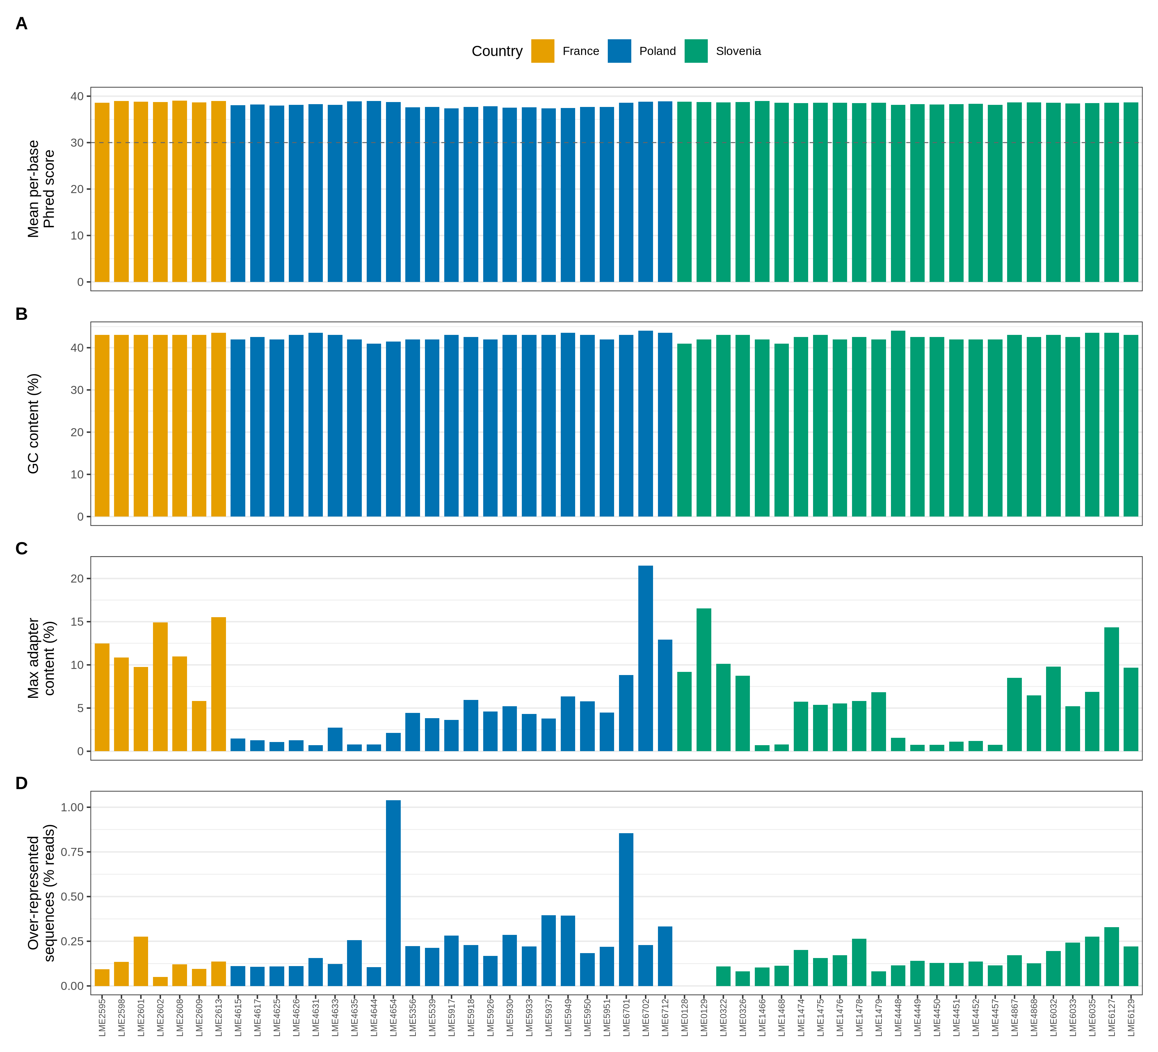
Figure S2. MultiQC summary of pre-trimming read quality. Per-sample mean per-base Phred score, GC content, adapter contamination and over-represented-sequence counts for all libraries, before fastp trimming, are shown from top to bottom.

Table S2. SNP filtering cascade. Number of variants retained at each successive filtering step: raw GATK output, after VariantFiltration PASS, biallelic SNPs only, sample subset (n = 54) with F_MISSING ≤ 0.9, PLINK --geno 0.05 + --maf 0.05, per-population HWE p ≥ 1×10⁻⁶, and after LD pruning (R² < 0.2).
Raw GATK joint-genotype output | VariantFiltration PASS | Biallelic SNPs only | Sample subset (n = 54) | F_MISSING ≤ 0.9 | PLINK geno ≤ 0.05 + MAF ≥ 0.05 | HWE p ≥ 1×10⁻⁶ (per population) | LD pruning
31,197,788 | 28,199,612 | 24,014,927 | 24,014,927 | 23,977,506 | 10,954,471 | 10,948,074 | 778,950

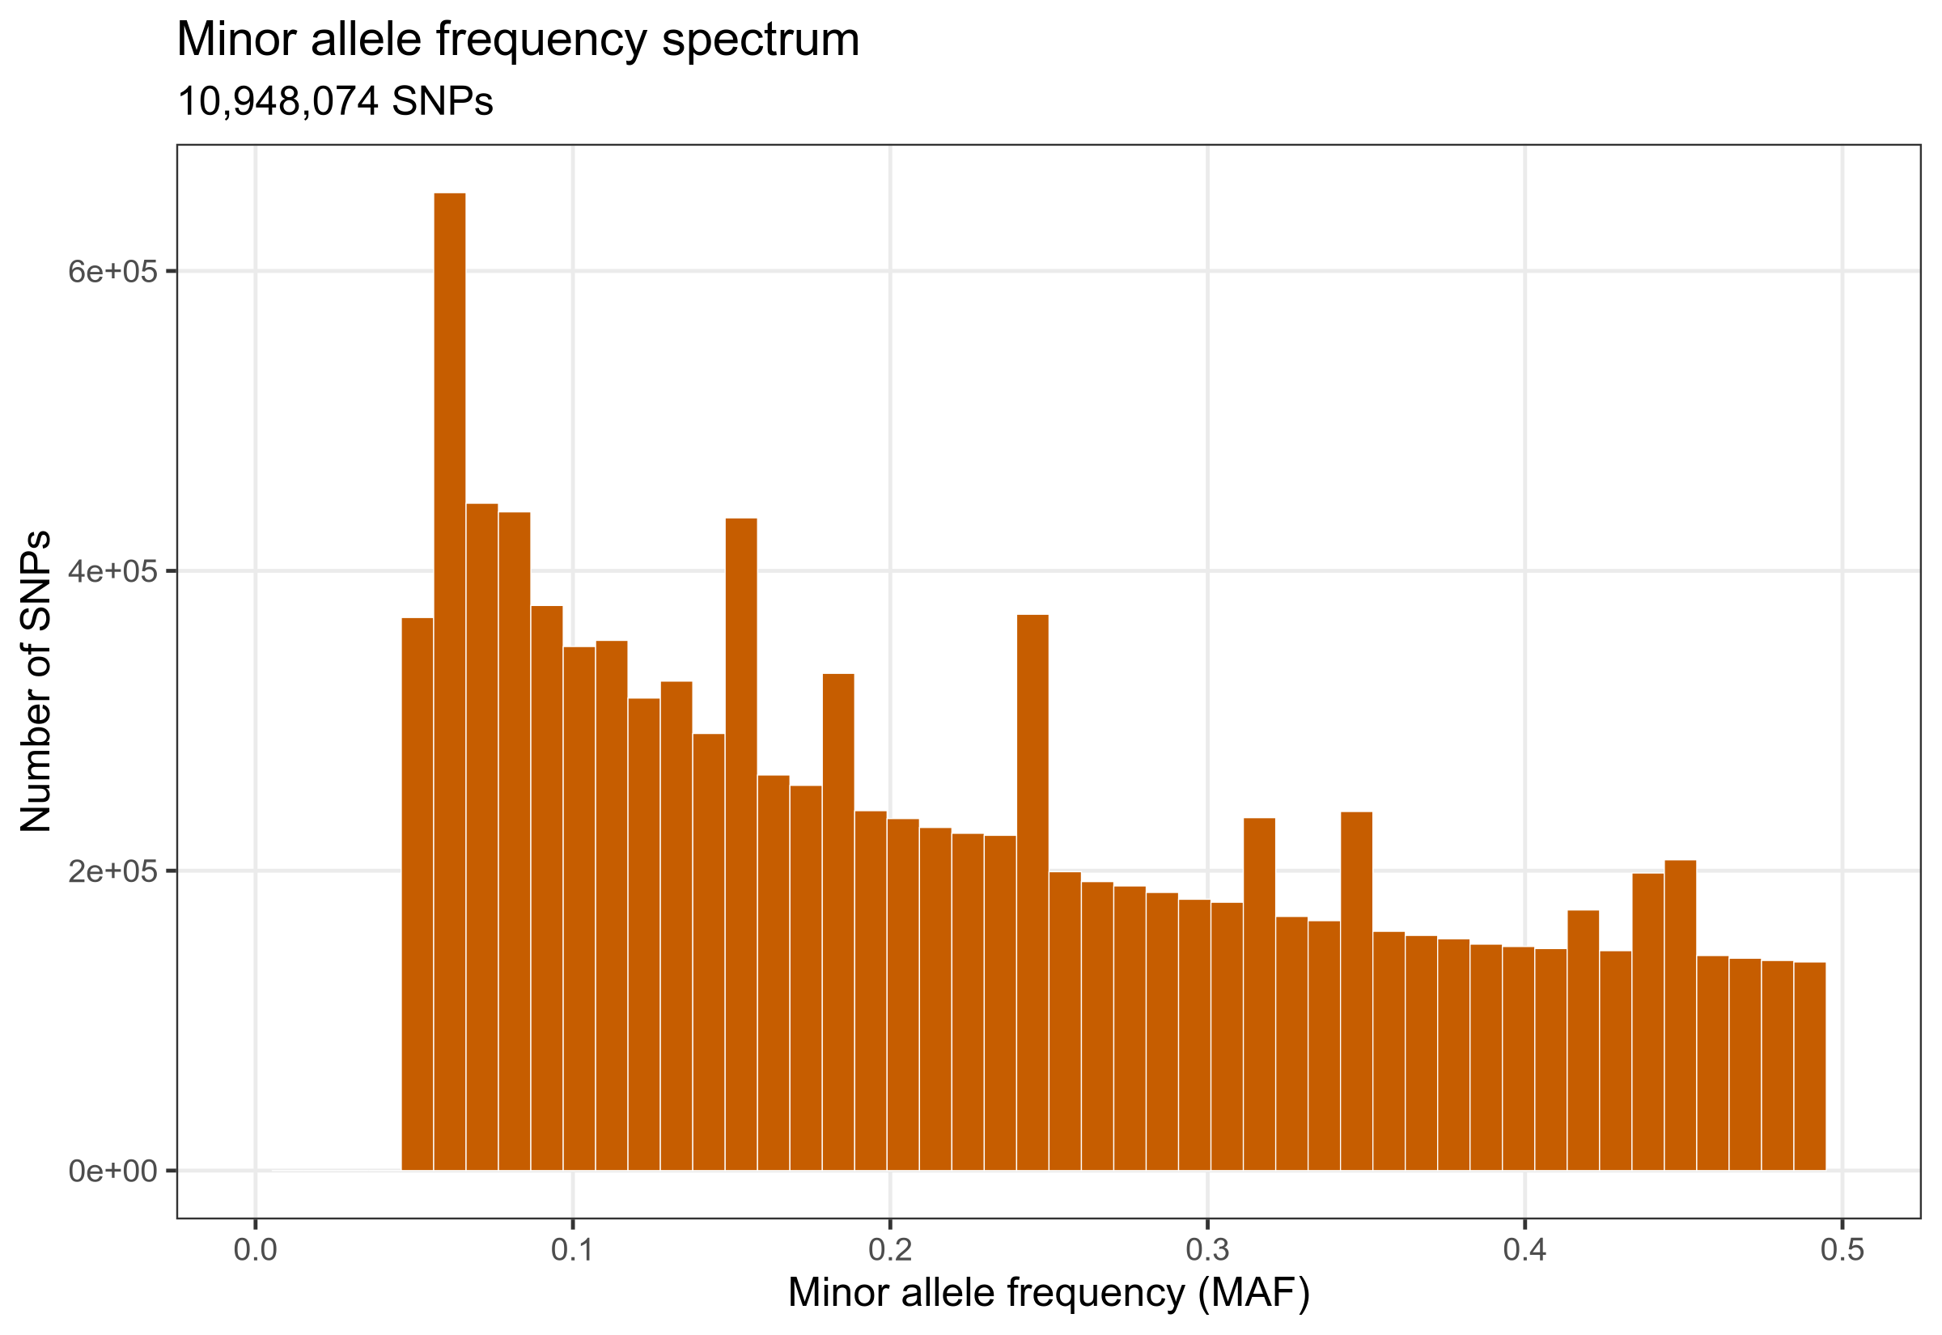
Figure S3. Minor-allele-frequency spectrum of the filtered SNP set. Distribution of MAF for 10,948,074 biallelic SNPs after --geno, MAF and HWE filtering.

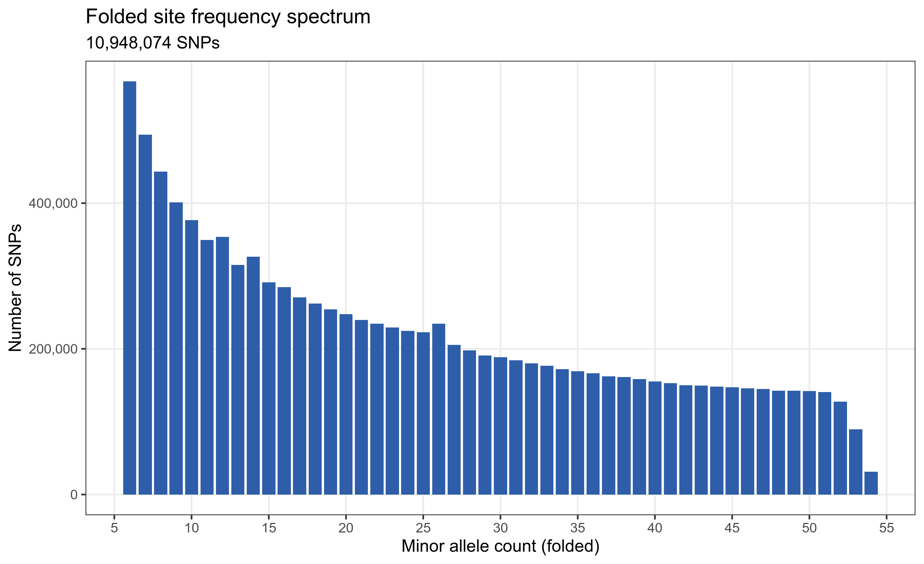
Figure S4. Genome-wide diversity spectra for SNPs. Folded site-frequency spectrum of the filtered biallelic SNP set (MAF on the x-axis, count on the y-axis; 10,948,074 variants).

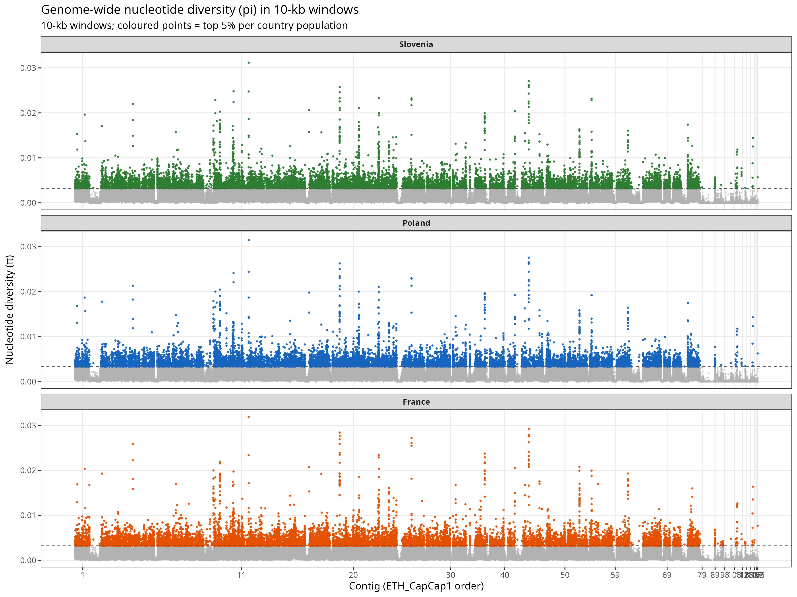Figure S5. Per-population genome-wide nucleotide diversity. Manhattan plot of nucleotide diversity (π) estimated in 10-kb sliding windows along the contigs of the C. capreolus ETH_CapCap1 assembly, shown separately for each country. Coloured dots above the horizontal dashed line indicate the top 5% most diverse windows across the genome.

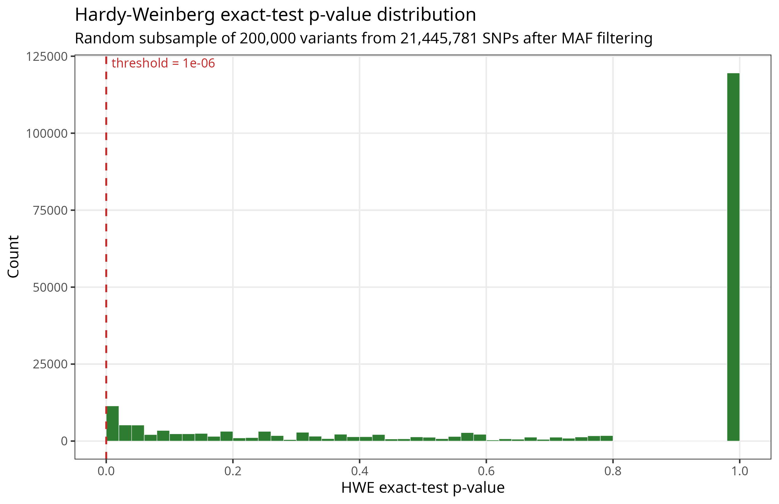
Figure S6. HWE p-value distribution of the SNP set. Histogram of Hardy–Weinberg exact-test p-values for a random subsample of 200,000 variants drawn from the 10,954,471 SNPs passing --geno 0.05 and --maf 0.05 on the missingness-filtered (unpruned) set (pooled across populations, pre-per-population HWE), with the p = 1×10⁻⁶ threshold marked. The distribution is approximately flat away from the 0/1 boundaries, consistent with well-calibrated genotyping and supporting the chosen HWE cut-off.

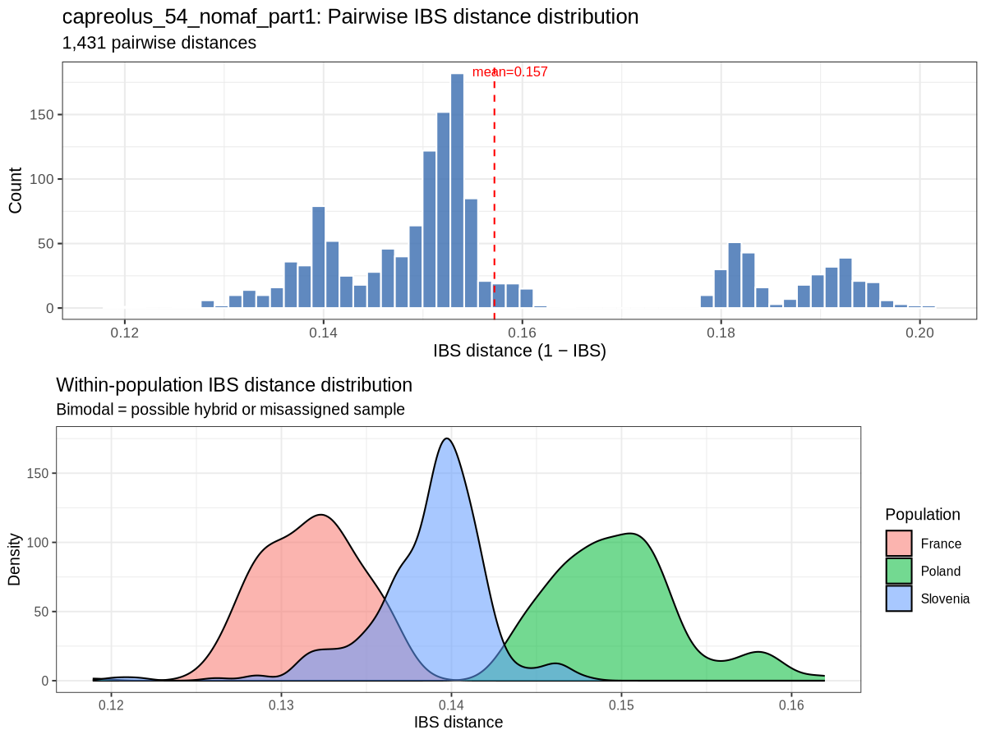
Figure S7. Genome-wide identity-by-state distance (IBS) distribution among C. capreolus individuals. Pairwise IBS distances were computed from the filtered SNP set with PLINK v1.9 (--distance square 1-ibs). Top: histogram of all pairwise IBS distances (1 − IBS; n = 1,431 pairs; mean 0.273; range 0.207–0.344). Bottom: within-population IBS distance distributions for Slovenia, Poland, and France. French individuals showed the lowest within-country IBS distances (mean 0.224), consistent with their restricted geographic sampling just to the north of the central Pyrenees rather than close kinship. No pairwise comparisons indicated parent–offspring or full-sibling relationships (maximum KING kinship 0.123).
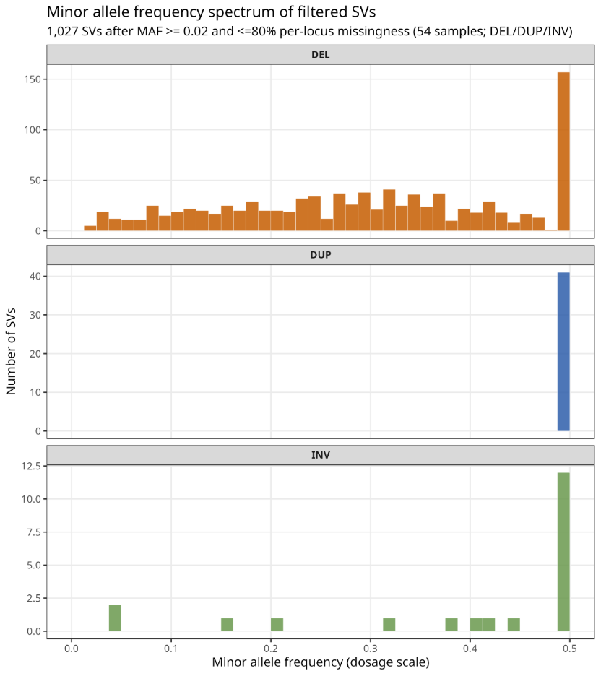
Figure S8. Minor-allele-frequency spectrum of the filtered SV set. Distribution of MAF for 1,027 SVs after MAF and missingness filtering, broken down by SV type (DEL, DUP, INV).

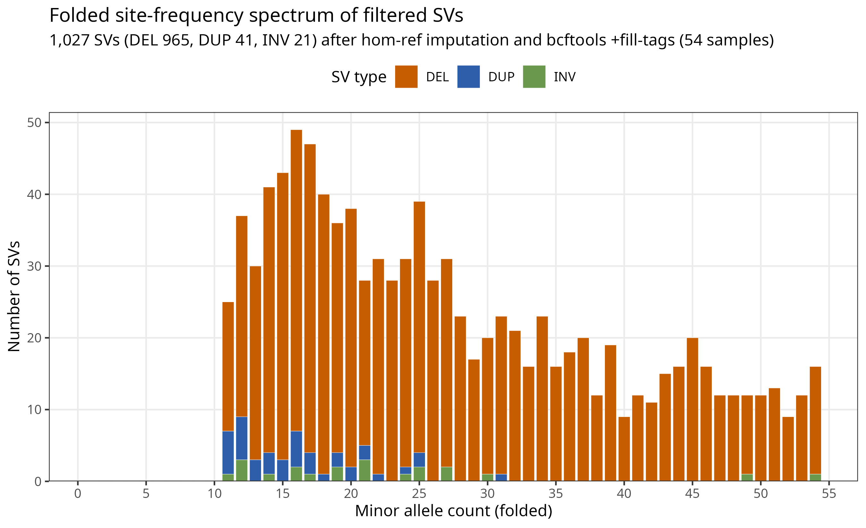Figure S9. Folded site-frequency spectrum (SFS) of the filtered SV set, broken down by SV type. Stacked bar plot of the folded SFS for DEL, DUP and INV variants (1,027 variants) after missing-genotype imputation to homozygous reference and allele-frequency recomputation with bcftools +fill-tags.

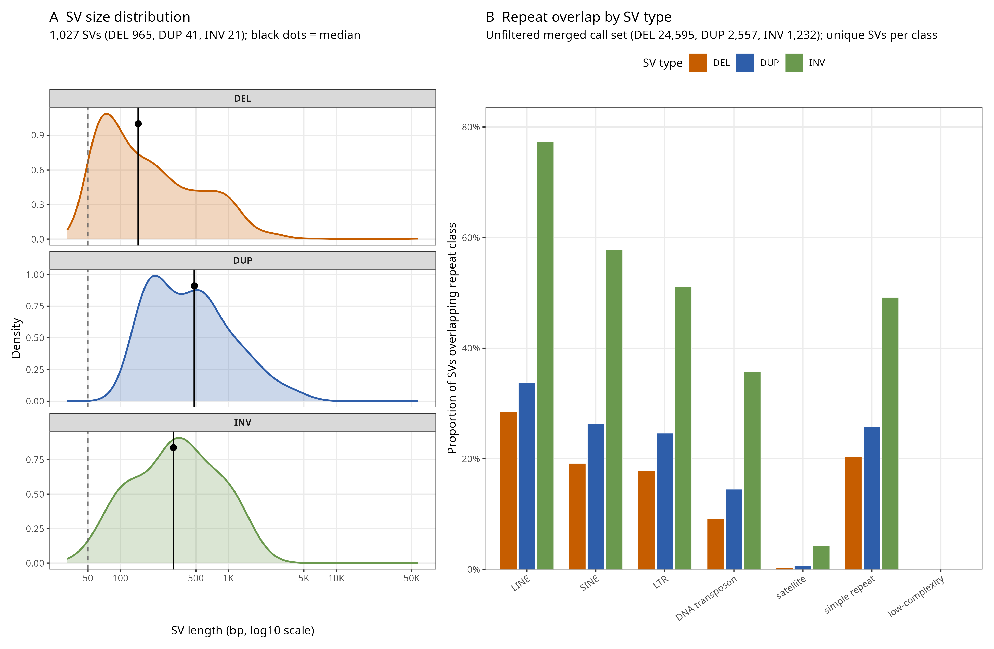
Figure S10. SV size distribution and repeat-element composition. (A) Size distribution of the final population-level SV set by type (DEL, DUP, INV); black dots indicate median length per class; the dashed vertical line at 50 bp marks the conventional lower bound for short-read-callable SVs. (B) Proportion of repeat classes (LINE, SINE, LTR, DNA transposon, satellite, simple repeat, low-complexity) overlapping SVs, broken down by SV type. Repeat overlaps computed against the RepeatModeler-derived species-specific TE library built for ETH_CapCap1.

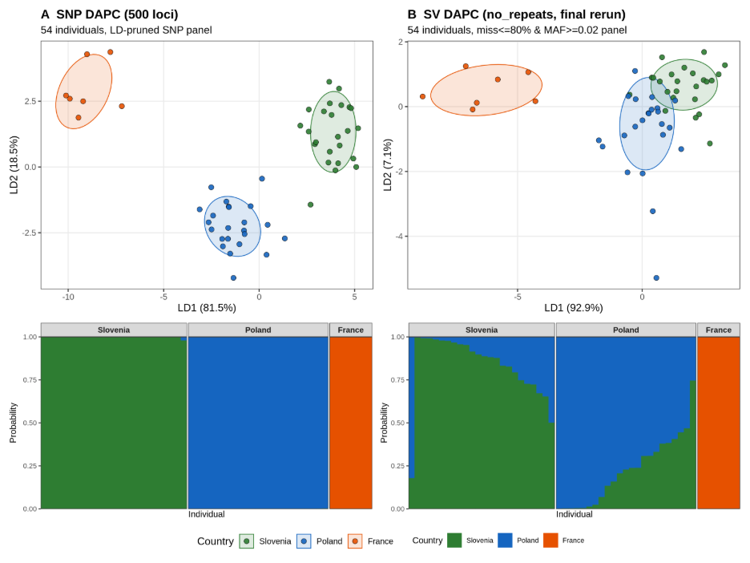Figure S11. Comparison of population structure of European roe deer (C. capreolus) inferred from SNPs and structural variants. (A) Supervised discriminant analysis of principal components (DAPC) based on ~110,000 evenly subsampled SNP loci (54 individuals). (B) Supervised DAPC based on repeat-masked SV loci (54 individuals; ≤ 80% per-locus missingness, MAF ≥ 0.02). In both scatter plots, individuals are coloured by country of origin, and ellipses represent 95% confidence intervals per group. The first two linear discriminants (LD1 and LD2) and their explained variance are shown on each axis. Lower panels show ADMIXTURE bar plots of individual ancestry proportions at the optimal K for each marker class, with individuals grouped by country. Both marker types recover the same three-population structure, with the SV-based analysis showing broadly concordant clustering and ancestry assignments.

Table S3. Number of SVs reported by each short-read-based caller, and number of SV calls merged across these callers.
Short-read caller | SV type |  |  |  |  | Per-caller total | Merged across callers
Short-read caller | DELs | DUPs | INSs | INVs | TRAs ¹ | Per-caller total | Merged across callers
Manta | 30,791 | 4,563 | 6,686 | 2,014 | 16,610 | 60,664 | -
Speedseq/Lumpy | 30,384 | 4,914 | 0 | 6,649 | 26,032 | 67,979 | -
Speedseq/Lumpy +Manta | 24,595 | 2,557 | 0 | 1,232 | 9,430 | - | 37,814
Abbreviations: DELs, deletions; DUPs, duplications; INSs, insertions; INVs, inversions; TRAs, translocations (inter-chromosomal breakend records).
Footnote ¹: Translocation (TRAs) calls reported by Manta and Lumpy. In the VCF these are generic breakpoint notations (SVTYPE=BND in caller output; relabeled as TRA by SURVIVOR during merging). They are not validated reciprocal translocations. On the scaffold-level ETH_CapCap1 assembly, inter-contig BNDs may include assembly artifacts. For Manta, a subset of BND pairs were reclassified as inversions (convert_inversions_sv.py) before merging; remaining BNDs are inter-contig breakends only.

