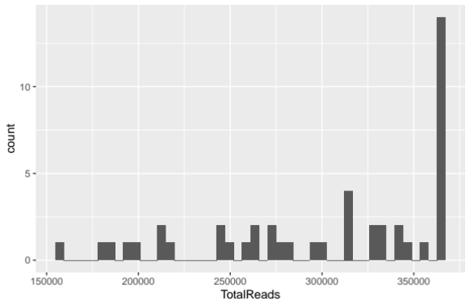
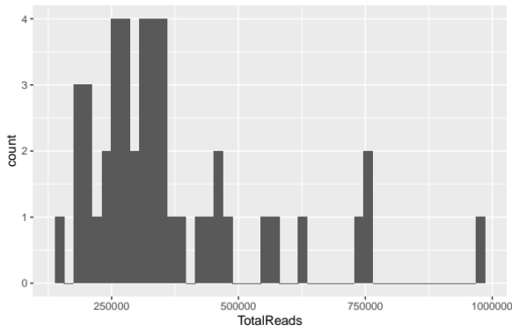
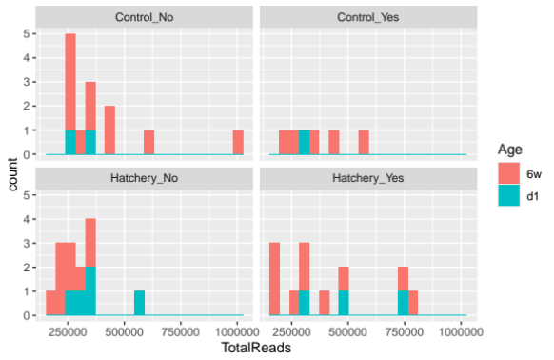
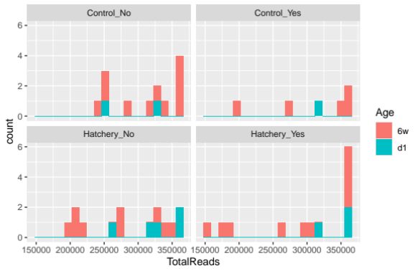
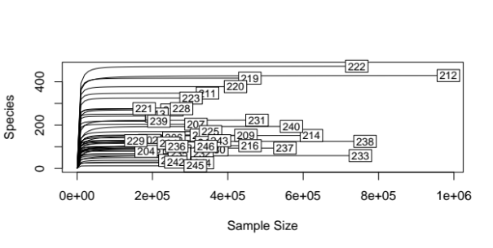
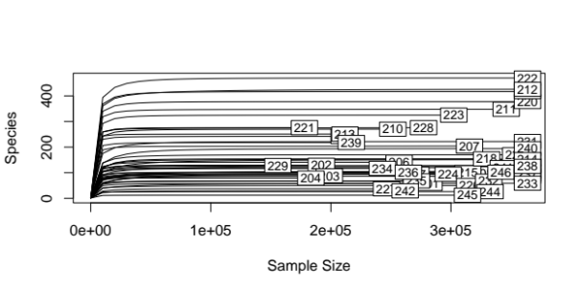
A
B
C
DC
E
F

Figure S1 Sequencing depth histograms and rarefaction curves. A) Overall sequencing depth distribution before rarefaction (total reads 16,735,404). B) Overall sequencing depth distribution after rarefying to the mean (363,813) read counts. Total read 13,831,328 count. C) Sequencing depth distribution by groups before rarefaction. D) Sequencing depth distribution by groups after rarefaction. E) Rarefaction curve before rarefaction. F) Rarefaction curve after rarefying to the mean read counts.

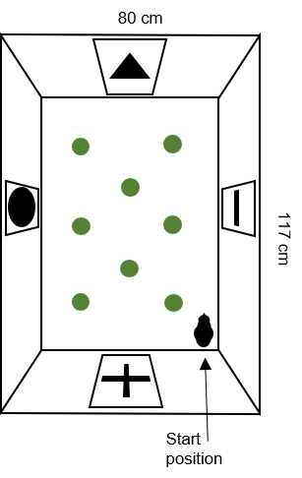
Figure S2 Arena used for 30-31 days old chicks to assess willingness to explore

Table S1 Background characteristics of the chicks
 |  | Control (N=3) | Hatchery (N=8) | Fisher test
Day 1 | Female | 1 (33.3%) | 7 (87.5%) | 0.15
Day 1 | Male | 2 (66.6%) | 1 (12.5%) | 0.15
 |  | Control (N=16) | Hatchery (N=19) | Fisher test
Day 42 | Probiotic | 11 (68.7%) | 9 (47.4%) | 0.31
Day 42 | Placebo | 5 (31.2%) | 10 (52.5%) | 0.31
Day 42 | Female | 6 (37.5%) | 10 (52.6%) | 0.50
Day 42 | Male | 10 (52.5%) | 9 (47.3%) | 0.50

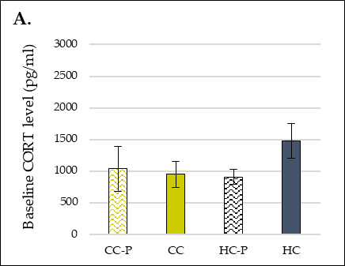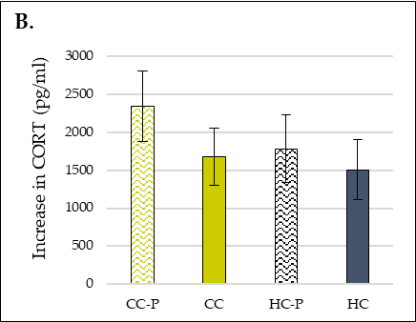
Figure S3 Blood plasma corticosterone levels in a restraint test. A) Baseline, and B) increase after restraint
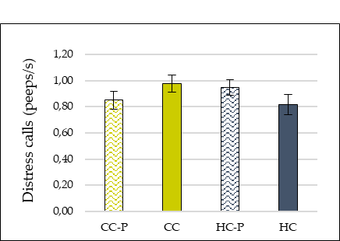
Figure S4 Social isolation test, frequency of distress calls

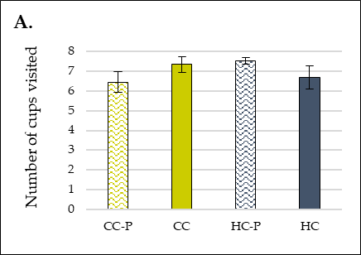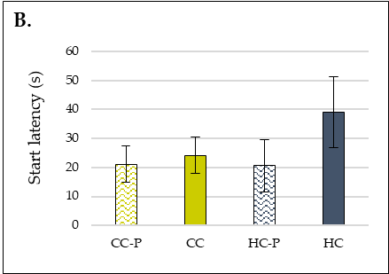
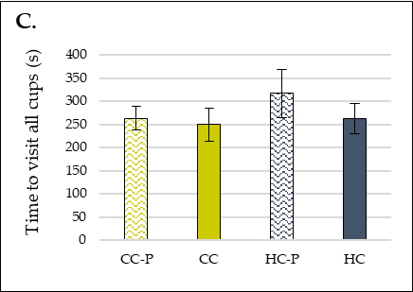
Figure S4 Behaviour in an exploration test. A) Number of cups visited, B) start latency, and C) time to visit all cups in an exploration test.

