Investigating the Effects of Metameric Light on EEG Spectral Measures
Authors: Elifnaz Gecer^{1*}, Karin Smolders¹, Luc Schlangen¹, Jan-Mathijs Schoffelen², Yvonne de Kort¹

Analysis on Beta Power
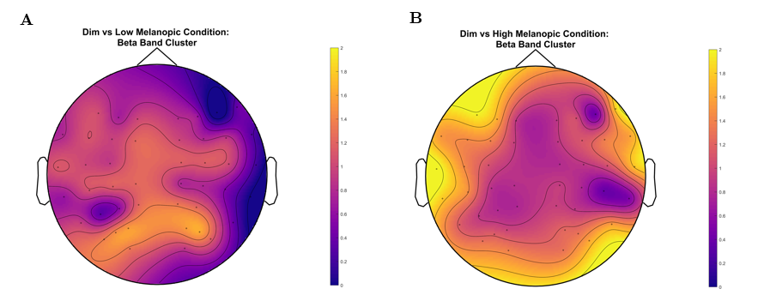
Supplementary Figure S1. Cluster-based Monte Carlo permutation results for pairwise comparisons of beta-band power differences between melanopic light conditions. a. Topographic representation of the largest cluster identified in the pairwise comparison between the Dim and Low melanopic light conditions (cluster-level corrected p = 0.120; not significant). b. Topographic representation of the largest cluster identified in the pairwise comparison between the Dim and High melanopic light conditions (cluster-level corrected p = 0.058; not significant).
Light Stimuli Description
The metameric light stimuli used in the present study were generated using a previously described calculation and optimization approach¹. with the corresponding implementation publicly available online.

1. Gecer, E. Designing Metameric Light: Advanced Methods for Isolated Photoreceptor Response and Testing NIF Effects of Light. in 2024 IEEE Sustainable Smart Lighting World Conference & Expo (LS24 (IEEE, 2024).

