List of supplementary
Supplementary 1: Spearman correlation coefficient (r-value) between the states in Q4 of 2020 (October – December 2020).

State1¹ | State2¹ | r value (p-value < 0.05)
Johor (6) | Kelantan (4) | 0.595
Johor (6) | Pahang (2) | 0.674
Johor (6) | Perak (5) | 0.607
Johor (6) | Sabah (1) | -0.530
Johor (6) | Selangor (5) | 0.756
Johor (6) | FT Kuala.Lumpur (6) | 0.756
Kelantan (4) | Perak (5) | 0.592
Kelantan (4) | Selangor (5) | 0.608
Kelantan (4) | FT Kuala.Lumpur (6) | 0.640
Negeri.Sembilan (2) | Perak (5) | 0.539
Negeri.Sembilan (2) | Selangor (5) | 0.532
Pahang (2) | FT Kuala.Lumpur (6) | 0.542
Perak (5) | Selangor (5) | 0.676
Perak (5) | FT Kuala.Lumpur (6) | 0.675
Pulau.Pinang (1) | FT Kuala.Lumpur (6) | 0.523
Selangor (5) | FT Kuala.Lumpur (6) | 0.766
Note: ¹Value in parenthesis indicates the degree of interaction of the state.

Supplementary 2: Spearman correlation coefficient (r-value) between the states in Q1 2021 (January – March 2021)

State 1¹ | State 2¹ | r-value ( p-value < 0.05)
Johor (9) | Kedah (9) | 0.552
Johor (9) | Melaka (8) | 0.566
Johor (9) | Negeri.Sembilan (5) | 0.535
Johor (9) | Pahang (8) | 0.536
Johor (9) | Sabah (9) | 0.646
Johor (9) | Selangor (9) | 0.715
Johor (9) | Terengganu (9) | 0.637
Johor (9) | FT Kuala.Lumpur (8) | 0.754
Johor (9) | FT Putrajaya (9) | 0.574
Kedah (9) | Kelantan (1) | 0.507
Kedah (9) | Melaka (8) | 0.666
Kedah (9) | Pahang (8) | 0.702
Kedah (9) | Sabah (9) | 0.667
Kedah (9) | Selangor (9) | 0.550
Kedah (9) | Terengganu (9) | 0.627
Kedah (9) | FT Kuala.Lumpur (8) | 0.559
Kedah (9) | FT Putrajaya (9) | 0.682
Melaka (8) | Pahang (8) | 0.645
Melaka (8) | Sabah (9) | 0.576
Melaka (8) | Selangor (9) | 0.609
Melaka (8) | Terengganu (9) | 0.514
Melaka (8) | FT Kuala.Lumpur (8) | 0.615
Melaka (8) | FT Putrajaya (9) | 0.599
Negeri.Sembilan (5) | Sabah (9) | 0.597
Negeri.Sembilan (5) | Selangor (9) | 0.514
Negeri.Sembilan (5) | Terengganu (9) | 0.516
Negeri.Sembilan (5) | FT Putrajaya (9) | 0.584
Pahang (8) | Sabah (9) | 0.645
Pahang (8) | Selangor (9) | 0.508
Pahang (8) | Terengganu (9) | 0.504
Pahang (8) | FT Kuala.Lumpur (8) | 0.557
Pahang (8) | FT Putrajaya (9) | 0.677
Sabah (9) | Selangor (9) | 0.584
Sabah (9) | Terengganu (9) | 0.551
Sabah (9) | FT Kuala.Lumpur (8) | 0.701
Sabah (9) | FT Putrajaya (9) | 0.834
Selangor (9) | Terengganu (9) | 0.656
Selangor (9) | FT Kuala.Lumpur (8) | 0.703
Selangor (9) | FT Putrajaya (9) | 0.518
Terengganu (9) | FT Kuala.Lumpur (8) | 0.643
Terengganu (9) | FT Putrajaya (9) | 0.537
FT Kuala.Lumpur (8) | FT Putrajaya (9) | 0.618
Note: ¹Value in parenthesis indicates the degree of interaction of the state.

Supplementary 3: Spearman correlation coefficient (r-value) between the states in Q2 2021 (April – June 2021)

State 1¹ | State 2¹ | r-value ( p-value < 0.05)
Johor (11) | Kedah (12) | 0.783
Johor (11) | Melaka (12) | 0.776
Johor (11) | Negeri.Sembilan (9) | 0.727
Johor (11) | Pahang (12) | 0.712
Johor (11) | Perak (10) | 0.750
Johor (11) | Pulau.Pinang (8) | 0.607
Johor (11) | Sabah (7) | 0.545
Johor (11) | Selangor (12) | 0.799
Johor (11) | Terengganu (11) | 0.764
Johor (11) | FT Kuala.Lumpur (11) | 0.761
Johor (11) | FT Labuan (9) | 0.615
Kedah (12) | Melaka (12) | 0.799
Kedah (12) | Negeri.Sembilan (9) | 0.702
Kedah (12) | Pahang (12) | 0.808
Kedah (12) | Perak (10) | 0.736
Kedah (12) | Perlis (4) | 0.585
Kedah (12) | Pulau.Pinang (8) | 0.635
Kedah (12) | Selangor (12) | 0.832
Kedah (12) | Terengganu (11) | 0.770
Kedah (12) | FT Kuala.Lumpur (11) | 0.771
Kedah (12) | FT Labuan (9) | 0.539
Kedah (12) | FT Putrajaya (4) | 0.506
Kelantan (1) | Terengganu (11) | 0.605
Melaka (12) | Negeri.Sembilan (9) | 0.860
Melaka (12) | Pahang (12) | 0.854
Melaka (12) | Perak (10) | 0.760
Melaka (12) | Pulau.Pinang (8) | 0.524
Melaka (12) | Sabah (7) | 0.674
Melaka (12) | Selangor (12) | 0.883
Melaka (12) | Terengganu (11) | 0.619
Melaka (12) | FT Kuala.Lumpur (11) | 0.824
Melaka (12) | FT Labuan (9) | 0.745
Melaka (12) | FT Putrajaya (4) | 0.536
Negeri.Sembilan (9) | Pahang (12) | 0.725
Negeri.Sembilan (9) | Perak (10) | 0.654
Negeri.Sembilan (9) | Sabah (7) | 0.670
Negeri.Sembilan (9) | Selangor (12) | 0.843
Negeri.Sembilan (9) | FT Kuala.Lumpur (11) | 0.824
Negeri.Sembilan (9) | FT Labuan (9) | 0.757
Pahang (12) | Perak (10) | 0.722
Pahang (12) | Perlis (4) | 0.549
Pahang (12) | Pulau.Pinang (8) | 0.642
Pahang (12) | Selangor (12) | 0.821
Pahang (12) | Terengganu (11) | 0.683
Pahang (12) | FT Kuala.Lumpur (11) | 0.739
Pahang (12) | FT Labuan (9) | 0.579
Pahang (12) | FT Putrajaya (4) | 0.574
Perak (10) | Pulau.Pinang (8) | 0.552
Perak (10) | Selangor (12) | 0.752
Perak (10) | Terengganu (11) | 0.652
Perak (10) | FT Kuala.Lumpur (11) | 0.672
Perak (10) | FT Labuan (9) | 0.585
Perlis (4) | Selangor (12) | 0.511
Perlis (4) | Terengganu (11) | 0.530
Pulau.Pinang (8) | Selangor (12) | 0.576
Pulau.Pinang (8) | Terengganu (11) | 0.762
Pulau.Pinang (8) | FT Kuala.Lumpur (11) | 0.528
Sabah (7) | Sarawak (1) | 0.510
Sabah (7) | Selangor (12) | 0.609
Sabah (7) | FT Kuala.Lumpur (11) | 0.622
Sabah (7) | FT Labuan (9) | 0.726
Selangor (12) | Terengganu (11) | 0.680
Selangor (12) | FT Kuala.Lumpur (11) | 0.886
Selangor (12) | FT Labuan (9) | 0.684
Terengganu (11) | FT Kuala.Lumpur (11) | 0.607
Terengganu (11) | FT Putrajaya (4) | 0.544
FT Kuala.Lumpur (11) | FT Labuan (9) | 0.622
Note: ¹Value in parenthesis indicates the degree of interaction of the state.

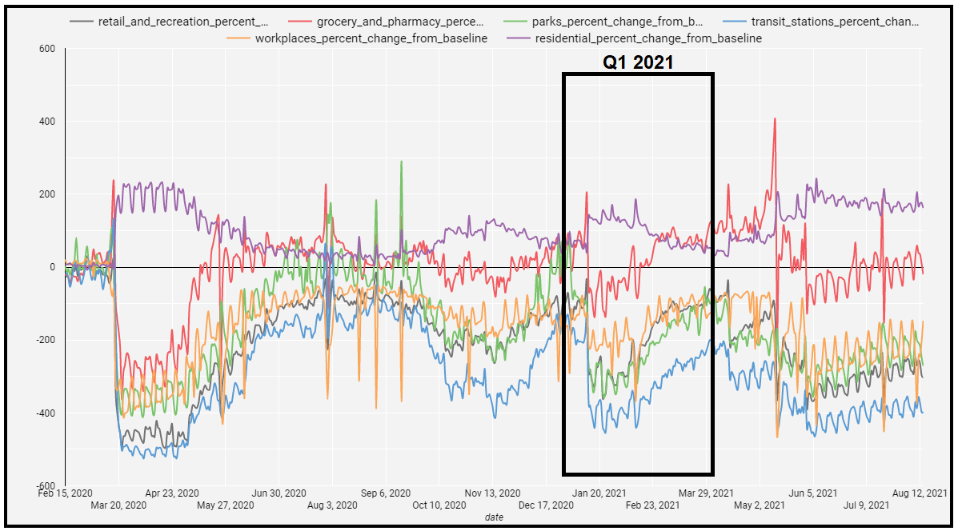

Supplementary 4: Cumulative mobility data (%) over time for Johor, Kedah, Sabah, Selangor, Terengganu, and F.T. Putrajaya in Q1 of 2021 (Google LLC, 2021)
(a)
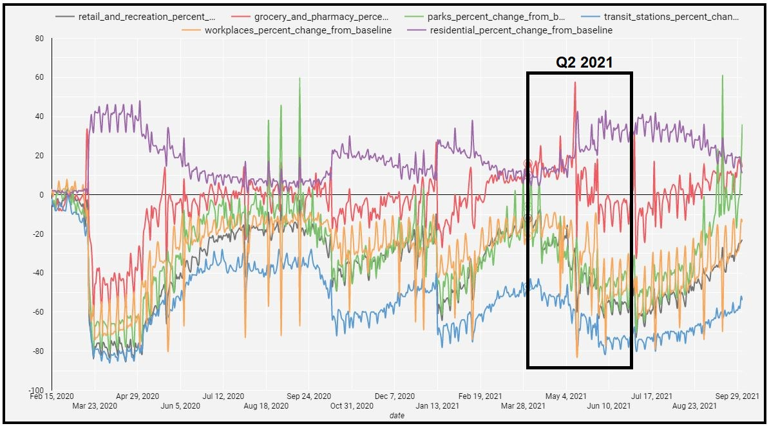

(b)
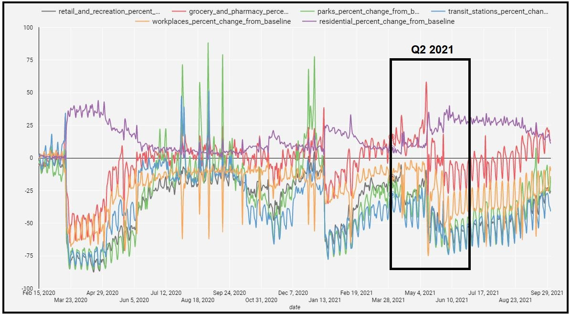
Supplementary 5: Cumulative mobility data (%) over time for (a) Selangor and (b) Melaka in Q2 of 2021 (Google LLC, 2021)

