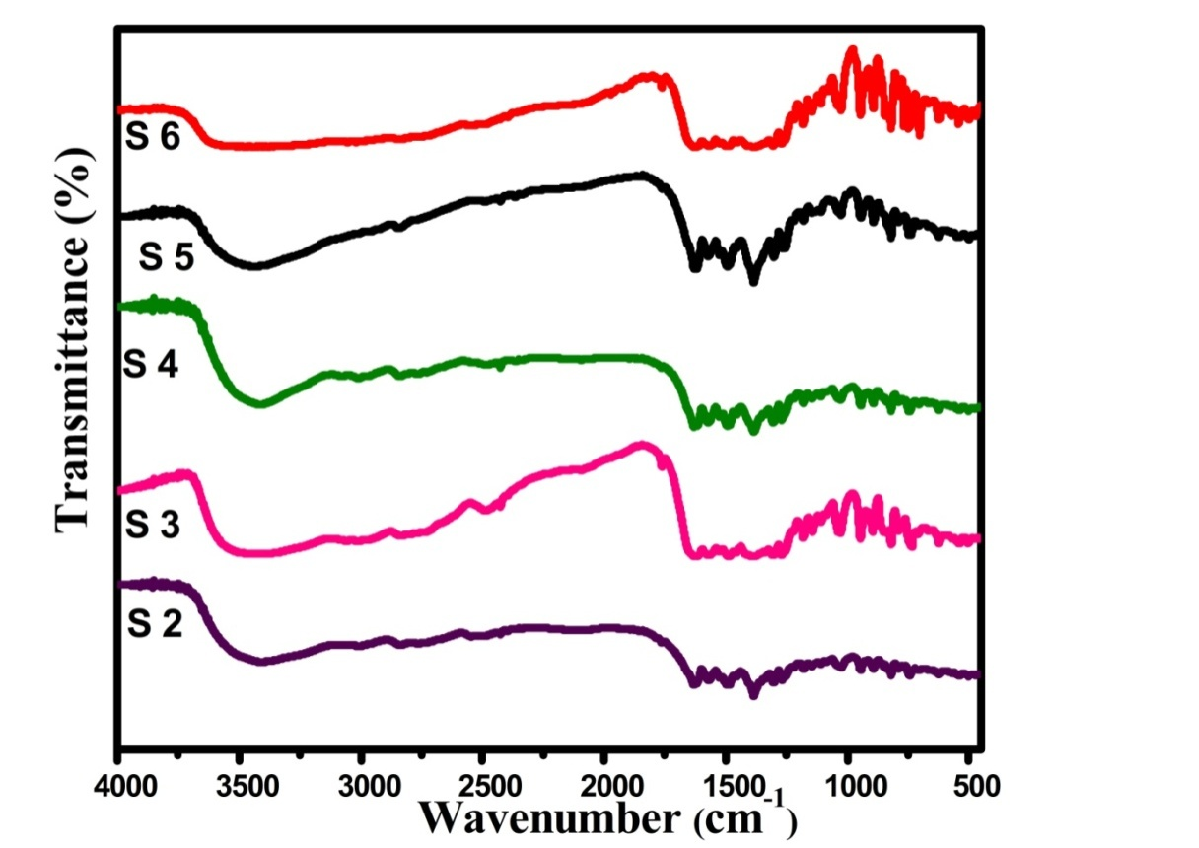
Figure S1 The IR spectra of samarium (III) S2-S6 complexes.

(L) (S1)
Figure S2 The ¹³C-NMR spectrum of ligand L and its S1 complex.

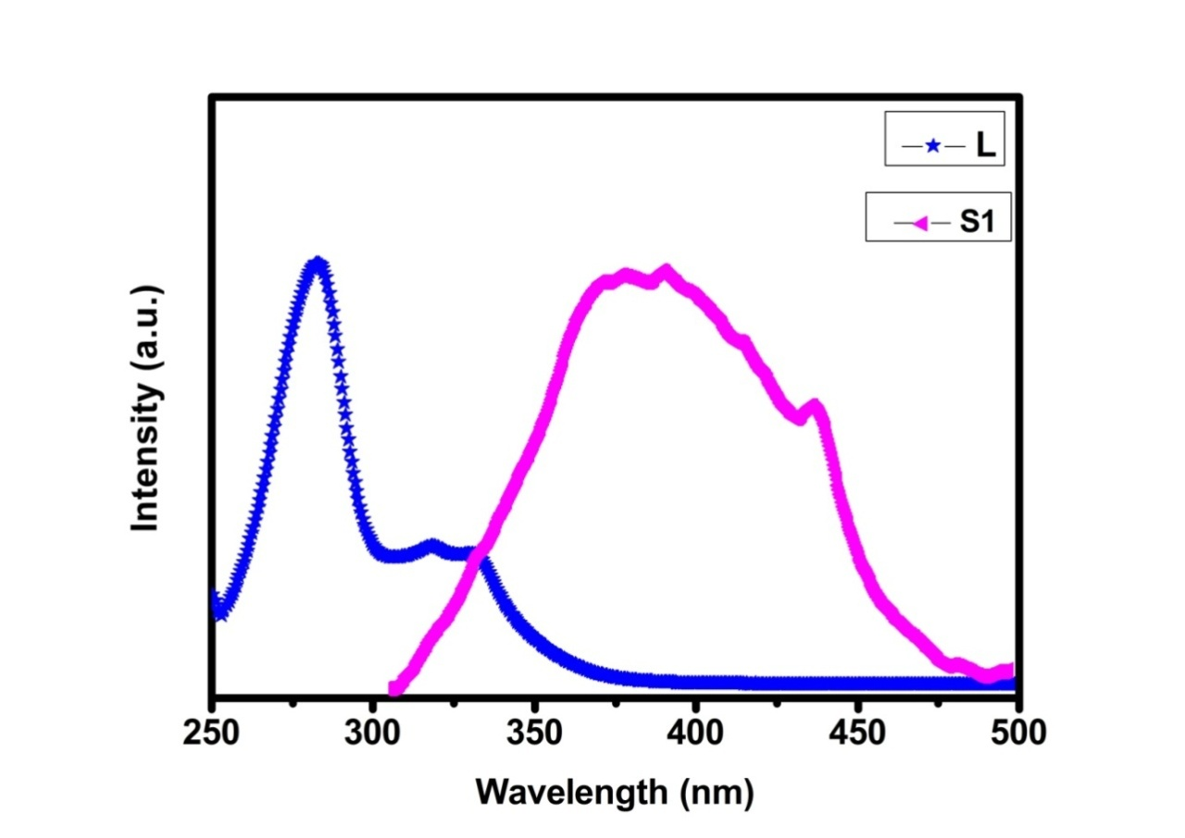 Figure S3 The overlap between absorption spectrum of ligand and excitation spectrum of complex S1.
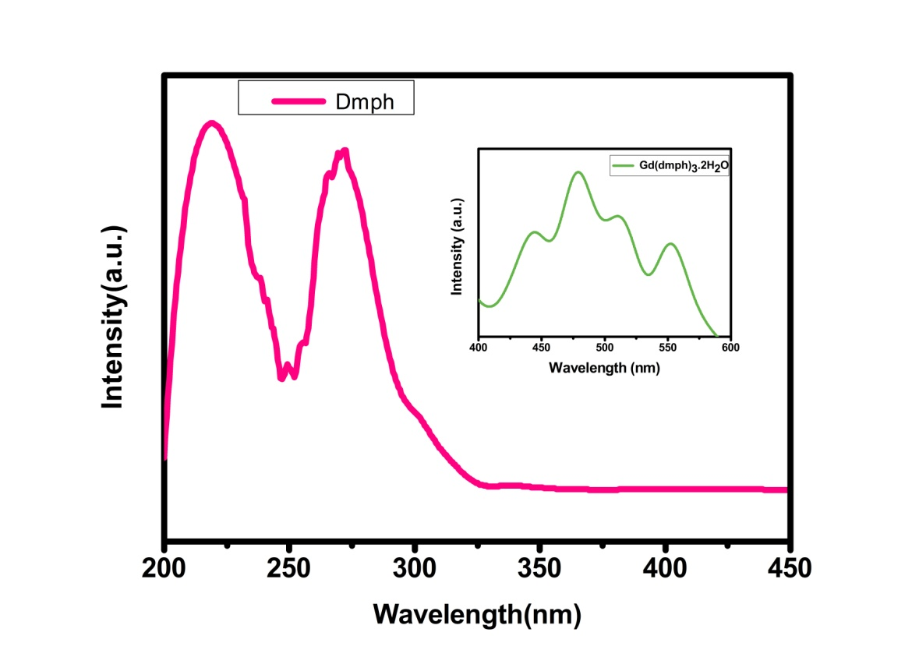
Figure S4 The absorbance of dmph spectrum and inset represent the phosphorescence spectrum of corresponding gadolinium complex.

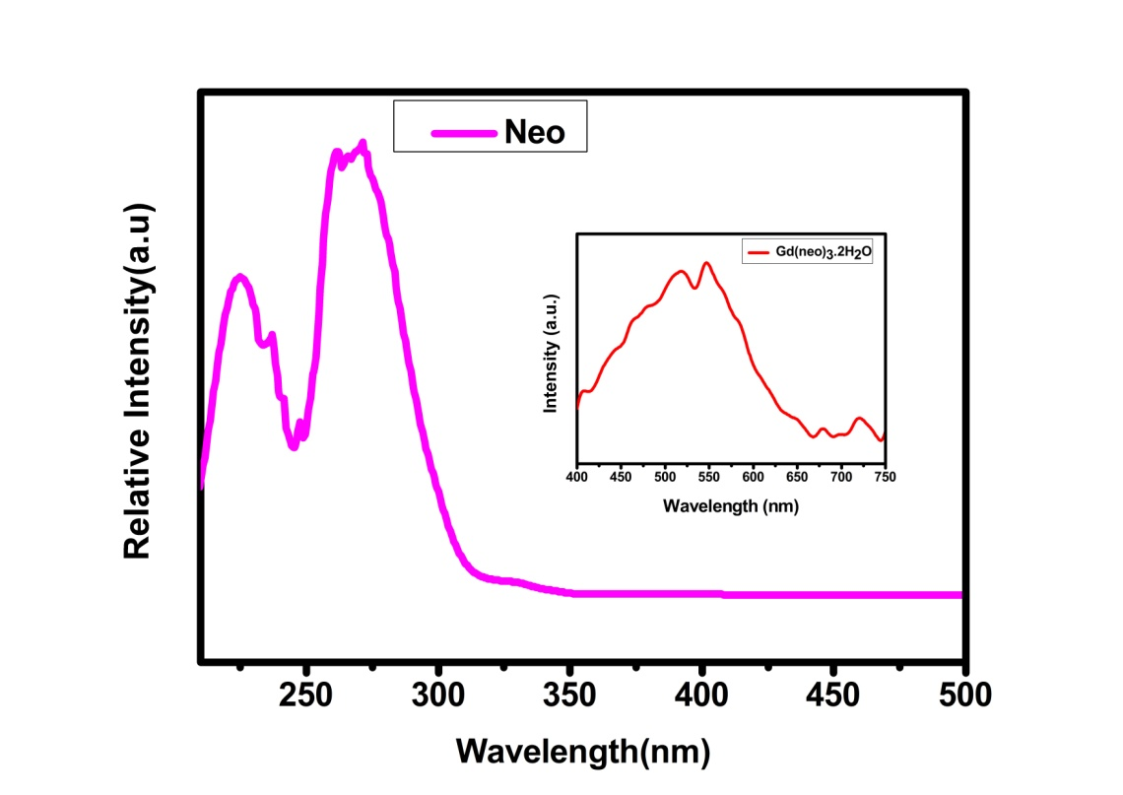
Figure S5 The absorbance of neo spectrum and inset represent the phosphorescence spectrum of corresponding gadolinium complex.

