Search string step
We developed a straightforward prompt, around simple design guidelines(1), containing contextual information of the task, the clinical question each SRMA is attempting to answer, and the database-specific keyword format required. An individual search string was generated for each database each SRMA had originally queried, which in total were Medline, Embase, PubMed, Web of Science and CENTRAL. Multiple prompt layering(2), or many-shot iterative prompt development strategies(3) exist for search string production, and while perhaps more effective, did not lend themselves to the current study’s “copy-paste, user-friendly" objective.

GPT 5 Pro’s outputs (the latest version available at the time of this step) were complete search strings, specific to each SRMA and database, which were used to query each database, yielding medical article references as results, exported as raw csv files. We authorized a minimal level of troubleshooting regarding erroneous keywords or search strings yielding amounts of references in orders of magnitude above or below what would be commonly expected of a human query (approximately 200 to 2000 references). All original human and LLM-generated data were then subjected to pre-processing, or “cleaning”, involving merging and systematizing of dataframes, removal of articles after last human query date, and deduplication using a multi-level matching Python script. All code is available in Supplementary Materials 1.3.

We performed two separate analyses, comparing GPT 5 Pro’s search strings’ results with the original full human search strings’ results, as well as with the original authors’ included articles (whether they were included in the final analysis or not). While the first case allows direct comparison between both queries’ raw results, only a median of 2.9% of all extracted references end up being included in final SRMAs(4). We concluded that the primary metric should be whether the LLM produces a search string that captures the references ultimately included in the final review, rather than one that is similar to the original human search string regardless of it yielding the limited number of pertinent articles. The second comparison, between GPT 5 Pro’s search string results and the articles included in the final human SRMAs, addresses this specifically.

Evaluation of GPT 5 Pro’s performance was conducted by matching its outputs, in the form of a post-processed csv dataframe of medical article references, with a structurally identical pre-processed csv dataframe of human-generated medical article references. This was done using a multi-level matching Python script, according to identical doi, pmid matching, and fuzzy title, author, year and journal matching, producing confusion matrices, absent of true negatives data (which represent the articles not captured by both human and LLM search strings, i.e. the quasi-entirety of each database). SRMA-specific and pooled performance metrics including sensitivity, specificity, and F1 scores were calculated using a specific Python script.

Figure 1.1: Full search string step workflow for GPT search string generation, data processing and performance evaluation.
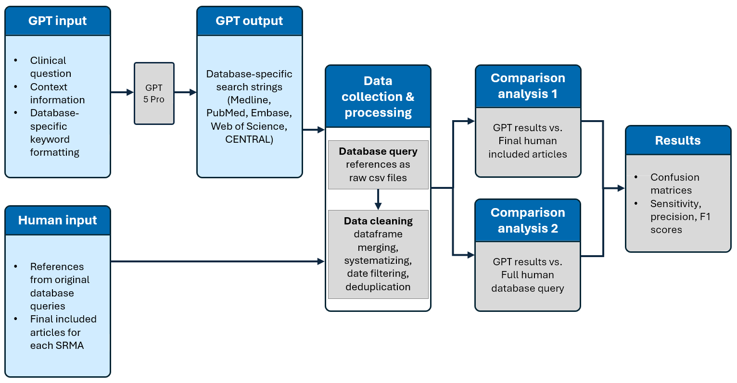

Article screening step
The article screening step was subdivided into two steps, analogous to the human process: a first abstract-based screening, followed by a second full text-based screening. Prompt design in both cases incorporated contextual information of the task, inclusion criteria, exclusion criteria, and a decision rule, identical to those human reviewers used, both during their abstract-based and full text-based screening sub-steps, as well as instructions for the output format(5). GPT 5 Pro was used for the abstract-screening sub-step, while GPT 5.2 Pro was used for the full-text screening sub-step, as they were respectively the latest available versions at the time.

For the abstract screening sub-step, Rayyan data containing all human references exported from the original human database query was extracted for all pertinent SRMAs as raw csv files. Raw csv files were further processed into clean dataframes, by removing corrupted data and systematizing formats for later analysis. GPT 5 Pro’s outputs were csv files containing each included article’s reference, associated with pertinent metadata to allow for easier subsequent matching during comparison analysis. For the full text screening sub-step, full data distinguishing human abstract and full text screenings was unavailable, and as such we could not retrieve the full texts of human included abstracts. We instead manually retrieved all available full text articles, in pdf format, included as abstracts by GPT 5 Pro during the previous abstract screening step. The LLM outputs were simply csv files containing the pdf file names of included articles, which were manually concatenated with the corresponding pertinent metadata for later analysis.

Evaluation of GPT’s performance was conducted by matching its output to a newly constructed dataframe from Rayyan reviewer decision data, containing only articles included in the final human SRMA. Matching was performed by use of Rayyan “keys”, unique numerical identifiers for each article reference imported into the platform, which allow for error-free matching of both LLM-generated and original human datasets. Performance metrics were selected based on our best appreciation of the current literature(6,7), consisting of SRMA-specific and pooled accuracy, sensitivity, specificity, precision, F1 scores, Cohen’s kappa and PABAK, calculated from confusion matrices with specific Python scripts.

Figure 1.2: Full article screening step workflow for GPT abstract and full text screening, data processing and performance evaluation.
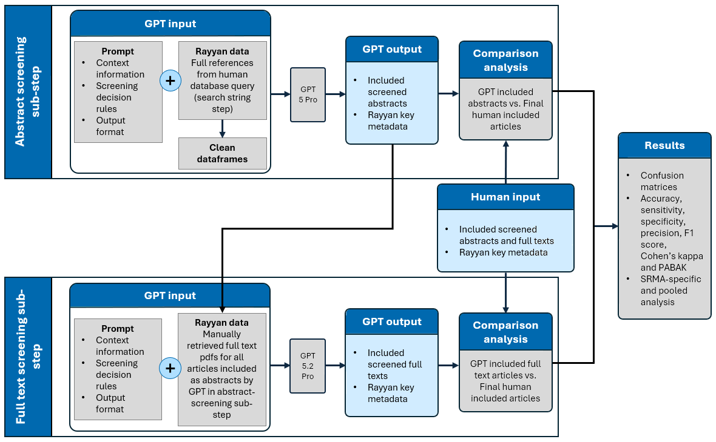

Data extraction step
GPT 5 Pro’s input was developed with the same general design in mind as for previous steps, containing task-specific contextual information, instructions identical to those humans used for extraction of each individual datapoint, a template output format, and full text articles. Outputs were raw csv files containing all LLM-extracted data for each SRMA which underwent minimal post-processing, mainly involving dataframe systematizing.

We calculated a required sample size of 384 datapoints, based on the standard formula for sample size calculation for estimating a single proportion with a specified margin of error(8):
$$n=Z^{2}\frac{P\left(1-P\right)}{d^{2}}$$
Where Z is 1.96 for a 95% confidence interval, P is the prevalence (expected agreement between LLM and humans at 0.90(9–11)), d is the precision (0.05 generally, 0.03 in this case to ensure lower marginal error and higher power). To this effect, a Python script was developed to randomly sample studies across all SRMAs. We also considered a datapoint to be the value of a cell in an Excel data table, whether string (roughly equivalent to text), integer (whole number) or a float (number with decimal points).

Human data extraction accuracy is reported abundantly in medical literature, with rates spanning on average from 66 to 86%(12–17). While error rates remain substantial for database queries and article screening as well(18–20), development of gold-standards for these steps was beyond the scope of this current study. However, based partly on the methodology of Cao et al.(21), we developed a human-LLM hybrid data extraction data table gold-standard, to be used as reference for evaluating GPT 5 Pro’s performance. To this effect, we developed a Python script to match all identical datapoints between the original human and the LLM-generated data extraction data tables, and retrieve only discordant datapoints. These discordant datapoints were adjudicated by two blinded expert reviewers (VB and SW), none having participated in the SRMAs included within the current study. Disagreements between reviewers were resolved by consensus, and the newly adjudicated datapoints were merged with the previous concordant datapoints, to form a gold-standard data extraction data table.

Comparison of GPT 5 Pro’s performances with our novel gold-standard was first performed by reporting the directionality of the human expert reviewers’ adjudication decisions. For all human-to-GPT discordant datapoints, we therefore reported the proportion of adjudicated values correctly extracted by GPT, the proportion of adjudicated values correctly extracted by the original authors, and the proportion of adjudicated values incorrectly extracted by both GPT and original authors. Subsequently, after minimal data cleaning of human and LLM data tables, we calculated GPT 5 Pro-to-gold-standard performance metrics by running the csv files through a strict concordance matching Python script, producing both SRMA-specific and pooled accuracies, Cohen’s kappas and PABAKs with 95% confidence intervals.

Figure 1.3: Full data extraction step workflow for GPT data extraction, gold-standard dataset creation, and performance evaluation.
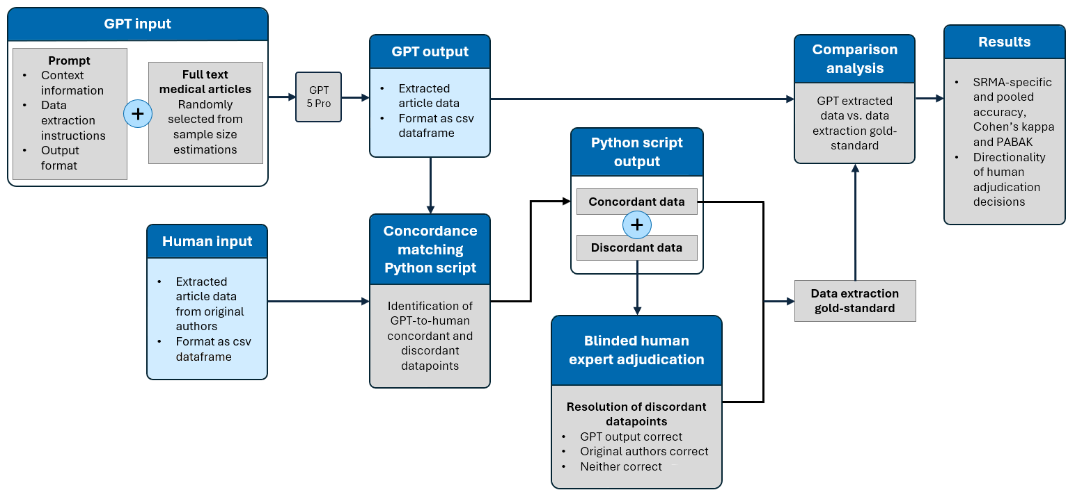

Risk of bias assessment step
We prompted GPT 5.1 Pro in a similar manner to previous steps, with task-specific contextual information, instructions for risk of bias (ROB) assessments and output format. Furthermore, inputs also contained templates for output formats, corresponding ROB assessment tools (ROB 1, ROB 2 and ROBINS-I), and full-text articles. Exception was made for the “Overall judgement” domains, where the inputs were specifically tailored prompts, along with ROB tools and GPT 5.1 Pro’s concatenated risk of bias assessments for all previous domains for each article. Outputs were raw csv data tables presented with studies as rows and columns as bias domains. Owing to lengthiness and implementation complexity of the ROB tools’ decisional algorithms, we sequentially prompted GPT 5.1 Pro to separately assess risk of bias for each domain across all studies. Post-processing therefore consisted mainly of concatenating ROB assessments across all domains for all studies. Human data underwent minimal pre-processing, including csv conversion and standardization.

We calculated a required sample size of 384 datapoints, based on the same formula as used previously(8), albeit with differing parameters such as expected agreement between LLMs and humans at 0.5(22–25) and precision at 0.05. While we recognize all risk of bias assessments may not be truly independent, use of the design effect formula for clustered trials was not feasible due to lack of intraclass correlation coefficient data in the literature(26–28).

Human interrater reliability (IRR) of ROB assessments has been reported in the current literature as slight to fair, with Cohen’s kappa coefficients spanning 0.06 to 0.37(29–31), while proportion of agreement for ROB assessments using the ROB 1 tool has been reported by Bertizzolo et al. at 57 to 81%(32). To this effect, we developed a novel human-LLM hybrid ROB assessment gold-standard, to be used as reference for evaluating GPT 5.1 Pro’s performance, in the same manner as previously described in the “Data extraction step” section. Both expert human reviewers (RH and SW) had previous ROB assessment experience in multiple anesthesia-related SRMAs and performed blinded adjudications of human-to-GPT 5.1 Pro discordant datapoints, resolving discrepancies through consensus, to produce the final gold-standard ROB assessment table.

In the same manner as for the data extraction step, comparison of GPT 5.1 Pro’s performances with our novel gold-standard was first performed by reporting the directionality of the human expert reviewers’ adjudication decisions. For all human-to-GPT discordant risk of bias assessments, we therefore reported the proportion of adjudicated assessments correctly generated by GPT, the proportion of adjudicated assessments correctly generated by the original authors, and the proportion of adjudicated assessments incorrectly generated by both GPT and original authors. Subsequently, after minimal data cleaning of human and LLM ROB assessments tables, we calculated GPT 5.1 Pro-to-gold-standard performance metrics by running the csv files through a strict concordance matching Python script. We produced SRMA-specific, domain-specific and pooled performance metrics such as accuracy, Cohen’s kappa and PABAK with 95% confidence intervals. We also report sensitivity, specificity and F1 scores with 95% confidence intervals for dichotomous low versus non-low (i.e. medium and high) ROB assessment decisions. An alluvial diagram reporting differential classification of ROB assessments across all domains for all studies in each of the original authors’, gold standard and GPT datasets was generated using Claude Sonnet 4.5. For the purpose of this diagram, ROB assessments were systematized in the following manner: “Low” corresponding to ROBINS-I and ROB 2’s “low” assessments, “Medium” corresponding to ROBINS-I and ROB 2’s “some concerns” and “moderate” assessments, and “High” corresponding to ROBINS-I and ROB 2’s “high”, “serious” and “critical” assessments.
Figure 1.4: Full risk of bias assessment step workflow for GPT risk of bias assessment, gold-standard dataset creation, and performance evaluation.
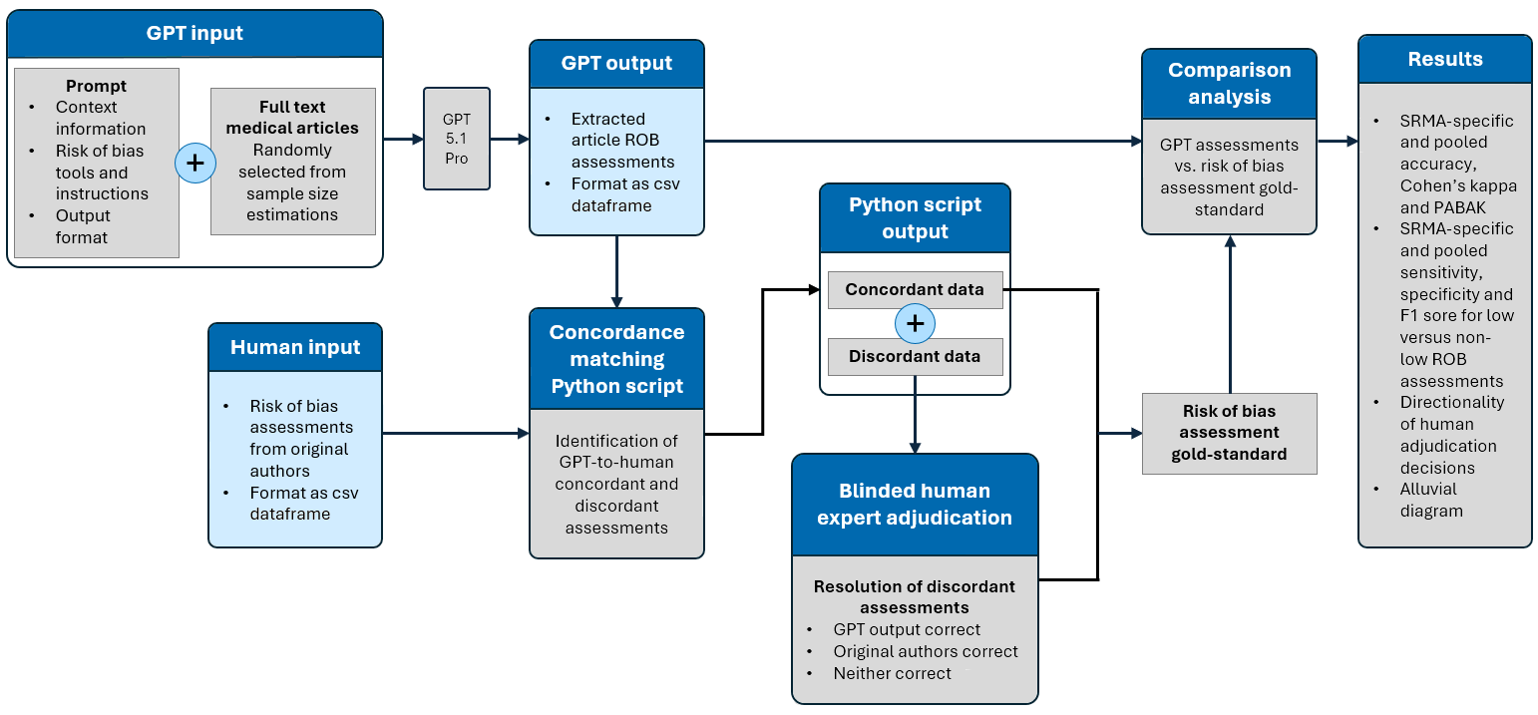

Data synthesis step
GPT 5.2 Pro’s input for this step was a prompt containing step-specific contextual information and detailed instructions for reading attached data tables as well as for producing or calculating pooled outcomes, in terms of specific models and metrics to be used(33). Full human data tables for each SRMA were provided, as well as a template outcome table for output format. Outputs for numerical-based data were pooled statistical analyses, for selected primary and secondary outcomes of each SRMA, with 95% confidence intervals, as well as heterogeneity metrics. Outputs for text-based data, in the case of the “LLM study”, were both pooled text-based and numerical non-statistical results (e.g. total number of studies where LLMs perform similarly to humans in answering patient FAQs).

Data collection essentially involved selection of outcomes and corresponding data for which full original human extracted data was available, i.e. the entirety of data necessary to be able to reproduce the exact same results, if the same calculations were applied. The outcomes which met these requirements were all primary outcomes, 95% confidence intervals and heterogeneity for all SRMAs, as well as all or most secondary outcomes. Human data tables were exported into Excel format and underwent systematization for easier “readability” by GPT.

Assessment of GPT 5.2 Pro’s performance was conducted by comparing its pooled results outputs to the original human-published pooled results, using the exact same human datasets. Unfortunately, the scarcity of literature concerning the data synthesis step of SRMAs provides little framework for statistical analysis. We did not calculate any performance metrics by use of statistical testing, opting for a descriptive analysis, similarly to a previous paper on network meta-analysis automatization(34). In this instance, statistical testing would have been inappropriate, since the data synthesis step seeks to investigate whether GPT 5.2 Pro can apply the correct formulas to the correct data. It constitutes a set of single calculations from the same dataset, without any sampling variability or any hypothesis testing about a sample, whose results are deterministic given the same data and calculation. Hence, sample size could not be calculated for this step either.

Lastly, results from the “Epidural”, “TIVA” and “VR” studies were numerically based, e.g. pooled incidences, risk and odds ratios, standardized mean differences, heterogeneity metrics etc., whose comparison with study and step specific GPT outputs was descriptive, and performed directly without adjudication. Conversely, the “LLM” study did not provide meta-analytics, focusing instead on text-based results, i.e. study summaries, GPT-to-human performance comparison and answering high-level questions. Such interpretative text-based results required adjudication from a blinded expert reviewer (SW), assessing the meaningful equivalence or difference between both human and GPT’s results. Assessments were reported in terms of directionality of adjudication decisions, alongside raw results.

Figure 1.5: Full data synthesis step workflow for GPT input, output and performance evaluations.
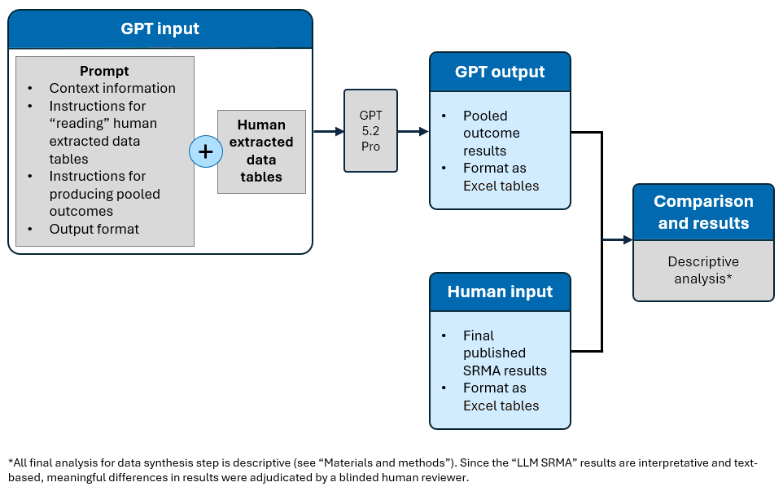

Statistical analysis
All code for data processing and statistical analysis was written in Python 3.14 language(35), using the statistical software packages SciPy(36) and Scikit-learn(37), on Jupyter Notebooks(38) which were shared between authors with Google Colaboratory(39). Code was both manually written and generated using Claude Sonnet 4.5(40), which was subsequently manually reviewed. All code is available at the following link: https://doi.org/10.6084/m9.figshare.c.8518413. The statistical analysis metrics used in our study are listed below(41–49).

Sensitivity, or recall, as a performance metric of GPT 5 Pro, refers to its ability to correctly identify true positives in a binary classification model. It is especially crucial in search string and article screening steps, as high sensitivity corresponds to GPT’s ability to include all or most of the articles included by humans. This translates into a high rate of capture of pertinent literature for each SRMA.
$$Sensitivity=\frac{TP}{TP+FN}$$
Where TP are true positives and FN are false negatives.

Specificity as a performance metric of GPT 5 Pro, refers to its ability to correctly identify true negatives in a binary classification model. Although less crucial than sensitivity in search string and article steps, high specificity corresponds to GPT’s ability to exclude all or most of the articles excluded by humans. This translates to a high rate of exclusion of irrelevant literature, which is the most time-consuming aspect of human article screening.
$$Specificity=\frac{TN}{TN+FP}$$
Where TN are true negatives and FP are false positives.

Accuracy is the proportion of all GPT 5 Pro-generated classifications or datapoints that were correct, relative to all classifications or datapoints for a specific SRMA step. This is the most important metric for data extraction performance evaluation, and is crucial for ROB assessment as well, since these steps are not binary classification problems, and do not produce confusion matrices which allow for calculation of sensitivity and specificity. A high accuracy signifies GPT’s ability to generate correct datapoints and risk of bias assessments for example.
$$Accuracy =\frac{correct classifications}{total classifications}=\frac{correct datapoints}{total datapoints}$$

The F1 score as a performance metric of GPT 5 Pro, represents the model’s accuracy, especially useful in case of class imbalances. In the example of a heavily imbalanced dataset, such as article screening data, where included articles represent 1% of total articles, a model that predicts negative 100% of the time would score 99% on accuracy, despite being useless. Hence, the F1 score is calculated as the harmonic mean of sensitivity and precision, or positive predictive value (the amount of correctly identified true positives among all those identified as true positives by GPT), whose simplification is the following formula:
$$F1 score=\frac{TP}{TP +\frac{1}{2}\left(FP+FN\right)}$$
Where TP are true positives, FP are false positives and FN are false negatives.

Cohen’s kappa is a measure of interrater reliability, in this study, between GPT 5 Pro and original human publishers, between GPT 5 Pro and a novel gold-standard. The metric represents the extent to which GPT assigns the same value as its comparator, accounting for chance agreement. 0 represents the amount of agreement that can be expected by random chance, and 1 represents perfect agreement, with intermediate values interpreted as follows: 0.01-0.2 indicating none or slight agreement, 0.21-0.4 fair agreement, 0.41-0.6 moderate agreement, 0.61-0.8 substantial agreement, and 0.81-1.00 almost perfect agreement.
$$κ = \frac{P_{o}- P_{e}}{1-P_{e}}$$
Where P_{o} is the observed agreement and P_{e} is the chance agreement.

PABAK (prevalence-adjusted and bias-adjusted kappa) has been developed as a prevalence and bias adjusted kappa, for imbalanced datasets such as article screening data, since Cohen’s kappa, while chance-adjusted, does not account for bias between observers and the distribution of categories (or prevalence). Hence, PABAK assumes a 50% prevalence of the condition, and absence of any bias. PABAK values can be interpreted with the same scale used for Cohen’s kappa (see above).
$$PABAK = 2P_{o}-1$$
Where P_{o} is the observed agreement.

95% confidence intervals were calculated using the Wilson score method, for all performance metrics, aside F1 score, Cohen’s kappa, and PABAK, where the bootstrap method was used. We produced pooled performance metrics, by calculating the same metrics on the sum of all data, i.e. confusion matrices or datapoints depending on the SRMA step. The formula for pooled sensitivity is given as an example below, calculated for all confusion matrices combined.
$$Pooled sensitvity=\frac{ΣTP}{Σ\left(TP+FN\right)}$$
Where ΣTP is the sum of all true positives across SRMAs for a single step, and ΣFN are the sum of all false negatives across SRMAs for a single step.

Bibliography
1. Meskó B. Prompt Engineering as an Important Emerging Skill for Medical Professionals: Tutorial. J Med Internet Res. 2023 Oct 4;25:e50638. doi:10.2196/50638 PubMed PMID: 37792434; PubMed Central PMCID: PMC10585440.
2. Alaniz L, Vu C, Pfaff MJ. The Utility of Artificial Intelligence for Systematic Reviews and Boolean Query Formulation and Translation. Plast Reconstr Surg Glob Open. 2023 Oct 30;11(10):e5339. doi:10.1097/GOX.0000000000005339 PubMed PMID: 37908326; PubMed Central PMCID: PMC10615538.
3. Wang S, Scells H, Koopman B, Zuccon G. Can ChatGPT Write a Good Boolean Query for Systematic Review Literature Search? [Internet]. arXiv; 2023 [cited 2025 Oct 10]. Available from: http://arxiv.org/abs/2302.03495 doi:10.48550/arXiv.2302.03495
4. Sampson M, Tetzlaff J, Urquhart C. Precision of healthcare systematic review searches in a cross-sectional sample. Res Synth Methods. 2011;2(2):119–25. doi:10.1002/jrsm.42
5. Galli C, Gavrilova AV, Calciolari E. Large Language Models in Systematic Review Screening: Opportunities, Challenges, and Methodological Considerations. Information. 2025 May;16(5):378. doi:10.3390/info16050378
6. Guo E, Gupta M, Deng J, Park YJ, Paget M, Naugler C. Automated Paper Screening for Clinical Reviews Using Large Language Models: Data Analysis Study. J Med Internet Res. 2024 Jan 12;26:e48996. doi:10.2196/48996 PubMed PMID: 38214966; PubMed Central PMCID: PMC10818236.
7. Syriani E, David I, Kumar G. Assessing the Ability of ChatGPT to Screen Articles for Systematic Reviews. J Comput Lang. 2024 Aug;80:101287. doi:10.1016/j.cola.2024.101287
8. Hajian-Tilaki K. Sample size estimation in diagnostic test studies of biomedical informatics. J Biomed Inform. 2014 Apr;48:193–204. doi:10.1016/j.jbi.2014.02.013 PubMed PMID: 24582925.
9. Khraisha Q, Put S, Kappenberg J, Warraitch A, Hadfield K. Can large language models replace humans in systematic reviews? Evaluating GPT-4’s efficacy in screening and extracting data from peer-reviewed and grey literature in multiple languages. Res Synth Methods. 2024;15(4):616–26. doi:10.1002/jrsm.1715
10. Gartlehner G, Kahwati L, Hilscher R, Thomas I, Kugley S, Crotty K, et al. Data extraction for evidence synthesis using a large language model: A proof-of-concept study. Res Synth Methods. 2024 Jul;15(4):576–89. doi:10.1002/jrsm.1710 PubMed PMID: 38432227.
11. Khan MA, Ayub U, Naqvi SAA, Khakwani KZR, Sipra Z bin R, Raina A, et al. Collaborative Large Language Models for Automated Data Extraction in Living Systematic Reviews. medRxiv. 2024 Sep 23;2024.09.20.24314108. doi:10.1101/2024.09.20.24314108 PubMed PMID: 39399004; PubMed Central PMCID: PMC11469465.
12. Horton J, Vandermeer B, Hartling L, Tjosvold L, Klassen TP, Buscemi N. Systematic review data extraction: cross-sectional study showed that experience did not increase accuracy. J Clin Epidemiol. 2010 Mar;63(3):289–98. doi:10.1016/j.jclinepi.2009.04.007 PubMed PMID: 19683413.
13. Buscemi N, Hartling L, Vandermeer B, Tjosvold L, Klassen TP. Single data extraction generated more errors than double data extraction in systematic reviews. J Clin Epidemiol. 2006 Jul;59(7):697–703. doi:10.1016/j.jclinepi.2005.11.010 PubMed PMID: 16765272.
14. Carroll C, Scope A, Kaltenthaler E. A case study of binary outcome data extraction across three systematic reviews of hip arthroplasty: errors and differences of selection. BMC Res Notes. 2013 Dec 17;6:539. doi:10.1186/1756-0500-6-539 PubMed PMID: 24344873; PubMed Central PMCID: PMC3878552.
15. Tang L, Wang R, Doi SAR, Furuya-Kanamori L, Lin L, Qin Z, et al. Double data extraction was insufficient for minimizing errors in evidence synthesis: a randomized controlled trial [Internet]. medRxiv; 2024 [cited 2026 Mar 10]. p. 2023.10.16.23297056. Available from: https://www.medrxiv.org/content/10.1101/2023.10.16.23297056v2 doi:10.1101/2023.10.16.23297056
16. Xu C, Yu T, Furuya-Kanamori L, Lin L, Zorzela L, Zhou X, et al. Validity of data extraction in evidence synthesis practice of adverse events: reproducibility study. BMJ. 2022 May 10;377:e069155. doi:10.1136/bmj-2021-069155 PubMed PMID: 35537752; PubMed Central PMCID: PMC9086856.
17. Li T, Saldanha IJ, Jap J, Smith BT, Canner J, Hutfless SM, et al. A randomized trial provided new evidence on the accuracy and efficiency of traditional vs. electronically annotated abstraction approaches in systematic reviews. J Clin Epidemiol. 2019 Nov;115:77–89. doi:10.1016/j.jclinepi.2019.07.005 PubMed PMID: 31302205.
18. Salvador-Oliván JA, Marco-Cuenca G, Arquero-Avilés R. Errors in search strategies used in systematic reviews and their effects on information retrieval. J Med Libr Assoc JMLA. 2019 Apr;107(2):210–21. doi:10.5195/jmla.2019.567 PubMed PMID: 31019390; PubMed Central PMCID: PMC6466507.
19. Hanegraaf P, Wondimu A, Mosselman JJ, Jong R de, Abogunrin S, Queiros L, et al. Inter-reviewer reliability of human literature reviewing and implications for the introduction of machine-assisted systematic reviews: a mixed-methods review [Internet]. 2024 Mar 1. doi:10.1136/bmjopen-2023-076912
20. Belur J, Tompson L, Thornton A, Simon M. Interrater Reliability in Systematic Review Methodology: Exploring Variation in Coder Decision-Making. Sociol Methods Res. 2021 May 1;50(2):837–65. doi:10.1177/0049124118799372
21. Cao C, Arora R, Cento P, Manta K, Farahani E, Cecere M, et al. Automation of Systematic Reviews with Large Language Models [Internet]. medRxiv; 2025 [cited 2026 Mar 10]. p. 2025.06.13.25329541. Available from: https://www.medrxiv.org/content/10.1101/2025.06.13.25329541v1 doi:10.1101/2025.06.13.25329541
22. Eisele-Metzger A, Lieberum JL, Toews M, Siemens W, Heilmeyer F, Haverkamp C, et al. Exploring the potential of Claude 2 for risk of bias assessment: Using a large language model to assess randomized controlled trials with RoB 2. Res Synth Methods. 2025 May;16(3):491–508. doi:10.1017/rsm.2025.12
23. Lai H, Ge L, Sun M, Pan B, Huang J, Hou L, et al. Assessing the Risk of Bias in Randomized Clinical Trials With Large Language Models. JAMA Netw Open. 2024 May 1;7(5):e2412687. doi:10.1001/jamanetworkopen.2024.12687 PubMed PMID: 38776081; PubMed Central PMCID: PMC11112444.
24. Lai H, Liu J, Bai C, Liu H, Pan B, Luo X, et al. Language models for data extraction and risk of bias assessment in complementary medicine. Npj Digit Med. 2025 Jan 31;8(1):74. doi:10.1038/s41746-025-01457-w
25. Hasan B, Saadi S, Rajjoub NS, Hegazi M, Al-Kordi M, Fleti F, et al. Integrating large language models in systematic reviews: a framework and case study using ROBINS-I for risk of bias assessment. BMJ Evid-Based Med. 2024 Nov 22;29(6):394–8. doi:10.1136/bmjebm-2023-112597 PubMed PMID: 38383136.
26. Kish L. Survey sampling [Internet]. New York, J. Wiley; 1965 [cited 2026 Mar 10]. 674 p. Available from: http://archive.org/details/surveysampling00kish
27. Design Effect Components [Internet]. [cited 2025 Oct 27]. Available from: https://cran.r-project.org/web/packages/PracTools/vignettes/Design-effects.html
28. Hayes RJ, Moulton LH. Cluster Randomised Trials. 2nd ed. New York: Chapman and Hall/CRC; 2017. 424 p. doi:10.4324/9781315370286
29. Hartling L, Hamm MP, Milne A, Vandermeer B, Santaguida PL, Ansari M, et al. Testing the risk of bias tool showed low reliability between individual reviewers and across consensus assessments of reviewer pairs. J Clin Epidemiol. 2013 Sep;66(9):973–81. doi:10.1016/j.jclinepi.2012.07.005 PubMed PMID: 22981249.
30. Minozzi S, Cinquini M, Gianola S, Castellini G, Gerardi C, Banzi R. Risk of bias in nonrandomized studies of interventions showed low inter-rater reliability and challenges in its application. J Clin Epidemiol. 2019 Aug;112:28–35. doi:10.1016/j.jclinepi.2019.04.001 PubMed PMID: 30981833.
31. Minozzi S, Cinquini M, Gianola S, Gonzalez-Lorenzo M, Banzi R. The revised Cochrane risk of bias tool for randomized trials (RoB 2) showed low interrater reliability and challenges in its application. J Clin Epidemiol. 2020 Oct;126:37–44. doi:10.1016/j.jclinepi.2020.06.015 PubMed PMID: 32562833.
32. Bertizzolo L, Bossuyt P, Atal I, Ravaud P, Dechartres A. Disagreements in risk of bias assessment for randomised controlled trials included in more than one Cochrane systematic reviews: a research on research study using cross-sectional design. BMJ Open. 2019 Apr 1;9(4):e028382. doi:10.1136/bmjopen-2018-028382 PubMed PMID: 30940766; PubMed Central PMCID: PMC6500379.
33. Deeks JJ, Higgins JP. Statistical algorithms in Review Manager 5.
34. Reason T, Benbow E, Langham J, Gimblett A, Klijn SL, Malcolm B. Artificial Intelligence to Automate Network Meta-Analyses: Four Case Studies to Evaluate the Potential Application of Large Language Models. PharmacoEconomics Open. 2024 Feb 10;8(2):205–20. doi:10.1007/s41669-024-00476-9 PubMed PMID: 38340277; PubMed Central PMCID: PMC10884375.
35. Python Software Foundation. Python [Internet]. 2026. ([Computer software]). Available from: https://www.python.org/
36. Virtanen P, Gommers R, Oliphant T, Haberland M, Reddy T, Cournapeau D, et al. SciPy 1.0: Fundamental Algorithms for Scientific Computing in Python. 2020. 17(3):261–72. doi:10.1038/s41592-019-0686-2
37. Pedregosa F, Varoquaux G, Gramfort A, Michel V, Thirion B, Grisel O, et al. Scikit-learn: Machine Learning in Python. J Mach Learn Res. 2011;12(85):2825–30.
38. Kluyver T, Ragan-Kelley B, Pérez F, Granger B, Bussonnier M, Frederic J, et al. Jupyter Notebooks—a publishing format for reproducible computational workflows. In: IOS Press [Internet]. 2016 [cited 2026 Mar 10]. p. 87–90. Available from: https://ui.adsabs.harvard.edu/abs/2016ppap.book...87K doi:10.3233/978-1-61499-649-1-87
39. Google. Google Colaboratory [Internet]. Available from: https://colab.research.google.com/
40. Claude 4.5 Sonnet [Large language model] [Internet]. Anthropic; 2024. Available from: https://www.anthropic.com/claude
41. GeeksforGeeks [Internet]. 17:10:00+00:00 [cited 2026 Jan 30]. What is Specificity. Available from: https://www.geeksforgeeks.org/machine-learning/what-is-specificity/
42. Baratloo A, Hosseini M, Negida A, El Ashal G. Part 1: Simple Definition and Calculation of Accuracy, Sensitivity and Specificity. Emergency. 2015;3(2):48–9. PubMed PMID: 26495380; PubMed Central PMCID: PMC4614595.
43. Google for Developers [Internet]. [cited 2026 Jan 30]. Classification: Accuracy, recall, precision, and related metrics | Machine Learning. Available from: https://developers.google.com/machine-learning/crash-course/classification/accuracy-precision-recall
44. F1 Score in Machine Learning: Intro & Calculation [Internet]. [cited 2026 Jan 30]. Available from: https://www.v7labs.com/blog/f1-score-guide
45. McHugh ML. Interrater reliability: the kappa statistic. Biochem Medica. 2012 Oct 15;22(3):276–82. PubMed PMID: 23092060; PubMed Central PMCID: PMC3900052.
46. Byrt T, Bishop J, Carlin JB. Bias, prevalence and kappa. J Clin Epidemiol. 1993 May 1;46(5):423–9. doi:10.1016/0895-4356(93)90018-V PubMed PMID: 8501467.
47. Chen G, Faris P, Hemmelgarn B, Walker RL, Quan H. Measuring agreement of administrative data with chart data using prevalence unadjusted and adjusted kappa. BMC Med Res Methodol. 2009 Jan 21;9:5. doi:10.1186/1471-2288-9-5 PubMed PMID: 19159474; PubMed Central PMCID: PMC2636838.
48. Dunnigan K, Consulting S. Confidence Interval Calculation for Binomial Proportions.
49. Bootstrap Confidence Intervals [Internet]. [cited 2026 Jan 30]. Available from: https://acclab.github.io/bootstrap-confidence-intervals.html

