Integrative SMR and multi-model machine learning characterize FCER1A- and INSIG1-associated phenotypes in arterial aging-related disease
Manuscript No. ATH-S-26-02223
This file contains the uncropped and uncut Western blot images for Fig. 5A-C and Fig. 5G-H. Original filenames are shown above each image.
The source TIFF files were converted to PNG for insertion into this document. No cropping or image adjustment was applied.

Figure 5A-C. HUVEC Western blots

Replicate 1 - FCER1A
Original filename: FCER1A 1.Tif
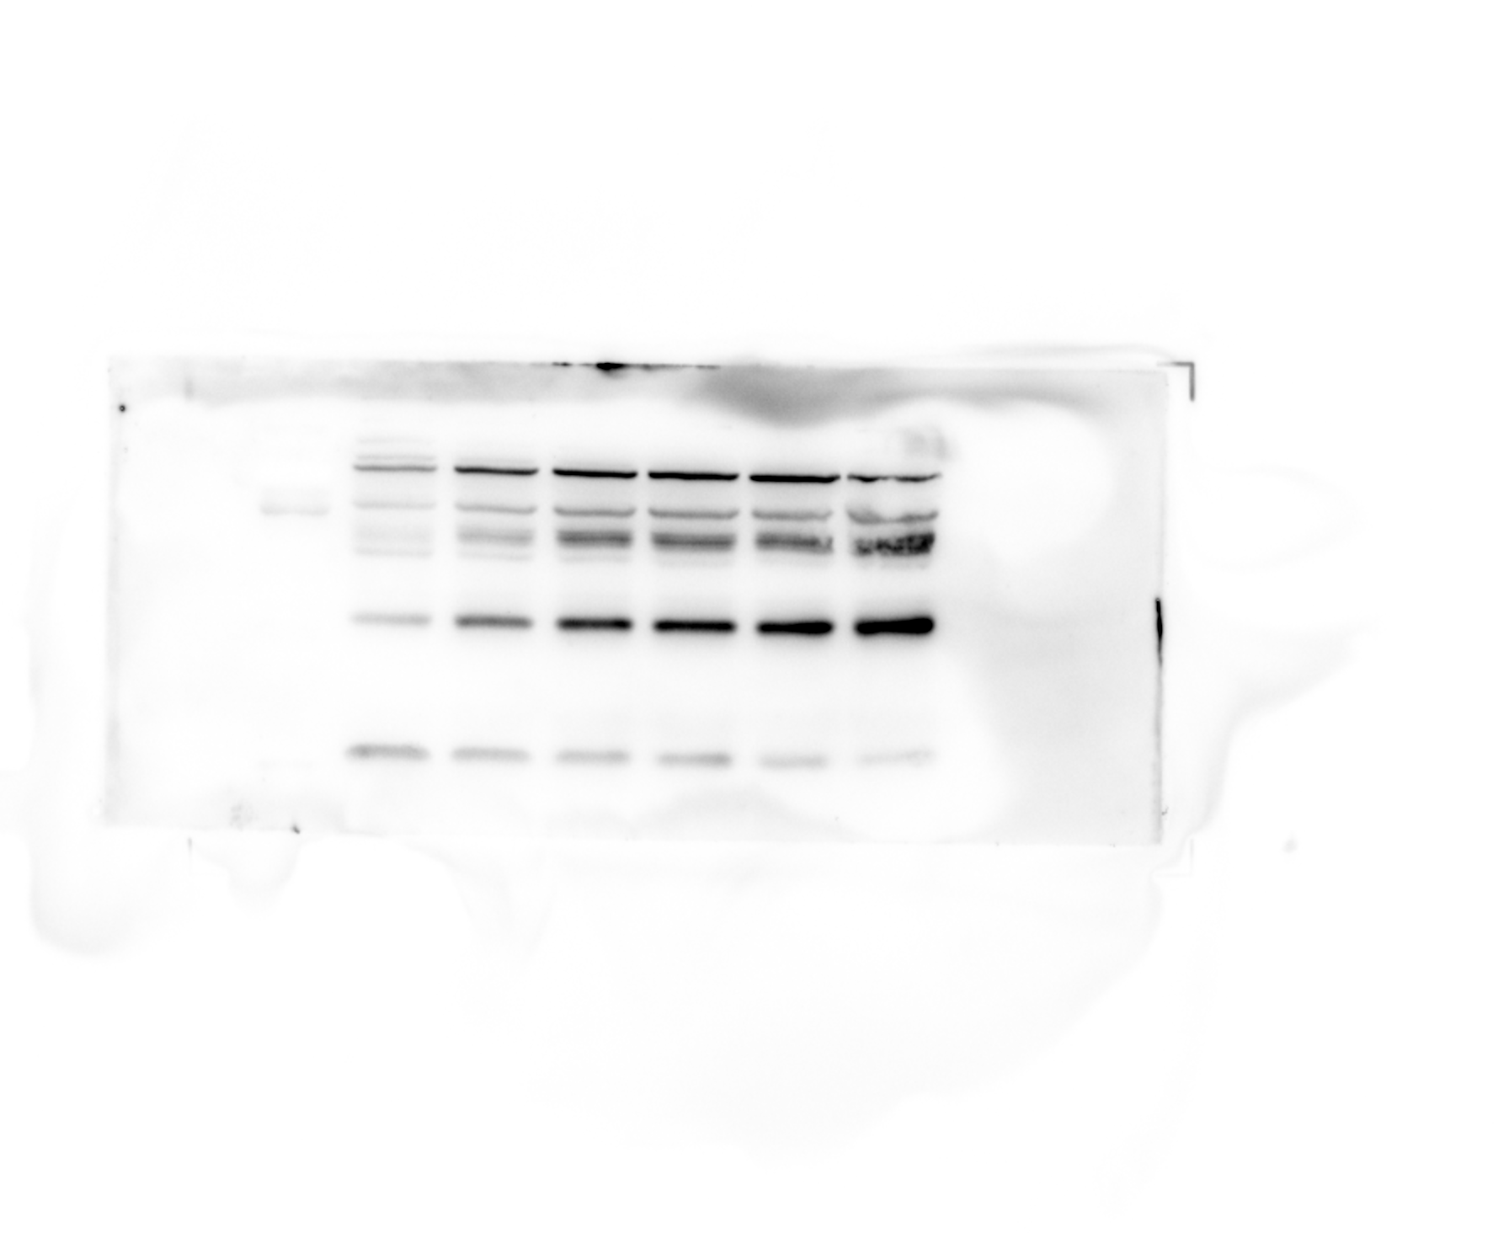
Original filename: FCER1A 1-1.Tif
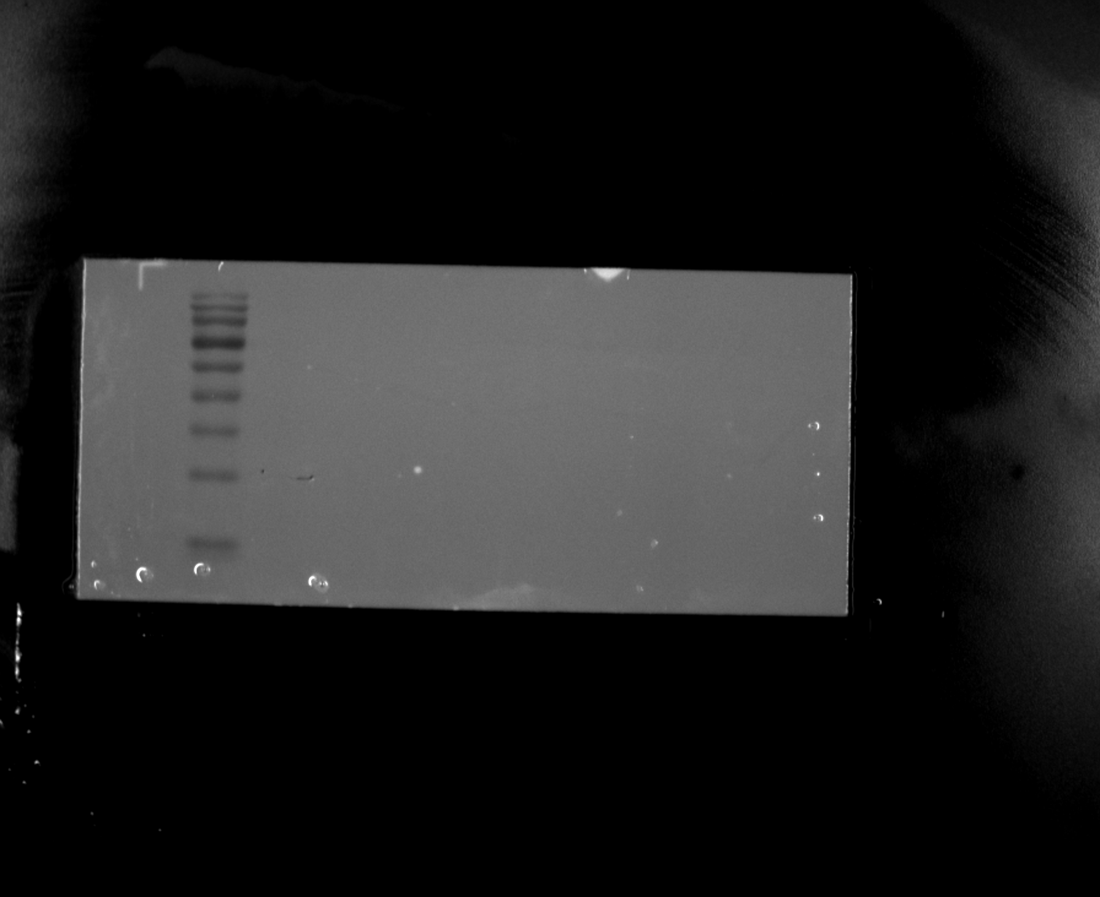
Original filename: FCER1A 1-2.Tif
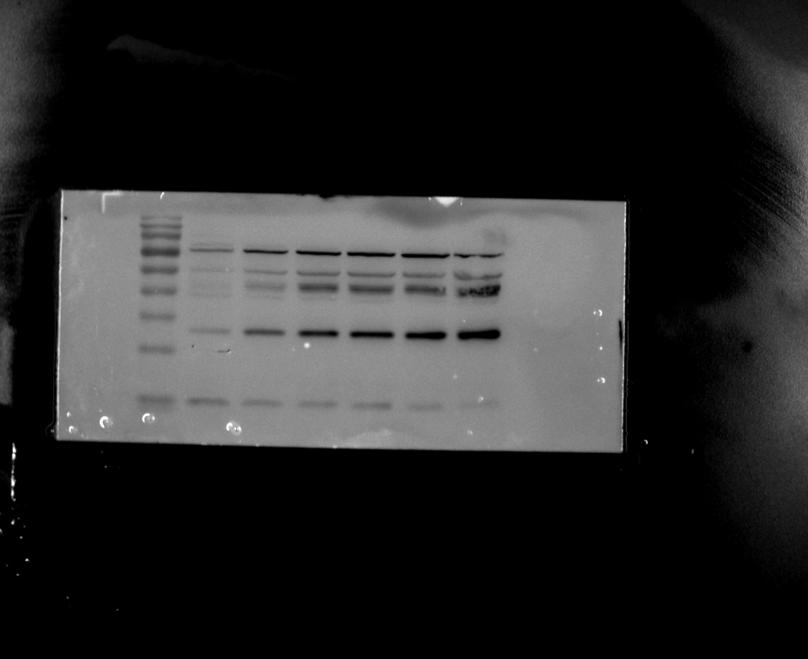

Figure 5A-C. HUVEC Western blots

Replicate 1 - FCER1A loading control (β-actin)
Original filename: FCER1A β-actin 1.Tif
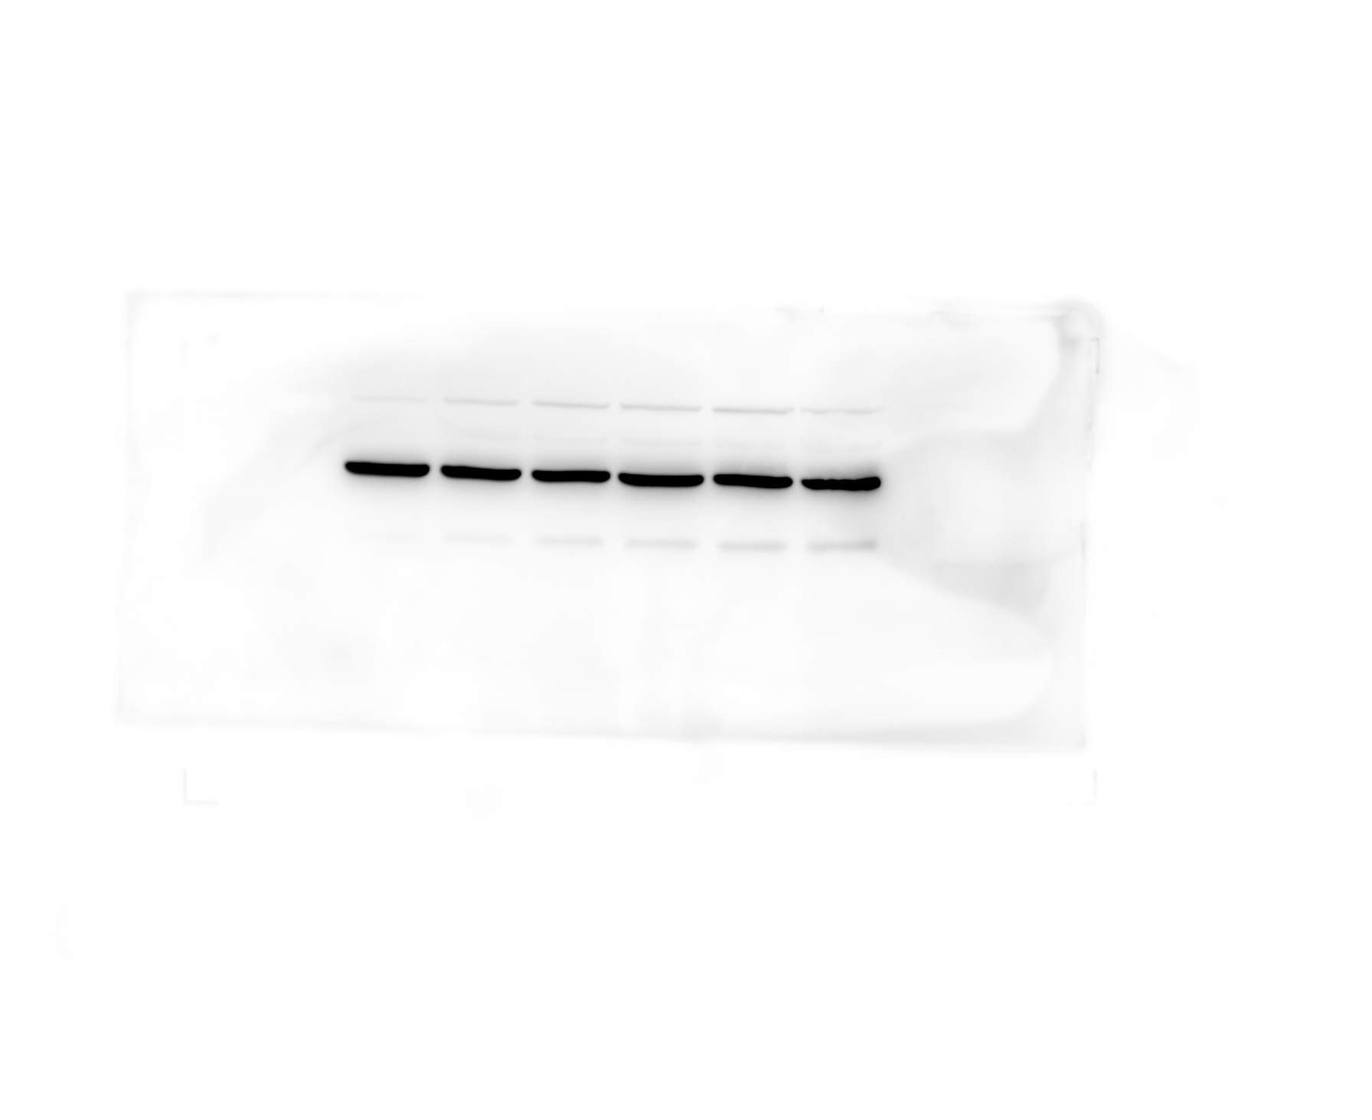
Original filename: FCER1A β-actin 1-1.Tif
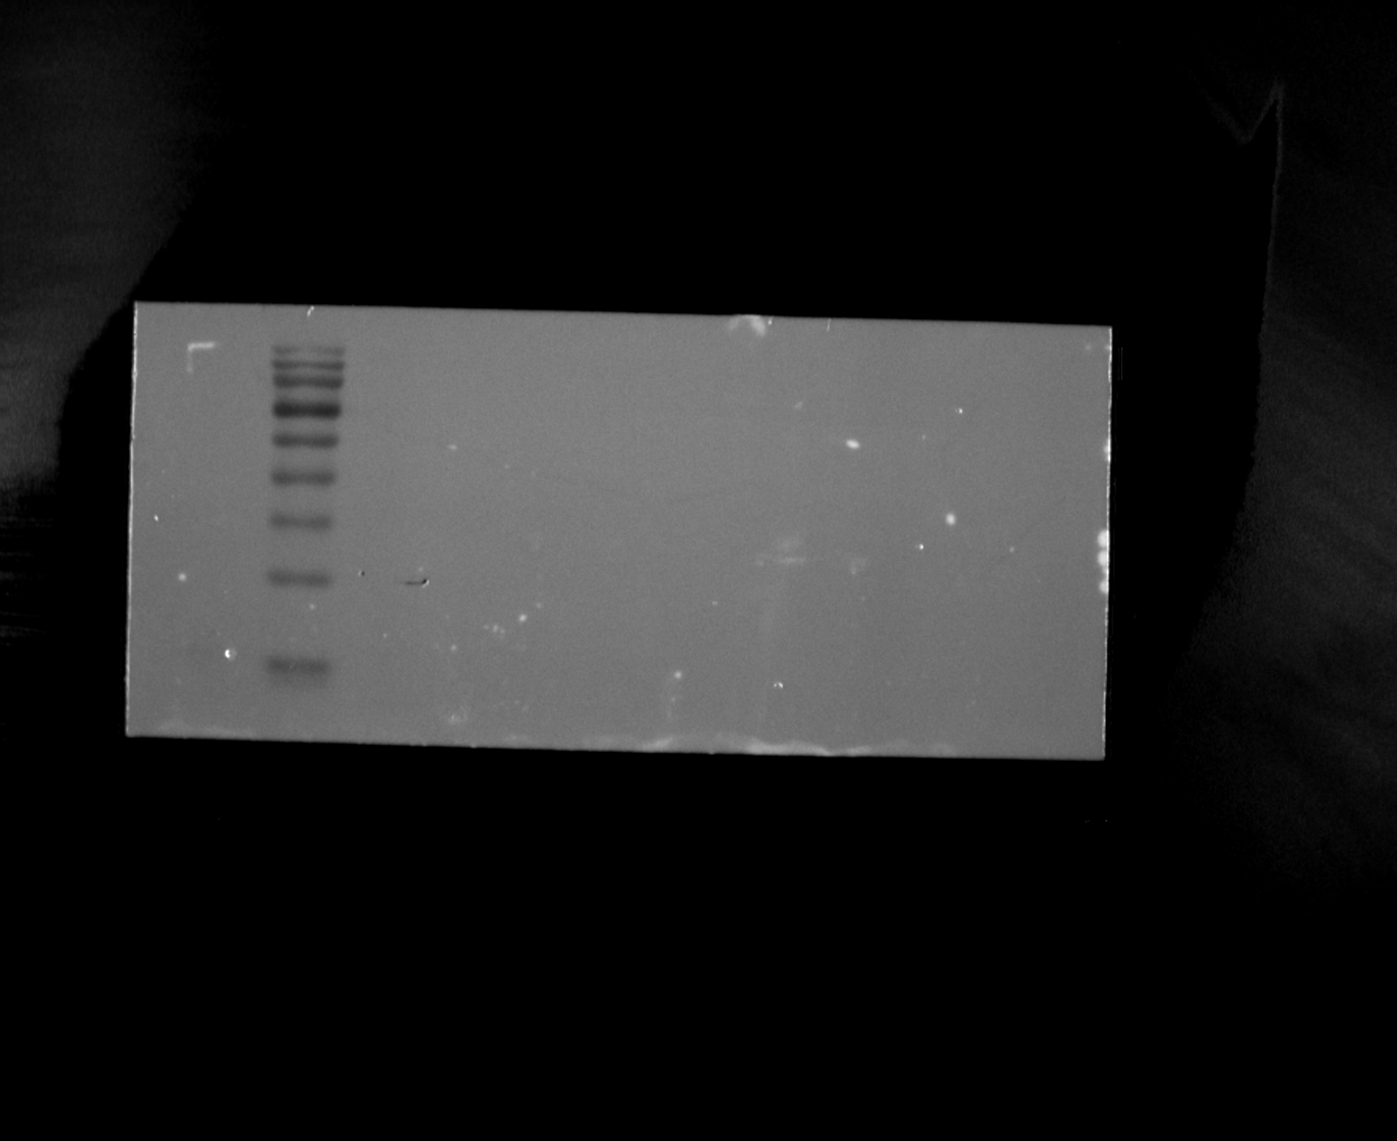
Original filename: FCER1A β-actin 1-2.Tif
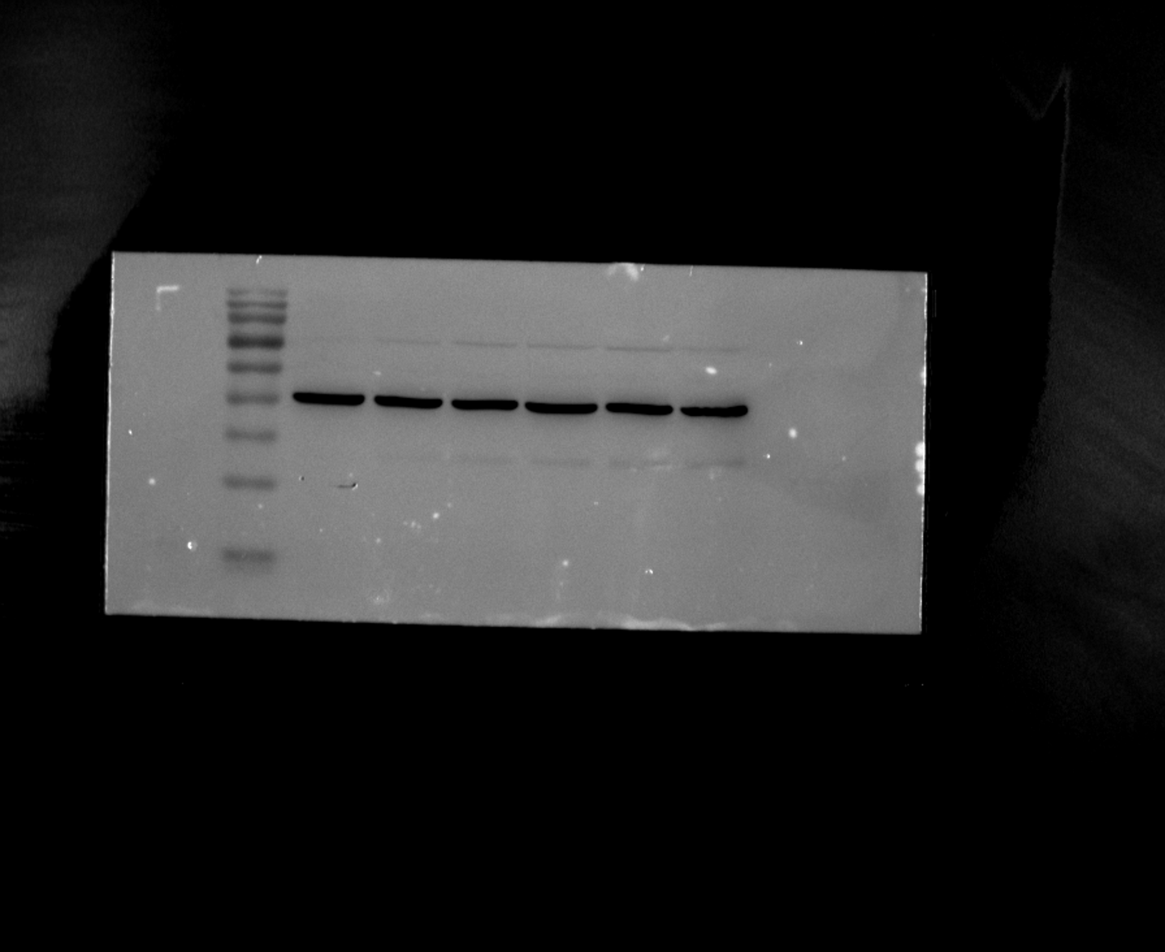

Figure 5A-C. HUVEC Western blots

Replicate 1 - INSIG1
Original filename: INSIG1 1.Tif
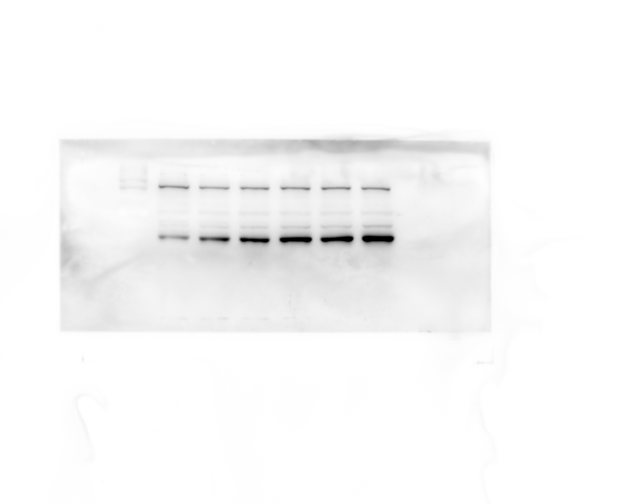
Original filename: INSIG1 1-1.Tif
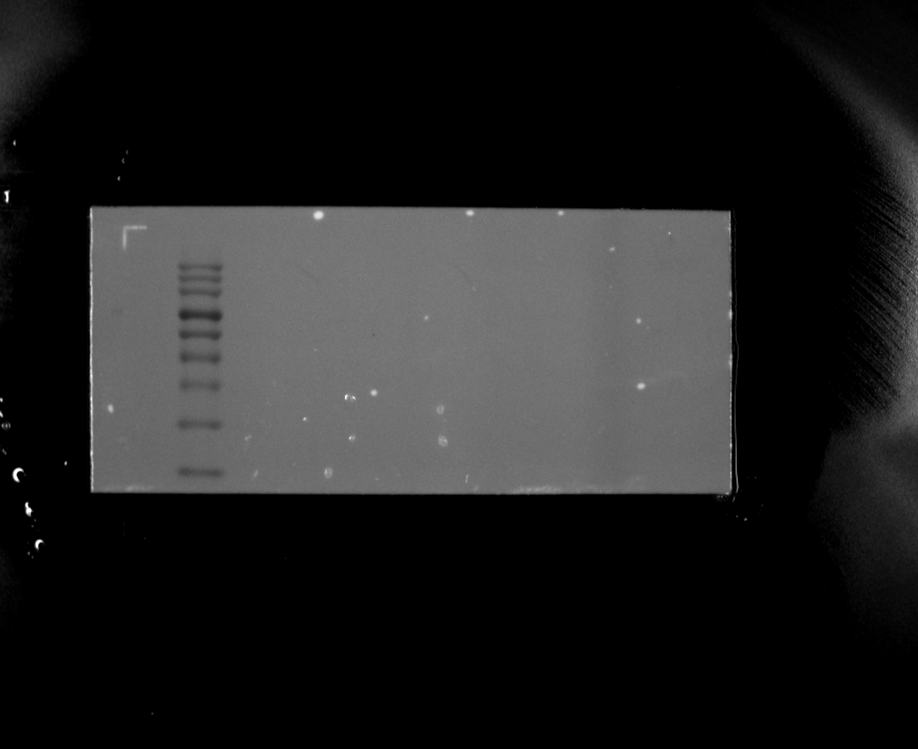
Original filename: INSIG1 1-2.Tif
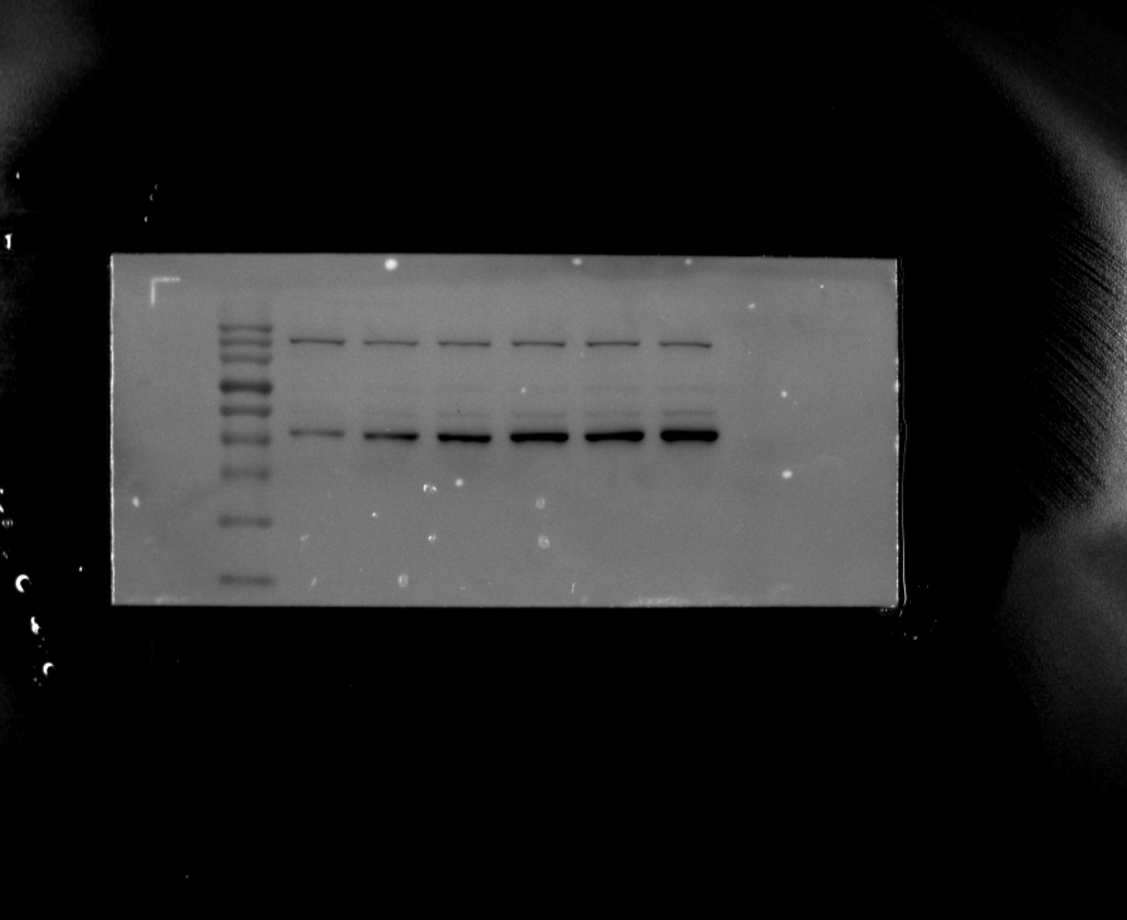

Figure 5A-C. HUVEC Western blots

Replicate 1 - INSIG1 loading control (β-actin)
Original filename: INSIG1 β-actin 1.Tif
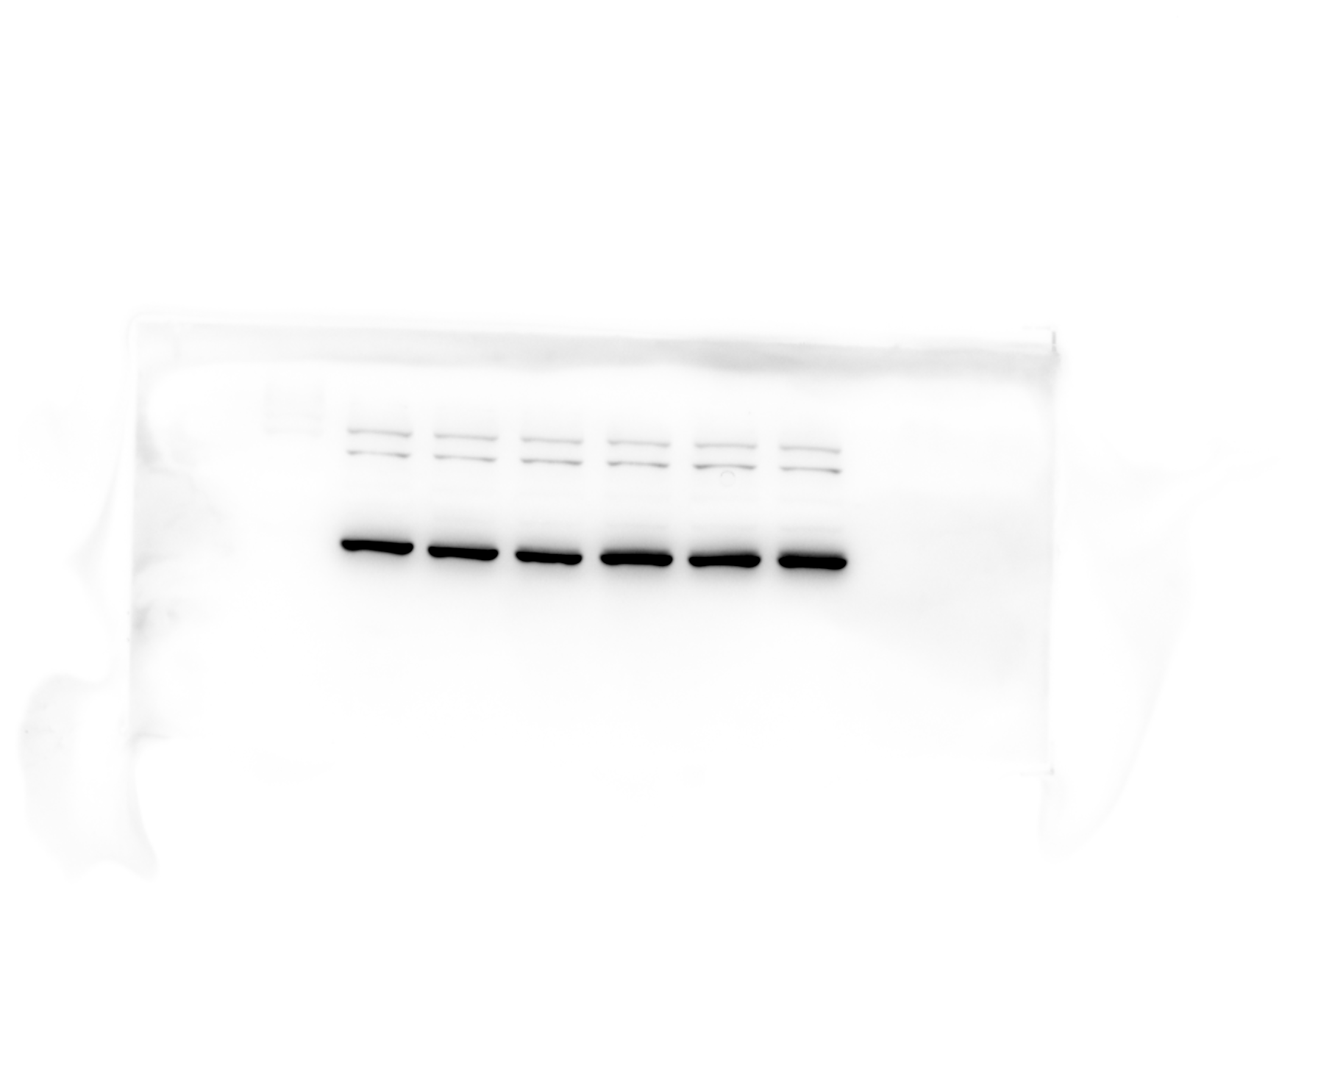
Original filename: INSIG1 β-actin 1-1.Tif
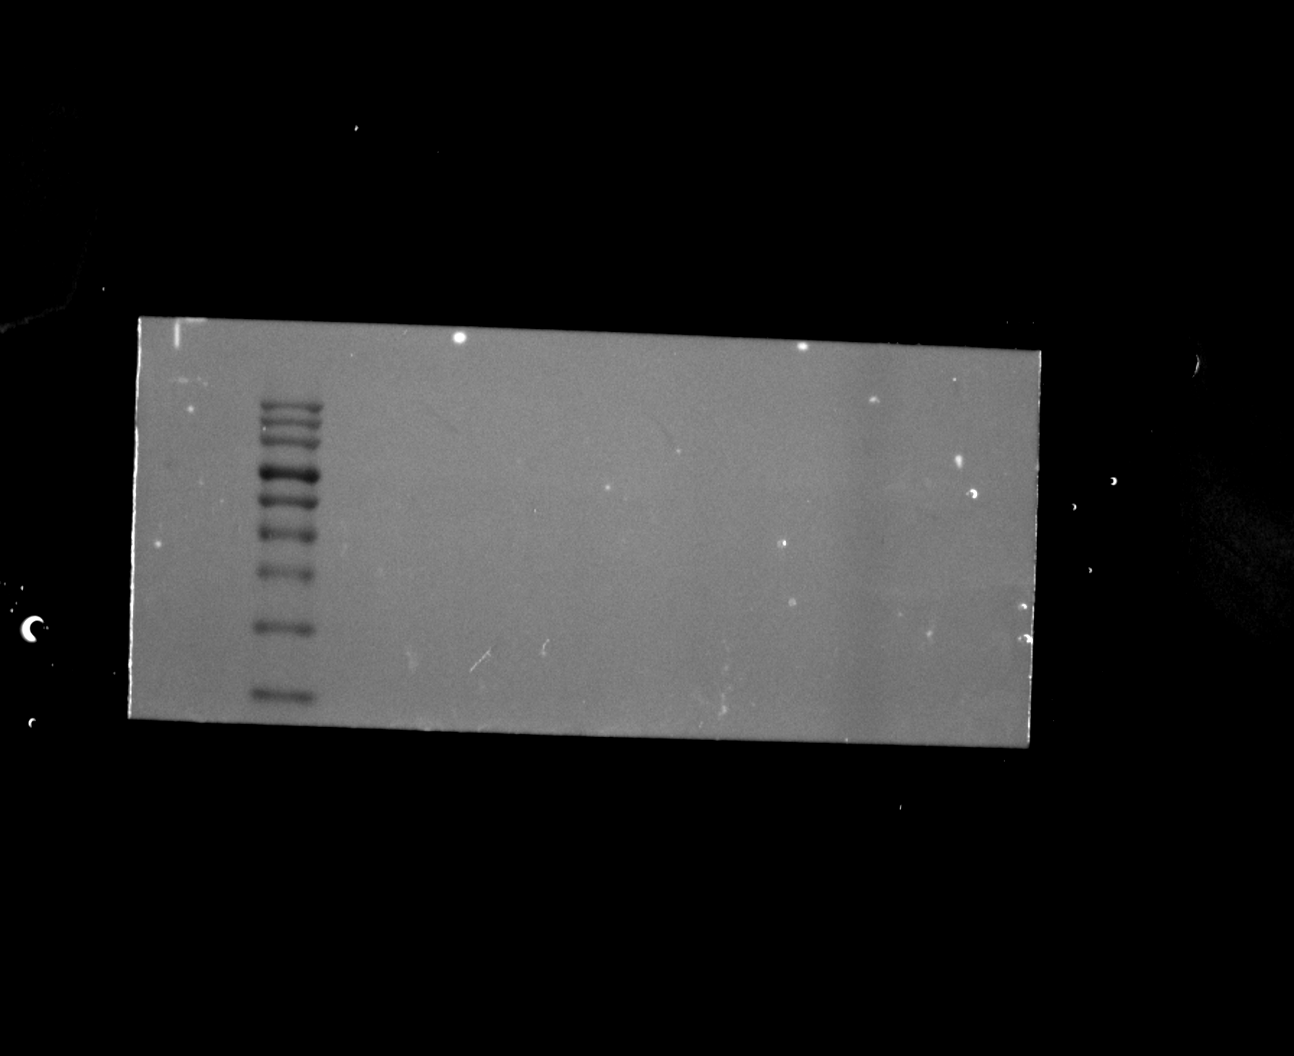
Original filename: INSIG1 β-actin 1-2.Tif
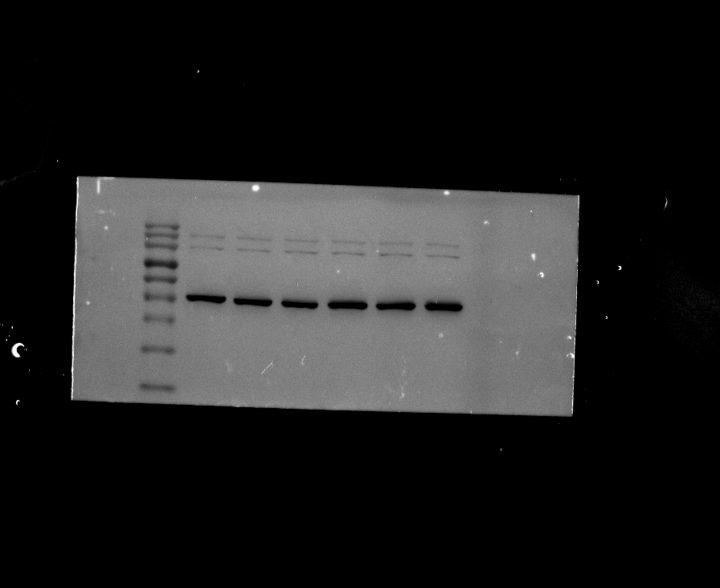

Figure 5A-C. HUVEC Western blots

Replicate 2 - FCER1A
Original filename: FCER1A 2.Tif
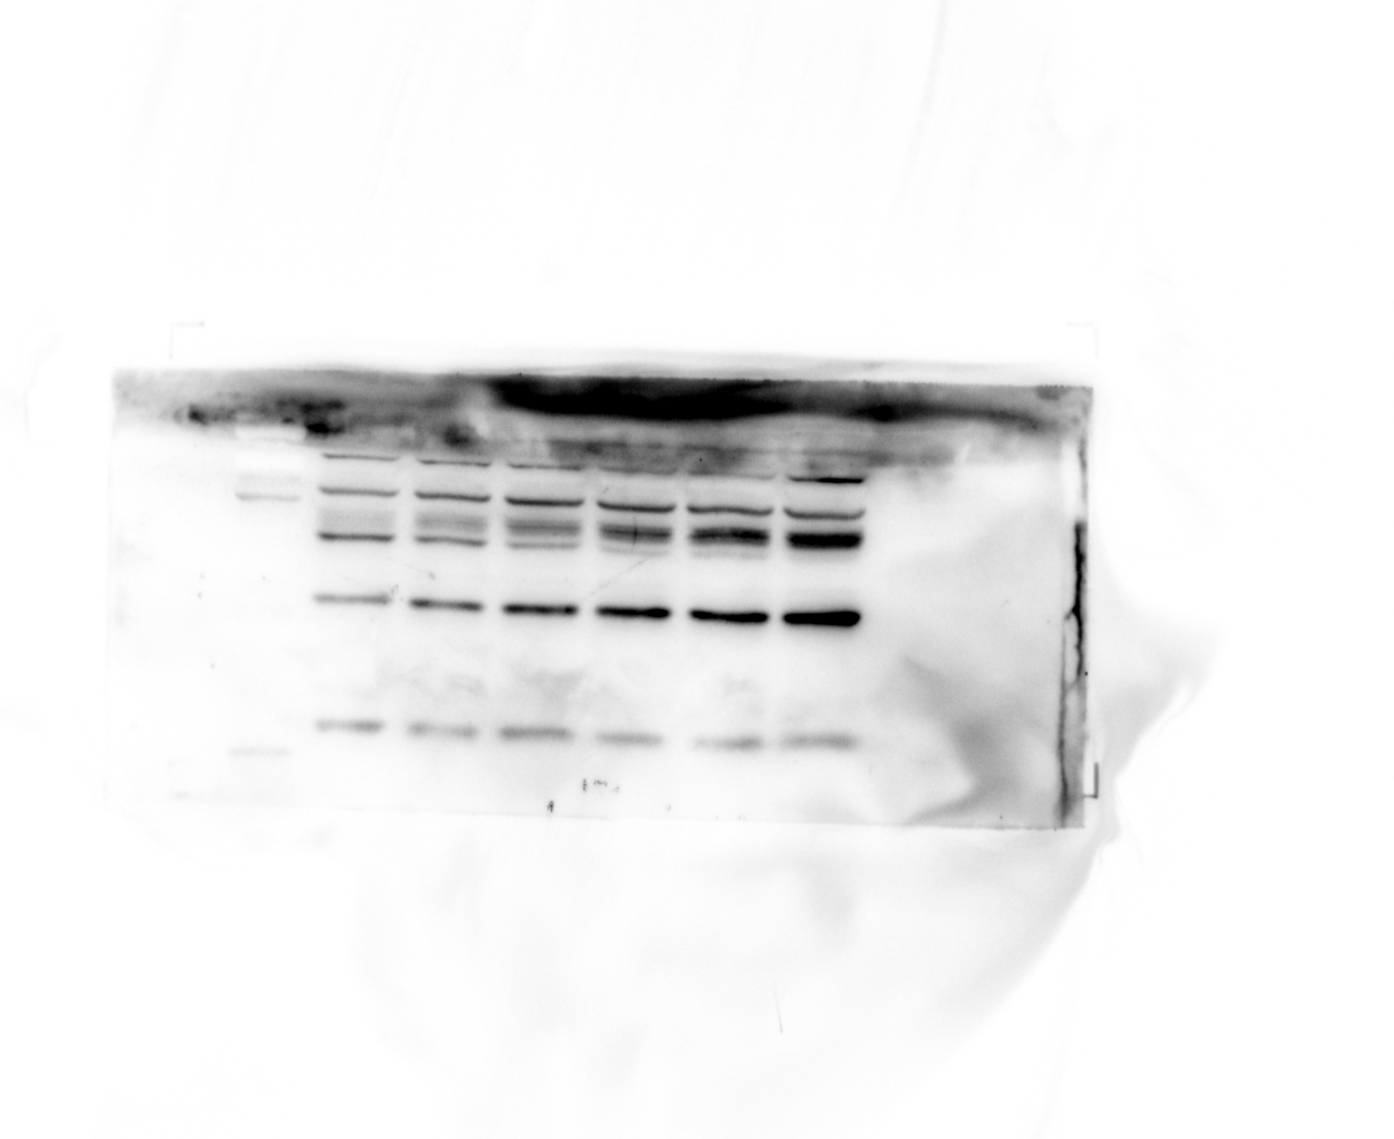
Original filename: FCER1A 2-1.Tif
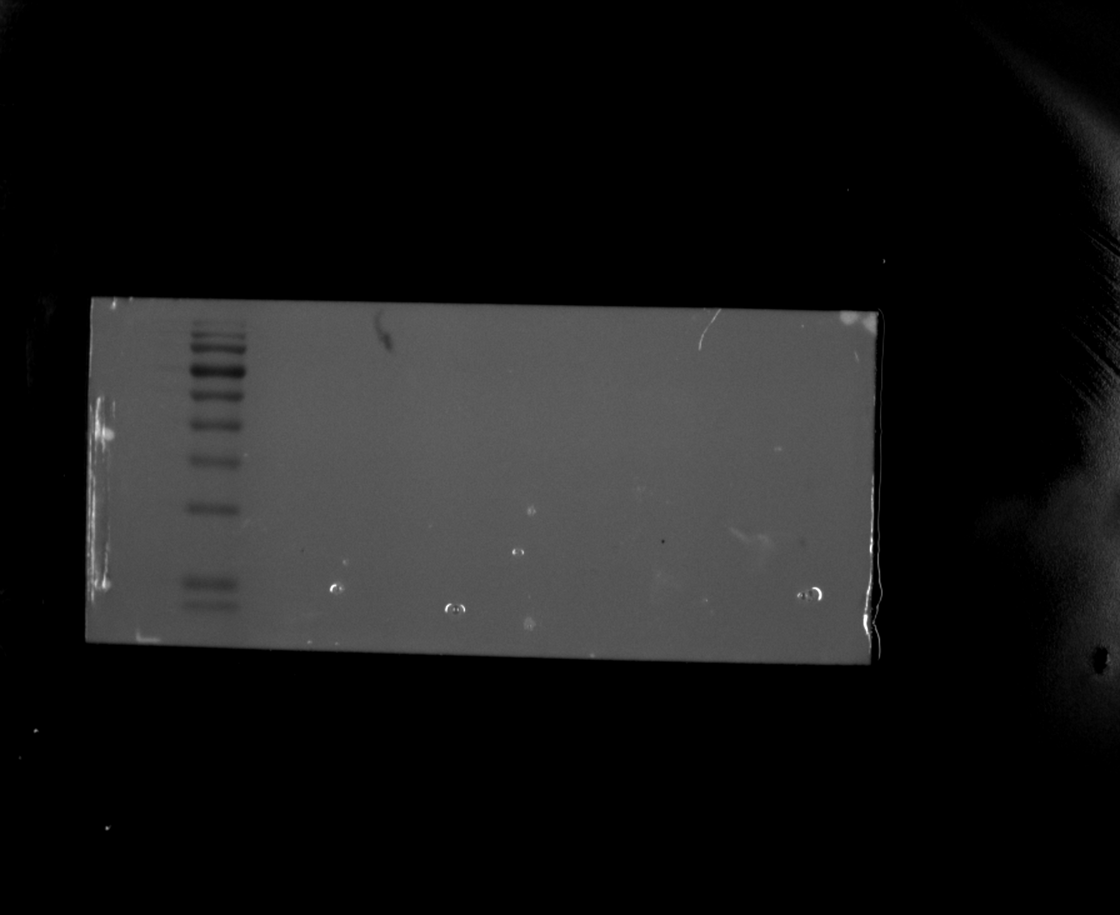
Original filename: FCER1A 2-2.Tif
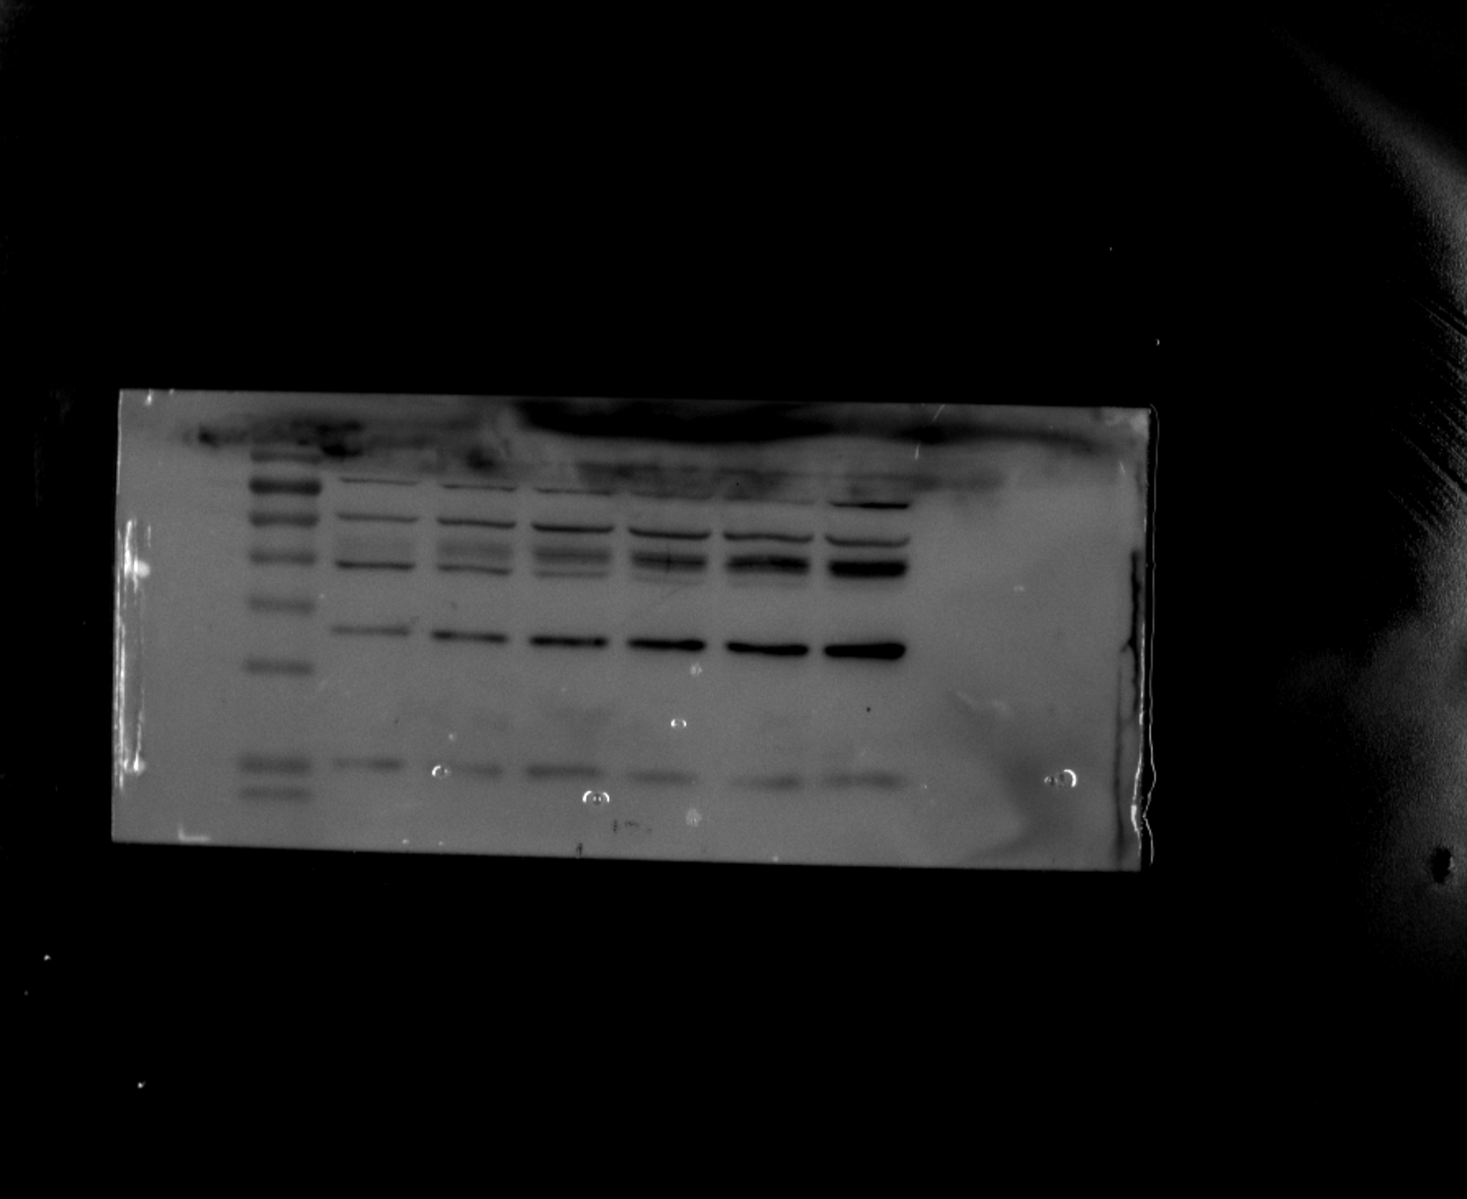

Figure 5A-C. HUVEC Western blots

Replicate 2 - FCER1A loading control (β-actin)
Original filename: FCER1A β-actin 2.Tif
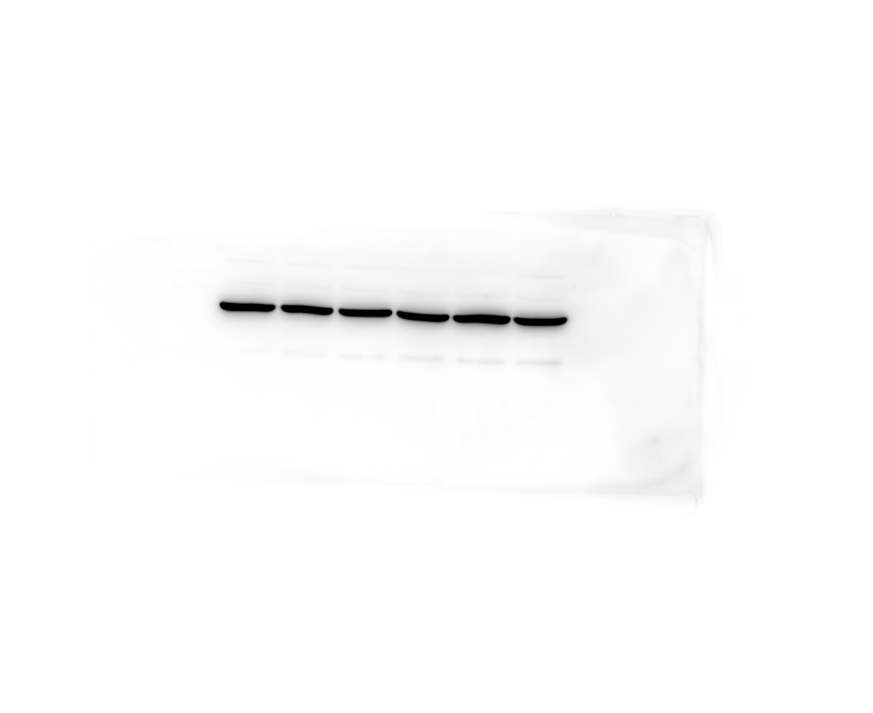
Original filename: FCER1A β-actin 2-1.Tif
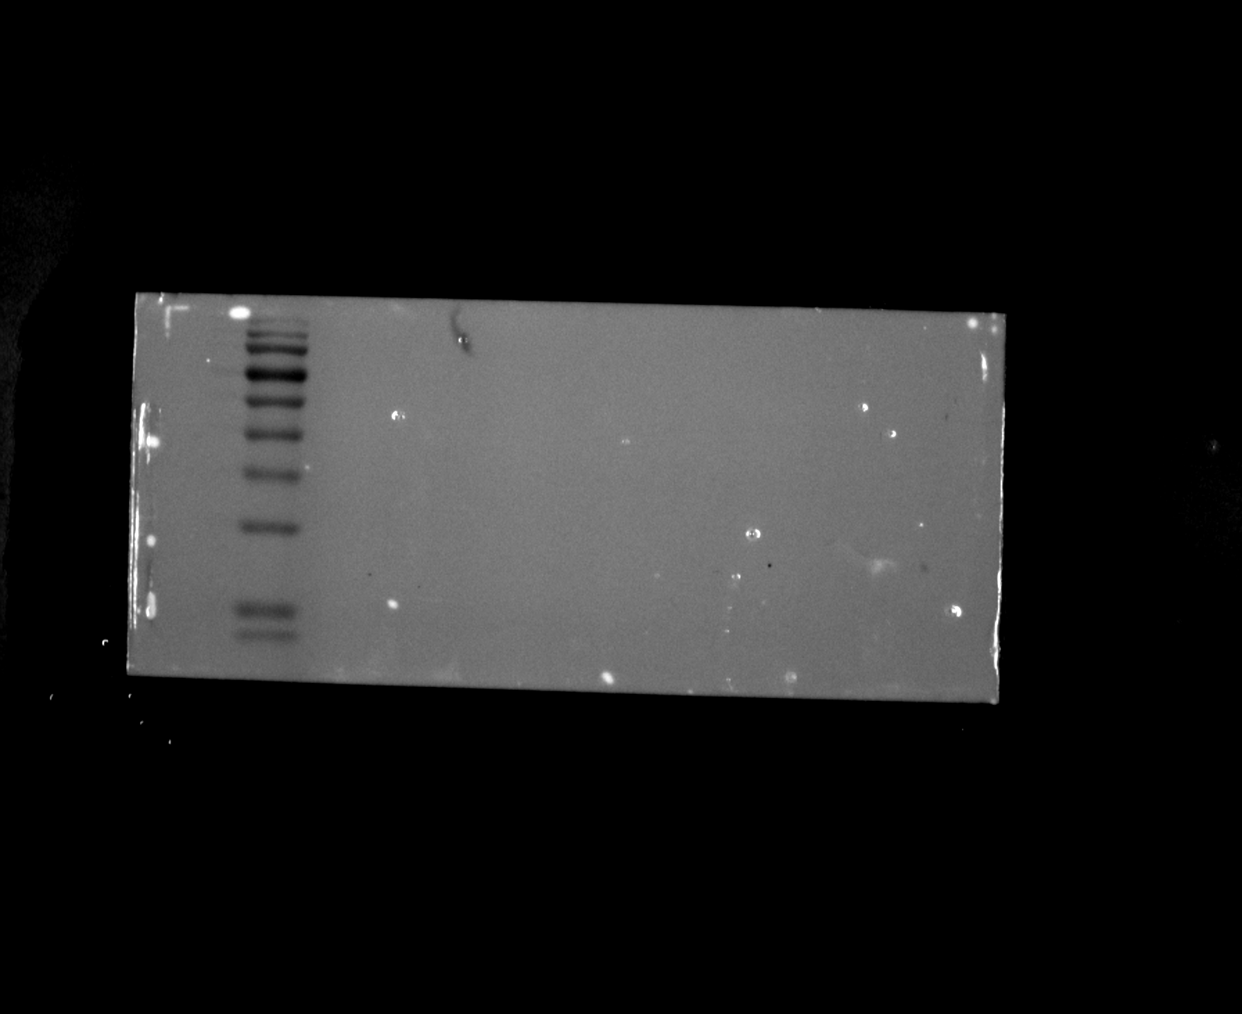
Original filename: FCER1A β-actin 2-2.Tif
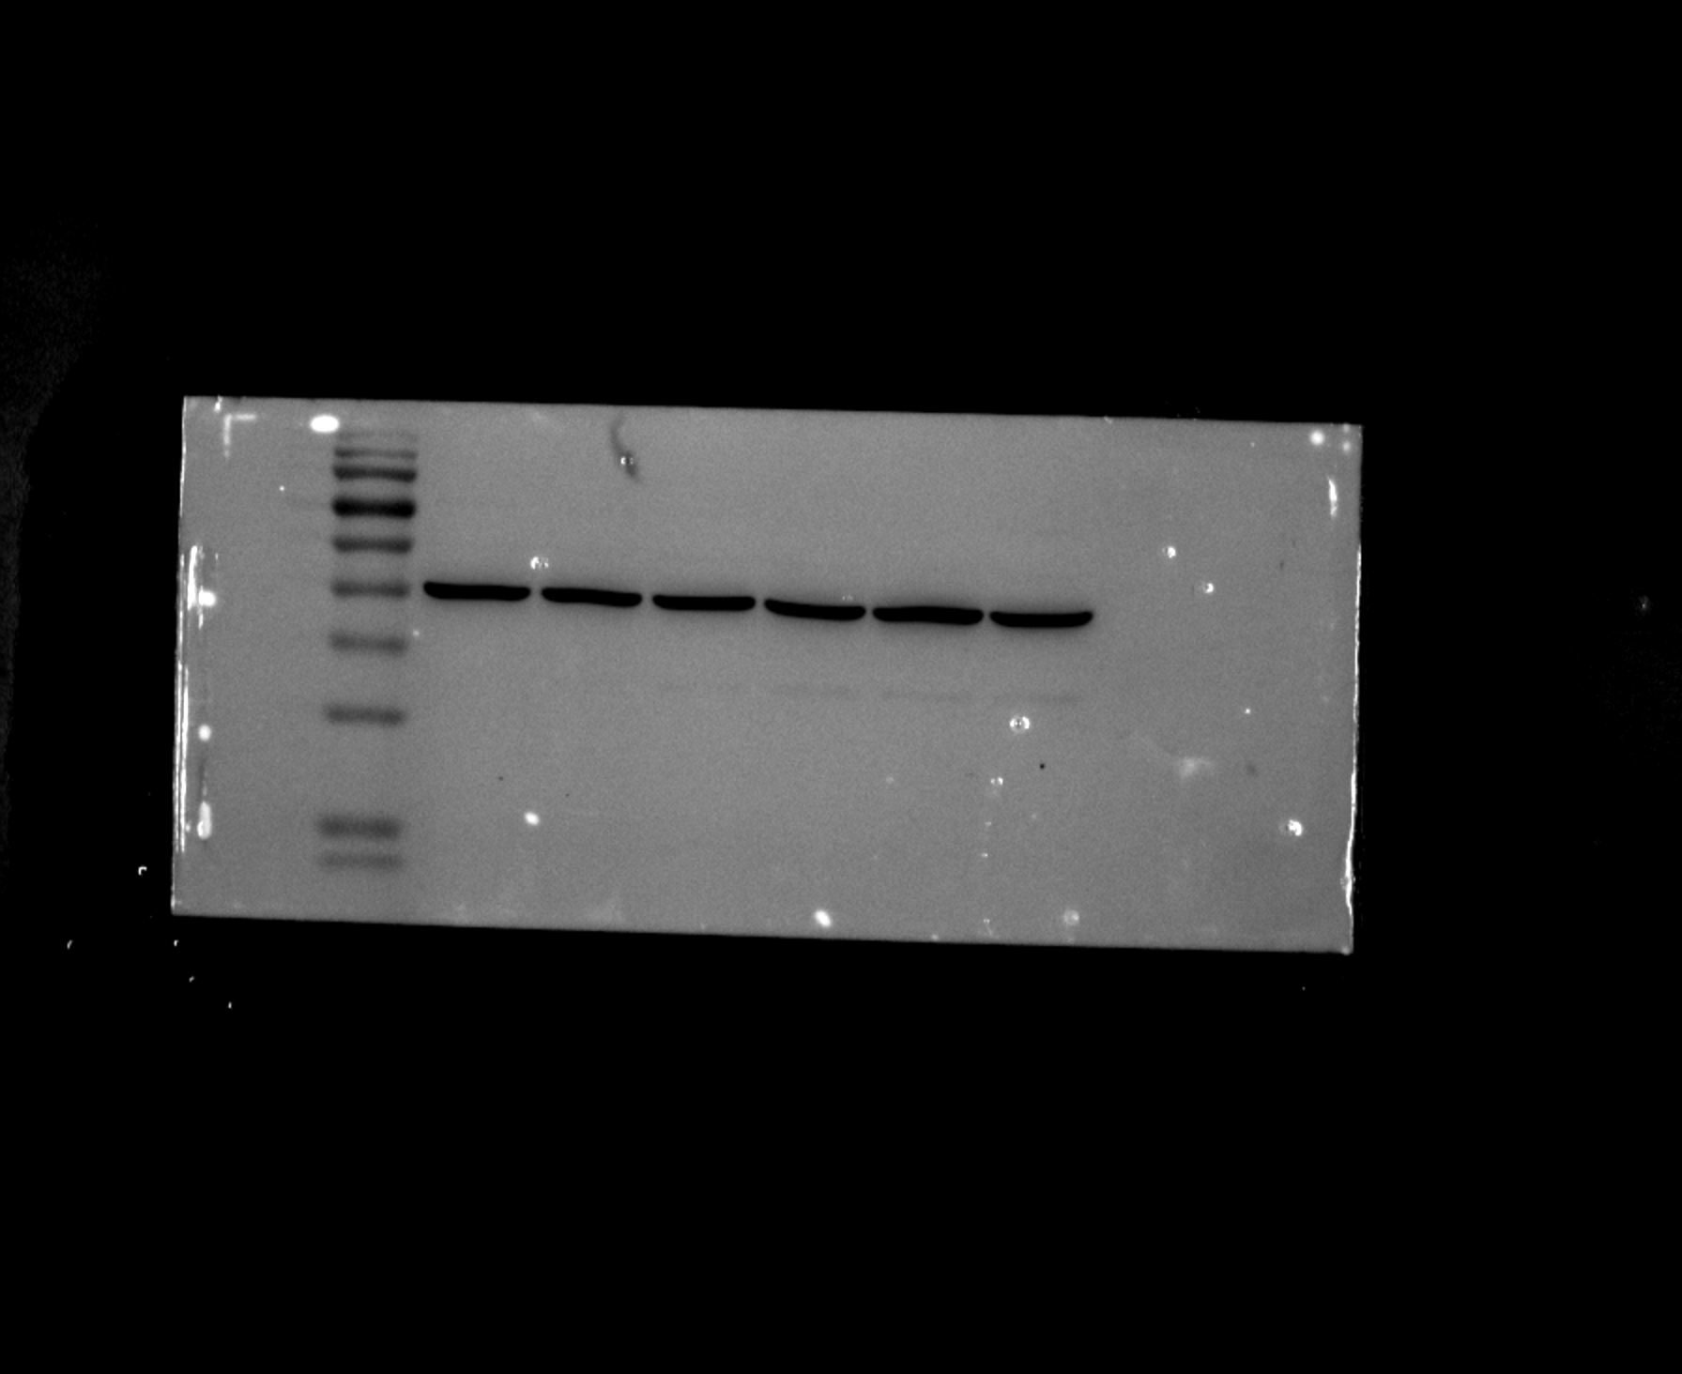

Figure 5A-C. HUVEC Western blots

Replicate 2 - INSIG1
Original filename: INSIG1 2.Tif
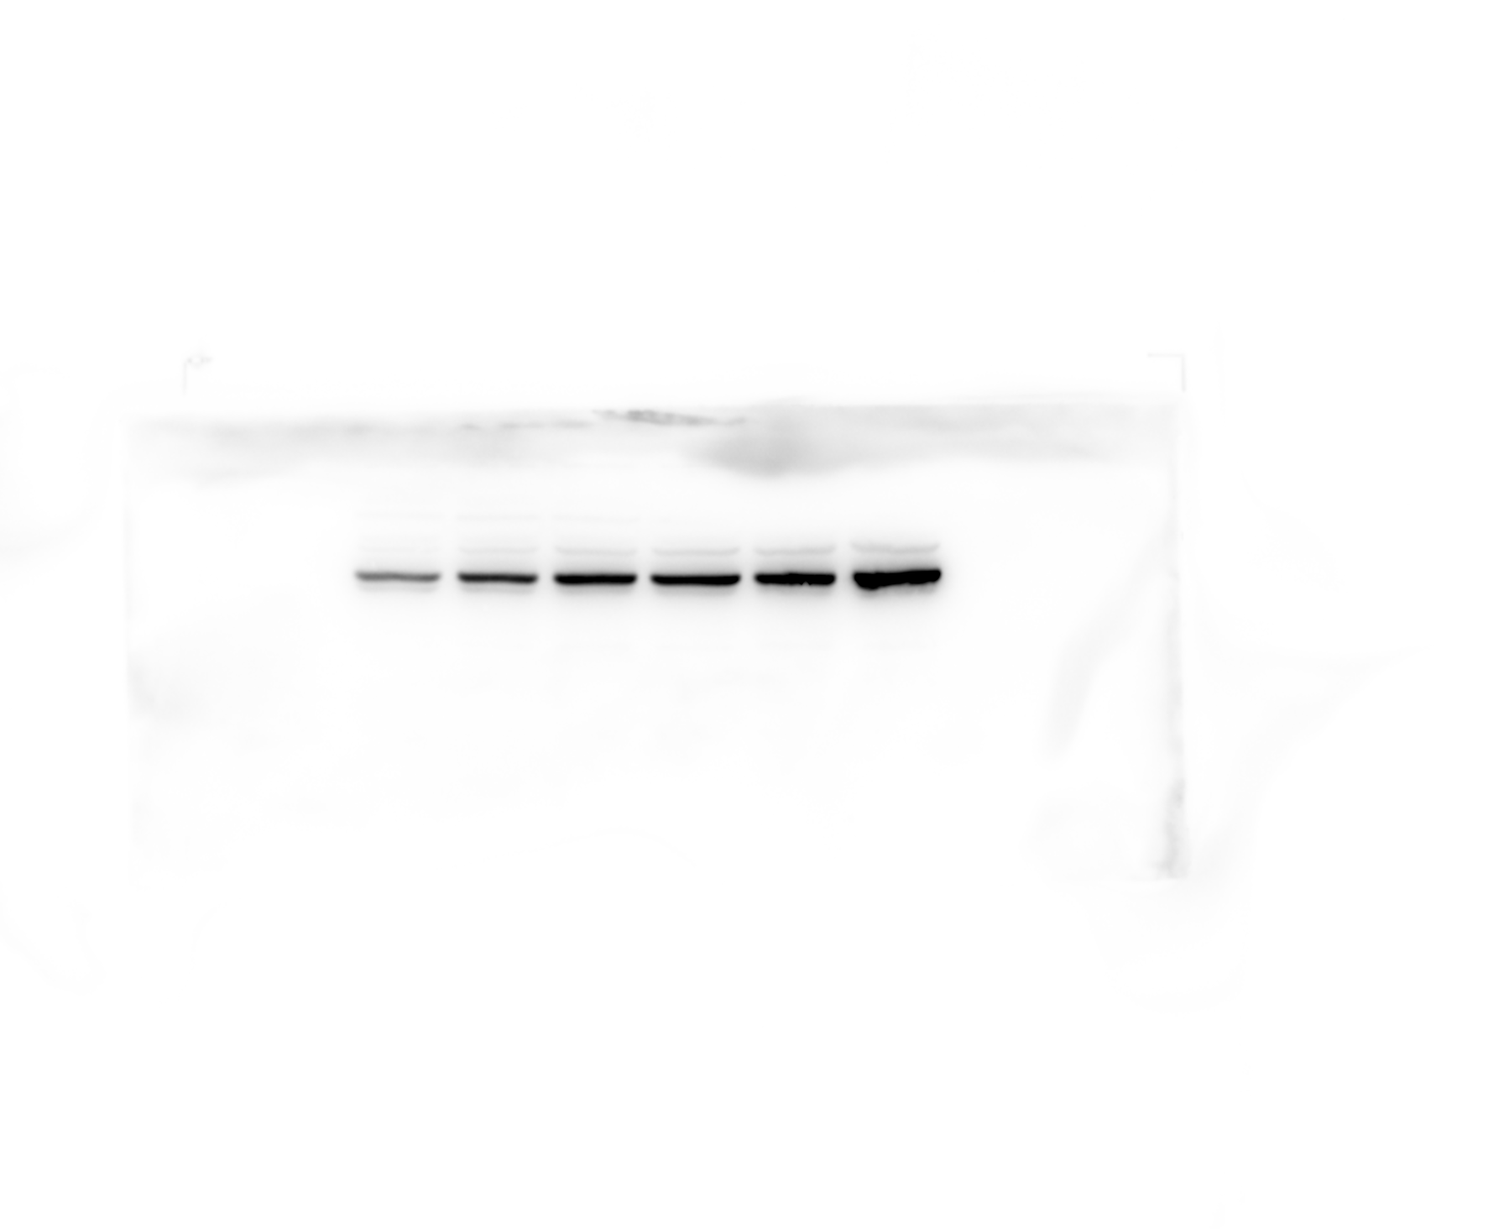
Original filename: INSIG1 2-1.Tif
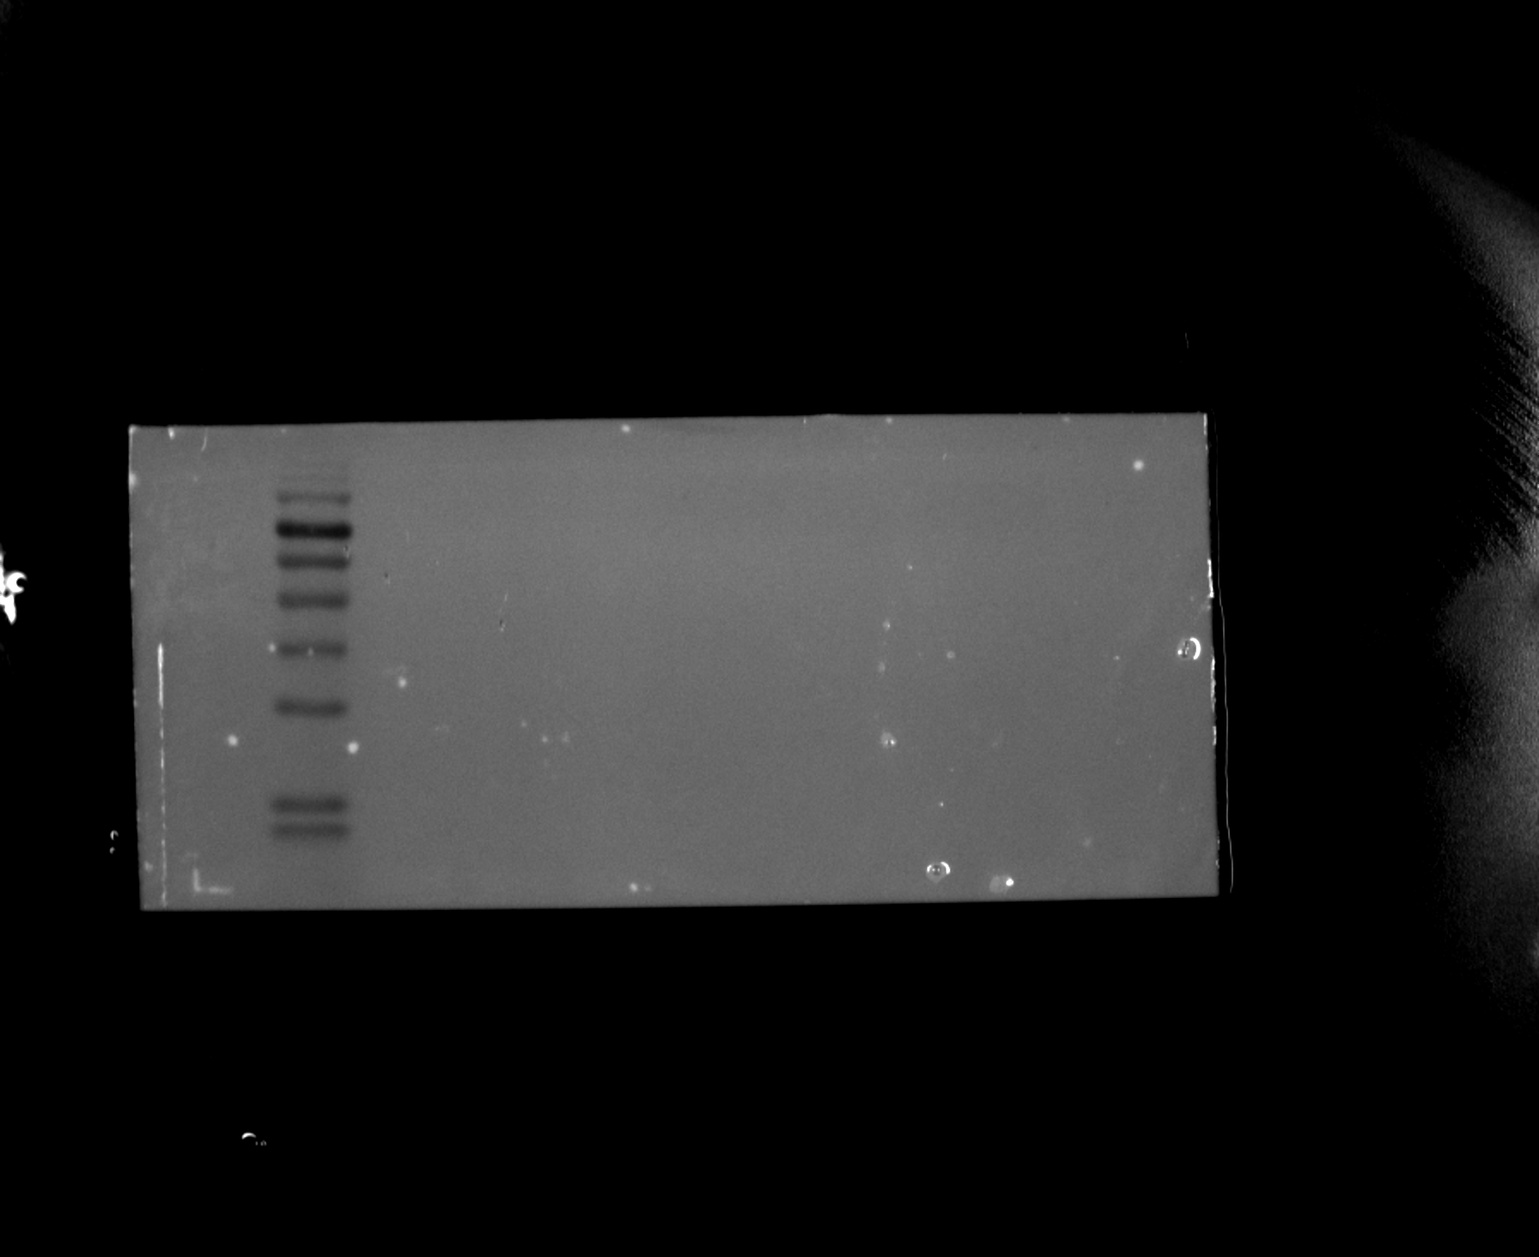
Original filename: INSIG1 2-2.Tif
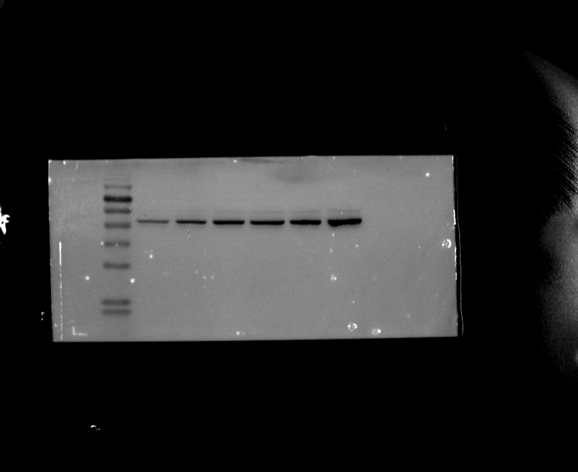

Figure 5A-C. HUVEC Western blots

Replicate 2 - INSIG1 loading control (β-actin)
Original filename: INSIG1 β-actin 2.Tif
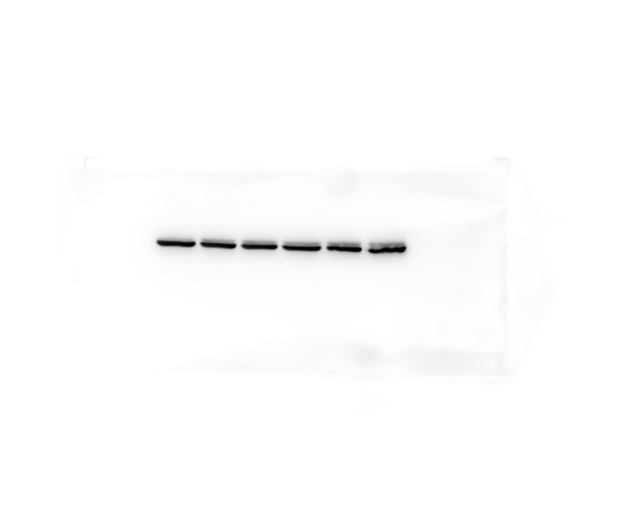
Original filename: INSIG1 β-actin 2-1.Tif
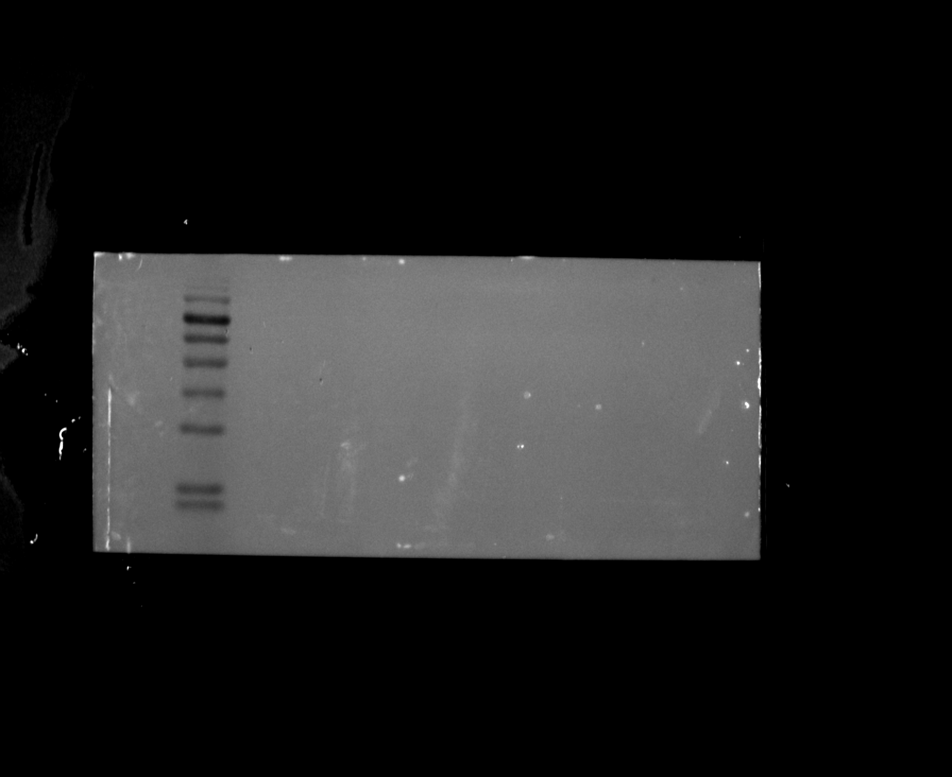
Original filename: INSIG1 β-actin 2-2.Tif
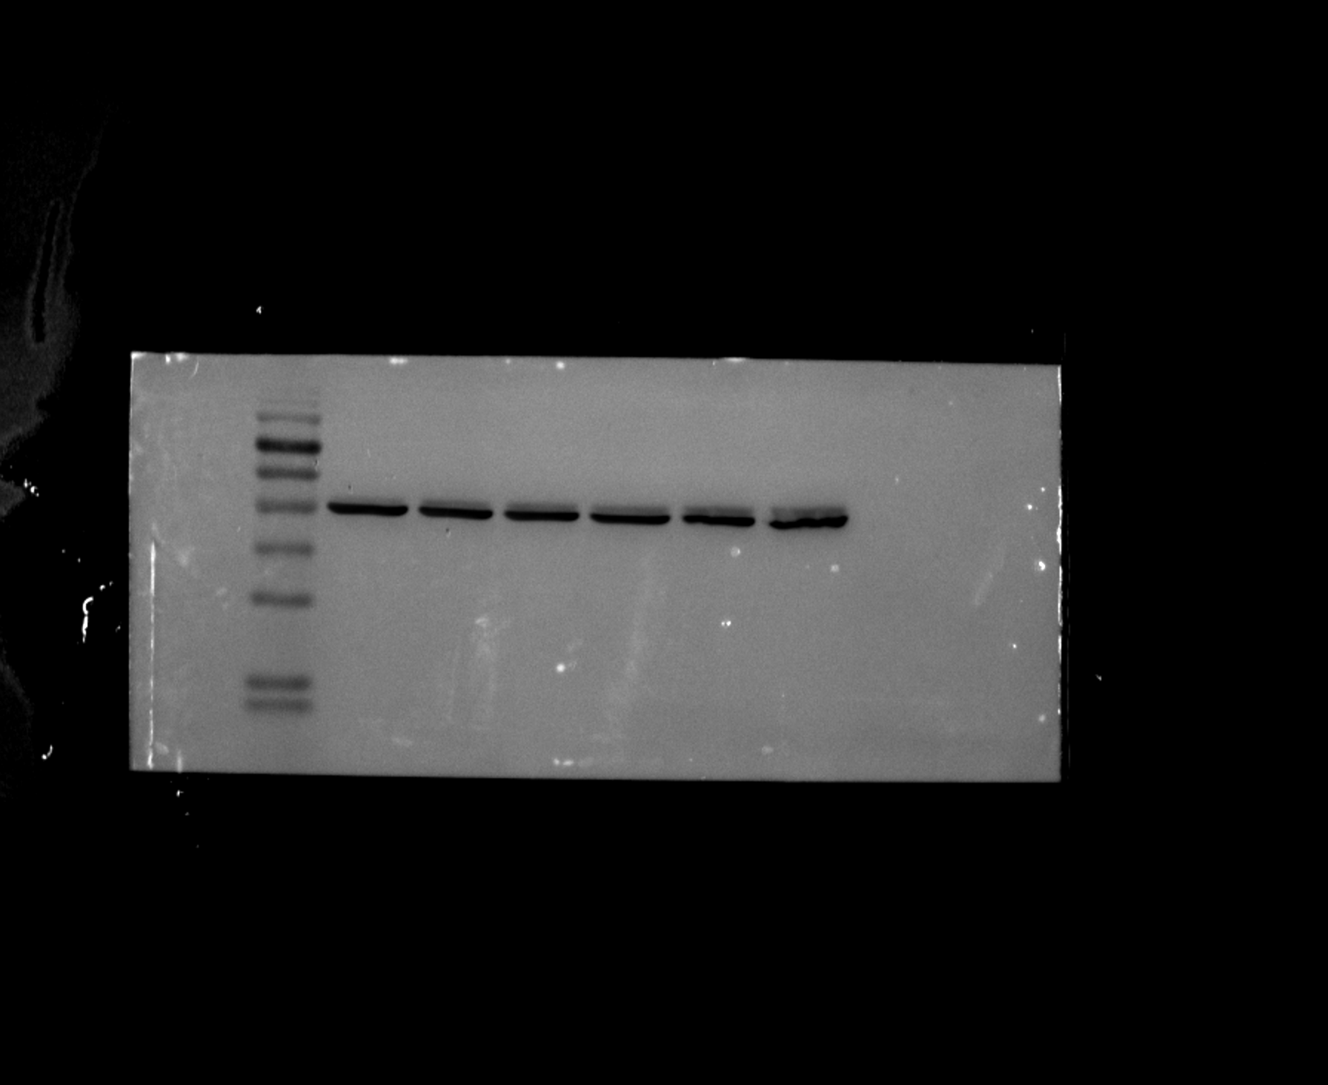

Figure 5A-C. HUVEC Western blots

Replicate 3 - FCER1A
Original filename: FCER1A 3.Tif
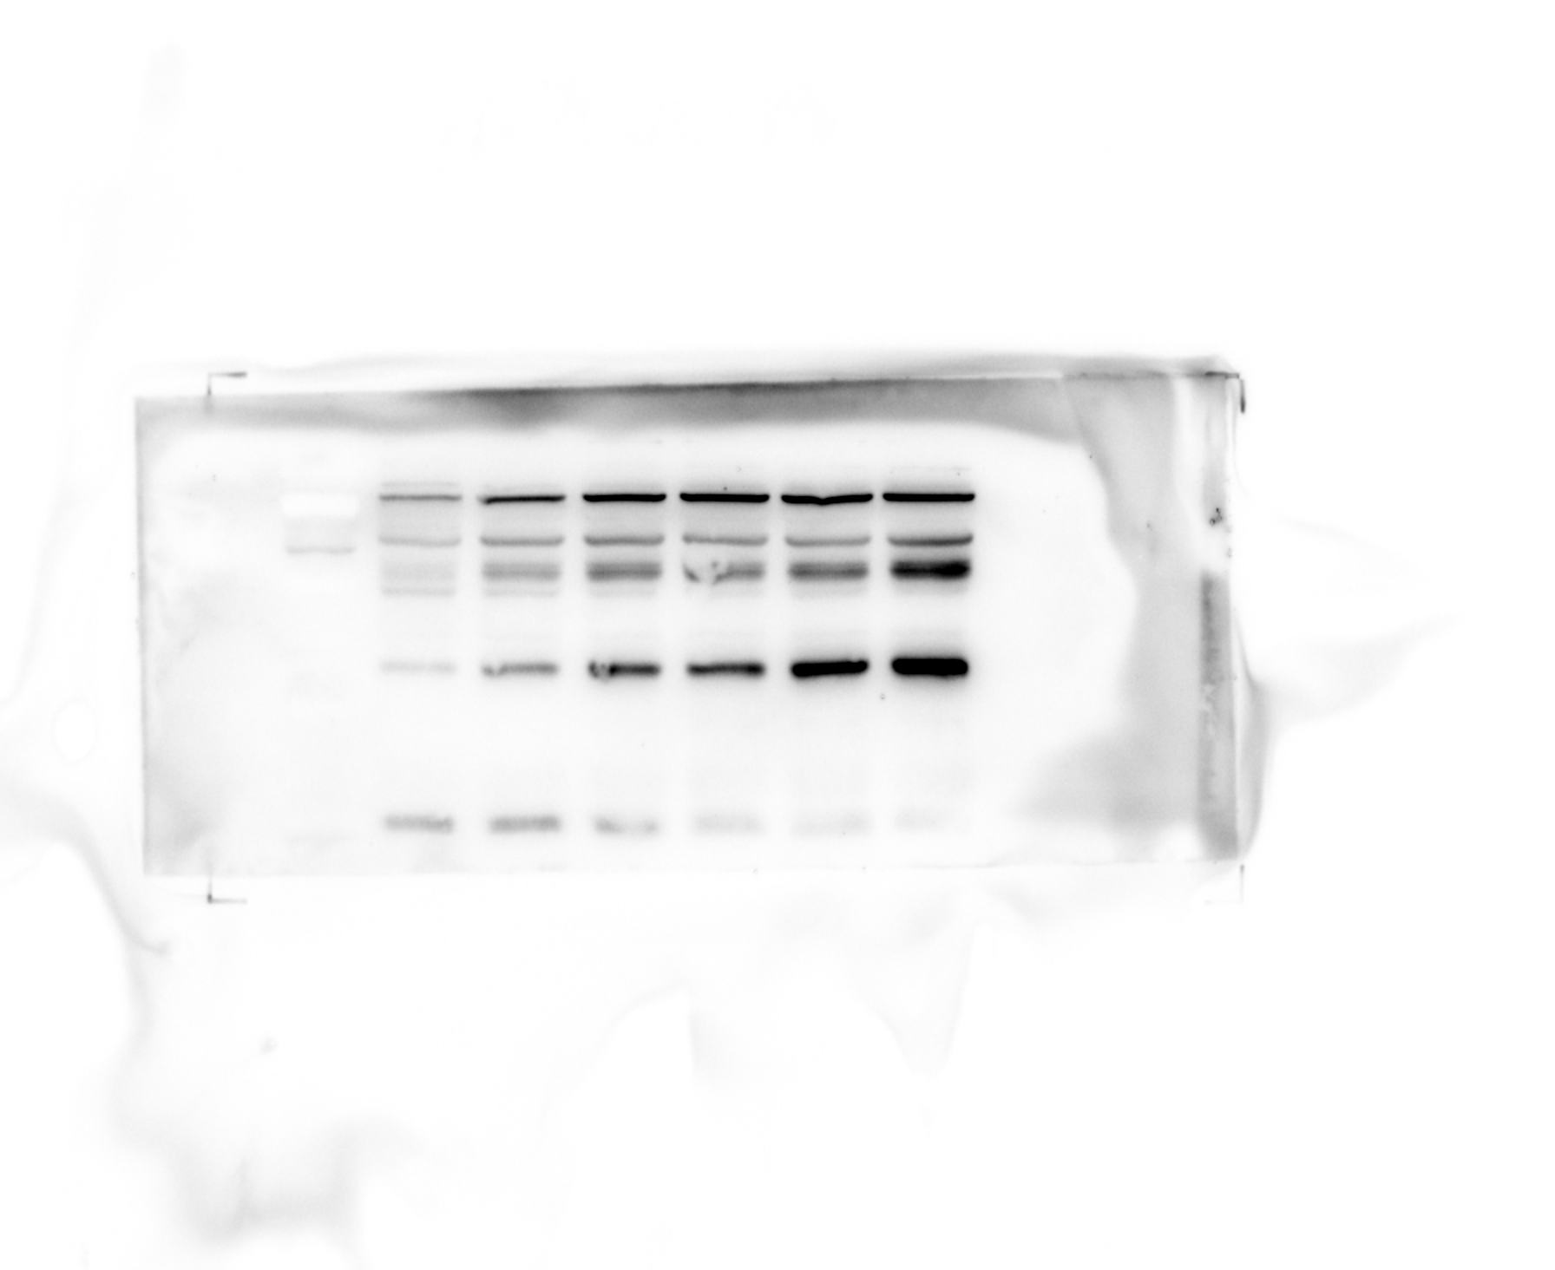
Original filename: FCER1A 3-1.Tif
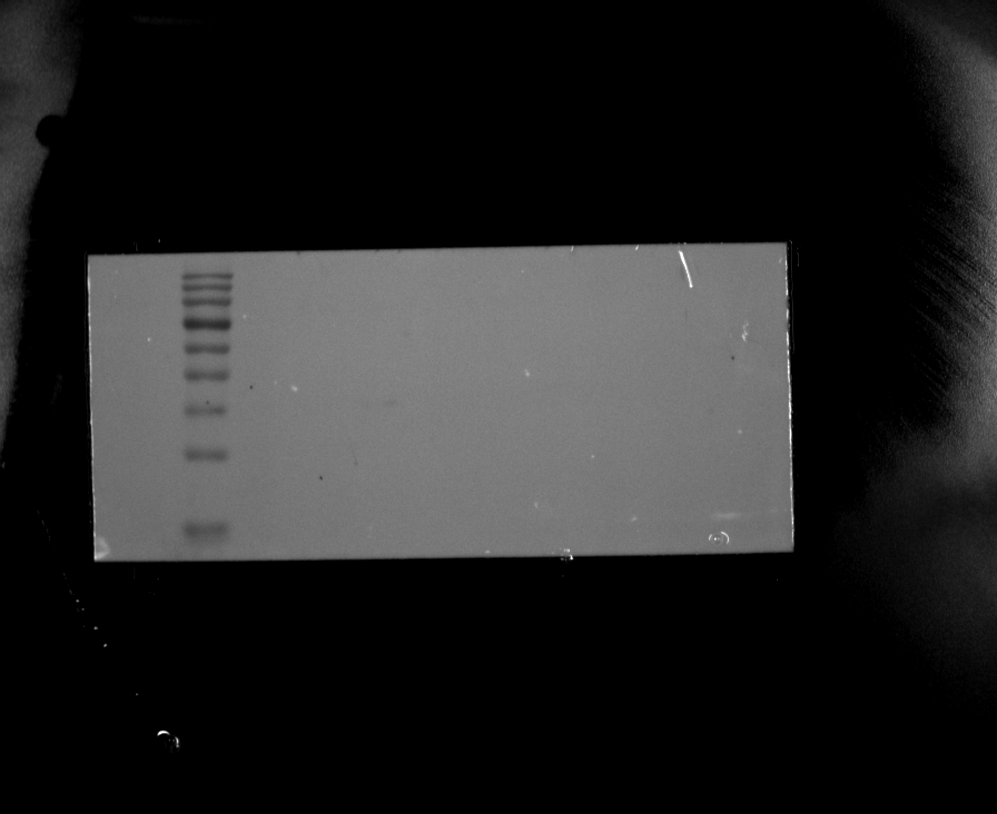
Original filename: FCER1A 3-2.Tif
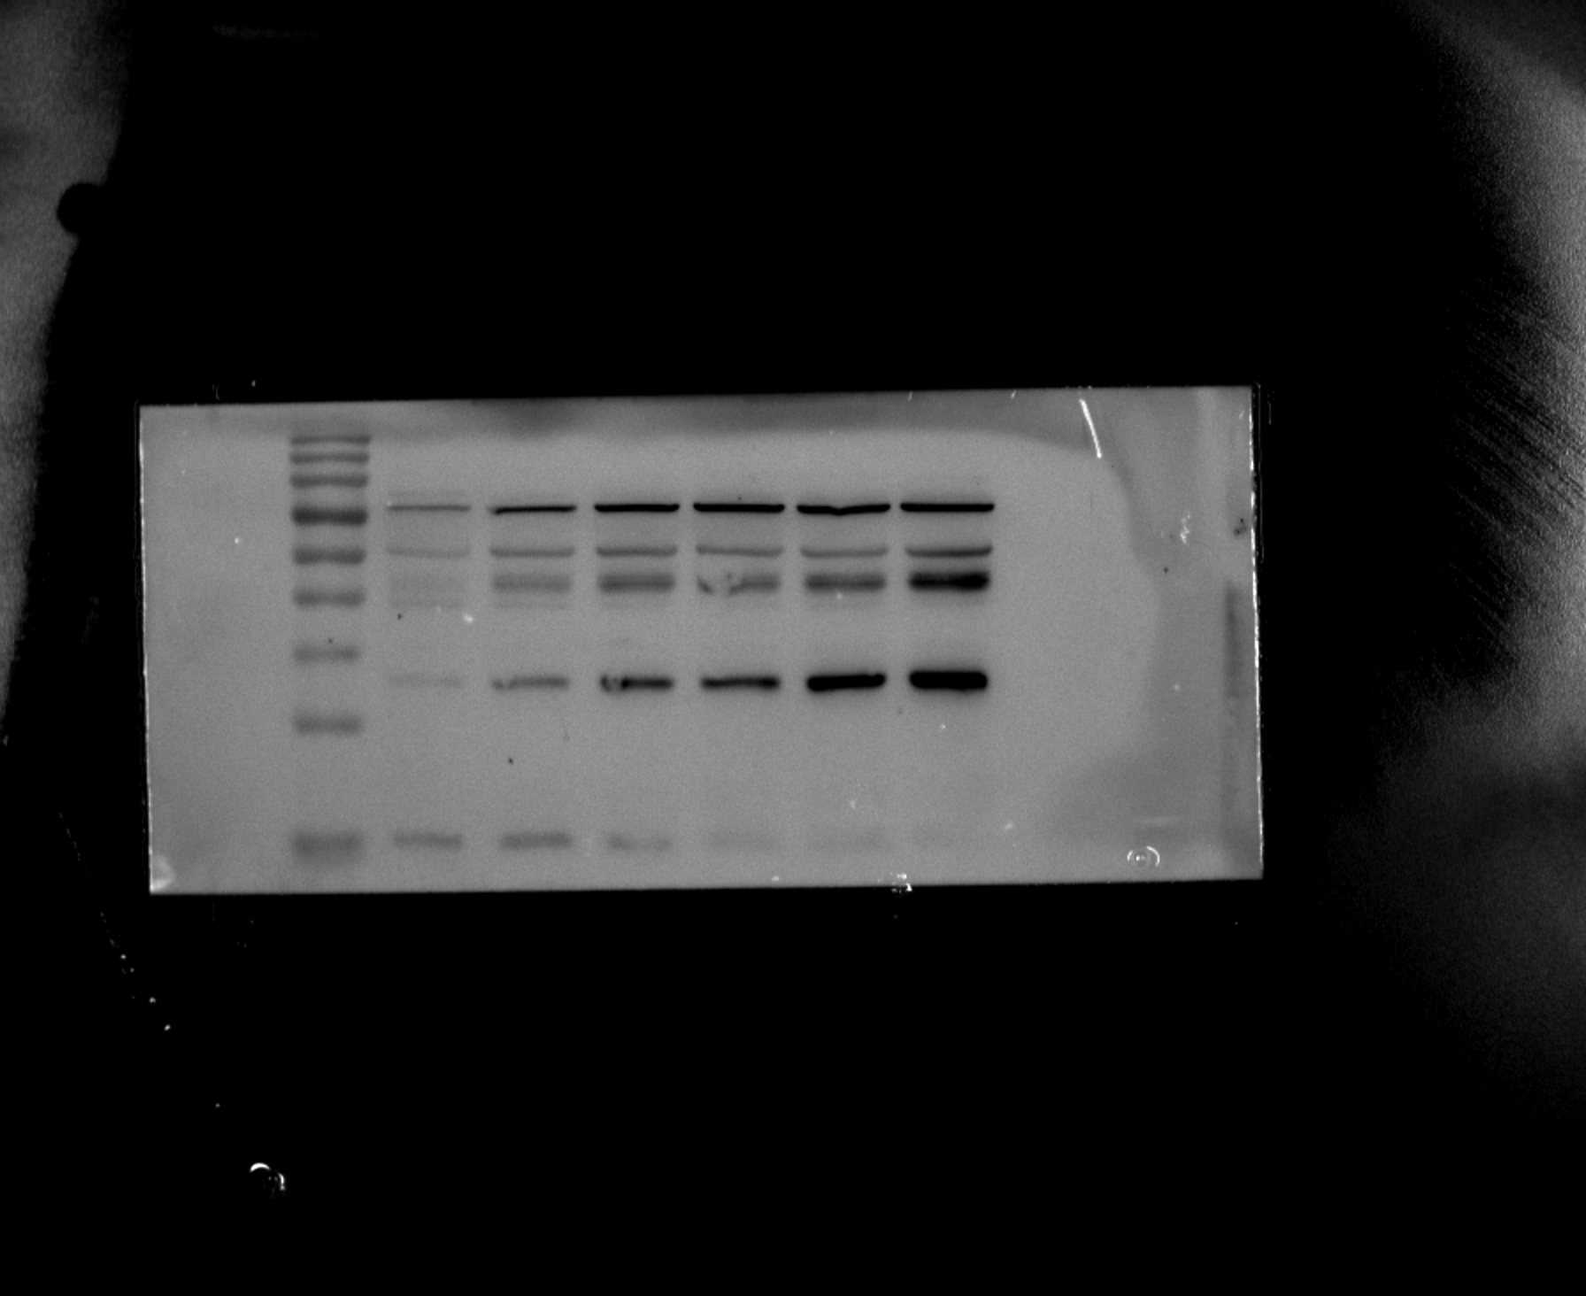

Figure 5A-C. HUVEC Western blots

Replicate 3 - FCER1A loading control (β-actin)
Original filename: FCER1A β-actin 3.Tif
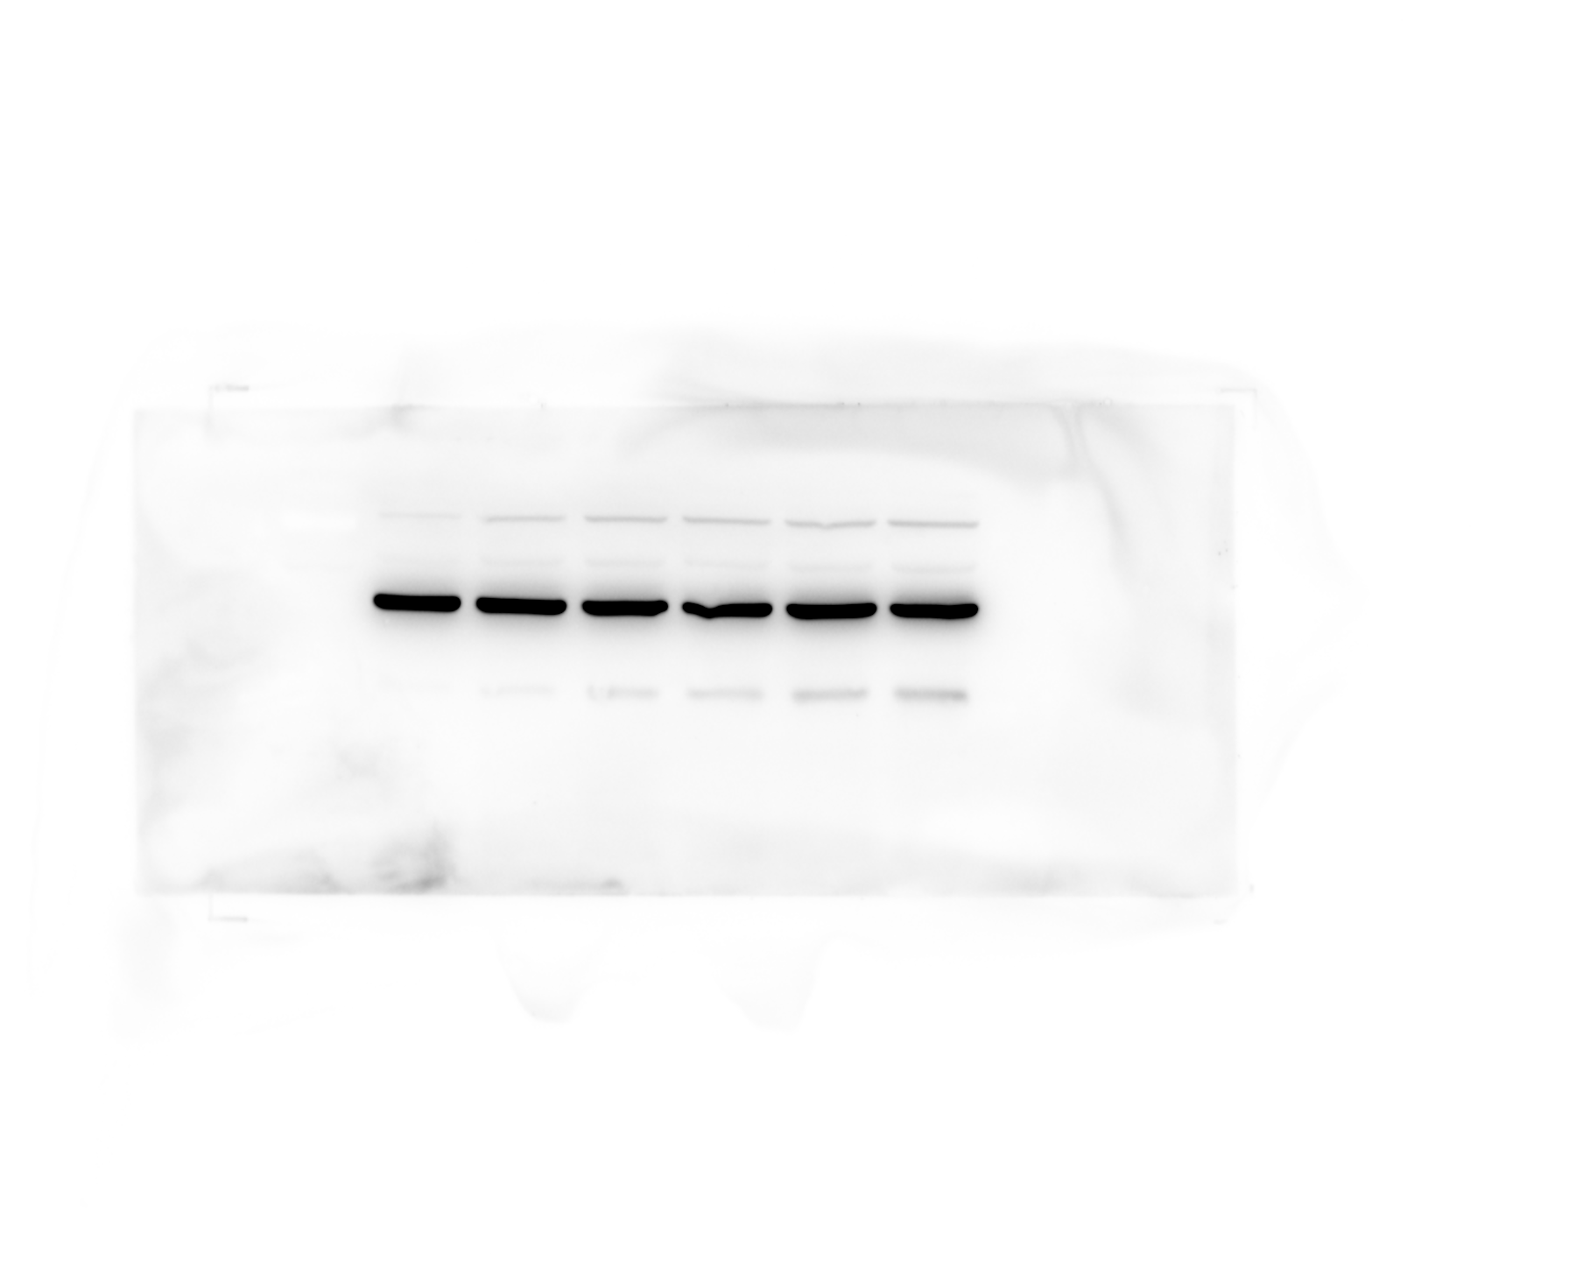
Original filename: FCER1A β-actin 3-1.Tif
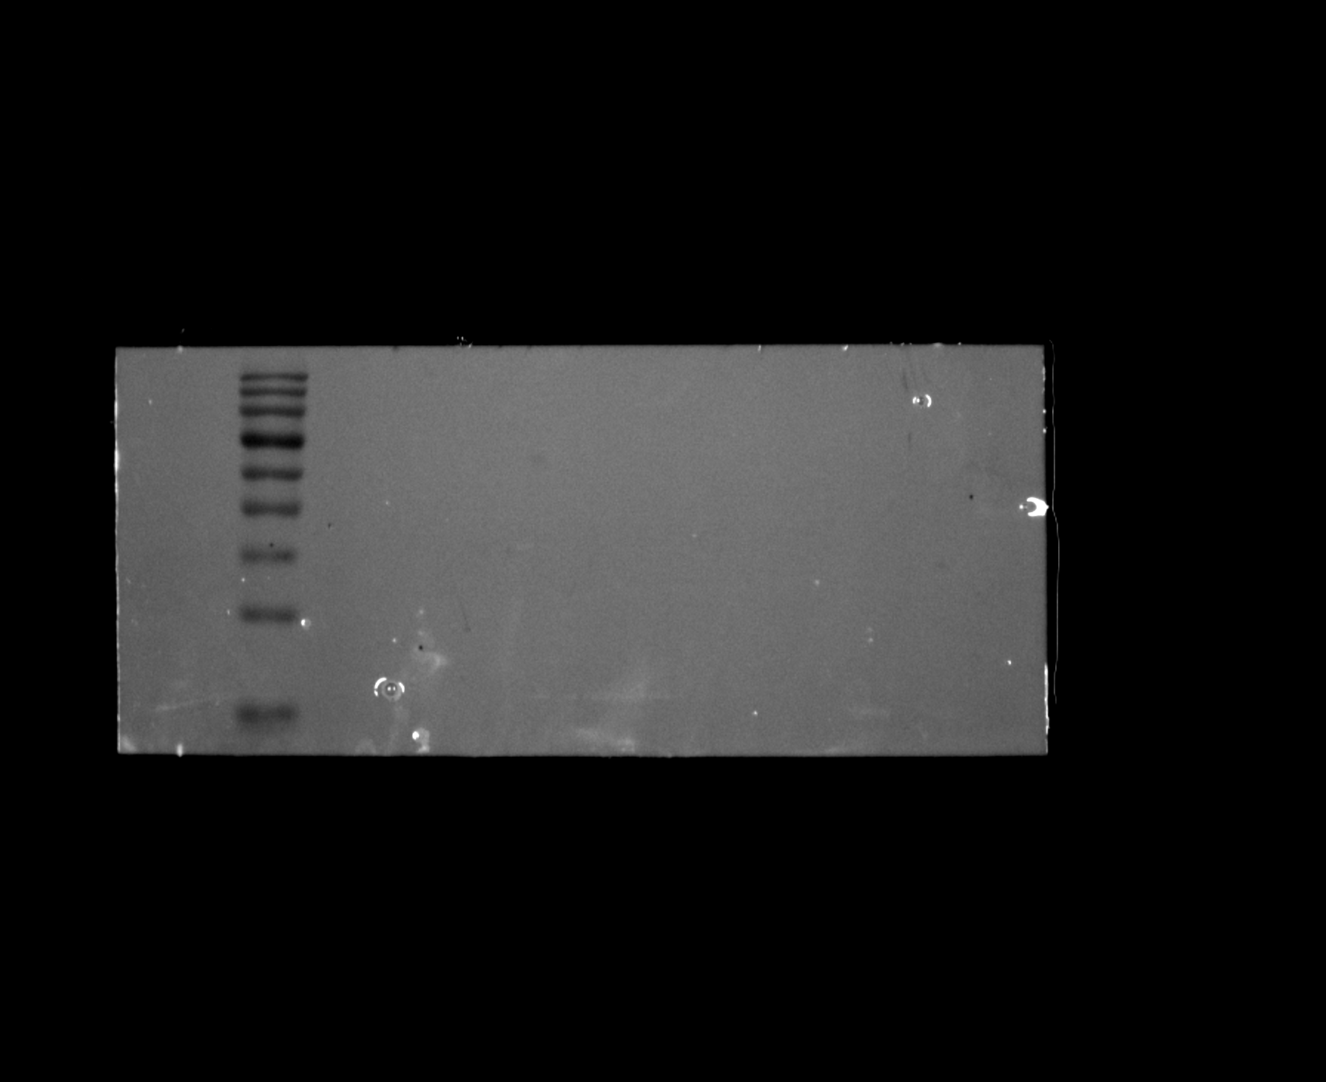
Original filename: FCER1A β-actin 3-2.Tif
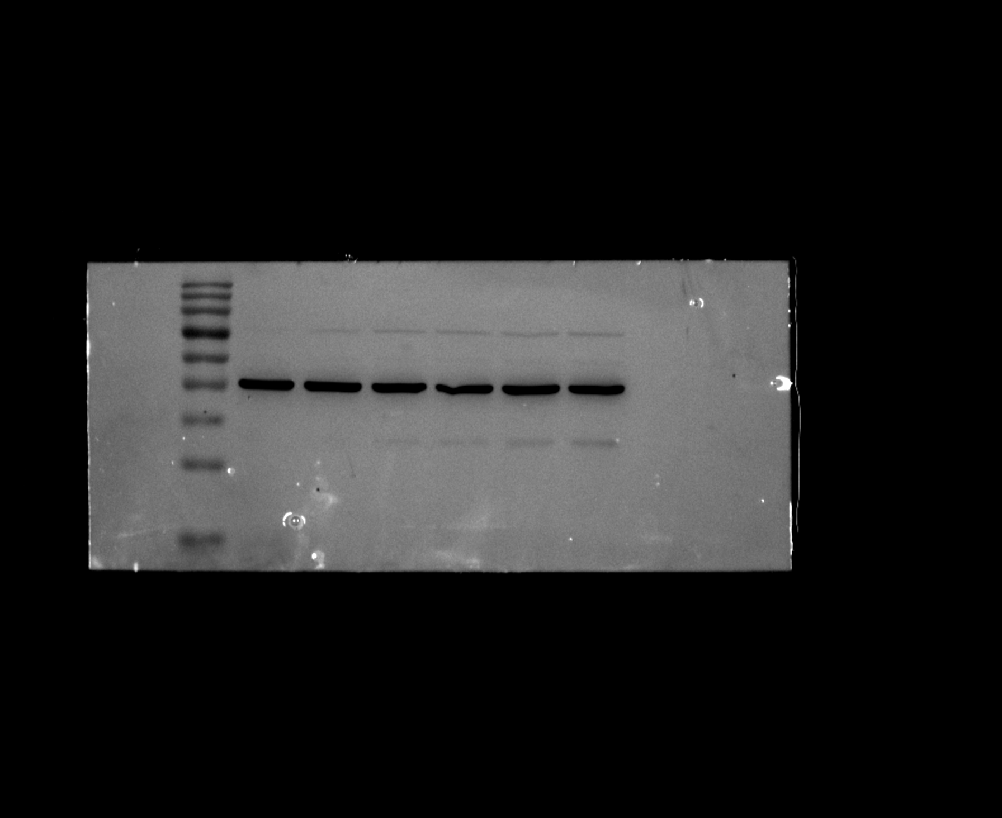

Figure 5A-C. HUVEC Western blots

Replicate 3 - INSIG1
Original filename: INSIG1 3.Tif
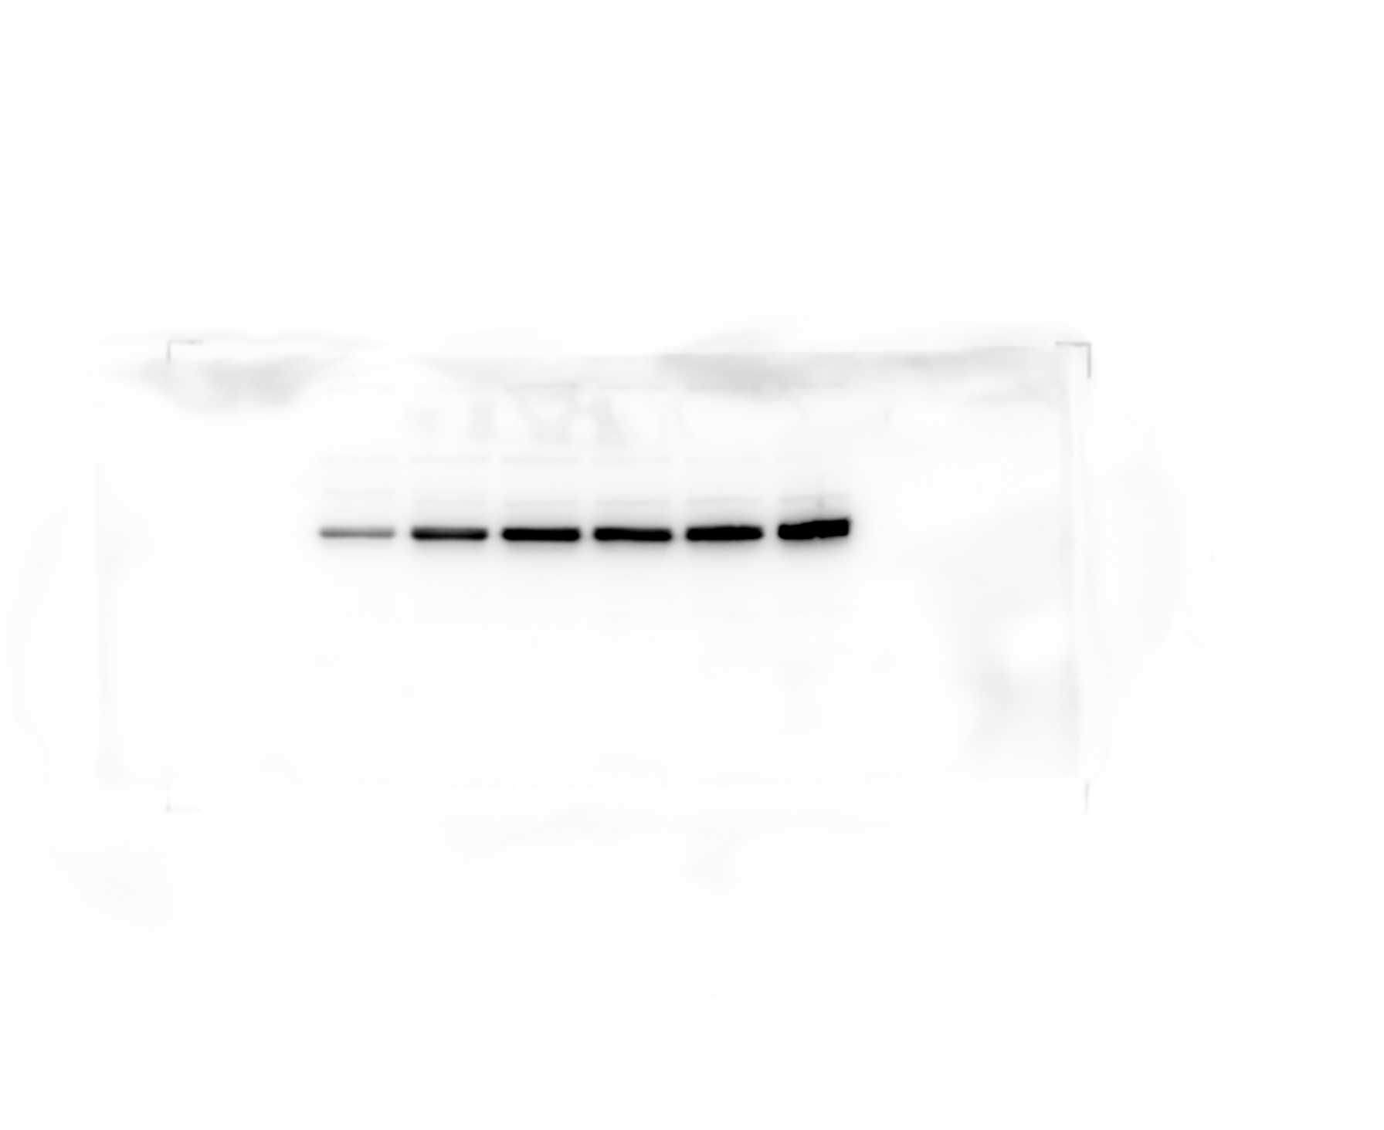
Original filename: INSIG1 3-1.Tif
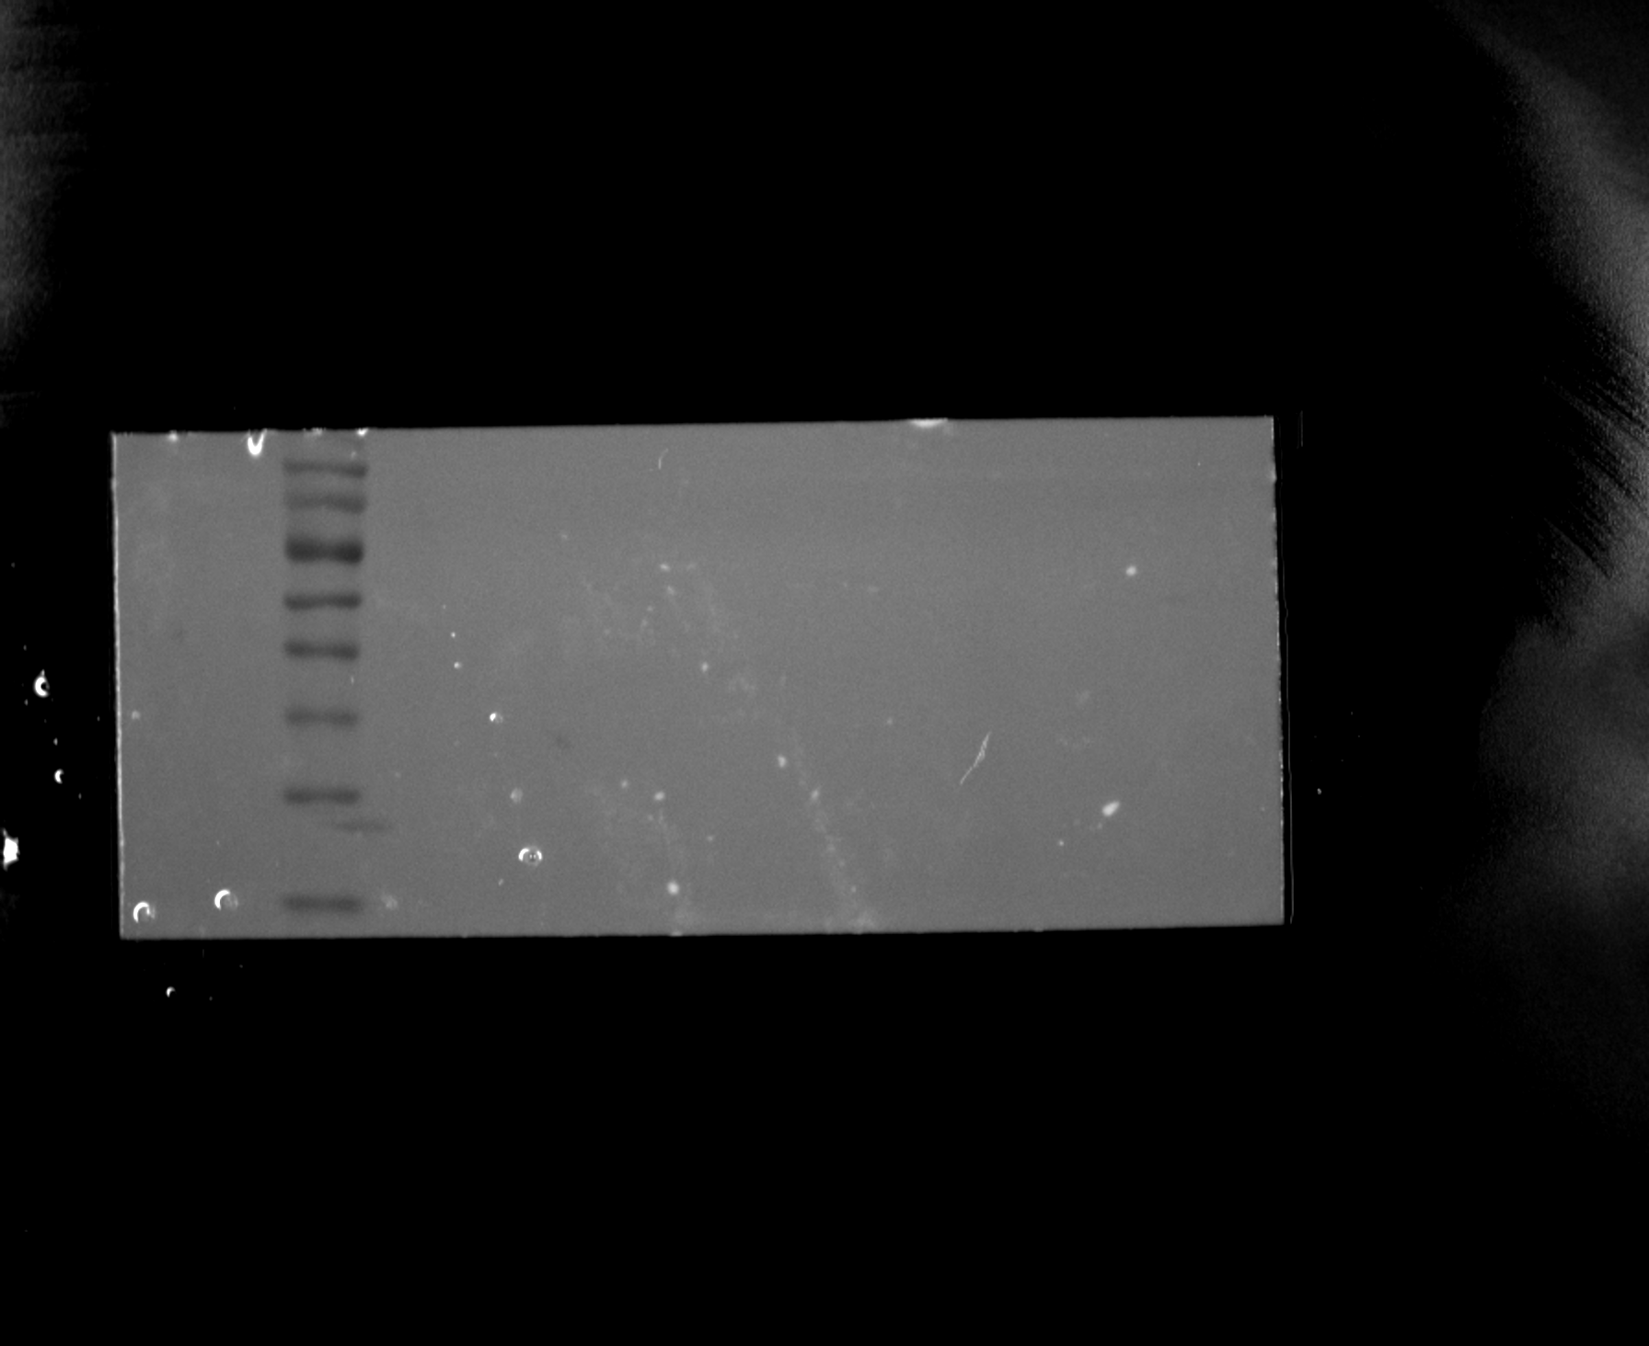
Original filename: INSIG1 3-2.Tif
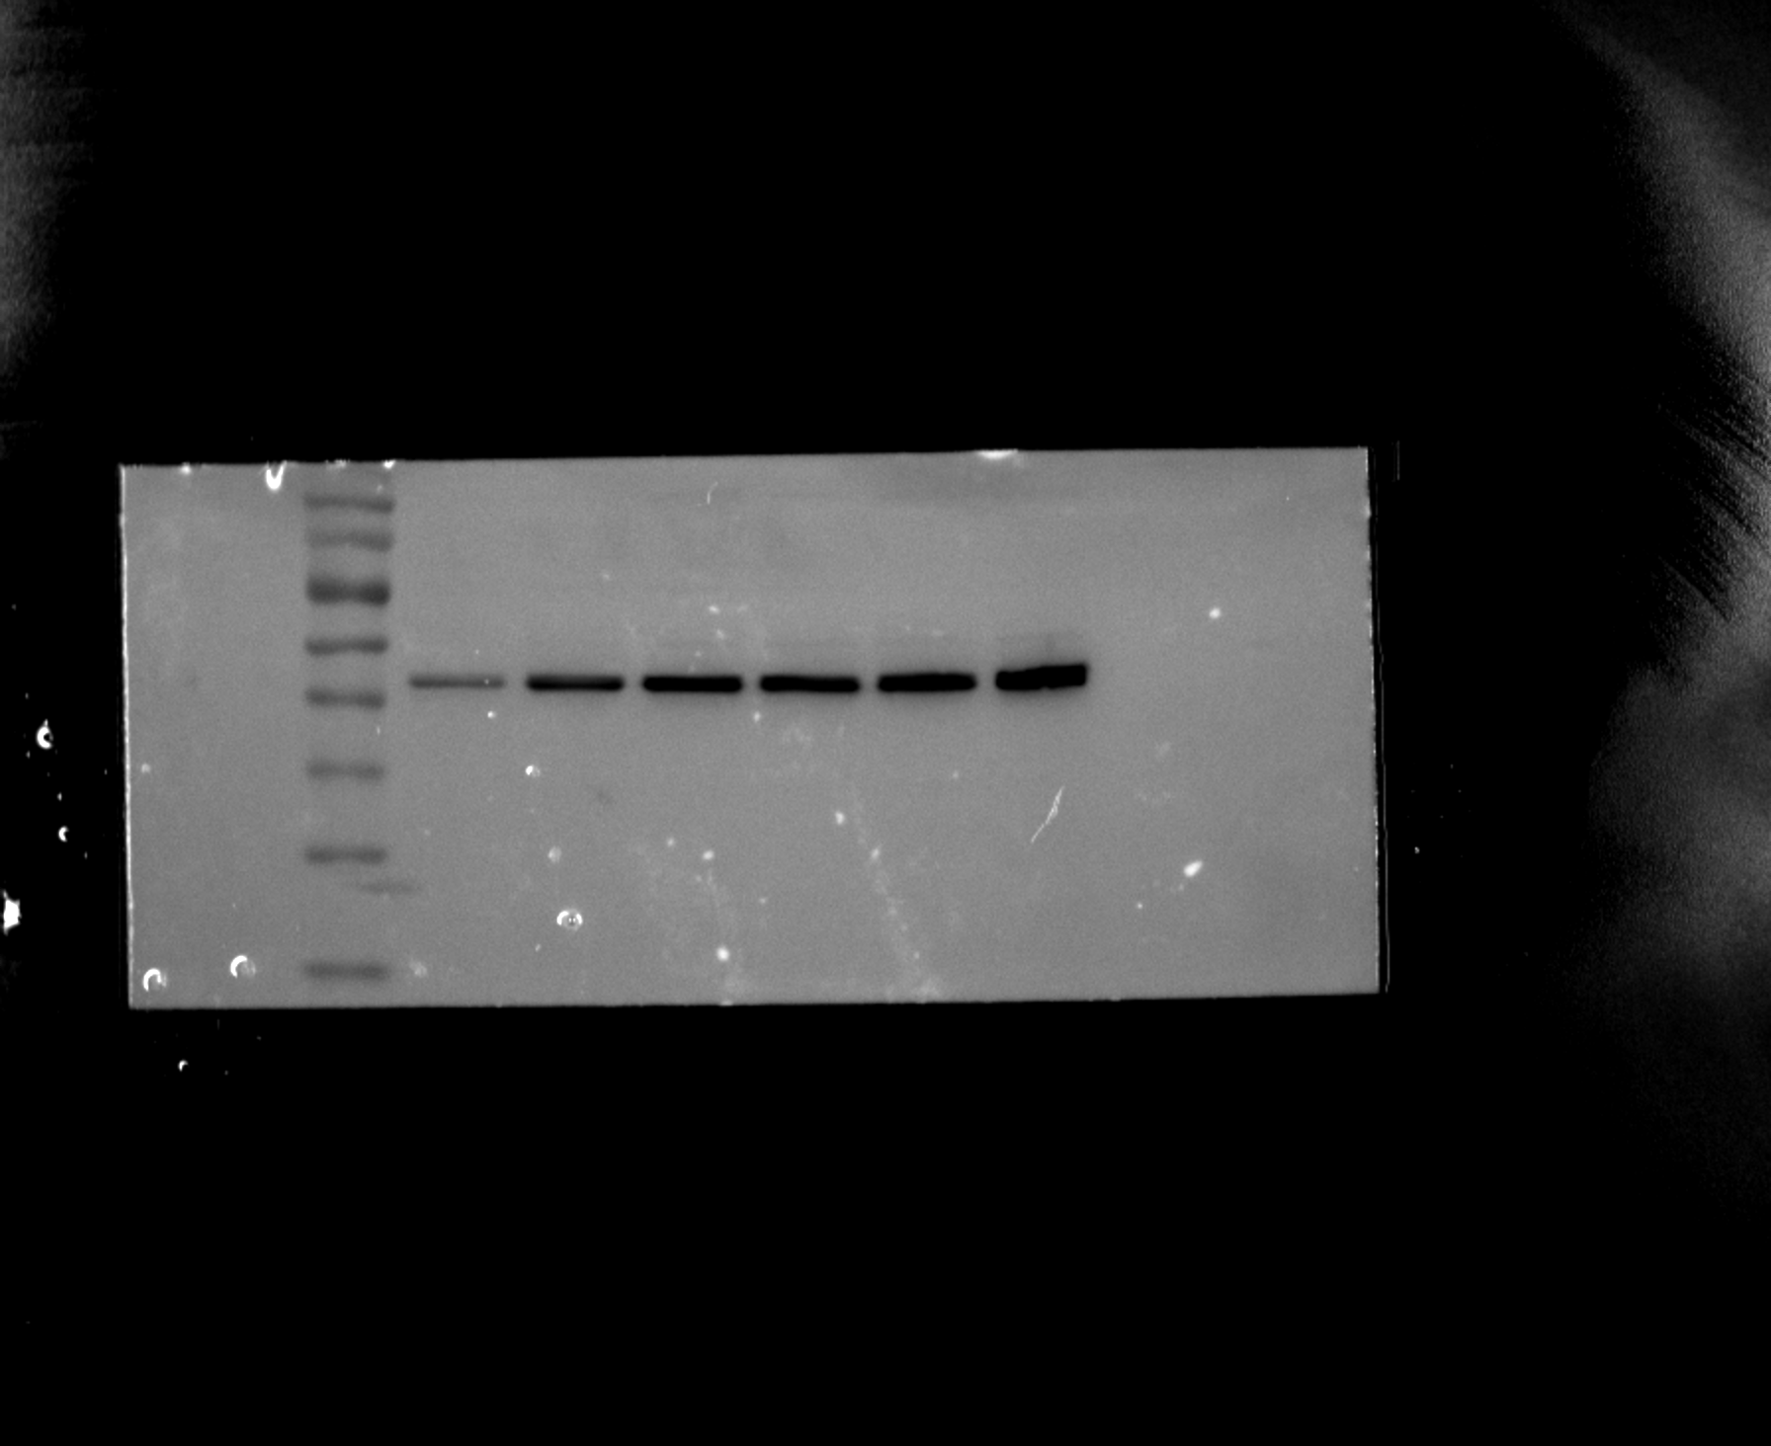

Figure 5A-C. HUVEC Western blots

Replicate 3 - INSIG1 loading control (β-actin)
Original filename: INSIG1 β-actin 3.Tif
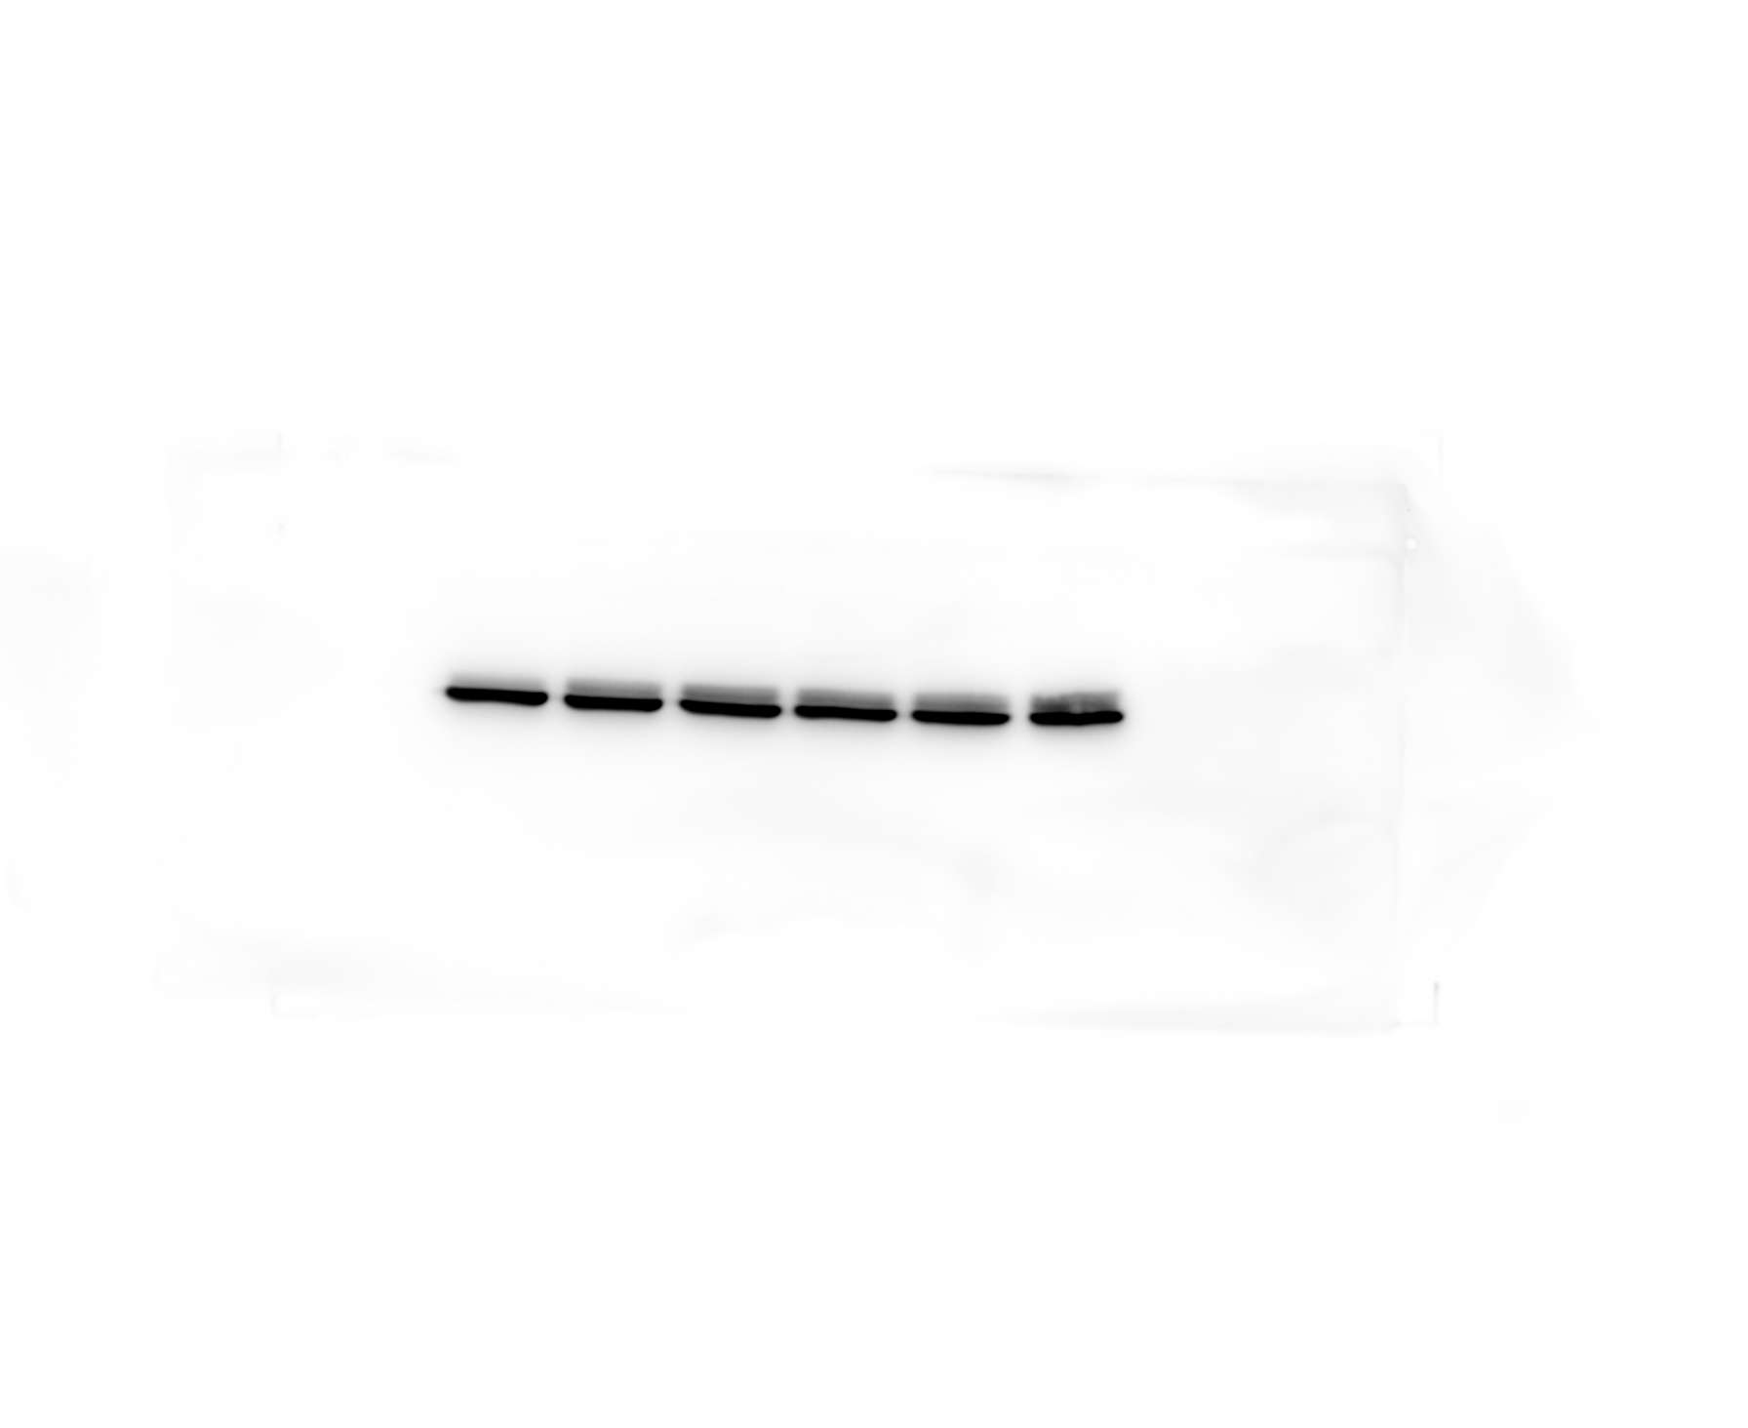
Original filename: INSIG1 β-actin 3-1.Tif
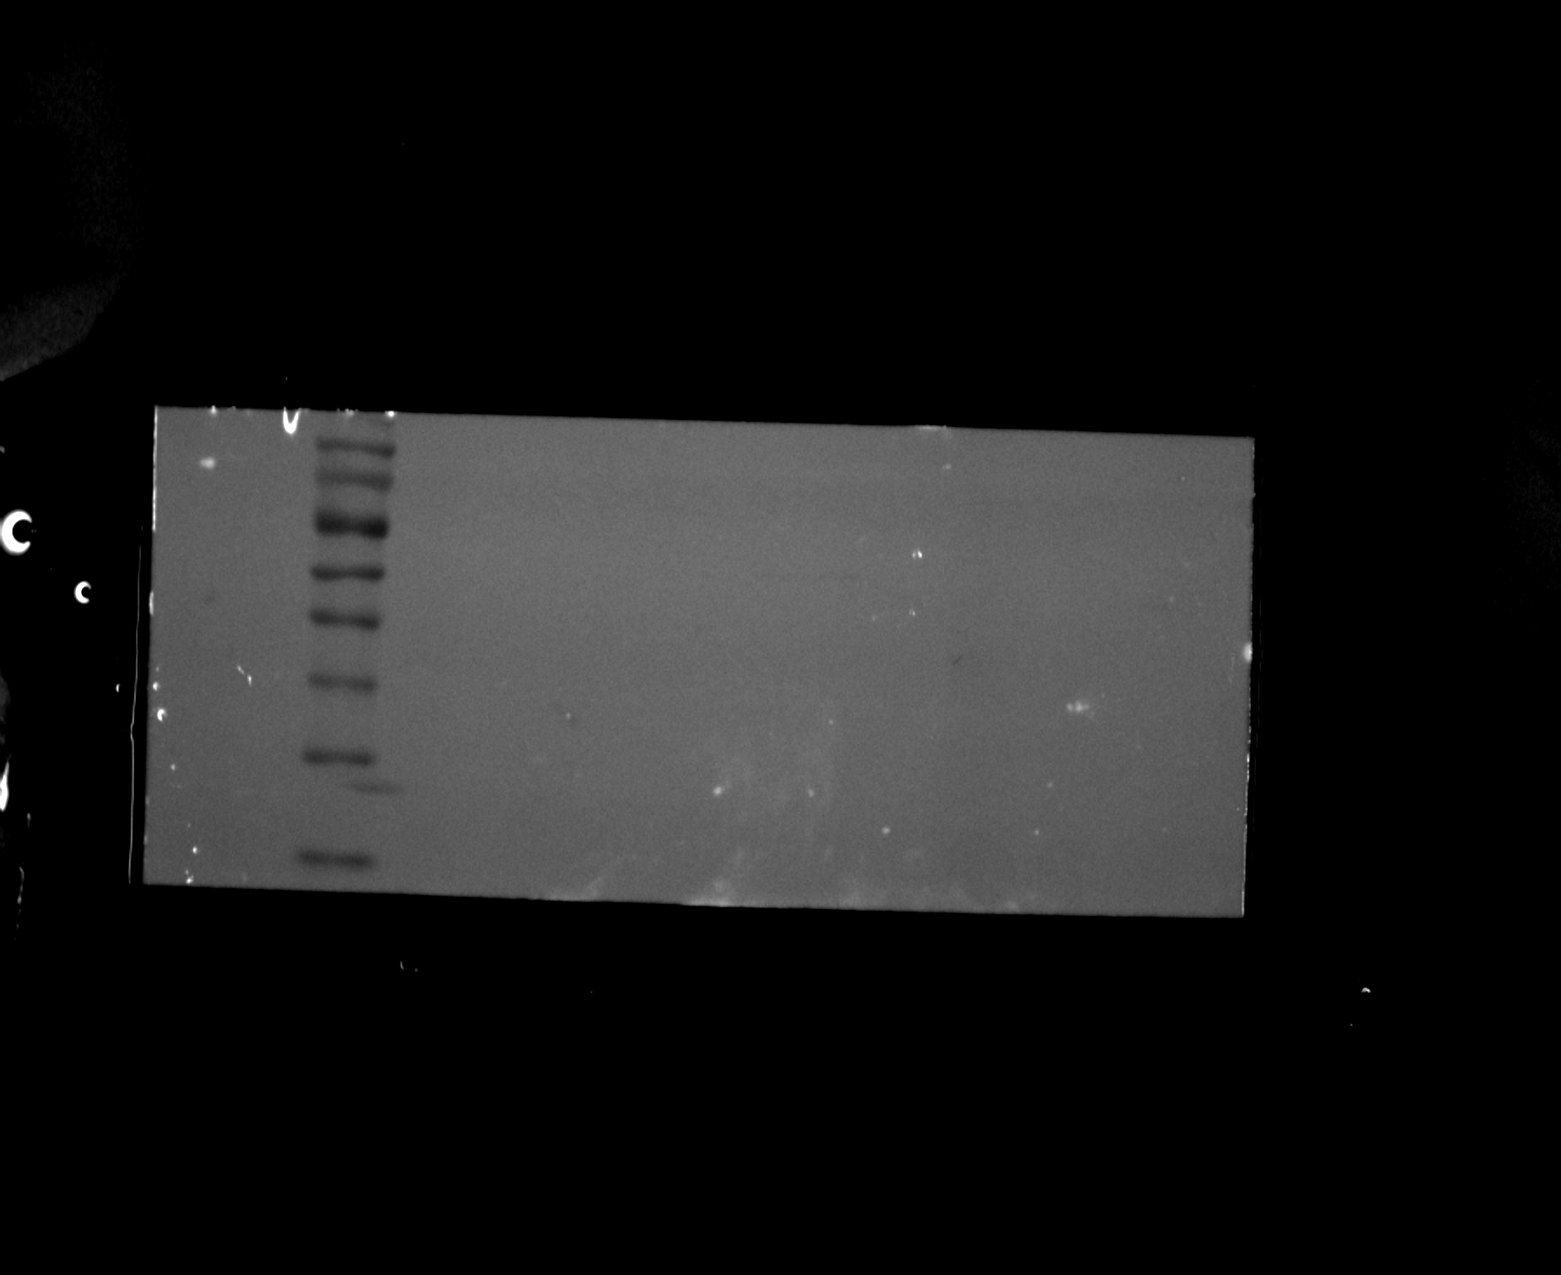
Original filename: INSIG1 β-actin 3-2.Tif
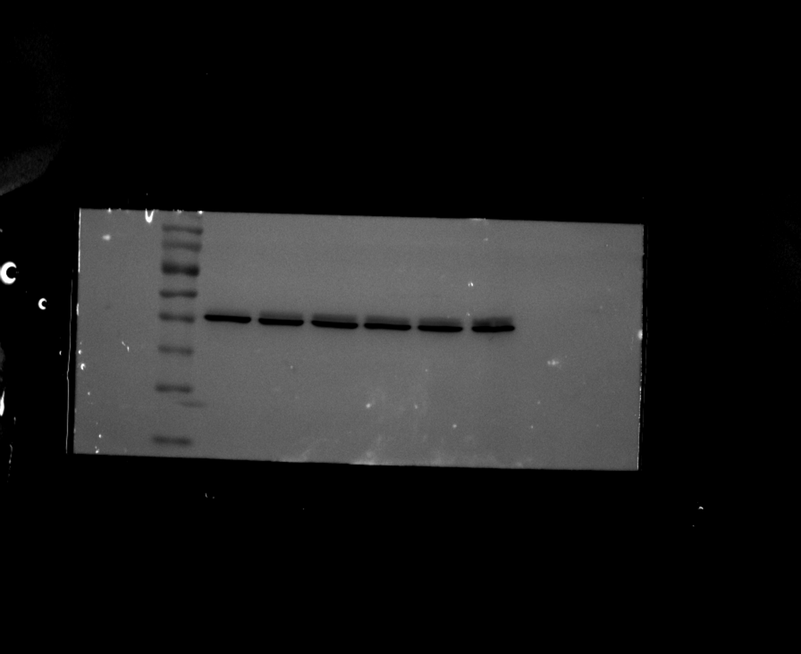

Figure 5G-H. Mouse arterial tissue Western blots

Replicate 1 - FCER1A
Original filename: FCER1A 1.Tif
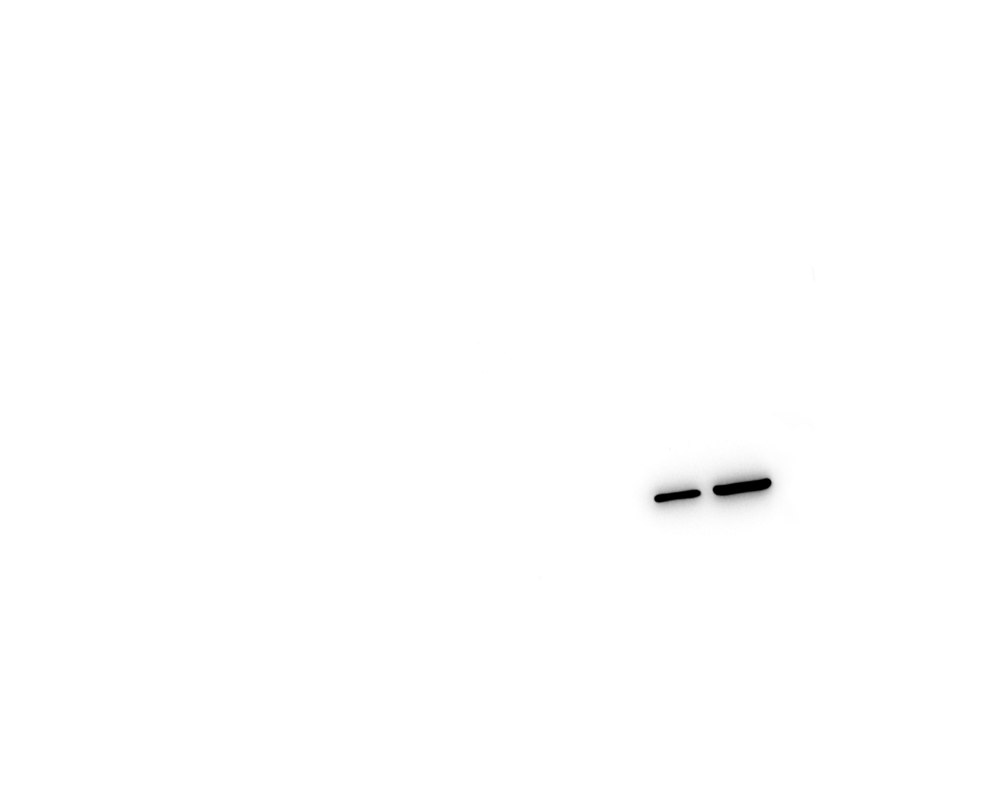
Original filename: FCER1A 1-1.Tif
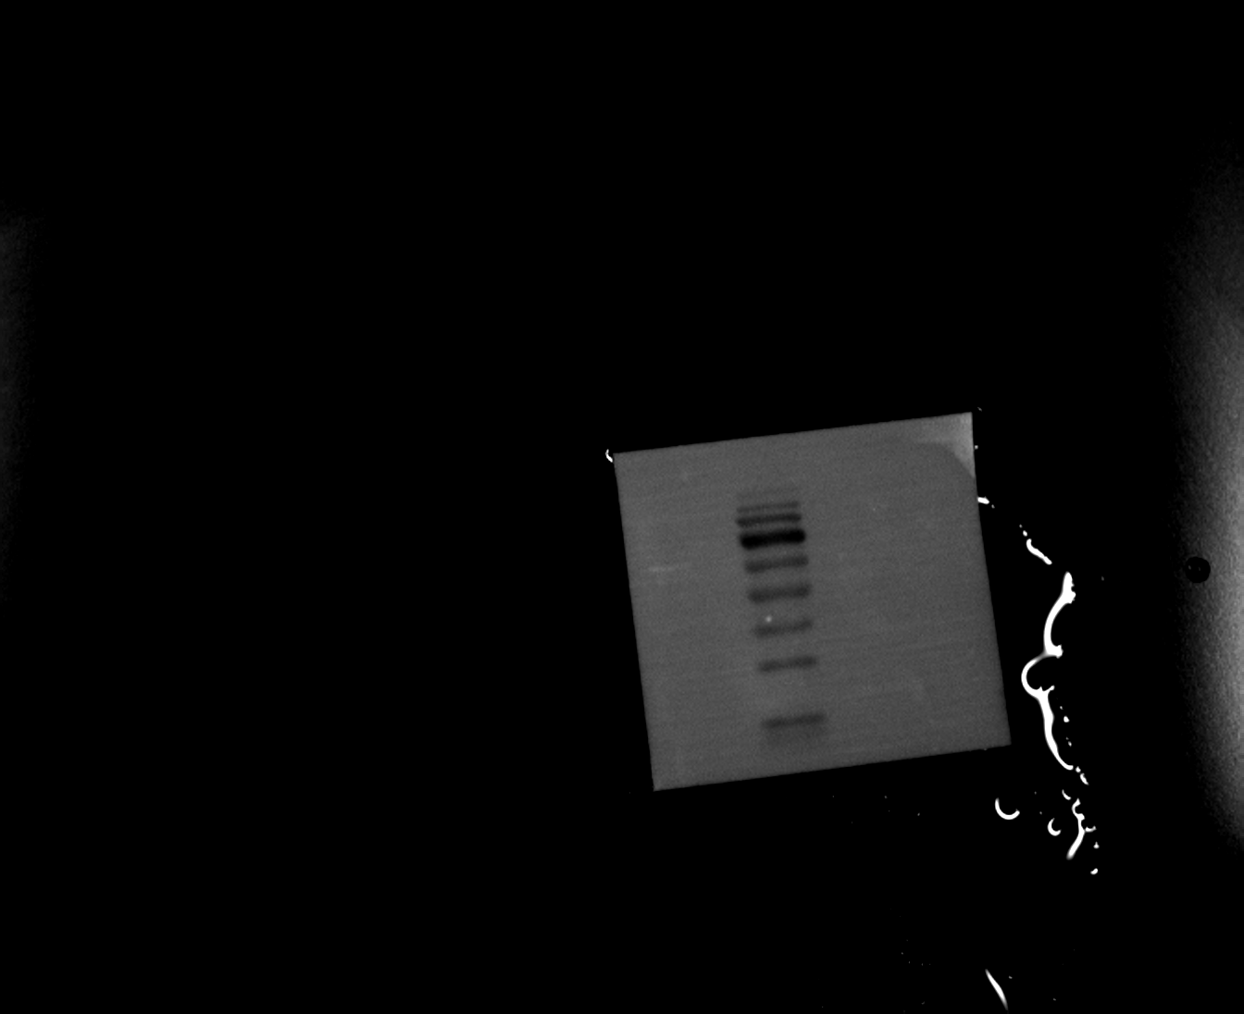
Original filename: FCER1A 1-2.tif
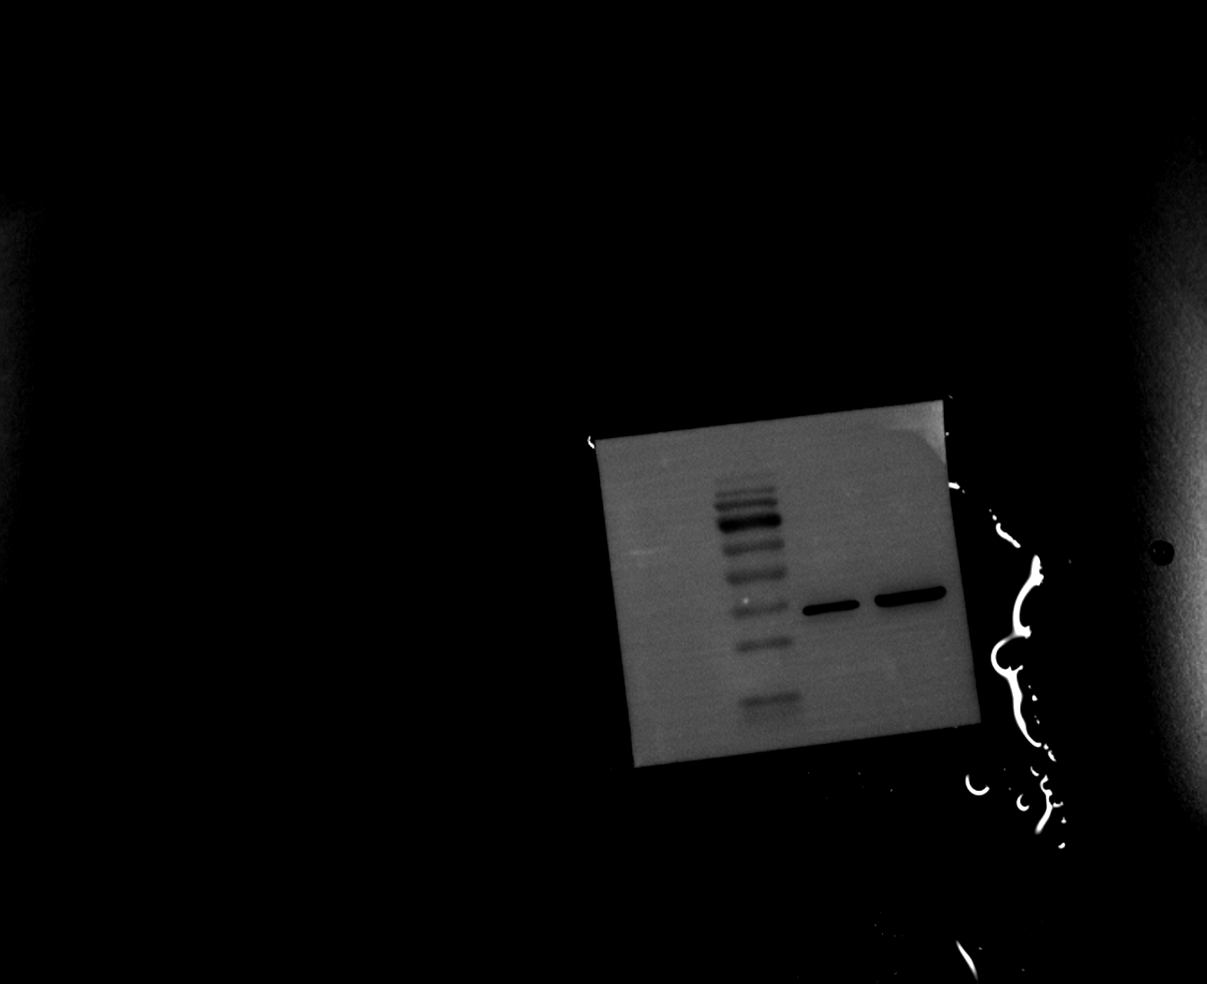

Figure 5G-H. Mouse arterial tissue Western blots

Replicate 1 - INSIG1
Original filename: INSIG1 1.Tif
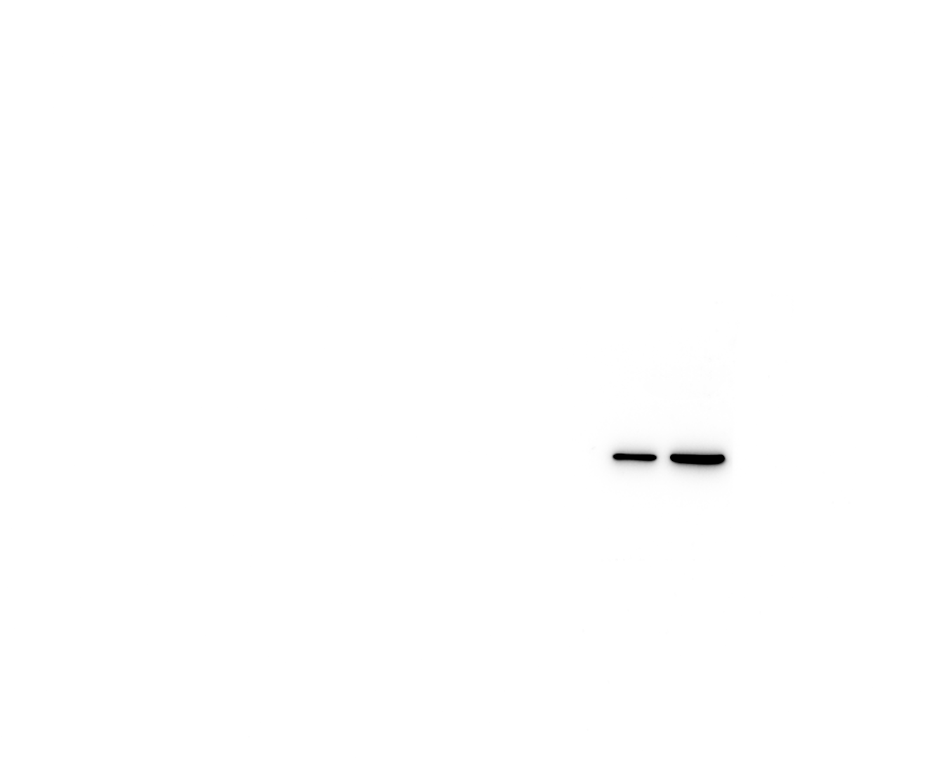
Original filename: INSIG1 1-1.Tif
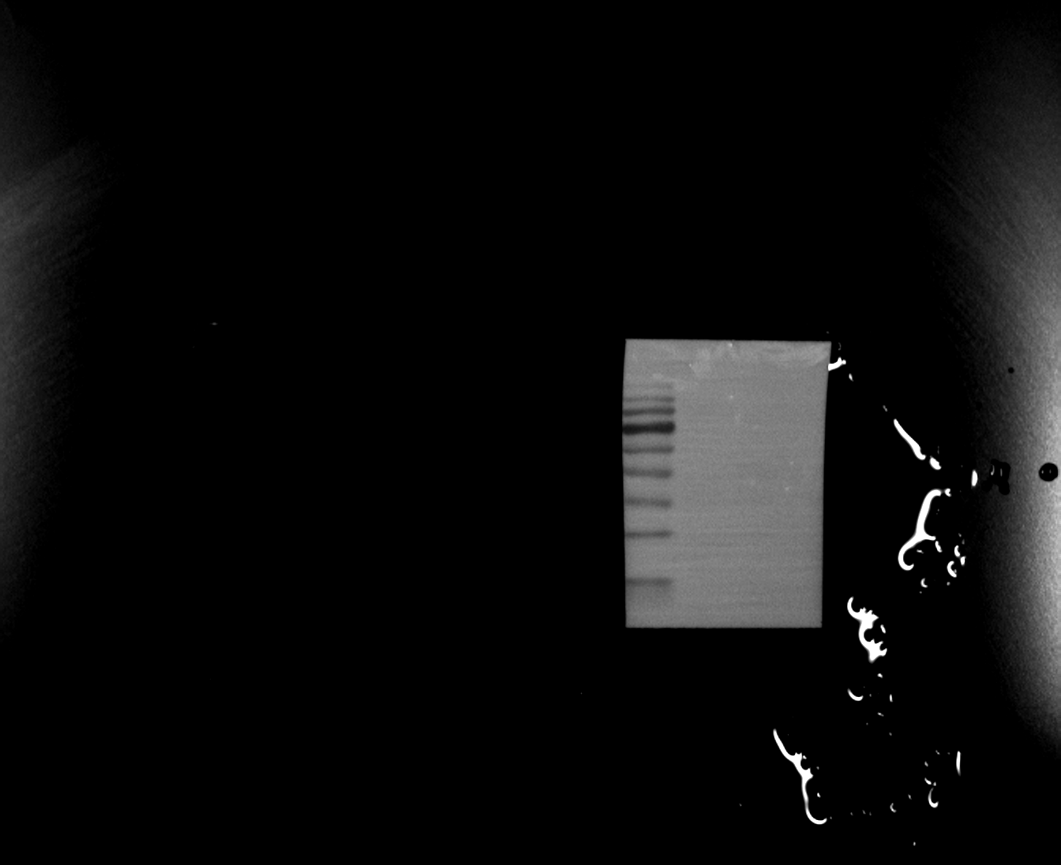
Original filename: INSIG1 1-2.tif
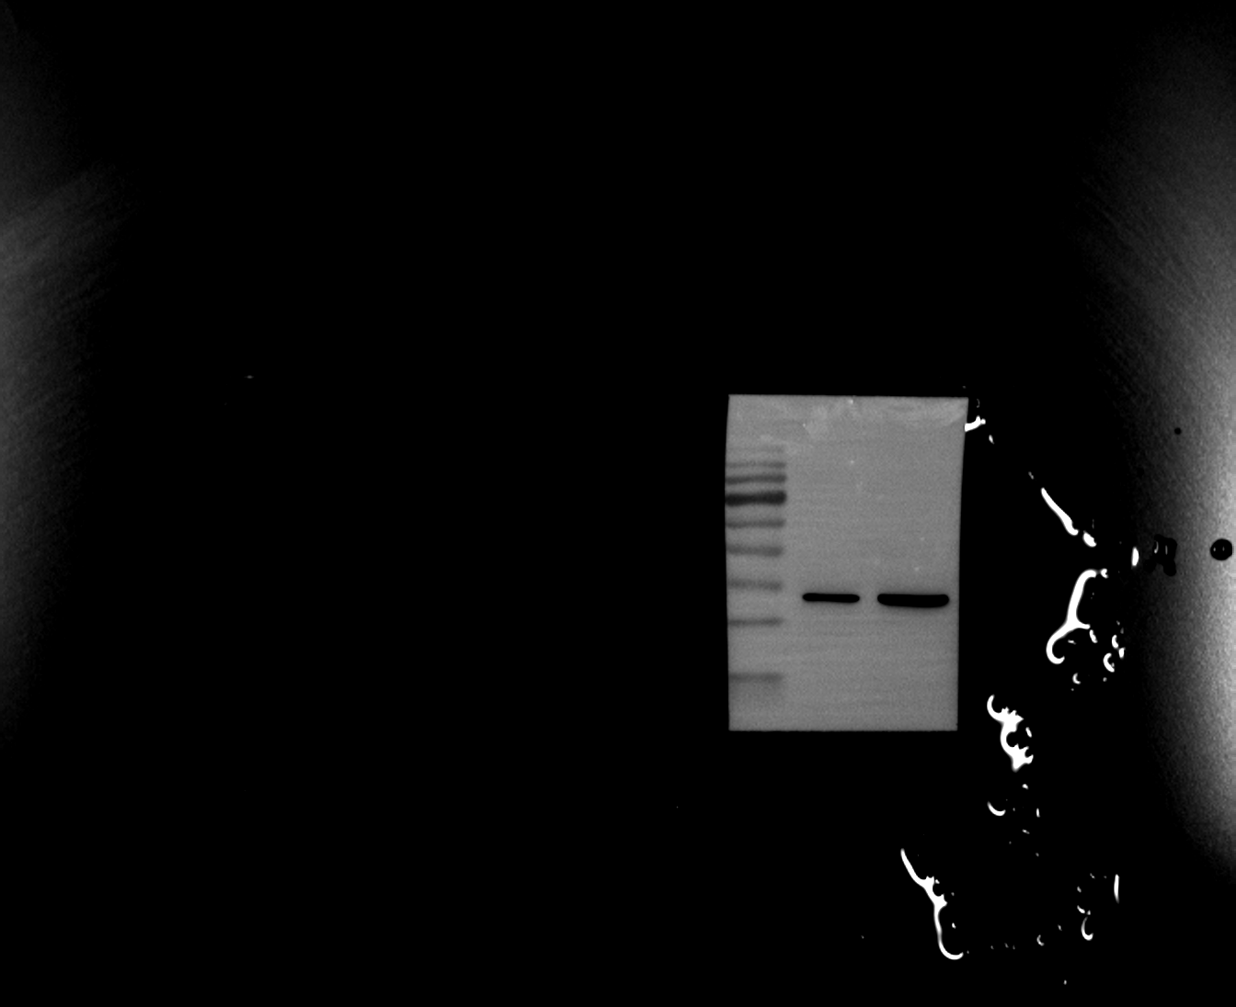

Figure 5G-H. Mouse arterial tissue Western blots

Replicate 1 - Loading control (β-actin)
Original filename: β-actin 1.Tif
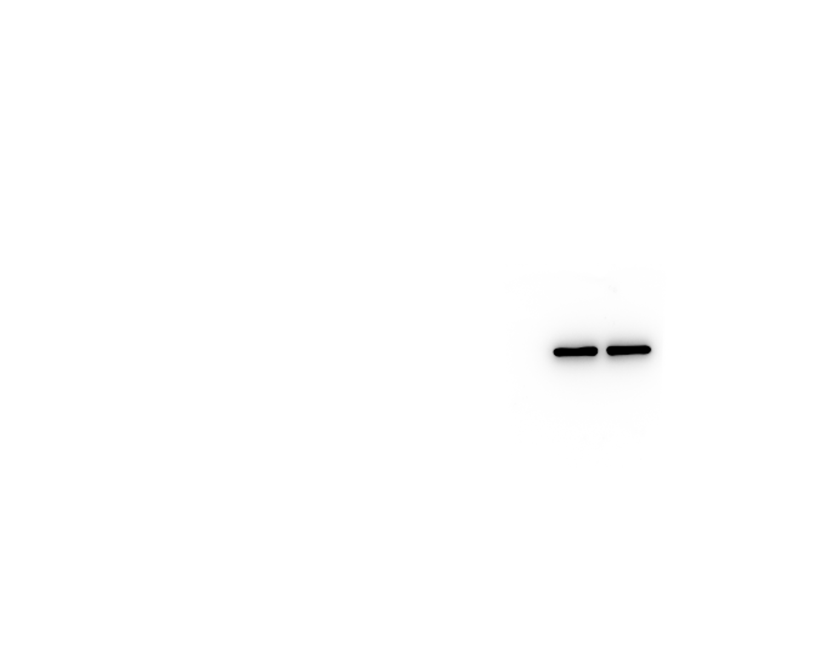
Original filename: β-actin 1-1.Tif

Original filename: β-actin 1-2.tif
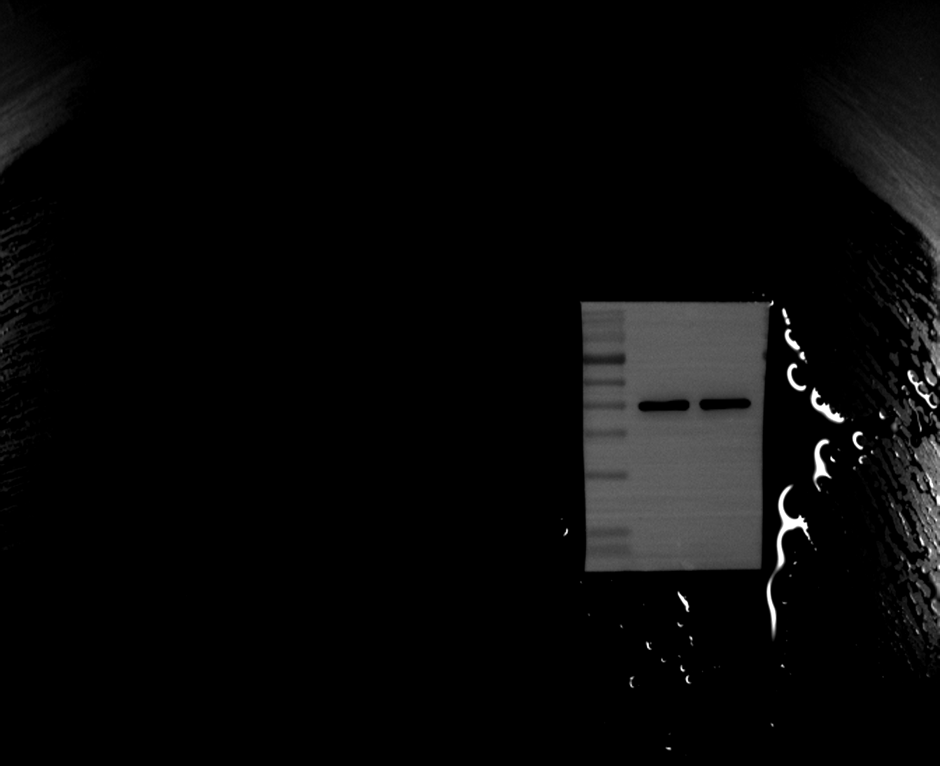

Figure 5G-H. Mouse arterial tissue Western blots

Replicate 2 - FCER1A
Original filename: FCER1A 2.Tif
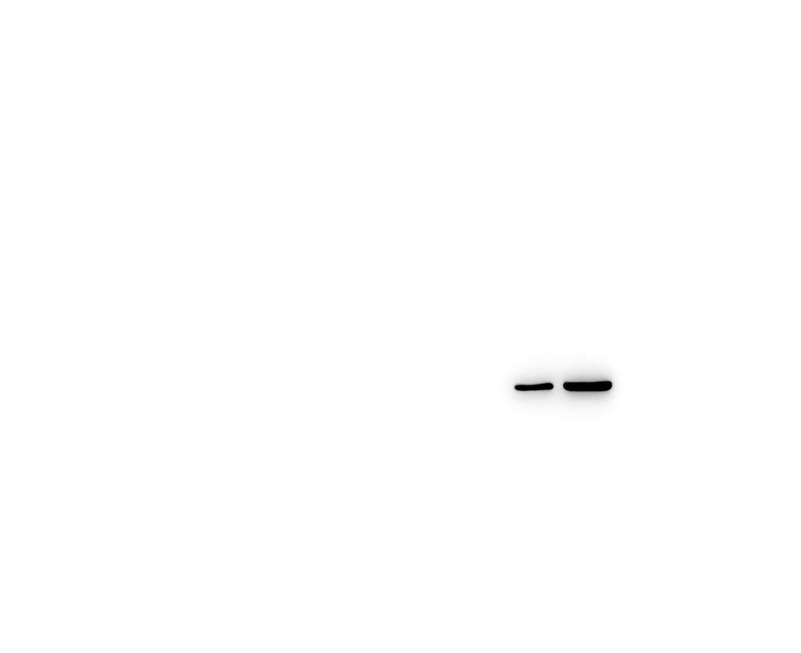
Original filename: FCER1A 2-1.Tif
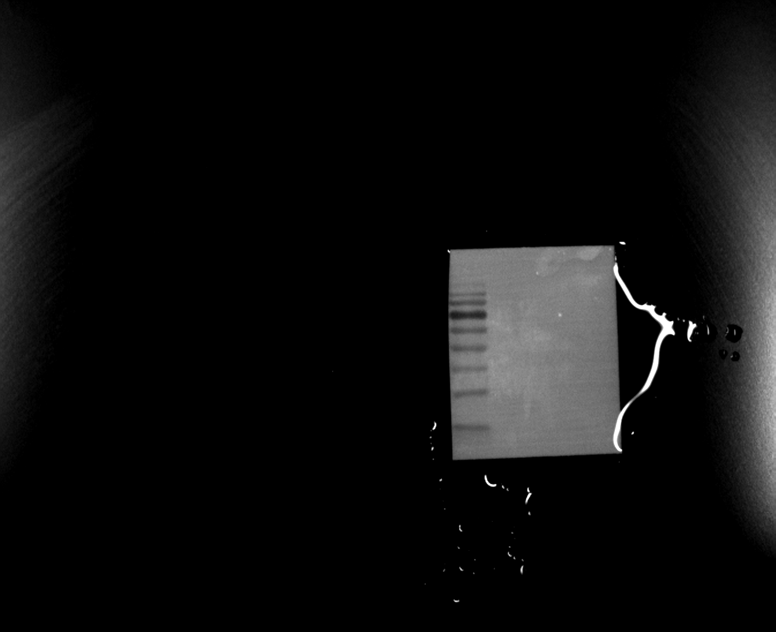
Original filename: FCER1A 2-2.tif
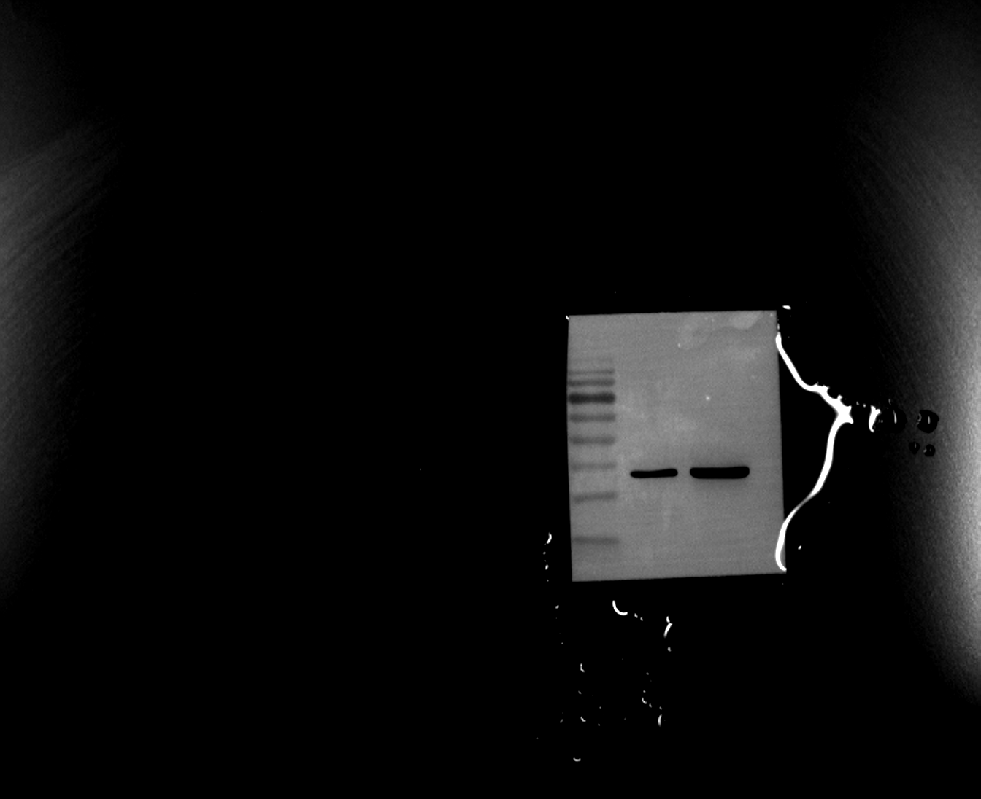

Figure 5G-H. Mouse arterial tissue Western blots

Replicate 2 - INSIG1
Original filename: INSIG1 2.Tif
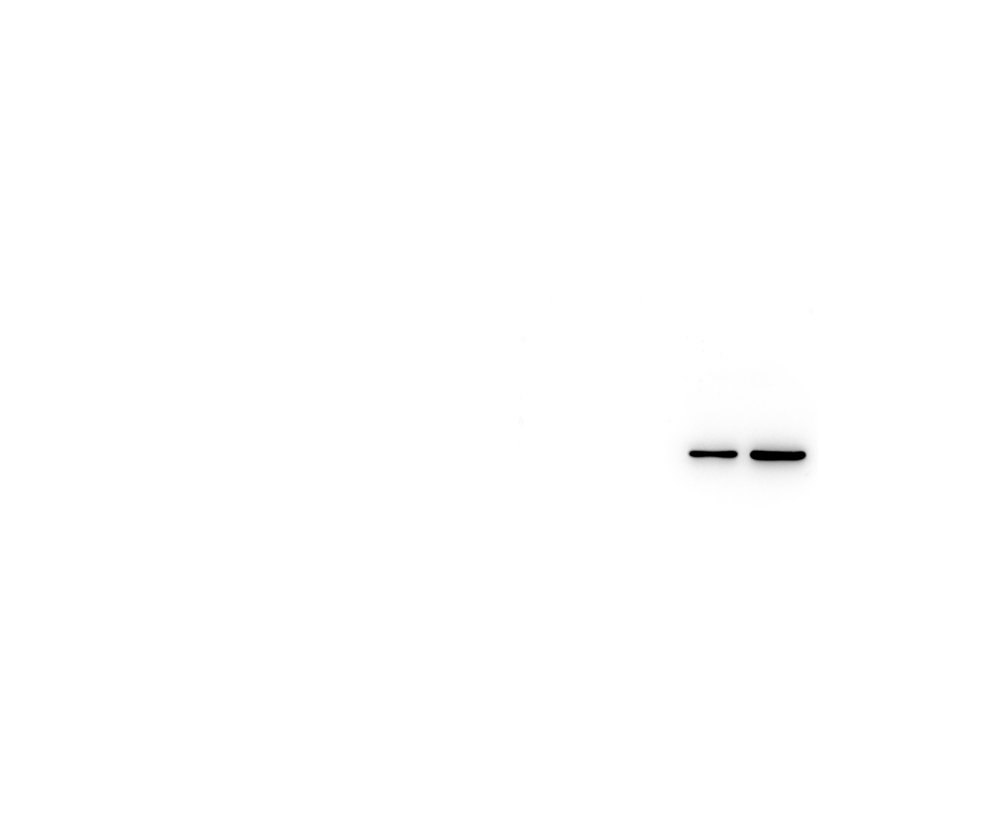
Original filename: INSIG1 2-1.Tif
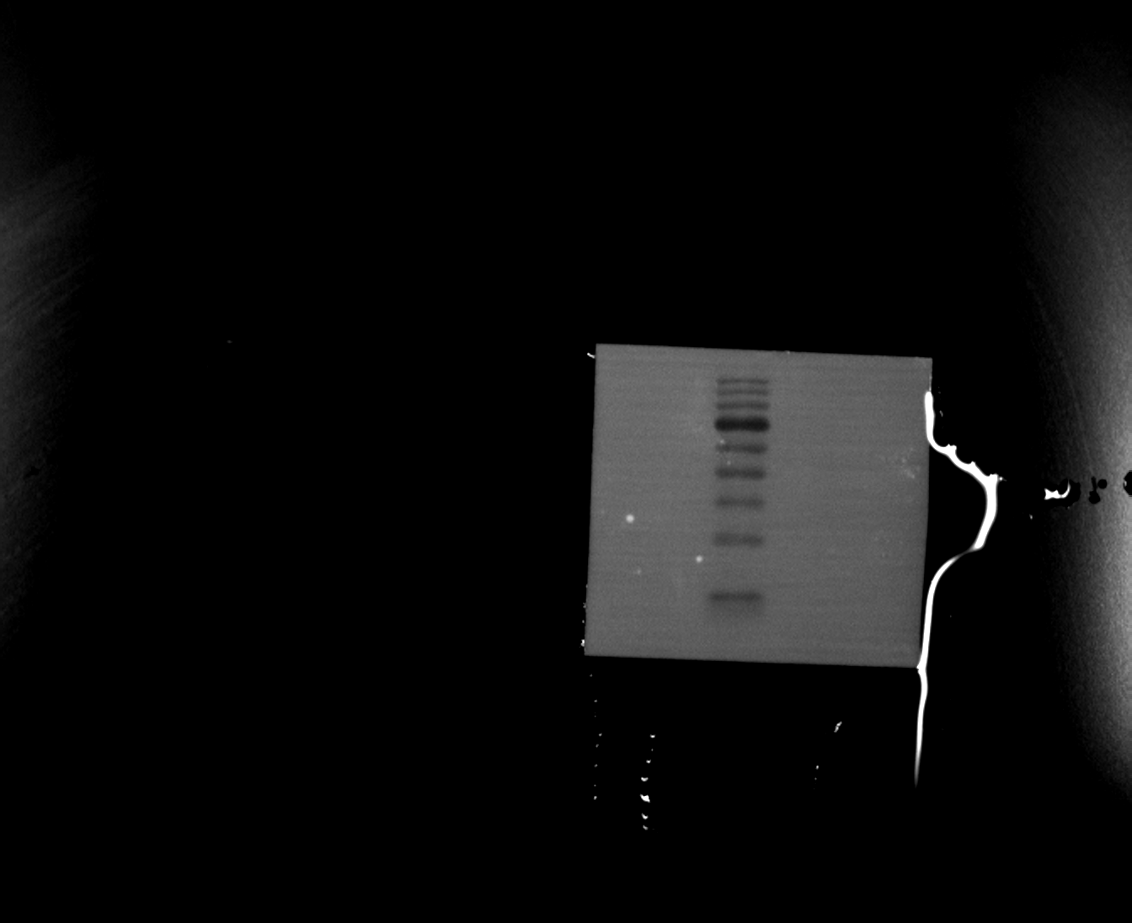
Original filename: INSIG1 2-2.tif
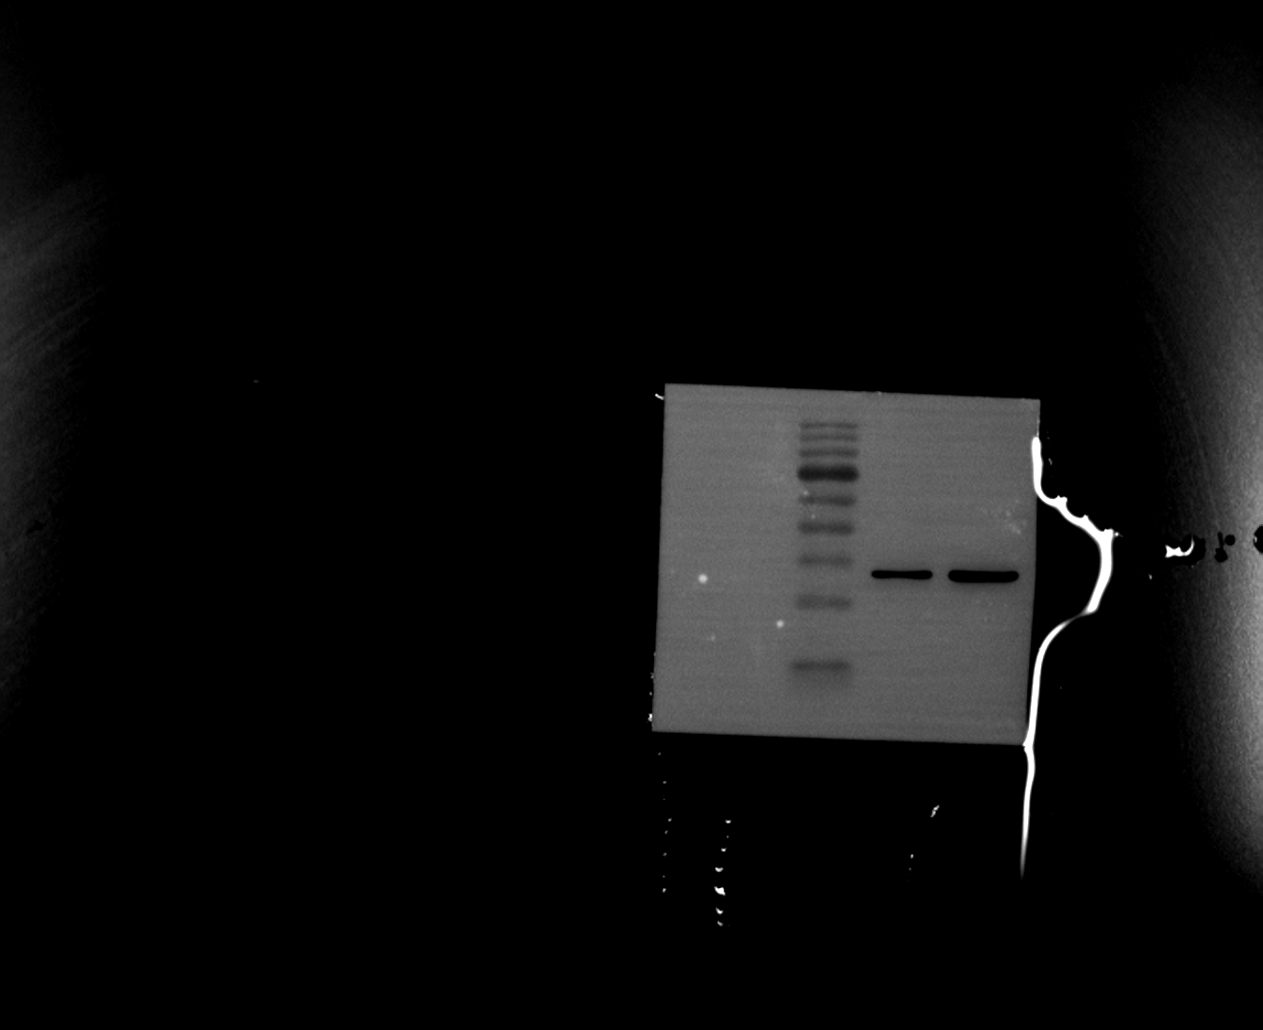

Figure 5G-H. Mouse arterial tissue Western blots

Replicate 2 - Loading control (β-actin)
Original filename: β-actin 2.Tif
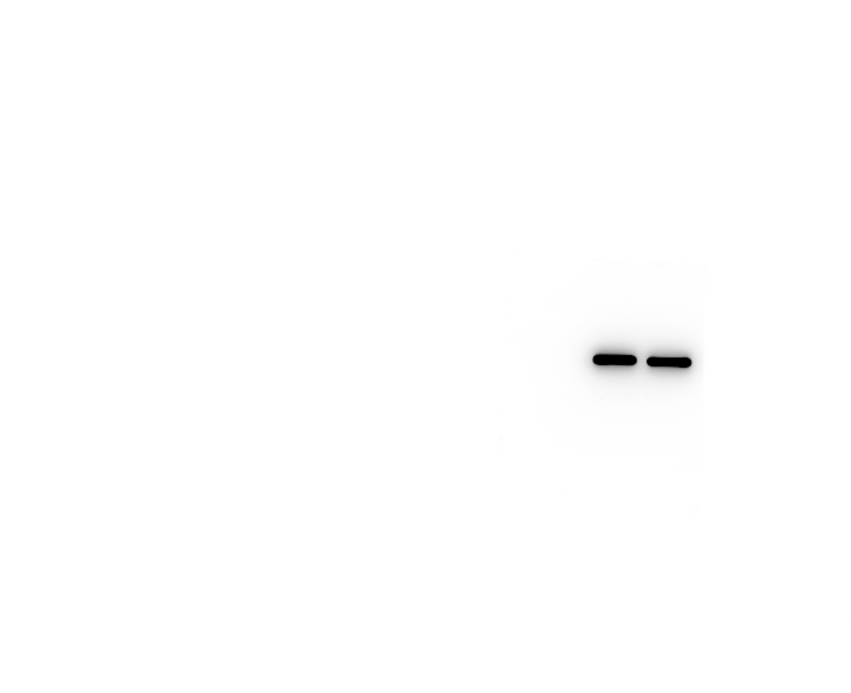
Original filename: β-actin 2-1.Tif
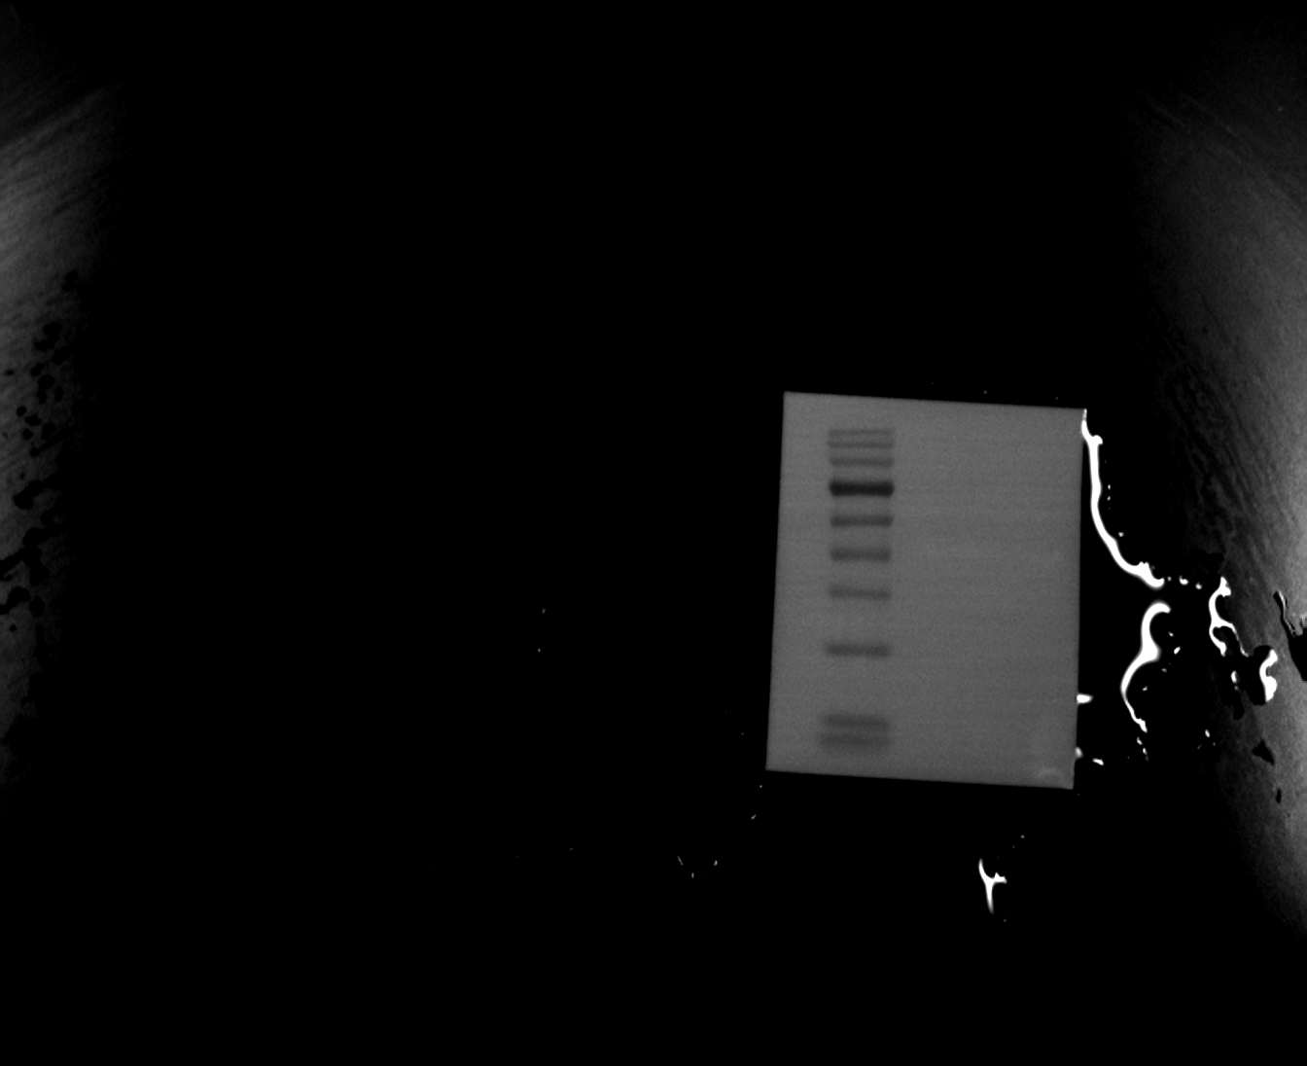
Original filename: β-actin 2-2.tif
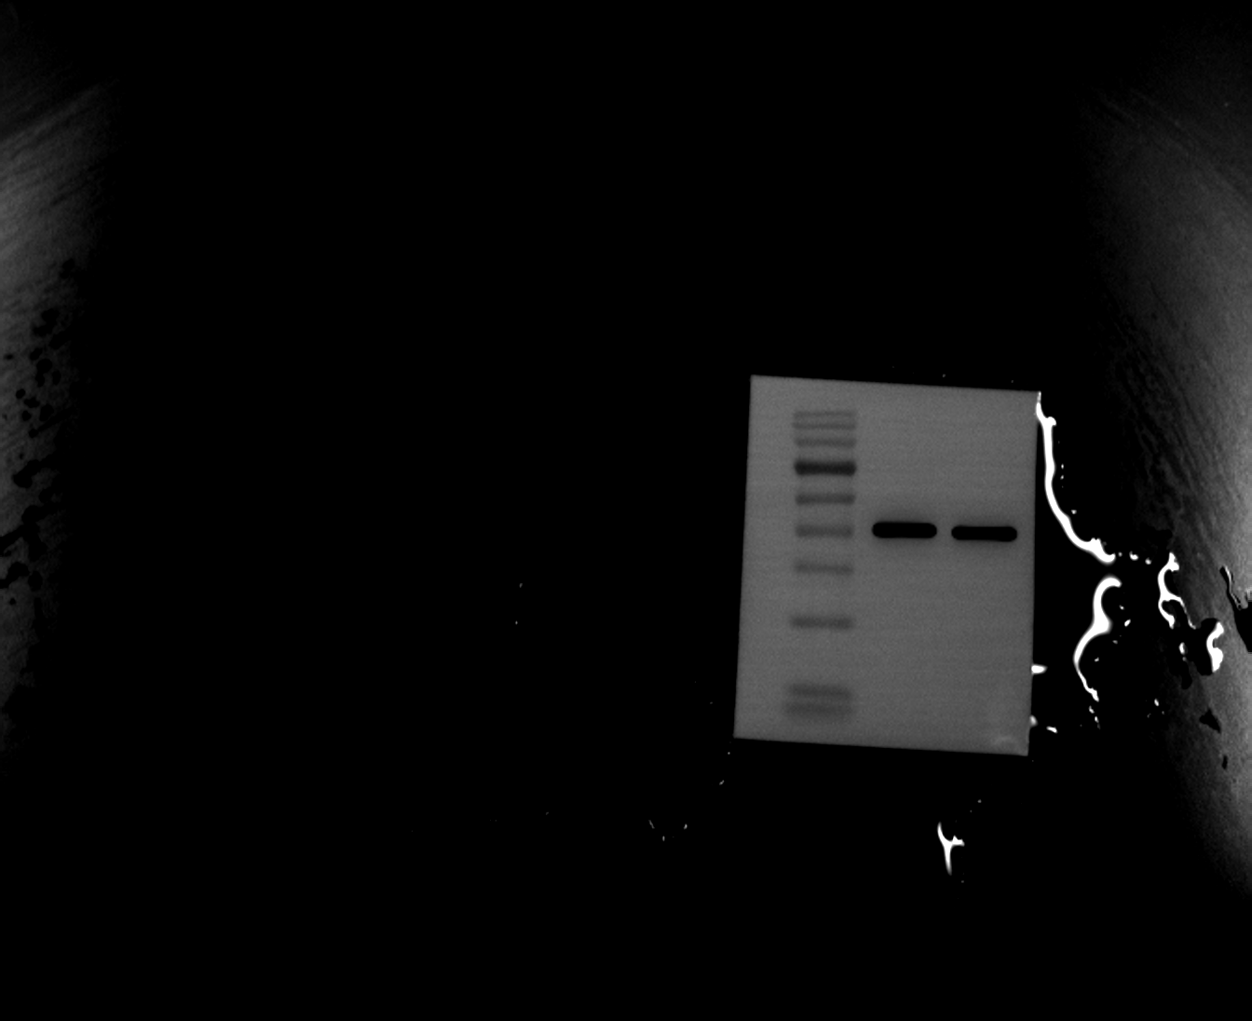

Figure 5G-H. Mouse arterial tissue Western blots

Replicate 3 - FCER1A
Original filename: FCER1A 3.Tif
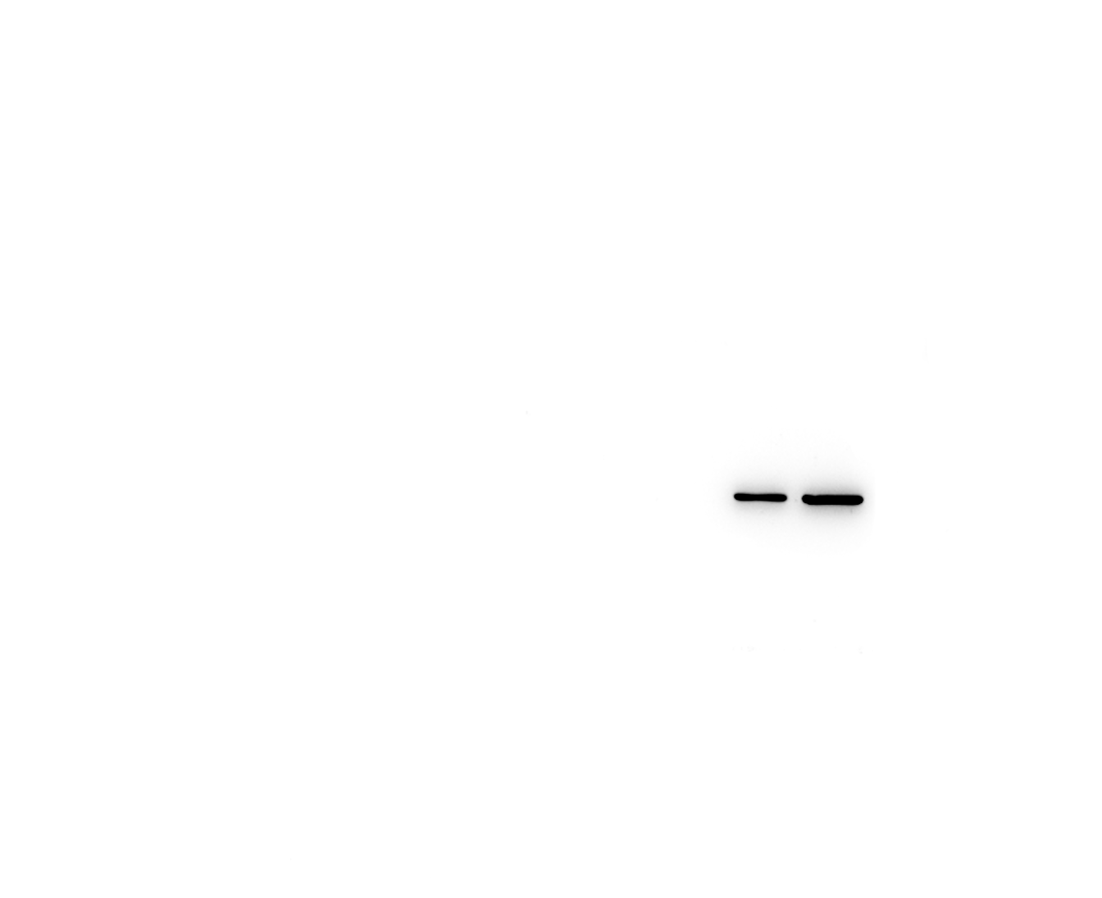
Original filename: FCER1A 3-1.Tif
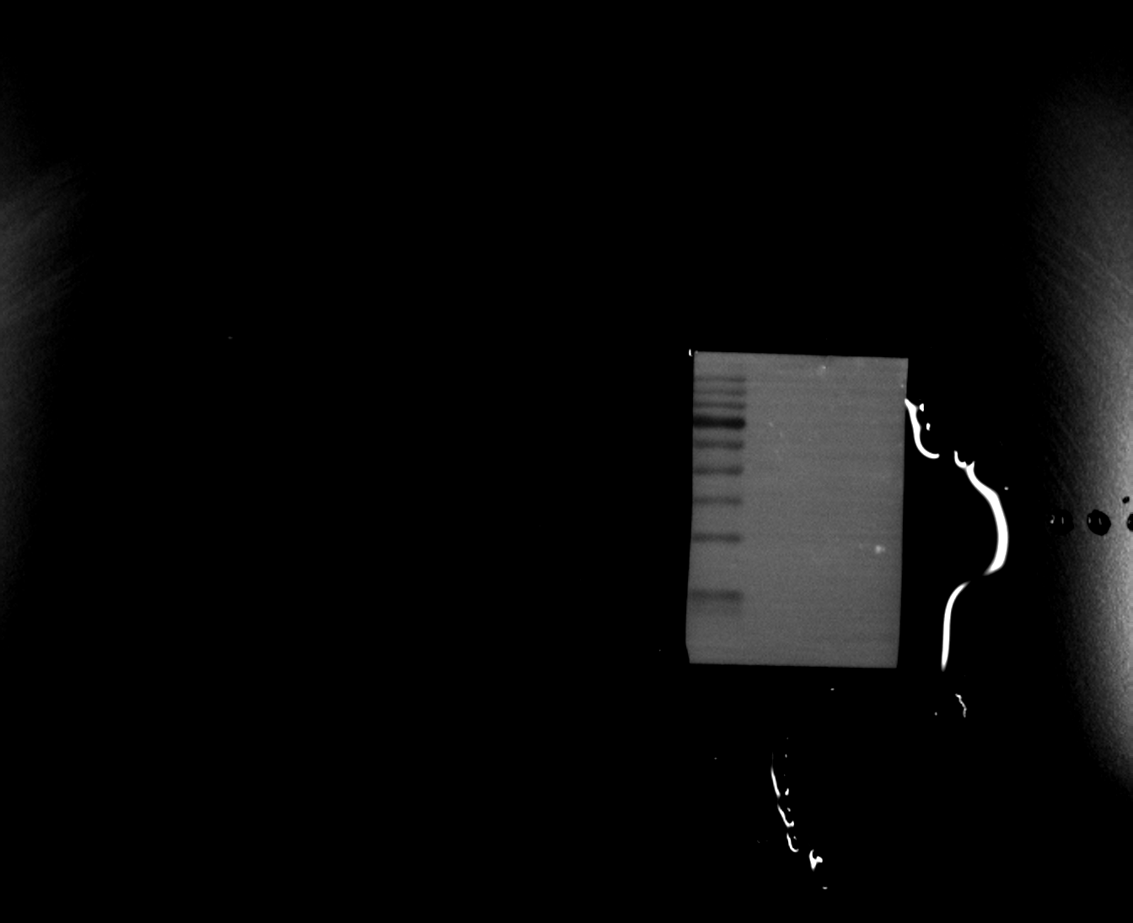
Original filename: FCER1A 3-2.tif
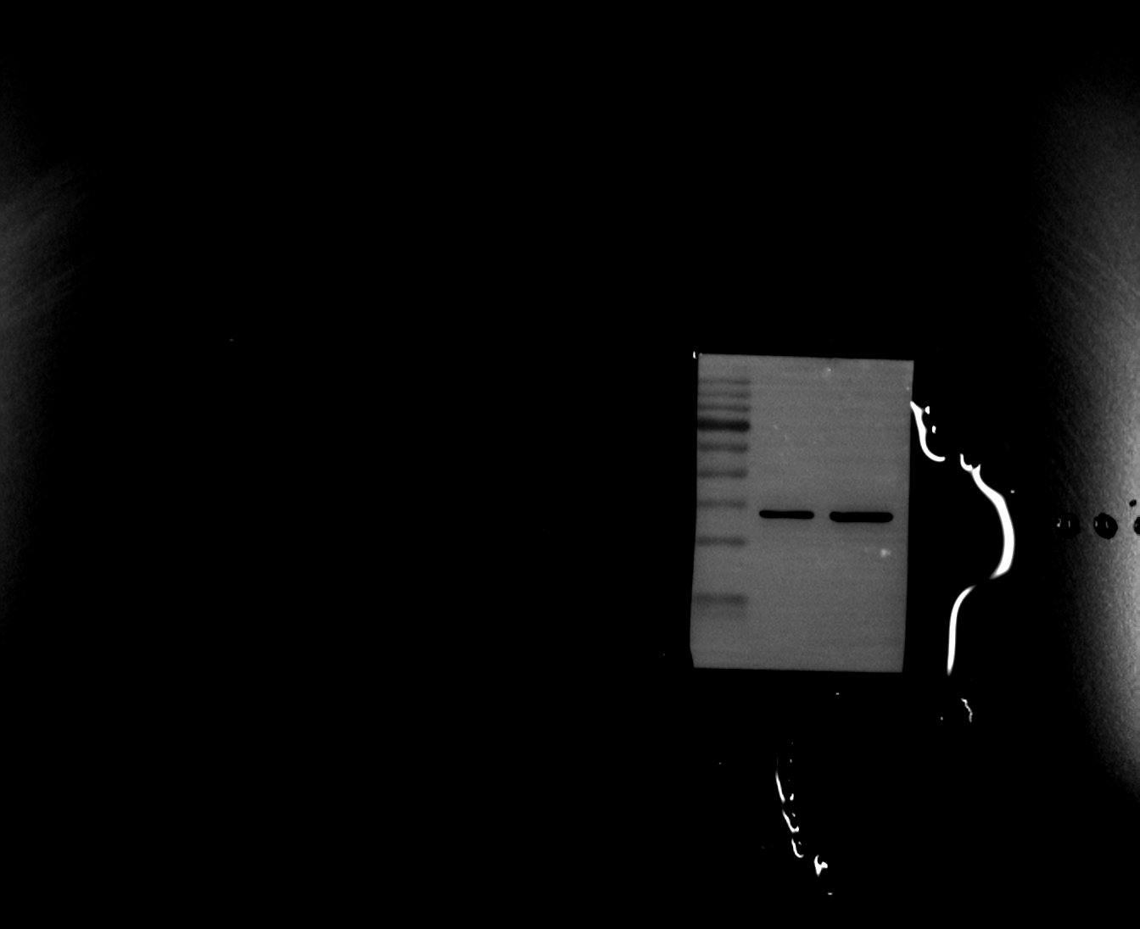

Figure 5G-H. Mouse arterial tissue Western blots

Replicate 3 - INSIG1
Original filename: INSIG1 3.Tif
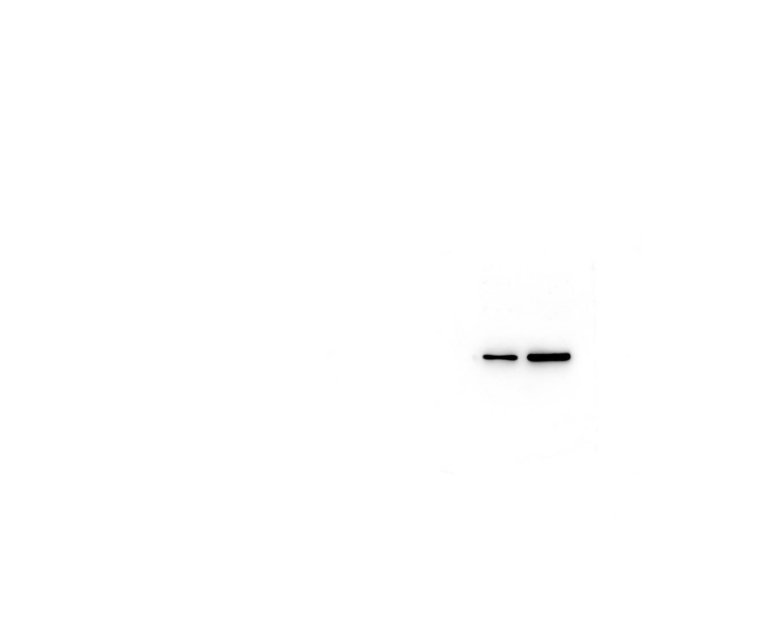
Original filename: INSIG1 3-1.Tif
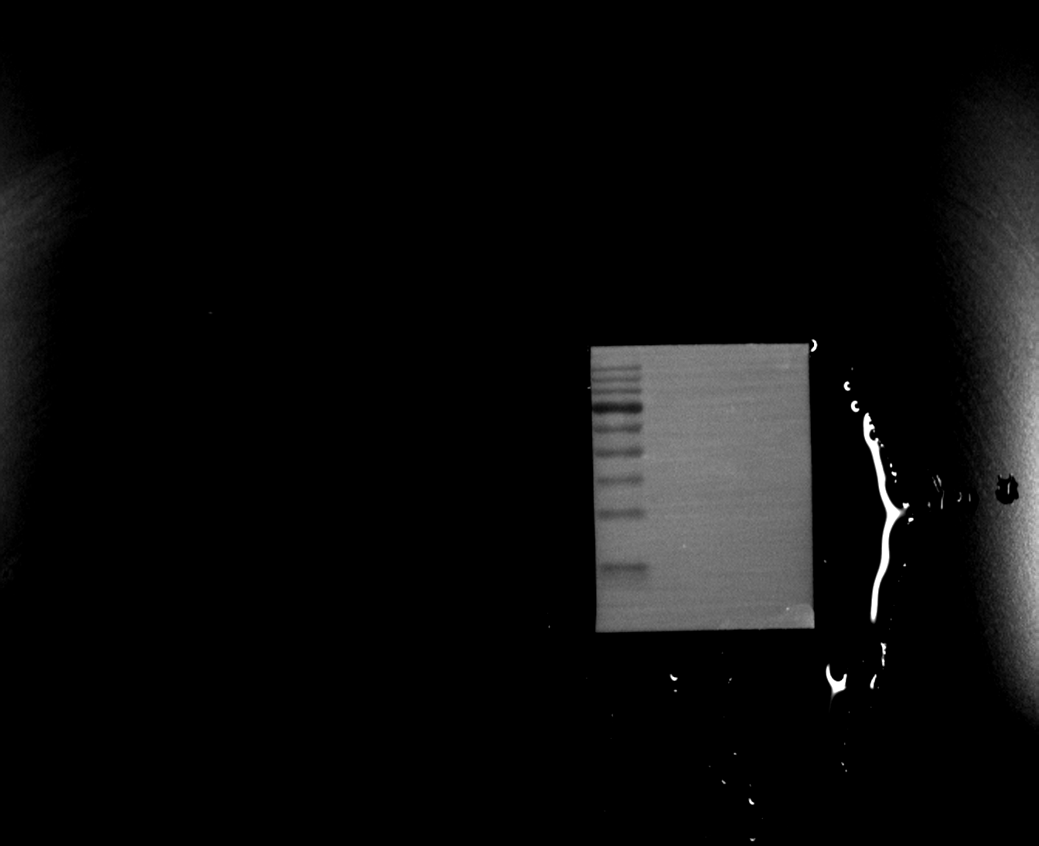
Original filename: INSIG1 3-2.tif
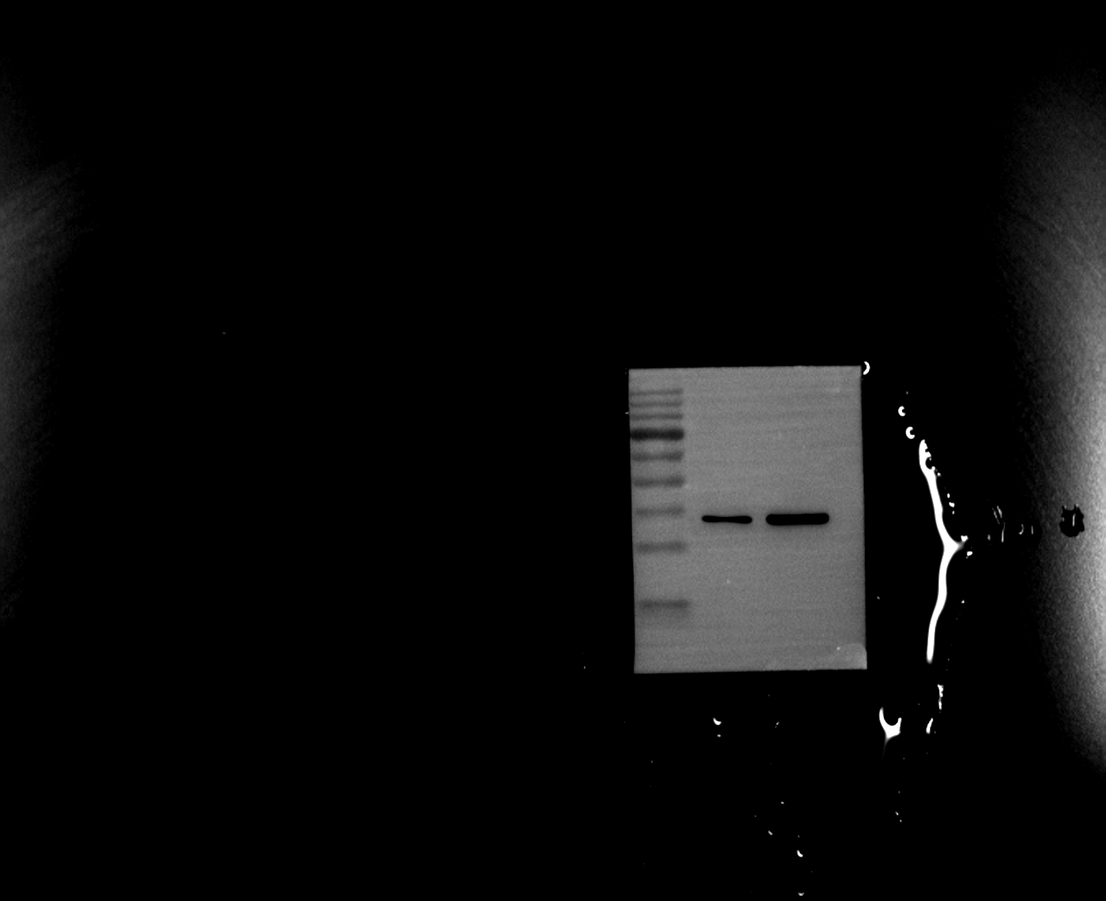

Figure 5G-H. Mouse arterial tissue Western blots

Replicate 3 - Loading control (β-actin)
Original filename: β-actin 3.Tif
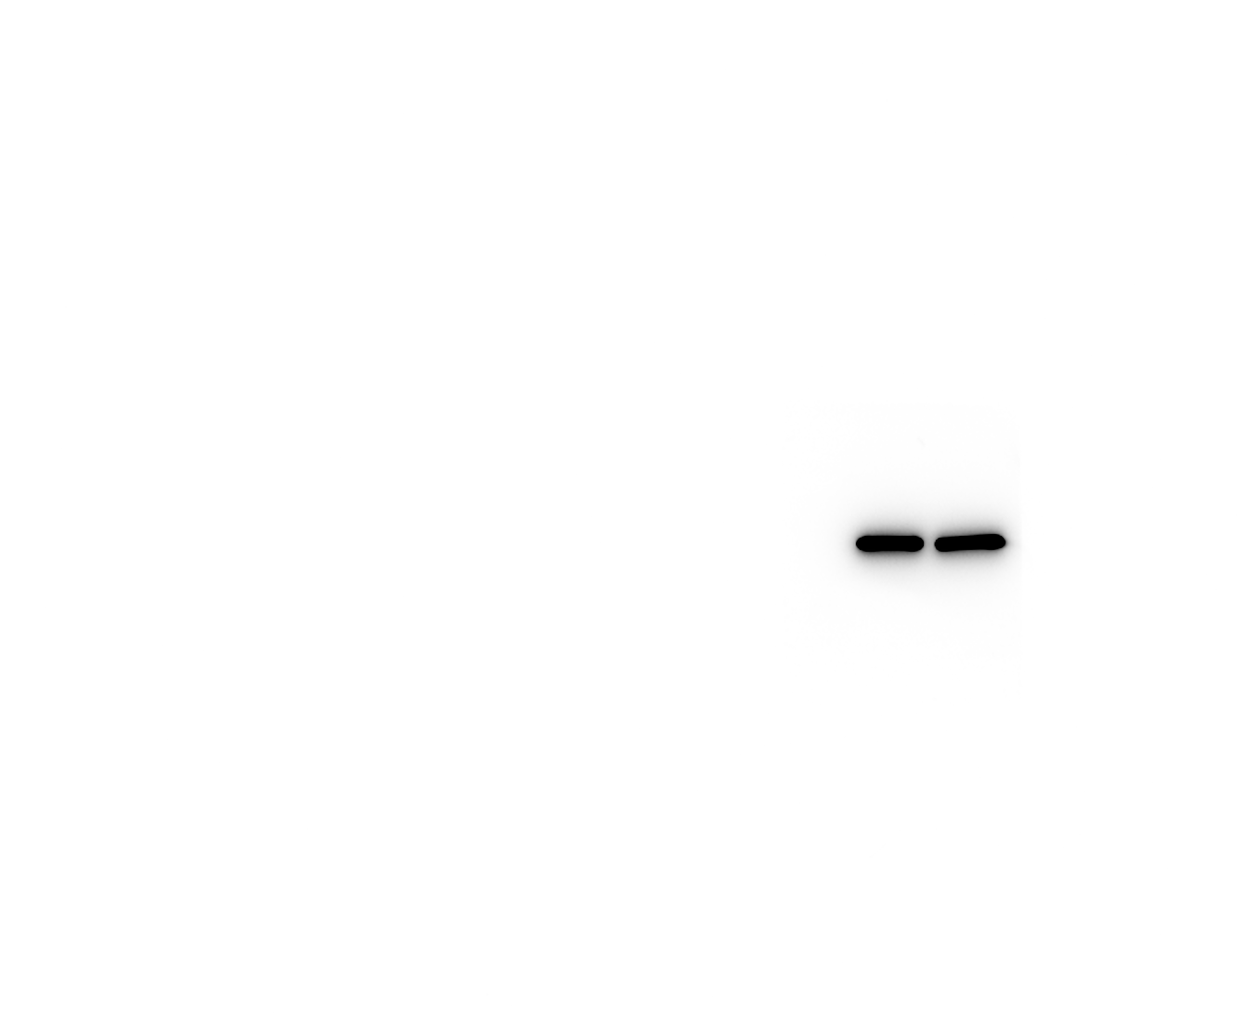
Original filename: β-actin 3-1.Tif
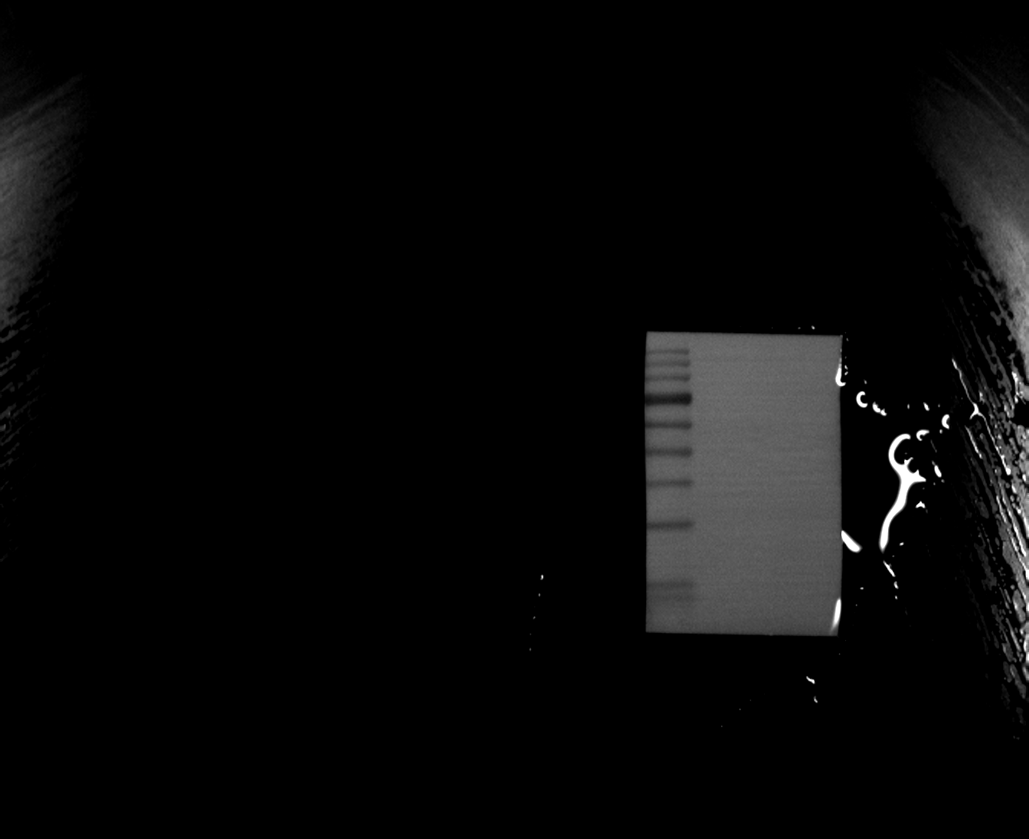
Original filename: β-actin 3-2.tif
