Integrative SMR and multi-model machine learning characterize FCER1A- and INSIG1-associated phenotypes in arterial aging-related disease
Shengping Jiang^{1,2}#, Dongmei Xiao¹#, Yue Chen¹, Yu Kuang¹, Xiangan Chen¹, Zhenyu Li²*, Chengliang Zhang³*, Jing Li¹*
- School of Pharmaceutical Sciences, South-Central Minzu University, Wuhan, 430074, China
2. Modern Research Center for Traditional Chinese Medicine, Shanxi University, Taiyuan, 030006, China
3. Department of Pharmacy, Tongji Hospital, Tongji Medical College, Huazhong University of Science and Technology, Wuhan 430030, China
* Corresponding authors.
Jing Li, PhD,
E-mail address: jinglisxu@163.com
Zhenyu Li, PhD,
- mail address: lizhenyu@sxu.edu.cn
Chengliang Zhang, PhD,
E-mail address:clzhang@tjh.tjmu.edu.cn
#Co-first authors.

Supplementary material Table

Table S1: Sequencing of primer transcripts.
Primer names | Gene sequence (5’ to 3’)
mouse actin F | TCGAGCAGAACCTCTCCGTA
mouse actin R | CTGACGAGTCTCCCATCTGC
mouse FCER1A F | TGAGTGCCACCGTTCAAGACAG
mouse FCER1A R | TGGCATCTGATGTCAAAGGATCC
mouse INSIG1 F | ATAGCCACCATCTTCTCCTCCG
mouse INSIG1 R | CCAACGAACACGGCAATACAGC

Database | Link | Data type
FinnGen study | https://www.finngen.fi/en | Coronary arterial disease dataset
Genotype-Tissue Expression v8(GTEx v8) project | https://gtexportal.org/home/ | eQTLs data
IEU OpenGWAS project | https://gwas.mrcieu.ac.uk/ | eQTLs data
GenAge | https://www.genomics.senescence.info/ | Aging genes
CellAge | https://genomics.senescence.info/cells/ | Aging genes
AgeAnnoMo | https://relab.xidian.edu.cn/AgeAnnoMO/#/ | Aging genes
SENCAN | https://rhpc.nki.nl/sites/senescence/classifier.php | Aging genes
Aging Atlas | https://ngdc.cncb.ac.cn/aging/index | Aging genes
MSigDB gene sets | http://www.gsea-msigdb.org/gsea/msigdb.index.jsp | Aging genes,Inflammation genes
NCBI GEO database | http://www.ncbi.nlm.nih.gov/geo/ | The transcriptomic data and single-cell sequencing data
PubChem | https://pubchem.ncbi.nlm.nih.gov/ | The 3D structures of the targeted drugs
Uniport | https://www.uniprot.org/ | The protein structures
Genomics database | https://www.cancerrxgene.org/ | A drug sensitivity analysis using data
Table S2: Data accessibility.
Supplementary Figure
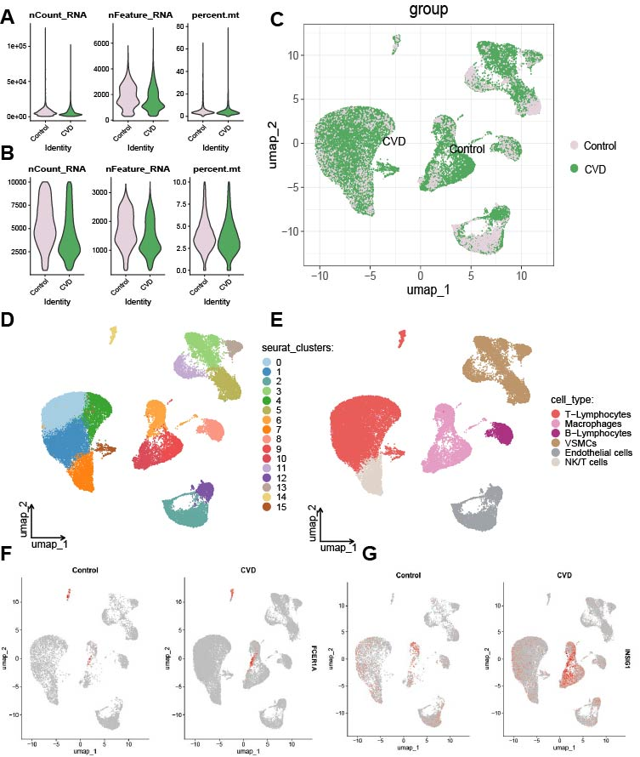
Figure S1 Single-cell quality control, integration, and major-cell-type annotation. (A) Distributions of nCount_RNA, nFeature_RNA, and mitochondrial transcript percentage before filtering. (B) Corresponding distributions among retained cells after quality control. (C) UMAP visualization of control and CVD cells after Harmony integration. (D) UMAP embedding of 16 unsupervised clusters. (E) UMAP annotation of six major cell types. (F, G) Group-stratified UMAP feature plots showing FCER1A and INSIG1 expression in control and CVD cells.

